Supplementary data

The raw data can be found on https://doi.pangaea.de/10.1594/PANGAEA.920071.
Table S 1. General information about the studied sediment cores.
Core Section | Longitude | Latitude | Northing | Easting | Zone | Length (cm) | Facies
N14-2 | 7.13431 | 53.71048 | 5952926 | 376,864.37 | 32 | 100 | channel fill, moraine, eolian/fluvial
N27-2 | 7.182342 | 53.6976533 | 5951418 | 379,997.65 | 32 | 95 | channel fill
N33-2 | 7.217895 | 53.6938717 | 5950937 | 382,334.11 | 32 | 99 | channel fill
N35-4 | 7.167479 | 53.6914642 | 5950754 | 378,998.73 | 32 | 108 | sand flat
N41-4 | 7.232223 | 53.6931083 | 5950829 | 383,277.96 | 32 | 99 | channel fill
N59-1 | 7.17137 | 53.75187 | 5957467 | 379,428.59 | 32 | 107 | channel fill
N72-2 | 7.14738 | 53.6951296 | 5951196 | 377,682.42 | 32 | 109 | eolian/fluvial
VVC16-3 | 7.130155 | 53.68284 | 5949859 | 376,509.28 | 32 | 117 | soil, eolian/fluvial
VVC16-4 | 7.130155 | 53.68284 | 5949859 | 376,509.28 | 32 | 119 | peat, lagoonal
VVC20-3 | 7.111546 | 53.7598445 | 5958457 | 375,508.10 | 32 | 25 | beach-foreshore

Table S 2. Data points obtained by X-ray fluorescence core scanning (XRF), CT core scanning (CT), digital photography (L*) and magnetic susceptibility scanning (MS) for each sediment facies.
Sediment facies | XRF | CT | L* | MS
moraine | 511 | 3878 | 24745 | 116
eolian/fluvial | 814 | 5495 | 34397 | 166
soil | 29 | 193 | 1234 | 6
peat | 278 | 1992 | 12562 | 61
lagoonal | 437 | 2972 | 19065 | 86
sand flat | 506 | 3651 | 23070 | 110
channel fill | 1992 | 13983 | 87735 | 415
beach-foreshore | 116 | 857 | 5283 | 26

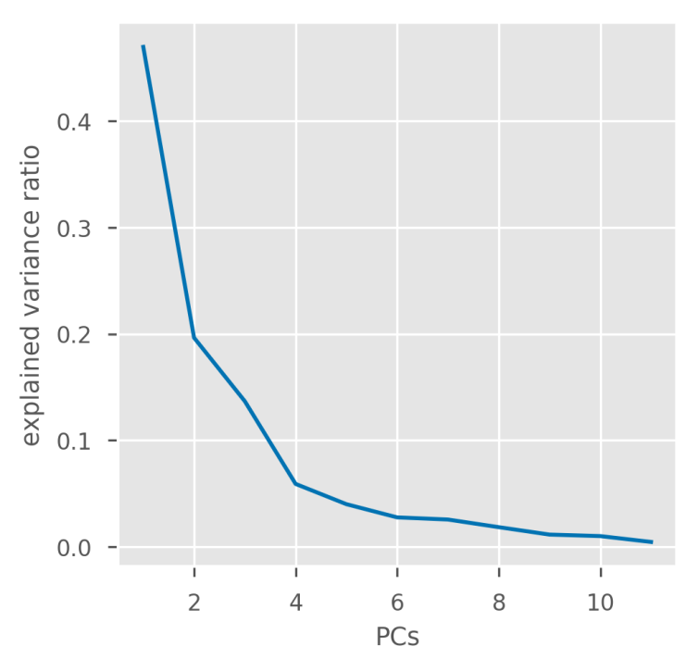
Fig. S1. Scree plot of the explained variance ratio for each principal component (PC).

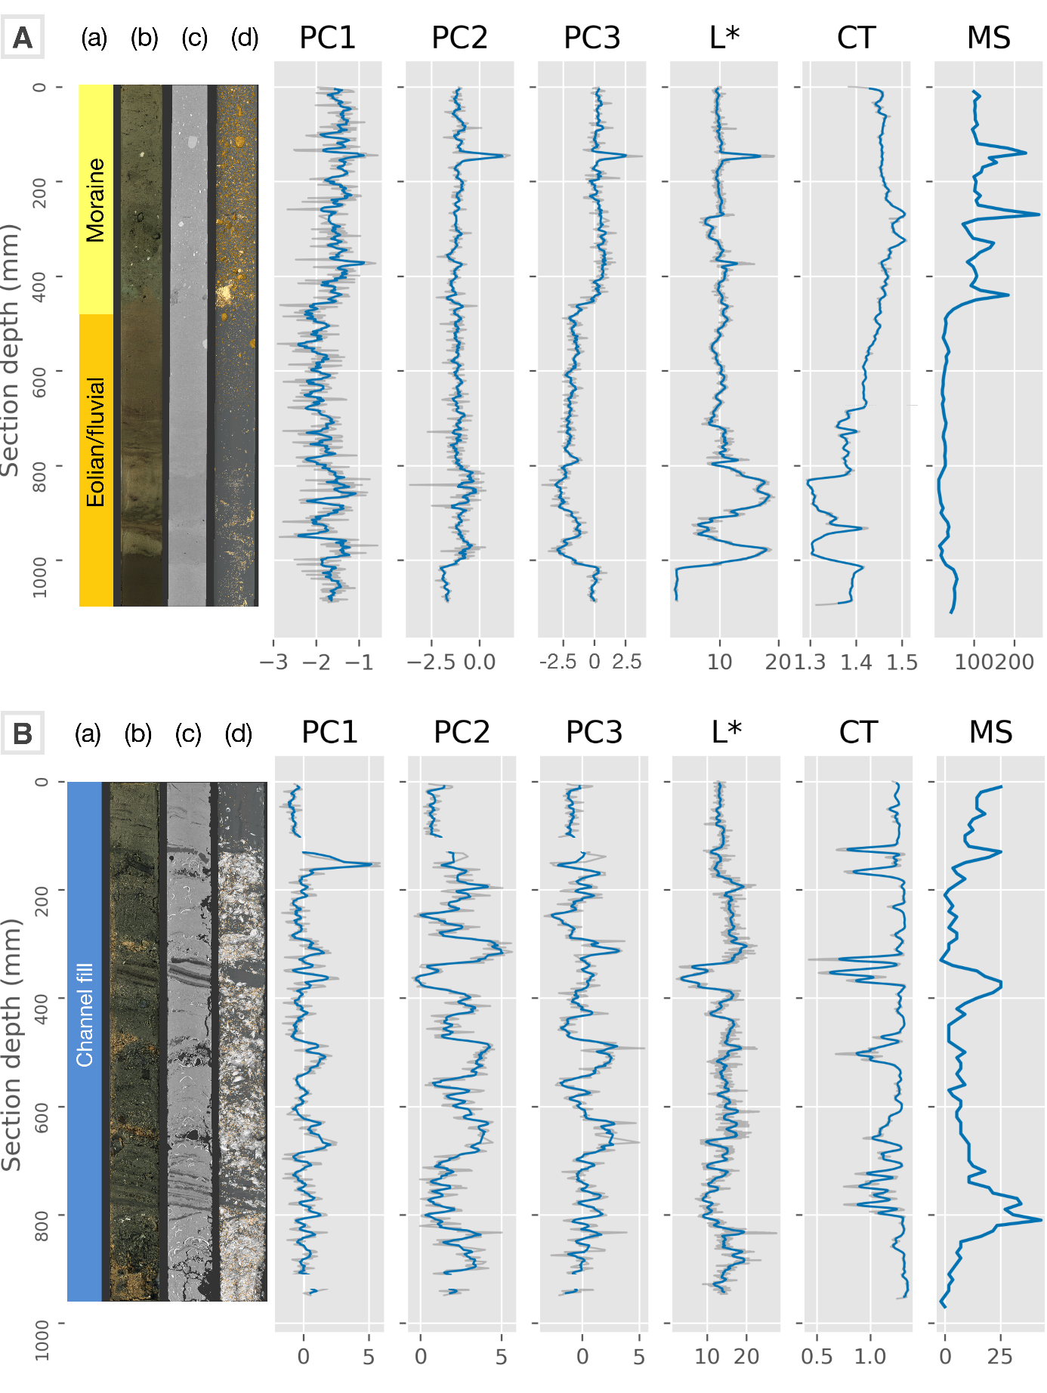
Fig. S2. Core N72-2 (A) and N27-2 (B): Facies labels (a), digital photograph (b), radiograph (c), and sediment constituents (golden: high-density sediments and lithic clasts, peach: low-density sediments, white: shell (fragments) separated using CT data (d). Scores of PC1-PC3 (dimensionless) from elemental intensities, lightness (L*), ranging from 0 (black) to 100 (white), CT density (CT in 10³ HU), and magnetic susceptibility (MS in 10⁻⁶ SI). Blue lines represent an 8 mm moving average, while grey lines represent raw data. No moving average is applied to MS.

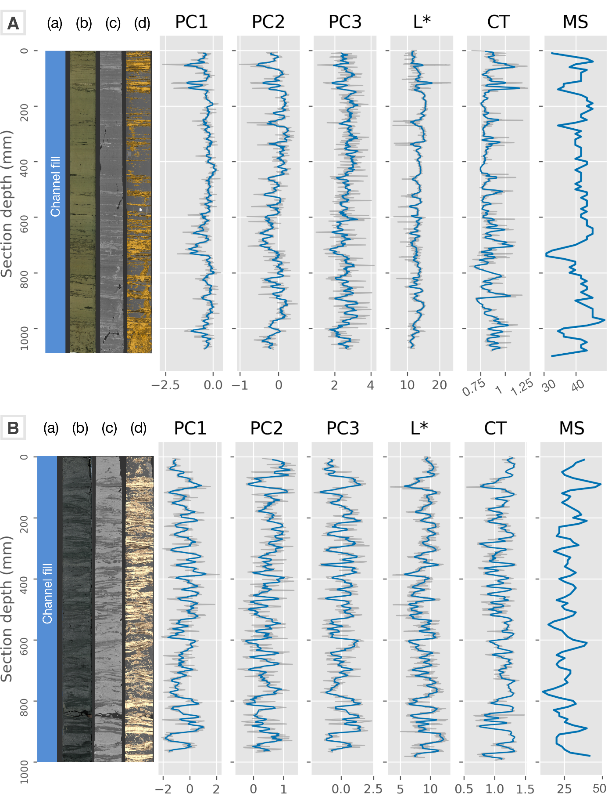
Fig. S3. Core N59-1 (A) and N41-4 (B): Facies labels (a), digital photograph (b), radiograph (c), and sediment constituents (golden: high-density sediments and lithic clasts, peach: low-density sediments, white: shell fragments) separated using CT data (d). The sediment constituents (d) reveals the intercalated layer structures and bioturbations. Scores of PC1-PC3 (dimensionless) from elemental intensities, lightness (L*), ranging from 0 (black) to 100 (white), CT density (CT in 10³ HU), and magnetic susceptibility (MS in 10⁻⁶ SI). Blue represent an 8 mm moving average, while grey lines represent raw data. No moving average is applied to MS.

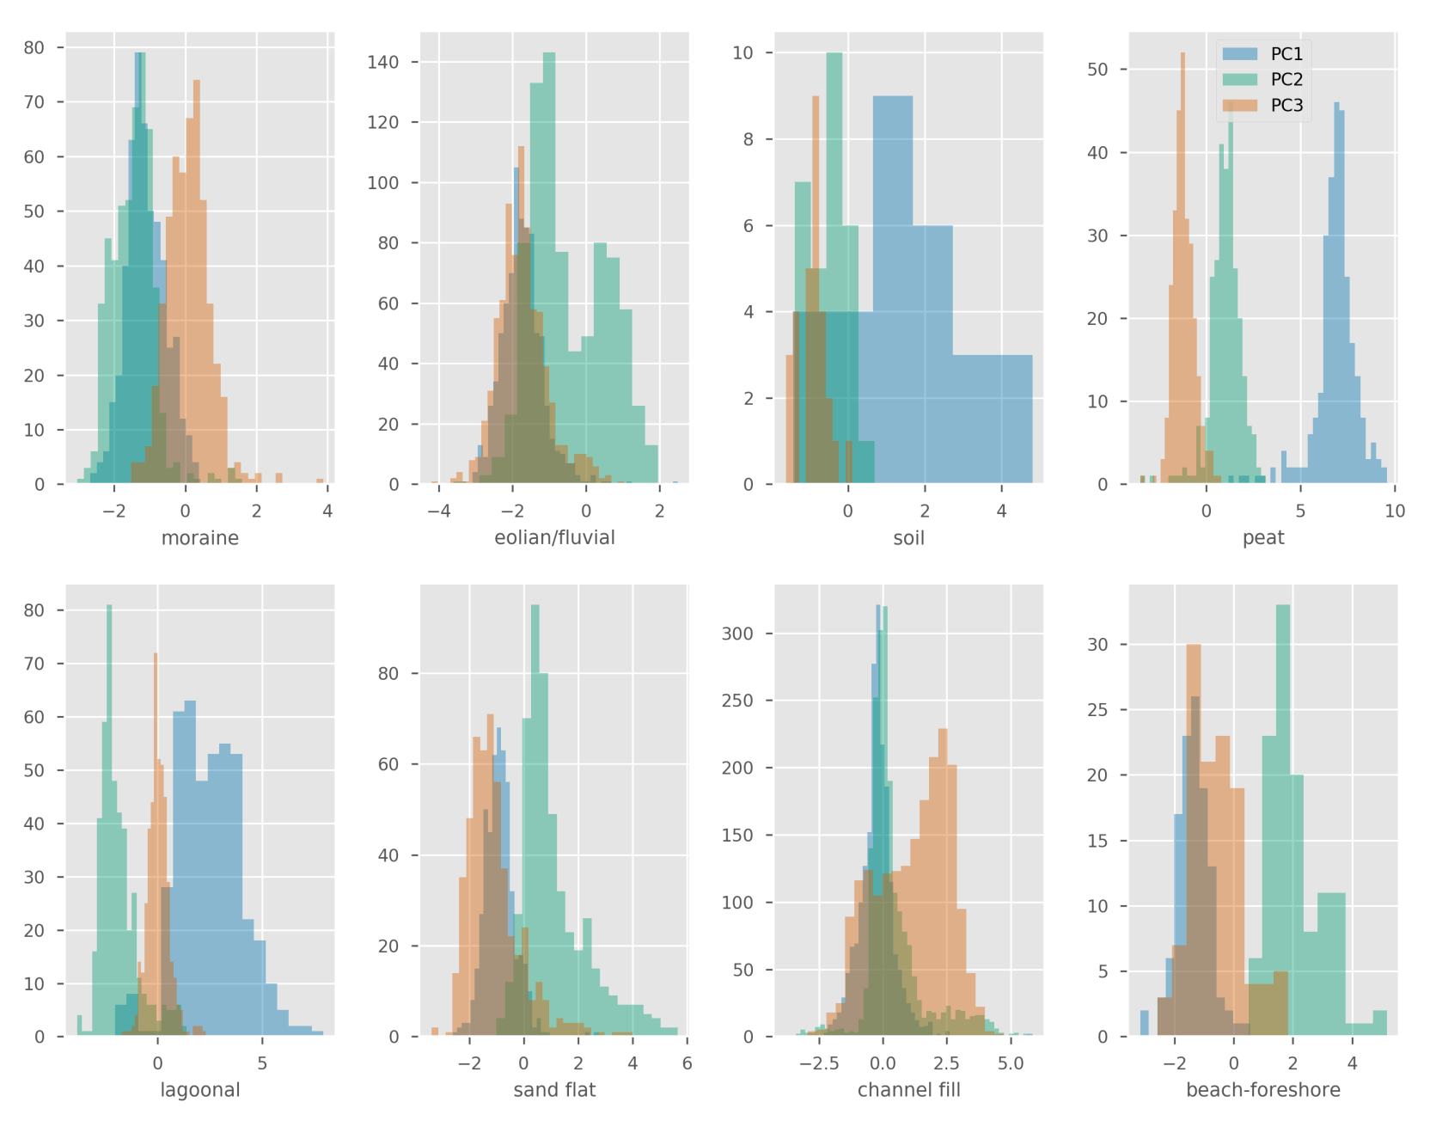
Fig. S4. Histograms of PC1 to PC3 scores for each facies. X-axis stands for the score value and y-axis shows the count.
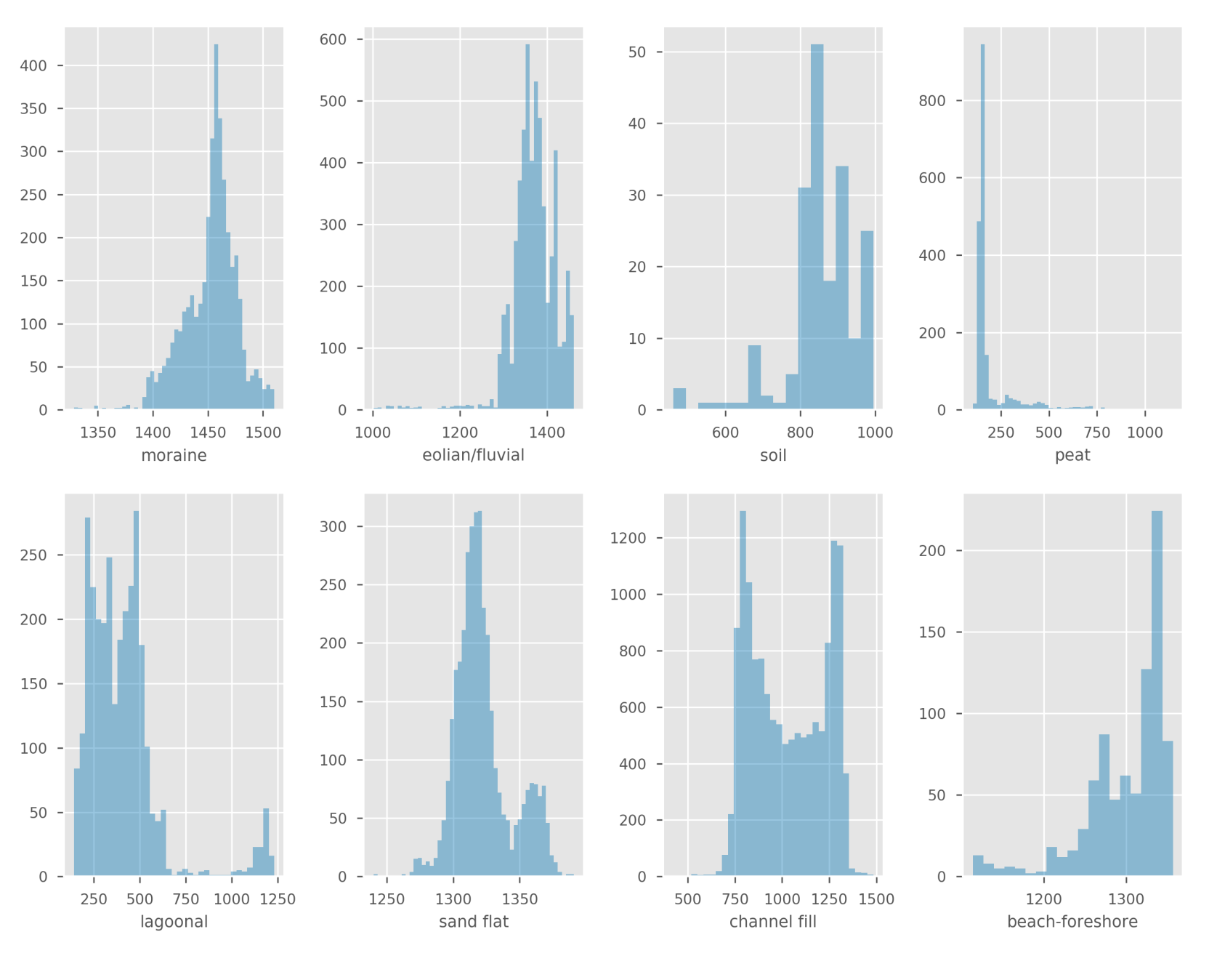
Fig. S5. Histogram of CT-density values for each facies. X-axis stands for the CT-density value (HU) and y-axis shows the count.
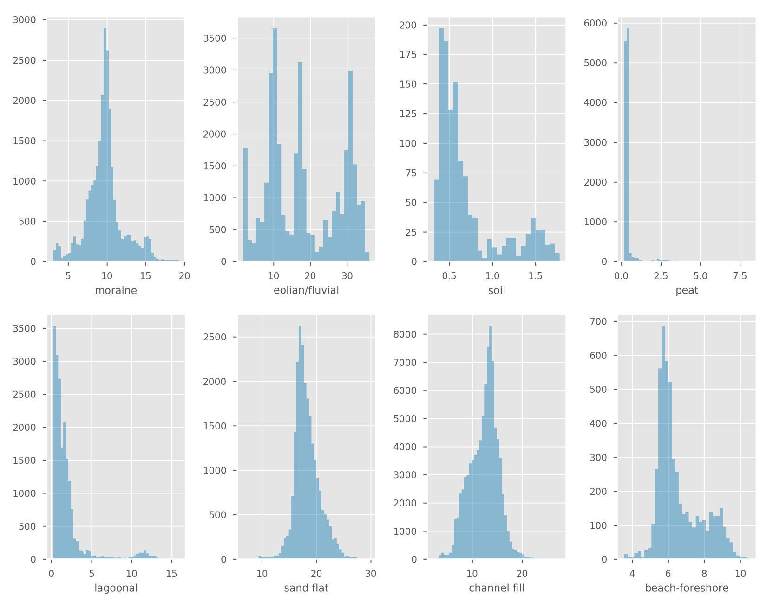
Fig. S6. Histogram of L* values for each facies. X-axis stands for the L* value and y-axis shows the count.
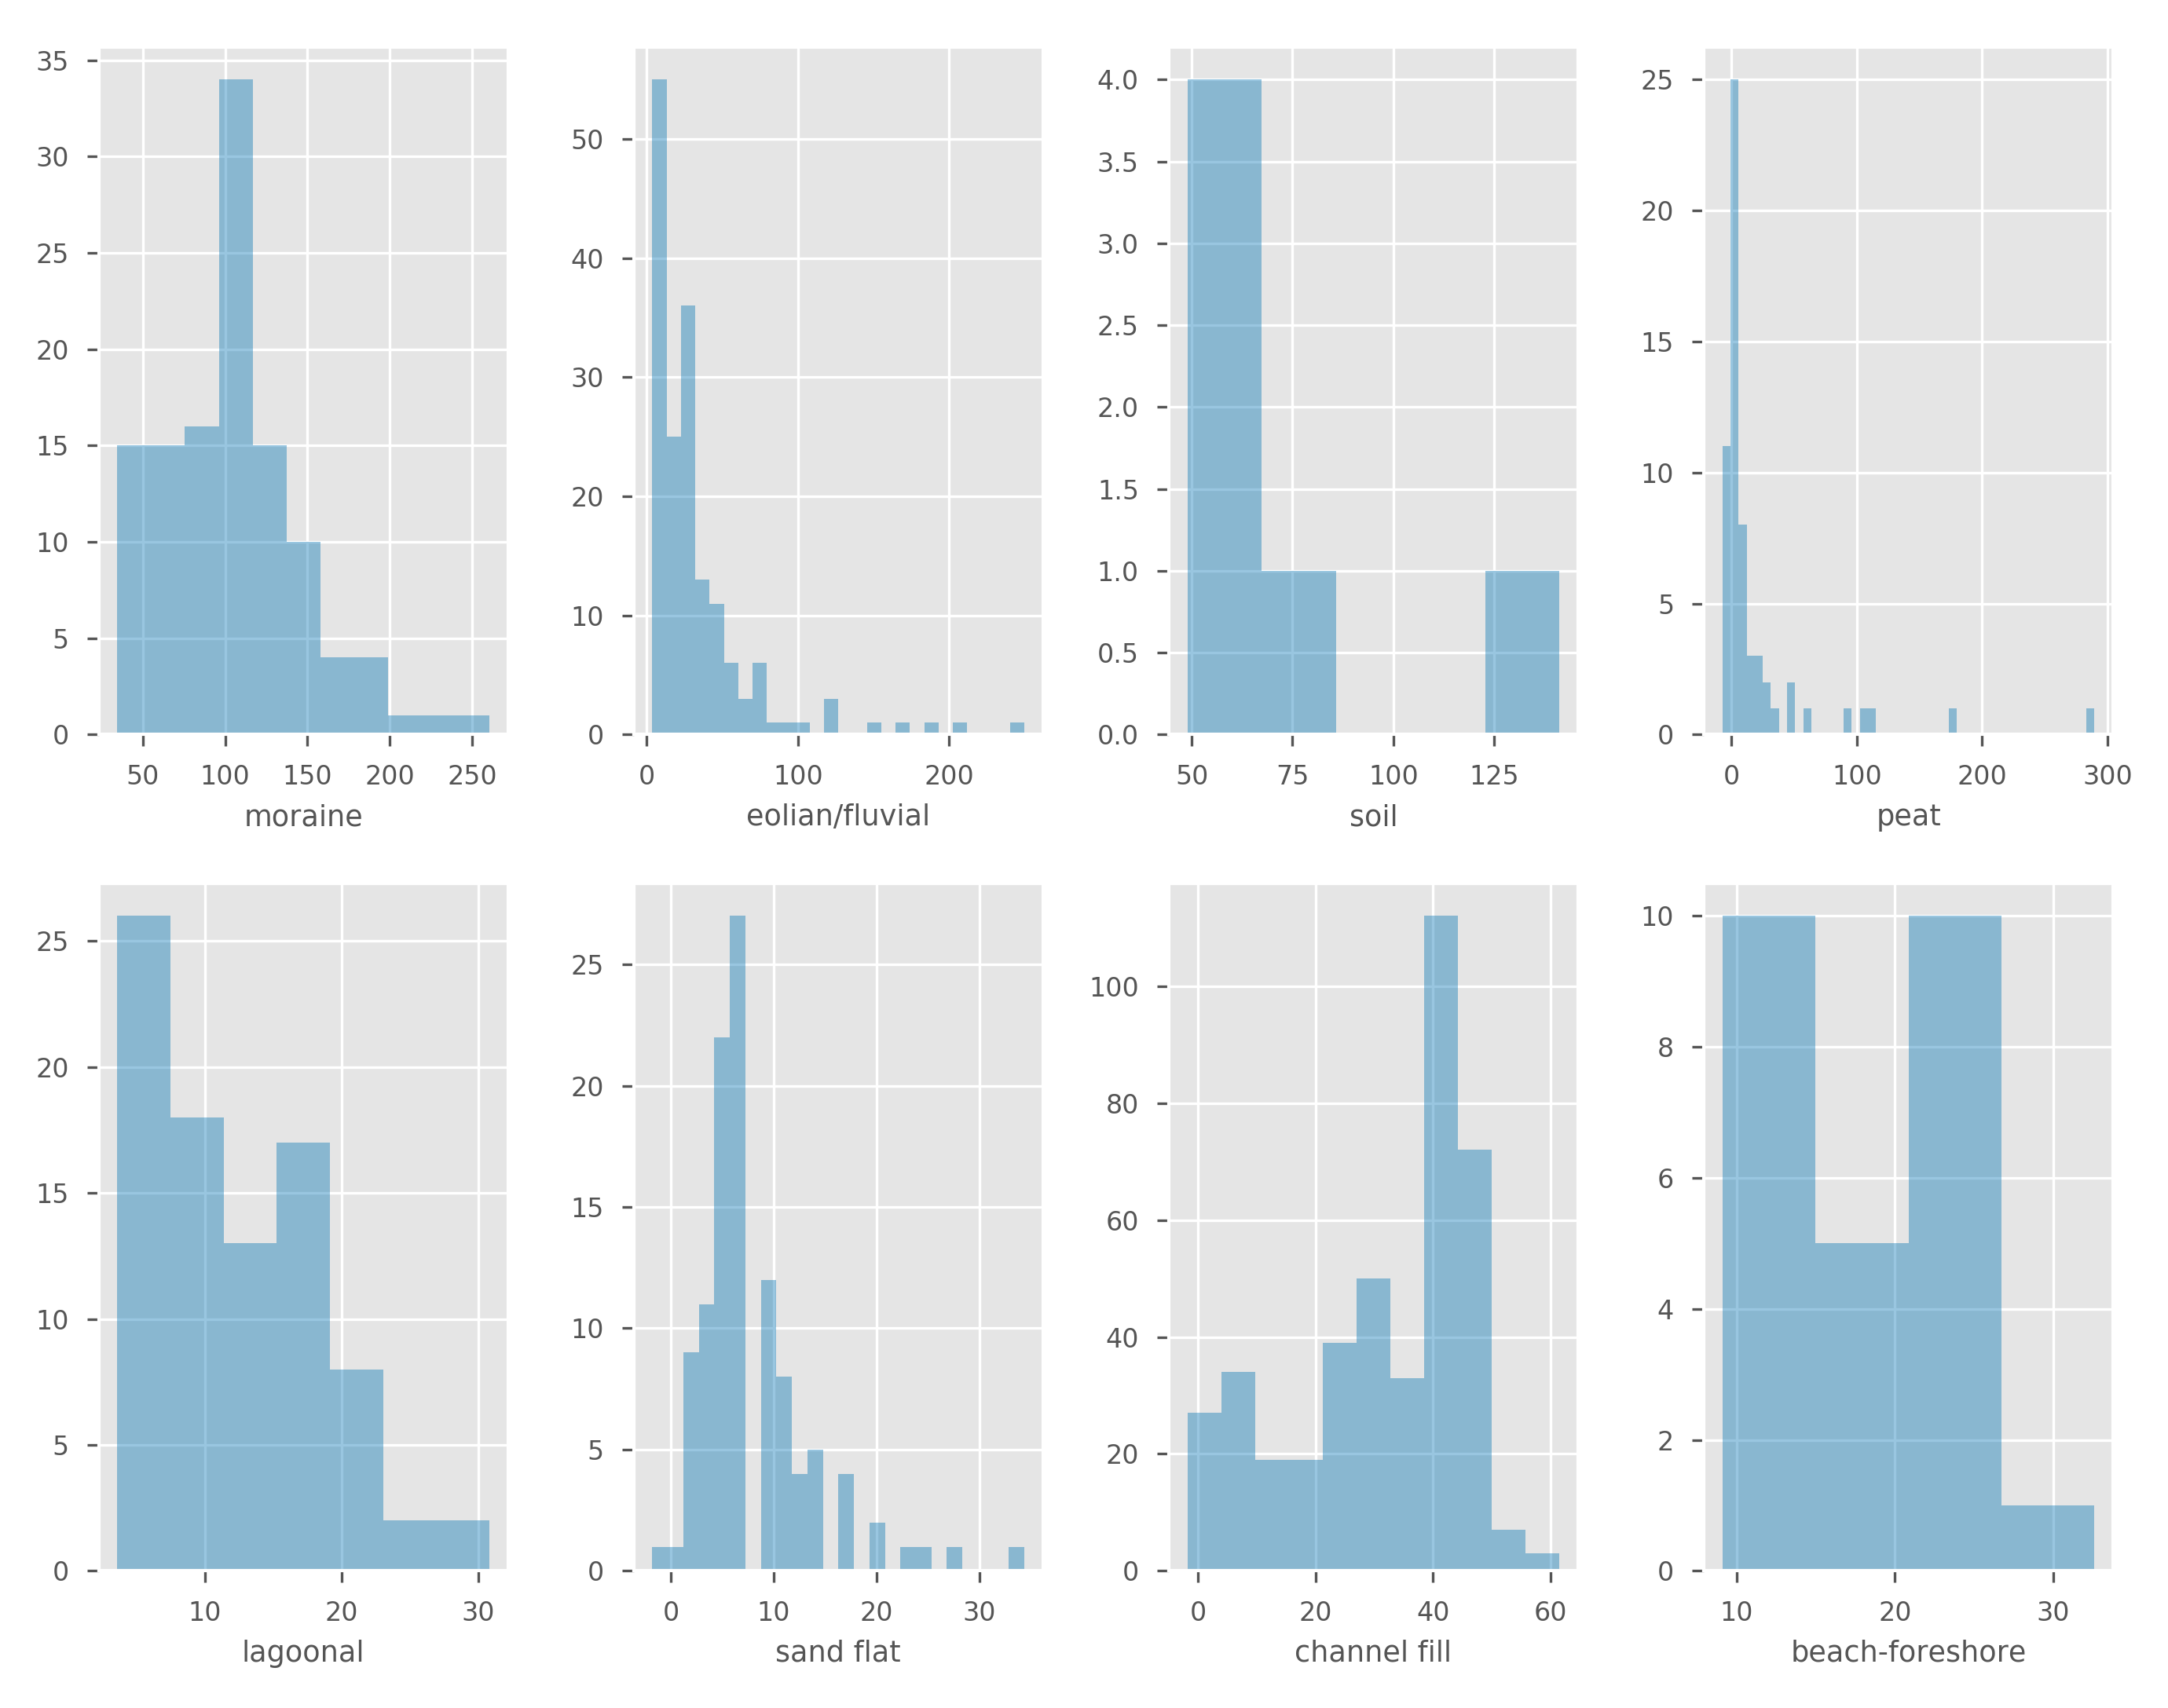
Fig. S7. Histogram of MS values for each facies. X-axis stands for the MS value (10⁻⁶ SI) and y-axis shows the count.

