Supplementary Material Elschner et al.
Netherlands Journal of Geosciences

Microfauna – taxa and ecological information
Tab. S1 Abundant foraminifer and ostracod species and their ecological characteristics(for visual information and distributions see Figs. 2, 3 and 4 [main article] and Figs. S1, S2 and S3 [supplement]).
Foraminifers
Ammonia tepida (Cushman, 1926)
Order |  | Superfamily |  | Family | Subfamily | Genus
Rotaliida |  | Rotalioidea |  | Ammoniidae | Ammoniinae | Ammonia
Ecology: sheltered, shallow marine, often slightly brackish, intertidal environments, may extend onto low and mid marshes (Murray 2006)
Cribroelphidium excavatum (Terquem, 1875)
Order |  | Superfamily |  | Family | Subfamily | Genus
Rotaliina |  | Rotalioidea |  | Elphidiidae | Elphidiinae | Cribroelphidium
Ecology: intertidal to subtidal, estuaries, lagoons, continental shelf and slope, sediments with highly variable sand, mud and TOC contents, salinity 15–31 psu (Murray, 2006)
Cribroelphidium williamsoni (Haynes, 1973)
Order |  | Superfamily |  | Family | Subfamily | Genus
Rotaliina |  | Rotalioidea |  | Elphidiidae | Elphidiinae | Cribroelphidium
Ecology: shallow parts of intertidal mud flats, estuaries, lagoons and sea-bound parts of salt marshes (Murray 2006); mainly less than 20 cm water depth, found in 0.1 to 0.5 m water depth and between 8 and 19 psu on mud to medium sand, also within the phytal zone, brackish water species, mainly temperate climate (Lehmann, 2000)
Elphidium spp. (Montfort, 1808)
Order |  | Superfamily |  | Family | Subfamily | Genus
Rotaliida |  | Rotalioidea |  | Elphidiidae | Elphidiinae | Elphidium
Ecology: braskish to hyper-saline salt marshes, lagoonal to marine, muddy to sandy substrate (Murray, 2006)
Haynesina germanica (Ehrenberg, 1840)
Order |  | Superfamily |  | Family |  | Genus
Rotaliina |  | Rotalioidea |  | Haynesinidae |  | Haynesina
Ecology: middle and low marshes, tidal flats (Horton and Edwards 2006); shallow marine, intertidal environments, may extend onto low and mid marshes (Murray 2006)
Entzia macrescens (Brady, 1870)
Order | Suborder | Superfamily | Family |  | Subfamily | Genus
Lituolida | Trochamminina | Trochamminoidea | Trochamminidae |  | Jadammininae | Entzia
Ecology: Euryhaline species, land-bound parts of salt marshes, sand flats also, in 0.1 to 0.3 m water depth and 8.5 to 19 psu on mud to medium sand and within the phytalzone of the southern Baltic; extremely euryhaline (Lehmann 2000); controlled more by substrate than salinity (Murray 2006)
 |  | – Continued on next page –
Miliammina fusca (Brady, 1870)
Order | Suborder | Superfamily | Family |  |  | Genus
Miliolida | Miliolina | Miliolacea | Miliamminidae |  |  | Entzia
Ecology: salt marshes and lagoons, brackish (Murray, 2006)
 |  | c
Triloculina oblonga (Montagu, 1803)
Order | Suborder | Superfamily |  | Family | Subfamily | Genus
Miliolida | Miliolina | Milioloidea |  | Hauerinidae | Miliolinellinae | Triloculina
Ecology: Salt marshes (Lehmann 2000)
Trochammina inflata (Montagu, 1808)
Order | Suborder | Family |  |  | Subfamily | Genus
Lituolida | Trochamminina | Trochamminoidea | Trochamminidae |  | Trochammininae | Trochammina
Ecology: Euryhaline brackish water species, shallow water, typical for salt marshes (Lehmann, 2000); high and middle marsh environments (Horton and Edwards 2006)
Ostracods
Cushmanidea elongata (Brady,1868)
Order | Suborder | Superfamily | Family |  | Genus
Podocopida | Cytherocopina | Cytheroidea | Cushmanideidae |  | Cushmanidea
Ecology: shallow marine, lagoons and open sea; euryhaline (Frenzel et al., 2010); sublittoral, on sandy substrate; estuaries to open sea (Athersuch et al., 1989)
Cyprideis torosa (Jones, 1850)
Order | Suborder | Superfamily | Family |  | Genus
Podocopida | Cytherocopina | Cytheroidea | Cytherideidae |  | Cyprideis
Ecology: common in brackish waters, but found in a wide range from almost freshwater to salinities up to 60 psu, inland ponds, lakes, marginal marine environments (e.g. lagoons, estuaries), prefers mud or sandy mud (Athersuch et al. 1989); very shallow to shallow waters, salt marshes (Frenzel et al., 2010)
Cytherois pusilla (Sars, 1928)
Order | Suborder | Superfamily | Family |  | Genus
Podocopida | Cytherocopina | Cytheroidea | Paradoxostomatidae |  | Cytherois
Ecology: very shallow to shallow, lagoons and open sea (Frenzel et al., 2010); shallow marine, living amongst littoral algae (Athersuch et al., 1989)
Hirschmannia viridis (Mueller, 1785)
Order | Suborder | Superfamily | Family |  | Genus
Podocopida | Cytherocopina | Cytheroidea | Loxoconchidae |  | Hirschmannia
Ecology: very shallow to shallow, ponds, lagoons and open sea, phytal, sandy substrate, meso- to euryhaline, high oxygen (Frenzel et al., 2010)
 |  | – Continued on next page –
Krite sp. (Crosskey & Robertson, 1874)
Order | Suborder | Superfamily | Family |  | Genus
Podocopida | Cytherocopina | Cytheroidea | Krithidae |  | Krithe
Ecology: open sea, deep, endobenthic, poly- to euryhaline (Frenzel et al., 2010)
Leptocythere spp. (Sars, 1925)
Order | Suborder | Superfamily | Family |  | Genus
Podocopida | Cytherocopina | Cytheroidea | Leptocytheridae |  | Lepthcythere
Ecology: useful envitonmental indicator, some species exclusively marine (e.g. L. pellucida), others typical for inner estuarine and salt marsh environments (e.g. L. castanea, L. lacertosa)
Loxoconcha sp. (Sars, 1866)
Order | Suborder | Superfamily | Family |  | Genus
Podocopida | Cytherocopina | Cytheroidea | Loxoconchidae |  | Loxoconcha
Ecology: very shallow to shallow, lagoons, estuaries, salt marsh, open sea, phytal, sand (Frenzel et al., 2010)
Leptocythere spp. (Sars, 1925)
Order | Suborder | Superfamily | Family |  | Genus
Podocopida | Cytherocopina | Cytheroidea | Leptocytheridae |  | Lepthcythere
Ecology: useful envitonmental indicator, some species exclusively marine (e.g. L. pellucida), others typical for inner estuarine and salt marsh environments (e.g. L. castanea, L. lacertosa)
Sahnicythere retroflexa (Klie, 1936)
Order | Suborder | Superfamily | Family |  | Genus
Podocopida | Cytherocopina | Cytheroidea | Neocytherididae |  | Sahnicythere
Ecology: fine-sandy substrate, litoral and sublittoral (Athersuch et al., 1989)
Semicytherura sp. (Wagner, 1957)
Order | Suborder | Superfamily | Family |  | Genus
Podocopida | Cytherocopina | Cytheroidea | Cytheruridae |  | Symicytherura
Ecology: differing between species; mainly very shallow to shallow marine; open sea, phytal zone
Urocythereis sp. (Ruggieri, 1950)
Order | Suborder | Superfamily | Family |  | Genus
Podocopida | Cytherocopina | Cytheroidea | Hemicytheridae |  | Urocythereis
Ecology: shallow, open sea, mud (Frenzel et al., 2010), sand (Athersuch et al., 1989)

Laboratory results of sediment cores
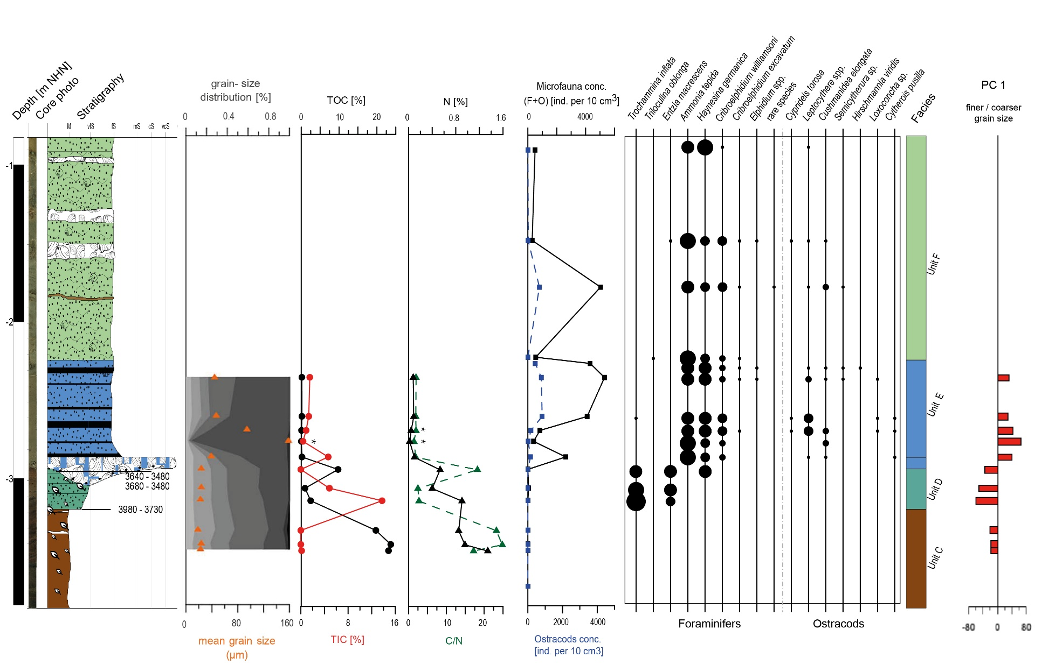
Fig. S1 Sedimentological, geochemical and microfaunal results of N44, including the most relevant component of the PCA (only lower part including all analyses). For colour legend see Fig. 3 (main article).

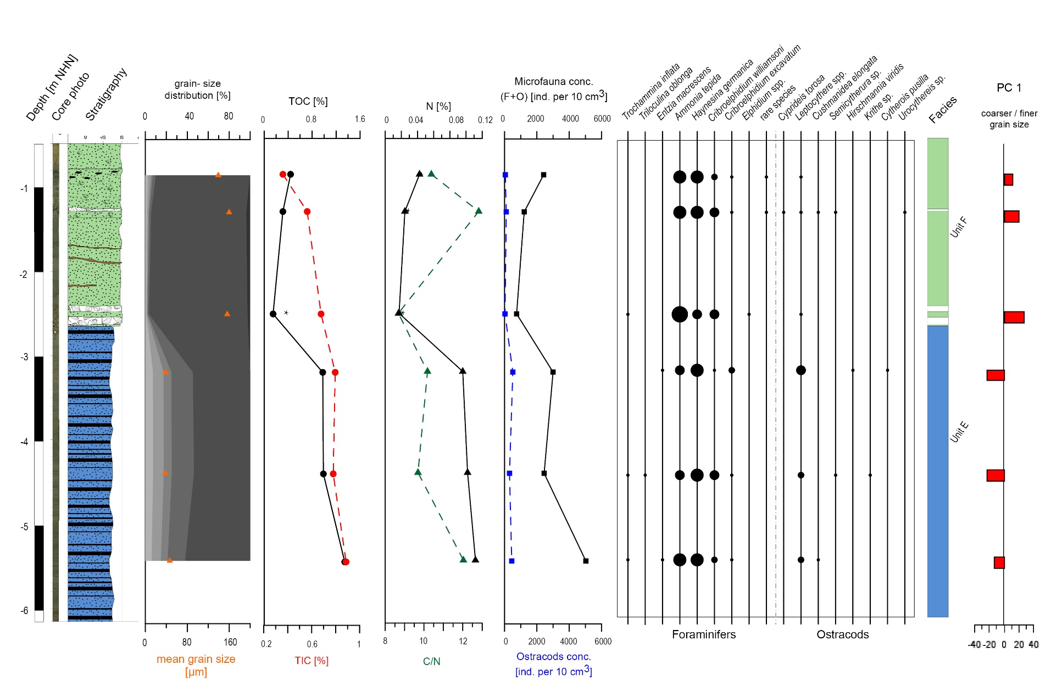
Fig. S2 Sedimentological, geochemical and microfaunal results of N45, including the most relevant component of the PCA. For colour legend see Fig. 3 (main article).
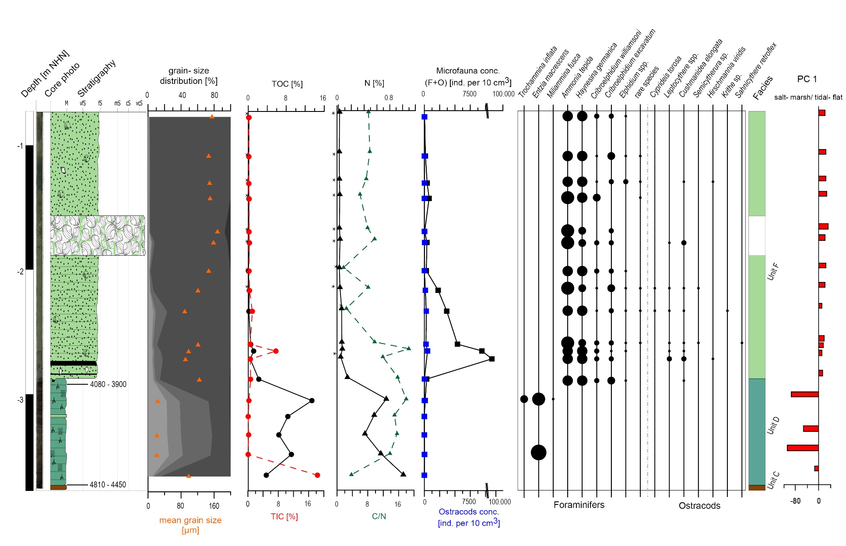
Fig. S3 Sedimentological, geochemical and microfaunal results of VC13, including the most relevant component of the PCA. For colour legend see Fig. 3 (main article).

Multivariate Statistics
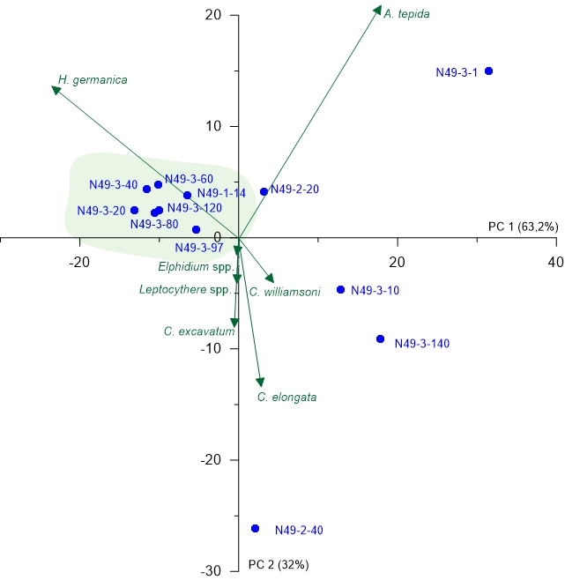
Fig. S4 PCA biplot of N49 (upper part of the core, Unit F) showing the two most relevant axes (PC 1 and PC 2). Colours of sample groupings relate to the colour legend in Fig. 3 (main article); green arrows represent microfaunal taxa and environmental parameters and blue points represent samples.
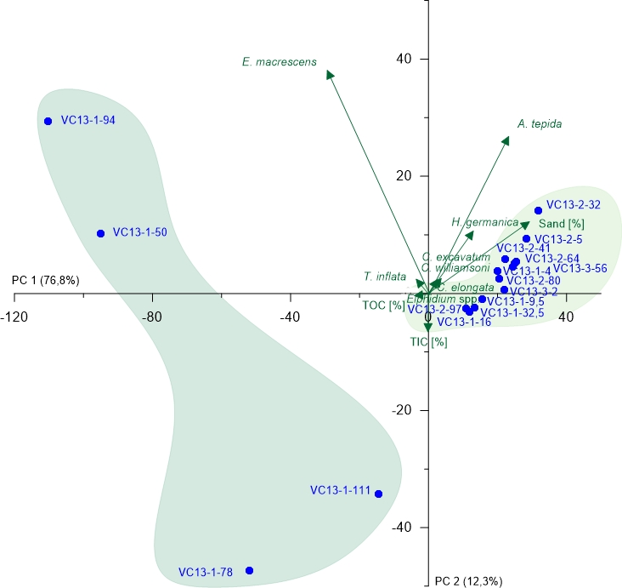
Fig. S5 PCA biplot of VC13 showing the two most relevant axes (PC 1 and PC 2). Colours of sample groupings relate to the colour legend in Fig. 3 (main article); green arrows represent microfaunal taxa and environmental parameters and blue points represent samples.
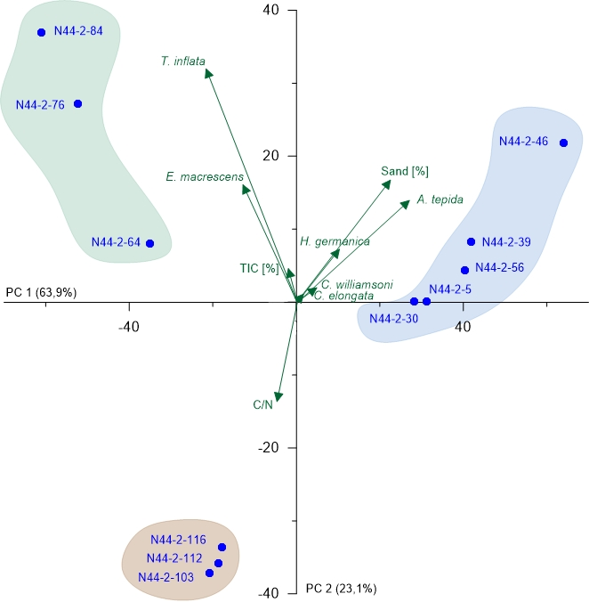
Fig. S6 PCA biplot of N44 (lower part of the core with all available data) showing the two most relevant axes (PC 1 and PC 2). Colours of sample groupings relate to the colour legend in Fig. 3 (main article); green arrows represent microfaunal taxa and environmental parameters and blue points represent samples.
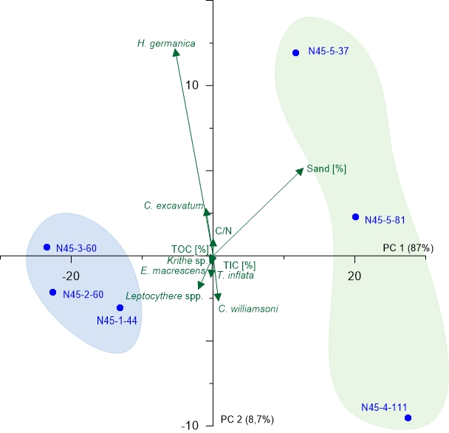
Fig. S7 PCA biplot of N45 showing the two most relevant axes (PC 1 and PC 2). Colours of sample groupings relate to the colour legend in Fig. 3 (main article); green arrows represent microfaunal taxa and environmental parameters and blue points represent samples.

Underlying data
Tab. S2 Grain-size data of all investigated cores.
Section Sample number | Depth NHN [m] | Coarse sand [%] | Medium sand [%] | Fine sand [%] | Coarse silt [%] | Medium silt [%] | Fine silt [%] | Clay [%] | mean grain size [µm]
N77-5-5 | -3.02 | 0.0 | 0.0 | 27.3 | 38.0 | 14.5 | 14.8 | 5.5 | 25.2
N77-5-21 | -3.18 | 0.0 | 0.2 | 36.8 | 34.3 | 11.9 | 12.3 | 4.6 | 32.5
N77-5-37 | -3.34 | 0.0 | 0.4 | 23.9 | 34.6 | 16.3 | 18.1 | 6.8 | 21.3
N77-4-21 | -3.56 | 0.0 | 2.3 | 14.7 | 28.9 | 17.9 | 22.7 | 13.6 | 13.0
N77-4-29 | -3.64 | 0.5 | 2.8 | 15.7 | 30.0 | 20.1 | 21.4 | 9.5 | 16.4
N77-4 70 | -4.05 | 0.5 | 3.9 | 20.0 | 29.4 | 17.0 | 19.0 | 10.3 | 19.0
N77-3-10 | -4.55 | 0.0 | 5.9 | 72.9 | 14.6 | 2.2 | 2.2 | 2.1 | 110.6
N77-3-28 | -4.73 | 0.0 | 8.6 | 86.7 | 2.8 | 0.3 | 0.5 | 1.1 | 156.1
N77-3-37 | -4.82 | 0.0 | 10.7 | 86.5 | 1.4 | 0.2 | 0.3 | 0.9 | 163.0
N77-3-58 | -5.03 | 0.0 | 2.5 | 94.8 | 1.2 | 0.2 | 0.4 | 1.0 | 149.3
N77-2-8 | -5.63 | 0.0 | 0.3 | 95.6 | 2.5 | 0.2 | 0.3 | 1.1 | 131.4
N77-2-68 | -6.23 | 0.0 | 4.0 | 90.3 | 3.1 | 0.5 | 0.8 | 1.3 | 141.0
N77-2-79 | -6.34 | 0.0 | 0.7 | 95.6 | 1.7 | 0.3 | 0.5 | 1.2 | 141.8
N77-1-23 | -6.88 | 0.0 | 3.1 | 88.7 | 5.4 | 0.6 | 0.8 | 1.4 | 128.5
N77-1 71 | -7.36 | 0.0 | 8.8 | 87.5 | 1.6 | 0.3 | 0.6 | 1.2 | 158.2
N77-1-95 | -7.60 | 1.9 | 41.5 | 55.0 | 0.4 | 0.1 | 0.3 | 0.8 | 232.5
N49-1-14 | -2.97 | 0.0 | 0.0 | 53.5 | 25.2 | 7.7 | 8.5 | 5.1 | 46.9
N49-1-29 | -3.12 | 0.0 | 1.2 | 27.4 | 37.1 | 15.3 | 13.9 | 5.1 | 26.8
N49-1-39 | -3.22 | 0.5 | 1.8 | 23.6 | 37.6 | 16.5 | 14.9 | 5.1 | 25.1
N49-1-49 | -3.32 | 0.0 | 0.7 | 18.1 | 40.8 | 18.5 | 16.2 | 5.7 | 20.6
N49-1-59 | -3.42 | 0.0 | 0.5 | 22.1 | 43.0 | 15.2 | 13.9 | 5.3 | 24.5
N49-1-69 | -3.52 | 0.0 | 0.4 | 36.4 | 36.0 | 11.2 | 11.5 | 4.5 | 33.7
N49-1-79 | -3.62 | 0.0 | 0.1 | 33.5 | 41.6 | 11.1 | 9.8 | 3.9 | 33.4
N49-1-89 | -3.72 | 0.0 | 0.2 | 38.0 | 37.2 | 10.3 | 10.3 | 3.9 | 35.8
N49-1-99 | -3.82 | 0.0 | 0.0 | 23.8 | 37.3 | 16.1 | 16.8 | 6.0 | 22.3
N49-1-109 | -3.92 | 0.0 | 0.4 | 33.5 | 34.8 | 13.1 | 13.4 | 4.8 | 30.0
N49-1-119 | -4.02 | 0.0 | 0.0 | 9.1 | 40.0 | 23.4 | 20.8 | 6.7 | 14.9
N49-1-129 | -4.12 | 0.0 | 0.0 | 24.1 | 33.5 | 17.4 | 18.3 | 6.7 | 20.8
N49-1-139 | -4.22 | 0.0 | 0.0 | 20.9 | 35.2 | 17.4 | 19.3 | 7.2 | 17.5
N49-1-142 | -4.25 | 0.0 | 0.0 | 12.9 | 37.5 | 20.3 | 21.1 | 8.1 | 15.1
VC13-3-2 | -0.75 | 0.0 | 0.5 | 97.3 | 0.8 | 0.1 | 0.3 | 0.9 | 154.7
VC13-3-34 | -1.07 | 0.0 | 0.2 | 97.4 | 1.0 | 0.2 | 0.4 | 1.0 | 146.7
VC13-3-56 | -1.29 | 0.0 | 0.2 | 97.3 | 1.0 | 0.2 | 0.4 | 1.0 | 149.0
VC13-2-5 | -1.42 | 0.0 | 0.3 | 97.2 | 1.0 | 0.2 | 0.4 | 0.9 | 150.2
VC13-2-32 | -1.69 | 0.0 | 7.3 | 90.3 | 0.7 | 0.2 | 0.5 | 1.0 | 168.1
VC13-2-41 | -1.78 | 0.0 | 3.7 | 88.4 | 2.8 | 1.3 | 1.9 | 1.9 | 158.5
VC13-2-64 | -2.01 | 0.0 | 0.4 | 96.7 | 1.2 | 0.3 | 0.5 | 1.0 | 146.8
VC13-2-80 | -2.17 | 0.0 | 0.0 | 93.4 | 3.7 | 0.6 | 0.9 | 1.4 | 120.8
VC13-2-97 | -2.34 | 0.0 | 0.1 | 76.7 | 13.8 | 3.1 | 3.6 | 2.7 | 88.8
– Continued on next page –
VC13-1-4 | -2.61 | 0.0 | 0.1 | 89.0 | 4.8 | 1.6 | 2.2 | 2.2 | 121.1
VC13-1-9,5 | -2.66 | 0.0 | 0.0 | 84.4 | 8.0 | 2.0 | 2.8 | 2.7 | 98.1
VC13-1-16 | -2.73 | 0.0 | 0.0 | 82.2 | 10.9 | 1.9 | 2.5 | 2.5 | 90.5
VC13-1-32,5 | -2.89 | 0.0 | 1.2 | 84.3 | 5.6 | 2.4 | 3.4 | 3.0 | 124.1
VC13-1-50 | -3.07 | 0.0 | 1.4 | 25.3 | 34.9 | 15.8 | 16.0 | 6.6 | 23.6
VC13-1-78 | -3.35 | 0.0 | 0.5 | 21.9 | 37.7 | 16.6 | 16.6 | 6.7 | 21.3
VC13-1-94 | -3.51 | 0.0 | 0.5 | 23.9 | 33.6 | 16.8 | 18.1 | 7.2 | 21.0
VC13-1 111 | -3.68 | 0.0 | 0.0 | 84.9 | 8.0 | 1.9 | 2.6 | 2.5 | 98.4
N44-2 5 | -2.36 | 0.0 | 0.0 | 52.3 | 26.7 | 8.3 | 8.3 | 4.4 | 44.4
N44-2 30 | -2.61 | 0.0 | 0.0 | 58.3 | 18.8 | 8.3 | 9.2 | 5.3 | 46.7
N44-2 39 | -2.70 | 0.0 | 0.7 | 77.0 | 11.7 | 3.0 | 4.1 | 3.5 | 94.1
N44-2 46 | -2.77 | 0.0 | 3.0 | 92.7 | 1.7 | 0.6 | 0.9 | 1.2 | 158.1
N44-2 56 | -2.87 | 0.0 | 2.5 | 45.5 | 24.1 | 9.5 | 11.5 | 6.9 | 38.9
N44-2 64 | -2.95 | 0.0 | 1.8 | 27.2 | 31.8 | 15.6 | 17.1 | 6.5 | 24.2
N44-2 76 | -3.07 | 0.0 | 1.6 | 28.8 | 30.0 | 15.2 | 17.3 | 7.0 | 24.1
N44-2 84 | -3.15 | 0.0 | 1.1 | 24.9 | 33.4 | 16.7 | 17.3 | 6.6 | 22.4
N44-2 103 | -3.34 | 2.6 | 3.9 | 14.2 | 32.7 | 18.7 | 19.8 | 8.2 | 19.0
N44-2 112 | -3.43 | 1.4 | 3.0 | 21.1 | 33.7 | 17.9 | 16.8 | 6.2 | 23.4
N44-2 116 | -3.47 | 1.1 | 2.7 | 21.5 | 32.8 | 17.4 | 17.9 | 6.6 | 22.0
N45-5-37 | -0.87 | 0.0 | 0.3 | 89.8 | 3.0 | 1.7 | 2.8 | 2.4 | 139.1
N45-5-81 | -1.31 | 0.0 | 3.8 | 90.8 | 1.9 | 0.7 | 1.3 | 1.6 | 159.8
N45-4-111 | -2.52 | 0.0 | 2.6 | 94.0 | 1.3 | 0.4 | 0.6 | 1.1 | 156.2
N45-3-60 | -3.21 | 0.0 | 0.0 | 54.7 | 20.5 | 7.4 | 10.1 | 7.3 | 38.8
N45-2-60 | -4.41 | 0.0 | 0.0 | 53.7 | 21.2 | 7.6 | 10.2 | 7.4 | 38.5
N45-1-44 | -5.45 | 0.0 | 0.0 | 62.1 | 16.6 | 6.5 | 8.8 | 5.9 | 46.7

Tab. S3 Geochemical data of all investigated cores.
Section Sample number | Depth NHN [m] | TC [%] | TOC [%] | TIC [%] | TN [%] | C/N
N77-5-5 | -3.02 | 2.17 | 2.21 | 0.00 | 0.19 | 11.52 | Below
N77-5-21 | -3.18 | 2.58 | 2.61 | 0.00 | 0.23 | 11.27 | detection limit
N77-5-37 | -3.34 | 6.50 | 6.59 | 0.00 | 0.48 | 13.63
N77-4-21 | -3.56 | 16.63 | 16.64 | 0.00 | 0.69 | 24.00
N77-4-29 | -3.64 | 18.81 | 19.14 | 0.00 | 0.89 | 21.50
N77-4 51 | -3.86 | 34.15 | 33.64 | 0.51 | 1.21 | 27.82
N77-4 70 | -4.05 | 20.08 | 19.92 | 0.15 | 0.95 | 20.97
N77-3-10 | -4.55 | 1.11 | 1.31 | 0.00 | 0.04 | 31.88
N77-3-28 | -4.73 | 0.99 | 1.11 | 0.00 | 0.05 | 23.87
N77-3-37 | -4.82 | 0.25 | 0.38 | 0.00 | 0.02 | 19.21
N77-3-58 | -5.03 | 0.10 | 0.20 | 0.00 | 0.01 | 14.72
N77-2-8 | -5.63 | 0.07 | 0.20 | 0.00 | 0.02 | 12.56
– Continued on next page –
N77-2-68 | -6.23 | 0.12 | 0.22 | 0.00 | 0.01 | 14.60
N77-2-79 | -6.34 | 0.12 | 0.17 | 0.00 | 0.02 | 9.43
N77-1-23 | -6.88 | 0.20 | 0.24 | 0.00 | 0.02 | 12.95
N77-1 71 | -7.36 | 0.10 | 0.15 | 0.00 | 0.01 | 11.03
N77-1-95 | -7.60 | 0.07 | 0.12 | 0.00 | 0.02 | 6.43
N49-1-14 | -2.97 | 2.05 | 1.39 | 0.66 | 0.09 | 15.44
N49-1-29 | -3.12 | 11.61 | 11.41 | 0.20 | 0.54 | 21.27
N49-1-39 | -3.22 | 14.10 | 13.87 | 0.23 | 0.76 | 18.23
N49-1-49 | -3.32 | 8.78 | 8.77 | 0.01 | 0.55 | 15.97
N49-1-59 | -3.42 | 2.64 | 2.60 | 0.04 | 0.23 | 11.09
N49-1-69 | -3.52 | 1.49 | 1.49 | 0.00 | 0.17 | 8.64
N49-1-79 | -3.62 | 1.62 | 1.50 | 0.12 | 0.17 | 8.80
N49-1-89 | -3.72 | 1.45 | 1.37 | 0.08 | 0.15 | 8.97
N49-1-99 | -3.82 | 2.04 | 2.08 | 0.00 | 0.21 | 10.14
N49-1-109 | -3.92 | 1.85 | 1.90 | 0.00 | 0.20 | 9.67
N49-1-119 | -4.02 | 3.62 | 3.59 | 0.03 | 0.30 | 11.92
N49-1-129 | -4.12 | 3.03 | 2.92 | 0.10 | 0.29 | 10.23
N49-1-139 | -4.22 | 6.39 | 6.29 | 0.10 | 0.52 | 12.12
N49-1-142 | -4.25 | 9.66 | 9.69 | 0.00 | 0.78 | 12.49
N49-1 149 | -4.32 | 35.02 | 34.93 | 0.09 | 1.41 | 24.83
VC13-3-2 | -0.75 | 0.33 | 0.15 | 0.18 | 0.02 | 8.17
VC13-3-34 | -1.07 | 0.36 | 0.12 | 0.24 | 0.01 | 8.52
VC13-3-56 | -1.29 | 0.32 | 0.12 | 0.21 | 0.02 | 7.61
VC13-2-5 | -1.42 | 0.46 | 0.12 | 0.33 | 0.02 | 5.98
VC13-2-32 | -1.69 | 0.43 | 0.12 | 0.31 | 0.02 | 7.94
VC13-2-41 | -1.78 | 0.60 | 0.25 | 0.35 | 0.03 | 9.77
VC13-2-64 | -2.01 | 0.33 | 0.02 | 0.31 | 0.01 | 1.72
VC13-2-80 | -2.17 | 0.62 | 0.20 | 0.42 | 0.02 | 8.11
VC13-2-97 | -2.34 | 1.29 | 0.12 | 1.16 | 0.05 | 2.44
VC13-1-4 | -2.61 | 1.11 | 0.51 | 0.59 | 0.05 | 9.78
VC13-1-9,5 | -2.66 | 8.51 | 1.13 | 7.38 | 0.06 | 18.65
VC13-1-16 | -2.73 | 1.06 | 0.42 | 0.64 | 0.04 | 11.90
VC13-1-32,5 | -2.89 | 2.91 | 2.21 | 0.70 | 0.14 | 15.75
VC13-1-50 | -3.07 | 13.68 | 13.41 | 0.27 | 0.75 | 17.98
VC13-1-63 | -3.20 | 8.41 | 8.33 | 0.07 | 0.56 | 14.94
VC13-1-78 | -3.35 | 6.63 | 6.44 | 0.18 | 0.41 | 15.60
VC13-1-94 | -3.51 | 9.14 | 9.08 | 0.05 | 0.66 | 13.76
VC13-1 111 | -3.68 | 22.12 | 3.80 | 18.33 | 1.01 | 3.75
N44-2 5 | -2.36 | 1.68 | 0.16 | 1.52 | 0.08 | 1.99
N44-2 30 | -2.61 | 1.51 | 0.17 | 1.34 | 0.09 | 1.94
N44-2 39 | -2.70 | 0.98 | 0.09 | 0.89 | 0.04 | 1.98
N44-2 46 | -2.77 | 0.40 | 0.03 | 0.37 | 0.02 | 1.44
N44-2 56 | -2.87 | 4.84 | 0.19 | 4.64 | 0.10 | 1.92
N44-2 64 | -2.95 | 9.57 | 9.74 | 0.00 | 0.53 | 18.24
– Continued on next page –
N44-2 76 | -3.07 | 5.85 | 1.00 | 4.85 | 0.40 | 2.49
N44-2 84 | -3.15 | 16.26 | 2.51 | 13.75 | 0.91 | 2.77
N44-2 103 | -3.34 | 19.70 | 19.74 | 0.00 | 0.85 | 23.25
N44-2 112 | -3.43 | 23.66 | 23.69 | 0.00 | 0.96 | 24.79
N44-2 116 | -3.47 | 23.22 | 23.08 | 0.14 | 1.34 | 17.21
N45-5-37 | -0.87 | 0.80 | 0.44 | 0.36 | 0.04 | 10.38
N45-5-81 | -1.31 | 0.88 | 0.31 | 0.56 | 0.02 | 12.82
N45-4-111 | -2.52 | 0.83 | 0.15 | 0.68 | 0.02 | 8.68
N45-3-60 | -3.21 | 1.77 | 0.98 | 0.80 | 0.10 | 10.18
N45-2-60 | -4.41 | 1.77 | 0.99 | 0.78 | 0.10 | 9.69
N45-1-44 | -5.45 | 2.23 | 1.34 | 0.89 | 0.11 | 12.03

Tab. S4 Foraminifer and osctracod counts of all investigated cores.
Section sample number | Depth NHN [m] | Foraminifers |  |  |  |  |  |  |  |  | Ostracods
 |  | Trochammina inflata | Triloculina oblonga | Entzia macrescens | Miliammina fusca | Ammonia tepida | Haynesina germanica | Cribroelphidium williamsoni | Cribroelphidium excavatum | Elphidium spp. |  | Cyprideis torosa | Leptocythere spp. | Cushmanidea elongata | Semicytherura sp. | Hirschmannia virdis | Krithe sp. | Loxoconcha sp. | Sahnicythere retroflexa | Cytherois pusilla | Urocythereis sp.
N77-5-5 | -3.02 | 65 | 0 | 42 | 0 | 0 | 0 | 0 | 0 | 0 |  | 0 | 0 | 0 | 0 | 0 | 0 | 0 | 0 | 0 | 0
N77-5-21 | -3.18 | 99 | 0 | 8 | 0 | 0 | 0 | 0 | 0 | 0 |  | 0 | 0 | 0 | 0 | 0 | 0 | 0 | 0 | 0 | 0
N77-5-37 | -3.34 | 0 | 0 | 0 | 0 | 0 | 0 | 0 | 0 | 0 |  | 0 | 0 | 0 | 0 | 0 | 0 | 0 | 0 | 0 | 0
N77-4-21 | -3.56 | 0 | 0 | 0 | 0 | 0 | 0 | 0 | 0 | 0 |  | 0 | 0 | 0 | 0 | 0 | 0 | 0 | 0 | 0 | 0
N77-4-29 | -3.64 | 0 | 0 | 0 | 0 | 0 | 0 | 0 | 0 | 0 |  | 0 | 0 | 0 | 0 | 0 | 0 | 0 | 0 | 0 | 0
N77-4-51 | -3.86 | 0 | 0 | 0 | 0 | 0 | 0 | 0 | 0 | 0 |  | 0 | 0 | 0 | 0 | 0 | 0 | 0 | 0 | 0 | 0
N77-4-70 | -4.05 | 0 | 0 | 0 | 0 | 0 | 0 | 0 | 0 | 0 |  | 0 | 0 | 0 | 0 | 0 | 0 | 0 | 0 | 0 | 0
N77-3-10 | -4.55 | 0 | 0 | 0 | 0 | 0 | 0 | 0 | 0 | 0 |  | 0 | 0 | 0 | 0 | 0 | 0 | 0 | 0 | 0 | 0
N77-3-28 | -4.73 | 0 | 0 | 0 | 0 | 0 | 0 | 0 | 0 | 0 |  | 0 | 0 | 0 | 0 | 0 | 0 | 0 | 0 | 0 | 0
N77-3-37 | -4.82 | 0 | 0 | 0 | 0 | 0 | 0 | 0 | 0 | 0 |  | 0 | 0 | 0 | 0 | 0 | 0 | 0 | 0 | 0 | 0
N77-3-58 | -5.03 | 0 | 0 | 0 | 0 | 0 | 0 | 0 | 0 | 0 |  | 0 | 0 | 0 | 0 | 0 | 0 | 0 | 0 | 0 | 0
N77-2-8 | -5.63 | 0 | 0 | 0 | 0 | 0 | 0 | 0 | 0 | 0 |  | 0 | 0 | 0 | 0 | 0 | 0 | 0 | 0 | 0 | 0
N77-2-68 | -6.23 | 0 | 0 | 0 | 0 | 0 | 0 | 0 | 0 | 0 |  | 0 | 0 | 0 | 0 | 0 | 0 | 0 | 0 | 0 | 0
N77-2-79 | -6.34 | 0 | 0 | 0 | 0 | 0 | 0 | 0 | 0 | 0 |  | 0 | 0 | 0 | 0 | 0 | 0 | 0 | 0 | 0 | 0
N77-1-23 | -6.88 | 0 | 0 | 0 | 0 | 0 | 0 | 0 | 0 | 0 |  | 0 | 0 | 0 | 0 | 0 | 0 | 0 | 0 | 0 | 0
N77-1-71 | -7.36 | 0 | 0 | 0 | 0 | 0 | 0 | 0 | 0 | 0 |  | 0 | 0 | 0 | 0 | 0 | 0 | 0 | 0 | 0 | 0
N77-1-95 | -7.60 | 0 | 0 | 0 | 0 | 0 | 0 | 0 | 0 | 0 |  | 0 | 0 | 0 | 0 | 0 | 0 | 0 | 0 | 0 | 0
N49-3-1 | -0.99 | 0 | 0 | 0 | 0 | 48 | 6 | 5 | 0 | 0 |  | 0 | 0 | 0 | 0 | 0 | 0 | 0 | 0 | 0 | 0
N49-3-10 | -1.08 | 0 | 0 | 0 | 0 | 54 | 15 | 6 | 9 | 1 |  | 2 | 0 | 7 | 0 | 0 | 0 | 0 | 0 | 0 | 0
N49-3-20 | -1.18 | 0 | 0 | 0 | 0 | 40 | 34 | 3 | 7 | 0 |  | 0 | 1 | 0 | 1 | 0 | 0 | 0 | 0 | 0 | 0
– Continued on next page –
N49-3-40 | -1.38 | 0 | 1 | 0 | 0 | 40 | 31 | 2 | 9 | 0 |  | 0 | 0 | 0 | 0 | 0 | 0 | 0 | 0 | 0 | 0
N49-3-60 | -1.58 | 0 | 0 | 0 | 0 | 46 | 37 | 3 | 4 | 3 |  | 0 | 1 | 0 | 0 | 0 | 0 | 0 | 0 | 0 | 0
N49-3-80 | -1.78 | 0 | 0 | 0 | 0 | 42 | 32 | 2 | 8 | 0 |  | 0 | 0 | 1 | 0 | 0 | 0 | 0 | 0 | 0 | 0
N49-3-97 | -1.95 | 0 | 0 | 0 | 0 | 49 | 32 | 3 | 5 | 4 |  | 0 | 0 | 4 | 0 | 0 | 0 | 0 | 0 | 0 | 0
N49-3-120 | -2.18 | 0 | 0 | 0 | 0 | 42 | 32 | 2 | 6 | 0 |  | 0 | 0 | 0 | 0 | 2 | 0 | 0 | 0 | 0 | 0
N49-3-140 | -2.38 | 0 | 0 | 0 | 0 | 48 | 8 | 7 | 13 | 1 |  | 0 | 0 | 5 | 0 | 0 | 0 | 0 | 0 | 0 | 0
N49-2-20 | -2.59 | 0 | 0 | 0 | 0 | 44 | 21 | 3 | 7 | 0 |  | 0 | 0 | 1 | 0 | 0 | 0 | 0 | 0 | 0 | 0
N49-2-40 | -2.79 | 0 | 0 | 0 | 0 | 29 | 12 | 8 | 9 | 2 |  | 2 | 5 | 13 | 0 | 2 | 0 | 0 | 0 | 0 | 0
N49-1-14 | -2.97 | 0 | 0 | 0 | 0 | 45 | 31 | 6 | 4 | 1 |  | 1 | 0 | 0 | 0 | 0 | 0 | 0 | 0 | 1 | 0
N49-1-29 | -3.12 | 0 | 0 | 0 | 0 | 0 | 0 | 0 | 0 | 0 |  | 0 | 0 | 0 | 0 | 0 | 0 | 0 | 0 | 0 | 0
N49-1-39 | -3.22 | 0 | 0 | 0 | 0 | 0 | 0 | 0 | 0 | 0 |  | 0 | 0 | 0 | 0 | 0 | 0 | 0 | 0 | 0 | 0
N49-1-49 | -3.32 | 0 | 0 | 0 | 0 | 0 | 0 | 0 | 0 | 0 |  | 0 | 0 | 0 | 0 | 0 | 0 | 0 | 0 | 0 | 0
N49-1-59 | -3.42 | 92 | 0 | 10 | 0 | 0 | 0 | 0 | 0 | 0 |  | 0 | 0 | 0 | 0 | 0 | 0 | 0 | 0 | 0 | 0
N49-1-69 | -3.52 | 92 | 0 | 18 | 0 | 0 | 0 | 0 | 0 | 0 |  | 0 | 0 | 0 | 0 | 0 | 0 | 0 | 0 | 0 | 0
N49-1-79 | -3.62 | 91 | 0 | 10 | 0 | 0 | 0 | 0 | 0 | 0 |  | 0 | 0 | 0 | 0 | 0 | 0 | 0 | 0 | 0 | 0
N49-1-89 | -3.72 | 95 | 0 | 13 | 0 | 0 | 0 | 0 | 0 | 0 |  | 0 | 0 | 0 | 0 | 0 | 0 | 0 | 0 | 0 | 0
N49-1-99 | -3.82 | 86 | 0 | 16 | 0 | 0 | 0 | 0 | 0 | 0 |  | 0 | 0 | 0 | 0 | 0 | 0 | 0 | 0 | 0 | 0
N49-1-109 | -3.92 | 63 | 0 | 39 | 0 | 0 | 0 | 0 | 0 | 0 |  | 0 | 0 | 0 | 0 | 0 | 0 | 0 | 0 | 0 | 0
N49-1-119 | -4.02 | 63 | 0 | 37 | 0 | 0 | 0 | 0 | 0 | 0 |  | 0 | 0 | 0 | 0 | 0 | 0 | 0 | 0 | 0 | 0
N49-1-129 | -4.12 | 104 | 0 | 18 | 0 | 1 | 0 | 0 | 0 | 0 |  | 0 | 0 | 0 | 0 | 0 | 0 | 0 | 0 | 0 | 0
N49-1-139 | -4.22 | 75 | 0 | 12 | 15 | 1 | 0 | 0 | 0 | 0 |  | 0 | 0 | 0 | 0 | 0 | 0 | 0 | 0 | 0 | 0
N49-1-142 | -4.25 | 89 | 0 | 13 | 0 | 0 | 0 | 0 | 0 | 0 |  | 0 | 0 | 0 | 0 | 0 | 0 | 0 | 0 | 0 | 0
– Continued on next page –
N49-1 149 | -4.32 | 0 | 0 | 0 | 0 | 0 | 0 | 0 | 0 | 0 |  | 0 | 0 | 0 | 0 | 0 | 0 | 0 | 0 | 0 | 0
VC13-3-02 | -0.75 | 0 | 0 | 0 | 0 | 15 | 18 | 3 | 4 | 2 |  | 0 | 0 | 0 | 0 | 0 | 0 | 0 | 0 | 0 | 0
VC13-3-34 | -1.07 | 0 | 0 | 0 | 0 | 39 | 25 | 3 | 11 | 1 |  | 0 | 0 | 0 | 0 | 0 | 0 | 0 | 0 | 0 | 0
VC13-3-56 | -1.29 | 0 | 0 | 0 | 0 | 52 | 34 | 5 | 6 | 6 |  | 0 | 0 | 1 | 0 | 1 | 0 | 0 | 0 | 0 | 0
VC13-2-5 | -1.42 | 0 | 0 | 0 | 0 | 58 | 28 | 12 | 0 | 0 |  | 0 | 0 | 0 | 0 | 0 | 0 | 0 | 0 | 0 | 0
VC13-2-32 | -1.69 | 0 | 0 | 0 | 0 | 36 | 11 | 0 | 4 | 0 |  | 0 | 0 | 0 | 0 | 0 | 0 | 0 | 0 | 0 | 0
VC13-2-41 | -1.78 | 0 | 0 | 0 | 0 | 61 | 16 | 9 | 7 | 0 |  | 0 | 2 | 8 | 0 | 0 | 0 | 0 | 0 | 0 | 0
VC13-2-64 | -2.01 | 0 | 0 | 0 | 0 | 48 | 33 | 8 | 7 | 2 |  | 0 | 0 | 0 | 0 | 0 | 0 | 0 | 0 | 0 | 0
VC13-2-80 | -2.17 | 0 | 0 | 0 | 0 | 54 | 23 | 5 | 14 | 3 |  | 2 | 2 | 2 | 2 | 0 | 0 | 0 | 0 | 0 | 0
VC13-2-97 | -2.34 | 0 | 0 | 0 | 0 | 42 | 28 | 4 | 9 | 1 |  | 1 | 2 | 4 | 0 | 0 | 1 | 0 | 0 | 0 | 0
VC13-1-4 | -2.61 | 0 | 0 | 0 | 0 | 53 | 24 | 7 | 8 | 1 |  | 0 | 1 | 1 | 1 | 0 | 0 | 0 | 2 | 0 | 0
VC13-1-9,5 | -2.66 | 0 | 0 | 0 | 0 | 46 | 45 | 6 | 4 | 2 |  | 0 | 5 | 1 | 0 | 0 | 0 | 0 | 0 | 0 | 0
VC13-1-16 | -2.73 | 0 | 0 | 0 | 0 | 38 | 28 | 5 | 9 | 0 |  | 0 | 5 | 6 | 0 | 1 | 0 | 0 | 0 | 0 | 0
VC13-1-32,5 | -2.89 | 0 | 0 | 0 | 0 | 32 | 23 | 6 | 14 | 2 |  | 0 | 0 | 2 | 0 | 0 | 0 | 0 | 0 | 0 | 0
VC13-1-50 | -3.07 | 26 | 0 | 83 | 5 | 0 | 0 | 0 | 0 | 0 |  | 0 | 0 | 0 | 0 | 0 | 0 | 0 | 0 | 0 | 0
VC13-1-63 | -3.20 | 0 | 0 | 0 | 0 | 0 | 0 | 0 | 0 | 0 |  | 0 | 0 | 0 | 0 | 0 | 0 | 0 | 0 | 0 | 0
VC13-1-78 | -3.35 | 0 | 0 | 0 | 0 | 0 | 0 | 0 | 0 | 0 |  | 0 | 0 | 0 | 0 | 0 | 0 | 0 | 0 | 0 | 0
VC13-1-94 | -3.51 | 0 | 0 | 36 | 0 | 0 | 0 | 0 | 0 | 0 |  | 0 | 0 | 0 | 0 | 0 | 0 | 0 | 0 | 0 | 0
VC13-1-111 | -3.68 | 0 | 0 | 0 | 0 | 0 | 0 | 0 | 0 | 0 |  | 0 | 0 | 0 | 0 | 0 | 0 | 0 | 0 | 0 | 0
N44-3-13 | -0.90 | 0 | 0 | 0 | 0 | 39 | 53 | 3 | 0 | 0 |  | 0 | 1 | 0 | 0 | 0 | 0 | 0 | 0 | 0 | 0
N44-3-71 | -1.48 | 0 | 0 | 1 | 0 | 57 | 23 | 10 | 1 | 1 |  | 2 | 1 | 3 | 0 | 0 | 0 | 0 | 0 | 0 | 0
N44-3-101 | -1.78 | 0 | 0 | 0 | 0 | 49 | 24 | 15 | 3 | 0 |  | 0 | 4 | 7 | 3 | 0 | 0 | 0 | 0 | 0 | 0
– Continued on next page –
N44-3-146 | -2.23 | 0 | 1 | 0 | 0 | 75 | 19 | 6 | 1 | 0 |  | 0 | 0 | 0 | 0 | 0 | 0 | 0 | 0 | 0 | 0
N44-3-150 | -2.27 | 0 | 0 | 0 | 0 | 39 | 39 | 10 | 3 | 1 |  | 0 | 4 | 2 | 2 | 2 | 0 | 0 | 0 | 0 | 0
N44-2-5 | -2.36 | 0 | 0 | 0 | 0 | 50 | 35 | 11 | 1 | 2 |  | 0 | 8 | 5 | 3 | 0 | 0 | 1 | 0 | 0 | 0
N44-2-30 | -2.61 | 1 | 0 | 0 | 0 | 33 | 30 | 16 | 0 | 0 |  | 2 | 15 | 0 | 0 | 0 | 0 | 1 | 0 | 2 | 0
N44-2-39 | -2.70 | 0 | 0 | 0 | 0 | 41 | 26 | 11 | 1 | 0 |  | 2 | 11 | 6 | 0 | 0 | 0 | 1 | 0 | 1 | 0
N44-2-46 | -2.77 | 0 | 0 | 0 | 0 | 63 | 23 | 7 | 0 | 0 |  | 0 | 0 | 5 | 0 | 0 | 0 | 0 | 0 | 0 | 0
N44-2-56 | -2.87 | 0 | 0 | 0 | 0 | 70 | 21 | 8 | 0 | 0 |  | 0 | 4 | 1 | 0 | 0 | 0 | 0 | 0 | 1 | 0
N44-2-64 | -2.95 | 3 | 0 | 4 | 0 | 0 | 3 | 0 | 0 | 0 |  | 0 | 0 | 0 | 0 | 0 | 0 | 0 | 0 | 0 | 0
N44-2-76 | -3.07 | 22 | 0 | 21 | 0 | 0 | 0 | 0 | 0 | 0 |  | 0 | 0 | 0 | 0 | 0 | 0 | 0 | 0 | 0 | 0
N44-2-84 | -3.15 | 26 | 0 | 6 | 0 | 0 | 0 | 0 | 0 | 0 |  | 0 | 0 | 0 | 0 | 0 | 0 | 0 | 0 | 0 | 0
N44-2-103 | -3.34 | 0 | 0 | 0 | 0 | 0 | 0 | 0 | 0 | 0 |  | 0 | 0 | 0 | 0 | 0 | 0 | 0 | 0 | 0 | 0
N44-2-112 | -3.43 | 0 | 0 | 0 | 0 | 0 | 0 | 0 | 0 | 0 |  | 0 | 0 | 0 | 0 | 0 | 0 | 0 | 0 | 0 | 0
N44-2-116 | -3.47 | 0 | 0 | 0 | 0 | 0 | 0 | 0 | 0 | 0 |  | 0 | 0 | 0 | 0 | 0 | 0 | 0 | 0 | 0 | 0
N44-2-139 | -3.70 | 0 | 0 | 0 | 0 | 0 | 0 | 0 | 0 | 0 |  | 0 | 0 | 0 | 0 | 0 | 0 | 0 | 0 | 0 | 0
N45-5-37 | -0.87 | 0 | 0 | 0 | 0 | 42 | 47 | 9 | 5 | 0 |  | 0 | 2 | 0 | 0 | 0 | 0 | 0 | 0 | 0 | 0
N45-5-81 | -1.31 | 0 | 0 | 0 | 0 | 42 | 33 | 13 | 5 | 0 |  | 1 | 5 | 1 | 1 | 0 | 0 | 0 | 0 | 0 | 1
N45-4-111 | -2.52 | 1 | 0 | 0 | 0 | 67 | 20 | 13 | 0 | 1 |  | 0 | 4 | 0 | 0 | 0 | 0 | 0 | 0 | 0 | 0
N45-3-60 | -3.21 | 0 | 0 | 1 | 0 | 24 | 46 | 4 | 8 | 0 |  | 0 | 14 | 0 | 0 | 1 | 0 | 0 | 0 | 2 | 0
N45-2-60 | -4.41 | 2 | 1 | 0 | 0 | 19 | 44 | 14 | 4 | 0 |  | 0 | 7 | 0 | 2 | 0 | 3 | 0 | 0 | 0 | 0
N45-1-44 | -5.45 | 3 | 0 | 3 | 0 | 32 | 41 | 10 | 4 | 0 |  | 0 | 8 | 1 | 0 | 0 | 0 | 0 | 0 | 0 | 0

