Pore water - Rupel Clay interactions

Thilo Behrends^{1*}, Iris van der Veen¹, Alwina Hoving¹, Jasper Griffoen^{2,3}

¹ Utrecht University, Department of Earth Sciences, P.O. Box 80021, NL-3508 TA Utrecht, the Netherlands
² Utrecht University, Copernicus Institute of Sustainable Development, P.O. Box 80115, NL-3508 TC Utrecht, the Netherlands
³ TNO – Geological Survey of the Netherlands, P.O. Box 80015, NL-3508 TA Utrecht, the Netherlands

Supplementary Material

*Email: t.behrends@uu.nl
Phone: +31 30 253-5008
Address: P.O. Box 80021, 3508 TA Utrecht, the Netherlands

To be submitted to
Netherlands Journal of Geosciences

Figures

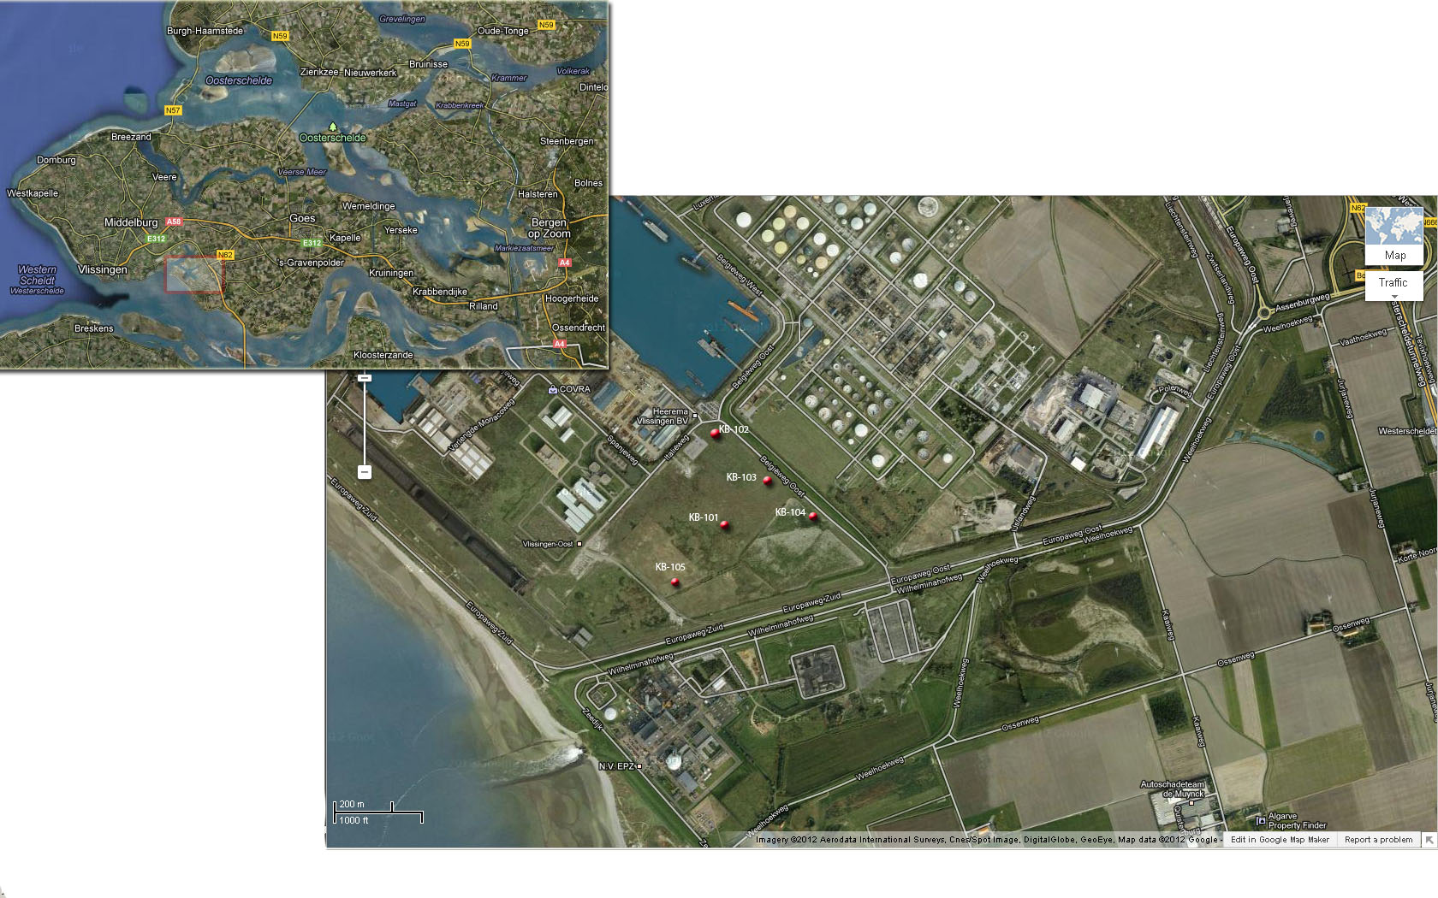
Figure S1: Satellite pictures extracted from Google Map indicating the location of the drillings at the location in Zeeland.

Figure S2: Transect exported from the digital geological model of the Netherlands DGM v.1.3. Hoogte in meters t.o.v. NAP = elevation with respect to sea level, Afstand in km = distance in km, RU= Rupel Formation, TO = Tongeren Formation, BR = Breda Formation, OO = Oosterhout Formation. Other Formations are Quaternary sediments.

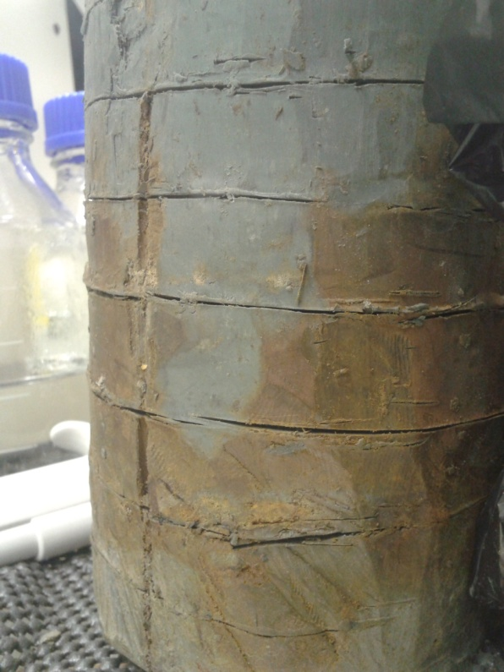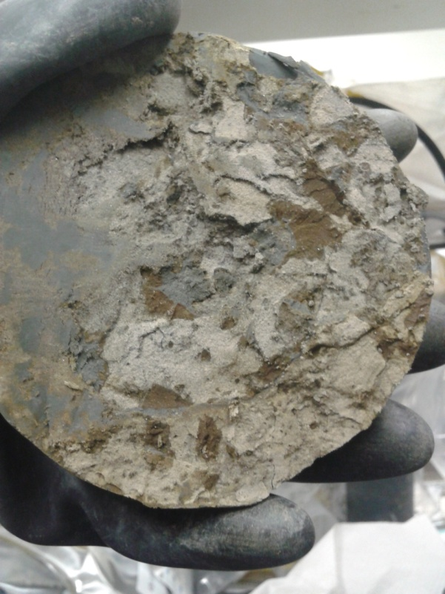
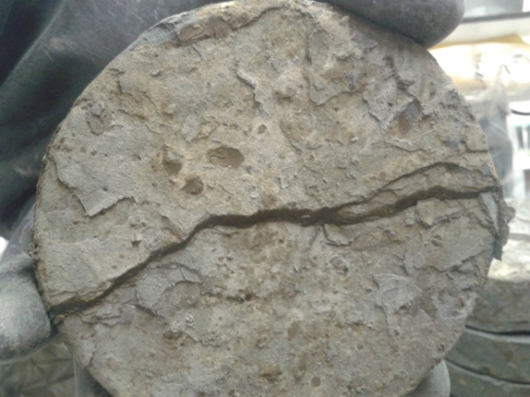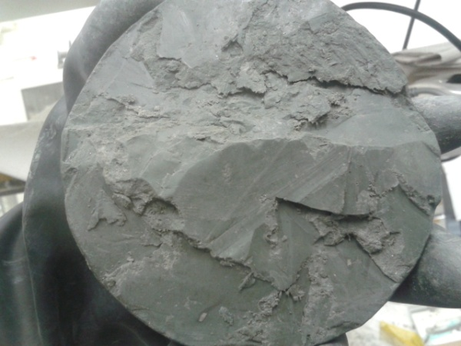

Figure S3: Pictures illustrating the oxidation of the core at the outer surface (upper left), and the diversity of material showing aggregates of brown colour inside coarser parts of the core (upper right and lower left), and grey colours in sections with high plasticity (lower right).

Tables

Table S1. Pictures and description of core slices used for dilution experiments and solid phase characterization. The number behind the hyphen in the name indicates the number of the 2 cm slices sampled from top to bottom.

Picture | Description
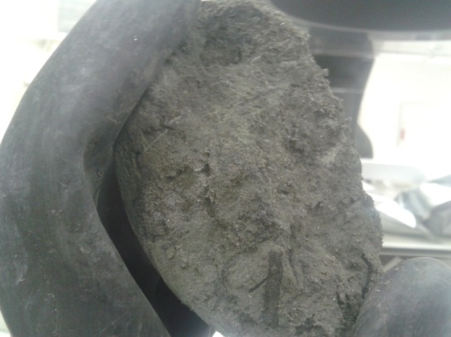 | 101-14  Grey colour, brittle, low plasticity
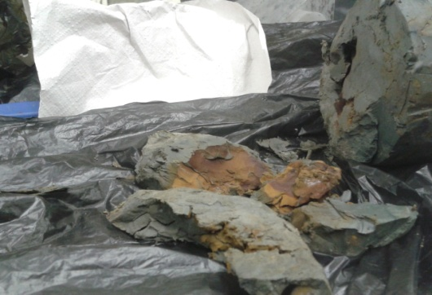 | 103A-01  Top layer of core sample 103A. Grey and brown colours, fractured, most likely effected by dehydration and oxidation during storage.
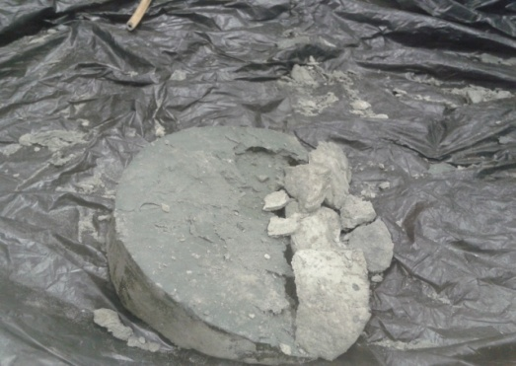 | 103A-19a  White to grey colours, brittle, higher content of coarse material (right side on picture)  103A-19b  Grey colour, high plasticity (left side on picture)
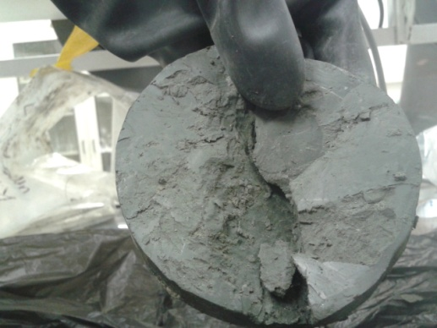 | 103A-22  Grey colour, high plasticity.

Table S2. List of core sections used in this study
Drilling | Description | Depth section
101 | Fat clay with sand (20%), medium plasticity, strong HCl reaction | 72.36 – 72.87 m
103A | Fat clay with sand (5%), high plasticity, weak HCl reaction | 78.72 – 79.25 m
104 | Fat clay with sand (5%), high plasticity, weak HCl reaction, mottled. | 75.36 – 75.91 m

Table S3. Composition of solutions in dilution experiments. All concentrations are in mM.

Time | Sample Name | Solution | S/L | B | Ba | Ca | Cl | Fe | K | Li | Mg | Mn | Mo | Na | S | Si | Sr | Zn | DIC | pH
T0 | KB 101-14 | NaHCO3 | 25 | 0.0277 | 0.0021 | 0.0264 | 0.2539 | 0.0014 | 0.0422 | 0.0014 | 0.0185 | b.d. | b.d. | 1.2384 | 0.0508 | 0.0014 | 0.0001 | 0.0002 |  | 8.17
T0 | KB 101-14 | NaHCO3 | 25 | 0.0185 | 0.0012 | 0.0252 | 0.2296 | 0.0014 | 0.0407 | 0.0014 | 0.0177 | b.d. | b.d. | 1.2271 | 0.0477 | 0.0014 | 0.0001 | 0.0002 |  | 8.19
T0 | KB 101-14 | NaHCO3 | 50 | 0.0185 | 0.0005 | 0.0422 | 0.4039 | 0.0014 | 0.0724 | 0.0014 | 0.0313 | b.d. | b.d. | 1.3085 | 0.0923 | 0.0018 | 0.0002 | 0.0002 |  | 8.00
T0 | KB 101-14 | NaHCO3 | 50 | 0.0185 | 0.0007 | 0.0464 | 0.4110 | 0.0013 | 0.0701 | 0.0014 | 0.0333 | b.d. | b.d. | 1.3550 | 0.1014 | 0.0021 | 0.0002 | 0.0002 |  | 8.08
T0 | KB 101-14 | NaHCO3 | 200 | 0.0277 | 0.0005 | 0.1430 | 1.3576 | 0.0014 | 0.1875 | 0.0014 | 0.1164 | b.d. | b.d. | 2.0714 | 0.4207 | 0.0050 | 0.0009 | 0.0003 |  | 7.66
T0 | KB 101-14 | NaHCO3 | 200 | 0.0277 | 0.0005 | 0.1460 | 1.3866 | 0.0014 | 0.1888 | 0.0014 | 0.1177 | b.d. | b.d. | 2.0949 | 0.4257 | 0.0046 | 0.0009 | 0.0003 |  | 7.72
T0 | KB 103 A 01 | NaHCO3 | 25 | 0.0185 | 0.0006 | 0.0097 | 0.1041 | 0.0016 | 0.0297 | 0.0014 | 0.0008 | b.d. | b.d. | 1.2741 | 0.0287 | 0.0160 | 0.0000 | 0.0002 |  | 9.36
T0 | KB 103 A 01 | NaHCO3 | 25 | 0.0185 | 0.0004 | 0.0107 | 0.0979 | 0.0016 | 0.0307 | 0.0000 | 0.0008 | b.d. | b.d. | 1.2697 | 0.0271 | 0.0160 | 0.0000 | 0.0003 |  | 9.38
T0 | KB 103 A 01 | NaHCO3 | 50 | 0.0277 | 0.0007 | 0.0075 | 0.1486 | 0.0018 | 0.0343 | 0.0014 | 0.0012 | b.d. | b.d. | 1.3754 | 0.0393 | 0.0214 | 0.0000 | 0.0002 |  | 9.64
T0 | KB 103 A 01 | NaHCO3 | 50 | 0.0277 | 0.0008 | 0.0065 | 0.1608 | 0.0018 | 0.0325 | 0.0014 | 0.0012 | b.d. | b.d. | 1.3576 | 0.0405 | 0.0224 | 0.0000 | 0.0002 |  | 9.66
T0 | KB 103 A 01 | NaHCO3 | 200 | 0.0832 | 0.0004 | 0.0037 | 0.4485 | 0.0030 | 0.0343 | 0.0014 | 0.0016 | b.d. | b.d. | 1.6651 | 0.1188 | 0.0402 | 0.0000 | 0.0005 |  | 10.32
T0 | KB 103 A 01 | NaHCO3 | 200 | 0.1480 | 0.0004 | 0.0037 | 0.6981 | 0.0030 | 0.0417 | 0.0014 | 0.0021 | b.d. | b.d. | 2.0340 | 0.1335 | 0.0420 | 0.0000 | 0.0003 |  | 10.55
T0 | KB 103A 19a | NaHCO3 | 25 | 0.0092 | 0.0006 | 0.0207 | 0.1845 | 0.0014 | 0.0253 | 0.0014 | 0.0144 | b.d. | b.d. | 0.9578 | 0.0049 | 0.0014 | 0.0001 | 0.0002 |  | 8.25
T0 | KB 103A 19a | NaHCO3 | 25 | 0.0092 | 0.0006 | 0.0235 | 0.2130 | 0.0014 | 0.0348 | 0.0014 | 0.0165 | b.d. | b.d. | 0.9957 | 0.0046 | 0.0014 | 0.0001 | 0.0003 |  | 8.10
T0 | KB 103A 19a | NaHCO3 | 50 | 0.0092 | 0.0007 | 0.0389 | 0.3610 | 0.0014 | 0.0506 | 0.0014 | 0.0280 | b.d. | b.d. | 1.0801 | 0.0075 | 0.0018 | 0.0002 | 0.0002 |  | 8.05
T0 | KB 103A 19a | NaHCO3 | 50 | 0.0092 | 0.0007 | 0.0382 | 0.3326 | 0.0014 | 0.0542 | 0.0014 | 0.0284 | b.d. | b.d. | 1.0370 | 0.0078 | 0.0025 | 0.0002 | 0.0002 |  | 8.15
T0 | KB 103A 19a | NaHCO3 | 200 | 0.0185 | 0.0004 | 0.1163 | 1.0620 | 0.0034 | 0.0824 | 0.0014 | 0.0926 | b.d. | b.d. | 1.4198 | 0.0137 | 0.0036 | 0.0007 | 0.0003 |  | 8.01
T0 | KB 103A 19a | NaHCO3 | 200 | 0.0185 | 0.0004 | 0.1235 | 1.1562 | 0.0023 | 0.0911 | 0.0014 | 0.0975 | b.d. | b.d. | 1.4659 | 0.0143 | 0.0039 | 0.0008 | 0.0003 |  | 7.87
T0 | KB 103A 19b | NaHCO3 | 25 | 0.0277 | 0.0013 | 0.0232 | 0.2237 | 0.0014 | 0.0345 | 0.0014 | 0.0160 | b.d. | b.d. | 1.0427 | 0.0090 | 0.0014 | 0.0001 | 0.0002 |  | 8.27
T0 | KB 103A 19b | NaHCO3 | 25 | 0.0185 | 0.0007 | 0.0247 | 0.1991 | 0.0014 | 0.0391 | 0.0014 | 0.0173 | b.d. | b.d. | 1.0309 | 0.0094 | 0.0018 | 0.0001 | 0.0002 |  | 8.35
T0 | KB 103A 19b | NaHCO3 | 50 | 0.0092 | 0.0004 | 0.0362 | 0.3117 | 0.0014 | 0.0381 | 0.0014 | 0.0255 | b.d. | b.d. | 1.0444 | 0.0058 | 0.0011 | 0.0002 | 0.0002 |  | 8.04
T0 | KB 103A 19b | NaHCO3 | 50 | 0.0092 | 0.0011 | 0.0359 | 0.3193 | 0.0014 | 0.0409 | 0.0014 | 0.0263 | b.d. | b.d. | 1.0357 | 0.0056 | 0.0014 | 0.0002 | 0.0002 |  | 7.99
T0 | KB 103A 19b | NaHCO3 | 200 | 0.0185 | 0.0006 | 0.1063 | 0.9968 | 0.0054 | 0.0783 | 0.0014 | 0.0860 | b.d. | b.d. | 1.3837 | 0.0122 | 0.0025 | 0.0007 | 0.0003 |  | 7.65
T0 | KB 103A 19b | NaHCO3 | 200 | 0.0185 | 0.0009 | 0.0991 | 0.9238 | 0.0045 | 0.0752 | 0.0014 | 0.0786 | b.d. | b.d. | 1.3398 | 0.0112 | 0.0021 | 0.0006 | 0.0002 |  | 7.80

Time | Sample Name | Solution | S/L | B | Ba | Ca | Cl | Fe | K | Li | Mg | Mn | Mo | Na | S | Si | Sr | Zn | DIC | pH
T0 | KB 101-14 | demi | 25 | 0.0083 | 0.0035 | 0.1280 | 2.9513 | 0.0220 | 0.2678 | 0.0115 | 0.0967 | b.d. | b.d. | 1.9218 | 0.5804 | 0.0214 | 0.0000 | 0.0018 |  | 7.73
T0 | KB 101-14 | demi | 25 | 0.0028 | 0.0008 | 0.1530 | 2.4345 | 0.0218 | 0.2614 | 0.0115 | 0.1119 | b.d. | b.d. | 1.7935 | 0.4697 | 0.0192 | 0.0001 | 0.0017 |  | 7.80
T0 | KB 101-14 | demi | 50 | 0.0102 | 0.0062 | 0.2767 | 3.9289 | 0.0217 | 0.4571 | 0.0115 | 0.2234 | b.d. | b.d. | 3.1145 | 0.7697 | 0.0217 | 0.0010 | 0.0018 |  | 7.85
T0 | KB 101-14 | demi | 50 | 0.0046 | 0.0007 | 0.2790 | 3.7151 | 0.0220 | 0.4530 | 0.0115 | 0.2292 | b.d. | b.d. | 3.0976 | 0.7388 | 0.0217 | 0.0009 | 0.0023 |  | 7.71
T0 | KB 101-14 | demi | 200 | 0.0203 | 0.0074 | 1.1894 | 13.0348 | 0.0303 | 1.2712 | 0.0173 | 1.0595 | b.d. | b.d. | 10.2049 | 3.4395 | 0.0360 | 0.0068 | 0.0024 |  | 7.10
T0 | KB 101-14 | demi | 200 | 0.0194 | 0.0046 | 1.0974 | 12.3144 | 0.0355 | 1.2231 | 0.0158 | 0.9879 | b.d. | b.d. | 9.9491 | 3.2545 | 0.0360 | 0.0064 | 0.0032 |  | 6.96
T0 | KB 103A 19b | demi | 25 | 0.0092 | 0.0058 | 0.1452 | 2.2751 | 0.0217 | 0.2171 | 0.0115 | 0.1136 | b.d. | b.d. | 1.8261 | 0.3412 | 0.0189 | 0.0002 | 0.0018 |  | 7.36
T0 | KB 103A 19b | demi | 25 | 0.0018 | 0.0006 | 0.1497 | 1.9446 | 0.0220 | 0.2657 | 0.0115 | 0.1119 | b.d. | b.d. | 1.7230 | 0.4173 | 0.0199 | 0.0001 | 0.0021 |  | 7.44
T0 | KB 103A 19b | demi | 50 | 0.0129 | 0.0057 | 0.3146 | 3.9343 | 0.0222 | 0.4463 | 0.0115 | 0.2551 | b.d. | b.d. | 3.2389 | 0.8704 | 0.0221 | 0.0013 | 0.0037 |  | 7.25
T0 | KB 103A 19b | demi | 50 | 0.0111 | 0.0062 | 0.2705 | 3.8045 | 0.0220 | 0.4670 | 0.0101 | 0.2177 | b.d. | b.d. | 3.1672 | 0.6986 | 0.0214 | 0.0010 | 0.0020 |  | 7.35
T0 | KB 103A 19b | demi | 200 | 0.0203 | 0.0040 | 1.2064 | 12.2718 | 0.0270 | 1.2374 | 0.0173 | 1.0562 | b.d. | b.d. | 9.5424 | 3.1763 | 0.0324 | 0.0070 | 0.0035 |  | 7.00
T0 | KB 103A 19b | demi | 200 | 0.0203 | 0.0046 | 1.1832 | 12.4676 | 0.0281 | 1.2683 | 0.0158 | 1.0307 | b.d. | b.d. | 10.1601 | 3.2012 | 0.0356 | 0.0068 | 0.0032 |  | 6.96
T0 | KB 103 A - 22 | demi | 25 | 0.0111 | 0.0063 | 0.2056 | 2.3725 | 0.0226 | 0.1847 | 0.0101 | 0.1214 | b.d. | b.d. | 1.6577 | 0.0000 | 0.0224 | 0.0005 | 0.0029 |  | 8.99
T0 | KB 103 A - 22 | demi | 25 | 0.0083 | 0.0036 | 0.1662 | 1.9085 | 0.0222 | 0.1289 | 0.0101 | 0.1029 | b.d. | b.d. | 1.2371 | 0.0000 | 0.0196 | 0.0002 | 0.0031 |  | 8.71
T0 | KB 103 A - 22 | demi | 50 | 0.0028 | 0.0006 | 0.3094 | 3.3323 | 0.0224 | 0.2445 | 0.0115 | 0.1958 | b.d. | b.d. | 2.0240 | 0.0000 | 0.0235 | 0.0009 | 0.0024 |  | 8.70
T0 | KB 103 A - 22 | demi | 50 | 0.0102 | 0.0068 | 0.3014 | 3.3473 | 0.0238 | 0.2371 | 0.0115 | 0.2098 | b.d. | b.d. | 2.0601 | 0.0000 | 0.0224 | 0.0010 | 0.0023 |  | 8.00
T0 | KB 103 A - 22 | demi | 200 | 0.0157 | 0.0095 | 0.9327 | 9.5042 | 0.0410 | 0.6673 | 0.0130 | 0.7287 | 0.0009 | b.d. | 5.4182 | 0.0000 | 0.0306 | 0.0055 | 0.0041 |  | 7.19
T0 | KB 103 A - 22 | demi | 200 | 0.0139 | 0.0072 | 0.9841 | 9.6450 | 0.0235 | 0.6985 | 0.0130 | 0.7254 | 0.0005 | b.d. | 5.4744 | 0.0000 | 0.0274 | 0.0055 | 0.0037 |  | 7.20
T0 | KB 103 A - 22 | NaHCO3 | 25 | 0.0092 | 0.0045 | 0.2261 | 2.1228 | 0.0220 | 0.1685 | 0.0101 | 0.1600 | b.d. | b.d. | 9.3471 | 0.0000 | 0.0210 | 0.0006 | 0.0038 |  | 8.15
T0 | KB 103 A - 22 | NaHCO3 | 25 | 0.0203 | 0.0039 | 0.2096 | 1.8831 | 0.0244 | 0.1463 | 0.0101 | 0.1498 | b.d. | b.d. | 9.3806 | 0.0000 | 0.0217 | 0.0005 | 0.0041 |  | 8.11
T0 | KB 103 A - 22 | NaHCO3 | 50 | 0.0092 | 0.0010 | 0.3847 | 3.0331 | 0.0299 | 0.2379 | 0.0101 | 0.2818 | b.d. | b.d. | 10.0304 | 0.0000 | 0.0246 | 0.0016 | 0.0060 |  | 8.03
T0 | KB 103 A - 22 | NaHCO3 | 50 | 0.0120 | 0.0060 | 0.3628 | 3.2926 | 0.0238 | 0.2325 | 0.0101 | 0.2711 | b.d. | b.d. | 10.1431 | 0.0000 | 0.0249 | 0.0016 | 0.0067 |  | 8.01
T0 | KB 103 A - 22 | NaHCO3 | 200 | 0.0166 | 0.0028 | 1.3109 | 10.7143 | 0.0226 | 0.8323 | 0.0130 | 0.9821 | 0.0002 | b.d. | 13.2655 | 0.0686 | 0.0367 | 0.0075 | 0.0054 |  | 7.72
T0 | KB 103 A - 22 | NaHCO3 | 200 | 0.0102 | 0.0005 | 1.1315 | 10.0602 | 0.0303 | 0.6826 | 0.0130 | 0.8998 | 0.0015 | b.d. | 13.1628 | 0.0000 | 0.0395 | 0.0066 | 0.0066 |  | 7.71

Time | Sample Name | Solution | S/L | B | Ba | Ca | Cl | Fe | K | Li | Mg | Mn | Mo | Na | S | Si | Sr | Zn | DIC | pH
T1 | KB 101-14 | NaHCO3 | 25 | 0.0092 | 0.0008 | 0.0274 | 0.2132 | 0.0016 | 0.0486 | 0.0014 | 0.0177 | b.d. | b.d. | 1.0514 | 0.0533 | 0.0036 | 0.0001 | 0.0003 |  | 8.18
T1 | KB 101-14 | NaHCO3 | 25 | 0.0092 | 0.0004 | 0.0259 | 0.1887 | 0.0014 | 0.0412 | 0.0014 | 0.0173 | b.d. | b.d. | 1.0283 | 0.0508 | 0.0032 | 0.0001 | 0.0003 |  | 8.16
T1 | KB 101-14 | NaHCO3 | 50 | 0.0092 | 0.0040 | 0.0437 | 0.4028 | 0.0014 | 0.0757 | 0.0014 | 0.0300 | b.d. | b.d. | 1.2241 | 0.1023 | 0.0043 | 0.0002 | 0.0005 |  | 7.99
T1 | KB 101-14 | NaHCO3 | 50 | 0.0185 | 0.0009 | 0.0512 | 0.3647 | 0.0014 | 0.0760 | 0.0014 | 0.0333 | b.d. | b.d. | 1.1762 | 0.1191 | 0.0043 | 0.0002 | 0.0003 |  | 7.97
T1 | KB 101-14 | NaHCO3 | 200 | 0.0277 | 0.0010 | 0.1475 | 1.2479 | 0.0014 | 0.1893 | 0.0014 | 0.1131 | b.d. | b.d. | 1.8948 | 0.4640 | 0.0075 | 0.0009 | 0.0005 |  | 7.55
T1 | KB 101-14 | NaHCO3 | 200 | 0.0277 | 0.0013 | 0.1562 | 1.2826 | 0.0014 | 0.2005 | 0.0014 | 0.1189 | b.d. | b.d. | 1.9383 | 0.4681 | 0.0071 | 0.0009 | 0.0005 |  | 7.51
T1 | KB 103 A 01 | NaHCO3 | 25 | 0.0370 | 0.0006 | 0.0082 | 0.1489 | 0.0025 | 0.0394 | 0.0014 | 0.0025 | b.d. | b.d. | 1.1175 | 0.0299 | 0.0281 | 0.0000 | 0.0028 |  | 9.68
T1 | KB 103 A 01 | NaHCO3 | 25 | 0.0277 | 0.0003 | 0.0022 | 0.0922 | 0.0018 | 0.0253 | 0.0014 | 0.0008 | b.d. | b.d. | 1.0692 | 0.0278 | 0.0263 | 0.0000 | 0.0003 |  | 9.72
T1 | KB 103 A 01 | NaHCO3 | 50 | 0.0647 | 0.0006 | 0.0020 | 0.2524 | 0.0021 | 0.0274 | 0.0014 | 0.0008 | b.d. | b.d. | 1.2058 | 0.0462 | 0.0399 | 0.0000 | 0.0003 |  | 10.17
T1 | KB 103 A 01 | NaHCO3 | 50 | 0.0832 | 0.0002 | 0.0017 | 0.3046 | 0.0023 | 0.0289 | 0.0014 | 0.0012 | b.d. | b.d. | 1.2576 | 0.0518 | 0.0445 | 0.0000 | 0.0003 |  | 10.23
T1 | KB 103 A 01 | NaHCO3 | 200 | 0.1480 | 0.0008 | 0.0636 | 0.2781 | 0.4518 | 0.2946 | 0.0058 | 0.2872 | 0.0007 | b.d. | 1.8848 | 0.1949 | 0.0000 | 0.0010 | 0.0012 |  | 11.59
T1 | KB 103 A 01 | NaHCO3 | 200 | 0.1850 | 0.0007 | 0.0878 | 0.2835 | 0.2056 | 0.1732 | 0.0043 | 0.1687 | 0.0005 | b.d. | 1.9618 | 0.1993 | 0.0000 | 0.0013 | 0.0012 |  | 11.61
T1 | KB 103A 19a | NaHCO3 | 25 | 0.0277 | 0.0008 | 0.0262 | 0.1949 | 0.0014 | 0.0448 | 0.0014 | 0.0185 | b.d. | b.d. | 1.0248 | 0.0000 | 0.0064 | 0.0001 | 0.0003 |  | 8.28
T1 | KB 103A 19a | NaHCO3 | 25 | 0.0185 | 0.0004 | 0.0274 | 0.2169 | 0.0016 | 0.0448 | 0.0014 | 0.0189 | b.d. | b.d. | 1.0361 | 0.0000 | 0.0046 | 0.0001 | 0.0005 |  | 8.25
T1 | KB 103A 19a | NaHCO3 | 50 | 0.0185 | 0.0009 | 0.0359 | 0.3907 | 0.0014 | 0.0701 | 0.0014 | 0.0276 | b.d. | b.d. | 1.1066 | 0.0100 | 0.0071 | 0.0002 | 0.0005 |  | 8.08
T1 | KB 103A 19a | NaHCO3 | 50 | 0.0185 | 0.0009 | 0.0372 | 0.3596 | 0.0014 | 0.0721 | 0.0014 | 0.0288 | b.d. | b.d. | 1.0818 | 0.0109 | 0.0068 | 0.0002 | 0.0003 |  | 8.08
T1 | KB 103A 19a | NaHCO3 | 200 | 0.0370 | 0.0007 | 0.1105 | 1.1875 | 0.0021 | 0.1159 | 0.0014 | 0.0897 | b.d. | b.d. | 1.5003 | 0.0193 | 0.0146 | 0.0007 | 0.0003 |  | 7.74
T1 | KB 103A 19a | NaHCO3 | 200 | 0.0277 | 0.0007 | 0.1140 | 1.2546 | 0.0018 | 0.1148 | 0.0014 | 0.0946 | b.d. | b.d. | 1.5203 | 0.0200 | 0.0132 | 0.0007 | 0.0003 |  | 7.76
T1 | KB 103A 19b | NaHCO3 | 25 | 0.0185 | 0.0009 | 0.0240 | 0.1966 | 0.0014 | 0.0473 | 0.0014 | 0.0177 | b.d. | b.d. | 0.9918 | 0.0106 | 0.0039 | 0.0001 | 0.0003 |  | 8.28
T1 | KB 103A 19b | NaHCO3 | 25 | 0.0092 | 0.0017 | 0.0245 | 0.2231 | 0.0014 | 0.0657 | 0.0014 | 0.0181 | b.d. | b.d. | 0.9918 | 0.0112 | 0.0039 | 0.0001 | 0.0003 |  | 8.29
T1 | KB 103A 19b | NaHCO3 | 50 | 0.0092 | 0.0007 | 0.0377 | 0.3176 | 0.0014 | 0.0591 | 0.0014 | 0.0267 | b.d. | b.d. | 1.0383 | 0.0000 | 0.0078 | 0.0002 | 0.0003 |  | 8.23
T1 | KB 103A 19b | NaHCO3 | 50 | 0.0185 | 0.0011 | 0.0419 | 0.3447 | 0.0023 | 0.0598 | 0.0014 | 0.0284 | b.d. | b.d. | 1.0492 | 0.0084 | 0.0093 | 0.0002 | 0.0003 |  | 8.21
T1 | KB 103A 19b | NaHCO3 | 200 | 0.0370 | 0.0005 | 0.1108 | 1.1999 | 0.0045 | 0.1074 | 0.0014 | 0.0922 | b.d. | b.d. | 1.4855 | 0.0193 | 0.0157 | 0.0007 | 0.0003 |  | 7.73
T1 | KB 103A 19b | NaHCO3 | 200 | 0.0370 | 0.0020 | 0.1158 | 1.2521 | 0.0050 | 0.1100 | 0.0014 | 0.0946 | b.d. | b.d. | 1.5112 | 0.0200 | 0.0157 | 0.0007 | 0.0005 |  | 7.67

Time | Sample Name | Solution | S/L | B | Ba | Ca | Cl | Fe | K | Li | Mg | Mn | Mo | Na | S | Si | Sr | Zn | DIC | pH
T1 | KB 101-14 | demi | 25 | 0.0166 | 0.0077 | 0.1609 | 2.6585 | 0.0233 | 0.4125 | 0.0115 | 0.1197 | b.d. | b.d. | 2.1441 | 0.4849 | 0.0356 | 0.0002 | 0.0083 |  | 8.10
T1 | KB 101-14 | demi | 25 | 0.0185 | 0.0066 | 0.1829 | 2.5857 | 0.0235 | 0.4039 | 0.0115 | 0.1317 | b.d. | b.d. | 2.3376 | 0.5769 | 0.0331 | 0.0003 | 0.0081 |  | 8.11
T1 | KB 101-14 | demi | 50 | 0.0203 | 0.0079 | 0.3598 | 4.1399 | 0.0229 | 0.6289 | 0.0130 | 0.2744 | b.d. | b.d. | 3.7888 | 1.1274 | 0.0395 | 0.0014 | 0.0084 |  | 7.84
T1 | KB 101-14 | demi | 50 | 0.0240 | 0.0092 | 0.3541 | 4.0987 | 0.0231 | 0.6151 | 0.0115 | 0.2720 | b.d. | b.d. | 3.9067 | 1.1988 | 0.0452 | 0.0015 | 0.0081 |  | 7.83
T1 | KB 101-14 | demi | 200 | 0.0305 | 0.0038 | 1.5572 | 13.5160 | 0.0263 | 1.4944 | 0.0187 | 1.3108 | b.d. | b.d. | 11.7604 | 5.7117 | 0.0897 | 0.0087 | 0.0087 |  | 7.15
T1 | KB 101-14 | demi | 200 | 0.0333 | 0.0022 | 1.4374 | 13.5440 | 0.0251 | 1.4788 | 0.0187 | 1.2286 | b.d. | b.d. | 11.7869 | 5.3883 | 0.0976 | 0.0078 | 0.0086 |  | 7.15
T1 | KB 103A 19b | demi | 25 | 0.0166 | 0.0106 | 0.2026 | 2.4108 | 0.0236 | 0.3519 | 0.0115 | 0.1456 | b.d. | b.d. | 2.2985 | 0.6480 | 0.0402 | 0.0006 | 0.0084 |  | 7.98
T1 | KB 103A 19b | demi | 25 | 0.0194 | 0.0087 | 0.1891 | 2.3493 | 0.0231 | 0.3739 | 0.0115 | 0.1407 | b.d. | b.d. | 2.2215 | 0.6374 | 0.0328 | 0.0005 | 0.0086 |  | 7.83
T1 | KB 103A 19b | demi | 50 | 0.0185 | 0.0055 | 0.4040 | 3.9512 | 0.0231 | 0.6067 | 0.0130 | 0.3032 | b.d. | b.d. | 3.7775 | 1.4021 | 0.0523 | 0.0016 | 0.0086 |  | 7.57
T1 | KB 103A 19b | demi | 50 | 0.0166 | 0.0015 | 0.3466 | 4.1715 | 0.0231 | 0.6169 | 0.0130 | 0.2699 | b.d. | b.d. | 3.7609 | 1.0522 | 0.0424 | 0.0011 | 0.0086 |  | 7.65
T1 | KB 103A 19b | demi | 200 | 0.0296 | 0.0038 | 1.4993 | 13.8336 | 0.0260 | 1.5187 | 0.0187 | 1.2767 | b.d. | b.d. | 11.8461 | 5.7450 | 0.0890 | 0.0083 | 0.0086 |  | 7.22
T1 | KB 103A 19b | demi | 200 | 0.0351 | 0.0025 | 1.7004 | 13.5516 | 0.0270 | 1.5154 | 0.0187 | 1.3763 | 0.0002 | b.d. | 11.8744 | 5.1017 | 0.1057 | 0.0089 | 0.0087 |  | 7.11
T1 | KB 103 A - 22 | demi | 25 | 0.0157 | 0.0061 | 0.2136 | 2.6768 | 0.0231 | 0.2760 | 0.0101 | 0.1267 | b.d. | b.d. | 2.0118 | 0.0000 | 0.0548 | 0.0005 | 0.0087 |  | 8.78
T1 | KB 103 A - 22 | demi | 25 | 0.0148 | 0.0144 | 0.1896 | 2.3640 | 0.0233 | 0.2340 | 0.0101 | 0.1099 | b.d. | b.d. | 1.7569 | 0.0000 | 0.0516 | 0.0003 | 0.0090 |  | 8.84
T1 | KB 103 A - 22 | demi | 50 | 0.0176 | 0.0078 | 0.3044 | 3.9010 | 0.0233 | 0.3581 | 0.0115 | 0.1971 | b.d. | b.d. | 2.8631 | 0.0000 | 0.0573 | 0.0010 | 0.0087 |  | 8.67
T1 | KB 103 A - 22 | demi | 50 | 0.0213 | 0.0079 | 0.3478 | 3.7529 | 0.0235 | 0.3711 | 0.0115 | 0.2275 | b.d. | b.d. | 2.8279 | 0.0000 | 0.0587 | 0.0014 | 0.0087 |  | 8.40
T1 | KB 103 A - 22 | demi | 200 | 0.0277 | 0.0049 | 1.2748 | 13.2433 | 0.0265 | 0.9223 | 0.0158 | 1.0372 | 0.0020 | b.d. | 8.4993 | 0.1459 | 0.1243 | 0.0074 | 0.0086 |  | 7.57
T1 | KB 103 A - 22 | demi | 200 | 0.0296 | 0.0136 | 1.2865 | 13.4314 | 0.0321 | 0.9090 | 0.0144 | 1.0878 | 0.0016 | b.d. | 8.4493 | 0.2024 | 0.1072 | 0.0073 | 0.0243 |  | 7.60
T1 | KB 103 A - 22 | NaHCO3 | 25 | 0.0176 | 0.0094 | 0.2677 | 2.5166 | 0.0242 | 0.2985 | 0.0101 | 0.2275 | b.d. | b.d. | 9.4658 | 0.0000 | 0.0641 | 0.0009 | 0.0145 |  | 8.09
T1 | KB 103 A - 22 | NaHCO3 | 25 | 0.0129 | 0.0175 | 0.2545 | 2.3220 | 0.0245 | 0.2788 | 0.0101 | 0.2033 | b.d. | b.d. | 9.2235 | 0.0000 | 0.0627 | 0.0008 | 0.0055 |  | 8.09
T1 | KB 103 A - 22 | NaHCO3 | 50 | 0.0194 | 0.0154 | 0.4312 | 4.0567 | 0.0263 | 0.4322 | 0.0115 | 0.3341 | b.d. | b.d. | 9.9861 | 0.0000 | 0.0855 | 0.0019 | 0.0057 |  | 7.91
T1 | KB 103 A - 22 | NaHCO3 | 50 | 0.0305 | 0.0064 | 0.4269 | 4.1289 | 0.0283 | 0.4361 | 0.0115 | 0.3357 | b.d. | b.d. | 10.0835 | 0.0000 | 0.0762 | 0.0019 | 0.0058 |  | 7.88
T1 | KB 103 A - 22 | NaHCO3 | 200 | 0.0314 | 0.0068 | 1.3773 | 13.3547 | 0.0247 | 1.0665 | 0.0158 | 1.0837 | 0.0004 | b.d. | 14.3878 | 0.1587 | 0.1043 | 0.0081 | 0.0064 |  | 7.48
T1 | KB 103 A - 22 | NaHCO3 | 200 | 0.0333 | 0.0084 | 1.1934 | 13.6382 | 0.0836 | 0.9361 | 0.0144 | 1.1401 | 0.0004 | b.d. | 14.8432 | 0.1553 | 0.1111 | 0.0081 | 0.0070 |  | 7.55

Time | Sample Name | Solution | S/L | B | Ba | Ca | Cl | Fe | K | Li | Mg | Mn | Mo | Na | S | Si | Sr | Zn | DIC | pH
T2 | KB 101-14 | NaHCO3 | 25 | 0.0000 | 0.0079 | 0.2577 | 2.8029 | 0.0159 | 0.4248 | 0.0086 | 0.1308 | b.d. | b.d. | 10.1892 | 0.0000 | 0.0602 | 0.0002 | 0.0014 |  | 8.15
T2 | KB 101-14 | NaHCO3 | 25 | 0.0000 | 0.0091 | 0.2423 | 2.8895 | 0.0158 | 0.3458 | 0.0086 | 0.1214 | b.d. | b.d. | 10.2084 | 0.0000 | 0.0534 | 0.0002 | 0.0012 |  | 8.15
T2 | KB 101-14 | NaHCO3 | 50 | 0.0000 | 0.0095 | 0.4032 | 4.3466 | 0.0174 | 0.6560 | 0.0101 | 0.2518 | b.d. | b.d. | 11.4168 | 0.6303 | 0.0773 | 0.0013 | 0.0018 |  | 7.88
T2 | KB 101-14 | NaHCO3 | 50 | 0.0000 | 0.0096 | 0.4648 | 3.8457 | 0.0167 | 0.6146 | 0.0115 | 0.2781 | b.d. | b.d. | 11.3219 | 0.6284 | 0.0869 | 0.0015 | 0.0012 |  | 7.72
T2 | KB 101-14 | NaHCO3 | 200 | 0.0000 | 0.0074 | 1.3593 | 12.4256 | 0.0294 | 1.4279 | 0.0158 | 1.0352 | b.d. | b.d. | 18.1609 | 0.6415 | 0.1944 | 0.0071 | 0.0017 |  | 7.15
T2 | KB 101-14 | NaHCO3 | 200 | 0.0000 | 0.0052 | 1.5073 | 12.8227 | 0.0227 | 1.5719 | 0.0158 | 1.1216 | b.d. | b.d. | 18.9525 | 0.7519 | 0.1916 | 0.0079 | 0.0017 |  | 7.10
T2 | KB 103 A 01 | NaHCO3 | 25 | 0.0000 | 0.0135 | 0.0971 | 1.4828 | 0.2269 | 0.3118 | 0.0101 | 0.1514 | b.d. | b.d. | 10.4211 | 0.0000 | 1.1946 | 0.0006 | 0.0021 |  | 9.70
T2 | KB 103 A 01 | NaHCO3 | 25 | 0.0000 | 0.0033 | 0.0252 | 2.0921 | 0.0210 | 0.2038 | 0.0086 | 0.0000 | b.d. | b.d. | 10.8495 | 0.0000 | 0.2211 | 0.0000 | 0.0014 |  | 9.70
T2 | KB 103 A 01 | NaHCO3 | 50 | 0.0000 | 0.0082 | 0.1445 | 1.8845 | 0.4940 | 0.5363 | 0.0130 | 0.3407 | b.d. | b.d. | 11.5246 | 0.0000 | 3.0560 | 0.0017 | 0.0050 |  | 10.15
T2 | KB 103 A 01 | NaHCO3 | 50 | 0.0000 | 0.0121 | 0.1989 | 1.5260 | 0.7947 | 0.6113 | 0.0144 | 0.5834 | 0.0007 | b.d. | 11.5207 | 0.0000 | 4.1306 | 0.0030 | 0.0061 |  | 10.22
T2 | KB 103 A 01 | NaHCO3 | 200 | 0.0000 | 0.0122 | 1.0312 | 2.2128 | 11.1048 | 5.8803 | 0.0980 | 7.9967 | 0.0155 | b.d. | 19.9674 | 1.8153 | 0.0000 | 0.0167 | 0.0173 |  | 11.59
T2 | KB 103 A 01 | NaHCO3 | 200 | 0.0000 | 0.0027 | 0.1594 | 5.2724 | 0.3637 | 0.4962 | 0.0101 | 0.2382 | b.d. | b.d. | 18.1482 | 1.7483 | 3.5470 | 0.0009 | 0.0038 |  | 11.62
T2 | KB 103A 19a | NaHCO3 | 25 | 0.0000 | 0.0075 | 0.2293 | 2.7194 | 0.0165 | 0.3767 | 0.0086 | 0.1354 | b.d. | b.d. | 9.8264 | 0.0000 | 0.0808 | 0.0003 | 0.0017 |  | 8.22
T2 | KB 103A 19a | NaHCO3 | 25 | 0.0000 | 0.0046 | 0.2271 | 1.9702 | 0.0161 | 0.3857 | 0.0101 | 0.1292 | b.d. | b.d. | 9.4580 | 0.0000 | 0.0723 | 0.0002 | 0.0011 |  | 8.35
T2 | KB 103A 19a | NaHCO3 | 50 | 0.0000 | 0.0034 | 0.3169 | 3.9075 | 0.0163 | 0.6010 | 0.0101 | 0.2205 | b.d. | b.d. | 9.9961 | 0.0000 | 0.0865 | 0.0009 | 0.0011 |  | 8.12
T2 | KB 103A 19a | NaHCO3 | 50 | 0.0000 | 0.0058 | 1.1602 | 3.5647 | 0.0215 | 0.8463 | 0.0101 | 0.6641 | b.d. | b.d. | 10.9931 | 0.0000 | 0.1079 | 0.0054 | 0.0031 |  | 7.43
T2 | KB 103A 19a | NaHCO3 | 200 | 0.0000 | 0.0079 | 1.0577 | 11.6341 | 0.0229 | 1.0139 | 0.0144 | 0.8208 | b.d. | b.d. | 14.1837 | 0.0000 | 0.1371 | 0.0058 | 0.0015 |  | 7.89
T2 | KB 103A 19a | NaHCO3 | 200 | 0.0000 | 0.0063 | 1.0986 | 12.2419 | 0.0229 | 1.0312 | 0.0144 | 0.8591 | b.d. | b.d. | 14.4278 | 0.0000 | 0.1381 | 0.0060 | 0.0015 |  | 7.86
T2 | KB 103A 19b | NaHCO3 | 25 | 0.0000 | 0.0079 | 0.2041 | 2.3273 | 0.0158 | 0.4136 | 0.0101 | 0.1206 | b.d. | b.d. | 9.4554 | 0.0000 | 0.0591 | 0.0002 | 0.0011 |  | 8.31
T2 | KB 103A 19b | NaHCO3 | 25 | 0.0000 | 0.0036 | 0.2196 | 2.2433 | 0.0158 | 0.5095 | 0.0101 | 0.1312 | b.d. | b.d. | 9.4175 | 0.0000 | 0.0573 | 0.0002 | 0.0012 |  | 8.22
T2 | KB 103A 19b | NaHCO3 | 50 | 0.0000 | 0.0148 | 0.3376 | 3.3357 | 0.0199 | 0.4837 | 0.0101 | 0.2131 | b.d. | b.d. | 9.9108 | 0.0000 | 0.0944 | 0.0009 | 0.0023 |  | 8.28
T2 | KB 103A 19b | NaHCO3 | 50 | 0.0000 | 0.0105 | 0.3421 | 3.5650 | 0.0167 | 0.4957 | 0.0101 | 0.2209 | b.d. | b.d. | 10.0030 | 0.0000 | 0.0865 | 0.0010 | 0.0020 |  | 8.17
T2 | KB 103A 19b | NaHCO3 | 200 | 0.0000 | 0.0101 | 1.0944 | 11.0810 | 0.0337 | 0.9384 | 0.0144 | 0.8578 | 0.0004 | b.d. | 14.2947 | 0.0000 | 0.1438 | 0.0062 | 0.0026 |  | 7.82
T2 | KB 103A 19b | NaHCO3 | 200 | 0.0000 | 0.0197 | 1.1348 | 12.1759 | 0.0394 | 0.9791 | 0.0144 | 0.8920 | 0.0007 | b.d. | 14.5065 | 0.0000 | 0.1474 | 0.0063 | 0.0093 |  | 7.81

Time | Sample Name | Solution | S/L | B | Ba | Ca | Cl | Fe | K | Li | Mg | Mn | Mo | Na | S | Si | Sr | Zn | DIC | pH
T2 | KB 101-14 | demi | 25 | 0.0000 | 0.0090 | 0.1916 | 2.5555 | 0.0217 | 0.4077 | 0.0072 | 0.1189 | b.d. | b.d. | 2.2572 | 0.5217 | 0.0502 | 0.0003 | 0.0021 |  | 7.75
T2 | KB 101-14 | demi | 25 | 0.0139 | 0.0062 | 0.2088 | 2.4334 | 0.0218 | 0.3778 | 0.0072 | 0.1263 | b.d. | b.d. | 2.2258 | 0.6231 | 0.0474 | 0.0006 | 0.0020 |  | 7.80
T2 | KB 101-14 | demi | 50 | 0.0083 | 0.0076 | 0.4102 | 3.9224 | 0.0218 | 0.6151 | 0.0086 | 0.2773 | b.d. | b.d. | 3.8270 | 1.2022 | 0.0595 | 0.0016 | 0.0017 |  | 7.55
T2 | KB 101-14 | demi | 50 | 0.0055 | 0.0022 | 0.3922 | 3.8784 | 0.0222 | 0.5970 | 0.0072 | 0.2670 | b.d. | b.d. | 3.7074 | 1.3566 | 0.0655 | 0.0015 | 0.0020 |  | 7.56
T2 | KB 101-14 | demi | 200 | 0.0194 | 0.0990 | 1.6697 | 13.5507 | 0.0786 | 1.5029 | 0.0144 | 1.3483 | b.d. | b.d. | 12.1367 | 5.7407 | 0.1314 | 0.0118 | 0.0026 |  | 7.16
T2 | KB 101-14 | demi | 200 | 0.0185 | 0.0150 | 1.5218 | 13.4320 | 0.0552 | 1.4530 | 0.0144 | 1.2508 | b.d. | b.d. | 12.0810 | 4.1125 | 0.1278 | 0.0087 | 0.0021 |  | 7.25
T2 | KB 103A 19b | demi | 25 | 0.0000 | 0.0072 | 0.2293 | 2.2244 | 0.0215 | 0.3182 | 0.0058 | 0.1354 | b.d. | b.d. | 2.1123 | 0.6437 | 0.0552 | 0.0006 | 0.0021 |  | 7.74
T2 | KB 103A 19b | demi | 25 | 0.0000 | 0.0060 | 0.2166 | 2.0261 | 0.0215 | 0.3399 | 0.0072 | 0.1329 | b.d. | b.d. | 2.0810 | 0.6596 | 0.0484 | 0.0006 | 0.0017 |  | 7.48
T2 | KB 103A 19b | demi | 50 | 0.0046 | 0.0076 | 0.4479 | 4.0770 | 0.0222 | 0.5775 | 0.0086 | 0.3012 | b.d. | b.d. | 3.9245 | 1.4957 | 0.0701 | 0.0019 | 0.0020 |  | 7.48
T2 | KB 103A 19b | demi | 50 | 0.0018 | 0.0089 | 0.4239 | 4.0767 | 0.0217 | 0.5949 | 0.0086 | 0.2954 | b.d. | b.d. | 3.8971 | 1.1414 | 0.0748 | 0.0018 | 0.0035 |  | 7.63
T2 | KB 103A 19b | demi | 200 | 0.0176 | 0.0524 | 1.5575 | 14.4610 | 0.0283 | 1.5172 | 0.0144 | 1.2857 | b.d. | b.d. | 12.5804 | 3.3019 | 0.1271 | 0.0098 | 0.0021 |  | 7.29
T2 | KB 103A 19b | demi | 200 | 0.0166 | 0.0036 | 1.7471 | 13.2427 | 0.0419 | 1.4435 | 0.0144 | 1.3697 | b.d. | b.d. | 11.8013 | 3.4335 | 0.1364 | 0.0092 | 0.0032 |  | 7.28
T2 | KB 103 A - 22 | demi | 25 | 0.0000 | 0.0061 | 0.2263 | 2.5947 | 0.0217 | 0.0000 | 0.0072 | 0.1053 | b.d. | b.d. | 1.9770 | 0.0000 | 0.0637 | 0.0006 | 0.0021 |  | 8.76
T2 | KB 103 A - 22 | demi | 25 | 0.0000 | 0.0075 | 0.1999 | 2.2876 | 0.0217 | 0.0000 | 0.0072 | 0.0856 | b.d. | b.d. | 1.7852 | 0.0000 | 0.0598 | 0.0005 | 0.0018 |  | 8.80
T2 | KB 103 A - 22 | demi | 50 | 0.0000 | 0.0028 | 0.3311 | 3.6654 | 0.0215 | 0.0000 | 0.0072 | 0.1839 | b.d. | b.d. | 2.7400 | 0.0000 | 0.0719 | 0.0011 | 0.0021 |  | 8.58
T2 | KB 103 A - 22 | demi | 50 | 0.0018 | 0.0066 | 0.3990 | 3.4688 | 0.0245 | 0.3432 | 0.0086 | 0.2292 | b.d. | b.d. | 2.7291 | 0.0000 | 0.0869 | 0.0016 | 0.0021 |  | 8.22
T2 | KB 103 A - 22 | demi | 200 | 0.0129 | 0.0084 | 2.4722 | 13.3042 | 0.3524 | 1.1082 | 0.0115 | 1.6721 | 0.0042 | b.d. | 9.5002 | 0.1640 | 0.1656 | 0.0134 | 0.0055 |  | 7.56
T2 | KB 103 A - 22 | demi | 200 | 0.0074 | 0.0048 | 3.2417 | 13.1003 | 0.0358 | 1.1860 | 0.0115 | 1.9288 | 0.0025 | b.d. | 9.4571 | 0.1681 | 0.0968 | 0.0160 | 0.0028 |  | 7.84
T2 | KB 103 A - 22 | NaHCO3 | 25 | 0.0000 | 0.0100 | 0.2732 | 2.4421 | 0.0224 | 0.0000 | 0.0072 | 0.1670 | b.d. | b.d. | 0.0000 | 0.0000 | 0.0801 | 0.0010 | 0.0029 |  | 8.20
T2 | KB 103 A - 22 | NaHCO3 | 25 | 0.0000 | 0.0075 | 0.3294 | 2.2828 | 0.0491 | 0.0000 | 0.0072 | 0.2119 | b.d. | b.d. | 0.0000 | 0.0000 | 0.0883 | 0.0014 | 0.0050 |  | 7.45
T2 | KB 103 A - 22 | NaHCO3 | 50 | 0.0018 | 0.0044 | 0.5826 | 3.5848 | 0.0714 | 0.4345 | 0.0072 | 0.3736 | b.d. | b.d. | 10.2027 | 0.0000 | 0.1146 | 0.0027 | 0.0038 |  | 7.41
T2 | KB 103 A - 22 | NaHCO3 | 50 | 0.0203 | 0.0043 | 0.6542 | 4.1120 | 0.1069 | 0.4908 | 0.0086 | 0.4493 | b.d. | b.d. | 10.8695 | 0.0000 | 0.1278 | 0.0033 | 0.0057 |  | 7.48
T2 | KB 103 A - 22 | NaHCO3 | 200 | 0.0194 | 0.0105 | 1.5113 | 13.0554 | 0.0324 | 1.0254 | 0.0115 | 1.0076 | 0.0007 | b.d. | 14.6405 | 0.1547 | 0.1182 | 0.0081 | 0.0035 |  | 7.69
T2 | KB 103 A - 22 | NaHCO3 | 200 | 0.0259 | 0.0093 | 1.6371 | 14.2917 | 0.3558 | 1.0272 | 0.0115 | 1.3047 | 0.0033 | b.d. | 15.8580 | 0.0000 | 0.1923 | 0.0099 | 0.0073 |  | 7.44

Time | Sample Name | Solution | S/L | B | Ba | Ca | Cl | Fe | K | Li | Mg | Mn | Mo | Na | S | Si | Sr | Zn | DIC | pH
T3 | KB 101-14 | NaHCO3 | 25 | 0.0000 | 0.0117 | 0.2340 | 2.5270 | 0.0158 | 0.5530 | 0.0101 | 0.1387 | b.d. | b.d. | 10.2749 | 0.0000 | 0.1061 | 0.0000 | 0.0014 |  | 7.90
T3 | KB 101-14 | NaHCO3 | 25 | 0.0000 | 0.0031 | 0.1999 | 1.8712 | 0.0159 | 0.2847 | 0.0086 | 0.0979 | b.d. | b.d. | 9.8343 | 0.0000 | 0.0790 | 0.0000 | 0.0005 |  | 8.07
T3 | KB 101-14 | NaHCO3 | 50 | 0.0000 | 0.0059 | 0.3458 | 3.7408 | 0.0174 | 0.5080 | 0.0101 | 0.2234 | b.d. | b.d. | 11.1549 | 0.0000 | 0.1374 | 0.0008 | 0.0014 |  | 7.60
T3 | KB 101-14 | NaHCO3 | 50 | 0.0000 | 0.0052 | 0.3957 | 3.7312 | 0.0174 | 0.5103 | 0.0101 | 0.2358 | b.d. | b.d. | 10.9974 | 0.0000 | 0.1414 | 0.0010 | 0.0006 |  | 7.89
T3 | KB 101-14 | NaHCO3 | 200 | 0.0000 | 0.0082 | 1.2992 | 12.0586 | 0.0353 | 1.2479 | 0.0158 | 0.9850 | b.d. | b.d. | 18.2274 | 0.0000 | 0.1873 | 0.0067 | 0.0040 |  | 7.18
T3 | KB 101-14 | NaHCO3 | 200 | 0.0000 | 0.0075 | 1.4724 | 12.1150 | 0.0451 | 1.3374 | 0.0158 | 1.0985 | b.d. | b.d. | 18.3818 | 0.0000 | 0.2339 | 0.0075 | 0.0035 |  | 7.12
T3 | KB 103 A 01 | NaHCO3 | 25 | 0.0000 | 0.0044 | 0.0352 | 0.9675 | 0.0220 | 0.1714 | 0.0086 | 0.0000 | b.d. | b.d. | 9.9052 | 0.0000 | 0.1641 | 0.0000 | 0.0005 |  | 9.60
T3 | KB 103 A 01 | NaHCO3 | 25 | 0.0000 | 0.0035 | 0.0312 | 1.1373 | 0.0218 | 0.1668 | 0.0086 | 0.0000 | b.d. | b.d. | 10.1614 | 0.0000 | 0.1688 | 0.0000 | 0.0006 |  | 9.64
T3 | KB 103 A 01 | NaHCO3 | 50 | 0.0000 | 0.0039 | 0.0357 | 1.8315 | 0.0319 | 0.1798 | 0.0086 | 0.0000 | b.d. | b.d. | 10.3428 | 0.0000 | 0.2478 | 0.0000 | 0.0009 |  | 10.12
T3 | KB 103 A 01 | NaHCO3 | 50 | 0.0000 | 0.0054 | 0.0202 | 2.0348 | 0.0326 | 0.1632 | 0.0086 | 0.0000 | b.d. | b.d. | 10.9444 | 0.0000 | 0.2745 | 0.0000 | 0.0009 |  | 10.19
T3 | KB 103 A 01 | NaHCO3 | 200 | 0.0000 | 0.0034 | 0.1063 | 3.0996 | 0.0519 | 0.2348 | 0.0072 | 0.0000 | b.d. | b.d. | 16.2112 | 1.7486 | 1.6995 | 0.0003 | 0.0012 |  | 11.64
T3 | KB 103A 19a | NaHCO3 | 25 | 0.0000 | 0.0007 | 0.8321 | 1.8227 | 0.0201 | 0.4808 | 0.0101 | 0.4057 | b.d. | b.d. | 10.0448 | 0.0000 | 0.1001 | 0.0030 | 0.0005 |  | 7.62
T3 | KB 103A 19a | NaHCO3 | 25 | 0.0000 | 0.0045 | 0.6869 | 1.4044 | 0.0245 | 0.5097 | 0.0101 | 0.3485 | b.d. | b.d. | 9.7029 | 0.0000 | 0.0976 | 0.0024 | 0.0017 |  | 7.50
T3 | KB 103A 19a | NaHCO3 | 50 | 0.0000 | 0.0036 | 0.2947 | 3.4765 | 0.0158 | 0.5463 | 0.0115 | 0.2041 | b.d. | b.d. | 9.7990 | 0.0000 | 0.0847 | 0.0007 | 0.0006 |  | 8.07
T3 | KB 103A 19a | NaHCO3 | 50 | 0.0000 | 0.0091 | 1.1203 | 3.3493 | 0.0206 | 0.7998 | 0.0115 | 0.6386 | b.d. | b.d. | 10.8891 | 0.0000 | 0.1079 | 0.0051 | 0.0031 |  | 7.48
T3 | KB 103A 19a | NaHCO3 | 200 | 0.0000 | 0.0070 | 1.8409 | 11.2313 | 0.0586 | 1.2318 | 0.0144 | 1.3606 | 0.0018 | b.d. | 15.2255 | 0.0000 | 0.1517 | 0.0102 | 0.0024 |  | 7.50
T3 | KB 103A 19a | NaHCO3 | 200 | 0.0000 | 0.0085 | 1.8736 | 11.2254 | 0.0541 | 1.2443 | 0.0158 | 1.4232 | 0.0016 | b.d. | 15.8019 | 0.0000 | 0.1506 | 0.0106 | 0.0021 |  | 7.51
T3 | KB 103A 19b | NaHCO3 | 25 | 0.0000 | 0.0082 | 1.5884 | 1.6901 | 0.0258 | 0.6036 | 0.0101 | 0.6365 | 0.0007 | b.d. | 10.3554 | 0.0000 | 0.0993 | 0.0058 | 0.0049 |  | 7.30
T3 | KB 103A 19b | NaHCO3 | 25 | 0.0000 | 0.0047 | 2.2873 | 1.8712 | 0.1955 | 0.8080 | 0.0101 | 1.0035 | 0.0046 | b.d. | 10.5263 | 0.0000 | 0.1716 | 0.0080 | 0.0052 |  | 6.30
T3 | KB 103A 19b | NaHCO3 | 50 | 0.0000 | 0.0076 | 0.5292 | 3.3972 | 0.0301 | 0.5606 | 0.0101 | 0.3394 | b.d. | b.d. | 10.4380 | 0.0000 | 0.1228 | 0.0022 | 0.0017 |  | 7.60
T3 | KB 103A 19b | NaHCO3 | 50 | 0.0000 | 0.0000 | 0.5073 | 3.4158 | 0.0000 | 0.5816 | 0.0101 | 0.3292 | b.d. | b.d. | 0.0000 | 0.0000 | 0.0000 | 0.0021 | 0.0017 |  | 7.60
T3 | KB 103A 19b | NaHCO3 | 200 | 0.0000 | 0.0052 | 1.8666 | 11.3723 | 0.0877 | 1.1701 | 0.0158 | 1.4199 | 0.0024 | b.d. | 15.8424 | 0.0000 | 0.1695 | 0.0104 | 0.0031 |  | 7.43
T3 | KB 103A 19b | NaHCO3 | 200 | 0.0000 | 0.0040 | 1.9005 | 12.3957 | 0.0709 | 1.1499 | 0.0144 | 1.4289 | 0.0022 | b.d. | 15.8402 | 0.0000 | 0.1495 | 0.0106 | 0.0014 |  | 7.58

Time | Sample Name | Solution | S/L | B | Ba | Ca | Cl | Fe | K | Li | Mg | Mn | Mo | Na | S | Si | Sr | Zn | DIC | pH
T3 | KB 101-14 | demi | 25 | 0.0203 | 0.0046 | 0.2193 | 2.5778 | 0.0188 | 0.4243 | 0.0000 | 0.1498 | b.d. | b.d. | 2.0345 | 0.4918 | 0.0851 | 0.0007 | 0.0060 | 0.135 | 7.49
T3 | KB 101-14 | demi | 25 | 0.0129 | 0.0081 | 0.2350 | 2.4461 | 0.0188 | 0.3847 | 0.0000 | 0.1588 | b.d. | b.d. | 2.0601 | 0.5601 | 0.0894 | 0.0008 | 0.0063 | 0.096 | 7.29
T3 | KB 101-14 | demi | 50 | 0.0176 | 0.0082 | 0.4551 | 4.1529 | 0.0193 | 0.5934 | 0.0000 | 0.3172 | b.d. | b.d. | 3.6761 | 0.9958 | 0.1075 | 0.0019 | 0.0060 | 0.106 | 7.24
T3 | KB 101-14 | demi | 50 | 0.0129 | 0.0088 | 0.4147 | 4.0668 | 0.0190 | 0.5706 | 0.0000 | 0.2925 | b.d. | b.d. | 3.6309 | 1.0385 | 0.1015 | 0.0018 | 0.0058 | 0.129 | 7.40
T3 | KB 101-14 | demi | 200 | 0.0324 | 0.0082 | 1.4300 | 13.6627 | 0.0184 | 1.2701 | 0.0130 | 1.1570 | b.d. | b.d. | 11.6943 | 0.0000 | 0.1923 | 0.0076 | 0.0064 | 0.380 | 7.47
T3 | KB 101-14 | demi | 200 | 0.0277 | 0.0027 | 1.6026 | 13.4703 | 0.0197 | 1.3423 | 0.0144 | 1.3207 | b.d. | b.d. | 11.7017 | 1.6497 | 0.1520 | 0.0082 | 0.0075 | 0.285 | 7.50
T3 | KB 103A 19b | demi | 25 | 0.0074 | 0.0054 | 0.2373 | 2.5186 | 0.0186 | 0.3374 | 0.0000 | 0.1531 | b.d. | b.d. | 2.1232 | 0.5688 | 0.0840 | 0.0007 | 0.0063 | 0.096 | 7.54
T3 | KB 103A 19b | demi | 25 | 0.0000 | 0.0078 | 0.2408 | 2.3942 | 0.0208 | 0.3471 | 0.0000 | 0.1638 | b.d. | b.d. | 2.0897 | 0.5507 | 0.0976 | 0.0009 | 0.0060 | 0.000 | 7.28
T3 | KB 103A 19b | demi | 50 | 0.0102 | 0.0031 | 0.4628 | 4.1241 | 0.0204 | 0.5601 | 0.0000 | 0.3189 | b.d. | b.d. | 3.7035 | 1.0725 | 0.1079 | 0.0019 | 0.0118 | 0.055 | 7.40
T3 | KB 103A 19b | demi | 50 | 0.0092 | 0.0090 | 0.3945 | 4.2679 | 0.0190 | 0.5455 | 0.0000 | 0.2921 | b.d. | b.d. | 3.7335 | 0.4865 | 0.1285 | 0.0017 | 0.0060 | 0.195 | 7.38
T3 | KB 103A 19b | demi | 200 | 0.0222 | 0.0209 | 1.4103 | 13.9039 | 0.0190 | 1.2947 | 0.0130 | 1.1668 | b.d. | b.d. | 11.9692 | 0.0000 | 0.1641 | 0.0074 | 0.0080 | 0.222 | 7.41
T3 | KB 103A 19b | demi | 200 | 0.0203 | 0.0083 | 1.6086 | 13.4785 | 0.0193 | 1.2522 | 0.0130 | 1.2565 | b.d. | b.d. | 11.6804 | 0.2392 | 0.1684 | 0.0082 | 0.0072 | 0.120 | 7.42
T3 | KB 103 A - 22 | demi | 25 | 0.0000 | 0.0049 | 0.2383 | 2.7445 | 0.0184 | 0.3192 | 0.0000 | 0.1206 | b.d. | b.d. | 1.9535 | 0.0000 | 0.0862 | 0.0008 | 0.0061 | 0.639 | 8.60
T3 | KB 103 A - 22 | demi | 25 | 0.0000 | 0.0188 | 0.2181 | 2.4345 | 0.0188 | 0.2345 | 0.0000 | 0.1057 | b.d. | b.d. | 1.8283 | 0.0000 | 0.0862 | 0.0008 | 0.0073 | 0.596 | 8.65
T3 | KB 103 A - 22 | demi | 50 | 0.0000 | 0.0074 | 0.3568 | 3.9478 | 0.0186 | 0.3857 | 0.0000 | 0.2037 | b.d. | b.d. | 2.7648 | 0.0000 | 0.0958 | 0.0015 | 0.0066 | 0.694 | 8.47
T3 | KB 103 A - 22 | demi | 50 | 0.0000 | 0.0087 | 0.4124 | 3.7678 | 0.0190 | 0.3923 | 0.0000 | 0.2427 | b.d. | b.d. | 2.7944 | 0.0000 | 0.1139 | 0.0018 | 0.0073 | 0.015 | 8.29
T3 | KB 103 A - 22 | demi | 200 | 0.0148 | 0.0050 | 2.4615 | 13.2622 | 0.0197 | 1.0980 | 0.0115 | 1.6540 | 0.0036 | b.d. | 9.2492 | 0.0000 | 0.1574 | 0.0130 | 0.0081 | 0.716 | 7.40
T3 | KB 103 A - 22 | demi | 200 | 0.0129 | 0.0079 | 3.2262 | 13.0896 | 0.0201 | 1.1750 | 0.0115 | 1.9568 | 0.0027 | b.d. | 9.2836 | 0.0000 | 0.1243 | 0.0163 | 0.0083 | 0.350 | 7.50
T3 | KB 103 A - 22 | NaHCO3 | 25 | 0.0000 | 0.0089 | 0.3828 | 2.5651 | 0.0199 | 0.3407 | 0.0000 | 0.2473 | b.d. | b.d. | 9.7273 | 0.0000 | 0.1214 | 0.0017 | 0.0076 | 5.583 | 7.75
T3 | KB 103 A - 22 | NaHCO3 | 25 | 0.0000 | 0.0055 | 0.3146 | 2.3744 | 0.0190 | 0.3085 | 0.0000 | 0.2135 | b.d. | b.d. | 9.4724 | 0.0000 | 0.1122 | 0.0014 | 0.0067 | 5.659 | 7.81
T3 | KB 103 A - 22 | NaHCO3 | 50 | 0.0194 | 0.0084 | 0.4980 | 3.8826 | 0.0193 | 0.4509 | 0.0000 | 0.3320 | b.d. | b.d. | 10.2419 | 0.0000 | 0.1260 | 0.0025 | 0.0081 | 3.926 | 7.90
T3 | KB 103 A - 22 | NaHCO3 | 50 | 0.0166 | 0.0091 | 0.5604 | 4.1799 | 0.0202 | 0.4849 | 0.0000 | 0.3724 | b.d. | b.d. | 10.4446 | 0.0000 | 0.1325 | 0.0027 | 0.0086 | 3.285 | 7.83
T3 | KB 103 A - 22 | NaHCO3 | 200 | 0.0222 | 0.0103 | 1.4407 | 13.1970 | 0.0199 | 1.0781 | 0.0115 | 1.0702 | 0.0004 | b.d. | 14.8858 | 0.0000 | 0.1421 | 0.0083 | 0.0093 | 2.105 | 7.55
T3 | KB 103 A - 22 | NaHCO3 | 200 | 0.0194 | 0.0178 | 1.4794 | 13.8596 | 0.0199 | 1.0067 | 0.0115 | 1.1652 | 0.0020 | b.d. | 15.1020 | 0.0000 | 0.1649 | 0.0087 | 0.0080 | 1.196 | 7.39

