Supplementary main text
Potential issues of the GBDB data and framework and future works
1. Geographical bias
GBDB data are largely limited to Chinese blocks and Paleozoic sections. The low fossil abundance in the post-Paleozoic may largely be attributed to the fact that non-marine strata prevail in the Chinese blocks during this time. Compared to the marine facies, fossil abundance in non-marine strata is generally low in the geological record.

2. Subjective definition of geological unit
Geological units are subjectively defined but follow stringent criteria. When a detailed lithological description is provided in a reference, a refined geological unit has been entered (Fig. S1). Detailed descriptions are provided in most Chinese stratigraphic books. If only a general lithological description is provided with respect to lithostratigraphy, a geologic unit is normally assigned to a lithostratigraphic unit, such as a bed, a member, a formation, or a group. In GBDB system, a sedimentary unit measures the smallest lithological part in a section column, and contains fossil collections if there is any. The recognition of a sedimentary unit in a section column is theoretically determined by lithological changes but also depends on arbitrary decisions of scientists. For example, when a section column is featured as limestone but differs in some part as nodular limestone, micrite limestone, then a unit can either be divided based on these changes in lithology or combined as one since it is limestone throughout. The identification of a geological formation or member in a section is usually where there are big changes in lithology and this is normally stated/labeled clearly in the literature. Sometimes, the data enterer will just use formation as unit, so lithostratigraphic units can be coarse. But mostly, the GBDB does encourage enterers to distinguish units according to minor lithological changes, that is, members and event beds may be distinguished.

3. Taxonomic problems
Taxonomic data are currently not well organized and poorly vetted in the GBDB (Table S2). Unlike the PBDB, the GBDB does not have a comprehensive framework for taxonomic authority and opinion data. For the current dataset used in this study, only some graptolites have been under critical evaluation by experts at NIGPAS (Nanjing Institute of Geology and Palaeontology) (Fan et al. 2014). Careful taxonomic reviews of the rest of data are in process via the volunteers and potential GBDB users. Simultaneously, we are working on cleaning taxonomic data by establishing an automated link to the PBDB.

Supplementary tables and figures

Table S1. The geographic distribution of occurrences in the GBDB. Note that 86% of all occurrences are from China.

Country | Freq.
China | 149306
Iran | 8713
Estonia | 5130
UK and Northern Ireland | 3677
Belgium | 1621
Russian Federation | 1311
Norway | 858
United States of America | 649
Canada | 584
Argentina | 460
Austria | 449
Portugal | 295
Italy | 152
Others | 540

Table S2. Occurrence distribution among fossil groups in GBDB.

Fossil group | Number of occurrences
Foraminifera | 38152
Conodonta | 37734
Graptolithina (Hemichordata) | 37531
Brachiopoda | 30258
Trilobitomorpha (Arthropoda) | 18840
Bivalvia (Mollusca) | 11093
Anthozoa (Cnidaria) | 10218
Cephalopoda (Mollusca) | 7731
Crustacea (Arthropoda) | 5411
Sporites | 3287
Cycadophyta | 2468
Acritarchs | 2006
Gastropoda (Mollusca) | 1997
Hyolitha (Mollusca) | 1891
Equisetophyta | 1750
Chitinozoa | 1712
Magnoliophyta | 1601
Bryozoa/Ectoprocta | 1307
Coniferophyta | 1260
Dinoflagellata | 1176
Lycopodiophyta | 775
Radiolaria | 772
Porifera | 543
Pollenites | 484
Filicophyta | 441
Charophyta | 428
Trace fossils | 407
Tentaculita (Mollusca) | 392
Ginkgophyta | 338
Annelida | 301
Monoplacophora (Mollusca) | 268
Archaeocyatha | 224
Hydrozoa (Cnidaria) | 215
Crinozoa (Echinodermata) | 209
Rotifera | 208
Chlorophyta | 193
Placodermi (Vertebrata) | 160
Ciliophora | 140
Rhodophyta | 104
Others | 968
unknown | 4072

Figure S1. A simplified example GBDB database structure. The core item of the database is a stratigraphic section. A section can be divided into formations, and a formation can be split into bed-by-bed units. If a unit contains fossil collection(s), then fossil occurrences are listed.

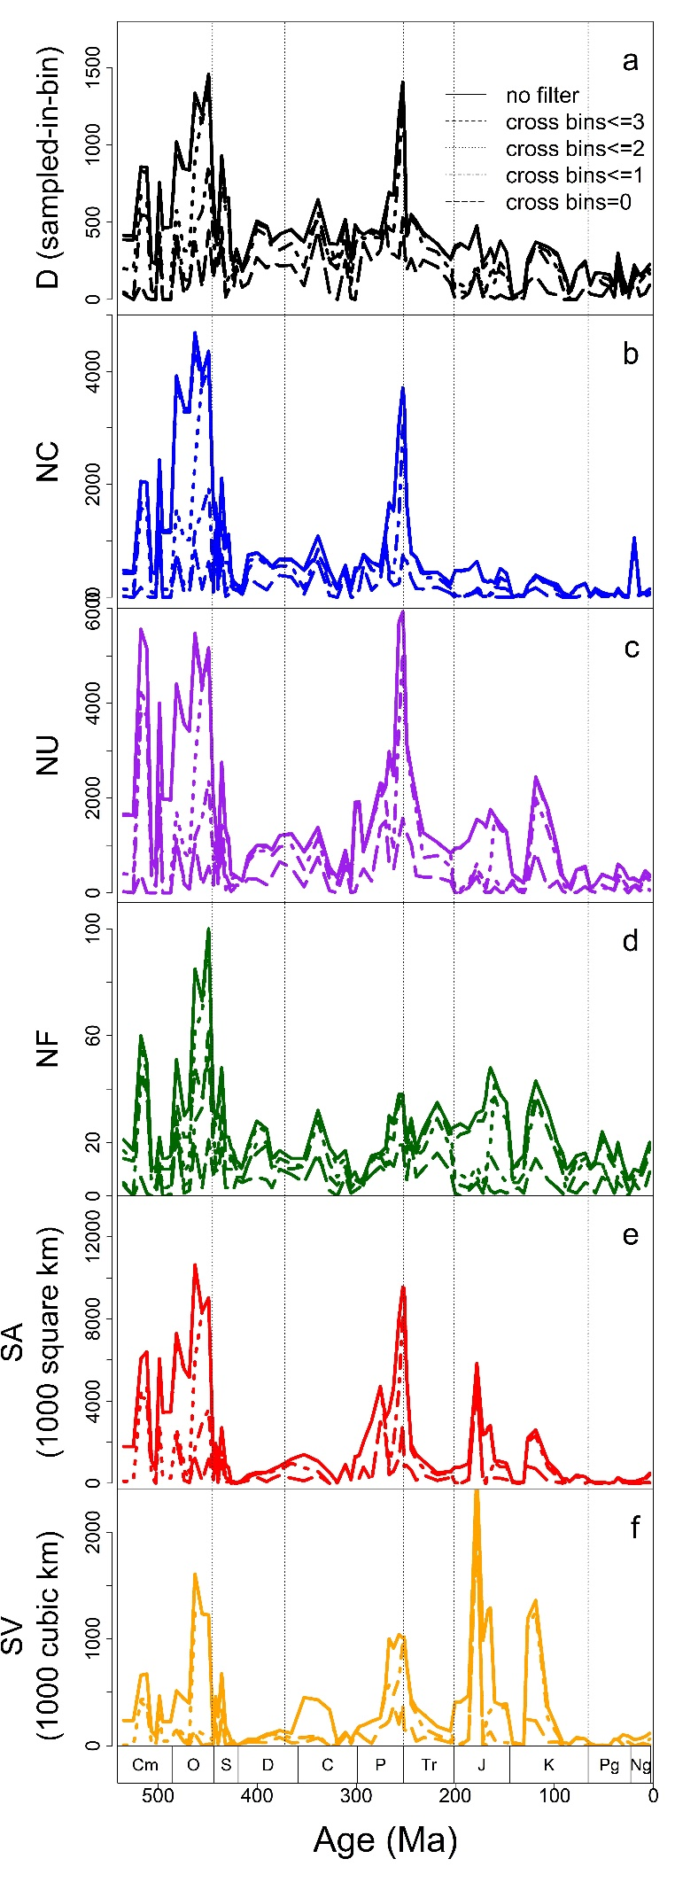
Figure S2. The time series of sampled genus richness and all sample-related variables over the Phanerozoic based on the formations that span longer than one, two, and three geological stage. Note that all curves in each plot mirror with each other. D, raw genus diversity (sampled-in-bin). NC, number of collections. NF, number of formations. NU, number of sedimentary units. SA, sedimentary area. SV, sedimentary volume. Dashed lines denote five mass extinction events during the Phanerozoic. Ma, millions of years ago. Cm, Cambrian; O, Ordovician; S, Silurian; D, Devonian; C, Carboniferous; P, Permian; Tr, Triassic; J, Jurassic; K, Cretaceous; Pg, Paleogene; Ng, Neogene.

