Supplementary materials

Paleo-trade wind directions over the Yangtze Carbonate Platform during the Cambrian–Ordovician, Southern China

Chenlin Hu, Tianyou Qin, Jinghui Ma, Changcheng Han, and Xuliang Wang

Table S1. Location and sampling information for the nine study outcrops.
NO. | Outcrop | Location | Thickness* (m) | No. of analyses for thin section | No. analyses for AMS
1 | LJ  (Liujiachang Outcrop) | 30°03′34″ N  111°28′59″ E | 1130 (SJ-LX formations) | 66 | 274
2 | FD  (Fandian Outcrop) | 29°33′16″ N  103°47′28″ E | 650 (QZ-XX formations) | 38 | 140
3 | YK  (Yankong Outcrop) | 27°33′07″ N 106°15′28″ E | 820 (NT-MT formations) | 48 | 149
4 | YS  (Yangsiqiao Outcrop) | 31°49′02″ N  109°00′08″ E | 270 (SJ-SY formations) | 16 | 133
5 | YJ  (Yangjiaping Outcrop) | 29°58′42″ N  110°43′13″ E | 2330 (NT-MT formations) | 137 | 137
6 | HH  (Honghuayuan Outcrop) | 28°04′15″ N  106°50′53″ E | 440 (TZ-WF formations) | 26 | 139
7 | JF  (Jinfoshan Outcrop) | 29°00′50″ N  107°09′57″ E | 300 (TZ-WF formations) | 18 | 144
8 | NS  (Nanshanping Outcrop) | 29°19′31″ N  110°54′06″ E | 520 (TZ-BT formations) | 31 | 135
9 | YH  (Yanhe Outcrop) | 28°33′11″ N  108°28′48″ E | 170 (TZ-WF formations) | 10 | 149
*Total observed and measured thickness in a given outcrop. SJ = Shuijingtuo Formation; LX = Linxiang Formation; QZ = Qiongzhusi Formation; XX = Xixiangchi Formation; NT = Niutitang Formation; MT =Maotianba Formatiom; SY = Sanyoudong Formation; TZ = Tongzi Formation; WF = Wufeng Formation; and BT = Baota Formation.
Table S2. Parameters of oolitic grainstone in different sites of Cambrian-Ordovician. The statistical results are based on Table S3.
Sites | Cambrian |  | Ordovician
 | Bedding thickness (m) | Ooid size (mm) | Bedding thickness (m) | Ooid size (mm)
Northwestern YCP | 1.5 ± 1.1 | 0.8 ± 0.7 | 1.4 ± 0.9 | 0.7 ± 0.5
Central YCP | 0.7 ± 0.5 | 0.6 ± 0.6 | 0.6 ± 0.4 | 0.6 ± 0.5
Southeastern YCP | 2.2 ± 1.1 | 1.0 ± 0.9 | 2.1 ± 1.2 | 0.9 ± 0.8

Table S3. Oolitic grainstone (a total of 120 samples) showing different parameters on bedding thickness, ooid size, sorting, and cement types.
Sites | Sample ID | System | Thickness (m) | Size (mm) | Sorting
Northwestern YCP | 1 | Cambrian | 1.1 | 0.5 | Well
 | 2 | Cambrian | 1.4 | 0.1 | Well
 | 3 | Cambrian | 0.9 | 0.6 | Moderate
 | 4 | Cambrian | 0.6 | 0.2 | Well
 | 5 | Cambrian | 1.9 | 0.9 | Moderate
 | 6 | Cambrian | 2.1 | 1.2 | Well
 | 7 | Cambrian | 1.6 | 1.0 | Moderate
 | 8 | Cambrian | 1.5 | 0.9 | Moderate
 | 9 | Cambrian | 1.8 | 0.5 | Well
 | 10 | Cambrian | 1.7 | 0.7 | Moderate
 | 11 | Cambrian | 2.2 | 0.9 | Well
 | 12 | Cambrian | 1.2 | 0.5 | Well
 | 13 | Cambrian | 1.5 | 0.3 | Moderate
 | 14 | Cambrian | 1.5 | 1.3 | Well
 | 15 | Cambrian | 2.6 | 0.6 | Well
 | 16 | Cambrian | 1.0 | 0.8 | Moderate
 | 17 | Cambrian | 1.8 | 1.5 | Well
 | 18 | Cambrian | 0.4 | 1.2 | Poorly
 | 19 | Cambrian | 0.9 | 0.3 | Moderate
 | 20 | Cambrian | 2.1 | 1.2 | Well
 | 21 | Ordovician | 2.0 | 1.1 | Well
 | 22 | Ordovician | 1.0 | 0.6 | Well
 | 23 | Ordovician | 1.2 | 0.3 | Moderate
 | 24 | Ordovician | 1.4 | 1.2 | Well
 | 25 | Ordovician | 0.9 | 0.3 | Well
 | 26 | Ordovician | 0.9 | 0.4 | Moderate
 | 27 | Ordovician | 1.8 | 0.2 | Well
 | 28 | Ordovician | 0.6 | 0.8 | Well
 | 29 | Ordovician | 1.9 | 0.8 | Well
 | 30 | Ordovician | 1.0 | 1.0 | Moderate
 | 31 | Ordovician | 1.5 | 0.8 | Well
 | 32 | Ordovician | 2.1 | 0.7 | Moderate
 | 33 | Ordovician | 1.7 | 0.9 | Well
 | 34 | Ordovician | 1.3 | 0.5 | Moderate
 | 35 | Ordovician | 2.2 | 1.1 | Well
 | 36 | Ordovician | 1.1 | 1.1 | Well
 | 37 | Ordovician | 2.3 | 0.4 | Poorly
 | 38 | Ordovician | 1.9 | 0.7 | Moderate
 | 39 | Ordovician | 1.2 | 1.1 | Well
 | 40 | Ordovician | 0.5 | 0.6 | Well
Central YCP | 41 | Cambrian | 0.3 | 0.5 | Poorly
 | 42 | Cambrian | 0.9 | 0.5 | Moderate
 | 43 | Cambrian | 0.5 | 1.0 | Poorly
 | 44 | Cambrian | 0.7 | 1.2 | Moderate
 | 45 | Cambrian | 1.2 | 1.0 | Well
 | 46 | Cambrian | 0.5 | 0.5 | Poorly
 | 47 | Cambrian | 1.1 | 1.1 | Poorly
 | 48 | Cambrian | 0.3 | 0.2 | Moderate
 | 49 | Cambrian | 0.8 | 0.1 | Poorly
 | 50 | Cambrian | 1.1 | 0.2 | Poorly
 | 51 | Cambrian | 0.7 | 0.3 | Moderate
 | 52 | Cambrian | 1.0 | 0.9 | Poorly
 | 53 | Cambrian | 0.6 | 0.4 | Moderate
 | 54 | Cambrian | 0.3 | 0.3 | Poorly
 | 55 | Cambrian | 0.8 | 1.0 | Poorly
 | 56 | Cambrian | 0.6 | 0.7 | Moderate
 | 57 | Cambrian | 0.8 | 0.4 | Poorly
 | 58 | Cambrian | 1.2 | 0.2 | Moderate
 | 59 | Cambrian | 0.2 | 0.4 | Poorly
 | 60 | Cambrian | 0.3 | 0.6 | Moderate
 | 61 | Ordovician | 0.5 | 0.3 | Poorly
 | 62 | Ordovician | 0.6 | 1.1 | Poorly
 | 63 | Ordovician | 0.9 | 0.8 | Moderate
 | 64 | Ordovician | 0.7 | 0.9 | Poorly
 | 65 | Ordovician | 0.5 | 0.1 | Moderate
 | 66 | Ordovician | 0.6 | 0.5 | Poorly
 | 67 | Ordovician | 1.0 | 0.3 | Well
 | 68 | Ordovician | 0.5 | 0.4 | Poorly
 | 69 | Ordovician | 0.5 | 1.1 | Moderate
 | 70 | Ordovician | 0.5 | 0.4 | Poorly
 | 71 | Ordovician | 0.2 | 0.2 | Poorly
 | 72 | Ordovician | 0.8 | 0.4 | Moderate
 | 73 | Ordovician | 0.5 | 0.8 | Poorly
 | 74 | Ordovician | 0.3 | 0.4 | Poorly
 | 75 | Ordovician | 0.6 | 0.2 | Poorly
 | 76 | Ordovician | 0.4 | 0.4 | Poorly
 | 77 | Ordovician | 0.6 | 0.6 | Poorly
 | 78 | Ordovician | 0.6 | 0.9 | Moderate
 | 79 | Ordovician | 0.3 | 1.0 | Poorly
 | 80 | Ordovician | 0.4 | 0.2 | Poorly
Southeastern YCP | 81 | Cambrian | 2.6 | 1.3 | Moderate
 | 82 | Cambrian | 1.9 | 1.7 | Moderate
 | 83 | Cambrian | 2.4 | 0.8 | Moderate
 | 84 | Cambrian | 2.2 | 1.2 | Moderate
 | 85 | Cambrian | 3.3 | 0.1 | Well
 | 86 | Cambrian | 1.6 | 0.5 | Poorly
 | 87 | Cambrian | 2.0 | 1.2 | Moderate
 | 88 | Cambrian | 2.0 | 1.7 | Moderate
 | 89 | Cambrian | 1.7 | 0.5 | Poorly
 | 90 | Cambrian | 2.7 | 1.9 | Moderate
 | 91 | Cambrian | 1.9 | 1.3 | Moderate
 | 92 | Cambrian | 2.6 | 0.7 | Moderate
 | 93 | Cambrian | 2.9 | 0.6 | Moderate
 | 94 | Cambrian | 1.1 | 0.4 | Poorly
 | 95 | Cambrian | 2.5 | 0.8 | Moderate
 | 96 | Cambrian | 2.4 | 0.8 | Moderate
 | 97 | Cambrian | 2.4 | 0.6 | Moderate
 | 98 | Cambrian | 2.8 | 1.7 | Well
 | 99 | Cambrian | 2.7 | 1.4 | Well
 | 100 | Cambrian | 1.2 | 1.0 | Moderate
 | 101 | Ordovician | 1.9 | 1.4 | Moderate
 | 102 | Ordovician | 1.7 | 0.5 | Moderate
 | 103 | Ordovician | 3.0 | 0.6 | Moderate
 | 104 | Ordovician | 1.6 | 0.1 | Poorly
 | 105 | Ordovician | 3.0 | 0.5 | Moderate
 | 106 | Ordovician | 1.2 | 1.0 | Moderate
 | 107 | Ordovician | 3.1 | 1.2 | Moderate
 | 108 | Ordovician | 2.0 | 0.3 | Moderate
 | 109 | Ordovician | 2.4 | 0.9 | Moderate
 | 110 | Ordovician | 3.1 | 0.5 | Moderate
 | 111 | Ordovician | 1.2 | 1.2 | Poorly
 | 112 | Ordovician | 1.6 | 0.9 | Moderate
 | 113 | Ordovician | 2.3 | 1.5 | Moderate
 | 114 | Ordovician | 1.3 | 1.7 | Moderate
 | 115 | Ordovician | 1.2 | 1.1 | Moderate
 | 116 | Ordovician | 3.3 | 1.3 | Well
 | 117 | Ordovician | 0.9 | 0.9 | Poorly
 | 118 | Ordovician | 1.4 | 1.6 | Moderate
 | 119 | Ordovician | 2.7 | 0.4 | Well
 | 120 | Ordovician | 2.3 | 1.3 | Moderate

Table S4. Parameters of intraclastic grainstone in different sites of Cambrian-Ordovician. The statistical results are based on Table S5.
Sites | Cambrian |  | Ordovician
 | Bedding thickness (m) | Intraclast size (cm) | Bedding thickness (m) | Intraclast size (cm)
Northwestern YCP | 1.7 ± 1.3 | 2.5 ± 1.7 | 1.8 ± 1.4 | 2.4 ± 1.5
Central YCP | 1.2 ± 0.9 | 1.7 ± 1.1 | 1.3 ± 0.8 | 1.5 ± 0.9
Southeastern YCP | 0.6 ± 0.5 | 0.8 ± 0.7 | 0.7 ± 0.5 | 0.7 ± 0.6

Table S5. Intraclastic grainstone (a total of 120 samples) showing different parameters on bedding thickness, intraclast size, roundness, sorting, and cement types.
Sites | Sample ID | System | Thickness (m) | Size (cm) | Roundness | Sorting
Northwestern YCP | 1 | Cambrian | 2.0 | 0.8 | Rounded | Moderate
 | 2 | Cambrian | 0.4 | 2.2 | Angular | Poorly
 | 3 | Cambrian | 0.9 | 3.3 | Sub-rounded | Moderate
 | 4 | Cambrian | 2.7 | 2.6 | Rounded | Well
 | 5 | Cambrian | 2.9 | 3.4 | Rounded | Well
 | 6 | Cambrian | 1.3 | 2.1 | Sub-rounded | Moderate
 | 7 | Cambrian | 2.1 | 2.4 | Sub-angular | Moderate
 | 8 | Cambrian | 1.4 | 3.1 | Sub-rounded | Moderate
 | 9 | Cambrian | 2.7 | 1.0 | Sub-angular | Moderate
 | 10 | Cambrian | 1.0 | 2.9 | Sub-rounded | Moderate
 | 11 | Cambrian | 1.6 | 3.0 | Sub-angular | Moderate
 | 12 | Cambrian | 0.6 | 4.1 | Sub-rounded | Poorly
 | 13 | Cambrian | 1.1 | 1.1 | Sub-rounded | Moderate
 | 14 | Cambrian | 2.9 | 3.6 | Rounded | Well
 | 15 | Cambrian | 0.9 | 1.1 | Sub-rounded | Moderate
 | 16 | Cambrian | 3.0 | 2.3 | Rounded | Well
 | 17 | Cambrian | 2.7 | 1.9 | Sub-rounded | Well
 | 18 | Cambrian | 1.2 | 1.4 | Sub-rounded | Moderate
 | 19 | Cambrian | 1.8 | 4.2 | Sub-angular | Moderate
 | 20 | Cambrian | 1.3 | 3.0 | Sub-rounded | Moderate
 | 21 | Ordovician | 0.9 | 1.2 | Sub-rounded | Moderate
 | 22 | Ordovician | 0.4 | 2.8 | Sub-angular | Poorly
 | 23 | Ordovician | 1.4 | 2.1 | Sub-rounded | Moderate
 | 24 | Ordovician | 2.6 | 1.7 | Rounded | Well
 | 25 | Ordovician | 2.2 | 2.2 | Rounded | Moderate
 | 26 | Ordovician | 2.1 | 0.9 | Sub-rounded | Moderate
 | 27 | Ordovician | 2.1 | 1.4 | Sub-rounded | Moderate
 | 28 | Ordovician | 2.2 | 2.0 | Sub-rounded | Moderate
 | 29 | Ordovician | 2.1 | 2.8 | Sub-rounded | Moderate
 | 30 | Ordovician | 1.1 | 3.9 | Sub-angular | Moderate
 | 31 | Ordovician | 0.4 | 1.6 | Angular | Poorly
 | 32 | Ordovician | 3.2 | 3.7 | Rounded | Well
 | 33 | Ordovician | 3.0 | 3.3 | Sub-rounded | Well
 | 34 | Ordovician | 1.5 | 3.4 | Sub-rounded | Moderate
 | 35 | Ordovician | 3.0 | 2.6 | Rounded | Well
 | 36 | Ordovician | 2.1 | 2.4 | Rounded | Well
 | 37 | Ordovician | 1.7 | 3.8 | Sub-rounded | Moderate
 | 38 | Ordovician | 0.5 | 3.0 | Sub-angular | Moderate
 | 39 | Ordovician | 1.2 | 1.4 | Sub-rounded | Moderate
 | 40 | Ordovician | 2.2 | 1.5 | Rounded | Well
Central YCP | 41 | Cambrian | 1.3 | 1.5 | Sub-angular | Moderate
 | 42 | Cambrian | 1.2 | 2.7 | Sub-angular | Moderate
 | 43 | Cambrian | 1.4 | 0.6 | Sub-angular | Moderate
 | 44 | Cambrian | 1.3 | 2.1 | Sub-angular | Moderate
 | 45 | Cambrian | 0.5 | 1.5 | Sub-angular | Poorly
 | 46 | Cambrian | 0.9 | 1.3 | Sub-angular | Moderate
 | 47 | Cambrian | 0.4 | 1.6 | Angular | Poorly
 | 48 | Cambrian | 0.3 | 1.9 | Sub-angular | Poorly
 | 49 | Cambrian | 1.2 | 1.0 | Sub-rounded | Moderate
 | 50 | Cambrian | 0.7 | 0.7 | Sub-angular | Moderate
 | 51 | Cambrian | 1.5 | 2.7 | Sub-rounded | Moderate
 | 52 | Cambrian | 0.7 | 2.5 | Sub-angular | Moderate
 | 53 | Cambrian | 2.0 | 1.7 | Sub-rounded | Well
 | 54 | Cambrian | 1.9 | 1.3 | Sub-rounded | Well
 | 55 | Cambrian | 0.5 | 1.4 | Angular | Poorly
 | 56 | Cambrian | 1.9 | 1.1 | Sub-rounded | Well
 | 57 | Cambrian | 1.8 | 2.8 | Sub-rounded | Moderate
 | 58 | Cambrian | 0.8 | 2.1 | Sub-angular | Moderate
 | 59 | Cambrian | 1.3 | 2.4 | Sub-rounded | Moderate
 | 60 | Cambrian | 2.1 | 1.1 | Rounded | Well
 | 61 | Ordovician | 1.2 | 1.7 | Sub-angular | Moderate
 | 62 | Ordovician | 1.4 | 1.8 | Sub-angular | Moderate
 | 63 | Ordovician | 1.1 | 2.0 | Sub-angular | Moderate
 | 64 | Ordovician | 1.2 | 2.1 | Sub-angular | Moderate
 | 65 | Ordovician | 1.3 | 2.1 | Sub-angular | Moderate
 | 66 | Ordovician | 1.0 | 0.7 | Sub-angular | Moderate
 | 67 | Ordovician | 1.7 | 0.8 | Sub-rounded | Moderate
 | 68 | Ordovician | 1.3 | 1.0 | Sub-angular | Moderate
 | 69 | Ordovician | 0.7 | 2.1 | Angular | Poorly
 | 70 | Ordovician | 1.9 | 0.8 | Sub-rounded | Well
 | 71 | Ordovician | 0.8 | 0.6 | Sub-angular | Moderate
 | 72 | Ordovician | 1.7 | 1.7 | Sub-rounded | Well
 | 73 | Ordovician | 1.7 | 0.7 | Sub-rounded | Well
 | 74 | Ordovician | 0.5 | 0.7 | Angular | Poorly
 | 75 | Ordovician | 0.7 | 1.1 | Angular | Poorly
 | 76 | Ordovician | 1.8 | 1.2 | Sub-rounded | Moderate
 | 77 | Ordovician | 1.9 | 1.5 | Sub-rounded | Well
 | 78 | Ordovician | 0.8 | 2.0 | Sub-angular | Moderate
 | 79 | Ordovician | 2.1 | 2.4 | Rounded | Well
 | 80 | Ordovician | 1.7 | 2.2 | Sub-angular | Moderate
Southeastern YCP | 81 | Cambrian | 0.6 | 0.8 | Sub-angular | Poorly
 | 82 | Cambrian | 0.4 | 0.3 | Sub-angular | Poorly
 | 83 | Cambrian | 0.7 | 1.4 | Sub-angular | Poorly
 | 84 | Cambrian | 0.5 | 1.2 | Sub-angular | Poorly
 | 85 | Cambrian | 0.2 | 1.3 | Angular | Poorly
 | 86 | Cambrian | 0.5 | 0.4 | Sub-angular | Poorly
 | 87 | Cambrian | 0.6 | 1.5 | Sub-angular | Moderate
 | 88 | Cambrian | 0.4 | 0.6 | Sub-angular | Poorly
 | 89 | Cambrian | 0.7 | 0.9 | Sub-angular | Moderate
 | 90 | Cambrian | 1.1 | 1.1 | Rounded | Well
 | 91 | Cambrian | 0.3 | 0.2 | Angular | Poorly
 | 92 | Cambrian | 0.6 | 0.5 | Sub-angular | Moderate
 | 93 | Cambrian | 0.5 | 1.5 | Sub-angular | Poorly
 | 94 | Cambrian | 0.8 | 0.4 | Sub-rounded | Moderate
 | 95 | Cambrian | 0.5 | 0.1 | Angular | Poorly
 | 96 | Cambrian | 0.6 | 0.8 | Sub-rounded | Moderate
 | 97 | Cambrian | 0.1 | 1.1 | Angular | Poorly
 | 98 | Cambrian | 0.4 | 0.9 | Angular | Moderate
 | 99 | Cambrian | 0.9 | 0.3 | Sub-rounded | Moderate
 | 100 | Cambrian | 0.3 | 0.8 | Angular | Moderate
 | 101 | Ordovician | 0.9 | 0.9 | Sub-angular | Moderate
 | 102 | Ordovician | 0.8 | 1.0 | Sub-angular | Moderate
 | 103 | Ordovician | 0.6 | 1.3 | Sub-angular | Poorly
 | 104 | Ordovician | 0.5 | 0.2 | Sub-angular | Poorly
 | 105 | Ordovician | 0.8 | 1.0 | Sub-angular | Poorly
 | 106 | Ordovician | 1.1 | 1.2 | Sub-rounded | Moderate
 | 107 | Ordovician | 1.1 | 0.6 | Sub-rounded | Moderate
 | 108 | Ordovician | 0.3 | 0.6 | Angular | Poorly
 | 109 | Ordovician | 0.5 | 0.8 | Sub-angular | Poorly
 | 110 | Ordovician | 0.3 | 0.1 | Angular | Poorly
 | 111 | Ordovician | 0.2 | 0.2 | Angular | Poorly
 | 112 | Ordovician | 1.1 | 0.4 | Sub-rounded | Moderate
 | 113 | Ordovician | 0.9 | 0.5 | Sub-angular | Poorly
 | 114 | Ordovician | 0.6 | 0.5 | Sub-angular | Poorly
 | 115 | Ordovician | 0.9 | 0.6 | Sub-angular | Poorly
 | 116 | Ordovician | 0.3 | 0.5 | Angular | Poorly
 | 117 | Ordovician | 1.2 | 0.6 | Rounded | Well
 | 118 | Ordovician | 0.9 | 0.6 | Sub-angular | Moderate
 | 119 | Ordovician | 1.1 | 0.9 | Sub-rounded | Moderate
 | 120 | Ordovician | 0.3 | 0.5 | Angular | Poorly

Table S6. Mean orientations and uncertainty values of the AMS during each series of Cambrian-Ordovician.
NO. | Series | Outcrops | D-K_{max} | I-K_{max} | D-K_{int} | I-K_{int} | D-K_{min} | I-K_{min} | Uncertainty values of D-K_{max}
1 | Upper Ordovician | LJ, HH, JF, NS, and YH | 90.5° | 17.3° | 182.8° | 18.4° | 272.4° | 78.2° | ± 67.5°
2 | Middle Ordovician |  | 139.1° | 9.3° | 229.3° | 29.9° | 324.0° | 79.3° | ± 72.6°
3 | Lower Ordovician |  | 168.8° | 19.2° | 264.4° | 9.3° | 352.6° | 75.8° | ± 70.2°
4 | Upper Cambrian | LJ, FD, YK, YS, and YJ | 158.9° | 9.8° | 247.9° | 13.6° | 337.8° | 85.2° | ± 62.3°
5 | Middle Cambrian |  | 145.3° | 8.7° | 235.7° | 10.7° | 320.2° | 76.4° | ± 56.7°
6 | Lower Cambrian |  | 115.7° | 7.1° | 201.5° | 18.3° | 291.7° | 87.8° | ± 51.8°

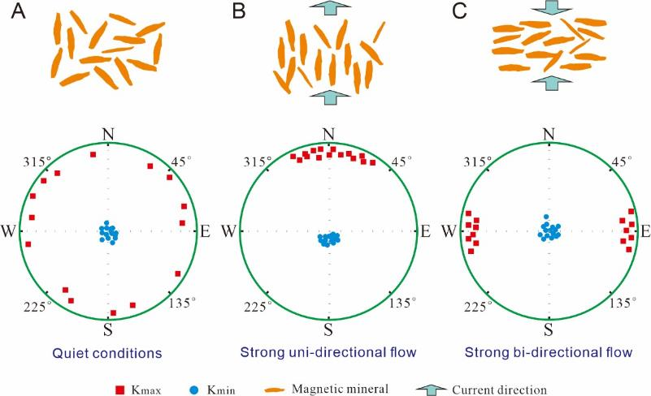
Fig. S1. Theoretical depositional fabric in the presence of wind or water currents (after Tarling and Hrouda, 1993; Zhu et al., 2004; Zhang et al., 2010). The orange grains illustrate the preferred alignment of most magnetic particles.

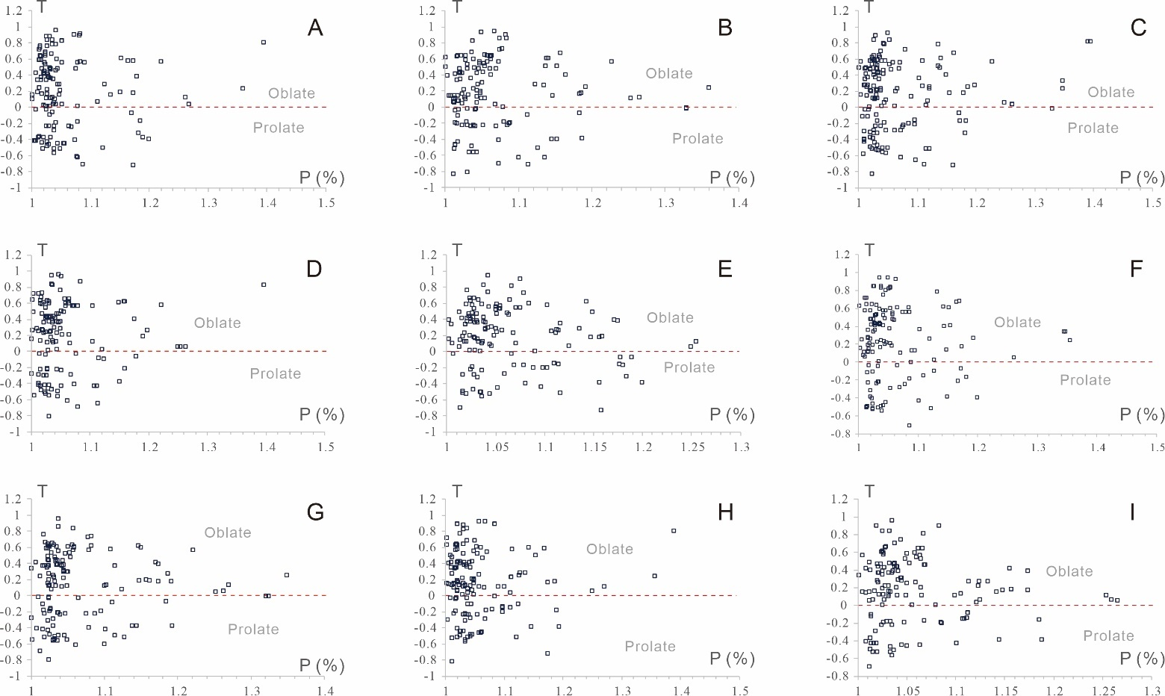
Fig. S2. Relationships between the AMS parameters of P and T. (A) Samples from Cambrian units at LJ Outcrop (n = 136). (B) Samples from Cambrian units at FD Outcrop (n = 140). (C) Samples from Cambrian units at YK Outcrop (n = 149). (D) Samples from Cambrian units at YS Outcrop (n = 133). (E) Samples from Cambrian units at YJ Outcrop (n = 137). (F) Samples from Ordovician units at LJ Outcrop (n = 138). (G) Samples from Ordovician units at HH Outcrop (n = 139). (H) Samples from Ordovician units at JF Outcrop (n = 144). (I) Samples from Ordovician units at NS Outcrop (n = 135).

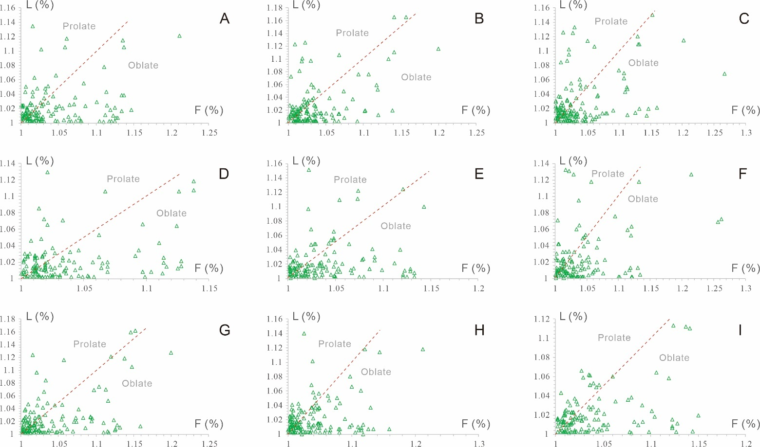
Fig. S3. Relationships between the AMS parameters of F and L. (A) Samples from Cambrian units at LJ Outcrop (n = 136). (B) Samples from Cambrian units at FD Outcrop (n = 140). (C) Samples from Cambrian units at YK Outcrop (n = 149). (D) Samples from Cambrian units at YS Outcrop (n = 133). (E) Samples from Cambrian units at YJ Outcrop (n = 137). (F) Samples from Ordovician units at LJ Outcrop (n = 138). (G) Samples from Ordovician units at HH Outcrop (n = 139). (H) Samples from Ordovician units at JF Outcrop (n = 144). (I) Samples from Ordovician units at NS Outcrop (n = 135).

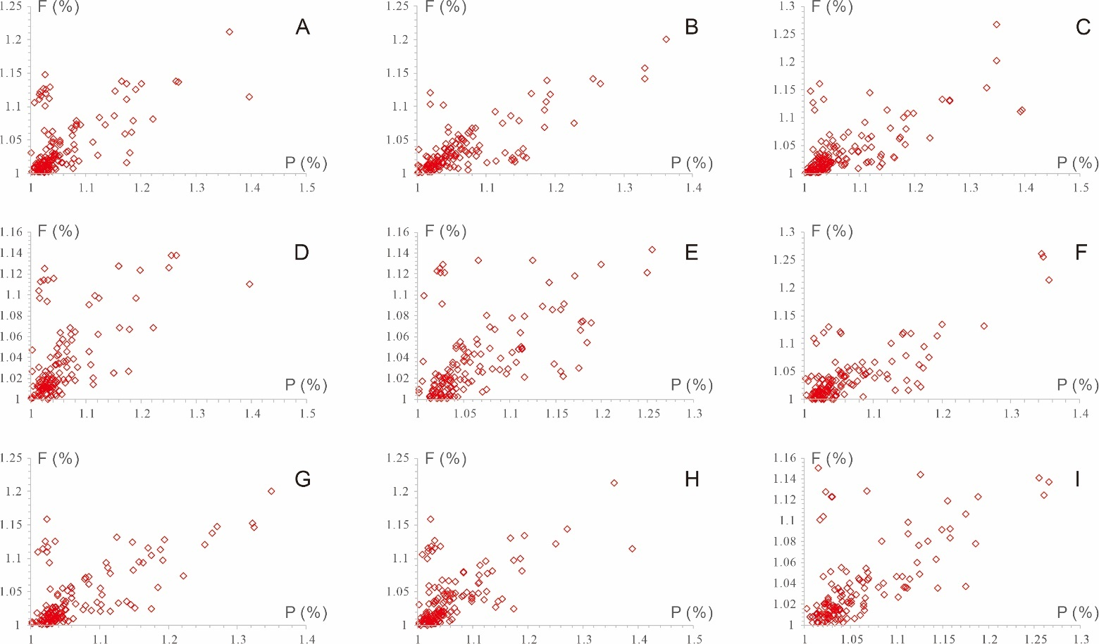
Fig. S4. Relationships between the AMS parameters of P and F. (A) Samples from Cambrian units at LJ Outcrop (n = 136). (B) Samples from Cambrian units at FD Outcrop (n = 140). (C) Samples from Cambrian units at YK Outcrop (n = 149). (D) Samples from Cambrian units at YS Outcrop (n = 133). (E) Samples from Cambrian units at YJ Outcrop (n = 137). (F) Samples from Ordovician units at LJ Outcrop (n = 138). (G) Samples from Ordovician units at HH Outcrop (n = 139). (H) Samples from Ordovician units at JF Outcrop (n = 144). (I) Samples from Ordovician units at NS Outcrop (n = 135).

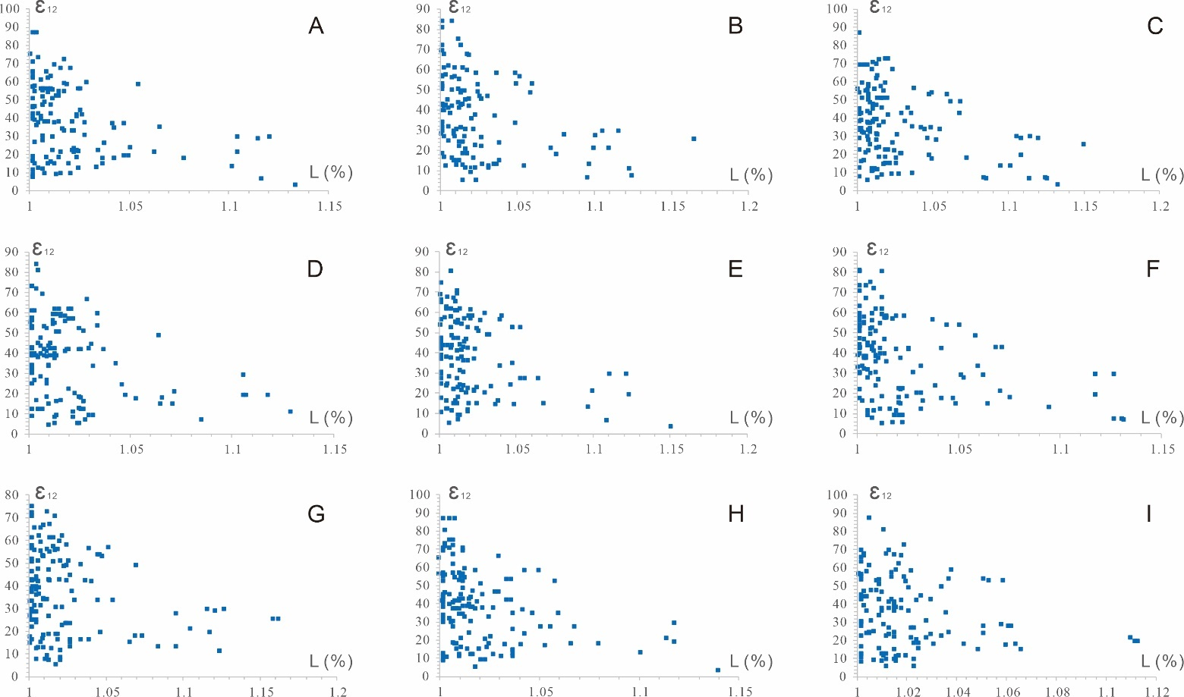
Fig. S5. Relationships between the AMS parameters of L and ε₁₂. (A) Samples from Cambrian units at LJ Outcrop (n = 136). (B) Samples from Cambrian units at FD Outcrop (n = 140). (C) Samples from Cambrian units at YK Outcrop (n = 149). (D) Samples from Cambrian units at YS Outcrop (n = 133). (E) Samples from Cambrian units at YJ Outcrop (n = 137). (F) Samples from Ordovician units at LJ Outcrop (n = 138). (G) Samples from Ordovician units at HH Outcrop (n = 139). (H) Samples from Ordovician units at JF Outcrop (n = 144). (I) Samples from Ordovician units at NS Outcrop (n = 135).

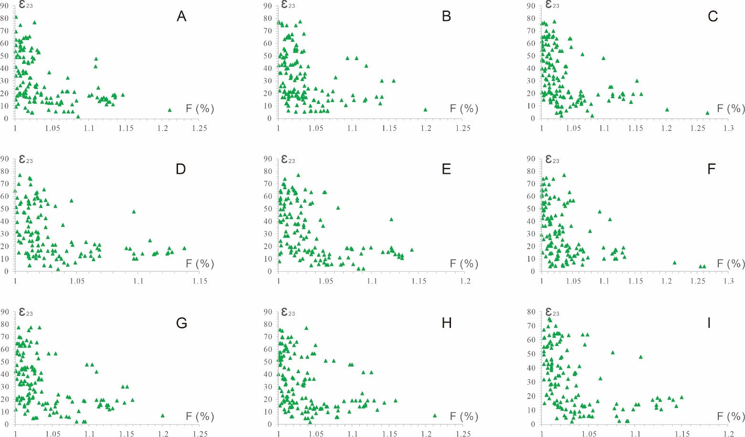
Fig. S6. Relationships between the AMS parameters of F and ε₂₃. (A) Samples from Cambrian units at LJ Outcrop (n = 136). (B) Samples from Cambrian units at FD Outcrop (n = 140). (C) Samples from Cambrian units at YK Outcrop (n = 149). (D) Samples from Cambrian units at YS Outcrop (n = 133). (E) Samples from Cambrian units at YJ Outcrop (n = 137). (F) Samples from Ordovician units at LJ Outcrop (n = 138). (G) Samples from Ordovician units at HH Outcrop (n = 139). (H) Samples from Ordovician units at JF Outcrop (n = 144). (I) Samples from Ordovician units at NS Outcrop (n = 135).

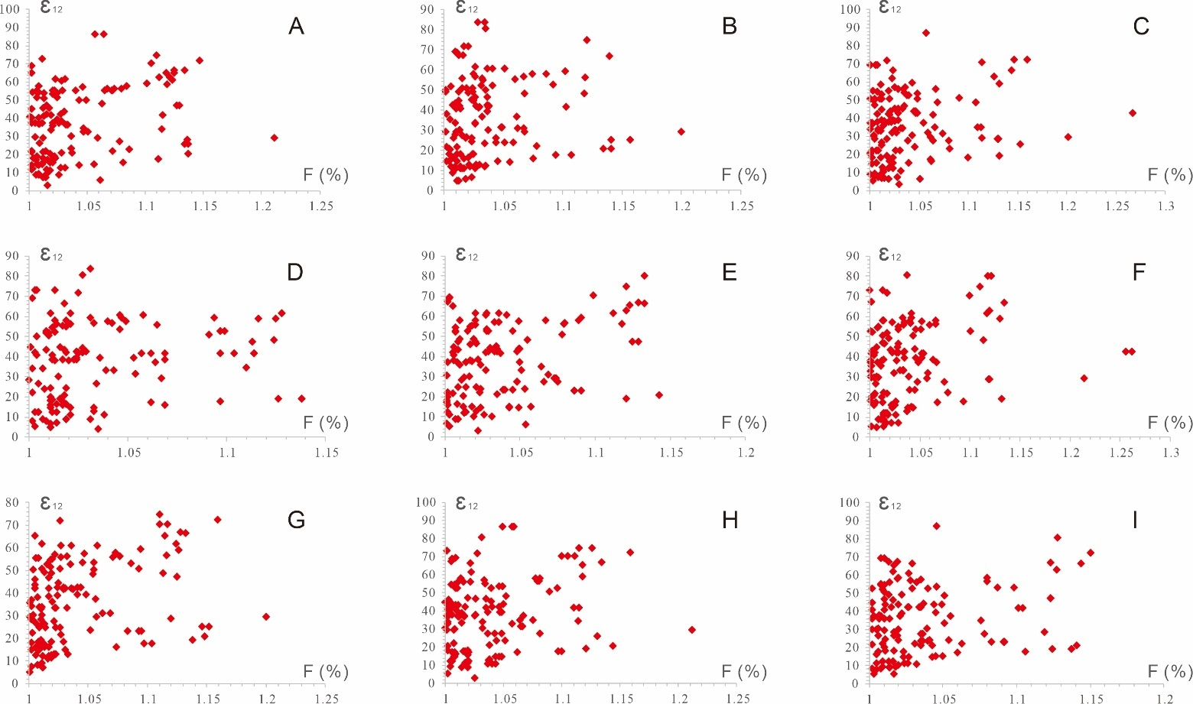
Fig. S7. Relationships between the AMS parameters of F and ε₁₂. (A) Samples from Cambrian units at LJ Outcrop (n = 136). (B) Samples from Cambrian units at FD Outcrop (n = 140). (C) Samples from Cambrian units at YK Outcrop (n = 149). (D) Samples from Cambrian units at YS Outcrop (n = 133). (E) Samples from Cambrian units at YJ Outcrop (n = 137). (F) Samples from Ordovician units at LJ Outcrop (n = 138). (G) Samples from Ordovician units at HH Outcrop (n = 139). (H) Samples from Ordovician units at JF Outcrop (n = 144). (I) Samples from Ordovician units at NS Outcrop (n = 135).

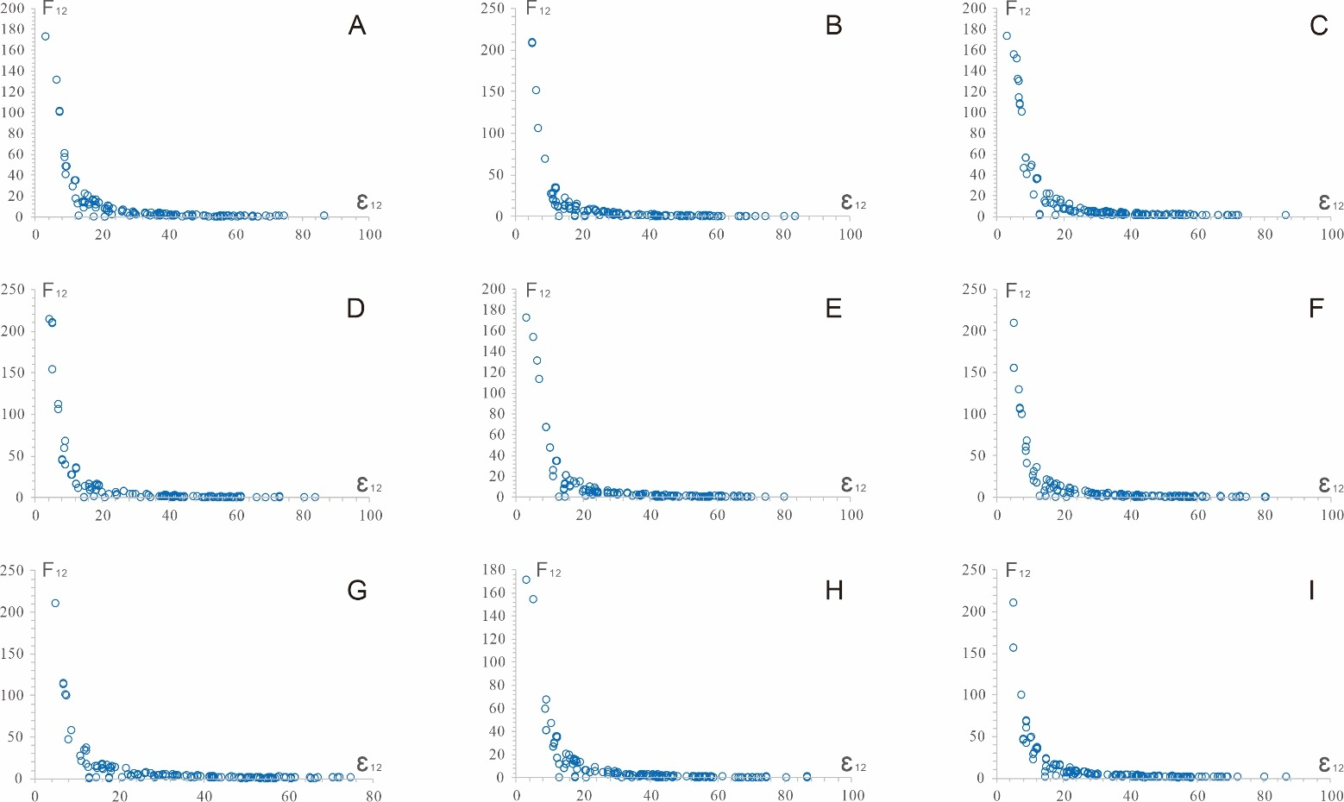
Fig. S8. Relationships between the AMS parameters of ε₁₂ and F₁₂. (A) Samples from Cambrian units at LJ Outcrop (n = 136). (B) Samples from Cambrian units at FD Outcrop (n = 140). (C) Samples from Cambrian units at YK Outcrop (n = 149). (D) Samples from Cambrian units at YS Outcrop (n = 133). (E) Samples from Cambrian units at YJ Outcrop (n = 137). (F) Samples from Ordovician units at LJ Outcrop (n = 138). (G) Samples from Ordovician units at HH Outcrop (n = 139). (H) Samples from Ordovician units at JF Outcrop (n = 144). (I) Samples from Ordovician units at NS Outcrop (n = 135).

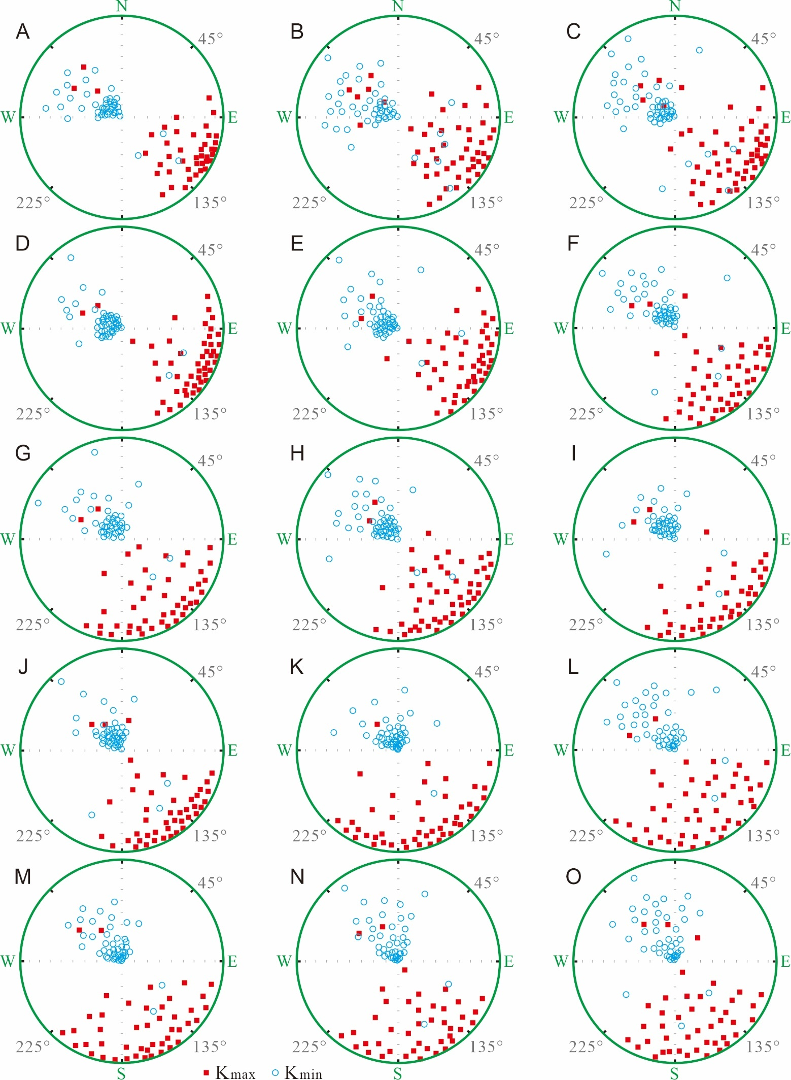
Fig. S9. Equal-area projections (modern coordinates) of AMS principal axes of all samples for each series of Cambrian from the five outcrops. (A) Lower Cambrian at the LJ Outcrop (n = 42). (B) Lower Cambrian at the FD Outcrop (n = 49). (C) Lower Cambrian at the YK Outcrop (n = 53). (D) Lower Cambrian at the YS Outcrop (n = 48). (E) Lower Cambrian at the YJ Outcrop (n = 49). (F) Middle Cambrian at the LJ Outcrop (n = 48). (G) Middle Cambrian at the FD Outcrop (n = 45). (H) Middle Cambrian at the YK Outcrop (n = 51). (I) Middle Cambrian at the YS Outcrop (n = 43). (J) Middle Cambrian at the YJ Outcrop (n = 45). (K) Upper Cambrian at the LJ Outcrop (n = 46). (L) Upper Cambrian at the FD Outcrop (n = 46). (M) Upper Cambrian at the YK Outcrop (n = 45). (N) Upper Cambrian at the YS Outcrop (n = 42). (O) Upper Cambrian at the YJ Outcrop (n = 43). K_{max} = maximum principal axes of the 3D AMS ellipsoid and K_{min} = minimum principal axes of the 3D AMS ellipsoid.

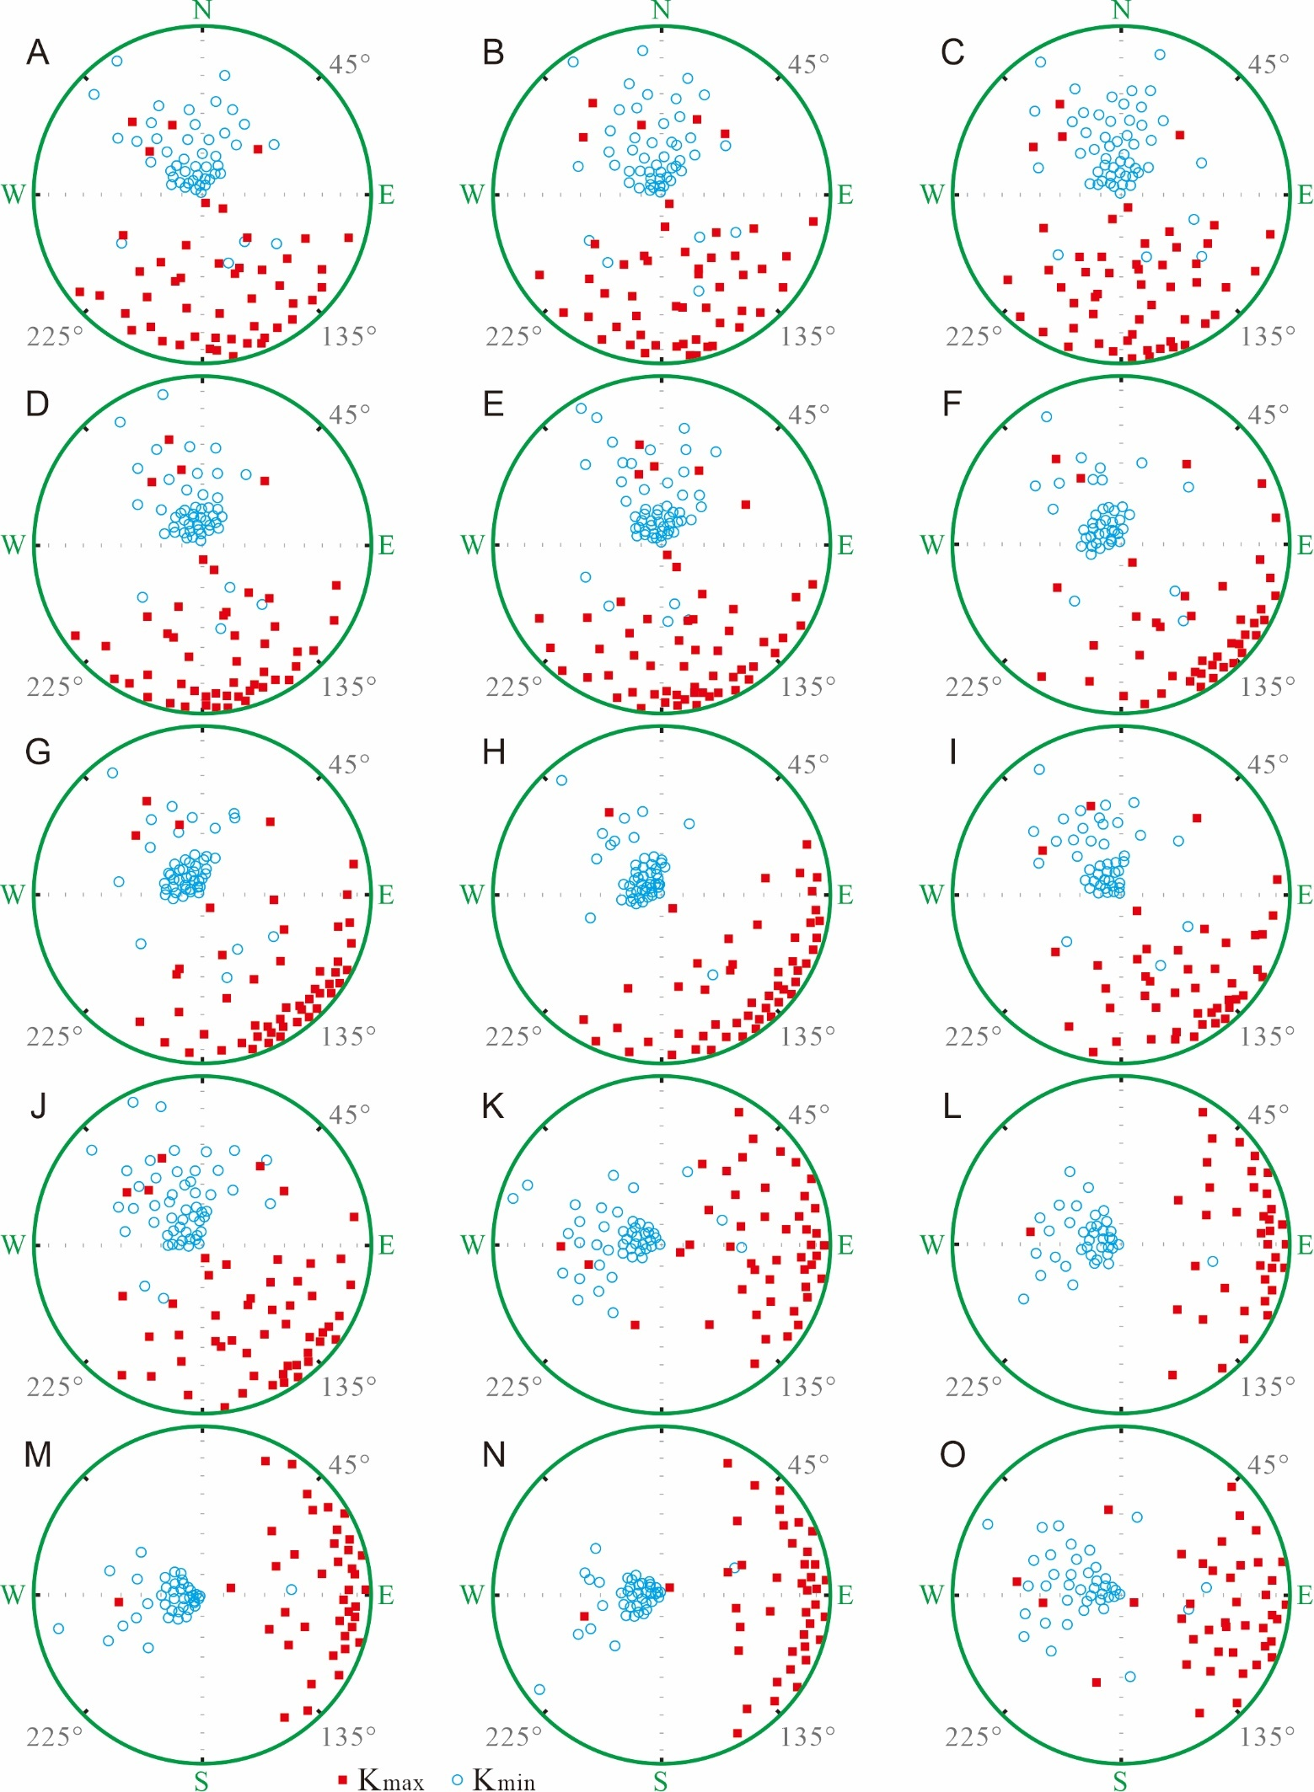

Fig. S10. Equal-area projections (modern coordinates) of AMS principal axes of all samples for each series of Ordovician from the five outcrops. (A) Lower Ordovician at the LJ Outcrop (n = 48). (B) Lower Ordovician at the HH Outcrop (n = 51). (C) Lower Ordovician at the JF Outcrop (n = 53). (D) Lower Ordovician at the NS Outcrop (n = 49). (E) Lower Ordovician at the YH Outcrop (n = 55). (F) Middle Ordovician at the LJ Outcrop (n = 43). (G) Middle Ordovician at the HH Outcrop (n = 50). (H) Middle Ordovician at the JF Outcrop (n = 51). (I) Middle Ordovician at the NS Outcrop (n = 45). (J) Middle Ordovician at the YH Outcrop (n = 52). (K) Upper Ordovician at the LJ Outcrop (n = 47). (L) Upper Ordovician at the HH Outcrop (n = 38). (M) Upper Ordovician at the JF Outcrop (n = 40). (N) Upper Ordovician at the NS Outcrop (n = 41). (O) Upper Ordovician at the YH Outcrop (n = 41). K_{max} = maximum principal axes of the 3D AMS ellipsoid and K_{min} = minimum principal axes of the 3D AMS ellipsoid.

Supplemental references
Tarling, D.H., Hrouda F., 1993. Magnetic Anisotropy of Rocks: London, Chapman and Hall, 220 pp.
Zhang, R., Kravchinsky, V.A., Zhu, R.X., Yue, L.P., 2010. Paleomonsoon route reconstruction along a W–E transect in the Chinese Loess Plateau using the anisotropy of magnetic susceptibility: Summer monsoon model. Earth and Planetary Science Letters 299, 436-446. https://doi.org/10.1016/j.epsl.2010.09.026.
Zhu, R.X., Liu, Q.S., Jackson, M.J., 2004. Paleoenvironmental significance of the magnetic fabrics in Chinese loess-paleosols since the last interglacial (< 130 ka). Earth and Planetary Science Letters 221, 55-69. https://doi.org/10.1016/S0012-821X(04)00103-7.

