Figure S3

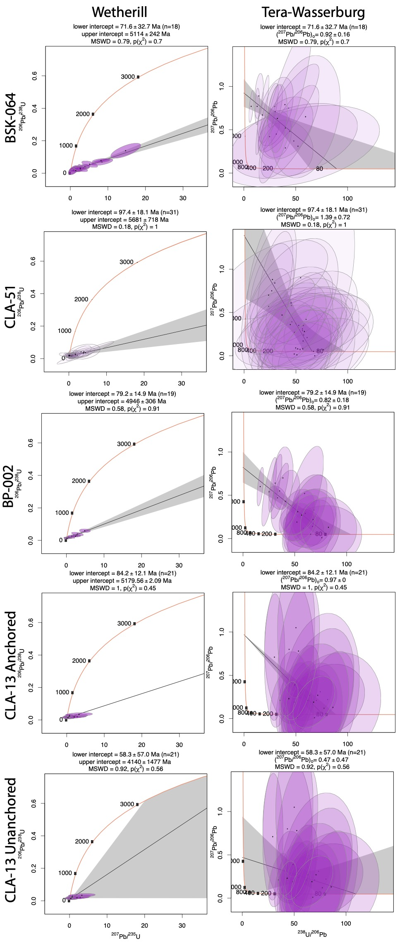

Caption: All four samples from Bultfontein displayed separately. Because yields an imprecise age it is displayed with both an anchored (207/206 = 0.97, derived from figure 2) and unanchored age.

