Supplementary Material

Weak and intermittent anoxia during the mid-Tournaisian (Mississippian) anoxic event in the Montagne Noire (France)

Michał Rakociński^{a#}, Daria Książakª, Agnieszka Pisarzowskaª, Michał Zatońª, Markus Aretz^{b}
ªUniversity of Silesia in Katowice, Faculty of Natural Sciences, Institute of Earth Sciences, Będzińska 60, Sosnowiec 41- 200, Poland; #michal.rakocinski@us.edu.pl
^{b}Géosciences Environnement Toulouse (GET), Observatoire Midi Pyrénées, Université de Toulouse, CNRS, IRD, 14 avenue E. Belin, F-31400 Toulouse, France
Corresponding author: michal.rakocinski@us.edu.pl

Figure S1. Lower part of the section (the section is overturned) at Puech de la Suque. Abbreviation: HBS – Hangenberg Black Shale (photo 31 May 2016): A-B. Uppermost Famennian (nodular limestone and shales); C-H. Lower Tournaisian nodular and pelitic limestones
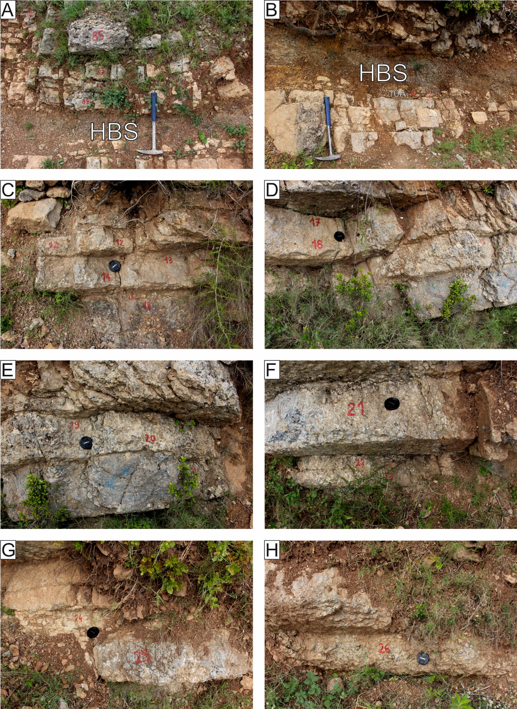

Figure S2. Upper part of the section at Puech de la Suque (photo 31 May 2016): A-B. Shales with carbonate nodules (bed 27). C. Contact between shales with carbonate nodules (bed 27) and cherts (bed 28). D-G. Mid-Tournaisian bedded black radiolarian cherts (Lydiennes Fm).

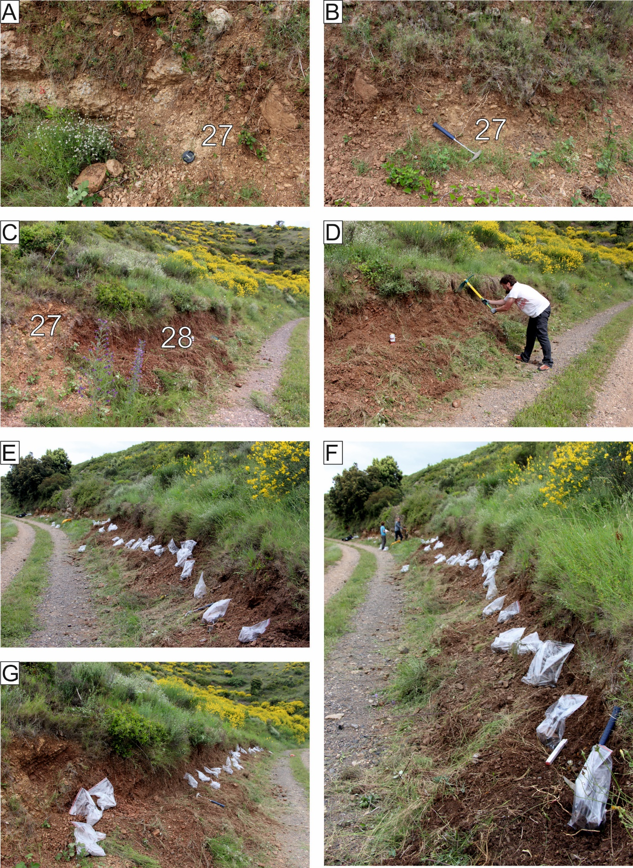

Figure S3. The section at Col des Tribes section (photo 30 May 2016): A. Contact between limestones and radiolarian cherts. B-C. Mid-Tournaisian black radiolarian cherts (Lydiennes Fm). D. Uppermost part sampled interval of black radiolarian cherts.

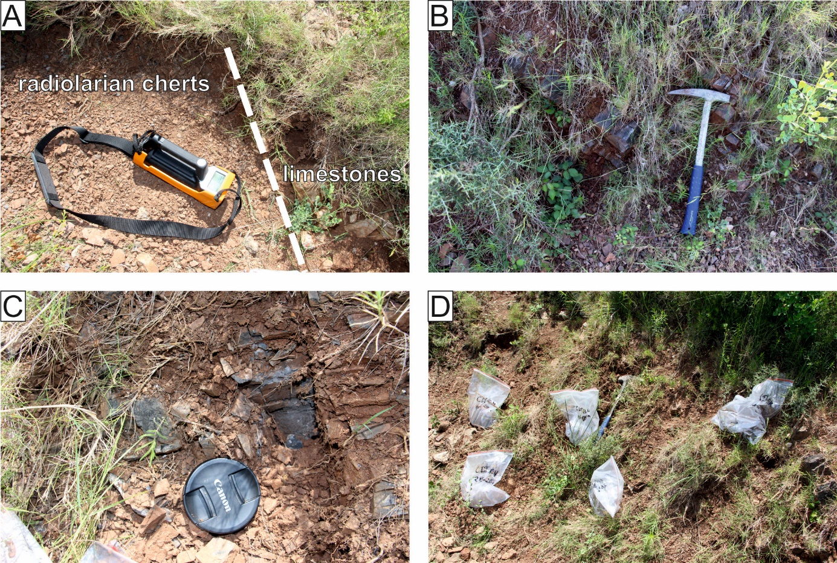

Figure S4. Lithological logs of the Mont Peyroux Succession: Puech de la Suque and Col des Tribes. Biostratigraphy is based on Kaiser et al. (2008) and Feist et al. (2021). Abbreviations of conodont zones and lithostratigraphy: sulc. – sulcata, sa. – sandbergi, quadr. – quadruplicata, Events: HBS – Hangenberg Black Shale, LASE – Lower Alum Black Shale.

Figure S5. Comparison of Th/U values obtained from gamma-ray spectrometry and ICP-MS method at Puech de la Suque. Anoxic conditions are shaded according to the values indicated in Myers & Wignall (1987), Bond & Zatoń (2003) and Bond et al. (2004).

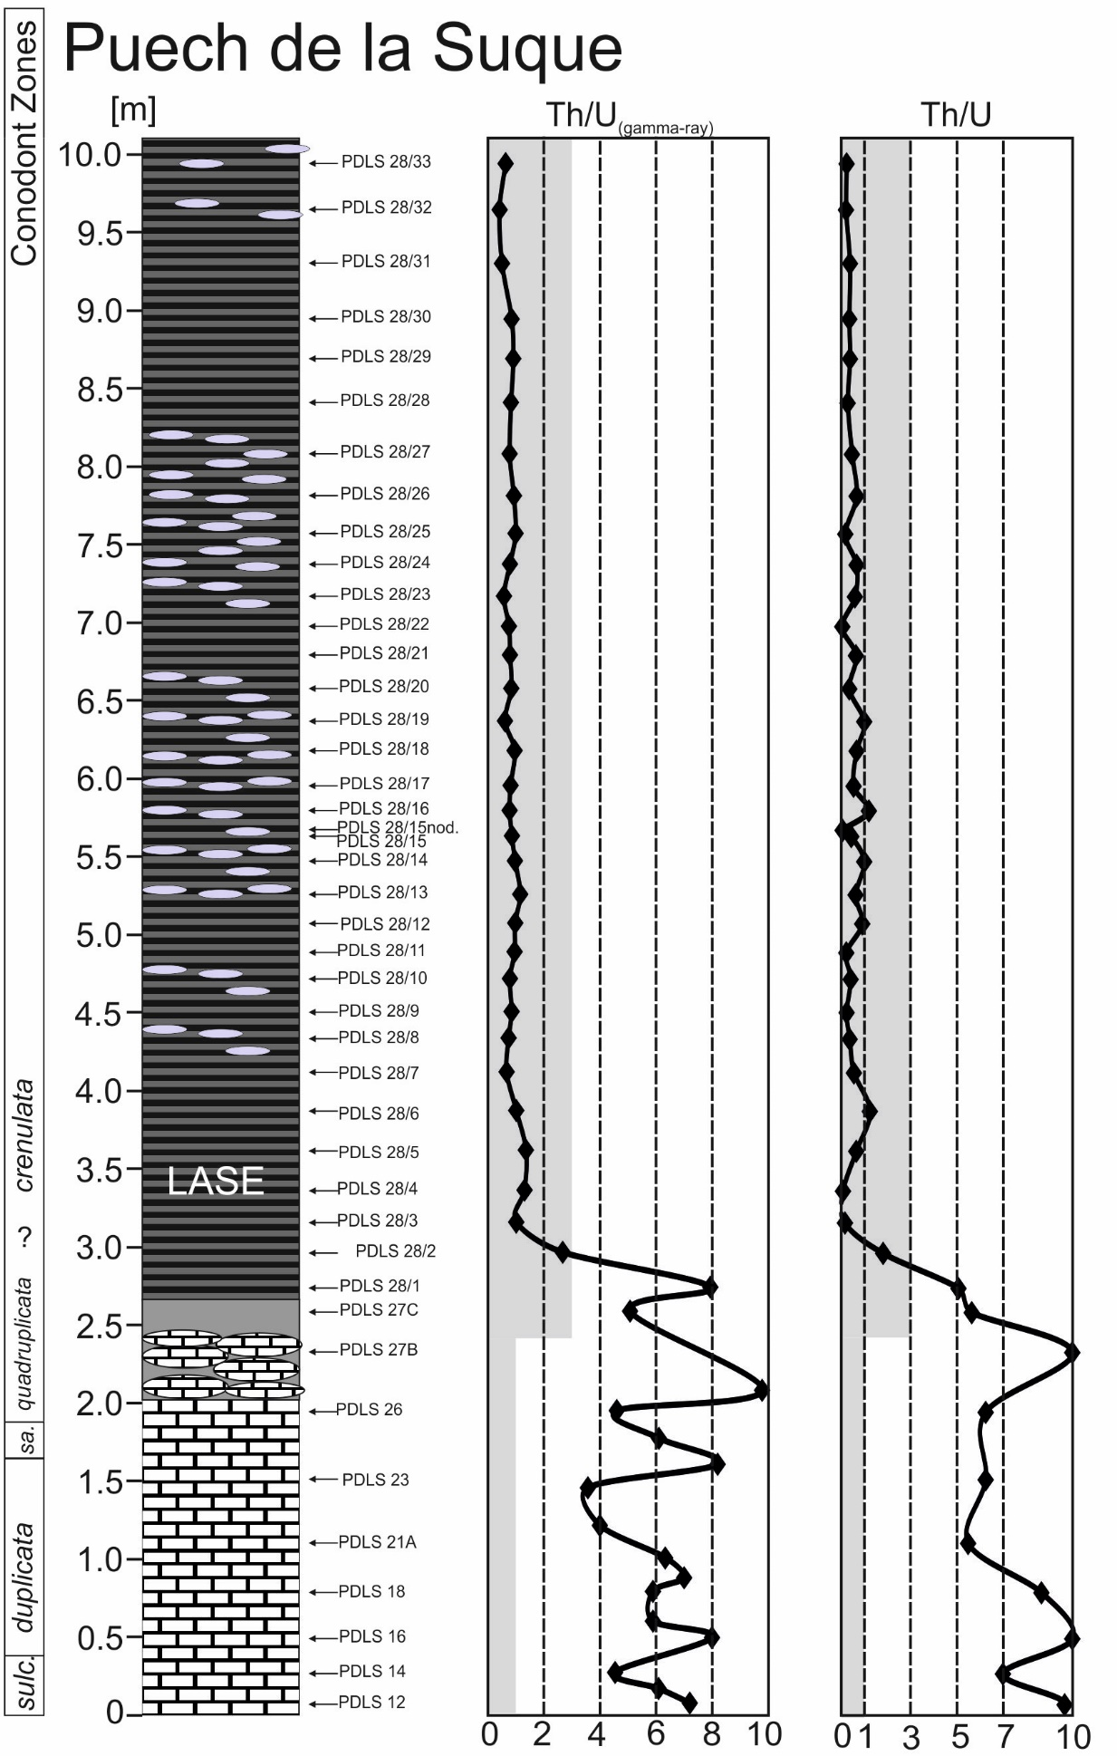

Figure S6. Comparison of Th/U values obtained from gamma-ray spectrometry and ICP-MS method at Coles des Tribes. Anoxic conditions are shaded according to the values indicated in Myers & Wignall (1987), Bond & Zatoń (2003) and Bond et al. (2004).

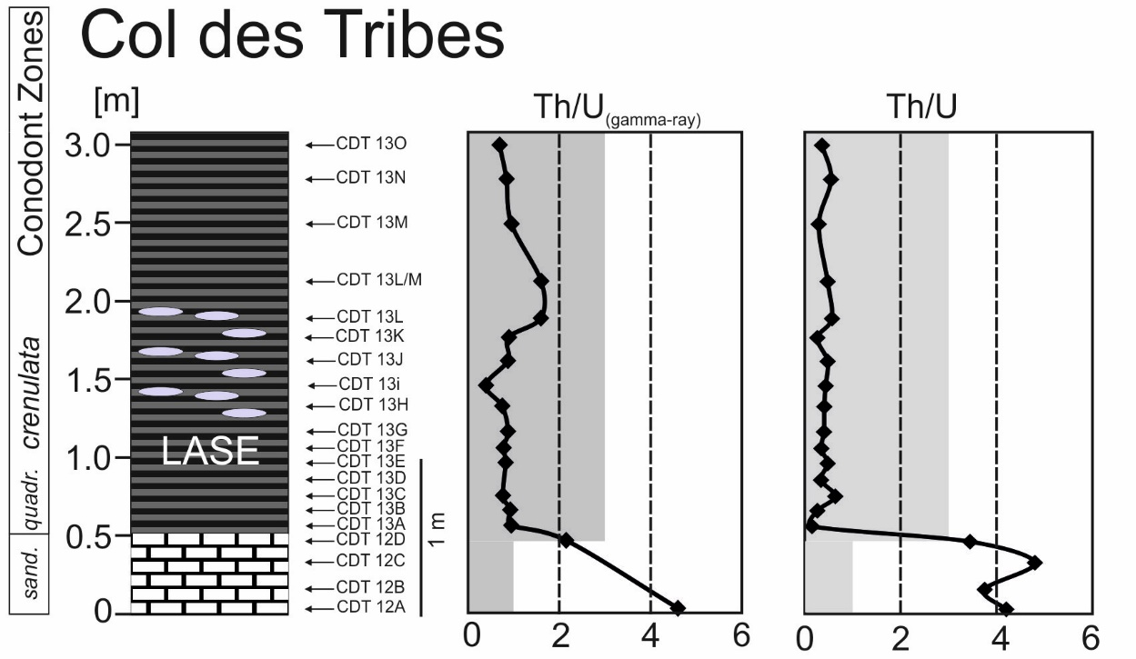
Short description Th/U ratios
Generally low values < 3 in detrital sediments and < 1 in carbonates, are characteristic for sediments deposited under anoxic conditions (see Myers & Wignall, 1987; Bond & Zatoń, 2003; Bond et al. 2004). Th/U ratio in limestones is high ranging from 3.44 to 4.80 in the CDT section and above 5 in the PDLS. While in almost all black radiolarian cherts from CDT, the Th/U values decrease to 0.15-0.64, in the PDLS section the values decrease to 0.07-1.82 (with exception of two lower samples in PDLS, where Th/U ratio is > 5). The Th/U ratios which were obtained by gamma-ray spectrometry very closely correspond to the Th/U data resulted from the ICP-MS method (for detail see SD. 5-6). The U/Th ratios in limestones in both sections are relatively low, reaching values below 0.5. The Th/U ratios above 3 in the limestones in CDT and above 5 in PDLS point to oxic conditions (Myers & Wignall, 1987; Bond et al. 2004; Rakociński et al. 2021). In the lowermost part of the PDLS section, the black radiolarian cherts reached high values of the Th/U ratios > 5 (samples 27C and 28/1), indicating oxic conditions, while in the higher part of black radiolarian cherts, the Th/U ratio significantly decreases below 1, pointing to anoxic bottom water conditions (e.g. Myers & Wignall, 1987; Bond et al. 2004). In the CDT section, the Th/U ratios generally correspond to those from PDLS, reaching values below 1 in the whole black radiolarian cherts succession, implying anoxic bottom-water conditions.

Table S1. Pyrite framboid diameter values at Puech de la Suque and Col des Tribes. Abbreviations: n – number of measured framboids, min – minimum value, max – maximum value, mean – mean value, sd – standard deviation.

Sample | Pyrite framboid diameter [μm]
 | n | min | max | mean | sd | % < 5 μm
PDLS 28/33 | 100 | 2.3 | 7.7 | 3.9 | 1.1 | 86.0
PDLS 28/32 | 60 | 2.4 | 10.0 | 5.2 | 1.5 | 46.7
PDLS 28/31 | 32 | 2.1 | 8.5 | 4.9 | 1.6 | 59.4
PDLS 28/30 | - | - | - | - | - | -
PDLS 28/29 | 100 | 1.9 | 10.2 | 4.7 | 1.6 | 62.0
PDLS 28/28 | 100 | 2.2 | 16.5 | 5.2 | 2.0 | 53.0
PDLS 28/27 | 100 | 2.4 | 10.0 | 4.5 | 1.6 | 75.0
PDLS 28/26 | - | - | - | - | - | -
PDLS 28/25 | - | - | - | - | - | -
PDLS 28/24 | 102 | 2.2 | 9.2 | 4.7 | 1.3 | 60.8
PDLS 28/23 | 100 | 2.3 | 7.5 | 4.3 | 0.9 | 78.0
PDLS 28/22 | - | - | - | - | - | -
PDLS 28/21 | - | - | - | - | - | -
PDLS 28/20 | - | - | - | - | - | -
PDLS 28/19 | 100 | 2.22 | 12.6 | 5.1 | 1.6 | 55.0
PDLS 28/18 | - | - | - | - | - | -
PDLS 28/17 | 78 | 2.8 | 11.5 | 6.2 | 2.0 | 30.8
PDLS 28/16 | - | - | - | - | - | -
PDLS 28/15 | 101 | 2.1 | 20.4 | 6.0 | 2.7 | 33.7
PDLS 28/14 | 17 | - | - | - | - | -
PDLS 28/13 | 42 | 4.4 | 13.0 | 7.2 | 2.5 | 7.0
PDLS 28/12 | 100 | 2.6 | 7.3 | 4.8 | 1.1 | 59.0
PDLS 28/11 | 102 | 2.2 | 8.7 | 4.5 | 1.4 | 67.7
PDLS 28/10 | 100 | 2.3 | 9.8 | 4.7 | 1.6 | 65.0
PDLS 28/9 | 9 | - | - | - | - | -
PDLS 28/8 | 103 | 2.2 | 13.2 | 5.3 | 1.6 | 47.6
PDLS 28/7 | 102 | 2.7 | 9.8 | 4.9 | 1.5 | 62.8
PDLS 28/6 | 37 | 5.1 | 18.0 | 9.7 | 2.9 | 0.0
PDLS 28/5 | 99 | 1.9 | 15.9 | 5.03 | 2.0 | 54.6
PDLS 28/4 | - | - | - | - | - | -
PDLS 28/3 | 100 | 1.9 | 10.1 | 4.4 | 1.5 | 69.0
PDLS 28/2 | - | - | - | - | - | -
PDLS 28/1 | - | - | - | - | - | -
CDT13/O | 38 | 4.1 | 12.3 | 6.31 | 1.57 | 18.4
CDT13/N | - | - | - | - | - | -
CDT13/M | - | - | - | - | - | -
CDT13/LM | - | - | - | - | - | -
CDT13/L | - | - | - | - | - | -
CDT13/K | 100 | 2.4 | 14.9 | 5.1 | 1.5 | 56.0
CDT13/J | 51 | 2.3 | 11.2 | 4.4 | 1.6 | 68.6
CDT13/I | 61 | 4.4 | 17.9 | 7.0 | 2.5 | 13.1
CDT13/H | - | - | - | - | - | -
CDT13/G | - | - | - | - | - | -
CDT13/F | 44 | 2.1 | 7.3 | 4.4 | 1.6 | 75.0
CDT13/E | - | - | - | - | - | -
CDT13/D | - | - | - | - | - | -
CDT13/C | 23 | 2.7 | 7.3 | 5.4 | 1.2 | 39.1
CDT13/B | 31 | 2.7 | 9.7 | 5.2 | 1.3 | 41.9
CDT13/A | - | - | - | - | - | -

Table S2. Inorganic geochemical data - major elements obtained from the in the Puech de la Suque section. MDL - Minimum detection limit. Limestone and carbonate-rich samples are marked in blue.
lith. | Sample | SiO₂  [%] | Al₂O₃  [%] | Fe₂O₃  [%] | MgO  [%] | CaO  [%] | Na₂O  [%] | K₂O  [%] | TiO₂  [%] | P₂O₅  [%] | MnO  [%] | Cr₂O₃  [%]
black cherts and lydites | MDL | 0.01 | 0.01 | 0.04 | 0.01 | 0.01 | 0.01 | 0.01 | 0.01 | 0.01 | 0.01 | 0.002
 | 28/33 | 92.18 | 2.27 | 0.75 | 0.08 | 0.31 | 0.03 | 0.30 | 0.06 | 0.16 | <0.01 | 0.004
 | 28/32 | 91.95 | 2.26 | 0.76 | 0.13 | 0.29 | 0.04 | 0.34 | 0.07 | 0.23 | 0.01 | 0.006
 | 28/31 | 93.21 | 2.59 | 0.67 | 0.12 | 0.19 | 0.03 | 0.40 | 0.08 | 0.14 | <0.01 | 0.010
 | 28/30 | 83.87 | 4.01 | 4.09 | 0.22 | 0.50 | 0.06 | 0.79 | 0.14 | 0.50 | <0.01 | 0.008
 | 28/29 | 89.24 | 3.08 | 2.14 | 0.19 | 0.21 | 0.08 | 0.71 | 0.13 | 0.15 | <0.01 | 0.005
 | 28/28 | 91.89 | 2.37 | 1.17 | 0.13 | 0.24 | 0.03 | 0.39 | 0.07 | 0.21 | <0.01 | 0.005
 | 28/27 | 95.02 | 1.99 | 0.94 | 0.08 | 0.08 | 0.04 | 0.26 | 0.06 | 0.05 | 0.01 | 0.002
 | 28/26 | 94.29 | 2.08 | 1.05 | 0.09 | 0.12 | 0.04 | 0.33 | 0.06 | 0.04 | <0.01 | 0.004
 | 28/25 | 90.40 | 1.56 | 0.42 | 0.07 | 3.50 | 0.04 | 0.25 | 0.05 | 2.40 | 0.02 | 0.004
 | 28/24 | 94.35 | 1.92 | 1.29 | 0.08 | 0.15 | 0.04 | 0.26 | 0.05 | 0.05 | 0.02 | 0.004
 | 28/23 | 88.74 | 3.82 | 3.74 | 0.22 | 0.15 | 0.04 | 0.77 | 0.16 | 0.05 | 0.02 | 0.007
 | 28/22 | 79.12 | 1.05 | 0.37 | 0.04 | 10.72 | 0.04 | 0.14 | 0.03 | 7.47 | 0.03 | 0.005
 | 28/21 | 95.73 | 1.81 | 0.55 | 0.09 | 0.10 | 0.04 | 0.26 | 0.05 | 0.02 | <0.01 | 0.008
 | 28/20 | 94.31 | 1.64 | 0.37 | 0.05 | 1.36 | 0.03 | 0.21 | 0.04 | 0.90 | <0.01 | 0.006
 | 28/19 | 94.97 | 2.06 | 0.51 | 0.09 | 0.15 | 0.04 | 0.31 | 0.06 | 0.03 | 0.01 | 0.007
 | 28/18 | 96.82 | 1.53 | 0.47 | 0.06 | 0.05 | 0.03 | 0.21 | 0.04 | 0.02 | 0.02 | 0.007
 | 28/17 | 95.95 | 1.17 | 0.33 | 0.04 | 0.95 | 0.03 | 0.14 | 0.03 | 0.64 | 0.01 | 0.005
 | 28/16 | 96.51 | 1.65 | 0.35 | 0.05 | 0.08 | 0.03 | 0.21 | 0.04 | 0.02 | <0.01 | 0.005
 | 28/15 nod | 20.92 | 0.55 | 0.14 | 0.04 | 44.70 | 0.07 | 0.08 | <0.01 | 31.03 | <0.01 | <0.002
 | 28/15 | 94.11 | 1.52 | 0.45 | 0.05 | 1.70 | 0.03 | 0.18 | 0.03 | 1.17 | <0.01 | 0.004
 | 28/14 | 94.83 | 2.29 | 0.51 | 0.12 | 0.21 | 0.04 | 0.38 | 0.06 | 0.09 | 0.01 | 0.007
 | 28/13 | 94.25 | 1.82 | 0.76 | 0.09 | 0.58 | 0.04 | 0.28 | 0.05 | 0.35 | <0.01 | 0.005
 | 28/12 | 94.88 | 1.94 | 1.04 | 0.08 | 0.25 | 0.04 | 0.32 | 0.06 | 0.16 | 0.01 | 0.004
 | 28/11 | 93.82 | 1.42 | 0.53 | 0.05 | 1.77 | 0.03 | 0.20 | 0.04 | 1.24 | 0.01 | 0.003
 | 28/10 | 93.73 | 1.58 | 0.58 | 0.07 | 1.50 | 0.04 | 0.24 | 0.04 | 1.02 | 0.01 | 0.006
 | 28/9 | 93.45 | 1.65 | 0.56 | 0.08 | 1.74 | 0.03 | 0.26 | 0.04 | 1.21 | 0.01 | 0.004
 | 28/8 | 91.61 | 2.20 | 0.82 | 0.14 | 2.09 | 0.02 | 0.42 | 0.06 | 1.47 | <0.01 | 0.005
 | 28/7 | 95.52 | 1.49 | 0.52 | 0.07 | 0.51 | 0.03 | 0.23 | 0.04 | 0.34 | <0.01 | 0.004
 | 28/6 | 96.31 | 1.75 | 0.51 | 0.07 | 0.07 | 0.04 | 0.27 | 0.04 | 0.04 | <0.01 | 0.005
 | 28/5 | 95.24 | 1.87 | 1.12 | 0.08 | 0.15 | 0.04 | 0.32 | 0.05 | 0.08 | <0.01 | 0.004
 | 28/4 | 91.87 | 1.20 | 1.94 | 0.05 | 2.01 | 0.03 | 0.20 | 0.04 | 1.44 | <0.01 | 0.003
 | 28/3 | 92.52 | 1.34 | 0.78 | 0.05 | 2.35 | 0.03 | 0.22 | 0.04 | 1.63 | <0.01 | 0.003
 | 28/2 | 92.01 | 3.54 | 1.53 | 0.19 | 0.18 | 0.03 | 0.82 | 0.13 | 0.06 | 0.12 | 0.003
 | 28/1 | 70.52 | 14.06 | 5.13 | 0.97 | 0.27 | 0.08 | 3.63 | 0.59 | 0.09 | 0.08 | 0.011
 | 27C | 67.52 | 15.46 | 5.06 | 1.10 | 0.39 | 0.08 | 4.13 | 0.65 | 0.09 | 0.05 | 0.012
limestone | 27B | 4.64 | 0.76 | 0.68 | 0.37 | 52.03 | <0.01 | 0.21 | 0.03 | 0.01 | 0.17 | <0.002
 | 26 | 11.19 | 2.81 | 1.52 | 0.61 | 45.53 | 0.02 | 0.76 | 0.11 | 0.02 | 0.25 | <0.002
 | 23top | 10.59 | 2.94 | 1.31 | 0.53 | 45.96 | 0.02 | 0.79 | 0.12 | 0.02 | 0.22 | <0.002
 | 21A | 12.97 | 3.69 | 1.58 | 0.64 | 43.95 | 0.02 | 1.01 | 0.16 | 0.04 | 0.19 | <0.002
 | 18 top | 11.10 | 3.05 | 1.24 | 0.55 | 45.59 | 0.02 | 0.85 | 0.14 | 0.03 | 0.19 | 0.002
 | 16 | 10.37 | 3.07 | 1.18 | 0.50 | 46.24 | 0.02 | 0.83 | 0.13 | 0.03 | 0.21 | <0.002
 | 14 | 9.60 | 2.30 | 1.23 | 0.45 | 47.69 | <0.01 | 0.61 | 0.10 | 0.02 | 0.31 | <0.002
 | 12 | 9.15 | 3.41 | 1.58 | 0.35 | 46.67 | 0.01 | 0.86 | 0.15 | 0.03 | 0.28 | <0.002

Table S3. Inorganic geochemical data - major elements obtained from the Col des Tribes section. MDL - Minimum detection limit. Limestone are marked in blue.
lith. | Sample | SiO₂  [%] | Al₂O₃  [%] | Fe₂O₃  [%] | MgO  [%] | CaO  [%] | Na₂O  [%] | K₂O  [%] | TiO₂  [%] | P₂O₅  [%] | MnO  [%] | Cr₂O₃  [%]
black cherts and lydites | MDL | 0.01 | 0.01 | 0.04 | 0.01 | 0.01 | 0.01 | 0.01 | 0.01 | 0.01 | 0.01 | 0.002
 | CDT 13O | 92.91 | 2.21 | 0.47 | 0.08 | 1.31 | 0.04 | 0.26 | 0.06 | 0.82 | 0.03 | 0.003
 | CDT 13N | 94.55 | 2.22 | 0.53 | 0.09 | 0.14 | 0.04 | 0.30 | 0.06 | 0.02 | 0.02 | 0.004
 | CDT 13M | 96.16 | 1.46 | 0.28 | 0.04 | 0.12 | 0.04 | 0.14 | 0.04 | 0.02 | <0.01 | 0.006
 | CDT 13L/M | 93.26 | 2.89 | 0.95 | 0.12 | 0.21 | 0.03 | 0.41 | 0.08 | 0.04 | 0.01 | 0.003
 | CDT 13L | 94.01 | 2.21 | 0.49 | 0.10 | 0.29 | 0.04 | 0.32 | 0.06 | 0.11 | 0.04 | 0.003
 | CDT 13K | 89.31 | 2.04 | 0.51 | 0.08 | 3.22 | 0.04 | 0.26 | 0.05 | 2.16 | 0.02 | 0.006
 | CDT 13J | 93.65 | 1.93 | 0.52 | 0.11 | 0.26 | 0.04 | 0.32 | 0.06 | 0.06 | 0.01 | 0.007
 | CDT 13i | 94.37 | 1.79 | 0.43 | 0.08 | 0.47 | 0.04 | 0.24 | 0.04 | 0.22 | 0.01 | 0.005
 | CDT 13H | 89.74 | 1.99 | 0.43 | 0.07 | 3.01 | 0.05 | 0.25 | 0.05 | 1.98 | <0.01 | 0.003
 | CDT 13G | 90.05 | 1.71 | 0.83 | 0.06 | 3.14 | 0.04 | 0.22 | 0.05 | 2.16 | 0.02 | <0.002
 | CDT 13F | 92.46 | 1.65 | 0.95 | 0.07 | 1.36 | 0.04 | 0.24 | 0.05 | 0.87 | 0.05 | 0.002
 | CDT 13E | 93.56 | 1.70 | 0.68 | 0.07 | 0.31 | 0.04 | 0.22 | 0.05 | 0.09 | 0.02 | 0.004
 | CDT 13D | 90.36 | 1.78 | 0.54 | 0.10 | 2.32 | 0.04 | 0.28 | 0.06 | 1.46 | <0.01 | 0.004
 | CDT 13C | 91.60 | 2.20 | 0.60 | 0.11 | 1.21 | 0.05 | 0.33 | 0.06 | 0.69 | <0.01 | 0.004
 | CDT 13B | 85.52 | 1.49 | 0.44 | 0.06 | 5.96 | 0.05 | 0.20 | 0.04 | 3.98 | 0.01 | 0.003
 | CDT 13A | 70.41 | 2.59 | 0.67 | 0.10 | 13.54 | 0.07 | 0.33 | 0.06 | 9.19 | <0.01 | 0.002
lst. | CDT 12D | 12.23 | 3.33 | 1.17 | 0.52 | 44.90 | 0.02 | 0.92 | 0.14 | 0.06 | 0.22 | <0.002
 | CDT 12C | 7.71 | 2.43 | 0.99 | 0.52 | 48.53 | 0.01 | 0.59 | 0.09 | 0.05 | 0.13 | <0.002
 | CDT 12B | 10.32 | 3.39 | 1.44 | 0.53 | 45.85 | 0.02 | 0.84 | 0.14 | 0.06 | 0.19 | 0.002
 | CDT 12A | 6.82 | 2.05 | 0.91 | 0.47 | 49.27 | <0.01 | 0.51 | 0.08 | 0.03 | 0.13 | <0.002

Table S4. Inorganic geochemical data - selected trace elements obtained from the Puech de la Suque section. MDL - Minimum detection limit. Limestone and carbonate-rich samples are marked in blue.

lith. | Sample | Mo  [ppm] | U  [ppm] | Th  [ppm] | V  [ppm] | Se  [ppm] | Cu  [ppm] | Pb  [ppm] | Zn  [ppm] | Ni  [ppm] | As  [ppm] | Co  [ppm] | Zr  [ppm]
black cherts and lydites | MDL | 0.1 | 0.1 | 0.2 | 8 | 0.5 | 0.1 | 0.1 | 1 | 0.1 | 0.5 | 0.2 | 0.1
 | 28/33 | 3.5 | 4.2 | 1.0 | 88 | 20.6 | 52.9 | 17.9 | 2 | 12.1 | 4.5 | 1.3 | 18.5
 | 28/32 | 4.6 | 6.0 | 1.3 | 352 | 8.6 | 108.3 | 11.2 | 4 | 21.8 | 5.7 | 1.3 | 24.2
 | 28/31 | 2.7 | 3.7 | 1.4 | 243 | 6.0 | 152.3 | 11.6 | 2 | 19.0 | 5.1 | 1.8 | 17.8
 | 28/30 | 9.2 | 7.9 | 2.8 | 379 | 49.3 | 599.8 | 43.1 | 5 | 39.2 | 18.2 | 3.1 | 39.9
 | 28/29 | 9.5 | 6.5 | 2.5 | 130 | 10.6 | 19.7 | 32.1 | 3 | 10.6 | 13.6 | 0.4 | 42.8
 | 28/28 | 5.9 | 5.2 | 1.5 | 183 | 10.1 | 80.0 | 12.6 | 7 | 8.0 | 9.3 | 0.4 | 25.6
 | 28/27 | 1.1 | 2.1 | 1.0 | 54 | 18.3 | 57.1 | 7.5 | 3 | 20.6 | 10.5 | 2.5 | 13.4
 | 28/26 | 0.9 | 1.8 | 1.2 | 84 | 2.5 | 79.8 | 8.5 | 6 | 46.9 | 19.9 | 3.5 | 16.9
 | 28/25 | 0.5 | 6.4 | 1.2 | 64 | 1.4 | 44.4 | 4.6 | 2 | 28.0 | 6.5 | 11.6 | 17.4
 | 28/24 | 1.2 | 1.5 | 1.0 | 86 | 1.1 | 60.1 | 9.8 | 4 | 62.0 | 31.6 | 18.6 | 15.5
 | 28/23 | 13.6 | 4.8 | 2.9 | 202 | 2.7 | 82.6 | 42.7 | 11 | 106.6 | 85.9 | 15.0 | 36.3
 | 28/22 | 0.6 | 10.6 | 0.5 | 105 | 0.9 | 25.7 | 4.7 | 1 | 40.9 | 8.9 | 6.8 | 9.9
 | 28/21 | 0.9 | 1.7 | 1.1 | 169 | <0.5 | 66.9 | 5.8 | 2 | 19.6 | 14.8 | 1.4 | 15.2
 | 28/20 | 0.4 | 3.6 | 1.3 | 137 | 0.9 | 33.9 | 4.9 | 2 | 19.5 | 12.9 | 1.3 | 11.8
 | 28/19 | 0.7 | 1.4 | 1.4 | 144 | <0.5 | 91.3 | 5.8 | 2 | 24.7 | 8.4 | 1.1 | 17.5
 | 28/18 | 1.0 | 0.9 | 0.6 | 139 | <0.5 | 20.9 | 3.8 | 3 | 22.7 | 12.7 | 2.1 | 12.0
 | 28/17 | 0.7 | 1.1 | 0.6 | 79 | <0.5 | 35.2 | 3.2 | 3 | 19.5 | 9.8 | 1.2 | 9.1
 | 28/16 | 1.1 | 0.5 | 0.6 | 93 | <0.5 | 51.1 | 4.2 | 3 | 20.7 | 7.8 | 1.7 | 11.6
 | 28/15 nod | 0.2 | 17.6 | 1.3 | 50 | 0.8 | 25.4 | 5.4 | <1 | 5.9 | 5.6 | 0.8 | 15.9
 | 28/15 | 0.7 | 1.8 | 0.8 | 84 | <0.5 | 28.2 | 4.0 | 4 | 19.1 | 21.5 | 1.2 | 11.3
 | 28/14 | 0.6 | 1.5 | 1.5 | 109 | 1.2 | 55.8 | 4.5 | 2 | 12.7 | 7.5 | 0.7 | 24.2
 | 28/13 | 1.2 | 1.9 | 1.2 | 79 | <0.5 | 80.6 | 7.0 | 4 | 19.7 | 14.3 | 1.6 | 17.2
 | 28/12 | 0.7 | 1.1 | 1.0 | 132 | 1.2 | 46.7 | 6.9 | 7 | 47.9 | 48.3 | 3.7 | 17.7
 | 28/11 | 1.1 | 5.4 | 1.2 | 151 | 0.6 | 29.6 | 4.3 | 3 | 21.0 | 17.3 | 1.5 | 12.4
 | 28/10 | 0.7 | 2.2 | 0.9 | 141 | <0.5 | 23.2 | 4.6 | 2 | 22.1 | 22.2 | 2.3 | 18.2
 | 28/9 | 1.4 | 4.7 | 1.1 | 275 | 1.9 | 27.9 | 5.7 | 3 | 14.4 | 14.2 | 0.9 | 18.6
 | 28/8 | 1.4 | 4.6 | 1.7 | 435 | <0.5 | 30.6 | 9.5 | 3 | 12.6 | 19.3 | 0.7 | 25.3
 | 28/7 | 1.0 | 1.8 | 1.0 | 177 | <0.5 | 24.6 | 3.6 | 3 | 18.2 | 14.6 | 1.3 | 15.3
 | 28/6 | 0.4 | 0.8 | 1.0 | 103 | <0.5 | 33.1 | 3.8 | 3 | 25.6 | 18.2 | 1.7 | 16.3
 | 28/5 | 1.7 | 2.0 | 1.3 | 95 | <0.5 | 45.5 | 9.7 | 4 | 29.6 | 29.0 | 6.0 | 19.4
 | 28/4 | 21.0 | 10.0 | 0.8 | 283 | <0.5 | 54.3 | 20.6 | 3 | 20.9 | 35.6 | 1.8 | 20.6
 | 28/3 | 2.8 | 6.7 | 1.1 | 357 | <0.5 | 26.0 | 9.5 | 3 | 16.8 | 16.7 | 1.9 | 19.7
 | 28/2 | 1.3 | 1.7 | 3.1 | 44 | <0.5 | 38.2 | 9.6 | 6 | 48.1 | 29.2 | 6.2 | 29.6
 | 28/1 | 1.3 | 2.5 | 12.7 | 143 | <0.5 | 102.8 | 20.8 | 7 | 87.6 | 32.0 | 26.4 | 124.5
 | 27C | 2.2 | 2.3 | 13.0 | 148 | <0.5 | 160.8 | 21.0 | 7 | 71.0 | 31.8 | 19.2 | 117.7
limestone | 27B | 0.3 | <0.1 | 1.0 | 13 | <0.5 | 19.1 | 4.8 | 5 | 38.5 | 6.5 | 8.0 | 7.0
 | 26 | 0.3 | 0.4 | 2.5 | 30 | <0.5 | 21.9 | 6.6 | 10 | 19.5 | 7.1 | 8.3 | 23.1
 | 23top | 0.4 | 0.4 | 2.5 | 27 | <0.5 | 15.8 | 5.4 | 8 | 14.7 | 7.5 | 4.6 | 23.9
 | 21A | 0.6 | 0.6 | 3.3 | 28 | <0.5 | 26.5 | 6.4 | 7 | 22.4 | 9.5 | 12.0 | 36.1
 | 18 top | 0.6 | 0.3 | 2.6 | 30 | <0.5 | 19.4 | 5.7 | 8 | 10.6 | 8.5 | 6.2 | 29.8
 | 16 | 0.8 | 0.3 | 3.0 | 27 | <0.5 | 15.1 | 6.1 | 7 | 15.7 | 6.3 | 3.8 | 43.6
 | 14 | 2.1 | 0.3 | 2.1 | 23 | <0.5 | 12.2 | 5.7 | 9 | 43.1 | 71.4 | 30.2 | 27.9
 | 12 | 1.5 | 0.3 | 2.9 | 31 | <0.5 | 21.9 | 6.7 | 6 | 28.0 | 29.5 | 8.9 | 32.5

Table S5. Inorganic geochemical data - selected trace elements obtained from the Col des Tribes section. MDL - Minimum detection limit. Limestone are marked in blue.

lith. | Sample | Mo  [ppm] | U  [ppm] | Th  [ppm] | V  [ppm] | Se  [ppm] | Cu  [ppm] | Pb  [ppm] | Zn  [ppm] | Ni  [ppm] | As  [ppm] | Co  [ppm] | Zr  [ppm]
black cherts and lydites | MDL | 0.1 | 0.1 | 0.2 | 8 | 0.5 | 0.1 | 0.1 | 1 | 0.1 | 0.5 | 0.2 | 0.1
 | CDT 13O | 0.8 | 3.6 | 1.3 | 52 | 1.8 | 44.3 | 8.7 | 6 | 23.4 | 8.0 | 14.3 | 19.1
 | CDT 13N | 0.7 | 2.0 | 1.1 | 59 | 2.2 | 63.7 | 6.8 | 5 | 14.8 | 11.1 | 5.2 | 18.6
 | CDT 13M | 0.4 | 1.7 | 0.5 | 37 | 1.0 | 27.2 | 3.3 | 4 | 9.2 | 3.4 | 1.4 | 10.8
 | CDT 13L/M | 4.5 | 2.3 | 1.1 | 329 | 1.1 | 70.4 | 17.1 | 8 | 30.8 | 29.9 | 3.4 | 21.4
 | CDT 13L | 2.2 | 2.3 | 1.3 | 147 | 2.0 | 58.5 | 7.6 | 6 | 21.1 | 12.0 | 3.5 | 18.7
 | CDT 13K | 4.1 | 4.5 | 1.2 | 300 | 1.8 | 54.3 | 5.7 | 6 | 23.2 | 11.3 | 1.7 | 14.6
 | CDT 13J | 3.0 | 2.3 | 1.1 | 287 | 0.9 | 52.4 | 6.2 | 7 | 29.8 | 10.6 | 1.8 | 18.0
 | CDT 13i | 1.3 | 2.3 | 1.0 | 239 | 1.1 | 69.6 | 5.1 | 5 | 19.4 | 10.5 | 1.2 | 16.2
 | CDT 13H | 0.8 | 2.7 | 1.1 | 68 | 1.4 | 43.4 | 4.9 | 7 | 20.7 | 12.4 | 1.2 | 19.5
 | CDT 13G | 1.1 | 3.0 | 1.2 | 67 | 1.3 | 28.0 | 8.6 | 18 | 45.2 | 33.3 | 8.3 | 14.4
 | CDT 13F | 5.8 | 3.2 | 1.1 | 153 | 2.3 | 35.7 | 11.6 | 12 | 61.2 | 21.2 | 11.0 | 15.4
 | CDT 13E | 2.5 | 2.1 | 1.0 | 167 | 1.7 | 21.6 | 6.8 | 4 | 24.5 | 6.6 | 1.4 | 20.7
 | CDT 13D | 1.1 | 3.8 | 1.3 | 130 | 0.9 | 55.3 | 7.6 | 4 | 29.3 | 7.5 | 1.0 | 21.3
 | CDT 13C | 1.5 | 2.2 | 1.4 | 105 | 1.0 | 92.5 | 6.7 | 5 | 26.6 | 7.5 | 2.2 | 23.0
 | CDT 13B | 0.7 | 4.2 | 1.1 | 57 | 1.0 | 55.2 | 5.3 | 5 | 16.7 | 4.8 | 1.3 | 21.3
 | CDT 13A | 2.1 | 12.7 | 1.9 | 81 | 1.4 | 65.2 | 12.4 | 11 | 29.3 | 8.3 | 2.2 | 29.2
lst. | CDT 12D | 0.5 | 0.9 | 3.1 | 38 | <0.5 | 23.9 | 8.0 | 11 | 24.0 | 5.2 | 8.1 | 30.6
 | CDT 12C | 0.5 | 0.5 | 2.4 | 24 | <0.5 | 14.3 | 7.1 | 21 | 16.8 | 6.5 | 4.9 | 20.2
 | CDT 12B | 1.3 | 0.8 | 3.0 | 38 | <0.5 | 23.9 | 7.1 | 11 | 45.4 | 12.9 | 17.1 | 29.1
 | CDT 12A | 0.8 | 0.5 | 2.1 | 22 | <0.5 | 18.4 | 8.0 | 21 | 25.6 | 7.8 | 4.9 | 45.6

Table S6. Comparaison enrichments factors of selected major and trace elements in the carbonate-rich rocks at Puech de la Suque section, samples normalised to average limestone of (Wedepohl, 1970) (in blue), and PAAS Taylor and McLennan (1985) (in grey). Sample 28/15nod# excluded to calculation avg. EF.
 | Sample | U_{(EF)} | Mo_{(EF)} | V_{(EF)} | Ni_{(EF)} | Zn_{(EF)} | Pb_{(EF)} | Cu_{(EF)} | Zr_{(EF)} | P_{(EF)} | Cr_{(EF)} | Co_{(EF)} | Mn_{(EF)}
limestones | 28/15nod# | 28.79 | 1.72 | 8.59 | 1.35 | 0.15 | 2.06 | 21.82 | 2.88 | 1550.82 | 4.27 | 1.37 | 0.38
 | 27B | 0.12 | 1.86 | 1.62 | 6.38 | 0.54 | 1.33 | 11.87 | 0.92 | 0.36 | 3.09 | 9.95 | 4.68
 | 26 | 0.13 | 0.50 | 1.01 | 0.87 | 0.29 | 0.49 | 3.68 | 0.82 | 0.20 | 0.84 | 2.79 | 1.86
 | 23top | 0.12 | 0.64 | 0.87 | 0.63 | 0.22 | 0.39 | 2.54 | 0.81 | 0.19 | 0.80 | 1.48 | 1.56
 | 21A | 0.15 | 0.77 | 0.72 | 0.76 | 0.16 | 0.36 | 3.39 | 0.97 | 0.30 | 0.64 | 3.07 | 1.08
 | 18 top | 0.09 | 0.93 | 0.93 | 0.44 | 0.22 | 0.39 | 3.00 | 0.97 | 0.27 | 0.77 | 1.92 | 1.30
 | 16 | 0.09 | 1.23 | 0.83 | 0.64 | 0.19 | 0.42 | 2.32 | 1.41 | 0.27 | 0.77 | 1.17 | 1.43
 | 14 | 0.12 | 4.31 | 0.94 | 2.36 | 0.32 | 0.52 | 2.51 | 1.21 | 0.24 | 1.02 | 12.41 | 2.82
 | 12 | 0.08 | 2.08 | 0.86 | 1.03 | 0.14 | 0.41 | 3.03 | 0.95 | 0.24 | 0.69 | 2.47 | 1.72
 | avg. EF | 0.11 | 1.54 | 0.97 | 1.64 | 0.26 | 0.54 | 4.04 | 1.01 | 0.26 | 1.08 | 4.41 | 2.06
 | 28/15nod# | 195.06 | 6.87 | 11.45 | 3.69 | 0.40 | 9.28 | 17.46 | 2.60 | 6664.40 | 4.27 | 1.20 | 3.12
 | 27B | 0.87 | 7.46 | 2.16 | 17.41 | 1.46 | 5.97 | 9.50 | 0.83 | 1.55 | 3.09 | 8.65 | 38.43
 | 26 | 0.83 | 2.02 | 1.35 | 2.38 | 0.79 | 2.22 | 2.95 | 0.74 | 0.84 | 0.84 | 2.43 | 15.29
 | 23top | 0.99 | 2.57 | 1.16 | 1.72 | 0.61 | 1.74 | 2.03 | 0.73 | 0.80 | 0.80 | 1.29 | 12.86
 | 21A | 0.60 | 3.07 | 0.96 | 2.09 | 0.42 | 1.64 | 2.71 | 0.88 | 1.28 | 0.64 | 2.67 | 8.85
 | 18 top | 0.60 | 3.72 | 1.24 | 1.19 | 0.58 | 1.77 | 2.40 | 0.88 | 1.16 | 0.77 | 1.67 | 10.70
 | 16 | 0.80 | 4.93 | 1.11 | 1.76 | 0.51 | 1.88 | 1.86 | 1.28 | 1.15 | 0.77 | 1.02 | 11.75
 | 14 | 0.54 | 17.26 | 1.26 | 6.44 | 0.87 | 2.34 | 2.01 | 1.09 | 1.03 | 1.02 | 10.79 | 23.16
 | 12 | 0.80 | 8.31 | 1.15 | 2.82 | 0.39 | 1.86 | 2.43 | 0.86 | 1.04 | 0.69 | 2.14 | 14.11
 | avg. EF | 0.75 | 6.17 | 1.30 | 4.48 | 0.70 | 2.43 | 3.24 | 0.91 | 1.11 | 1.08 | 3.83 | 16.89

Table S7. Comparaison enrichments factors of selected major and trace elements in the limestones at Col de Tribes section, samples normalised to average limestone of (Wedepohl, 1970) (in blue), and PAAS Taylor & McLennan (1985) (in grey).
 | Sample | U_{(EF)} | Mo_{(EF)} | V_{(EF)} | Ni_{(EF)} | Zn_{(EF)} | Pb_{(EF)} | Cu_{(EF)} | Zr_{(EF)} | P_{(EF)} | Cr_{(EF)} | Co_{(EF)} | Mn_{(EF)}
limestones | 12D | 0.24 | 0.71 | 1.08 | 0.91 | 0.27 | 0.50 | 3.39 | 0.91 | 0.50 | 0.71 | 2.30 | 1.38
 | 12C | 0.19 | 0.97 | 0.93 | 0.87 | 0.71 | 0.61 | 2.78 | 0.83 | 0.57 | 0.97 | 1.91 | 1.12
 | 12B | 0.21 | 1.81 | 1.06 | 1.69 | 0.27 | 0.44 | 3.33 | 0.85 | 0.49 | 0.69 | 4.77 | 1.17
 | 12A | 0.22 | 1.84 | 1.01 | 1.57 | 0.84 | 0.82 | 4.24 | 2.21 | 0.40 | 1.15 | 2.26 | 1.33
 | avg. EF | 0.22 | 1.33 | 1.02 | 1.26 | 0.52 | 0.59 | 3.44 | 1.20 | 0.49 | 0.88 | 2.81 | 1.25
 | 12D | 1.65 | 2.84 | 1.44 | 2.48 | 0.73 | 2.27 | 2.71 | 0.83 | 2.13 | 0.71 | 2.00 | 11.35
 | 12C | 1.25 | 3.89 | 1.24 | 2.38 | 1.92 | 0.74 | 2.22 | 0.75 | 2.43 | 0.97 | 1.66 | 3.94
 | 12B | 1.44 | 7.25 | 1.41 | 4.60 | 0.72 | 0.68 | 2.66 | 0.77 | 2.09 | 0.69 | 4.15 | 6.22
 | 12A | 1.49 | 7.38 | 1.35 | 4.29 | 2.28 | 1.73 | 3.39 | 2.00 | 1.73 | 1.15 | 1.96 | 9.26
 | avg. EF | 1.46 | 5.34 | 1.36 | 3.44 | 1.41 | 1.36 | 2.75 | 1.09 | 2.09 | 0.88 | 2.44 | 7.69

References:

Bond, D. & Zatoń, M. 2003. Gamma-ray spectrometry across the Upper Devonian basin succession at Kowala in the Holy Cross Mountains (Poland). Acta Geologica Polonica 53, 93–99.
Bond, D., Wignall, P.B. & Racki, G. 2004. Extent and duration of marine anoxia during the Frasnian–Famennian (Late Devonian) mass extinction in Poland, Germany, Austria and France. Geological Magazine 141, 173–193.
Feist, R., Cornée, J-J., Corradini, C.,Hartenfels, S., Aretz, M. & Girard, C. 2021. The Devonian–Carboniferous boundary in the stratotype area (SE Montagne Noire, France). Palaeobiodiversity and Palaeoenvironments 101, 295–311.
Kaiser, S.I., Steuber, T. & Becker, R.T. 2008. Environmental change during the late Famennian and early Tournaisian (Late Devonian-Early Carboniferous) - implications from stable isotopes and conodont biofacies in southern Europe. Geological Journal 43, 241–260.
Myers, K.J. & Wignall, P.B. 1987. Understanding Jurassic organic-rich mudrocks — new concepts using gamma-ray spectrometry and palaeoecology: examples from the Kimmeridge Clay of Dorset and the Jet Rock of Yorkshire. In: Leggett, J.K. & Zuffa, G.G. (Eds.), Marine Clastic Sedimentology. Graham and Trotman, London, pp. 172–189.

Rakociński, M., Marynowski, L., Zatoń, M. & Filipiak, P. 2021. The mid-Tournaisian (Early Carboniferous) anoxic event in the Laurussian shelf basin (Poland): An integrative approach. Palaeogeography, Palaeoclimatology, Palaeoecology 566, 110236, 1–28.
Taylor, S.R. & McLennan, S.M. 1985. The Continental Crust: Its Composition and Evolution. Blackwell, Oxford, 312.
Wedepohl, K.H. 1970. Geochemische Daten von sedimentären Karbonaten und Karbonatgesteinen in ihrem faziellen und petrogenetischen Aussagewert. Verhandlungen der geologischen Bundesanstalt 4, 692–705.

