Geological Magazine
Multispectral satellite imaging allows detection of large individual fossils.
Ghezzo E., Massironi M., Davis E.B.
Supplementary Material 1

Software
If not differently declared, all maps have been obtained using ENVI v. 5.1. ENVI (acronym for Environment for Visualizing Images) is software released and maintained by L3Harris Geospatial. It is a platform for GIS image processing. It includes multiple tools for image rectification, correction, and classification through a user-friendly interface. It recognises common file extensions, so data can be imported and exported easily and be readable with different supports.

Metadata and pre-processing of the WV2 imagery
In 2007, the DigitalGlobe corporation released a new satellite constellation. The WorldView satellites combine the highest pixel resolution and multiband sensors, reaching a comprehensive view of both objects and their optical characteristics on the ground. In particular, the satellite WorldView2 (WV2) was launched in 2009. It integrates a TMA (three-mirror anastigmat) telescope with an aperture diameter of 1.1 m, able to record multispectral images of the Earth surface, associated with 8-bands in the visible light (VIS) and near infrared (NIR1 and NIR2), at 0.41 m and 1.80 m ground resolution at nadir, respectively. It reaches an accuracy of less than 3 m without ground control points (GCP) from an orbital altitude of 770 km.
Each pixel in the released imagery represents a digital number (DN), an indicative set of values specific for each satellite camera. For the purpose of this study, the DN must be turned to a value of reflectance and successively filtered from atmospheric scattering to allow consistent comparisons and analyses to be run (see following paragraphs for details).
In this study, we selected a multispectral image of the Petrified Forest National Park recorded on August 2nd, 2014. The package includes a panchromatic image and 8 images of corresponding bands from UV to NIR2 of the same scene, with 50 cm and 2 m of spatial resolution, respectively (Sup. tab. 1).

collectionStart | 2014-08-02 T18:30:44.002694Z
collectionStop | 2014-08-02 T18:30:55.607432Z
cloudCover | 0.010
nwLat | 34.90242000;
nwLong | -109.83417600
seLat | 34.85121900
seLong | -109.76517100
Projection | UTM12
Supplementary table S1. Metadata of the WV2 satellite imagery chosen for testing the method

This imagery was chosen because summer season allows a minimum presence of cloud cover (0.010%) and vegetation. The whole area is 23 km². It is centered at the Crystal Forest (GPS coordinates: 34.86, -109.78 WGS84).

As said, satellite cameras store images as digital numbers (DN). To be suitable for analyses and comparison with other imagery, they must be translated as reflectance (%R) and then corrected with atmosphere local conditions. It is a two-step procedure: fist, the DN are calibrated to the top of the atmosphere (TOA) reflectance. The algorithm reads the metadata regarding solar irradiance, position (available through the University of Oregon Solar Radiation Monitoring Laboratory, for example) and elevation, gains, offsets and time of acquisition, returning an image still affected by atmospheric local conditions and dust. Second, the atmospheric aerosol is removed, and the imagery is corrected, obtaining the %R at the ground. The TOA is normalized through the QUick Atmospheric Correction (QUAC) tool implemented in ENVI (Atmospheric Correction Module 2009; Bernstein et al 2012, Saini et al 2016, https://www.l3harrisgeospatial.com/docs/backgroundquac.html) (Sup. tab. S2). Reflectance values range from 0 to 1 and correspond to how much energy is reflected from the surfaces, for each specific pixel in each band.

DN raw imagery |  | Pre-processed imagery
Pan DN | MLT DN  (bands 7-5-3) | TOA %R | Ground %R (normalized)
295 | 208  182  234 | 0.139635  0.130388  0.130882 | 0.11160  0.90100  0.49900
356 | 349  286  552 | 0.234291  0.204895  0.177741 | 0.207000  0.153000  0.097700
816 | 587  512  781 | 1.394066  0.366806  0.315490 | 0.368000  0.289800  0.238300
Supplementary table S2. example of values in the original panchromatic and multispectral digital number, TOA %R after Radiometric calibration and ground %R after QUick Atmospheric Correction for three random pixels in the scene. All data but Pan DN refers to the same pixel in false color (bands 7-5-3).

Topography
The USGS is working to release online complete topographic coverage for the United States (digital elevation model – DEM) with a meter of ground resolution (U.S. Geological Survey, 2017). It will enormously improve the current 30 m World DEM available from the Advanced Spaceborne Thermal Emission and Reflection Radiometer (ASTER) instrument of the Terra satellite. Unfortunately, this project is still a work in progress, and the only topographic map of the region we considered is the one with the lowest resolution (https://www.usgs.gov/the-national-map-data-delivery), not useful for an effective rectification of the used scene. In fact, because the Crystal Forest has ups and downs through the tourist trail less than a few vertical meters, we can assume it to be flat enough to not affect the results of the estimated maps.

Pansharpening
The pansharpening tool in ENVI works with both the panchromatic and multispectral imagery to create an increased multispectral image of the scene. Pixels are aligned in the two images (even though they are of different size), so the method ideally summarizes the values in the pixels on the panchromatic image on a rescaled temporary image that fits the multispectral image. Then, it reprojects the values of the entire block of layers onto a colorized high-resolution dataset (Laben and Brower 2000). The resulting image loses numerical homogeneity throughout the scene, so it should not be used for further spectral analyses. Nevertheless, it is always useful to consider the pansharpened image at the beginning of the study to improve the general understanding of the objects in the scene for preliminary considerations.
We pansharpened the original imagery of the PF, comparing that to the Google Earth renderings (Fig. S3). We did not use the Google Earth images for our classifications for multiple reasons; they are RGB-based images and they are sensitive to previous reworking by the data owner, giving room for errors or the creation of ghost features in the scene.

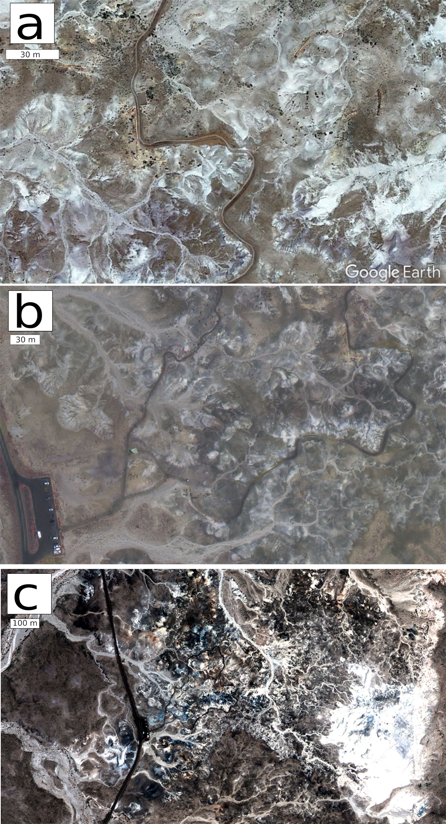
Supplementary figure S3. Comparison between a zoomed-in Google Earth image (A) and the full resolution of the satellite imagery in pansharpened multispectral (B) and the %R false color (C).

Ground correction
We used QGIS (version 2.18 and 3.2.3 Bonn) to correct the ground %R image according to the specific objects in the scene which were not relevant to our main goal. We filtered the image, masking vegetation and presence of anthropic artefacts. We used the Normalized Difference Vegetation Index (NDVI) to mask vegetation. Anthropic artefacts were removed manually.
The two obtained Boolean layers were aligned to the NDVI map and matched together within the QGIS environment, obtaining a unique boolean mask.
NDVI: The Normalized Difference Vegetation Index is a common and effective index that ranges between -1 and +1. It is calculated as the result of the difference between band 7 (NIR1) and band 5 (Red) over their sum. The obtained range of values is indicative of an increasing presence of vegetation. Emerson et al. (2015) applied the same index to the Eocene Great Divide Basin (Wyoming). They considered suitable for paleontological outcrops, i.e. with no vegetation coverage, only pixels with a NDVI value under 0.16. In our analysis, we obtained a NDVI range of 0.091 and 0.185 for the whole imagery. We accepted all values under 0.165 using the “raster calculator” tool in QGIS and the following rule:
(("NDVI@1"<0.165)*1+("NDVI@1 >= 0.165)*0)
Manual filter of anthropic artefacts: Anthropic artefacts were removed manually to maximize accuracy. They consisted of trails, cars, the road, parking lots, and the tourist information point. We created a vector shapefile, turned to a boolean raster with the same pixel size and limit of the NDVI layer.

Band Ratio
Random sampling of ground %R of fossils and sediments at the Crystal Forest suggests the main difference in the spectral signatures of the objects in the scene lies in the infrared and red bands. We analysed the variation of those bands performing ratios between the Red/NIR1 bands and the Blue/RedEdge bands (Fig. S4).
In the first attempt, higher values correspond to similar reflectance for band 5 and 7, pointing to anthropic artefacts and rough sediments, whereas low values indicate higher absorbance in the Red in comparison to NIR1, typical in vegetation and features related to water drainage.
The second comparison stresses differences on extreme bands, where clear and reworked sediments and trails have higher values for UV light (streambeds and erosional surfaces), and compact soil, vegetation, and fossil logs have higher response on the side of longwave light.
Results: In both cases, lower values pointed to the presence of petrified logs, but they were obliterated by vegetation and compact soil. Blue/RedEdge performed better for the detection of reddish fossils (shown in black on Fig. S4b) but the result is not impressive.
In summary, the ratio between bands is not informative for our purpose, because the values corresponding to fossilized logs do not diverge enough from other objects in the scene to allow us to unequivocally recognize them.

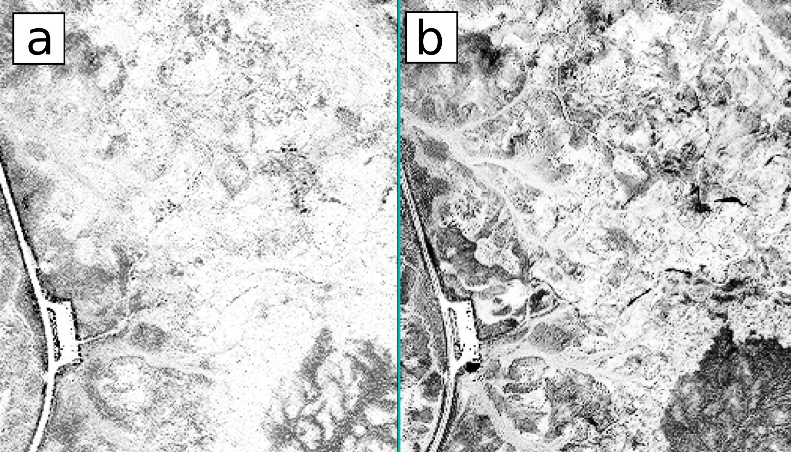
Supplementary figure 4. Red/NIR (a) and Blue/RedEdge band ratios (b) equalized of the Crystal Forest %R image. Grey scale pixels are increasing values for the ratio (minimum value in black, maximum value white).

Unsupervised classification
ISODATA: The Iterative Self-Organizing (ISODATA) classification is an unsupervised classification. We performed ISODATA on the %R imagery as an attempt to run a preliminary screening of the scene.
As with other unsupervised classification, ISODATA does not use trained regions to define the characteristics and the number of final classes; in particular, it calculates class means in the data space and it iteratively clusters the pixels in the scene using minimum distance approaches. The final number of clusters is flexible and adjusted automatically through the iterative process of classification, according to the standard deviation of class means (Abbas et al. 2016).
We forced the algorithm to classify at least three classes with an exaggerated maximum number of classes of 10. We fixed a change threshold at 5% of divergence with 1 standard deviation from the maximum class, and class distance was fixed to 5. 100 iterations were considered enough to reach the classification of the region. Each class was defined by a minimum of 1 pixel per group (4 square meters).
Results: The classification returned a chaotic image with three groups (plus the layer of unclassified pixels) after only 5 iterations (Fig. S5). In the resulting map, only the trail and the streambeds were homogeneously defined (in red and blue, respectively). None of the other features on the ground had been recognized. Therefore, we tested multiple sets of parameters, obtaining mostly the same results for the Crystal Forest; the algorithm did not return sufficient details on the ground, confusing coarse soil with the exposed fossil logs.

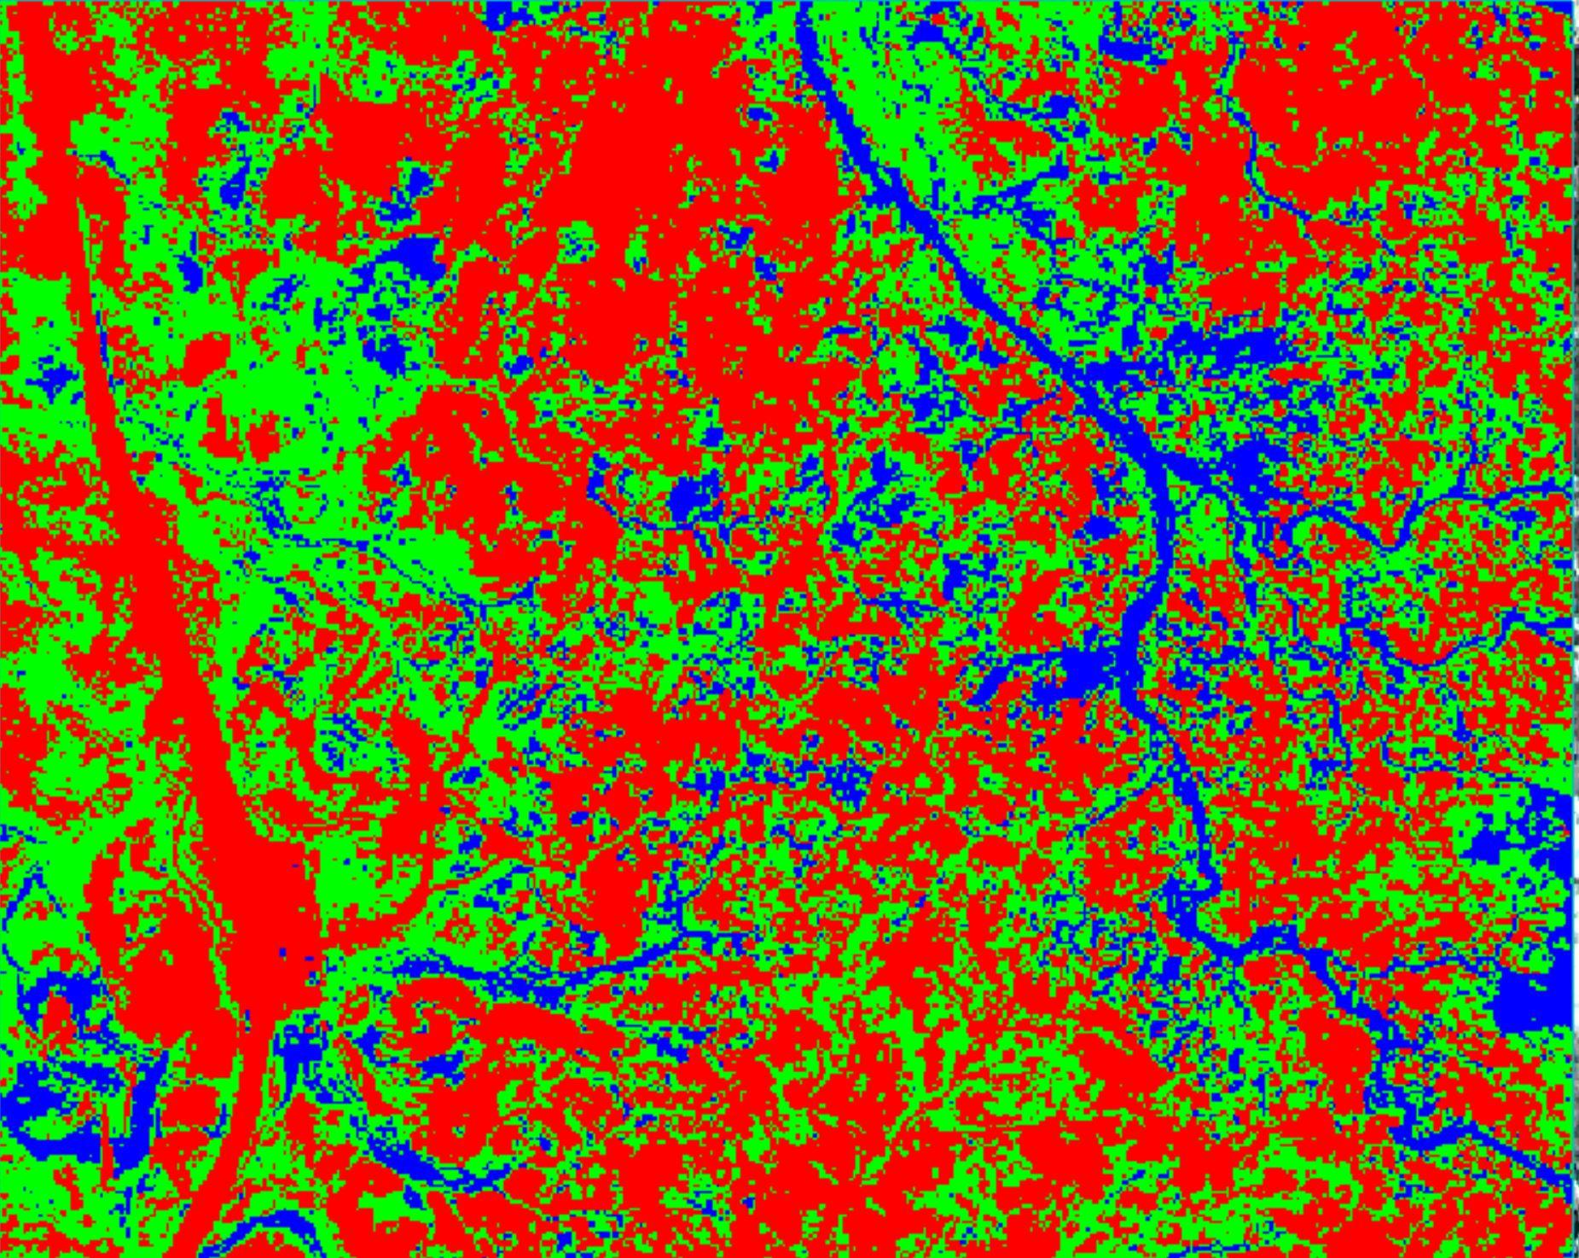
Supplemenary figure S5. ISODATA classification of the Crystal Forest.

Supervised Classification
All the supervised classifications tested here returned two maps, one corresponding to the clusters, the second consisting of a rule image, i.e. the probability of each pixel to match with the resulting class. The algorithm decides in which class a pixel will be included according to the highest value generated in the rule image for that class.
We selected 5 regions-of-interest (ROIs) to train the algorithm. They correspond to asphalt and trails (blue), un-reworked sediment (yellow), dry streambeds (green), red petrified logs (type-1 - light blue), and brownish petrified logs (type-2 - red). The latter two are our fossil target and they should correspond to almost all the fossil logs in the scene. The mean spectral signatures of ROIs plotted in Figure S6 shows that there is a strict similarity between type-1 fossil logs and un-reworked sediment, and between type-2 fossil logs and trails. This is an issue for the classification and it will affect the results of our analysis. Streambeds (in green) diverge enough from all the other ROIs to be clearly recognizable. Consequently, we expect a consistent classification of this group.

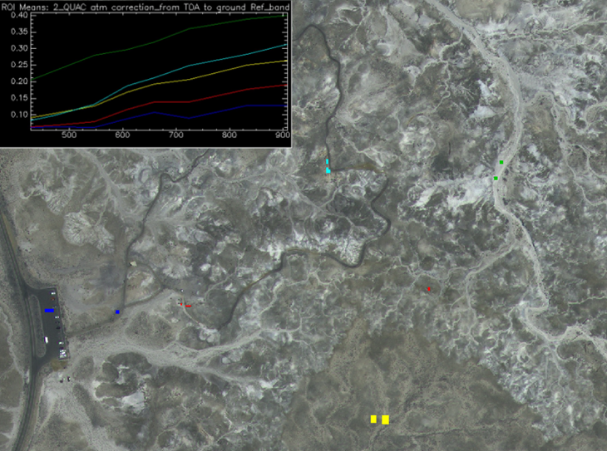
Supplementary figure S6. regions of interest (ROIs) used to train the supervised classification: Blue: anthropic path, yellow: coarse surfaces, green: streambed, light blue: type-1 fossil log (i.e. reddish logs), red: type-2 fossil logs (i.e. brownish logs)

Maximum likelihood classification: The ML calculates the probability a pixel belongs to one of the classes declared by the user using the discriminant function explained by Richards (1999). The ML assumes the values are normally distributed in both classes and bands. We did not declare a probability threshold, to obtain complete coverage of the images with classes.

SAM: We performed a Spectral Angle Mapper (SAM) classification (Kruse et al 1993) at the Chrystal Forest with a maximum angle (in radians) of 0.1. SAM works by reducing each spectral signature to a vector in an n-dimensional space where n is the number of considered bands, and then it compares the angle between that vector and the vectorized output obtained from the references in the ROIs (endmembers). The smaller the angle, the higher the probability that vector matches with the endmember (i.e. the pixel represents a %R value corresponding to a specific ROI). Being a non-metric analysis, it reduces the effect of difference in the illumination and albedo in the scene.

Control Map
US National Park law aims to protect and preserve the land for future generations. Therefore, permission for surveys off trail are restricted and difficult to obtain. The area we selected for our test area is known as the Crystal Forest and consists of a walkable trail surrounded by fossil logs open to visitors and easily mappable with a precise position of the fossil logs.
We mapped the fossil logs remotely, using high-resolution photos and street views available on Google Earth Pro and recently published on the web platform (May 2019) (Fig. S7a). We assumed that the position of the logs did not change between our reference images and the capture of our satellite imagery. The process required many hours of manual work, with obvious issues related to subjective misrecognition of logs and changes in ground resolution.
We populated a polygon shapefile with both fossil logs located next to the trail and the ones we recognized on the ground, for a total number of 325 polygons (our “control map”) (Fig. S7b).
The details shown in the Google Earth image allowed us to easily map the features that we considered the most plausible as petrified logs, being visible from the trail through street view or having an elongated shape on the easternmost part of the scene. We then used these georeferenced logs as our reference map for the evaluation of the accuracy of cluster analyses.
The vector layer was used as-is for the object matching verification, and it was converted to a raster layer (Fig. S7c) to verify the feasibility through a confusion matrix.

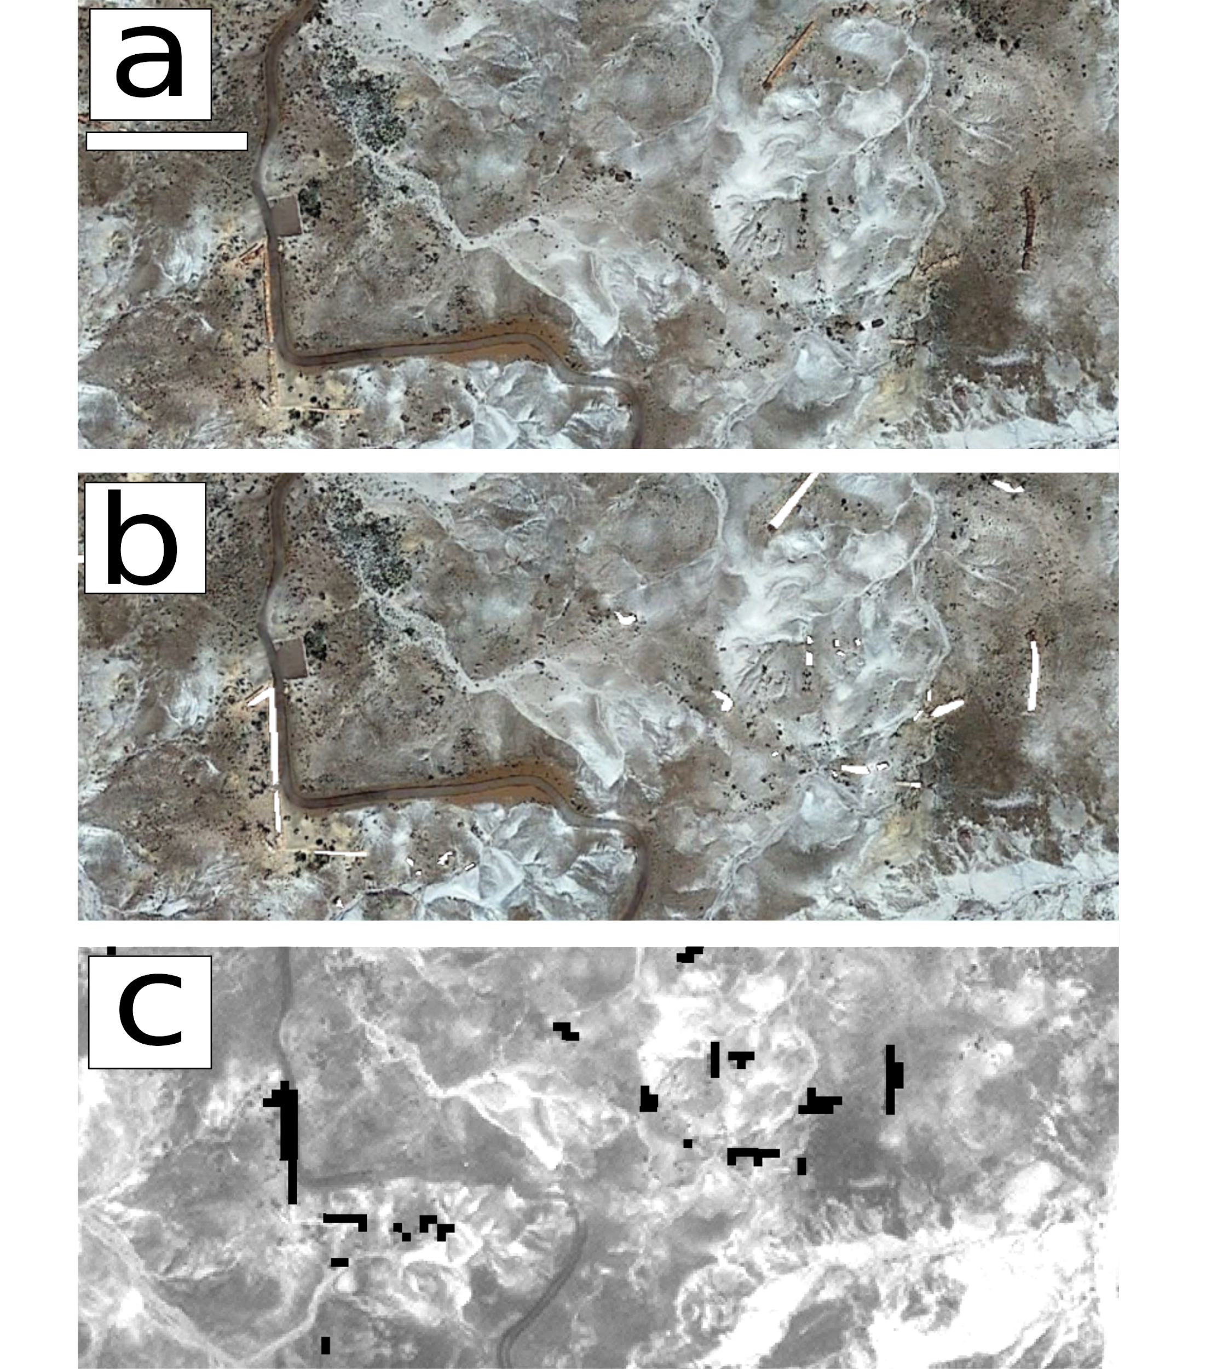
Supplementary figure S7. Zoom of a portion of the Crystal Forest trail showing distribution of recognized fossil logs next to the trail and randomly distributed on the eastern side of the scene (a), mapped creating a polygon shapefile (in white – (b)) and rasterized (in black – (c)). Misalignments are caused by different projections of the basemaps, i.e. Google Earth (WGS84 – (a) and (b)) and WV2 (UTM12 – (c)). Bar scale for all three images is approximately 30 m

Comparison of raster maps (see online Supplementary Material 2 at http://journals.cambridge.org/geo for statistics): We counted the number of matching pixels to create a confusion matrix between the control map and each estimated map of the presence of fossil logs, obtained with the ML and SAM classifications. We considered the estimated maps with type-1 and type-2 fossil logs together and separately.
The control map was rasterized (Fig. S7c), including in the new map only those polygons that were larger than 4 square meters (the limit of pixel resolution for the multispectral images – 2x2 meters).

Comparison of vector maps (see online Supplementary Material 2 at http://journals.cambridge.org/geo for statistics): We compared the estimated map inferred through the ML and SAM cluster classification for the type-1 and type2 fossil logs with the control map (Fig. S7b). We created vector layers out of the estimated maps, merging all the original features in each map into one polygon, to avoid duplications in the count of matching features. We created an incomplete confusion matrix where no polygons corresponded to the not-fossil log category in the control map (false positives are always 0) to compare the original number of estimated polygons (true positives + false negatives) to the matching (true positives).
The fossilized logs are large enough to be caught by a member of a hypothetical field crew walking in an area. Therefore, we tested our results using a conservative 2 m buffer zone around the polygons for each estimated map. As expected, we increased the number of matching objects in the layers, improving the positive output of our method.

References
Atmospheric Correction Module 2009. Atmospheric Correction Module: QUAC and FLAASH user’s guide, v. 4.7. ENVI - ITT visual information solution August 2009 edition: 3-44
ABBAS A.W., MINALLH N., AHMAD N., ABID S.A.R. & KHAN M.A.A. 2016. K-means and ISODATA clustering algorithms for landcover classification using remote sensing. Sindh University Research Journal (Science Series) 48(2), 315-318
BERNSTEIN, L. S., X. JIN, B. GREGOR & S. ADLER-GOLDEN 2012. Quick Atmospheric Correction Code: Algorithm Description and Recent Upgrades. Optical Engineering 51(11),111719-1 to 111719-11.
EMERSON C., BOMMERSBACH B., NACHMAN B. & ANEMONE R. 2015. An object-oriented approach to extracting productive fossil localities from remotely sensed imagery. Remote Sensing 7, 16555-16570
KRUSE, F. A., A. B. LEFKOFF, J. B. BOARDMAN, K. B. HEIDEBRECHT, A. T. SHAPIRO, P. J. BARLOON & A. F. H. GOETZ 1993. The Spectral Image Processing System (SIPS) - Interactive Visualization and Analysis of Imaging spectrometer Data. Remote Sensing of Environment 44, 145-163.
LABEN C.A. & BROWER B.V. 2000, Process for Enhancing the Spatial Resolution of Multispectral Imagery Using Pan-Sharpening. US Patent 6,011,875
RICHARDS J., 1999. Remote sensing digital image analysis. Berlin: Springer-Verlag 240 pp
SAINI V., TIWARI R.K. & GUPTA R.P. 2016. Comparison of FLAASH and QUAC atmospheric correction methods for Resourcesat-2 LISS-IV data. Proc. of SPIE, Earth Observing missions and sensors: development, implementation, and characterization IV, 9881, 9881V.
U.S. GEOLOGICAL SURVEY 2017. 1 meter Digital Elevation Models (DEMs) - USGS National Map 3DEP Downloadable Data Collection: U.S. Geological Survey.

