**Supplementary sheet**

**Supplementary figure 1:**

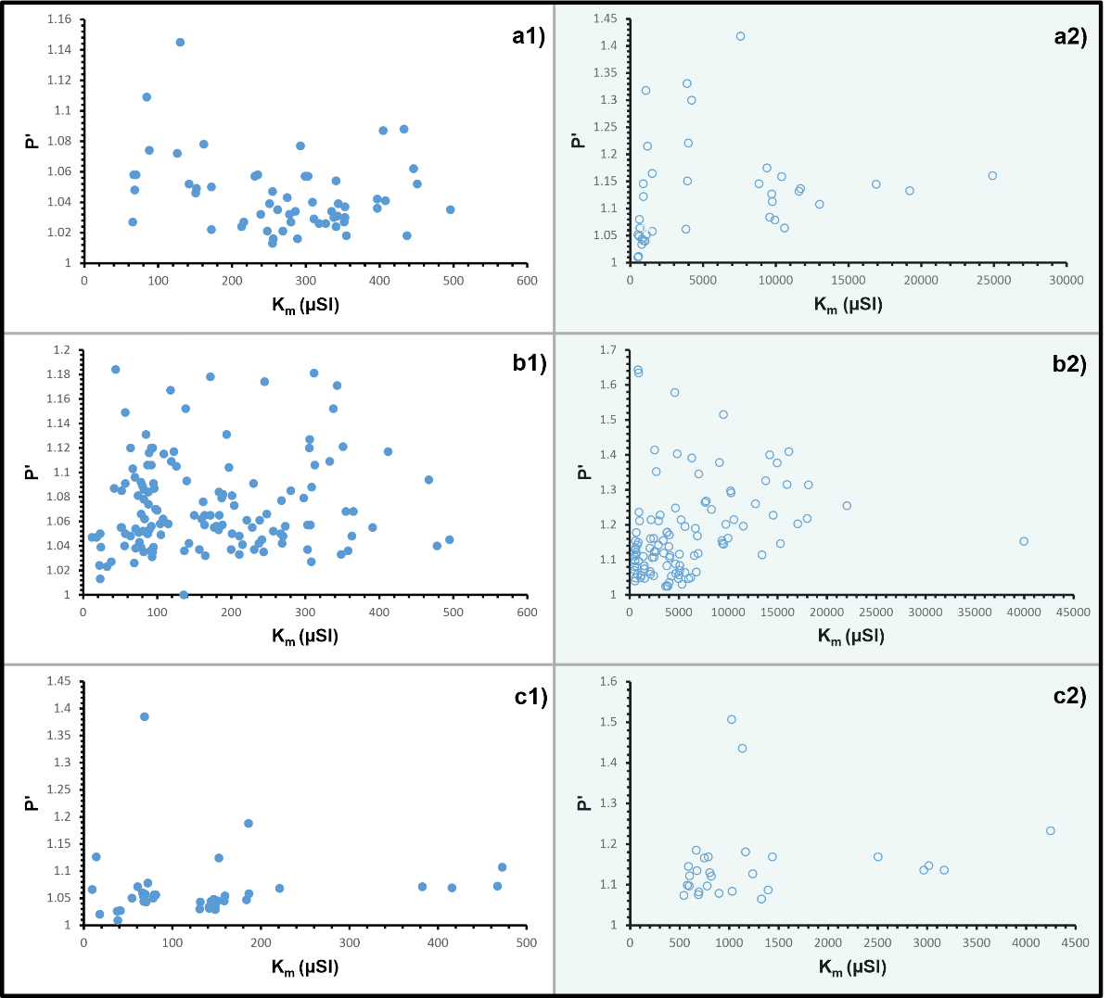

**Figure caption:** a, b, and c are the Jelinek (P’ vs Km) plots for the three granites (Malanjkhand domain-II, Godhra and Chitradurga (South), respectively) with substantial ferromagnetic character. a1, b1 and c1 are the scatterings for only paramagnetic, whereas a2, b2, and c2 (shaded region) represent ferromagnetic granites (please check the main manuscript for references of used data).

**Supplementary figure 2:**

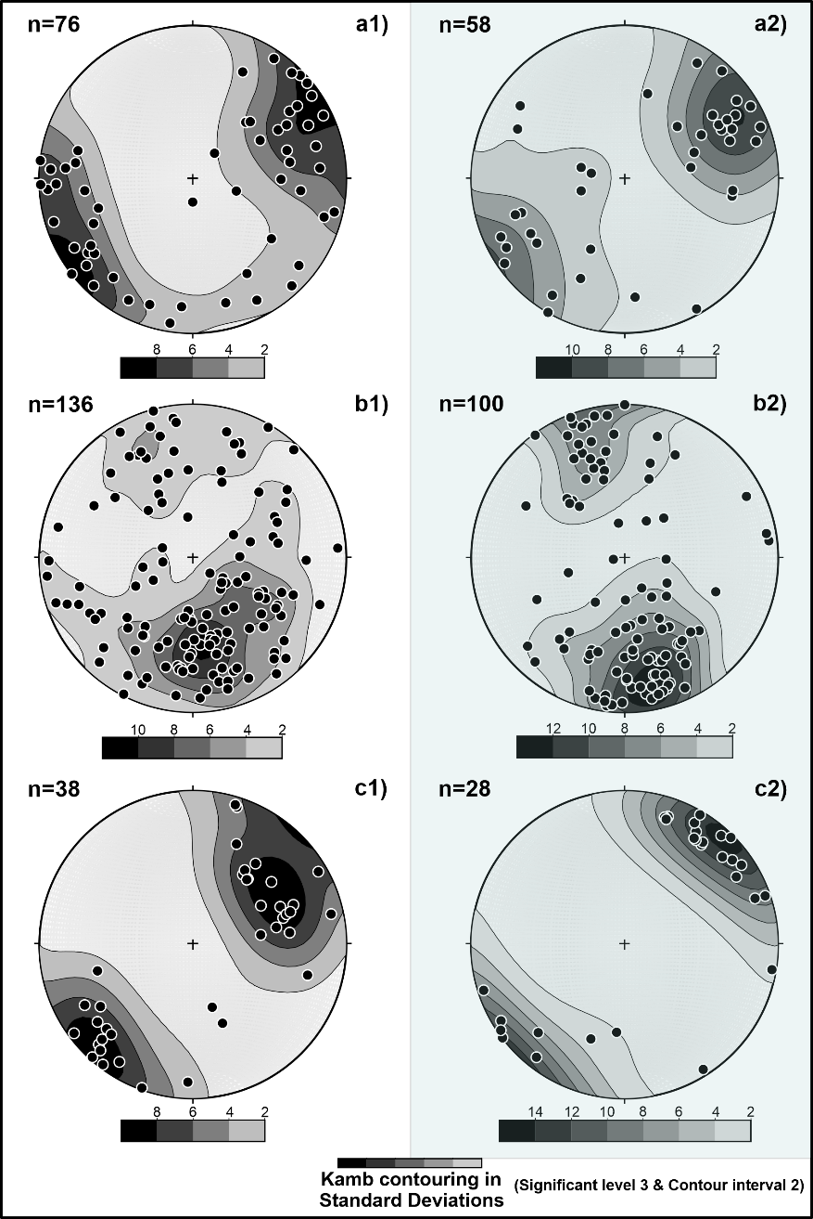

**Figure caption:** a, b, and c are contoured lower hemisphere equal area projections of pole to magnetic foliation (K3) for Malanjkhand domain-II, Godhra and Chitradurga (South), respectively. Shaded area (a2, b2, and c2) depicts the orientation of K3 in ferromagnetic granites, whilst a1, b1 and c1 indicate the cases of solely paramagnetic ones. The resemblance in contour patterns between paramagnetic and ferromagnetic granites may be noted for each of the three regions (please check the main manuscript for references of used data).