Geological Magazine

Joint inversion of tectonic stress and magma pressures using dyke trajectories
F. Maerten, L. Maerten, R. Plateaux & P. H. Cornard

Supplementary materials
All models in the manuscript can be visualized and used online following this link:
https://l.youwol.com/publications/2022-geol-mag-maerten

Supplementary 1

Validation against analytical solution
To validate the BEM method, we analyse the perturbed stress around a pressurized inclined cylinder subjected to an Andersonian far-field stress where the horizontal stress is anisotropic ($σ_{H}≠σ_{h}$). To do so, we use the analytical solution described by Fjaer et al. (2008, Ch. 4.3, p. 168), and presented below. As we use linear governing equations, the principle of superposition is used to sum the basic uncoupled loadings such as the external stresses and the pressure in the cylinder. This analytical solution is illustrated in Figure S1a, where the external principal stresses are represented by ($p_{x},p_{y},p_{z}$), and the pressure by $p_{w}$. The corresponding perturbed stress around the cylinder is described in terms of cylindrical polar coordinates as follow

$σ_{r}=\frac{σ_{xx}^{l}+σ_{yy}^{l}}{2}\left(1-\frac{a^{2}}{r^{2}}\right)+\left(1+3\frac{a^{4}}{r^{4}}-4\frac{a^{2}}{r^{2}}\right)\left(\frac{σ_{xx}^{l}-σ_{yy}^{l}}{2}\cos{2θ}+σ_{xy}^{l}\sin{2θ}\right)+p_{w}\frac{a^{2}}{r^{2}}$ (1.1)
$σ_{θ}=\frac{σ_{xx}^{l}+σ_{yy}^{l}}{2}\left(1+\frac{a^{2}}{r^{2}}\right)-\left(1+3\frac{a^{4}}{r^{4}}\right)\left(\frac{σ_{xx}^{l}-σ_{yy}^{l}}{2}\cos{2θ}+σ_{xy}^{l}\sin{2θ}\right)-p_{w}\frac{a^{2}}{r^{2}}$ (1.2)
$σ_{z}=σ_{zz}^{l}-4ν\frac{a^{2}}{r^{2}}\left[\frac{σ_{xx}^{l}-σ_{yy}^{l}}{2}\cos{2θ}+σ_{xy}^{l}\sin{2θ}\right]$ (1.3)
$σ_{rθ}=\left(1-3\frac{a^{4}}{r^{4}}+2\frac{a^{2}}{r^{2}}\right)\left(σ_{xy}^{l}\cos{2θ}+\frac{σ_{yy}^{l}-σ_{xx}^{l}}{2}sin{2θ}\right)$ (1.4)
$σ_{θz}=\left(1+\frac{a^{2}}{r^{2}}\right)\left(σ_{yz}^{l}\cos{2θ}-σ_{xz}^{l}sin{2θ}\right)$ (1.5)
$σ_{rz}=\left(1-\frac{a^{2}}{r^{2}}\right)\left(σ_{yz}^{l}\sin{2θ}+σ_{xz}^{l}\cos{2θ}\right)$ (1.6)
where
$\left\{\begin{matrix}\begin{matrix}σ_{xx}^{l}=l_{xx}^{2}p_{x}+l_{xy}^{2}p_{y}+l_{xz}^{2}p_{z} \\ σ_{yy}^{l}=l_{yx}^{2}p_{x}+l_{yy}^{2}p_{y}+l_{yz}^{2}p_{z}\end{matrix} \\ \begin{matrix}σ_{zz}^{l}=l_{zx}^{2}p_{x}+l_{zy}^{2}p_{y}+l_{zz}^{2}p_{z} \\ σ_{xy}^{l}=l_{xx}l_{yx}p_{x}+l_{xy}l_{yy}p_{y}+l_{xz}l_{yz}p_{z}\end{matrix} \\ \begin{matrix}σ_{yz}^{l}=l_{yx}l_{zx}p_{x}+l_{yy}l_{zy}p_{y}+l_{yz}l_{zz}p_{z} \\ σ_{xz}^{l}=l_{zx}l_{xx}p_{x}+l_{zy}l_{xy}p_{y}+l_{zz}l_{xz}p_{z}\end{matrix}\end{matrix}\right.$ (1.7)

and
$l=\left[\begin{matrix}\cos{α}\cos{β} & \sin{α\cos{β}} & -\sin{β} \\ -\sin{β} & \cos{α} & 0 \\ \cos{α}\cos{β} & \sin{α}\sin{β} & \cos{β}\end{matrix}\right]$ (1.8)
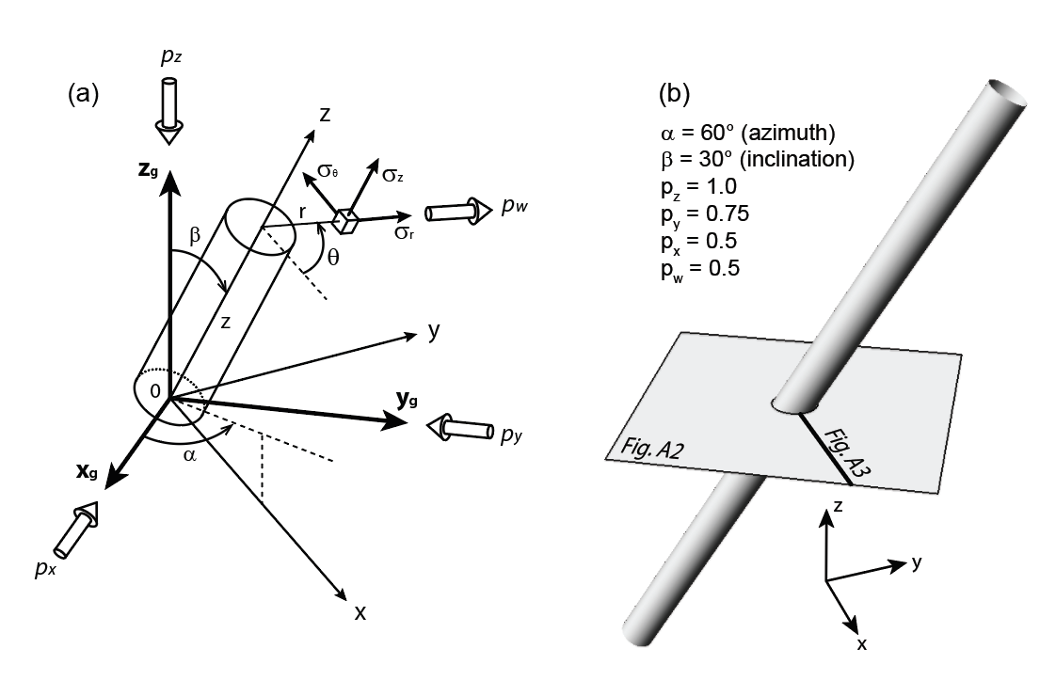
Figure S1. Comparison of analytical and BEM numerical model to validate the latter. (a) Illustration of the analytical solution, described by Fjaer et al. (2008) of a pressurized inclined cylindrical hole subjected to anisotropic far field stresses $(px,py,pz)$and an internal pressure (pw). (b) Configuration of the BEM model showing the inclined cylinder, as well as the 2D plane and 1D radial line, along which the models are compared in Figure S2 and S3.

For both the analytical and the BEM solutions, we impose a far field 3D stress field defined by normalized values $P_{z}=1 Pa$, $P_{y}=0.75 Pa$, $P_{x}=0.5 Pa$, an internal pressure $P_{w}=0.5 Pa$, a Young’s modulus of $1.0$ Pa and a Poisson’s ratio of $0.25$. The cylinder has a radius of $1$ m, a rotation about the $y_{g}$ axis or an inclination ($α$) of ${60}^{o}$ and a rotation about the $z_{g}$ axis or an azimuth ($β$) of ${30}^{o}$ (Fig. S1a). The 3D BEM model of the cylinder, the 2D observation grid and the 1D observation line are displayed in Figure S1b. First, we compare the component of the stress tensor $σ_{xx}$ computed on the 2D grid for both solutions (Fig. S2), which shows similar results for both solutions. The same good agreement between the two solutions is obtained for the other stress components computed along a line passing through the cylinder centre and aligned with the x-axis (Fig. S3) thus validating the use of pressurized discontinuities with BEM to model pressurized cavities.

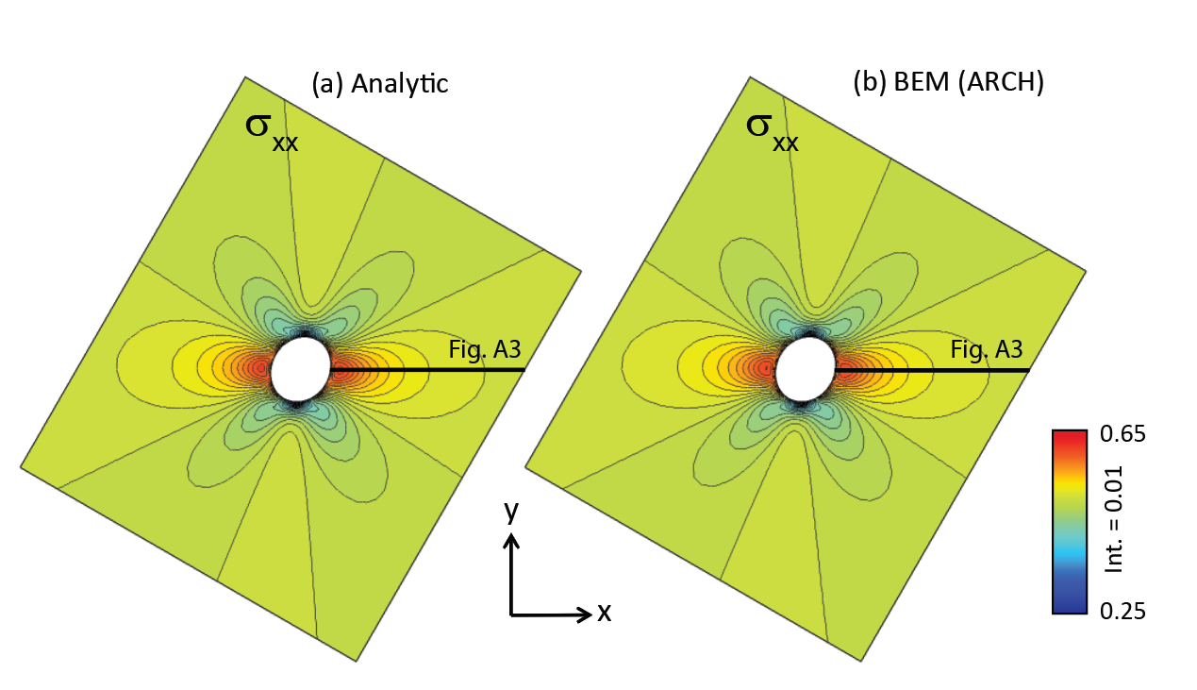
Figure S2. Comparison of σ_{xx} on the 2D plane shown in Figure S1, for a pressurized inclined cylindrical hole. (a) The analytical solution and (b) the BEM (ARCH) solution.

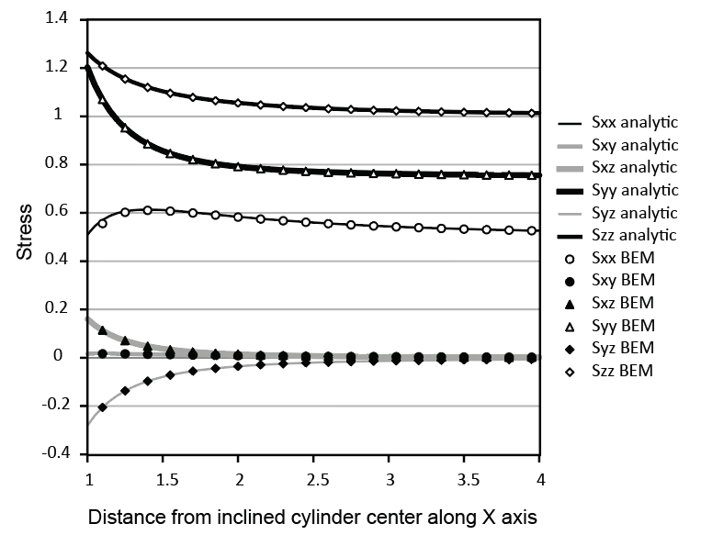
Figure S3. Different stresses calculated along the radial line shown in Figure S1 for both the analytical and the BEM (ARCH) solutions.

Supplementary 2

Algorithm: Fast computation of solution for one pressure
- Init: Compute and store the total stress, strain, and displacement fields at grid points for the eight (six for an Andersonian far field stress) initial simulations
- Input: user parameters $(φ,θ,ψ,R_{s},R_{v},ρ_{m}, p_{e})$ or $(θ,R_{s},R_{v},ρ_{m}, p_{e})$
- Compute: $α=\{σ_{xx},σ_{xy},σ_{xz},σ_{yy},σ_{yz},σ_{zz},ρ_{m}, p_{e}\}$ or $α=\{σ_{xx},σ_{xy},σ_{yy},σ_{zz},ρ_{m}, p_{e}\}$
- Get: The total stress, strain, and displacement fields at grid points by superposition
$\left\{\begin{matrix}σ_{p}=α_{i}σ_{P}^{i} \\ ϵ_{p}=α_{i}ϵ_{P}^{i} \\ u_{p}=α_{i}u_{P}^{i}\end{matrix}\right.$

Supplementary 3

Defining multiple pressures and excess pressures
Consider the inversion of $n≥2$ pressurized magma chambers where each magma chamber has its own excess pressure. In such a case, it is necessary to increase the number of initial simulations by $2n$ if we assume that the pressure (given by the magma density) and the excess pressure are unknowns. In the following, the effect of a unit pressure and excess pressure from a magma chamber $D_{j}$ on the total stress at one observation point $P$ will be used for the description and will be noted $π_{p}^{j}$ and ${\underline{π}}_{p}^{j}$, respectively.

The effect of $n$ pressurized magma chambers is determined as a weighted sum of $π_{p}^{j}$ and ${\underline{π}}_{p}^{j}$, for which the weights represent the effect of different pressure (or magma density) and excess pressure from the $n$ magma chambers. Parameters $α$, initially of size $\left(6+2\right)=8$ for one pressurized magma chamber, are increased consequently to $(6+2n)$, and the total stress at $P$ is given by

$σ_{p}=\sum_{i=1}^{6}{α_{i}σ_{p}^{i}} + \sum_{j=1}^{n}{\left(α_{2j+5}{\underline{π}}_{p}^{j}+α_{2j+6}π_{p}^{j}\right)}$ (3.1)

The first sum in Equation 3.1 represents the effect of the tectonic loading on $σ_{P}$, while the second part represents the effect of the $n$ pressured magma chambers on $σ_{P}$. Specifically, $α_{2j+5}$ represents the excess pressure effect from magma chamber $D_{j}$ to $σ_{P}$, and $α_{2j+6}$ the pressure gradient effect. As the pressure gradient already incorporates the depth effect, the total pressure at $P$ is $\left(α_{2j+5}{\underline{π}}_{p}^{j}+α_{2j+6}π_{p}^{j}\right)$. Note that if one supposes that all magma chambers have the same pressure and excess pressure (n= 1), then $α$ is of size 8. Furthermore, if one assumes an Andersonian stress regime, then $α$ is of size 6 (components $σ_{xz}$ and $σ_{yz}$ of the stress tensor are zero).

By changing the values of $α_{i}$ for $i∈[1,6]$, we implicitly change the far field stress applied to the model and consequently we modify the total stress at $P$. Similarly, by changing the values of $α_{i}$ for $i∈[7, 6+2n]$, we adjust the total pressure, $p_{m}$, for each magma chamber, which in turn directly affects the total stress at $P$. It is important to remember that the $n$ initial pressure simulations are performed without any far field stress. For each of them, two simulations are performed: one with an excess pressure of 1 and a density of 0, the other with an excess pressure of 0 and a density of 1. It is also worth mentioning that while using magma chambers as discontinuities with traction boundary conditions in the three directions, it is also possible to incorporate active fault surfaces as discontinuities. These faults can be set to freely slip in response to the applied far-field stress and the pressurized magma chambers, and they do not add extra unknowns. However, as we use the principal of superposition, i.e., a linear combination of initial simulations, frictional faults or any other type of inequality constraints cannot be used (Maerten et al., 2010b), except if they are linearly approximated.

Supplementary 4

All the simulations are run on a portable computer MacBook Pro M1 Pro, 16Go RAM, 10 cores (8 performance + 2 efficacity).
We use the 10 cores for the parallel computations for both the forward modelling and the Monte Carlo inversion. Note that the HMatrix optimization (Maerten, 2010b) is not yet re-implemented in ARCH and will drastically reduce the computation time for the forward modelling (see Galapagos below).
Nb DOF represents the number of degrees of freedom of the model. This is typically three times the number of triangular elements making the discontinuities (magma chambers and active faults if any). This nb DOF represents the size of the dense system matrix to construct.
Nb dykes represents the number of data to constrain the inversion.

Performances for Spanish Peak:
- Nb dykes: 1,024
- Nb DOF: 3,168
- 6 forward simulations for the superposition: 2s in parallel
- 30,000 simulations for the inversion (Mont Carlo): 5s in parallel

Performances for Galapagos:
- Nb dykes: 2,783
- Nb DOF: 26,880
- 12 forward simulations for the superposition: 12mn in parallel
- 30,000 simulations for the inversion (Mont Carlo): 22s in parallel

