Geological Magazine
The origin of Patagonia: insights from Permian to Middle Triassic magmatism of the North Patagonian Massif
Falco, Hauser, Sicvetti, Reimold, Folguera
Description of basin stratigraphy and petrography of the sampled rocks, together with a detailed description of the U-Pb and Lu-Hf methods.

1. Material and Methods
1.a. Log and sample description
The main characteristics of the rocks analyzed in this study are described below. Further descriptions of the stratigraphy, basin arrangement and petrography of the sampled layers were published in Falco et al. (2020). Field and microscope photos are shown here with permission of the Revista de la Asociación Geologica Argentina, as they were initially published in Falco et al. (2020).
1.a.1. The H. Álvarez log
A light-grey ignimbrite, matrix-supported with high-crystal concentration, is recognized at the bottom of this log, which belongs to the La Esperanza Complex. The crystals are quartz, biotite, K-feldspar, and plagioclase, and they are strongly fragmented. Pumice is scarce and barely flattened, subrounded, and seemingly weathered. Lithic clasts are derived from ignimbrite and lava; they are smaller than pumice fragments and strongly weathered. Glass in the matrix is devitrified to spherulites, and glass shards show pectinate texture; microcrystals of quartz are also present in the matrix. Sample PM3 was collected from the top of this layer (Fig. 1).
The second ignimbrite, from where sample PM4 was collected, occurs on top of a 1 m thick, massive ash-fall deposit (El Pilquin Member). This ignimbrite does not form a continuous stratum. The best exposures are found in small quarries north of Puesto H. Álvarez (Fig. 1). The ignimbrite is light-red and contains quartz, K-feldspar, plagioclase, and biotite crystals, some of which are strongly fragmented. Welded and subrounded, devitrified pumice is common. Lithic clasts are derived from lava and ignimbrite; occasionally, ignimbrite clasts exceed lapilli size. Clasts are partially fresh, angular, and show devitrification textures. At the top of the ignimbrite of sample PM3, a 10° angular unconformity was recognized (Fig. 1), which is interpreted as marking the western boundary of the LMB (Falco et al. 2020).

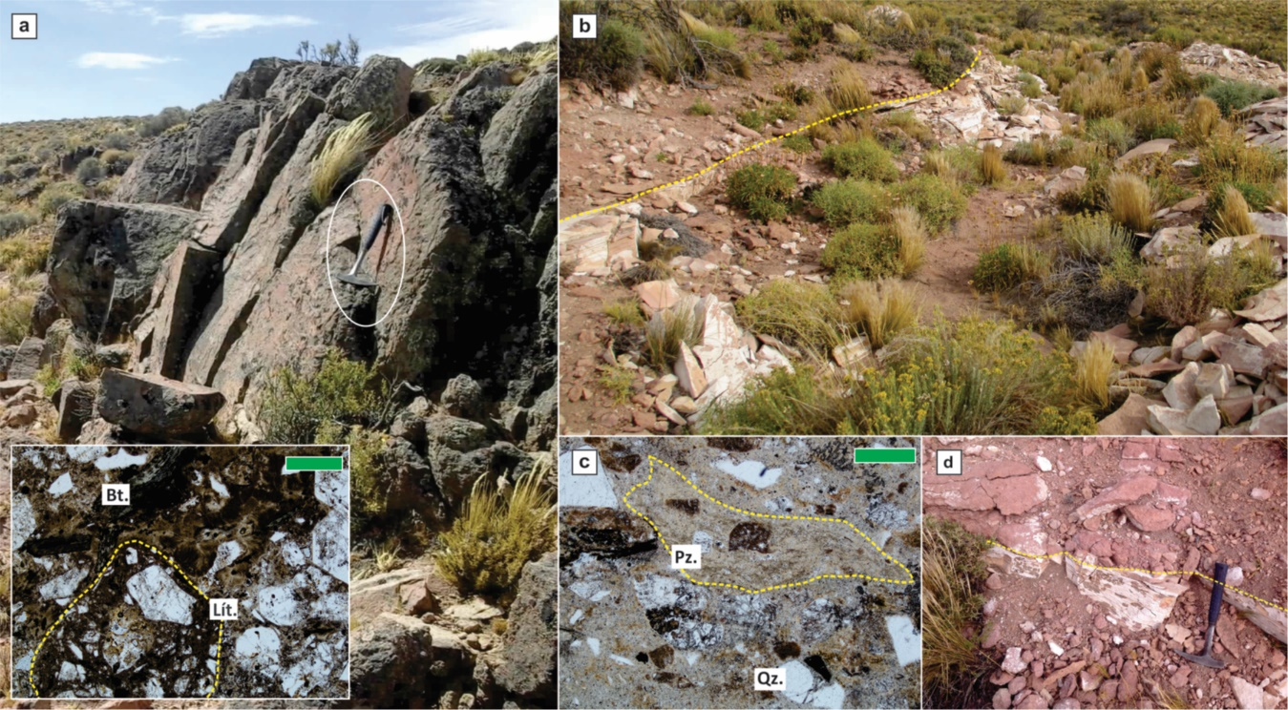
Figure 1. Field and microscope photos of the ignimbric layers where sample PM3 (a) and PM4 (b-d) were collected, in the H. Álvarez log. (a) general view of outcrops close to the Puesto H. Álvarez, the inset shows petrographic details of this deposit. (b) Photo of the quarry where the ignimbrite layer of sample PM4 is better exposed, the yellow dashed line (also in d) delimits the lower El Pilquin Member and the sampled deposit that belongs to the Sierra Colorada Formation. (c) Petrographic details of the Sample PM4. Bt: biotite, Lít: lithic fragment, Pz: pumice clast, Qz: quartz. Green scale bar: 500 µm.

1.a.2. The Tscherig Log
Above 25 m of alternating laminated mudstone and massive sandstone of the Cerro La Laja Member occurs the first massive to poorly stratified ignimbrite of this log; this ignimbrite belongs to the Barrancas Grandes Member (Fig. 3). The rock is matrix-supported and composed of strongly fragmented crystals and glass shards. While the lower part of this ignimibrite shows variations from massive to stratified facies, the upper section has well-developed columnar jointing. Moderately fragmented crystals are quartz, biotite, K-feldspar, and plagioclase. Pumice and glass shards show devitrification textures of pectinate or spherulitic types. Sample NH17 was collected from the upper part of this deposit (Fig. 3). Above this ignimbrite, El Pilquin Member (Puesto Vera Formation) occurs with a thickness of up to 1 m. The upper, dark-red, massive ignimbrite belongs to the Sierra Colorada Formation, and sample NH2 was collected from it (Fig. 3). Crystal fragments are composed of quartz, biotite, plagioclase, K-feldspar, and hornblende. Lithic clasts are derived from ignimbrite, appear fresh, have sub-angular shape and lapilli size, and pumice is intensely flattened. The glass of the matrix shows intense welding and devitrification textures, and shows perlitic fractures and/or spherulites (Fig. 3).

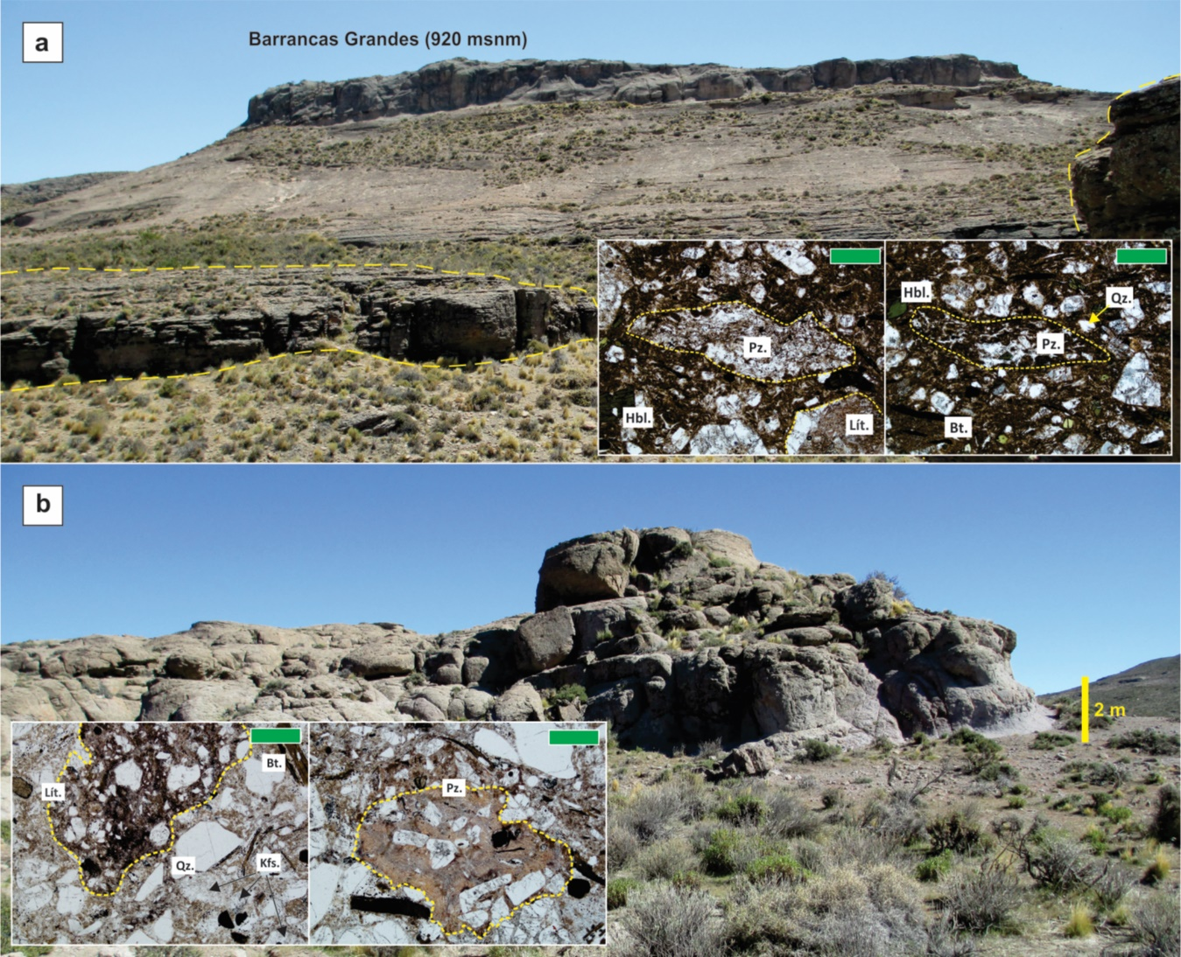
Figure 2. Field and microscope photos of the ignimbric layers where sample NH17 was collected in the Tscherig log. (a) Photo of the ignimbritic outcrop of the Barrancas Grandes locality, where the homonymous Barrancas Grandes Member was described and sample NH17 was collected. (b) Photo of the Barrancas Grandes Member to the north of the Los Menucos basin. Bt: biotite, Lít: lithic fragment, Pz: pumice clast, Qz: quartz, Kfs: k-feldspar, Hbl: horblende. Green scale bar: 500 µm.

1.a.3. The Vera Log
The log starts with a massive to poorly stratified ignimbrite body, which was assigned to the Barrancas Grandes Member. This ignimbrite has textural similarities to the lower ignimbrite of the Tscherig Log and was interpreted as correlative layers (Labudia & Bjerg, 2001; Falco et al., 2020). The last ignimbrite at the top of this log is the uppermost layer of the LMB. It is a light-brown ignimbrite with a variable thickness of up to 70 m at Puesto Paranao (Fig. 4). For this area, Luppo et al. (2018) obtained a U-Pb (SHRIMP) concordia age of 248.3 ± 1.6 Ma. Crystals are strongly fragmented and composed of quartz, K-feldspar, plagioclase, biotite, and hornblende. Lithic clasts are derived from ignimbrites and lavas; the former is strongly devitrified, and the latter has a subrounded shape and is strongly weathered. The fabric is matrix-supported, and the matrix is composed of devitrified glass shards and quartz. Sample PV1 was collected from the top of this log (Fig. 4).

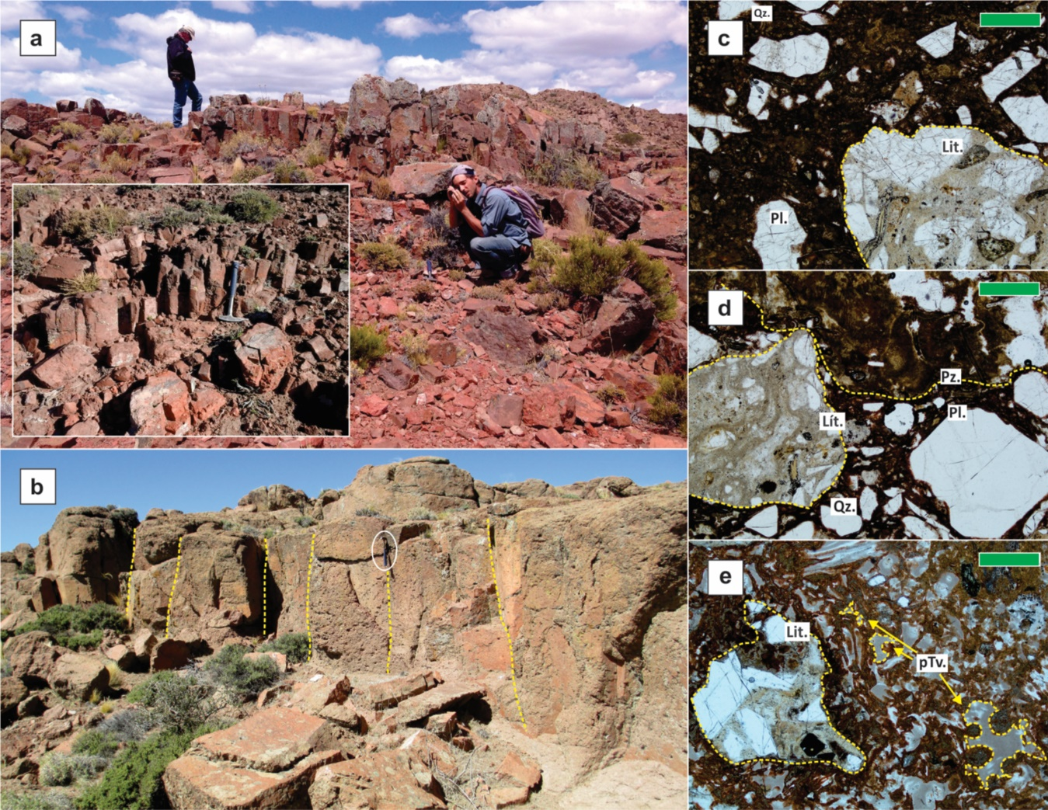
Figure 3. Field and microscope photos of the ignimbric layer where sample NH2 was collected, belonging to the Sierra Colorada Formation. Photo of the ignimbritic outcrop in the Puesto Vera (a) and in the Puesto Parano localites. (c) Petrographic detail of the same outcrop where sample NH2 was collected, (d-e) photos of the same layer but in the Paranao and Vera localities, respectively. Bt: biotite, Lít: lithic fragment, Pz: pumice clast, Qz: quartz, Kfs: k-feldspar, Hbl: horblende, Pl: plagioclase. Green scale bar: 500 µm.

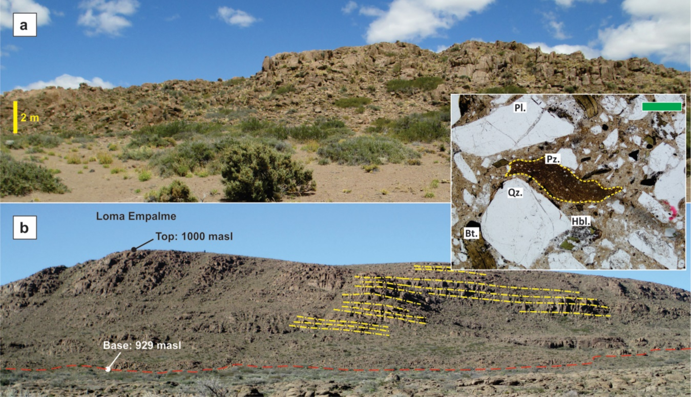
Figure 4. Field and microscope photos of the ignimbric layer where sample PV1 was collected, belonging to the upper part of the Sierra Colorada Formation. Photo of the ignimbritic outcrop in the Puesto Vera (a) and in the Puesto Parano localites. The inset shows the petrographic detail of the same outcrop where sample PV1 was collected. Bt: biotite, Pz: pumice clast, Hbl: horblende, Pl: plagioclase. Green scale bar: 500 µm.

2. Analytical Methods
Zircon concentrates were extracted from 5 kg samples of ignimbrite. The procedure included: crushing/grinding, sieving at different sizes (100 to 400 µm), gravimetric and magnetic separation. After separation, the grains were placed on a glass slide and then cast into an epoxy mount, polished to approximately half-thickness, and the polished surfaces were characterized by BSE and cathodoluminescence (CL) imaging using a FEI QUANTA 450 scanning electron microscope (SEM) - all at the Laboratory of Geochronology and Isotope geochemistry of the University of Brasilia, Brazil.
U-Pb and Lu-Hf isotope analyses on zircon were performed using a Thermo-Fisher Neptune MC-ICP-MS coupled with an Nd:YAG UP213 New Wave laser ablation system, at the same Laboratory. The U-Pb analyses were carried out by the standard-sample bracketing method (Albarède et al., 2004) using the GJ-1 standard zircon (Jackson et al., 2004) in order to quantify the amount of ICP-MS fractionation. Tuned masses were 238, 207, 206, 204 and 202. The integration time was 1 second, and the ablation time was 40 seconds. A 25 μm spot size was used, and the laser setting was 10 Hz and 2-3 J/cm2. Two to four unknown grains were analyzed between GJ-1 analyses. The ²⁰⁶Pb/²⁰⁷Pb and ²⁰⁶Pb/²³⁸U ratios were time corrected. On smaller zircon crystals (about 50 μm), single-spot laser-induced fractionation of the ²⁰⁶Pb/²³⁸U ratio was corrected using the linear regression method (Košler et al., 2002). The raw data were processed off-line and reduced using an Excel worksheet (Bühn et al., 2009). During analytical sessions, the zircon standard 91500 (Wiedenbeck et al., 2004) was also analyzed as an unknown.
Common ²⁰⁴Pb was monitored using the ²⁰²Hg and (²⁰⁴Hg+²⁰⁴Pb) masses. Common Pb corrections were not done due to very low signals for ²⁰⁴Pb (< 30 cps) and high ²⁰⁶Pb/²⁰⁴Pb ratios. Reported errors are propagated by quadratic addition [(2SD^2+2SE^2)1/2] (SD = standard deviation; SE = standard error) of external reproducibility and within-run precision. External reproducibility is represented by the standard deviation obtained from repeated analyses (n = 20, ~1.1 % for ²⁰⁷Pb/²⁰⁶Pb and up to ~2 % for ²⁰⁶Pb/²³⁸U) of the GJ-1 zircon standard during the analytical sessions, and the within-run precision is the standard error calculated for each analysis. Concordia diagrams (2σ error ellipses) and weighted average ages were calculated using the Isoplot-3/Ex software (Ludwig, 2003).
Zircon crystals previously analyzed for U-Pb isotopes and that show concordance of ²⁰⁶Pb/²³⁸U and ²⁰⁷Pb/²³⁵U ages between 90 and 110% were selected for Lu-Hf analysis. Before the Hf isotope measurements, replicate analyses of a 200 ppb Hf JMC 475 standard solution doped with Yb (Yb/Hf=0.02) were carried out (¹⁷⁶Hf/¹⁷⁷Hf=0.282162±13 2s, n = 4). During analytical sessions, replicate analyses of the GJ-1 standard zircon were executed, obtaining an average ¹⁷⁶Hf/¹⁷⁷Hf ratio of 0.282006±16 (2σ; n = 25), which is in good agreement with the reference value for the GJ standard zircon by Morel et al. (2008). Lu-Hf isotope data were collected over 40-50 seconds of ablation time and using a 40-50 μm spot size. Measurement spots were carefully positioned in the same growth area but not onto the same spot previously analyzed for U-Pb isotopes. The signals of the interference-free isotopes ¹⁷¹Yb, ¹⁷³Yb and ¹⁷⁵Lu were monitored during analysis in order to correct for isobaric interferences of ¹⁷⁶Yb and ¹⁷⁶Lu on the ¹⁷⁶Hf signal. The ¹⁷⁶Yb and ¹⁷⁶Lu contributions were calculated using the isotope abundance of Lu and Hf proposed by Chu et al. (2002). Contemporaneous measurement of ¹⁷¹Yb and ¹⁷³Yb provides a method to correct for mass-bias of Yb using a ¹⁷³Yb/¹⁷¹Yb normalization factor of 1.132685 (Chu et al., 2002). The Hf isotope ratios were normalized to ¹⁷⁹Hf/¹⁷⁷Hf of 0.7325 (Patchett, 1983).
Values for Hf(T) were calculated using the decay constant λ = 1.865x10⁻¹¹ year⁻¹ proposed by Scherer et al. (2006) and the ¹⁷⁶Lu/¹⁷⁷Hf and ¹⁷⁶Hf/¹⁷⁷Hf _{CHUR} values of 0.0332 and 0.282772 proposed by Blichert-Toft and Albarède (1997). Two-stage model ages (T_{DM}) were calculated from the zircon's initial Hf isotope composition, using an average crustal Lu/Hf ratio (Nebel et al., 2007; Gerdes and Zeh, 2009). The values of ¹⁷⁶Lu/¹⁷⁷Hf = 0.0384 and ¹⁷⁶Hf/¹⁷⁷Hf = 0.28325 were used for depleted mantle (Chauvel & Blichert-Toft, 2001), and ¹⁷⁶Lu/¹⁷⁷Hf = 0.0113 for average crust (Taylor & McLennan, 1985; Wedepohl, 1995).
The initial Hf composition of zircon represents the ¹⁷⁶Hf/¹⁷⁷Hf value calculated for the time of zircon crystallization. For concordant to nearly concordant analyses, the ²⁰⁶Pb/²³⁸U and ²⁰⁷Pb/²⁰⁶Pb ages were used for the recalculation of Hf isotope compositions at <1 Ga and >1 Ga grains, respectively. For more information, see Matteini et al. (2010).

References
ALBARÈDE, F., TELOUK, S. BLICHERT-TOFT, J., BOYET, M., AGRANIER, A. & NELSON, B. 2004. Precise and accurate isotopic measurements using multiple-collector ICPMS. Geochimica et Cosmochimica Acta 68, 2725-2744.
BLICHERT-TOFT, J. & ALBARÈDE, F., 1997. The Lu-Hf isotope geochemistry of chondrites and the evolution of the mantle-crust system. Earth and Planetary Science Letters 148(1-2), 243-258.
BÜHN, B., PIMENTEL, M.M., MTTEINI, M. & DANTAS, E. 2009. High spatial resolution analysis of Pb and U isotopes for geochronology by laser ablation multi-collector inductively coupled plasma mass spectrometry (LA-MC-ICPMS). Anais da Academia Brasileira de Ciências 81, 99-114.
CHAUVEL, C. & BLICHERT-TOFT, J.E. 2001. A hafnium isotope and trace element perspective on melting of the depleted mantle. Earth and Planetary Science Letters 190, 137-151.
CHU, N.C., TAYLOR, R.N., CHAVAGNAC, V., NESBITT, R.W., BOELLA, R.M., MILTON, J.A., GERMAN, C.R., BAYON, G. & BURTON, K. 2002. Hf isotope ratio analysis using multicollector inductively coupled plasma mass spectrometry: an evaluation of isobaric interference corrections. Journal of Analytical Atomic Spectrometry 17, 1567-1574.
FALCO, J.I., BODNAR, J. & DEL RÍO, D. 2020. Revisión Estratigráfica del Grupo Los Menucos, Pérmico tardío - Triásico temprano del Macizo Nordpatagónico, Prov. de Río Negro, Argentina. Revista de la Asociación Geológica Argentina 77(4), 532-555.
GERDES, A. & ZEH, A. 2009. Zircon formation versus zircon alteration - New insights from combined U–Pb and Lu–Hf in-situ LA-ICP-MS analyses, and consequences for the interpretation of Archean zircon from the Central Zone of the Limpopo Belt. Chemical Geology 261, 230-243.
JACKSON, S.E., PEARSON, N.J., GRIFFINA, W.L. & BELOUSOVA, E.A. 2004. The application of laser ablation-inductively coupled plasma-mass spectrometry to in situ U–Pb zircon geochronology. Chemical Geology 211, 47-69.
KOSLER, J., FONNELAND, H., SYLVESTER, P., TUBRETT, M. & PEDERSEN, R. 2002. U–Pb dating of detrital zircons for sediment provenance studies - a comparison of laser ablation ICPMS and SIMS techniques. Chemical Geology 2-4, 605-618.
LUDWIG, K.R. 2003. User's Manual for Isoplot/Ex V. 3.0, a Geochronological Toolkit for Microsoft Excel. Berkley Geochronology Center, Berkeley, CA Special Publication No. 4.
MATTEINI, M., DANTAS, E., PIMENTEL, M. & BÜHN, B. 2010. Combined U-Pb and Lu-Hf isotope analyses by laser ablation MC-ICP-MS: methodology and applications. Annals of the Brazilian Academy of Science 82(2), 479-491.
NEBEL, O., NEBEL-JACOBSEN, Y., MEZGER, K. & BERNDT, J. 2007. Initial Hf isotope compositions in magmatic zircon from early Proterozoic rocks from the Gawler Craton, Australia: A test for zircon model ages. Chemical Geology 241, 23-37.
PATCHETT, P.J. 1983. Importance of the Lu–Hf isotopic system in studies of planetary chronology and chemical evolution. Geochimica and Cosmochimica Acta 47, 81-89.
TAYLOR, S.R. & MCLENNAN, S.M. 1985. The Continental Crust: its Composition and Evolution. Blackwell Scientific Publications, Oxford, United Kingdom.
WEDEPHOL, K.H. 1995. The compositions of the continental crust. Geochimica et Cosmochimica Acta 59, 1217-1232.
WIEDENBECK, M.P., HANCHAR, J.M., PECK, W.H., SYLVESTER, P., VALLEY, J., WHITEHOUSE, M., KRONZ, A., MORISHITA, Y., NASDALA, L., FIEBIG, J., FRANCHI, I., GIRARD, J-P., GREENWOOD, R.C., HINTON, R., KITA, N., MASON, P.R.D., NORMAN, M., OGASAWARA, M., PICCOLI, P.M., RHEDE, D., SATOH, H., SCHULZ-DOBRICK, B., SSKAR, O., SPICUZZA, M.J., TERADA, K., TINDLE, A., TOGASHI, S., VENNEMANN, T., XIE, Q., ZHENG, Y-F., 2004. Further characterisation of the 91500 zircon crystal. Geostandards and Geoanalytical Research 28, 9–39.

