Geological Magazine
How sensitive intraplate inherited structures are? Insight from the Cevennes Fault System (Languedoc, SE France)

Oriane Parizot*¹, Yves Missenard¹, Jocelyn Barbarand¹, Thomas Blaise¹, Antonio Benedicto¹, Frederic Haurine¹, Philippe Sarda¹
¹Université Paris-Saclay, CNRS, GEOPS, 91405, Orsay, France.

Supplementary Material

SAMPLE COLLECTION AND PREPARATION
54 fault-related calcites were sampled focusing on “simple” objects: the faults are decimetric to metric, affecting the same formation, and have only played once. Indeed, the majority of the slickensides present on these faults are all parallels, which allows us to analyze single-phase calcites that have not undergone dissolution-recrystallization.
25% of the initial samples (13/54 samples) were datable by LA-ICPMS U-Pb geochronology. Unsuccessful samples consist of calcite with low uranium concentration and/or high common lead content. The characteristics of each sample are presented in Table 1.
Calcites were observed from polished samples using a cathodoluminescence microscope (an Olympus BX41 microscope coupled to a Cathodyne cold-cathode catholuminescence (NewTec, Nîmes, France) operating at 10 kV and 200-300 µA with an exposition time of 5 or 10 seconds (described in the Figure S1), and a Qicam Fast 1394 digital camera (TELEDYNE QIMAGING, Surrey, Canada) (Figure S1). In cathodoluminescence microscopy (CL), calcite crystals show relatively homogeneous luminescence without growth zonation. The color appears to be specific to the outcrop: samples SB-1 to 4 have colors ranging from red to bright yellow (Figure S1). Samples GD-1 to 3 have highly luminescent and samples PB-1 and 2 are weakly luminescent (orange). Samples SL-1 and 2 have a similar luminescence to samples SB-1 to 4 (from red to bright yellow, Figure S1). In contrast, samples SL-3 and DM-1 have a weakly luminescent, like samples PB-1 and 2. Areas where calcite crystals were not milky white or clear white-grey in reflected light were excluded. They generally correspond to the edges of the samples, and often show a color variation in CL in comparison with the determined ablation areas.

N° sample | GPS coordinates (geographical reference) | Host rock |  | Fault |  |  | Calcite
 |  | Lithology | Stratigraphy | Kinematics | Present-Day Orientation | Illustration | U-Pb Age
SB-1 | 43.901718° N  3.742944° E (Saint-Bauzille-de-Putois) | Limestone | Malm | Dextral | N78°-84°NO-p58°NE | 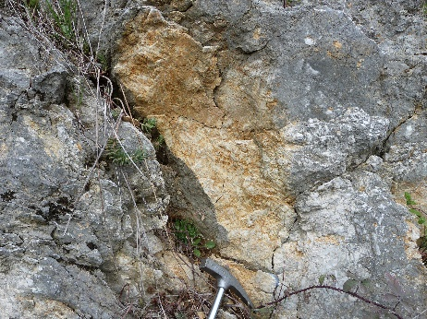 | 36.6 ± 1.8 Ma
SB-2 |  |  |  | Senestral | N66°-74°SE-p17°SO | 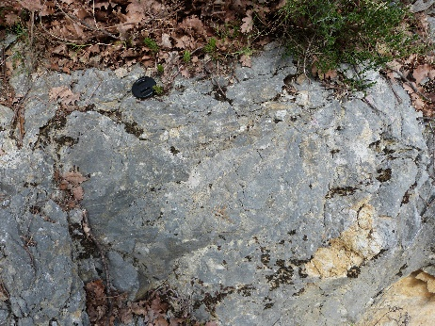 | 39.6 ± 3.4 Ma
SB-3 |  |  |  | Senestral | N59°-84°NO-p0° | 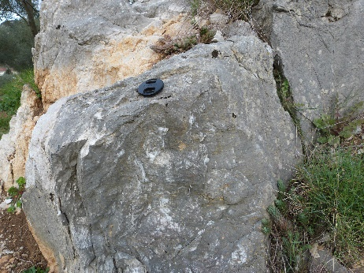 | 40.8 ± 3.3 Ma
SB-4 |  |  |  | Dextral | N76°-88°SE-p51°NE | 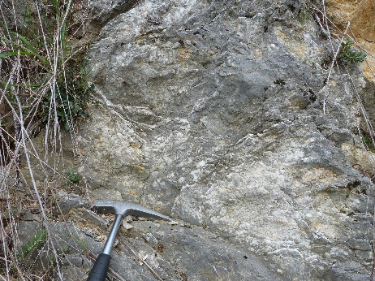 | 41.3 ± 2.1 Ma
GD-1 | 43.906668° N  3.740805° E  (Grotte des Demoiselles) | Limestone | Kimmeridgian-Tithonian | Dextral | N63°-29°NO-p56°N | 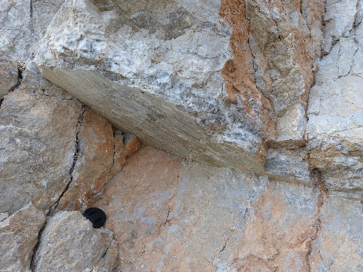 | 48.3 ± 2.7 Ma
GD-2 |  |  |  | Senestral | N52°-65°NO-p7°SO | 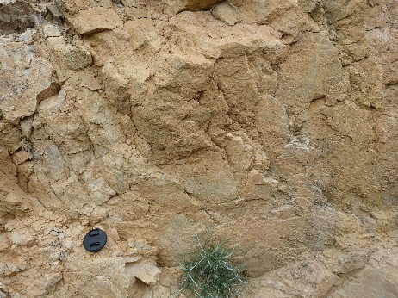 | 52.9 ± 6.3 Ma
GD-3 |  |  |  | Reverse | N73°-47°NO-p45°O | 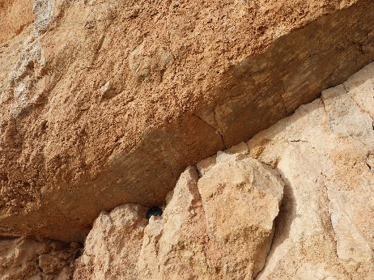 | 63.8 ± 11.9 Ma
PB-1 | 43.791361° N  3.563215° E  (Pégairolles-de-Buèges) | Limestone | Kimmeridgian | Senestral | N34°-52°SE-p2°SO | 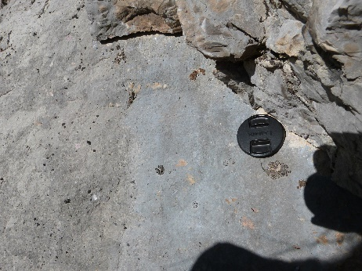 | 101.8 ± 8.9 Ma
PB-2 |  |  |  | Dextral | N171°-86°NE-p9°NO | 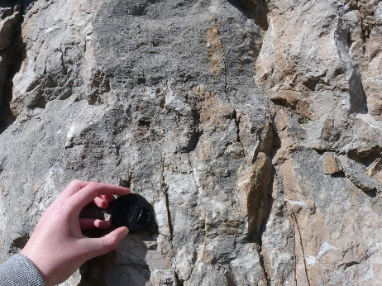 | 104.2 ± 6.2 Ma
SL-1 | 43.787608° N  3.855420° E (NE St-Loup terminaison) | Limestone | Berriasian (Lower Cretaceous) | Reverse | N90°-85°S-p90° | 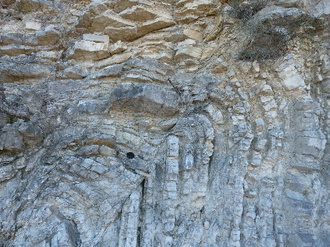 | 34.6 ± 3.2 Ma
SL-2 | 43.777095° N  3.757244° E  (St-Martin-de-Londres) | Breccia | Bartonian  (Eocene) | Reverse | N120°-30°NE-p47°NO | 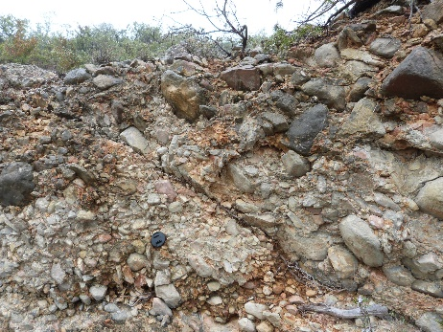 | 39.9 ± 6.9 Ma
SL-3 | 43.727046° N  3.631567° E  (NE St-Loup terminaison) | Limestone | Kimmeridgian-Tithonian | Senestral | N43°-47°SE-p13°NE | 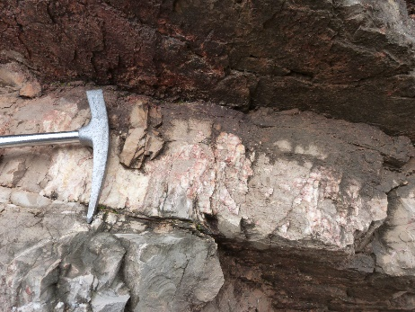 | 50.4 ± 8.3 Ma
DM-1 | 43.732433° N  3.800334° E | Limestone | Malm | Senestral | N176°-86°O-p0° | 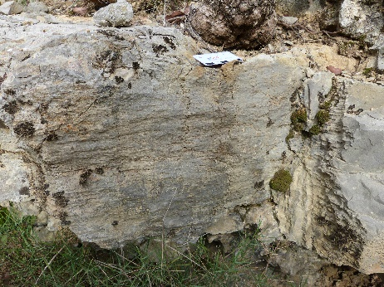 | 45.0 ± 8.5 Ma
Table S1 - Characteristics of dated samples

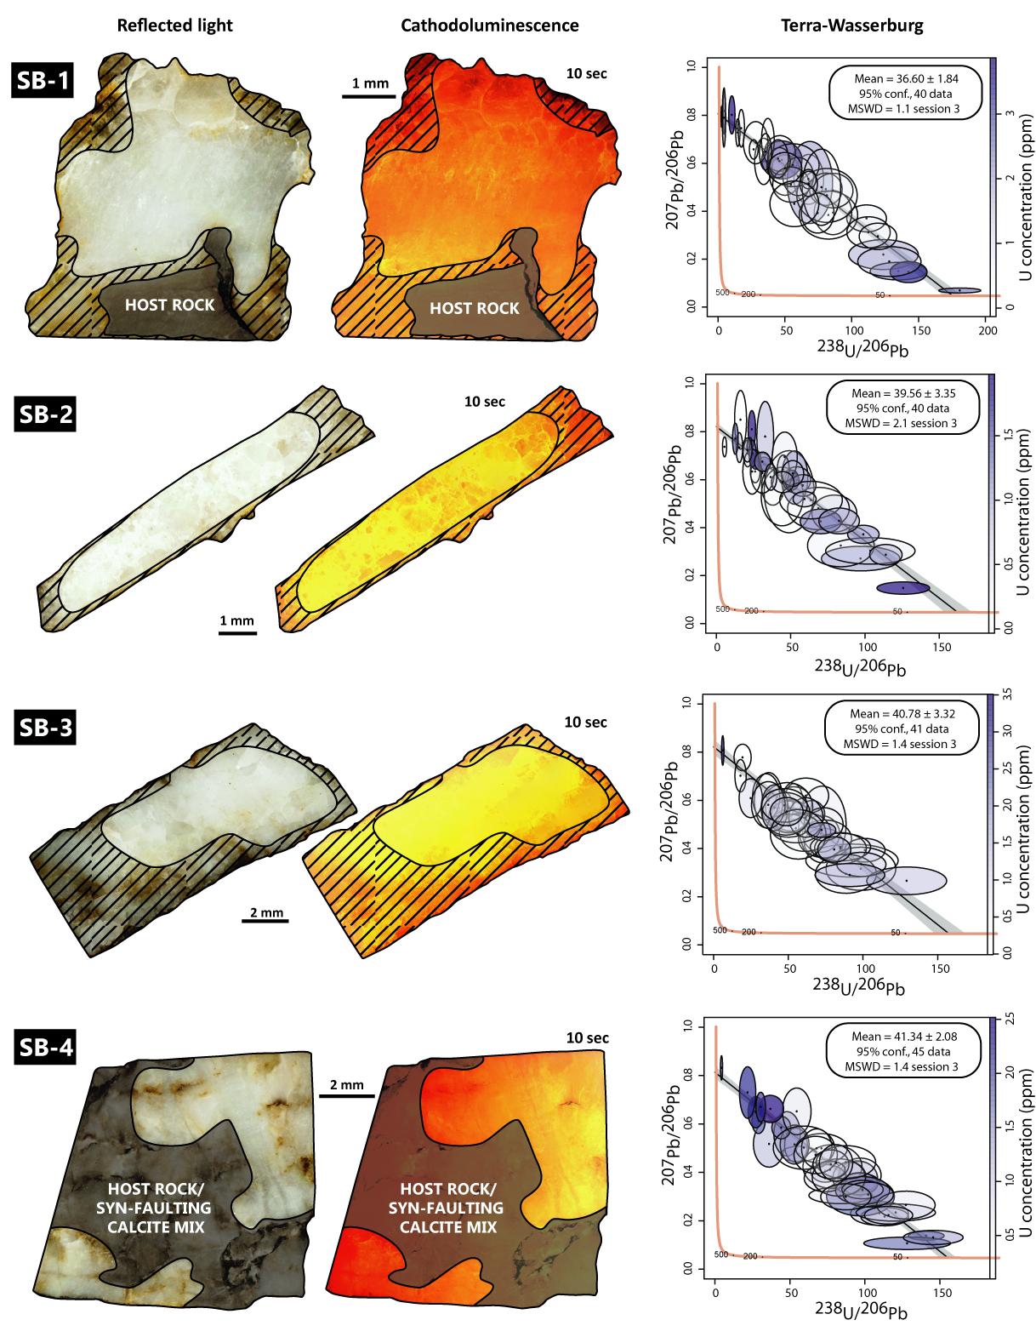
Figure S1 – Petrographic observations (reflected light and cathodoluminescence microscopy) and Lower intercept (Tera-Wasserburg) age for dated calcites

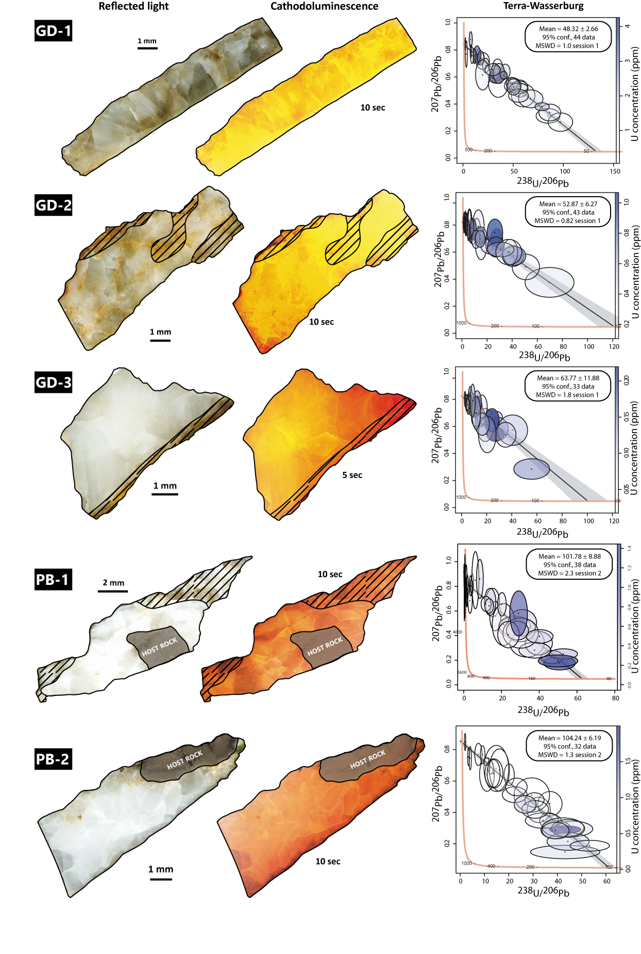
Figure S1 (continued) – Petrographic observations (reflected light and cathodoluminescence microscopy) and Lower intercept (Tera-Wasserburg) age for dated calcites
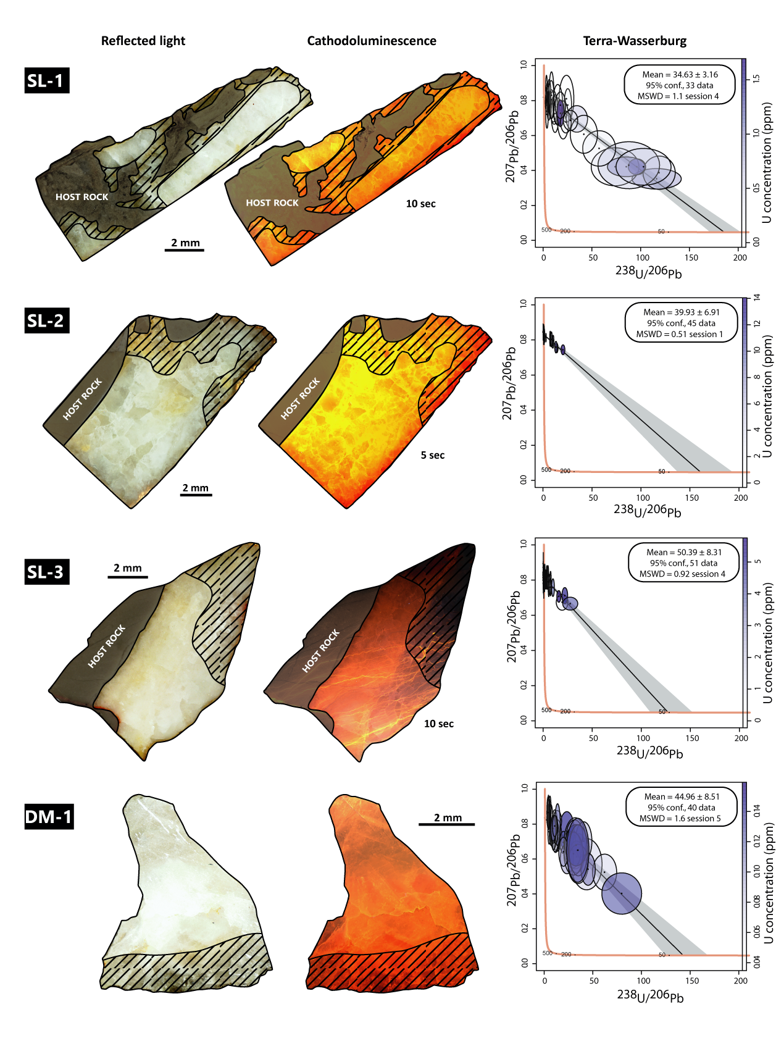
Figure S1 (continued) – Petrographic observations (reflected light and cathodoluminescence microscopy) and Lower intercept (Tera-Wasserburg) age for dated calcites

U-Pb GEOCHRONOLOGY
Analytical Protocol
U-Pb analyses were conducted using a Thermo ScientificTM High Resolution Inductively Coupled Plasma Mass Spectrometer (HR-ICP-MS) ELEMENT XR (ThermoFisher Scientific, Waltham, USA) coupled to a 193 nm ArF Laser Ablation System (Photon Machines Teledyne, Thousand Oaks, USA) at the Géosciences Paris-Saclay (GEOPS) laboratory at the University Paris-Saclay.
WC-1(Roberts et al., 2017) was used as primary reference material to correct for ²⁰⁶Pb/²³⁸U fractionation. NIST614 glass standard was used to correct ²⁰⁷Pb/²⁰⁶Pb mass bias and to evaluate the instrumental drift during analytical sessions; Duff Brown Tank (DBT) (Hill et al., 2016) and AUG-B6 (Pagel et al., 2018) were measured as secondary reference materials to ensure accuracy.
A "prescan" consisting in making 6 to 10 spots in each sample (random location when the calcites are homogeneous in reflected light and cathodoluminescence, or, if not, determined location according to the different zones distinguished) was carried out in order to select the most favourable ones for dating. Once the samples selected and the ablation spots placed, the automatic analysis was started for several hours (12-13h) with the operating conditions listed in the table below (Table S2).
The laser beam diameter for calcite unknowns and calcite reference materials (WC-1, AUG-B6 and DBT) was 150 μm. Calcite crystals (including reference materials) were ablated at a frequency of 8 Hz and a fluence of 4 J.cm⁻². Glass reference materials NIST612 (37.38 ppm U and 38.57 ppm Pb) and NIST614 (0.823 ppm U and 2.32 ppm Pb, Jochum et al.,(2011)) were ablated at a frequency of 10 Hz, a fluence of 6.25 J.cm⁻² and a beam size of 40 μm for NIST612 and 110 μm for NIST614.
Each analysis consists of 30 s background acquisition followed by 30 s of sample ablation and 30 s washout. Prior to analysis, each sample spot was pre-ablated during 3 s at a frequency of 8 Hz and with a fluence of 4 J.cm⁻² over an area larger than the beam diameter to clean the surface (155 μm) and remove potential surface contamination. The laser-induced aerosol was carried by helium (lage volume at 0. 5 l.min⁻¹ and inner cup at 0. 375 l.min⁻¹) from the sample cell to a mixing funnel in which the sample and He are mixed with 0.950 to 1 l.min⁻¹ argon to stabilize the aerosol input to the plasma. Signal strength of the ICP-MS was tuned for maximum sensitivity while keeping Th/U between 0.99 and 1.05 and ThO/Th around 0.3 % on NIST612. Isotopes ²⁰⁶Pb, ²⁰⁷Pb, ²⁰⁸Pb, ²³²Th and ²³⁸U were acquired with integration time per peak (ms) of 5 ms for ²⁰⁸Pb and ²³²Th, of 10 ms for ²³⁸U, of 35 ms for ²⁰⁶Pb and of 45 ms for ²⁰⁷Pb by 70 runs.
We used NIST614 to correct for ²⁰⁷Pb/²⁰⁶Pb fractionation (Woodhead, Horstwood & Cottle, 2016; Roberts et al., 2017). For mass-bias correction of the measured ²³⁸U/²⁰⁶Pb ratios, we used the calcite reference material from the Permian Reef Complex Walnut Canyon (WC-1, Roberts et al.,(2017)). This calcite reference material has been dated by thermal ionization mass spectrometry (TIMS) after isotope dilution at 254.4±6.4 Ma and has been used by many other labs for laser ablation mass-bias correction (Li et al., 2014; Coogan, Parrish & Roberts, 2016; Ring & Gerdes, 2016; Roberts & Walker, 2016; Roberts et al., 2017; Pagel et al., 2018; Lawson et al., 2018; Parrish, Parrish & Lasalle, 2018). WC-1 exhibits high U/Pb and homogeneous distribution of U (Roberts et al., 2017). To ensure accuracy, we analyzed two secondary calcite reference materials during the analytical session: Duff Brown Tank (DBT) calcite, dated at 64.0±0.7 Ma by U-Pb isotope dilution (Hill et al., 2016), and AUG-B6, a calcite breccia dated at 42.99±1 Ma (Pagel et al., 2018). Internal secondary reference calcite AUG-B6 comes from the Gondrecourt graben (Eastern Paris Basin), part of the European Cenozoic Rift System, and has been dated by Pagel et al.(2018) by LA-ICP-MS, and is routinely analyzed at GEOPS (university Paris-Saclay). Measurements have been made by sequences composed of 10 reference material analyses (2 NIST612, 2 NIST614, 2 DBT, 2 AUG-B6 and 2 WC-1), 10 spots on unknowns calcite, 8 reference material analysis (2 NIST614, 2 DBT, 2 AUG-B6 and 2 WC-1), 10 spots on unknowns calcite, etc., ending with 10 reference material analysis (2 NIST612, 2 NIST614, 2 DBT, 2 AUG-B6 and 2 WC-1). Data were acquired in fully automated mode overnight in sequences of max. 400 analyses from the 29th of October 2020 to the 16th of November 2020.
Data were reduced in Iolite© using NIST614 glass as the primary reference material to correct for baseline and for Pb isotope mass bias over the sequence time (Paton et al., 2011; Lawson et al., 2018). No down-hole fractionation correction is applied in Iolite© (Nuriel et al., 2017). The approach to data reduction was to define an acceptable and large window (time window of >25 s if possible) within the data profile and average the ratios. Our calcite samples typically have low (< 2-3 ppm) to very low (< 1 ppm) U concentration. The most favorable areas for dating are those with highest U/Pb and lowest ²⁰⁷Pb/²⁰⁶Pb values, i.e. with very low initial common Pb (Lawson et al., 2018; Parrish, Parrish & Lasalle, 2018), plotting close to the Concordia line. However, small -scale variations in U/Pb ratios are important to get well-constrained isochrones. The two sigma standard errors in ²⁰⁷Pb/²⁰⁶Pb and ²⁰⁶Pb/²³⁸U ratios measured on NIST614 during the analytical session (instrumental drift) were propagated to the final age uncertainty of calcite samples by quadratic addition. During the session, NIST614 two sigma error of the ²⁰⁷Pb/²⁰⁶Pb was max. 0.6 % and was max 1.20 % for ²⁰⁶Pb/²³⁸U (see Table S3). Each reduced data is plotted in a Tera-Wasserburg ²³⁸U/²⁰⁶Pb versus ²⁰⁷Pb/²⁰⁶Pb graph using the online version of IsoplotR© (Vermeesch, 2019). An isochron is drawn and the isochron age is deduced by the intersection on the concordia. For each sequence, the age and uncertainty of WC-1 reference calcite, following normalization using NIST614 glass, was calculated without further normalization using a Tera-Wasserburg intercept age calculated from the ²⁰⁶Pb/²³⁸U and NIST614-normalized ²⁰⁷Pb/²⁰⁶Pb ratios. Following the analytic run, we applied a linear correction factor to correct the ²⁰⁶Pb/²³⁸U such that the primary WC-1 yields the correct intercept age (i.e., 254.4±6.4 Ma, Roberts et al.,(2017)). Throughout the analytical session, we obtained 164.3±2.8 Ma (32 analyses), 162.9±6.0 Ma (32 analyses), 157.1±5.2 Ma (32 analyses), 152.9±3.2 Ma (30 analyses), 165.1±3.4 Ma (34 analyses), for WC1, hence we applied a linear correction factor of 0.60 to 0.65, depending on the analytical session, to correct all the ²⁰⁶Pb/²³⁸U ratios of carbonate samples (Table S3). We anchored the ²⁰⁷Pb/²⁰⁶Pb ratio at 0.85 for the common Pb based on Stacey and Kramers (1975) when we calculated the Tera-Wasserburg intercept age on WC-1 (see Roberts et al., (2017)). On unknown calcite samples, Tera-Wasserburg intercept ages are calculated by plotting each spot from a single sample (or a single calcite type) and by applying the linear correction factor found on WC-1 during the session to correct the ²⁰⁶Pb/²³⁸U. When data are spreading along a single regression line, this spread is interpreted as an isochron and an age is calculated from the IsoplotR© software without any constraint on the initial ²⁰⁷Pb/²⁰⁶Pb value. Error ellipses of each spots and the error on the Tera-Wasserburg intercept age are 2σ. In each Tera-Wasserburg graph, the age uncertainty is given, propagating the systematic uncertainty of primary reference material WC-1 age (2.6 %), and the two sigma error of the ²⁰⁷Pb/²⁰⁶Pb and ²⁰⁶Pb/²³⁸U of the corresponding analytical session by quadratic addition (Table S3). The uncertainty related to ²³⁵U and ²³⁸U decay constants is propagated using IsoplotR©. Following this description, calculated ages for secondary reference materials analyzed during the sequence are indicated in Figure S3, without anchoring ²⁰⁷Pb/²⁰⁶Pb at the origin.
The U-Pb data of each dated calcite sample is, sometimes, obtained from a combination of several analytical sequences. The ²⁰⁶Pb/²³⁸U correction was performed for each ablation spot based on the associated WC-1 data from the corresponding sequence.
Systematic long-term excess-variance uncertainty was not propagated in this study. Because sample ages were sometimes obtained from the compilation of data coming from several analytical sequences, the random uncertainties on ²⁰⁷Pb/²⁰⁶Pb and ²⁰⁶Pb/²³⁸U propagated from NIST 614 (instrumental drift) correspond to the maximum uncertainties obtained across all sequences.

Laboratory and Sample Preparation
Laboratory name | Géosciences Paris Saclay (GEOPS), University Paris-Saclay, Orsay, France
Sample type/mineral | Calcite
Sample preparation | In situ in polished fragments of fault-related calcite in epoxy mounts
Imaging | Cathodoluminescence microscope
Laser ablation system
Make, Model and type | 193nm ArF Photon Machines (Teledyne)
Ablation cell | HelEx
Laser wavelength (nm) | 193 m
Pulse width (ns) | 5 ns
Fluence (J.cm-2) | 4 J.cm⁻² for sample and carbonate standard, 6.25 J.cm⁻² for NIST 612 and NIST614
Repetition rate (Hz) | 8 Hz for sample and carbonate standard, 10 Hz for NIST 612 and NIST614
Pre-ablation | each spot during 3 s, 155 µm for sample and carbonate standard, 50 µm for NIST 612 and 135 µm for NIST614
Ablation duration (secs) | 30 s
Spot size (mm) | 150 μm for sample and carbonate standard, 40 µm for NIST 612 and 110 µm for NIST614
Sampling mode / pattern | Static spot ablation
Carrier gas | He
Cell carrier gas flow (l.min⁻¹) | Helium  Lage volume: 0.5 l.min⁻¹  Inner cup: 0.375 l.min⁻¹
ICPMS instrument
ICPMS instrument Make, Model & type | ThermoScientific Element XR
Sample introduction | Ablation aerosol
RF power (W) | 1175 W
Make-up gas flow in ablation funnel (l.min⁻¹) | Ar=0.950 to 1 l.min⁻¹
Detection system | Ion counter
Masses measured | 206, 207, 208, 232, 238
Average gas background (cps) | 30 for 206, 27 for 207, 67 for 208, 0.1 for 232, 0 for 238
Integration time per peak (ms) | 35 ms for 206, 45 ms for 207, 5 ms for 208, 5 ms for 232, 10 ms for 238
Total integration time per reading (secs) | 0.1 s
IC Dead time (ns) | 30 ns
Signal strength at ICPMS tuned conditions | Th/U ̴ 1  ²⁴⁸ThO/²³²Th around 0.3 %
Data Processing
Data acquisition | Fully automated mode overnight in sequences of 399 analysis maximum
Gas blank | 30 s background, 30 s sample ablation and 30 s washout
Calibration strategy | NIST614 for ²⁰⁷Pb-²⁰⁶Pb, calcite WC-1 for ²³⁸U-²⁰⁶Pb, secondary reference material calcite Duff Brown Tank and calcite breccia AUG-B6
Reference Material info | WC-1 age: 254.4±6.4 Ma (Roberts et al., 2017), Duff Brown Tank age: 64.04 ± 0.67 Ma (Hill et al., 2016) and calcite breccia AUG-B6 age: 42.99 ± 0.98 Ma (Pagel et al., 2018)
Data processing package used / Correction for LIEF | Iolite to calculate uncertainties, no down-hole fractionation correction
Mass discrimination | ²⁰⁷Pb/²⁰⁶Pb normalization to NIST614, ²⁰⁶Pb/²³⁸U normalized to WC-1
Common-Pb correction, composition and uncertainty | No common-Pb correction applied
Uncertainty level & propagation | Ages in the data table are quoted at 2sigma (2σ) absolute, uncertainty propagation by quadratic addition
Quality control / Validation | Measurements of WC-1, Duff Brown Tank (DBT), B6 and NIST614 were done along with samples throughout the analytical session
Table S2 - Ablation parameters and characteristics of U-Pb dating on fault-related calcite

Global results
Figure S2 shows some Tera-Wasserburg diagrams associated with samples from the Languedoc region that could not be dated. In most cases, high common lead together with low U (below ppm) prevent any dating attempt. Samples may also be undatable because individual spots are not aligned along an isochron corresponding to a common lead/radiogenic lead mixture line, which could be related with a re-opening of the isotope system. Finally, some calcite cannot be dated because uncertainties on the measured isotope ratios are too high.
Thirteen fault-related calcites, corresponding to 25% of all samples, were suitable for dating. Lower intercept (Tera-Wasserburg) ages (in Ma) for all dated samples are represented on Figure S1. The sessions number associated with each T-W diagram corresponds to the same number as those of the secondary reference materials (Figure S3 and Table S3). Some spots corresponding to an uncertainty of more than 30% of ²⁰⁷Pb/²⁰⁶Pb or ²⁰⁶Pb/²³⁸U ratios have been excluded. Uncertainties correspond to 2σ with random and systematic uncertainties - except long term excess variance of validation material - propagated. Estimation of the uranium content (in ppm) per spot in the samples is shown on the Tera-Wasserburg diagrams (colour variation). This content has been calibrated from WC-1, considering the latter homogeneous and with a mean U concentration of 5 ppm in the whole sample.

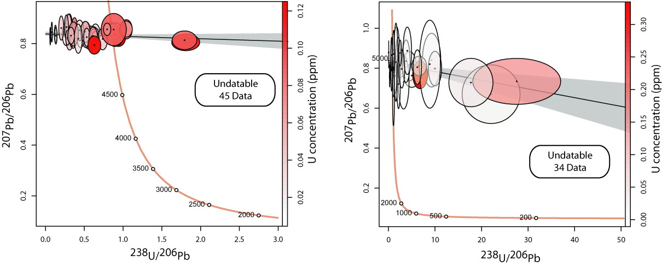
Figure S2 - Examples of Tera-Wasserburg diagrams of undatable samples

Reference materials results
NIST 614 glass standard, used to correct ²⁰⁷Pb/²⁰⁶Pb mass bias and to evaluate the instrumental drift during analytical sessions, gives an average ²⁰⁷Pb/²⁰⁶Pb ratio of 0.871 ± 0.021 over all sessions (Figure S3A and Table S3).
The dating of secondary calcite reference materials during the analytical session made it possible to evaluate the accuracy of the dating procedure. Indeed, Duff Brown Tank, dated at 64.04 ± 0.67 Ma by Hill et al.(2016) is here 63.7 ± 2.7 Ma in age (all sessions combined) and AUG-B6, dated at 42.99 ± 0.98 Ma by Pagel et al. (2018) is here 43.5 ± 0.6 Ma in age (all sessions combined) (Figure S3B, S3C). In detail, Duff Brown's age ranges from 61.8 ± 5.3 to 65.7 ± 5.7 Ma and AUG-B6 from 42.5 ± 1.7 to 44.1 ± 2.8 Ma (Figure S3 and Table S3).
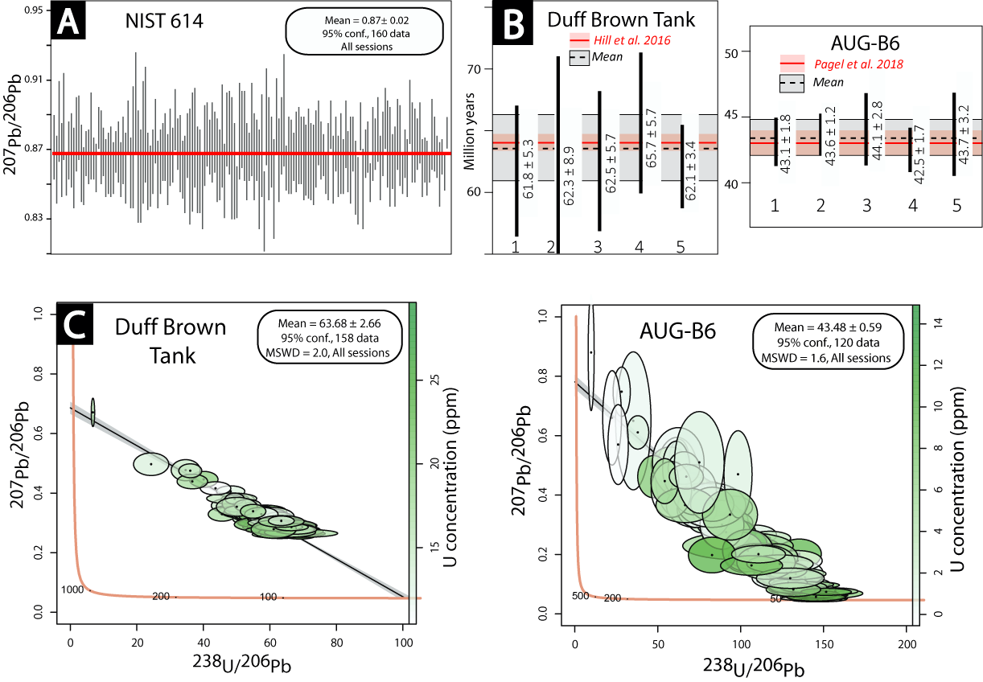
Figure S3 - Ages of secondary standards (in Ma, 2σ with random and systematic uncertainties - except long term excess variance of validation material - propagated) A. Pooled NIST614 ²⁰⁷Pb/²⁰⁶Pb measurements for all sessions B. Lower intercept (Tera-Wasserburg) age for Duff Brown and AUG-B6 for all sessions C. Pooled Tera-Wasserburg results for Duff-Brown and AUG-B6.

REFERENCES

Coogan, L.A., Parrish, R.R. & Roberts, N.M.W. 2016. Early hydrothermal carbon uptake by the upper oceanic crust: Insight from in situ U-Pb dating. Geology 44(2), 147–150.
Hill, C.A., Polyak, V.J., Asmerom, Y. & P. Provencio, P. 2016. Constraints on a Late Cretaceous uplift, denudation, and incision of the Grand Canyon region, southwestern Colorado Plateau, USA, from U-Pb dating of lacustrine limestone: U-PB AGE OF LACUSTRINE LIMESTONE. Tectonics 35(4), 896–906.
Jochum, K.P., Weis, U., Stoll, B., Kuzmin, D., Yang, Q., Raczek, I., Jacob, D.E., Stracke, A., Birbaum, K., Frick, D.A., Günther, D. & Enzweiler, J. 2011. Determination of Reference Values for NIST SRM 610-617 Glasses Following ISO Guidelines. Geostandards and Geoanalytical Research 35(4), 397–429.
Lawson, M., Shenton, B.J., Stolper, D.A., Eiler, J.M., Rasbury, E.T., Becker, T.P., Phillips-Lander, C.M., Buono, A.S., Becker, S.P., Pottorf, R., Gray, G.G., Yurewicz, D. & Gournay, J. 2018. Deciphering the diagenetic history of the El Abra Formation of eastern Mexico using reordered clumped isotope temperatures and U-Pb dating. GSA Bulletin 130(3–4), 617–629.
Li, Q., Parrish, R.R., Horstwood, M.S.A. & McArthur, J.M. 2014. U–Pb dating of cements in Mesozoic ammonites. Chemical Geology 376, 76–83.
Nuriel, P., Weinberger, R., Kylander-Clark, A.R.C., Hacker, B.R. & Craddock, J.P. 2017. The onset of the Dead Sea transform based on calcite age-strain analyses. Geology 45(7), 587–590.
Pagel, M., Bonifacie, M., Schneider, D.A., Gautheron, C., Brigaud, B., Calmels, D., Cros, A., Saint-Bezar, B., Landrein, P., Sutcliffe, C., Davis, D. & Chaduteau, C. 2018. Improving paleohydrological and diagenetic reconstructions in calcite veins and breccia of a sedimentary basin by combining Δ47 temperature, δ18Owater and U-Pb age. Chemical Geology 481, 1–17.
Parrish, R.R., Parrish, C.M. & Lasalle, S. 2018. Vein calcite dating reveals Pyrenean orogen as cause of Paleogene deformation in southern England. Journal of the Geological Society 175(3), 425–442.
Paton, C., Hellstrom, J., Paul, B., Woodhead, J. & Hergt, J. 2011. Iolite: Freeware for the visualisation and processing of mass spectrometric data. Journal of Analytical Atomic Spectrometry 26(12), 2508.
Ring, U. & Gerdes, A. 2016. Kinematics of the Alpenrhein-Bodensee graben system in the Central Alps: Oligocene/Miocene transtension due to formation of the Western Alps arc: Alpenrhein-Bodensee Graben System. Tectonics 35(6), 1367–1391.
Roberts, N.M.W. & Walker, R.J. 2016. U-Pb geochronology of calcite-mineralized faults: Absolute timing of rift-related fault events on the northeast Atlantic margin. Geology 44(7), 531–534.
Roberts, N.M.W., Rasbury, E.T., Parrish, R.R., Smith, C.J., Horstwood, M.S.A. & Condon, D.J. 2017. A calcite reference material for LA-ICP-MS U-Pb geochronology: calcite RM for LA-ICP-MS U-Pb dating. Geochemistry, Geophysics, Geosystems 18(7), 2807–2814.
Stacey, J.S. & Kramers, J.D. 1975. Approximation of terrestrial lead isotope evolution by a two-stage model. Earth and Planetary Science Letters 26(2), 207–221.
Vermeesch, P. 2019. U-Th-Pb discordia regression, Geochronological data analysis/statistics/modelling,p.
Woodhead, J.D., Horstwood, M.S.A. & Cottle, J.M. 2016. Advances in Isotope Ratio Determination by LA–ICP–MS. Elements 12(5), 317–322.

