Supplementary informations

S1 – Structural stations
Station | Latitude [deg.] | Longitude [deg.] | Formation (Epoch) | Methods (label)
1 | 42,13281 | 13,12463 | Ratiolitidae Limestones (Lower Cretaceous)¹,Lithothamnion and Bryozoan Limestones - LB1 (Miocene)² | Scan-area¹, Scan-lines (SL1-3)²
2 | 42,13366 | 13,12502 | Lithothamnion and Bryozoan Limestones - LB1 (Miocene) | Scan-area¹, Scan-lines (SL4)²
3 | 42,13295 | 13,12346 | Ratiolitidae Limestones (Lower Cretaceous) | Scan-line (SL5)
4 | 42,13225 | 13,13976 | Lithothamnion and Bryozoan Limestones - LB3 (Miocene) | Scan-line (SL6)
5 | 42,13697 | 13,12872 | Lithothamnion and Bryozoan Limestones - LB2 (Miocene) | Scan-line (SL7)
6 | 42,14499 | 13,12309 | Lithothamnion and Bryozoan Limestones - LB3 (Miocene) | Scan-line (SL8)
7 | 42,12347 | 13,14362 | Lithothamnion and Bryozoan Limestones - LB2 (Miocene) | Scan-line (SL9)
8 | ﻿42,13514 | ﻿13,13395 | Lithothamnion and Bryozoan Limestones - LB2 (Miocene) | Scan-line (SL10)
9 | ﻿42,13688 | ﻿13,12765 | Lithothamnion and Bryozoan Limestones - LB2 (Miocene) | Field
10 | ﻿42,13434 | ﻿13,13656 | Lithothamnion and Bryozoan Limestones - LB3 (Miocene) | Field
11 | ﻿42,13589 | ﻿13,13256 | Lithothamnion and Bryozoan Limestones - LB2 (Miocene) | Field
12 | ﻿42,13707 | ﻿13,13817 | Lithothamnion and Bryozoan Limestones - LB3 (Miocene) | Field
13 | 42,13558 | 13,13381 | Lithothamnion and Bryozoan Limestones - LB2-LB3 (Miocene) | Virtual Outcrop, Scan-lines (SL11, SL12)
F1 | 42,11769 | 13,10301 | Siliciclastic sandstones and marls (Miocene) | Field
F2 | 42,12932 | 13,11039 | Siliciclastic sandstones and marls (Miocene) | Field
F3 | 42,12366 | 13,17758 | Siliciclastic sandstones and marls (Miocene) | Field
F4 | 42,12796 | 13,18970 | Siliciclastic sandstones and marls (Miocene) | Field
F5 | 42,12253 | 13,18403 | Siliciclastic sandstones and marls (Miocene) | Field
F6 | 42,12856 | 13,14875 | Siliciclastic sandstones and marls (Miocene) | Field

S2 – Scan-lines
Station | Longitude | Latitude | Formation | Trend | Plunge | Length | Number of fractures | Spacing | Linear fracture frequency
 |  |  |  | deg | deg | cm |  | cm | m⁻¹
SL1 | 13.124362 | 42.132853 | CBZ1 | 133 | 0 | 1200 | 59 | 21 | 5
SL2 | 13.124581 | 42.132822 | CBZ1 | 303 | 10 | 559 | 20 | 29 | 3
SL3 | 13.124627 | 42.132807 | CBZ1 | 303 | 10 | 877 | 32 | 28 | 4
SL4 | 13.125020 | 42.133660 | CBZ1 | 249 | 5 | 825 | 120 | 7 | 14
SL5 | 13.123456 | 42.132945 | CRET | 135 | 0 | 964 | 60 | 16 | 6
SL6 | 13.139761 | 42.132253 | CBZ3 | 140 | 2 | 1033 | 78 | 13 | 7
SL7 | 13.128717 | 42.136967 | CBZ2 | 200 | 1 | 1876 | 41 | 47 | 2
SL8 | 13.123086 | 42.144994 | CBZ3 | 223 | 9 | 372 | 35 | 11 | 9
SL9 | 13.143622 | 42.123469 | CBZ2 | 131 | 6 | 519 | 89 | 6 | 17
SL10 | 13.133806 | 42.135575 | CBZ3 | 323 | 1 | 190 | 85 | 2 | 44
SL11 | 13.133782 | 42.135975 | CBZ2 | 160 | 59 | 200 | 31 | 7 | 15
SL12 | 13.133655 | 42.135690 | CBZ3 | 198 | 12 | 154 | 37 | 4 | 23

Station | Scan-line | Formation | Distance from the Pietrasecca fault (m) | Distance along the Pietrasecca fault (m) | Distance from the fold axis (m) | Distance along fold axis (m) | Intensity (number of fractures/length of scan-line) | Longitudinal joints |  | Transverse joints
 |  |  |  |  |  |  |  | Alpha | Intensity (m-1) | Beta | Intensity (m-1)
1 | SL1 | CBZ1 | -173 | 1344 | -543 | 2554 | 5 | -5 | 5 | 2 | 3
 | SL2 |  |  |  |  |  | 3 | 3 | 2 | 10 | 2
 | SL3 |  |  |  |  |  | 4 | 16 | 2 | 16 | 3
2 | SL4 | CBZ1 | -30 | 1420 | -504 | 2554 | 14 | 1 | 11 | -13 | 3
 |  |  |  |  |  |  |  |  |  | 39 | 2
3 | SL5 | CRET | -38 | 1284 | -742 | 2554 | 6 | 3 | 2 | 3 | 5
4 | SL6 | CBZ3 | 479 | 2545 | 291 | 3362 | 7 | -27 | 2 | 25 | 2
 |  |  |  |  |  |  |  |  |  | -33 | 4
5 | SL7 | CBZ2 | -278 | 1935 | -127 | 2469 | 2 | 27 | 1 | -5 | 2
6 | SL8 | CBZ3 | -1270 | 1708 | 73 | 1490 | 9 | -21 | 6 | 19 | 7
7 | SL9 | CBZ2 | 1705 | 2703 | 73 | 4511 | 17 | 30 | 2 | 31 | 9
 |  |  |  |  |  |  |  | -31 | 3 | 3 | 4
8 | SL10 | CBZ3 | 145 | 2256 | 62 | 2937 | 44 | -11 | 4 | 31 | 3
 |  |  |  |  |  |  |  |  |  | -41 | 2
 |  |  |  |  |  |  |  |  |  | -12 | 24
 |  |  |  |  |  |  |  |  |  | 9 | 13
9 |  | CBZ2 | -457 | 1792 | -208 | 2256 |  | 20 |  | 7
 |  |  |  |  |  |  |  | 35
10 |  | CBZ3 | 279 | 2484 | 302 | 3064 |  | -6 |  | -4
 |  |  |  |  |  |  |  | 41
11 |  | CBZ2 | -82 | 1997 | -125 | 2639 |  | 13 |  | 5
 |  |  |  |  |  |  |  | 32
12 |  | CBZ3 | -132 | 2505 | 365 | 2639 |  | 19
 |  |  |  |  |  |  |  | 35
13 | SL11 | CBZ2 | -4 | 2271 | 177 | 2809 | 15 |  |  | -4 | 21
 |  |  |  |  |  |  |  |  |  | -34 | 8
 | SL12 | CBZ3 | 21 | 2271 | 177 | 2809 | 23 |  |  | 22 | 23
 |  |  |  |  |  |  |  |  |  | -9 | 2
 |  |  |  |  |  |  |  |  |  | -28 | 4
S3 – Fracture sets identified in scan-lines

S4 – Scan areas
Label | Structural station | Formation (Epoch)
SA1.1 | 1 | Radiolitidae Limestones (Early Cretaceous)
SA1.2 | 1 | Radiolitidae Limestones (Early Cretaceous)
SA1.3 | 1 | Radiolitidae Limestones (Early Cretaceous)
SA1.4 | 1 | Radiolitidae Limestones (Early Cretaceous)
SA1.5 | 1 | Radiolitidae Limestones (Early Cretaceous)
SA1.6 | 1 | Radiolitidae Limestones (Early Cretaceous)
SA1.7 | 1 | Radiolitidae Limestones (Early Cretaceous)
SA1.8 | 1 | Radiolitidae Limestones (Early Cretaceous)
SA1.9 | 1 | Radiolitidae Limestones (Early Cretaceous)
SA1.10 | 1 | Radiolitidae Limestones (Early Cretaceous)
SA1.11 | 1 | Radiolitidae Limestones (Early Cretaceous)
SA2.1 | 2 | Lithothamnion & Briozoan Limestones (Miocene)
SA2.2 | 2 | Lithothamnion & Briozoan Limestones (Miocene)
SA2.3 | 2 | Lithothamnion & Briozoan Limestones (Miocene)

S5 – Interpreted scan areas

SA1.1
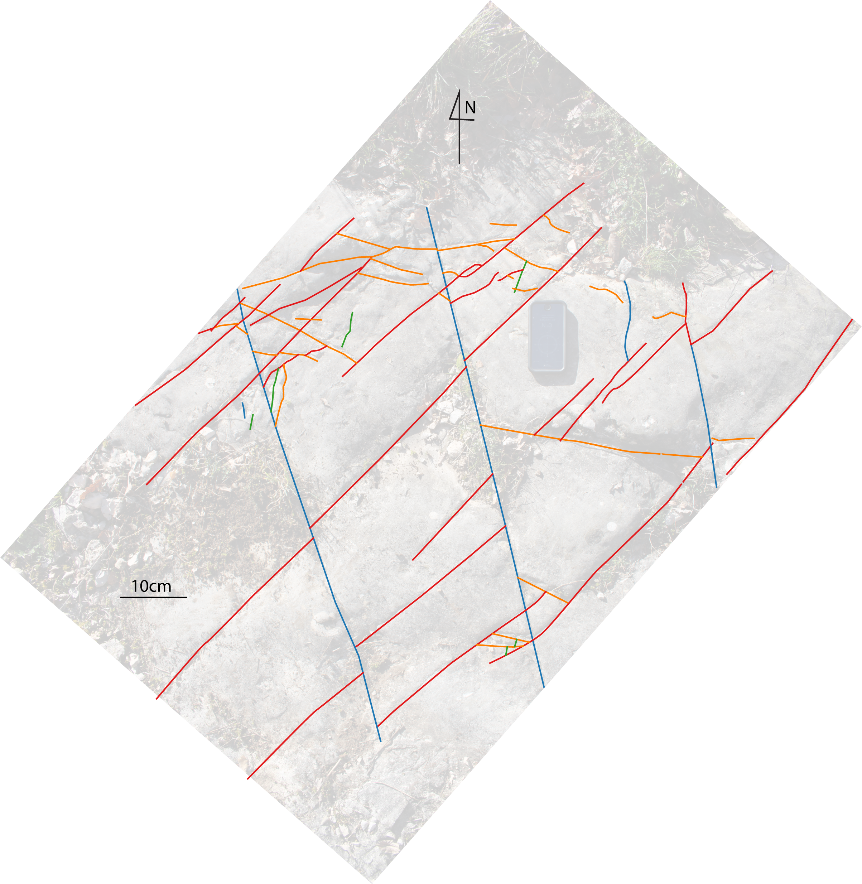
SA1.2
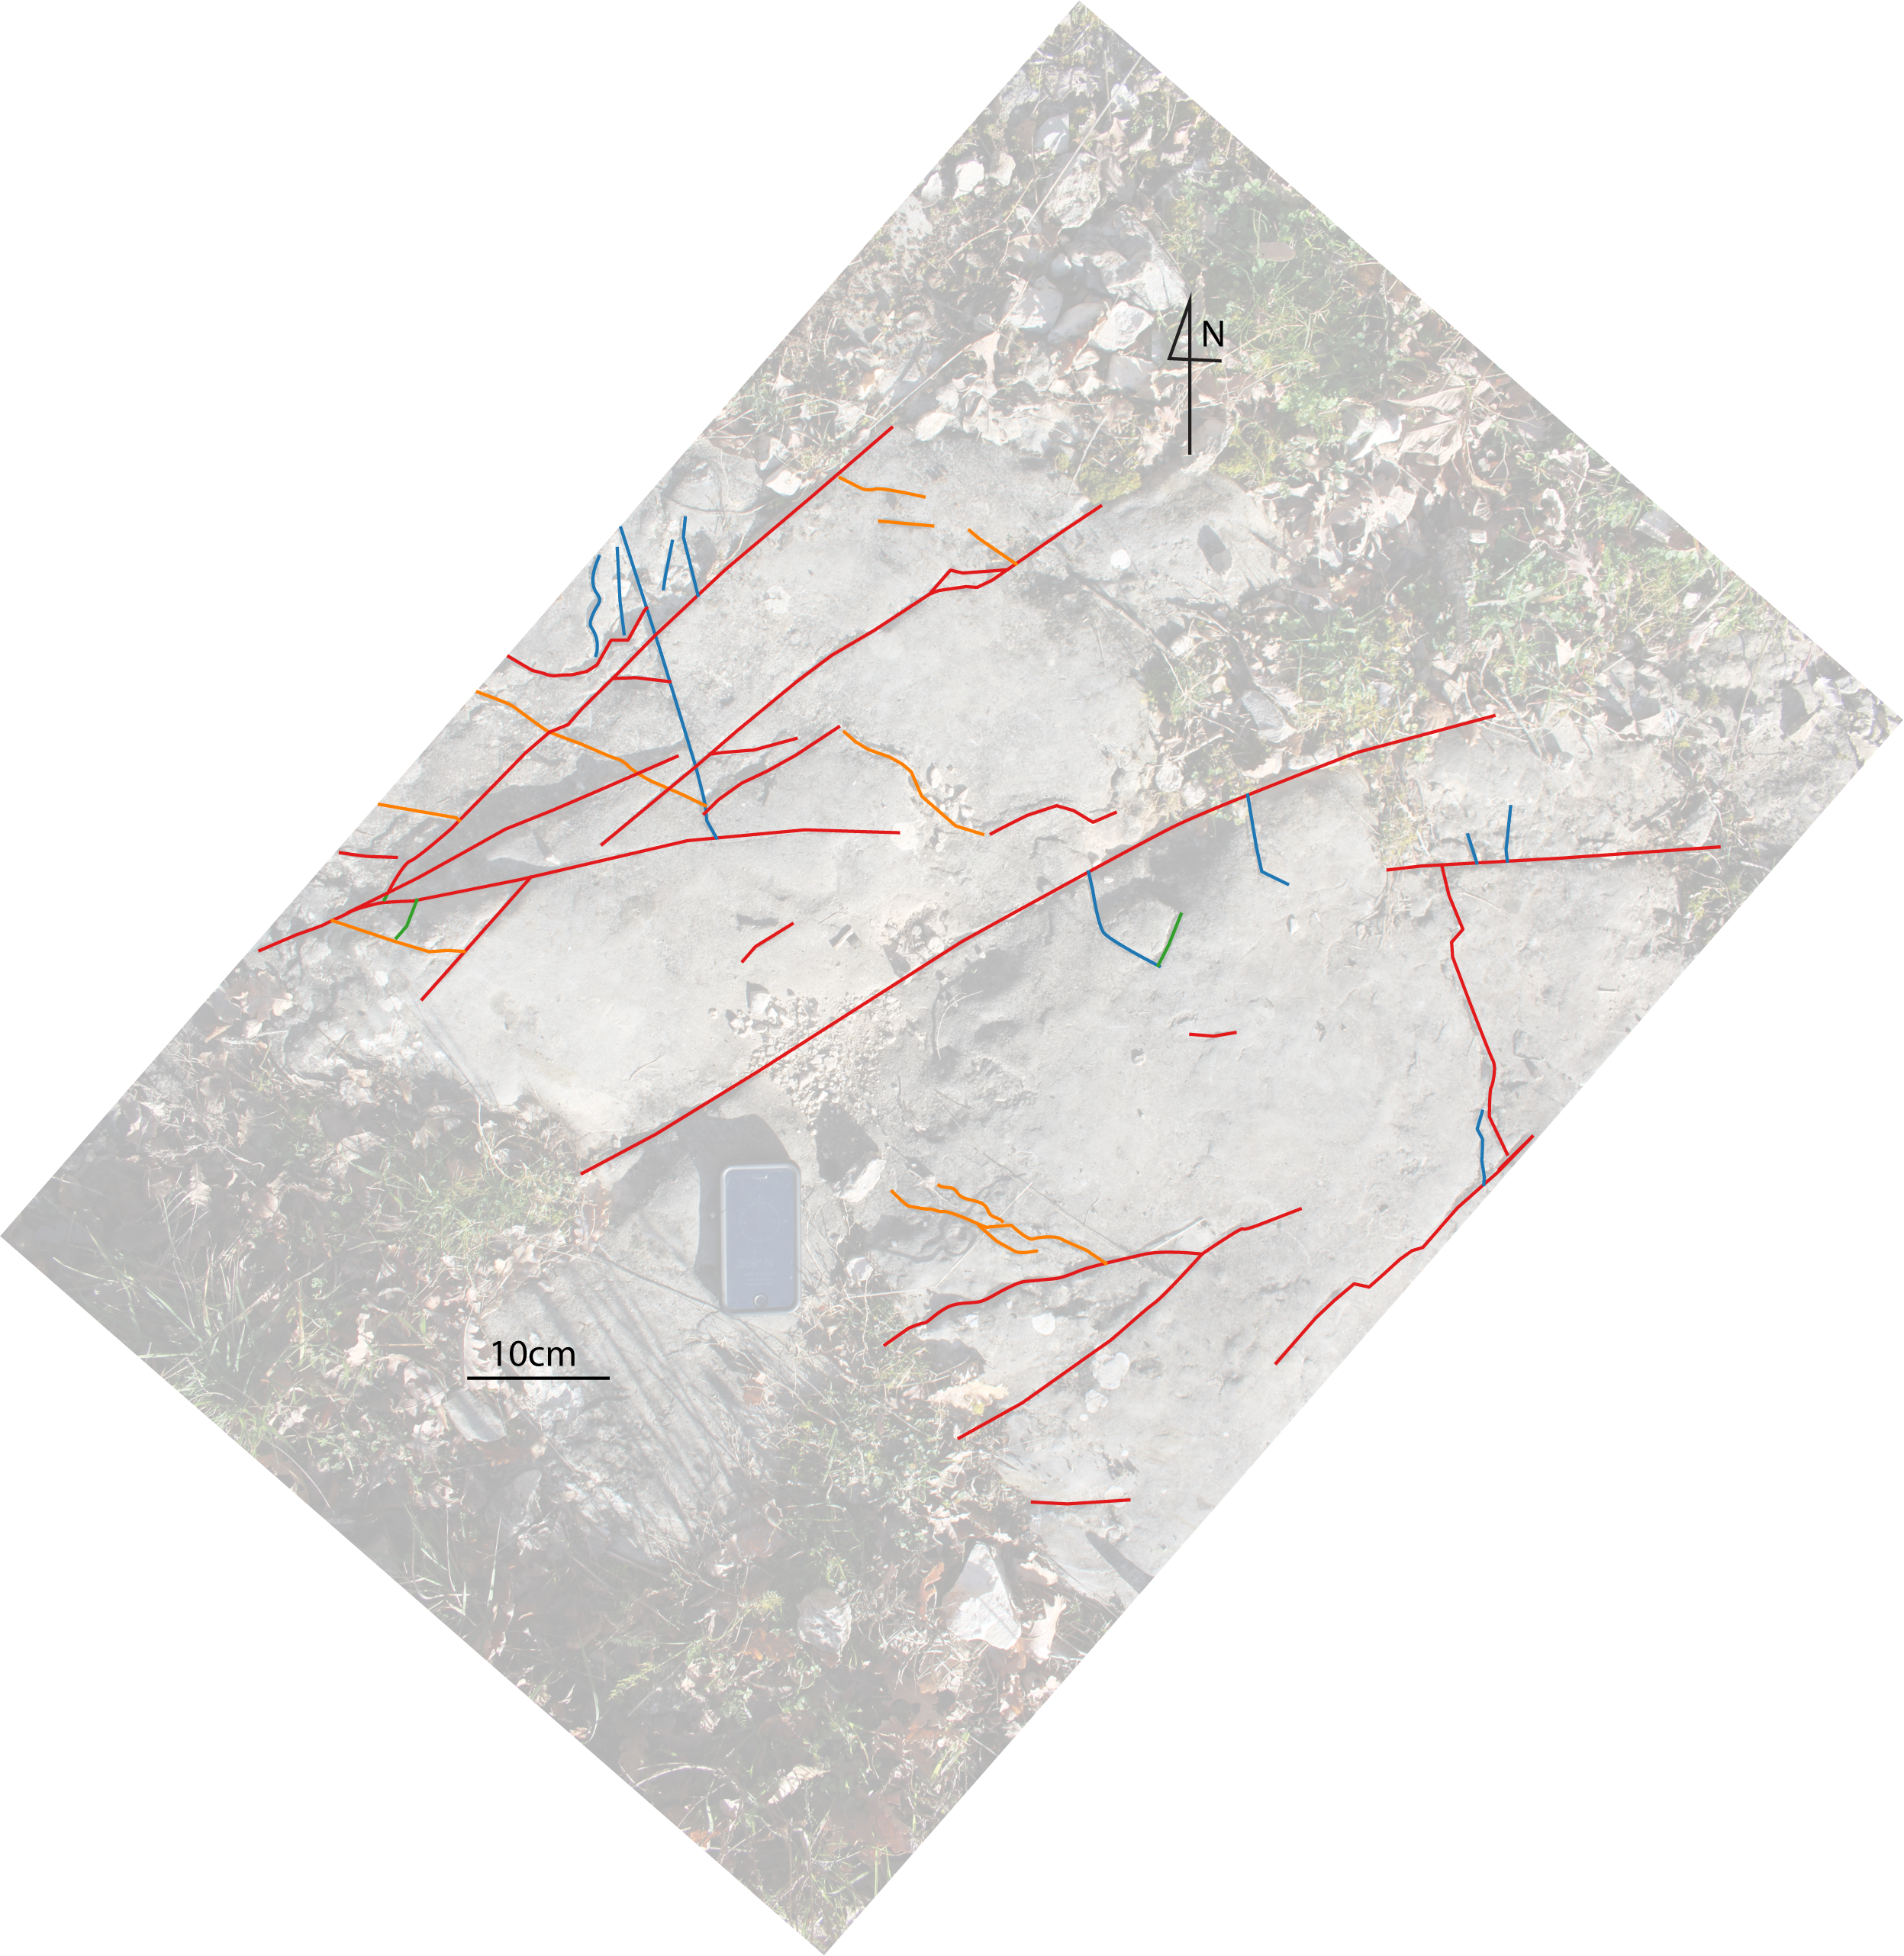
SA1.3
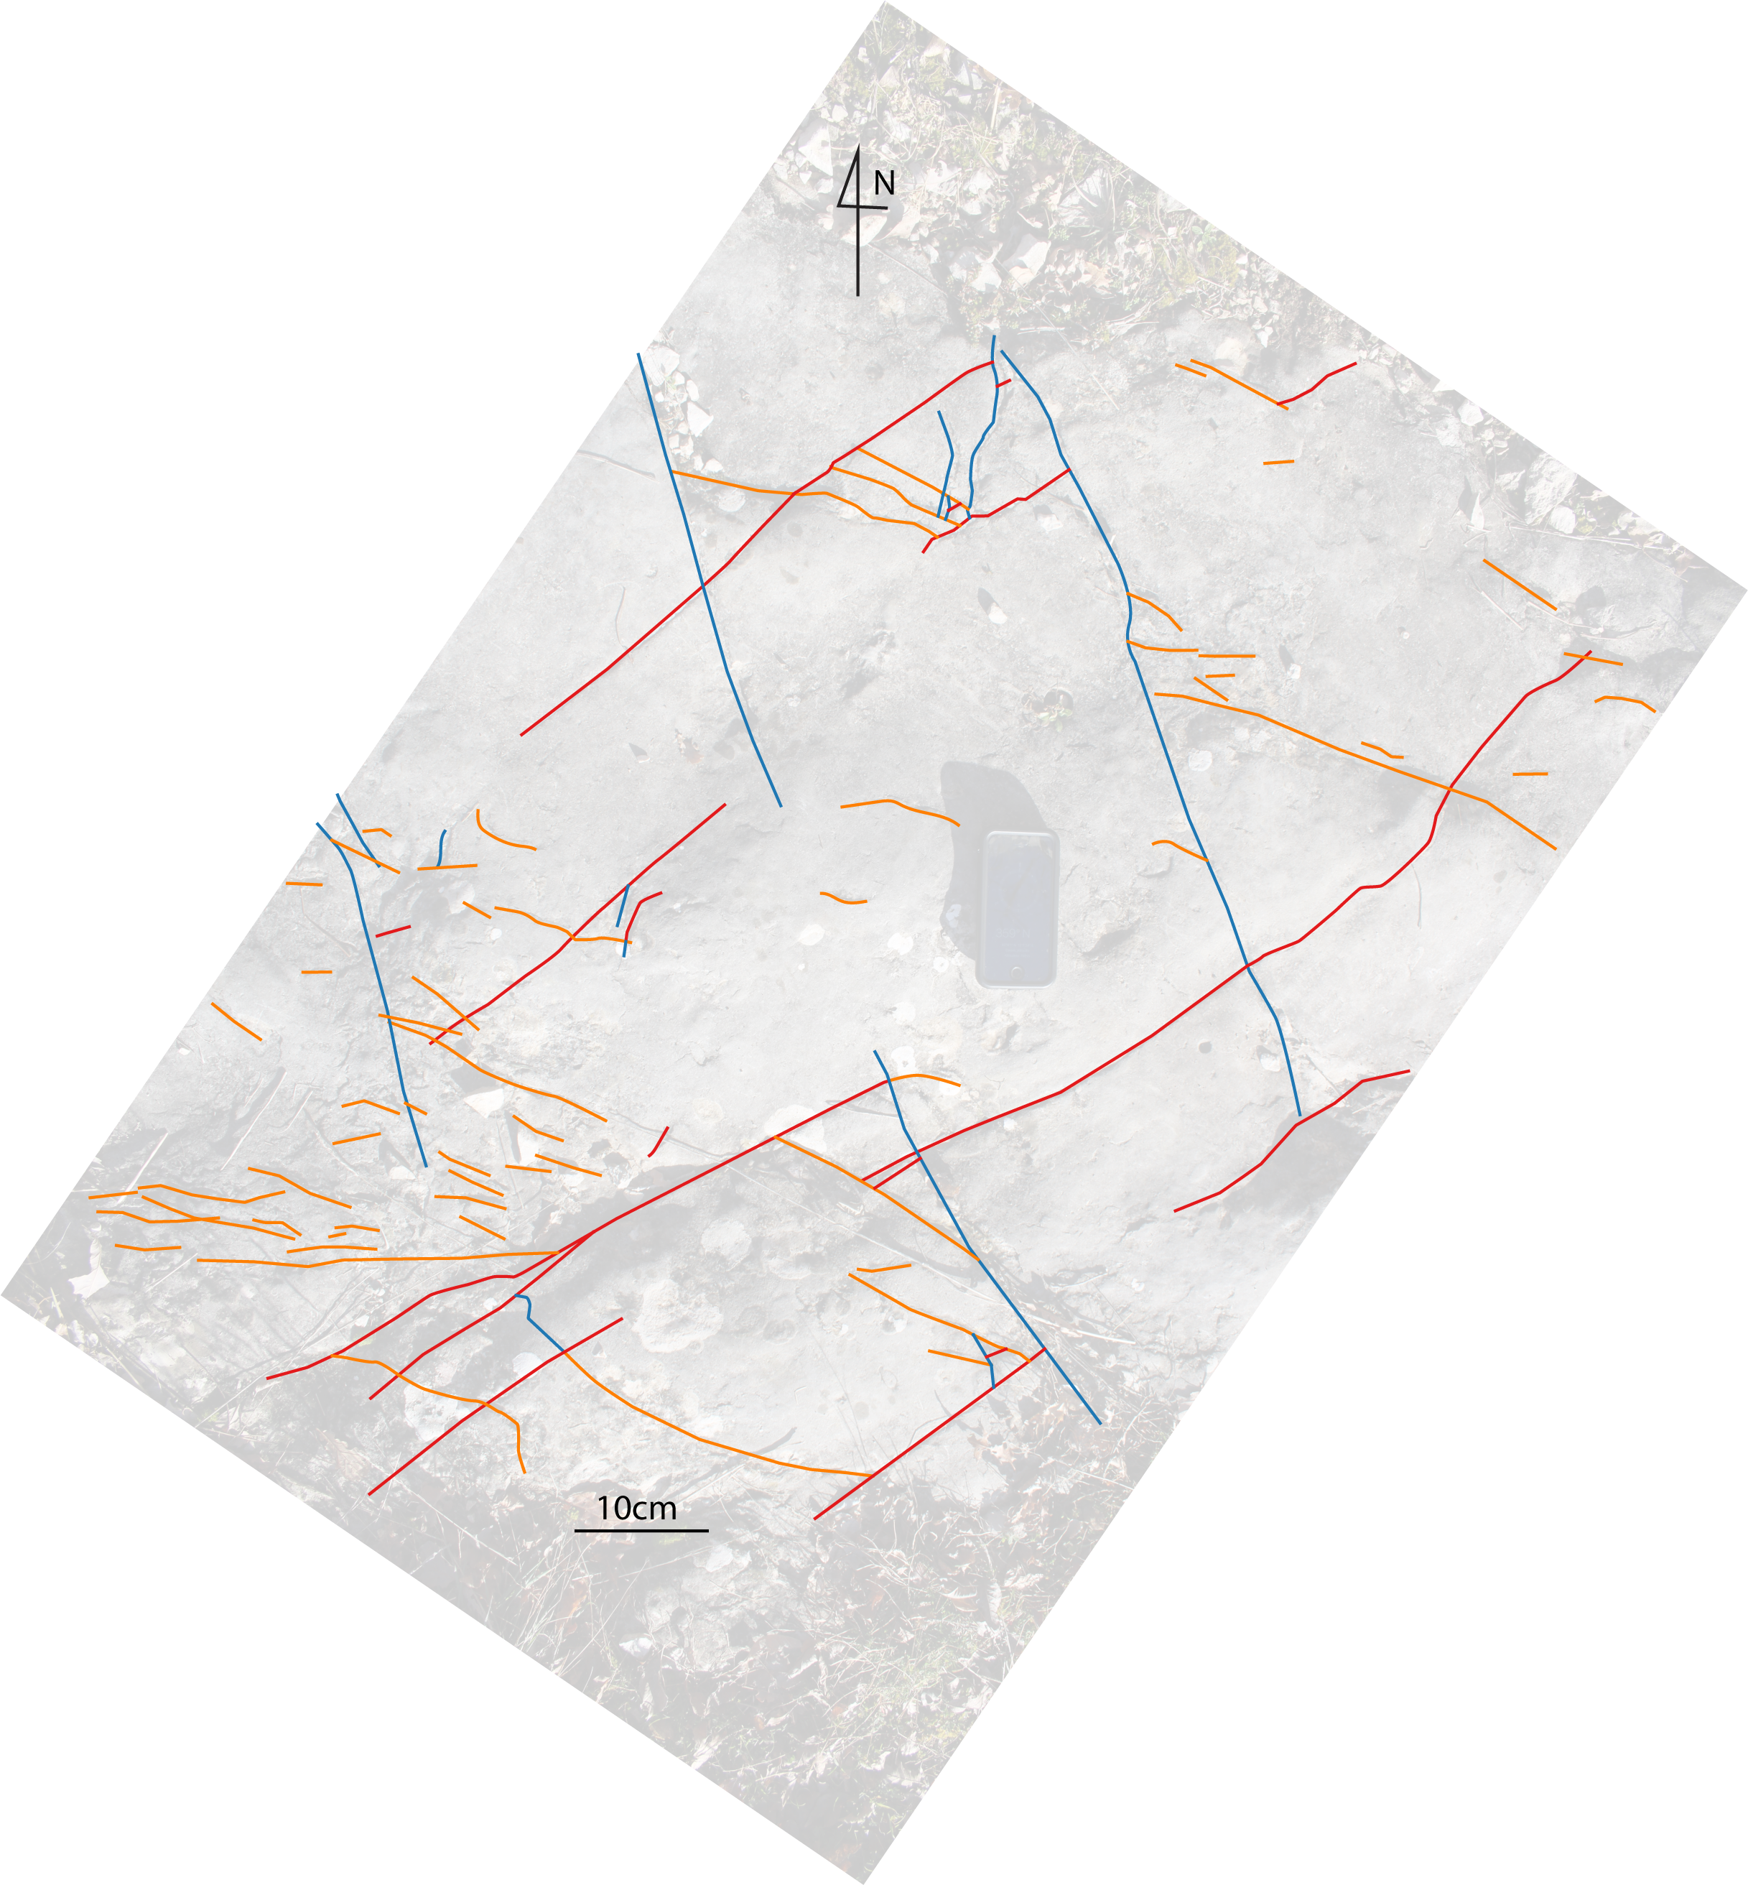
SA1.4

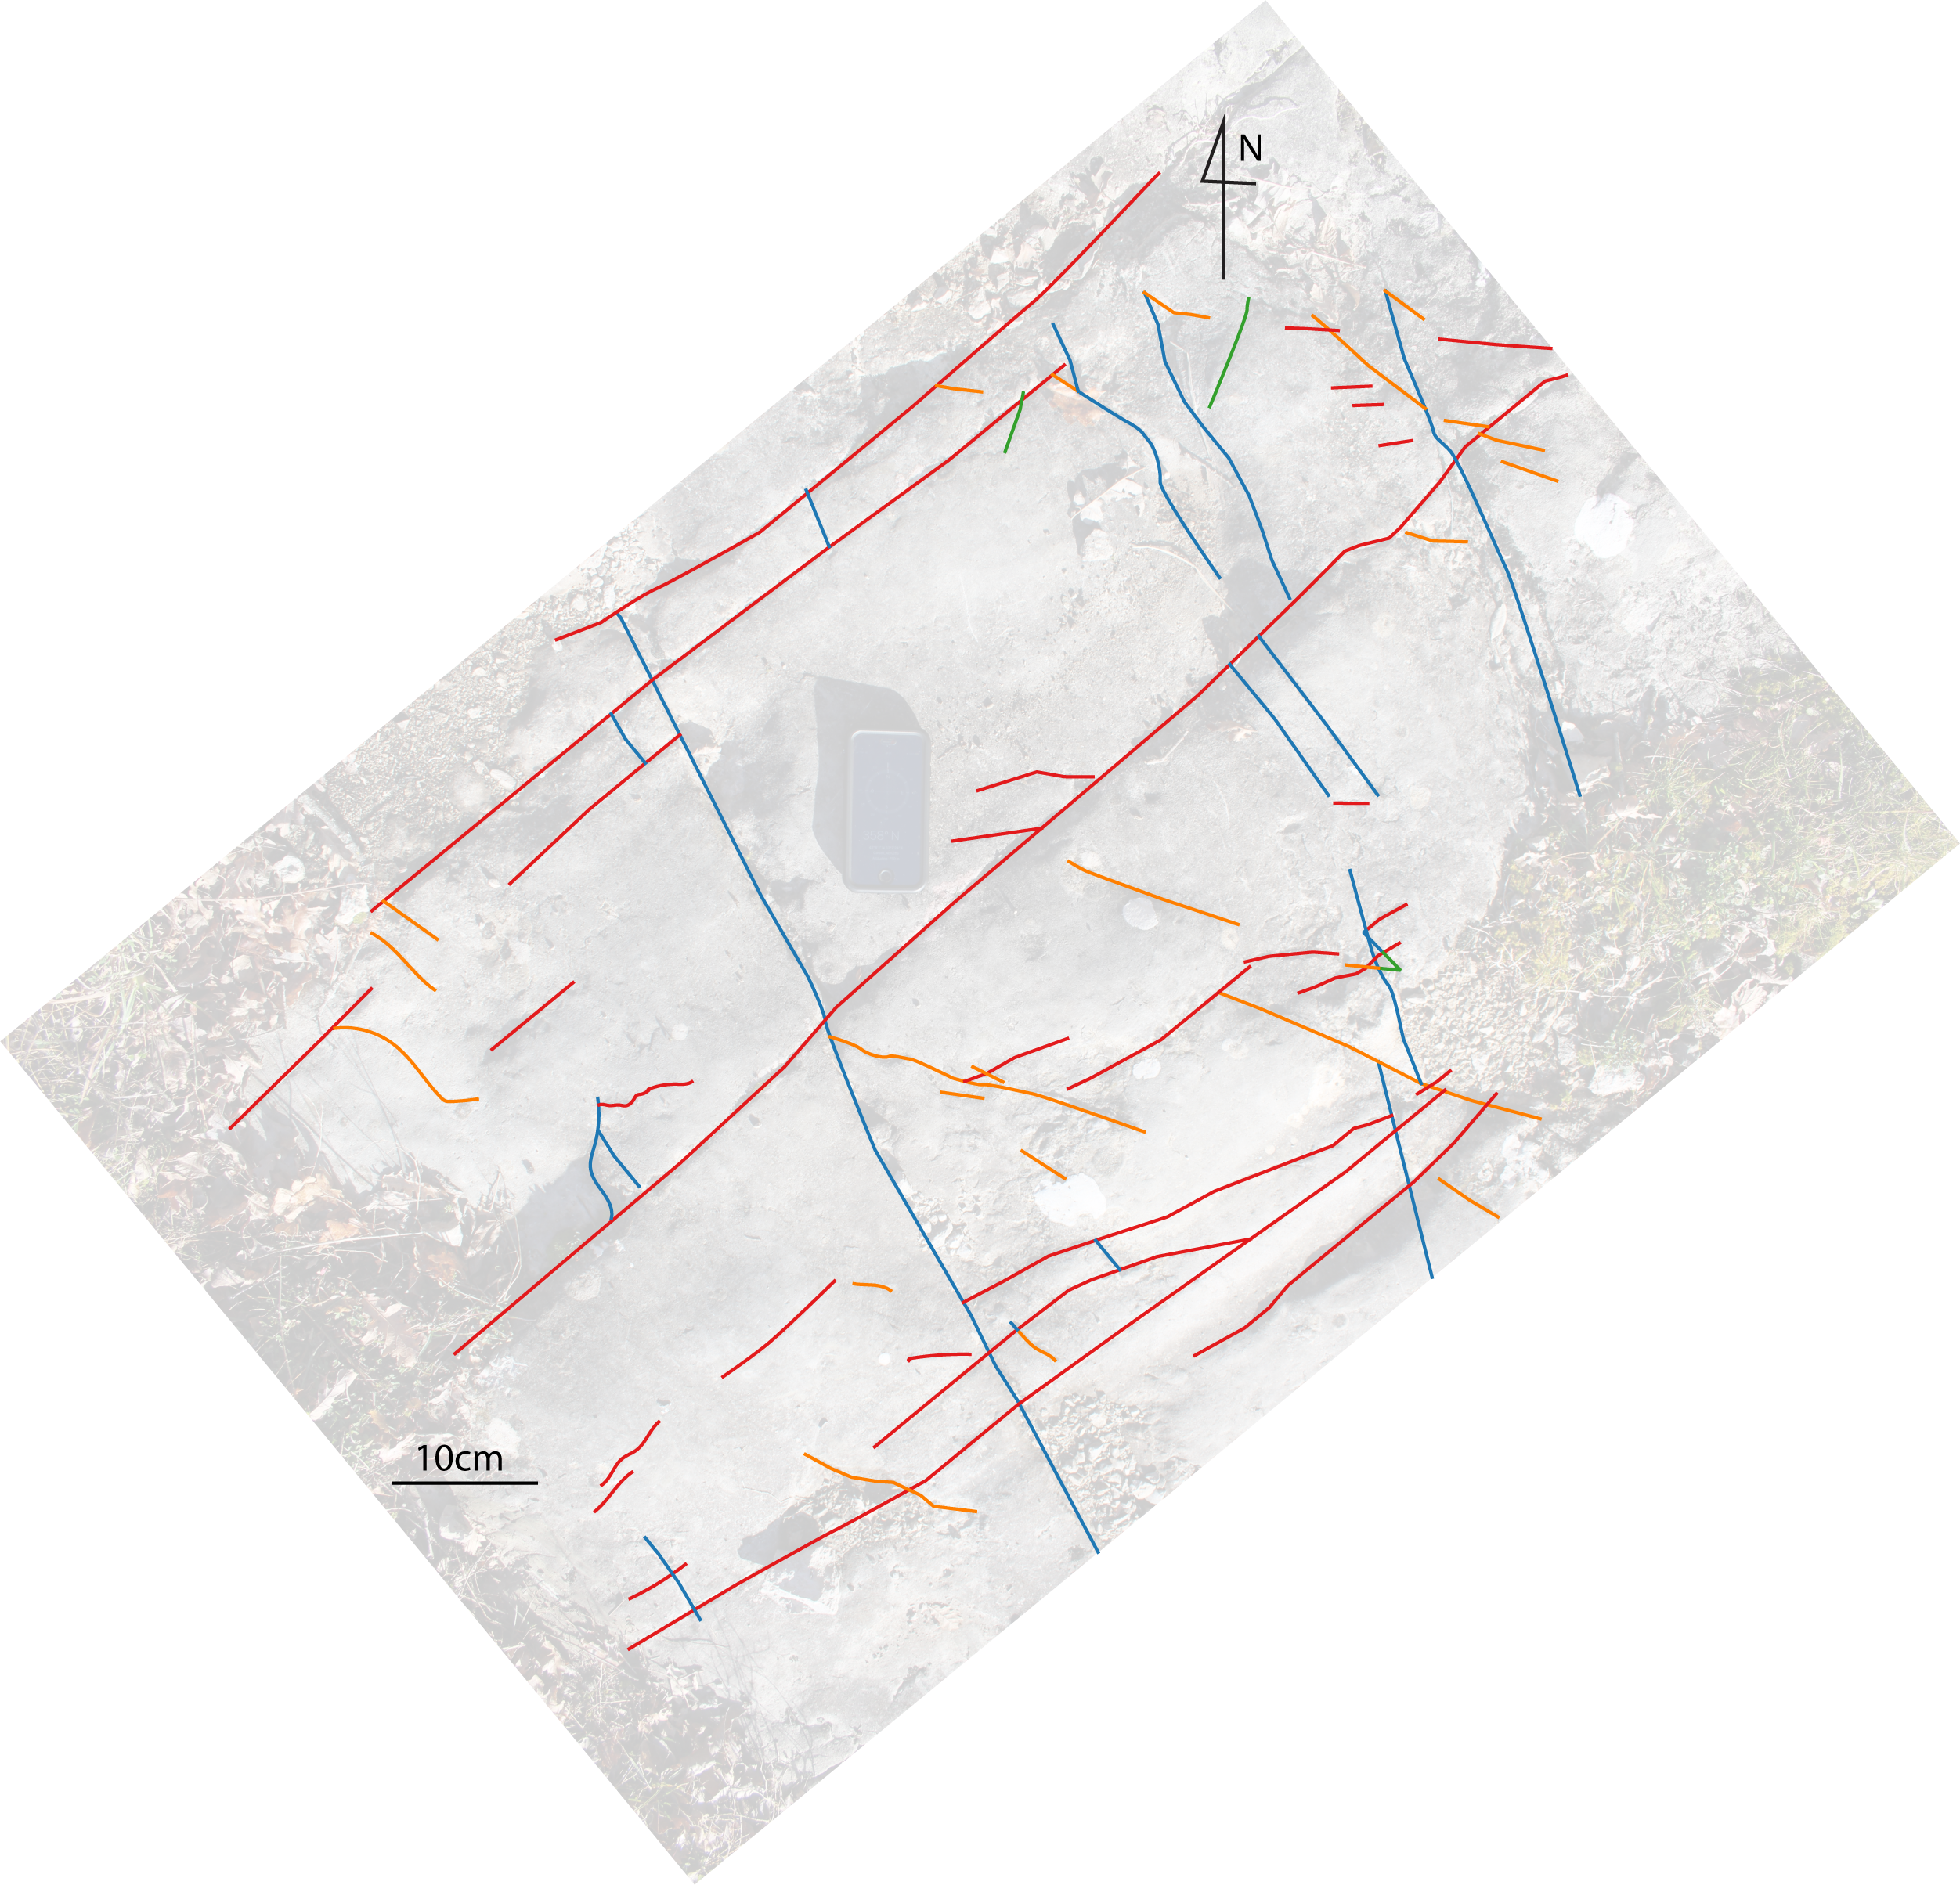
SA1.5
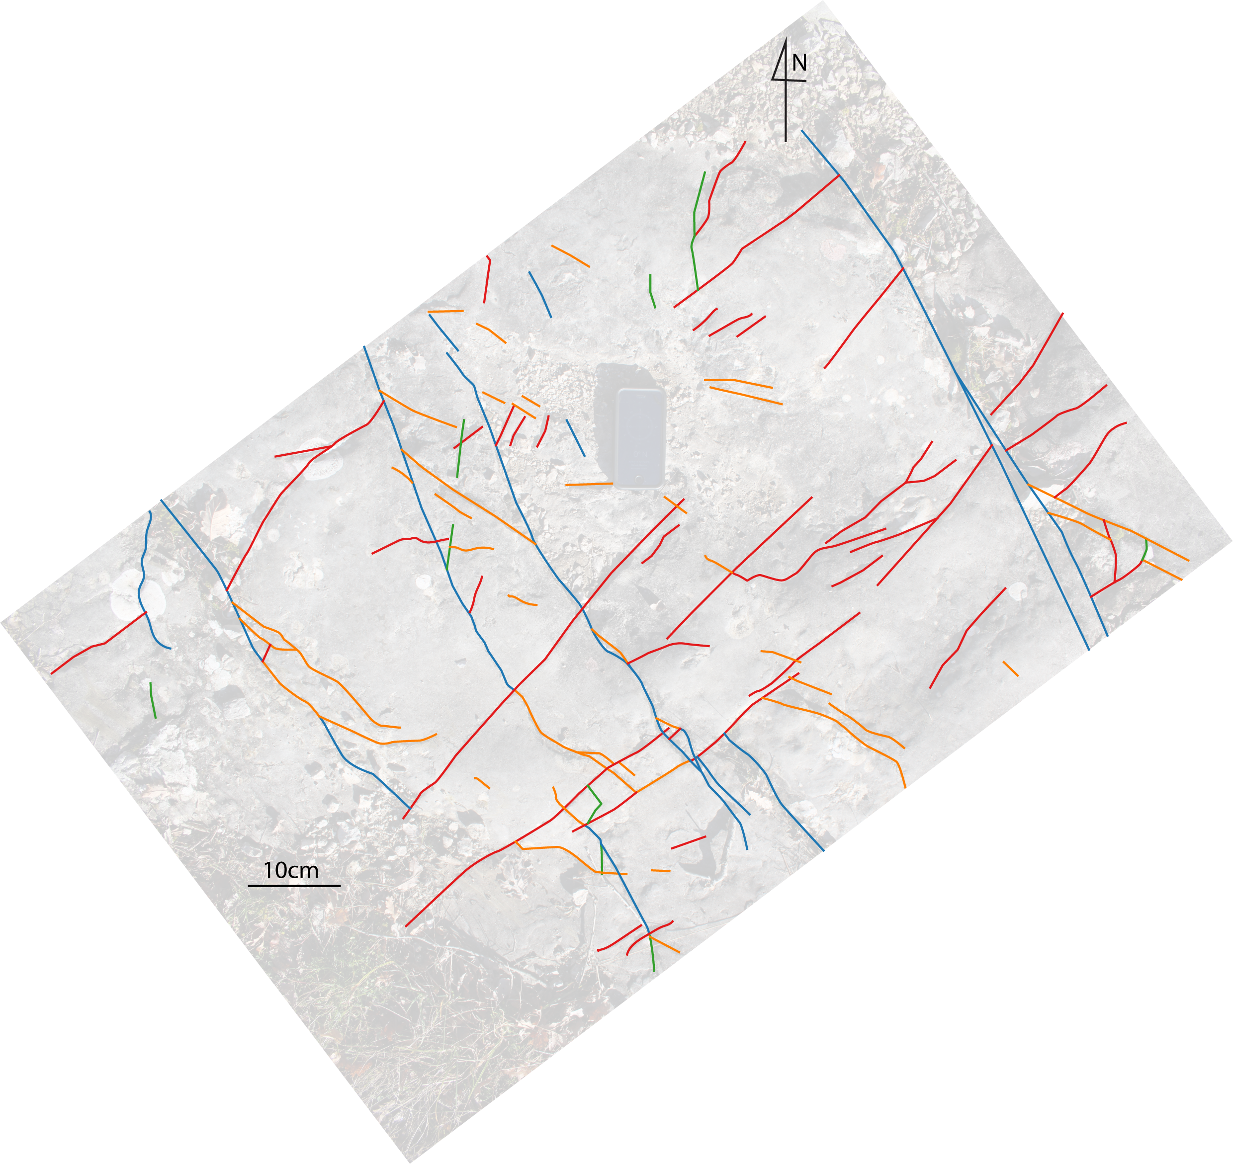
SA1.6
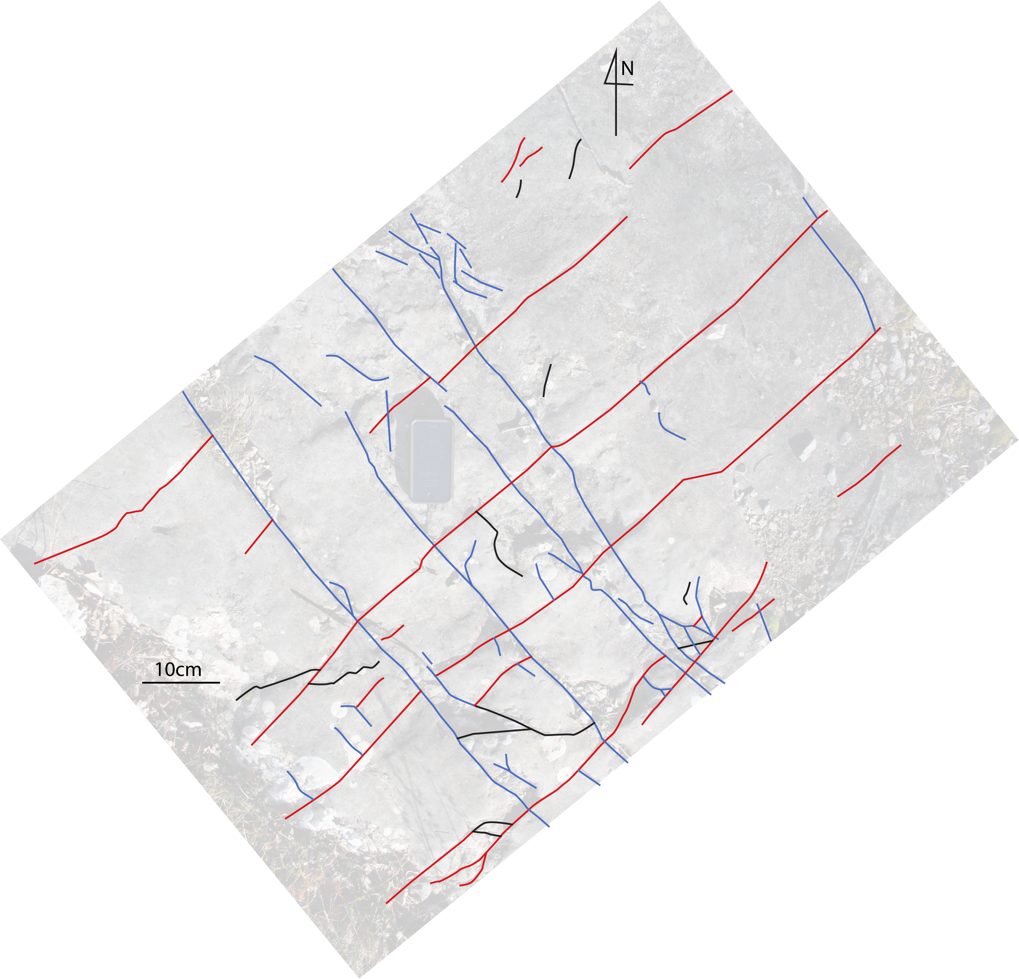
SA1.7
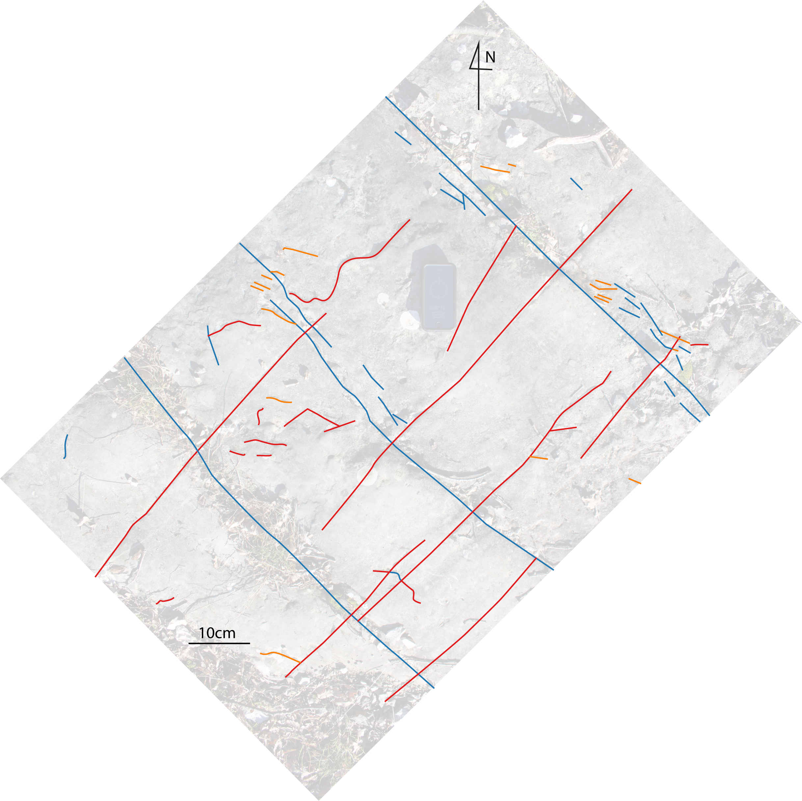
SA1.8
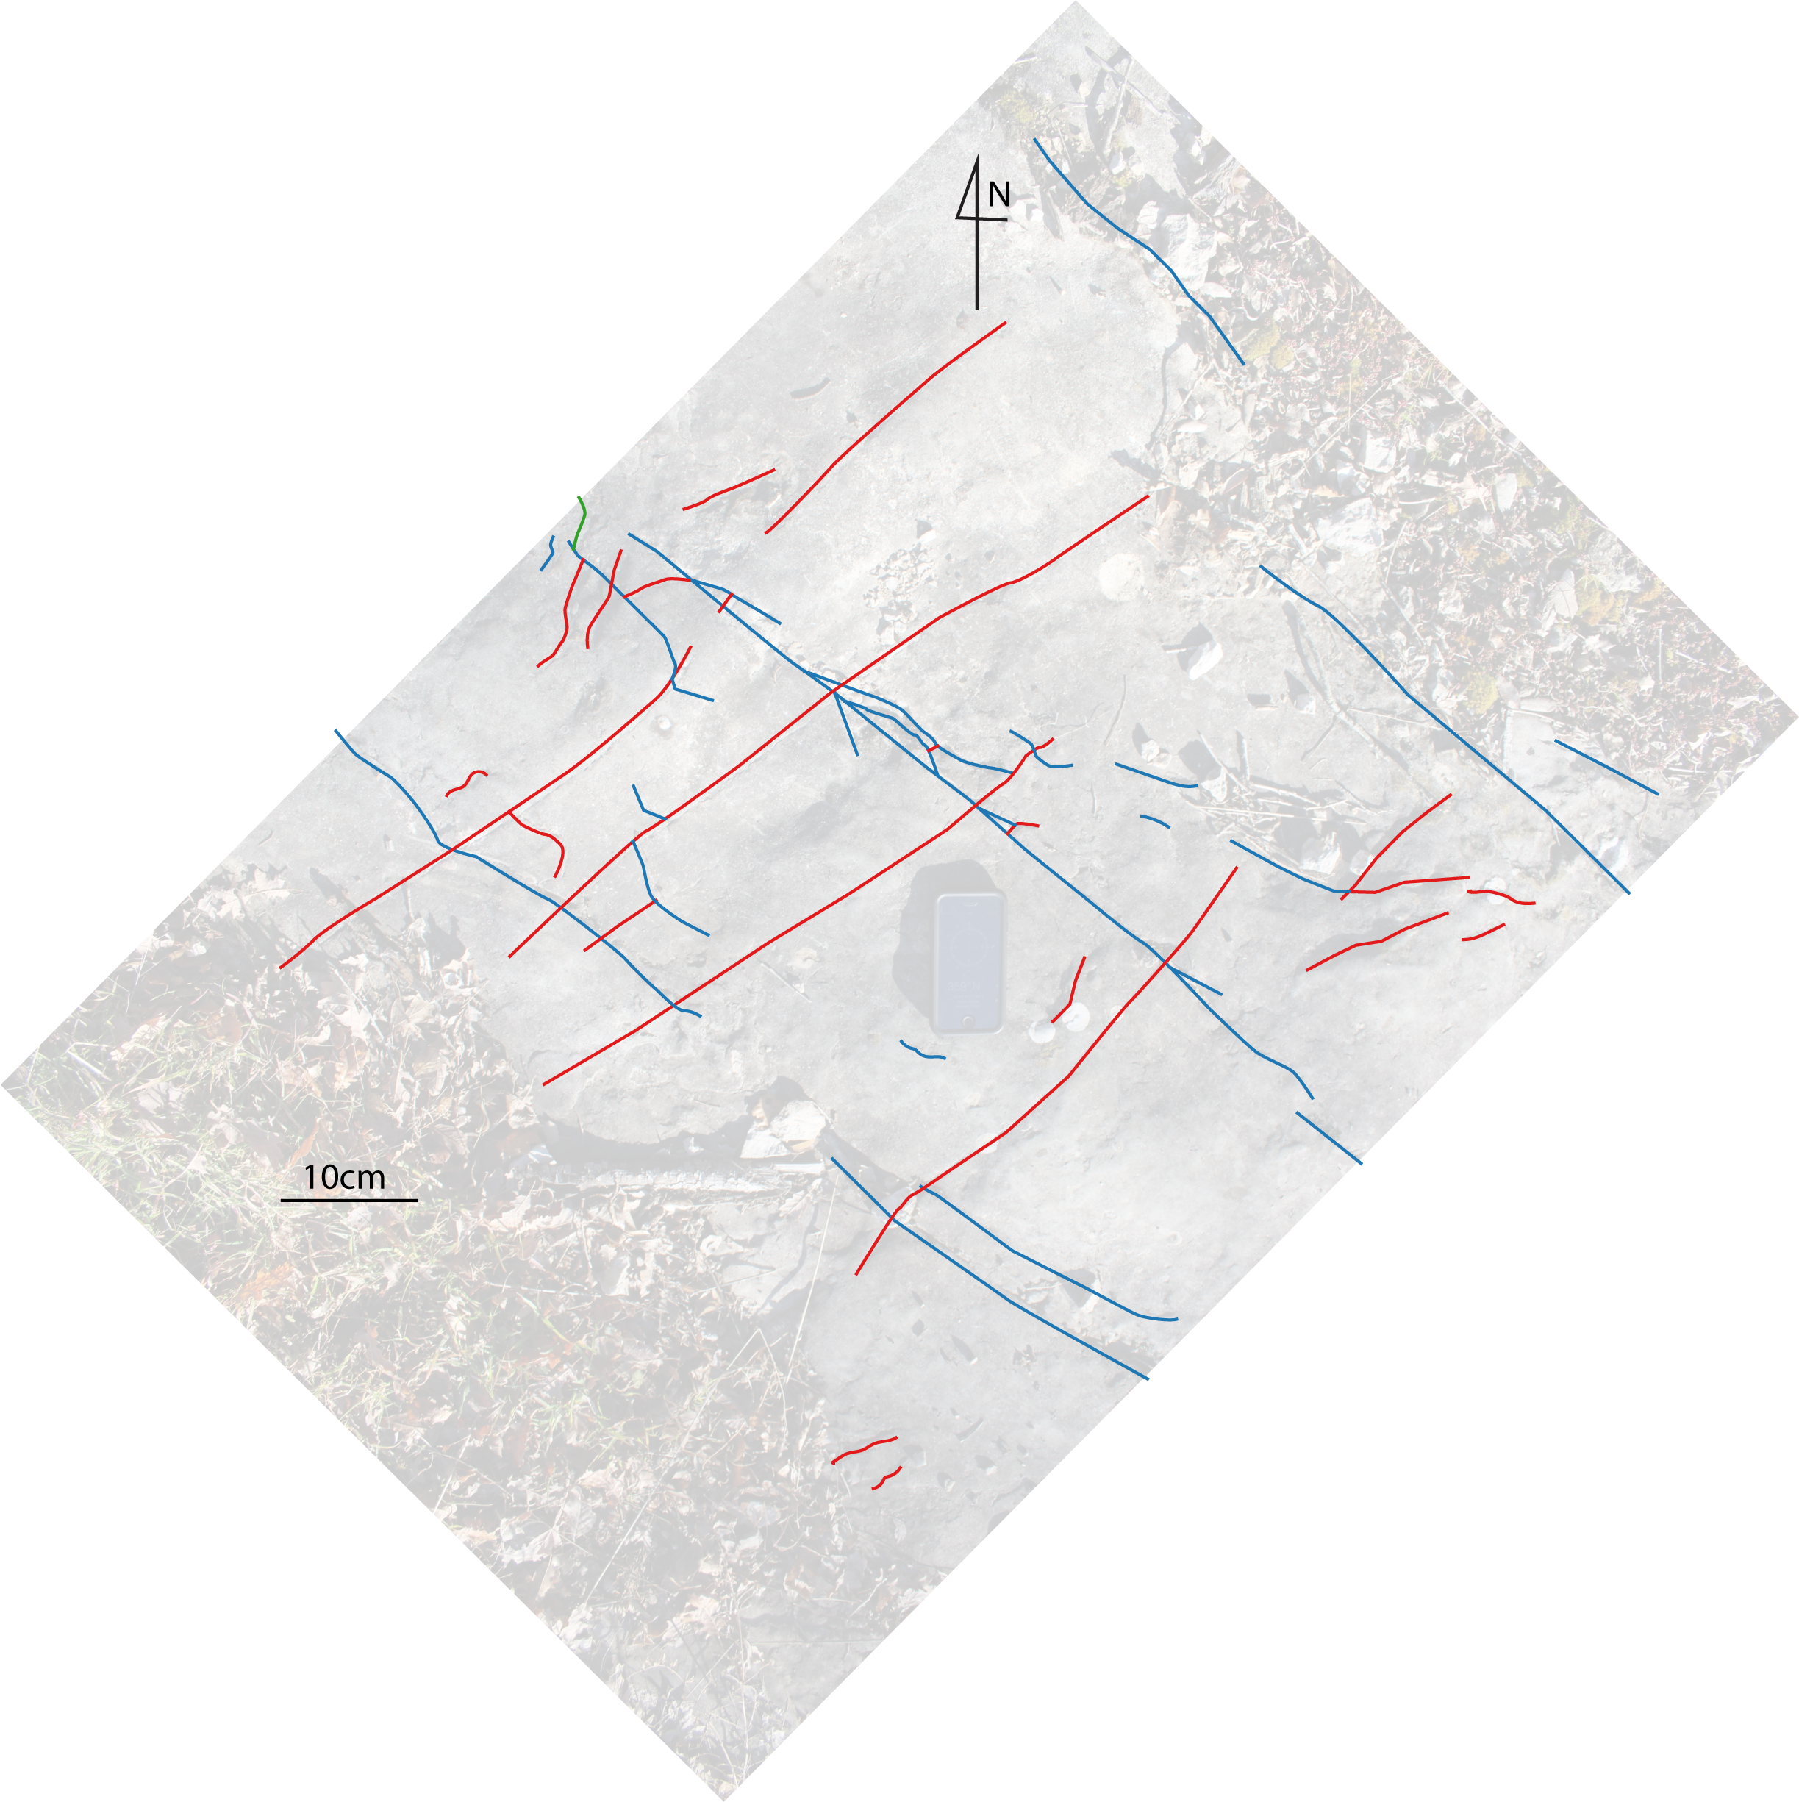
SA1.9
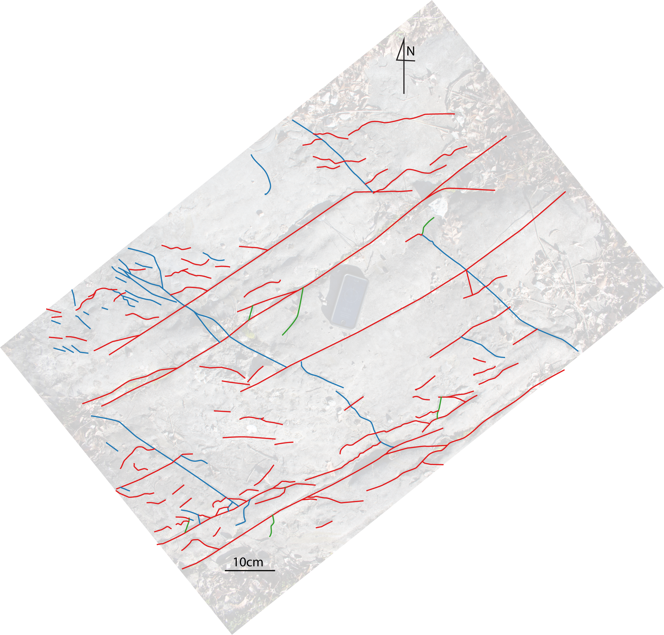
SA1.10
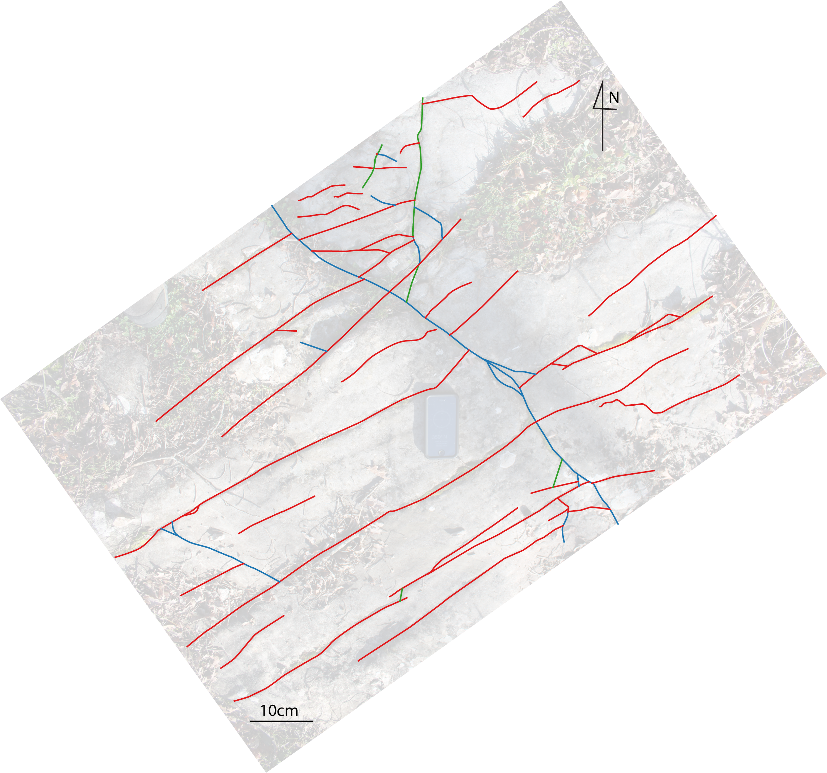
SA1.11
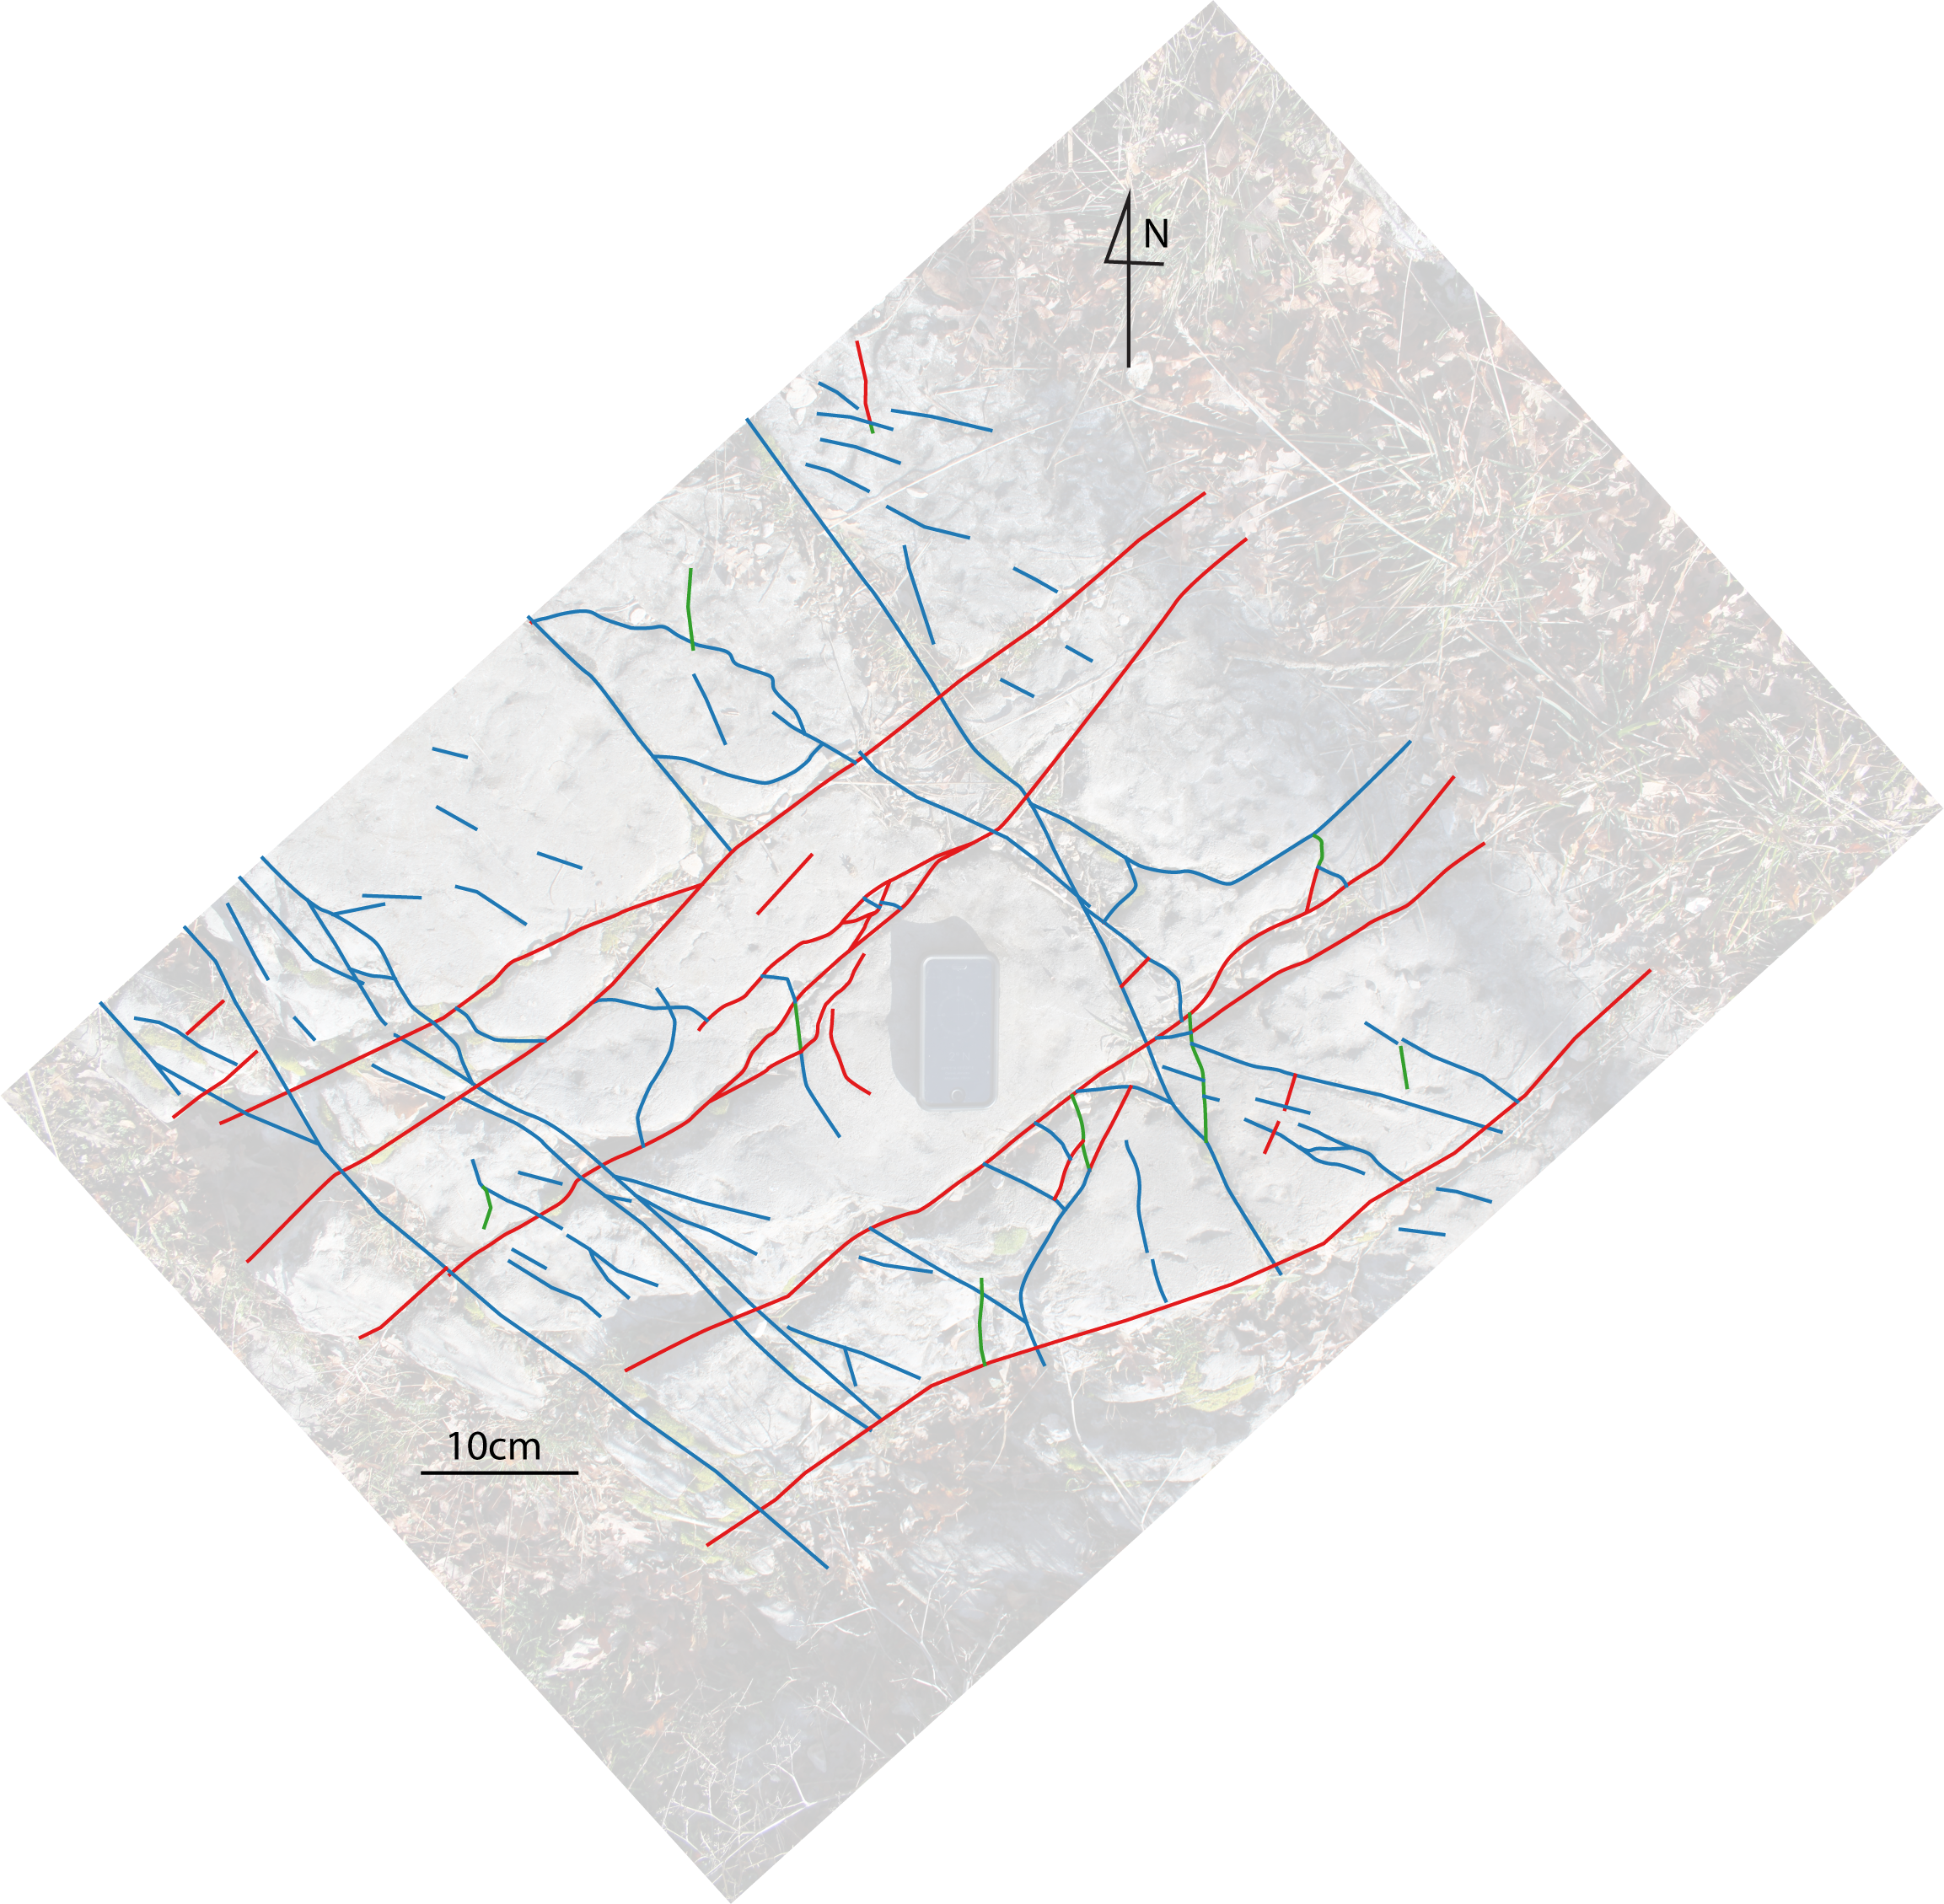
SA2.1
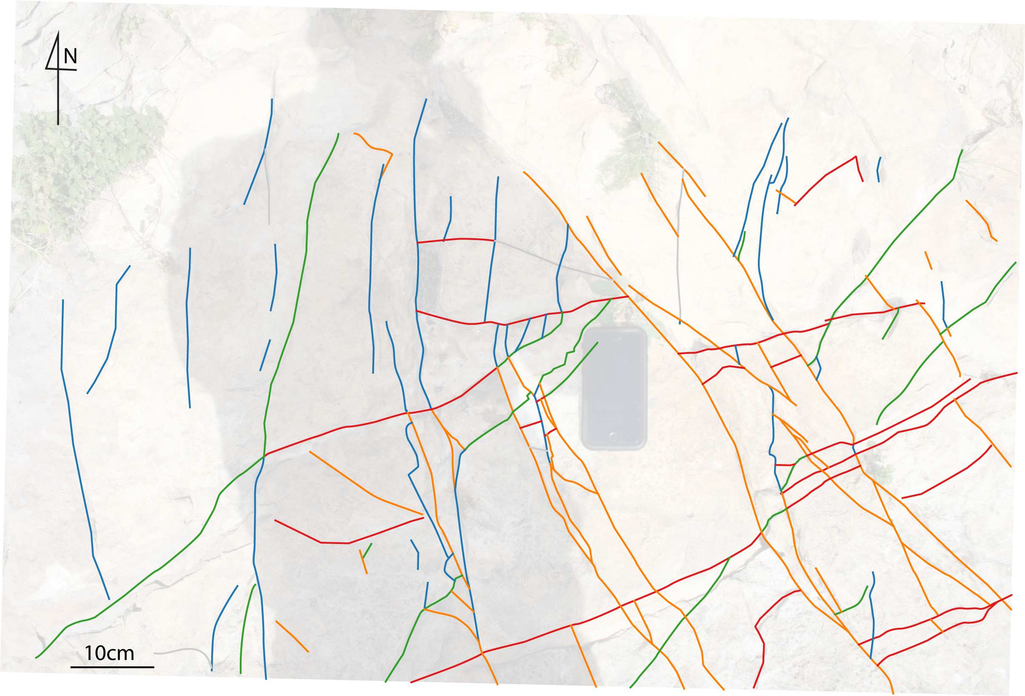

SA2.2
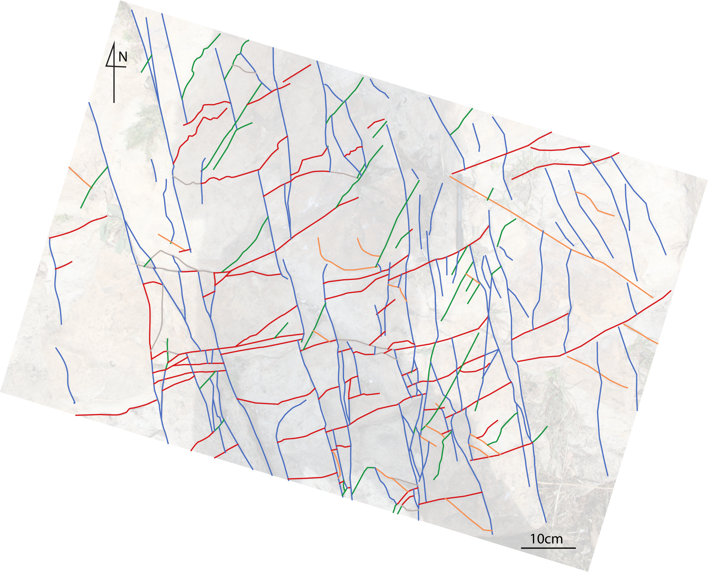
SA2.3
