Supplementary material file 1
2. Sample location and description
2.1 Sample 17GC1086 (Montauban group)
The quartzite sample 17GC1086C was detected within a package of garnet-sillimanite-biotite gneisses, metamorphosed wackes, garnetites, and amphibolites (i.e. metabasalts). The quartzite horizon has a thickness of ca. 1.5 m and is intercalated with metabasaltic bodies that form boudins within the adjacent lithologies. The quartzite has light grey colour and is characterised by the mineral assemblage: Qz-Grt-Kfls-Pl-Ccp-Py-Zrn. The metabasalts show commonly cm-scale banding defined by variations in the abundance of mafic minerals.
Sample name | Coordinates
17GC1086C | 47°45'14.20"N, 72°22'28.80"W
18YD2075 | 48° 6'30.10"N, 72°14'19.00"W
19FS7085 | 48°56'46.15"N, 72°48'50.18"W
19AM02 | 48°58'57.50"N, 72°59'58.32"W
Table 2.1. Coordinates of the quartzite samples

2.2 Sample 18YD2075 (Wabash Complex)
The sample 18YD2075 consists of a horizon of medium-grained, recrystallized quartzite characterised by the mineral assemblage: Qtz-Mc-Ms-Bt±Po. The quartzite is intermingled with gneisses of La Bostonnais complex.

2.3 Sample 19FS7085 (Barrois Complex)
The sample 19FS7085 is a meter-scale quartzite horizon with white colour characterised by the mineral assemblage: Qtz-Bt-Py-Gr. The quartzite is intermingled with calcosilicate rocks and paragneisses.

2.4 Sample 19AM02 (Barrois Complex)
The sample 19AM02 is a decimetre-scale, medium-grained, whitish quartzite horizon characterised by the mineral assemblage: Qtz-Gr-Afs-Bt-Py. The sample is intermingled with biotite-bearing paragneisses.
2. Analytical settings (U-Pb and Lu-Hf sessions)
Laboratory & Sample Preparation
Laboratory name | Geotop; Université du Québec à Montréal
Sample type/mineral | Zircon
Sample preparation | Conventional mineral separation, 1 inch resin mount, 1μm polish to finish and thin section
Imaging | Centorus CL imager on a Hitachi S3400N SEM
Laser ablation system
Make, Model & type | Photon-Machines G2
Ablation cell | Helix two-volume cell
Laser wavelength (nm) | 193 nm
Pulse width (ns) | 4 ns
Fluence (J.cm⁻²) | 3 Jcm⁻² (U-Pb)/ 9Jcm⁻² (Lu-Hf)
Repetition rate (Hz) | 5 Hz (U-Pb)/15 Hz (Lu-Hf)
Ablation duration (secs) | 30 secs (U-Pb)/ 20 secs (Lu-Hf)
Ablation pit depth / ablation rate | Not available
Spot diameter (μm) nominal/actual | 25 μm U-Pb/ 50 μm Lu-Hf
Sampling mode / pattern | Static spot ablation
Carrier gas | 100% He in ablation cell, Ar make-up gas combined using a Y-piece 35% along the sample transport line to the torch.
Cell carrier gas flow (l/min) | 0.7 l/min in first volume cell  0.5 l/min in second volume cell
ICP-MS Instruments
Make, Model & type | Nu Instruments, Nu Attom HR-ICP-MS and NuPlasma II MC-ICP-MS
Sample introduction | Ablation aerosol
RF power (W) | 1300W
Make-up gas flow (l/min) | Ar (ca. 0.75 l/min, optimized daily)
Detection system | Attom: Ion counter; full size discrete dynode type  NuPlasmaII : Faraday cups, 10^11 ohms resistors
Masses measured | 202, 204, 206, 207, 208, 232, 235, 238 for Attom  171 to 182 (Hf, Lu, Yb, Ta) for NPII
Integration time per peak/dwell times (µs) | 500µs per isotope, 20 sweeps per cycle for Attom  0.2 sec for NPII
Total integration time per output datapoint (secs) | - seconds  - seconds
‘Sensitivity’ as useful yield (%, element) | 0.4%U (NIST 610 = 500ppm, #atoms sampled:  500ppm*85um*5hz*3J/cm2: >20Mcps ²³⁸U) for Attom  Ca. 550 V/ppm Hf with Aridu II for NPII
IC Dead time (ns) | 12 ns
Data Processing
Gas blank | 30 second on-peak zero subtracted
Calibration strategy | 91500 used as primary reference material, in-house secondary
Reference Material info | 91500 (Wiedenbeck et al. 1995)
Data processing package used / Correction for LIEF | Nu Instruments TRA and Iolite (Paton et al., 2011) for data normalization, uncertainty propagation and age calculation. LIEF correction assumes reference material and samples behave identically.
Mass discrimination | Down-hole correction and standard bracketing (Iolite)
Common-Pb correction, composition and uncertainty | No common-Pb correction applied to the data.
Uncertainty level & propagation | Ages are quoted at 2s absolute, error propagation is by Iolite.
Quality control / Validation | Different zircon secondary reference materials (see below)
Other information

3. Secondary reference materials (U-Pb and Lu-Hf)
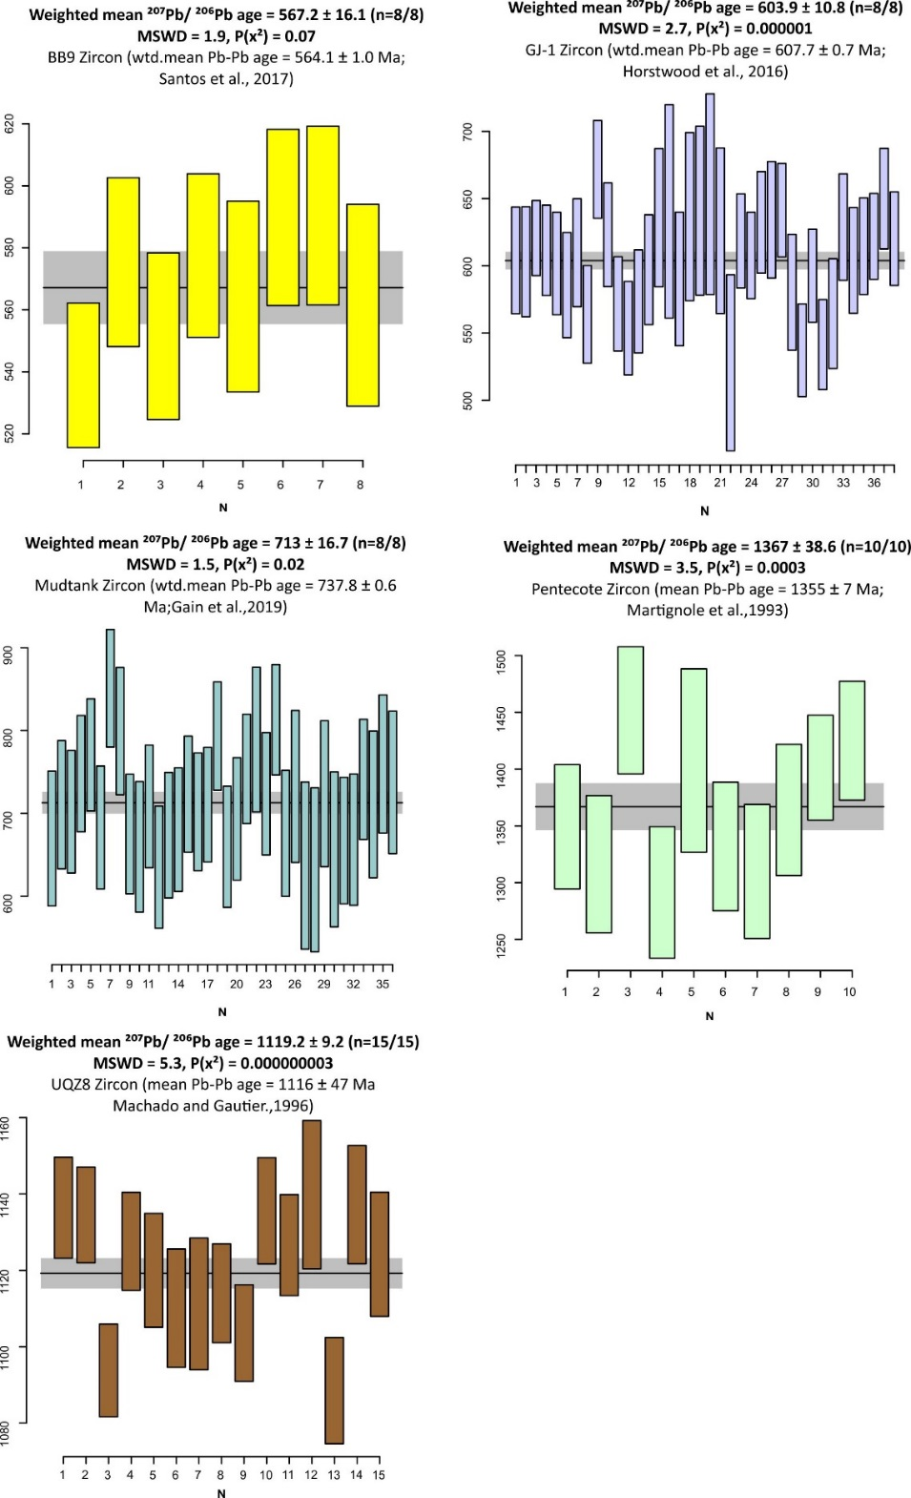
Figure 3.1 Weighted mean ²⁰⁷Pb/²⁰⁶Pb ages of secondary zircon reference materials
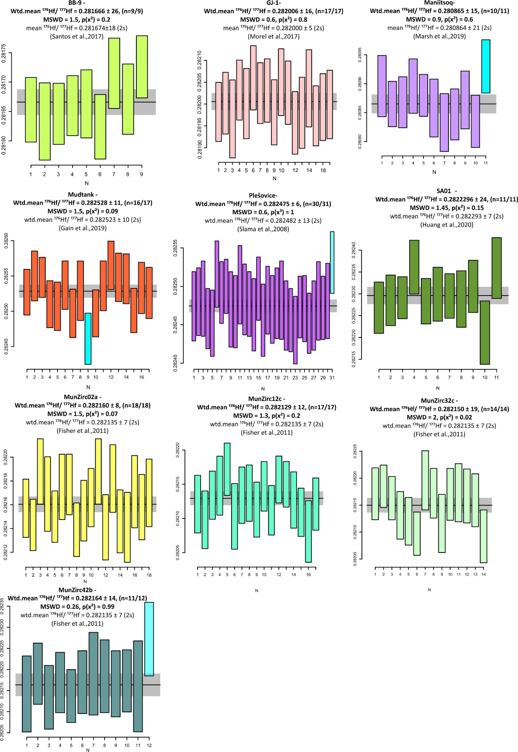
Figure 3.2. Weighted mean ¹⁷⁶Hf/¹⁷⁷Hf ratios of secondary reference materials

