**Supplementary sheet-3**

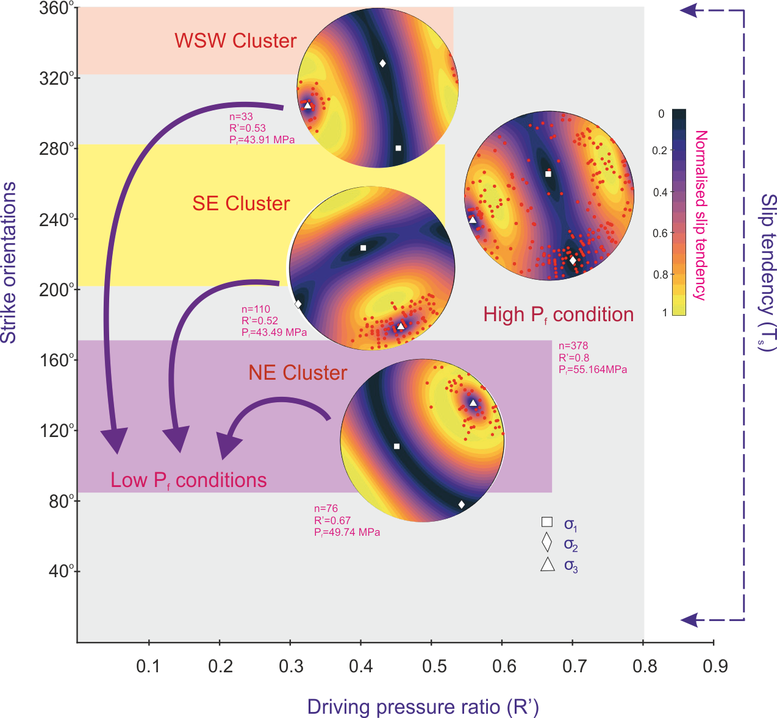

**Figure S2.** Bhowmick and Mondal

Slip tendency variation with driving pressure ratio (*Rˊ*) for the respective strike orientation of veins under both high and low *Pf* conditions. The colored rectangles represent the ranges of strike orientation and *Rˊ* values for each stress state. Lower hemisphere equal area projection of vein pole data (red dots) showing slip tendency variation with *Rˊ* (Fractend code available via Github, 2017). The warm color zones represent vein orientations with high slip tendency values (high shear to normal stress). ‘Thermal’ color scheme from Thyng et al., 2016. White square (*σ1*), white diamond (*σ2*), white triangle (*σ3*).