Supplementary information for
“Revisiting the phosphorite deposit of Fontanarejo (central Spain): new window into the early Cambrian evolution of sponges and the microbial origin of phosphorites”
by Joachim Reitner, Cui Luo, Pablo Suarez-Gonzales, Jan-Peter Duda

Extended figures form the recent outcrop conditions and geochemical data from the phosphorites.

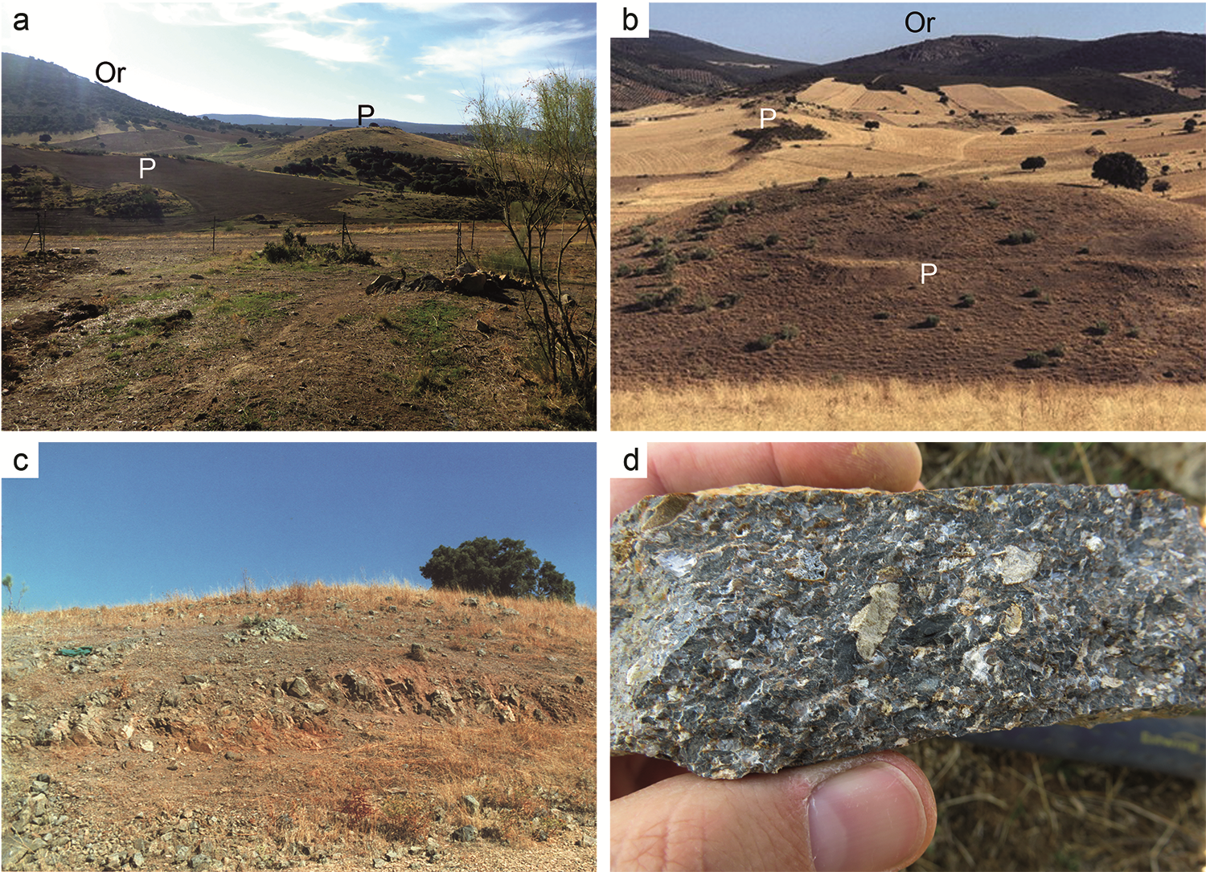
Fig. S1
Landscape view (a) to the south with hills showing phosphatic sediments (P). Tree-rich areas represent Ordovician quartzites (Or). (b) Landscape view to the north, with hills showing phosphatic sediments (P). (c) Bedded phosphatic sediments near elevation point 692 m in the southeast corner of the geological map. Note that the picture was taken in 2002, and that the area is planted with trees today. The beds show an inclination to the east of 70º. (d) Detailed picture of coarse phosphatic sediment from Fig. S1c.
Fig. S2
Sedimentary characteristics of the Pusa Formation. (a) Finely laminated specimen of the Pusa Formation, interpreted as distal turbidite facies. (b) Thin section micrograph of the panel in Fig. 2a, showing bright silt-rich layers overlain by dark mud layers (Bouma Td-e interval). (c) Gray silt-rich mudstones of the Pusa Formation. (d) Distal turbidite layers (Bouma Tc-e interval). (e) Meter-thick channel-filling conglomerate (without phosphorite).

Fig. S3
Micro X-ray fluorescence (μ-XRF) maps of a phosphatic rock (Fon1/19) showing the distribution of some major elements. The rock sample is cemented by silica (Si enrichments) and contains Fe-oxides (Fe enrichments), which are likely an alteration product of former pyrite. The most abundant mineral is apatite (Ca and P enrichments). The origin of anatase (TiO₂; Ti enrichments) is still unclear, but it might formed authigenically through microbially mediated precipitation.

Fig. S4
(a) Median-oblique cut of a cloudy-colloform microbialite, showing in the center a large stronglye megasclere. Rectangle marks the area of a Raman map. (b) Detail of the map area. (c) Raman map: red, organic matter; dark blue, anatase – (TiO₂); green, apatite; blue, apatite + organic matter (Fon10).

Fig. S5
(a) A domal microstromatolite, rectangle marks the Raman map area. (b) Detail of the map area. (c) Raman map: red, anatase – (TiO₂); blue, apatite + organic matter; green, apatite (Fon10).

