SUPPLEMENTARY MATERIAL (Figures)
Figure S1. QAP diagram of the studied samples from Huaco and Sanagasta Units.
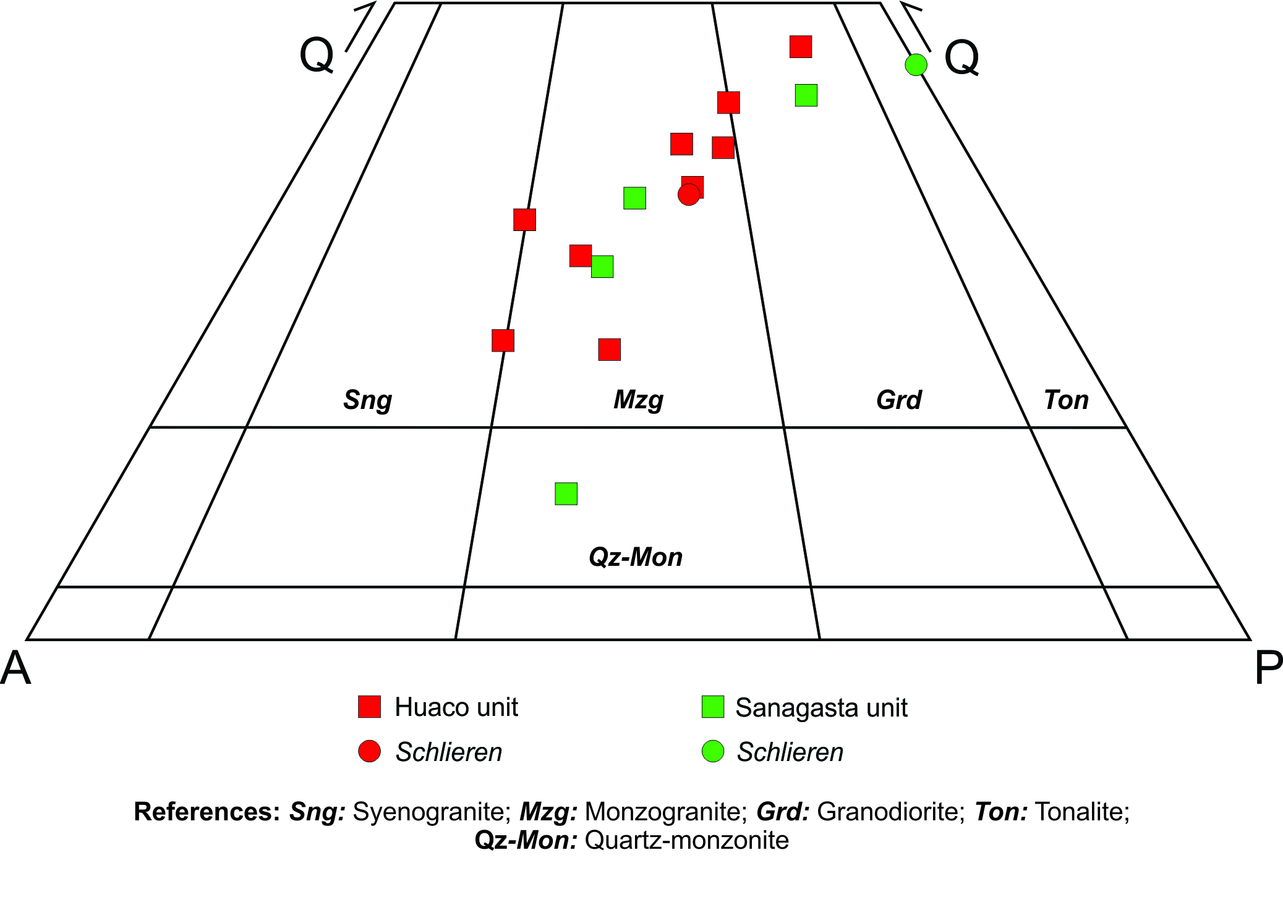

Figure S2. Ab-An-Or diagrams of average contents of plagioclases of Huaco Unit. Each colour is representative of a different analyzed crystal.
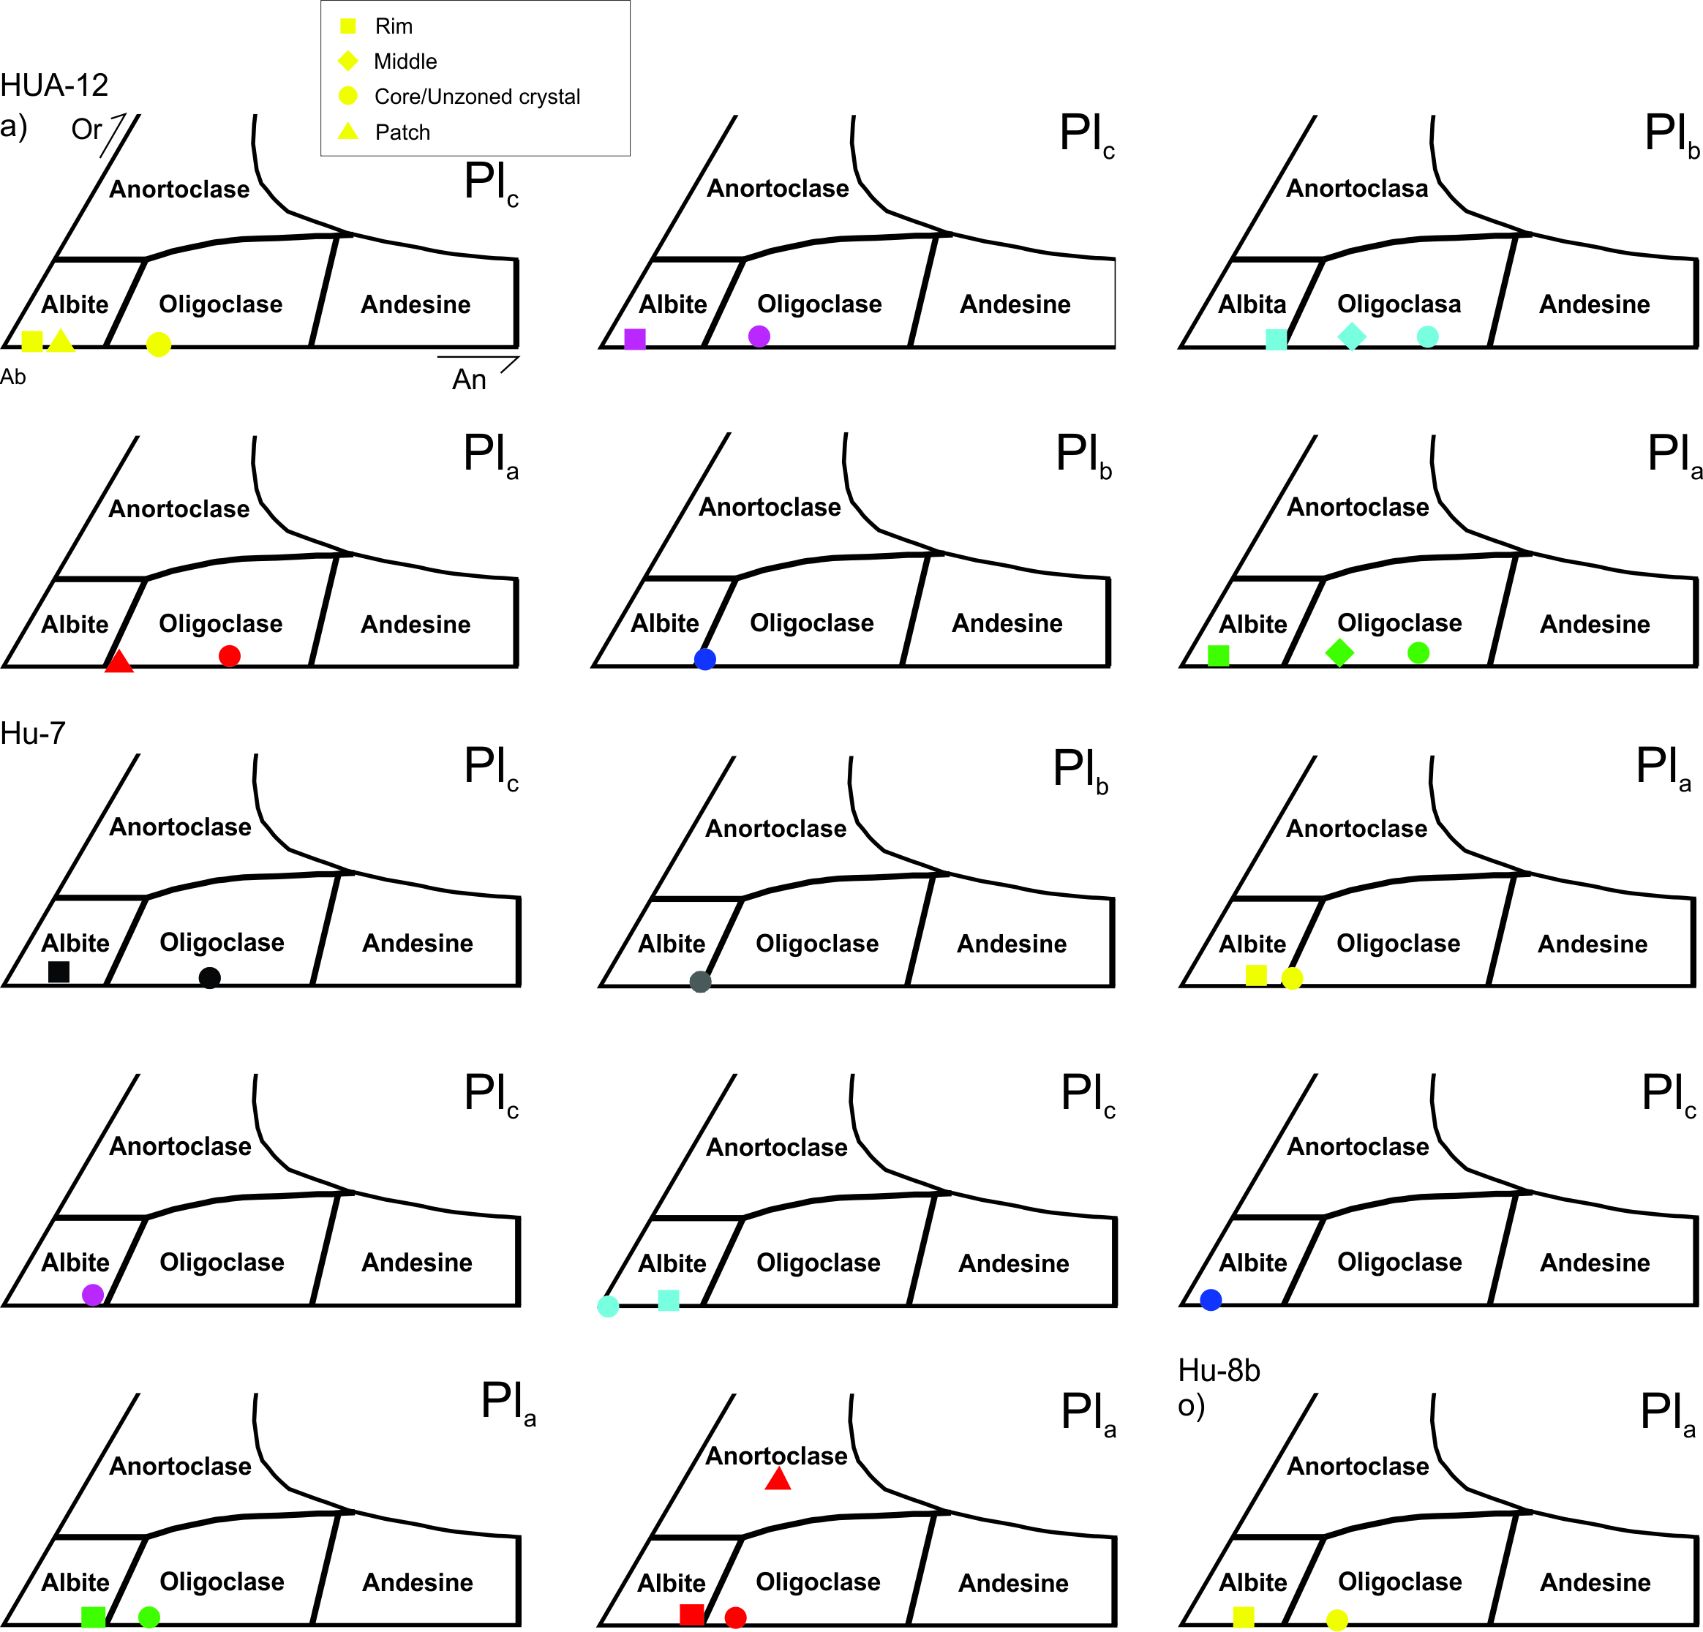

Figure S3. Ab-An-Or diagrams of average contents of plagioclases of Sanagasta Unit. Each colour is representative of a different analyzed crystal.
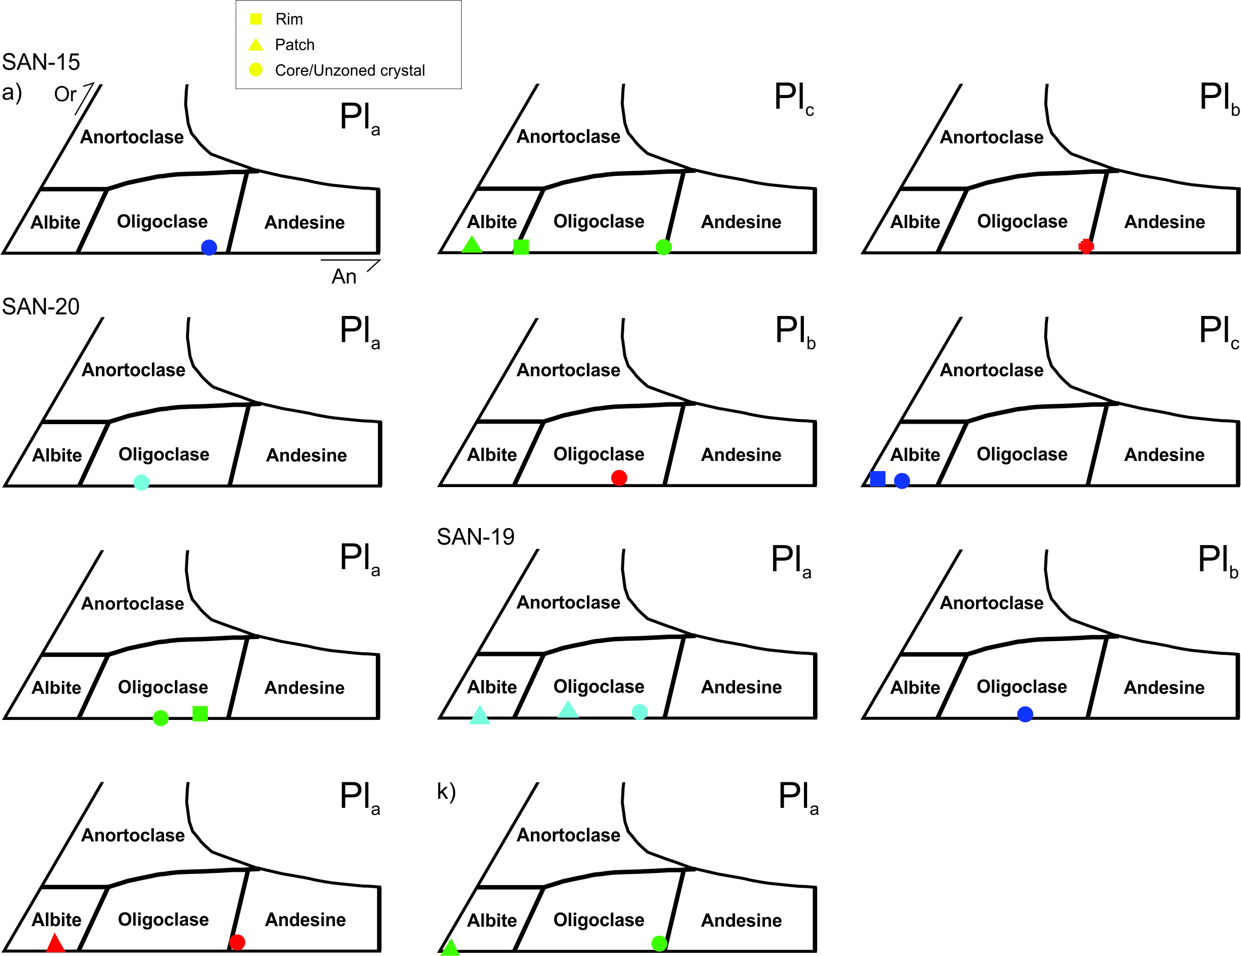

Figure S4. Feal vs Mgli diagram of Tischendorf et al. (2007).
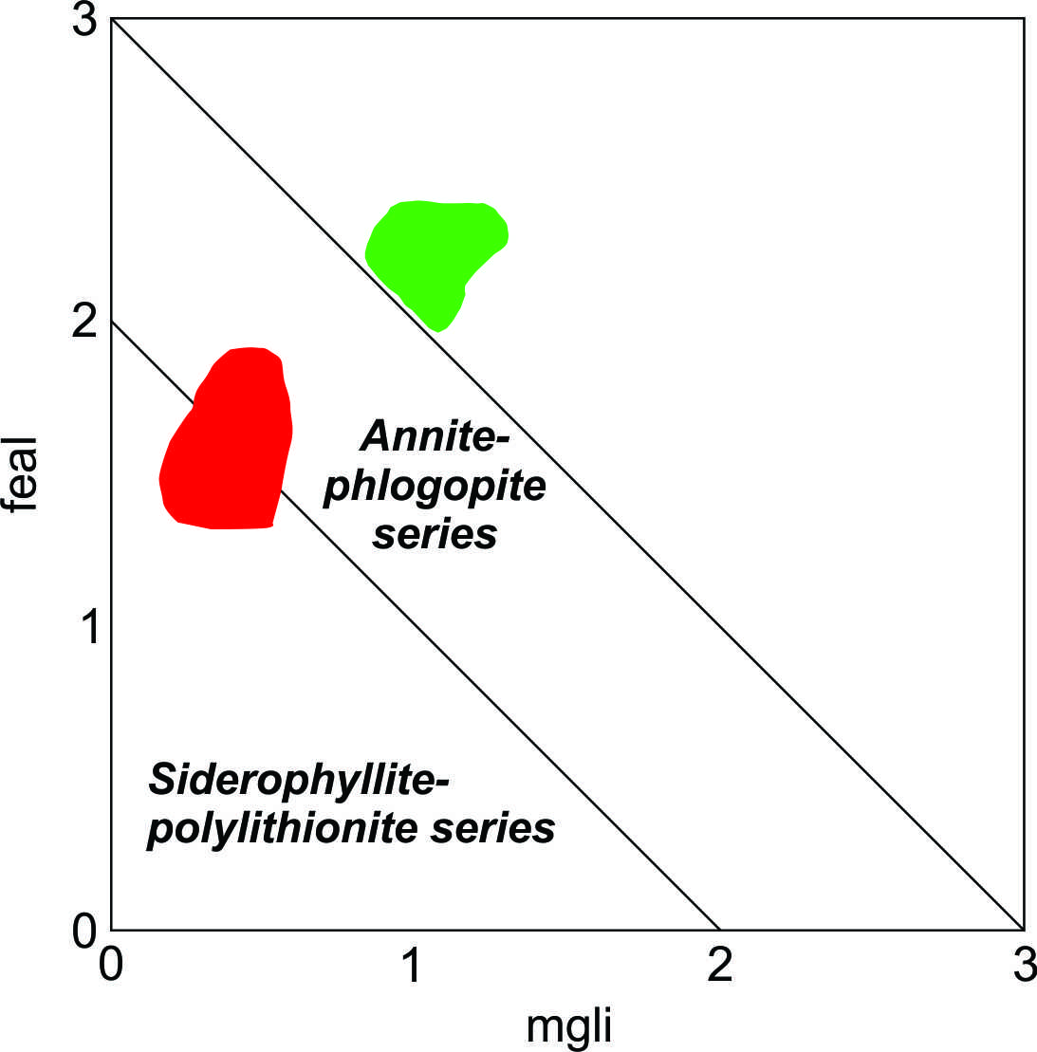

Figure S5. Diagram showing εNd values of Huaco and Sanagasta Units, as well as mafic enclaves included in them, Lower Mississippian mafic rocks and Ordovician meta-igneous and metasedimentary rocks from Sierra de Velasco. References are displayed in the figure.
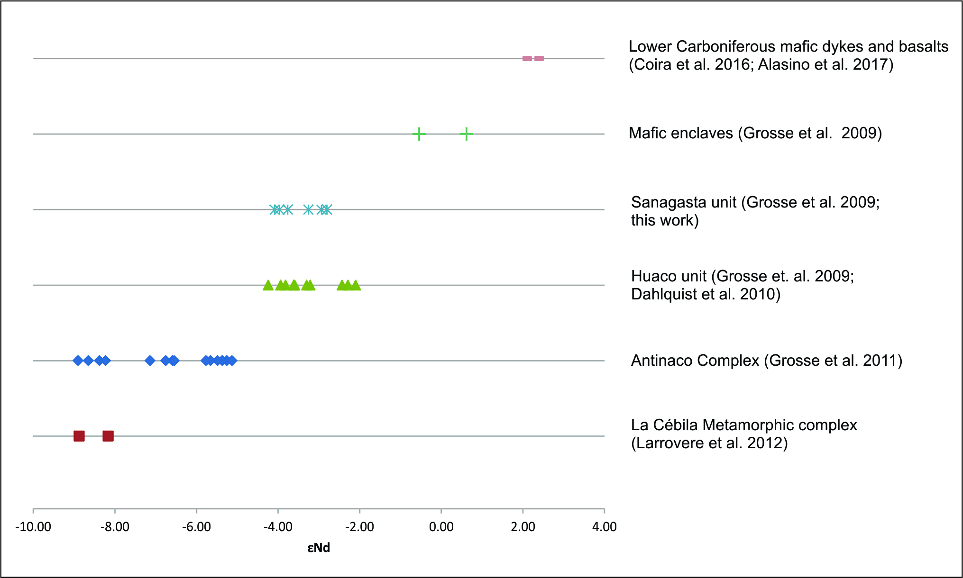
SUPPLEMENTARY MATERIAL (Tables)
Table S1. Major and trace elements of sample SAN-103.
Sample | SAN-103
wt %
SiO₂ | 69.89
TiO₂ | 0.53
Al₂O₃ | 14.4
Fe₂O₃ | 2.96
MnO | 0.06
MgO | 0.76
CaO | 1.84
Na₂O | 2.97
K₂O | 5.28
P₂O₅ | 0.22
LOI | 0.9
Total | 99.82
ASI | 1.04
AI | 0.57
K₂O/Na₂O | 1.78
FeO^{t}/(FeO^{t}+MgO) | 0.80
ppm
Be | 6.00
Sc | 8.00
V | 34.00
Co | 21.20
Cs | 6.60
Rb | 240.40
Sr | 158.80
Ba | 524.00
La | 77.00
Ce | 167.00
Pr | 18.51
Nd | 67.80
Sm | 12.25
Eu | 1.56
Gd | 9.40
Tb | 1.35
Dy | 6.75
Ho | 1.21
Er | 3.29
Tm | 0.46
Yb | 3.29
Lu | 0.46
U | 4.00
Th | 42.80
Y | 34.10
Nb | 18.30
Zr | 281.00
Hf | 7.20
Ta | 1.20
Ga | 18.40
Sn | 3.00
W | 161.00
Ni | 10.00
Total REE | 370.33
Ga/Al | 1.28
La_{N}/Yb_{N} | 15.78

Table S2. εNd values of Huaco and Sanagasta units. The average of each unit, as well as the average of both units together is displayed.
Sample | Sm (ppm) | Nd (ppm) | ¹⁴⁷Sm/¹⁴⁴Nd | (¹⁴³Nd/¹⁴⁴Nd)₀ | (¹⁴³Nd/¹⁴⁴Nd)_{t} | εNd(t) | T_{DM}  (1 stage)
Huaco Unit
(t=354 Ma)
HUA-4¹ | 4.6 | 20.1 | 0.1383 | 0.512338 | 0.512017 | -3.2 | 1.64
HUA-6¹ | 10.2 | 46.5 | 0.1326 | 0.512365 | 0.512058 | -2.4 | 1.47
HUA-7¹ | 9.8 | 43.6 | 0.1359 | 0.512335 | 0.512335 | -3.2 | 1.60
HUA-12¹ | 10.5 | 49.1 | 0.1293 | 0.512352 | 0.512352 | -2.5 | 1.44
HUA-13¹ | 9.2 | 44.8 | 0.1241 | 0.512318 | 0.512318 | -3.0 | 1.41
6931² | 8.8 | 49.3 | 0.108 | 0.512237 | 0.511987 | -3.8 | 1.32
6872² | 5.7 | 28.9 | 0.119 | 0.512274 | 0.511998 | -3.6 | 1.41
6880² | 8.3 | 40 | 0.126 | 0.512305 | 0.512013 | -3.3 | 1.47
7365² | 5.8 | 29.2 | 0.121 | 0.512355 | 0.512075 | -2.1 | 1.31
7381² | 5.7 | 26.2 | 0.131 | 0.512284 | 0.511980 | -3.9 | 1.59
7391² | 5.9 | 30.3 | 0.117 | 0.512268 | 0.511997 | -3.6 | 1.39
7698² | 6.5 | 32.6 | 0.12 | 0.512243 | 0.511965 | -4.2 | 1.47
7354² | 10.3 | 50.8 | 0.123 | 0.51235 | 0.512065 | -2.3 | 1.34
6923² | 7.1 | 35 | 0.123 | 0.512345 | 0.512060 | -2.4 | 1.35
Average |  |  |  |  |  | -3.1 ± 0.7
Sanagasta Unit (t=354 Ma)
7379² | 10.1 | 53.7 | 0.114 | 0.512296 | 0.512032 | -2.9 | 1.31
7251² | 11.5 | 62.8 | 0.111 | 0.512296 | 0.512039 | -2.8 | 1.27
7369² | 15.4 | 72.6 | 0.128 | 0.512312 | 0.512015 | -3.3 | 1.49
7703² | 8 | 45.5 | 0.107 | 0.512221 | 0.511973 | -4.1 | 1.33
7724² | 5.7 | 33.3 | 0.104 | 0.51222 | 0.511979 | -4.0 | 1.29
Average |  |  |  |  |  | -3.4 ± 0.6
SAN-103 | 10.8 | 57.4 | 0.114 | 0.512254 | 0.511989 | -3.8 | 1.37
Average (HU + SU) |  |  |  |  |  | -3.2 ± 0.7
¹ Samples from Dahlquist et al. (2010)
² Samples from Grosse et al. (2009)
Table S3. εNd_{t} (t = 354 Ma) values of Ordovician meta-igneous and metasedimentary rocks of Sierra de Velasco.
Sample number | εNd
Samples from metaigneous rocks (Grosse et al. 2009)
6999 | -5.26
7145 | -6.59
7293 | -5.37
7479 | -5.13
7466 | -5.48
7682 | -5.66
7920 | -7.14
7359 | -6.55
7688 | -5.77
7833 | -8.38
7907 | -8.65
7493 | -6.75
7663 | -8.23
7903 | -8.90
Samples from metasedimentary rocks (Larrovere et al. 2012)
6941 | -8.17
7252 | -8.87
Average | -6.93

Table S4. Two-component mixtures using equation 9.1 from Faure (1986, page 141). The averages were calculated from the samples above shown.
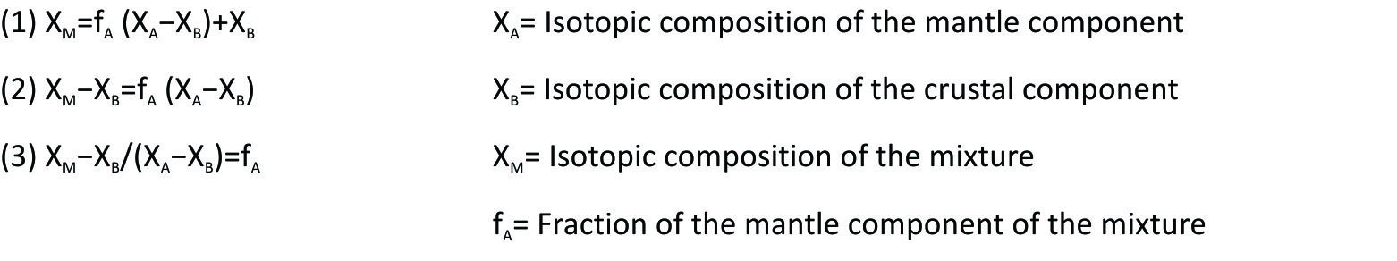
X_{A} | 0.5124035 | Average from mafic enclaves from Huaco and Sanagasta units
X_{B} | 0.5118270 | Average from Ordovician metaigneous and metasedimentary rocks from the Sierra de Velasco
X_{M} | 0.5120623 | Average of Huaco and Sanagasta units
f_{A} | 0.41

References
Alasino PH, Larrovere MA, Rocher S, Dahlquist JA, Basei MAS, Memeti V, Paterson S, Galindo C, Macchioli Grande M and da Costa Campos Neto M (2017) Incremental growth of an upper crustal, A-type pluton, Argentina: Evidence of a re-used magma pathway. Lithos 284–285, 347–366, doi: 10.1016/j.lithos.2017.04.013.
Coira B, Cisterna CE, Ulbrich HH and Cordani UG (2016). Extensional Carboniferous magmatism at the western margin of Gondwana: Las Lozas valley, Catamarca, Argentina. Andean Geology 43, 105–126.
Dahlquist JA, Alasino PH, Eby GN, Galindo C and Casquet C (2010) Fault controlled Carboniferous A-type magmatism in the proto-Andean foreland (Sierras Pampeanas, Argentina): Geochemical constraints and petrogenesis. Lithos 115(1–4), 65–81, doi: 10.1016/j.lithos.2009.11.006.
Grosse P, Bellos LI, de los Hoyos CR, Larrovere MA, Rossi JN and Toselli AJ (2011) Across-arc variation of the Famatinian magmatic arc (NW Argentina) exemplified by I-, S- and transitional I/S-type Early Ordovician granitoids of the Sierra de Velasco. Journal of South American Earth Sciences 32, 110–126, doi: 10.1016/j.jsames.2011.03.014.
Grosse P, Söllner F, Báez MA, Toselli AJ, Rossi JN and de la Rosa JD (2009) Lower Carboniferous post-orogenic granites in central-eastern Sierra de Velasco, Sierras Pampeanas, Argentina: U–Pb monazite geochronology, geochemistry and Sr–Nd isotopes. International Journal of Earth Sciences 98(5), 1001–1025, doi: 10.1007/s00531-007-0297-5.
Larrovere MA, de los Hoyos CR and Grosse P (2012) Los complejos metamórficos del retro-arco Famatiniano (noroeste de argentina): Caracterización geoquímica e isotópica de sus protolitos e implicancias geotectónicas. Revista Mexicana de Ciencias Geologicas 29, 676–695.
Tischendorf G, Förster H-J, Gottesmann B and Rieder M (2007) True and brittle micas: composition and solid-solution series. Mineralogical Magazine 71, 285-320, doi: 10.1180/minmag.2007.071.3.285.

