Supplementary Material
Large trilobites in a stress-free Early Ordovician environment
FARID SALEH¹*, MURIEL VIDAL², LUKÁŠ LAIBL^{3,4,5}, PIERRE SANSJOFRE², PIERRE GUERIAU³, FRANCESC PEREZ PERIS³, LORENZO LUSTRI³, VICTOIRE LUCAS², BERTRAND LEFEBVRE¹, BERNARD PITTET¹, KHADIJA EL HARIRI⁶ and ALLISON C. DALEY³
¹Université de Lyon, Université Claude Bernard Lyon1, École Normale Supérieure de Lyon, CNRS, UMR5276, LGL-TPE, Villeurbanne, France
²Univ. Brest, CNRS, IUEM Institut Universitaire Européen de la Mer, UMR 6538 Laboratoire Géosciences Océan, Place Nicolas Copernic, 29280 Plouzané, France
³Institute of Earth Sciences, University of Lausanne, Géopolis, CH-1015 Lausanne, Switzerland
⁴The Czech Academy of Sciences, Institute of Geology, Rozvojová 269, 165 00 Prague 6, Czech Republic
⁵Institute of Geology and Palaeontology, Faculty of Science, Charles University, Albertov 6, Prague, 12843, Czech Republic
⁶Département des Sciences de la Terre, Faculté des Sciences et Techniques, Université Cadi-Ayyad, BP 549, 40000 Marrakesh, Morocco
*farid.saleh@univ-lyon1.fr
Short running title: Large Ordovician trilobites

Complete trilobites sizes (cm)
Tamegroute | Bou Izargane | Ouled Slimane
4.9 | 9.8 | 18
3.3 | 13 | 19.1
6 | 14.2 | 21.5
6.2 | 16.1 | 23
3.7 | 8.5 | 24.2
2.2 | 3.7 | 26
2 | 4.1 | 26.7
2.8 | 3.8 | 27.2
2.9 | 6.2 | 28.4
4 | 3.9 | 28.5
4.8 | 0.9 | 29.7
3.1 | 5.6 | 30.1
3.1 | 9.3 | 31.3
3.7 | 4.2 | 31.6
4.1 |  | 31.9
 |  | 33.4
 |  | 33.7
 |  | 34.2
 |  | 24.1
 |  | 33.5
 |  | 35.2
 |  | 36.4
 |  | 37.3
 |  | 38
 |  | 39.2
 |  | 39.6
 |  | 41.7
 |  | 42.9
 |  | 43.2
 |  | 47
 |  | 49.1
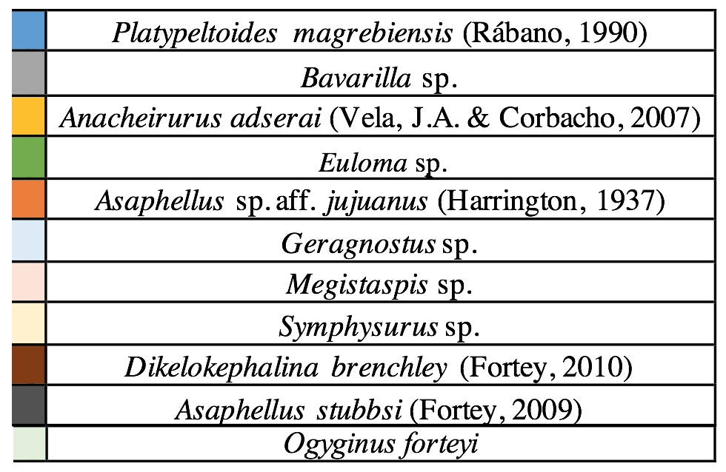
sp.

Table 1. Raw trilobites measurements in the studied localities.

Summary statistics
Tamegroute |  | Bou Izargane |  | Ouled Slimane
N | 15 | N | 14 | N | 31
Min | 2 | Min | 0,9 | Min | 18
Max | 6,2 | Max | 16,1 | Max | 49,1
Sum | 56,8 | Sum | 103,3 | Sum | 1005,7
Mean | 3,786667 | Mean | 7,378571 | Mean | 32,44194
Std. error | 0,3221751 | Std. error | 1,219853 | Std. error | 1,415633
Variance | 1,556952 | Variance | 20,83258 | Variance | 62,12452
Stand. dev | 1,247779 | Stand. dev | 4,564272 | Stand. dev | 7,881911
Median | 3,7 | Median | 5,9 | Median | 31,9
25 prcntil | 2,9 | 25 prcntil | 3,875 | 25 prcntil | 26,7
75 prcntil | 4,8 | 75 prcntil | 10,6 | 75 prcntil | 38
Skewness | 0,6465317 | Skewness | 0,6577487 | Skewness | 0,1820401
Kurtosis | -0,1826851 | Kurtosis | -0,6027403 | Kurtosis | -0,4525136
Geom. mean | 3,601623 | Geom. mean | 5,939102 | Geom. mean | 31,48845
Coeff. var | 32,95191 | Coeff. var | 61,85848 | Coeff. var | 24,29544

Table 2. Summary statistics on trilobite sizes from the Tamgroute, Bou Izargane and Ouled Slimane.

Normality test
Tamegroute |  | Bou Izargane |  | Ouled Slimane
N | 15 | N | 14 | N | 31
Shapiro-Wilk W | 0,9424 | Shapiro-Wilk W | 0,9175 | Shapiro-Wilk W | 0,9879
p(normal) | 0,4138 | p(normal) | 0,2021 | p(normal) | 0,9732
Anderson-Darling A | 0,3422 | Anderson-Darling A | 0,5364 | Anderson-Darling A | 0,09692
p(normal) | 0,4423 | p(normal) | 0,1385 | p(normal) | 0,9963
p(Monte Carlo) | 0,4561 | p(Monte Carlo) | 0,1391 | p(Monte Carlo) | 0,9997
Jarque-Bera JB | 0,9986 | Jarque-Bera JB | 1,18 | Jarque-Bera JB | 0,5749
p(normal) | 0,6069 | p(normal) | 0,5545 | p(normal) | 0,7502
p(Monte Carlo) | 0,361 | p(Monte Carlo) | 0,2449 | p(Monte Carlo) | 0,6932

Table 3. Normality tests for the studied sites showing that size distributions are normal.

Significant differences
Tamegroute vs Bou Izargane |  |  |  | Bou Izargane vs Ouled slimane
t : | 2,9361 | p (same mean): | 0,0067168 | t : | -11,047 | p (same mean): | 3,86E-14
Uneq. var. t : | 2,8469 | p (same mean): | 0,012365 | Uneq. var. t : | -13,412 | p (same mean): | 2,09E-16
Monte Carlo permutation: | p (same mean): | 0,005 |  | Monte Carlo permutation: | p (same mean): | 0,0001

Table 4. t-test showing that size differences between sites are significant.

Pygidial sagittal length for Platypeltoides (cm)
Tamegroute | Bou Izargane | Ouled Slimane
1.3 | 2.6 | 5,7
0.8 | 3.5 | 7,1
1.6 | 3.8 | 6,5
1.6 | 4.3 | 6
1 | 2.2 | 6,2
 |  | 7
 |  | 5,9
 |  | 6,9
 |  | 5,7

Table 5. Raw pygidial sagittal length in the studied localities.

Summary statistics
Tamegroute |  | Bou Izargane |  | Ouled Slimane
N | 5 | N | 5 | N | 9
Min | 0,8855 | Min | 2,2638 | Min | 5,7
Max | 1,6709 | Max | 4,3428 | Max | 7,1
Sum | 6,49056 | Sum | 16,5935 | Sum | 57
Mean | 1,298112 | Mean | 3,3187 | Mean | 6,333333
Std. error | 0,158821 | Std. error | 0,3823575 | Std. error | 0,186339
Variance | 0,1261206 | Variance | 0,7309864 | Variance | 0,3125
Stand. dev | 0,3551346 | Stand. dev | 0,8549774 | Stand. dev | 0,559017
Median | 1,32386 | Median | 3,5112 | Median | 6,2
25 prcntil | 0,9394 | 25 prcntil | 2,45245 | 25 prcntil | 5,8
75 prcntil | 1,64395 | 75 prcntil | 4,0887 | 75 prcntil | 6,95
Skewness | -0,133172 | Skewness | -0,1776892 | Skewness | 0,2802879
Kurtosis | -2,713525 | Kurtosis | -1,867874 | Kurtosis | -1,78304
Geom. mean | 1,257634 | Geom. mean | 3,226366 | Geom. mean | 6,311613
Coeff. var | 27,35778 | Coeff. var | 25,76242 | Coeff. var | 8,826584

Table 6. Summary statistics on pygidial length in Tamegroute, Bou Izargane, and Ouled Slimane.
Normality test
Tamegroute |  | Bou Izargane |  | Ouled Slimane
N | 5 | N | 5 | N | 9
Shapiro-Wilk W | 0,8966 | Shapiro-Wilk W | 0,9536 | Shapiro-Wilk W | 0,8897
p(normal) | 0,3913 | p(normal) | 0,7632 | p(normal) | 0,1982
Anderson-Darling A | 0,2979 | Anderson-Darling A | 0,2096 | Anderson-Darling A | 0,4006
p(normal) | 0,4268 | p(normal) | 0,7119 | p(normal) | 0,2836
p(Monte Carlo) | 0,4901 | p(Monte Carlo) | 0,8075 | p(Monte Carlo) | 0,3012
Jarque-Bera JB | 0,5935 | Jarque-Bera JB | 0,4602 | Jarque-Bera JB | 0,965
p(normal) | 0,7432 | p(normal) | 0,7945 | p(normal) | 0,6172
p(Monte Carlo) | 0,3947 | p(Monte Carlo) | 0,6023 | p(Monte Carlo) | 0,2444

Table 7. Normality test on pygidial lengths showing normal distributions.

Significant differences
Tamegroute vs Bou Izargane |  |  |  | Bou Izargane vs Ouled slimane
t : | -4,8803 | p (same mean): | 0,0012239 | t : | -8,0391 | p (same mean): | 3,58E-06
Uneq. var. t : | -4,8803 | p (same mean): | 0,0038096 | Uneq. var. t : | -7,0875 | p (same mean): | 0,0004085
Monte Carlo permutation: | p (same mean): | 0,0076 |  | Monte Carlo permutation: | p (same mean): | 0,0005
Exact permutation: | p (same mean): | 0,0039683 |  | Exact permutation: | p (same mean): | 0,0004995
Table 8. t-test showing significant differences in pygidial lengths between sites.

