*Geological Magazine*  
**Petrogenesis of plagiogranites in the Muslim Bagh Ophiolite, Pakistan: implications for the generation of Archaean continental crust  
Daniel Cox, Andrew C. Kerr, Alan R. Hastie, M. Ishaq Kakar**

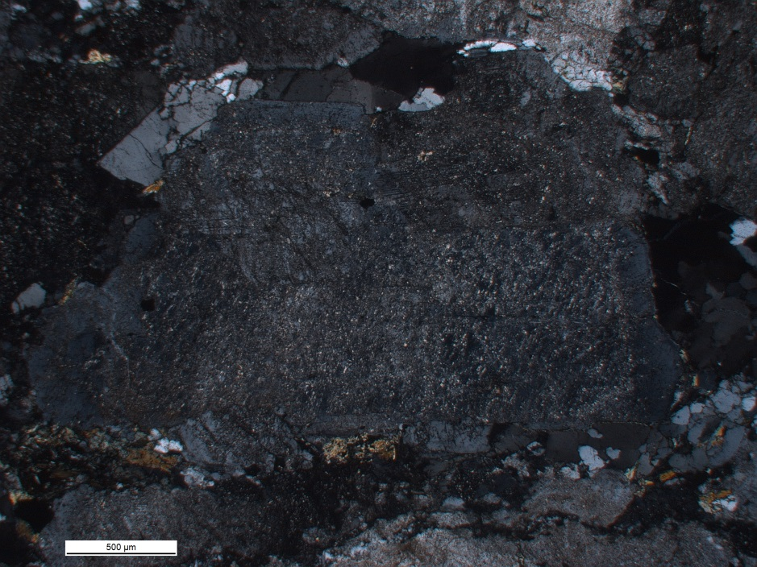

**Figure S1.** Photomicrograph of a plagioclase crystal with a sericitised core from a plagiogranite in the Muslim Bagh Ophiolite.

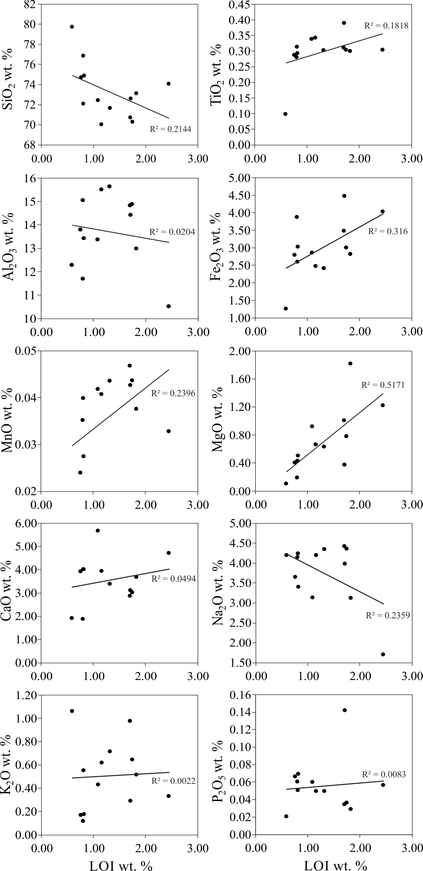

**Figure S2**. Major element (vs. LOI) variation plots of the Muslim Bagh Ophiolite plagiogranites.

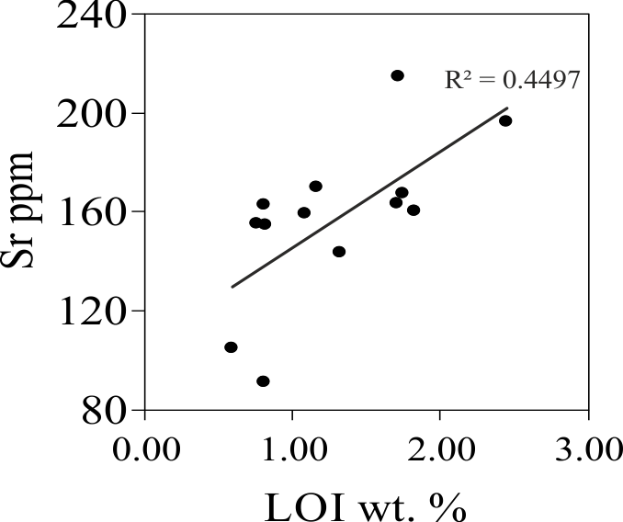

**Figure S3**. Sr (vs. LOI) variation plot of the Muslim Bagh Ophiolite plagiogranites.