Geological Magazine

Lawsonite-bearing eclogite from a tectonic mélange in the Ligurian Alps: new constraints for the subduction plate-interface evolution.

Marco Scarsi, Cristina Malatesta & Silvia Fornasaro

Supplementary Material

SUPPLEMENTARY FIGURES

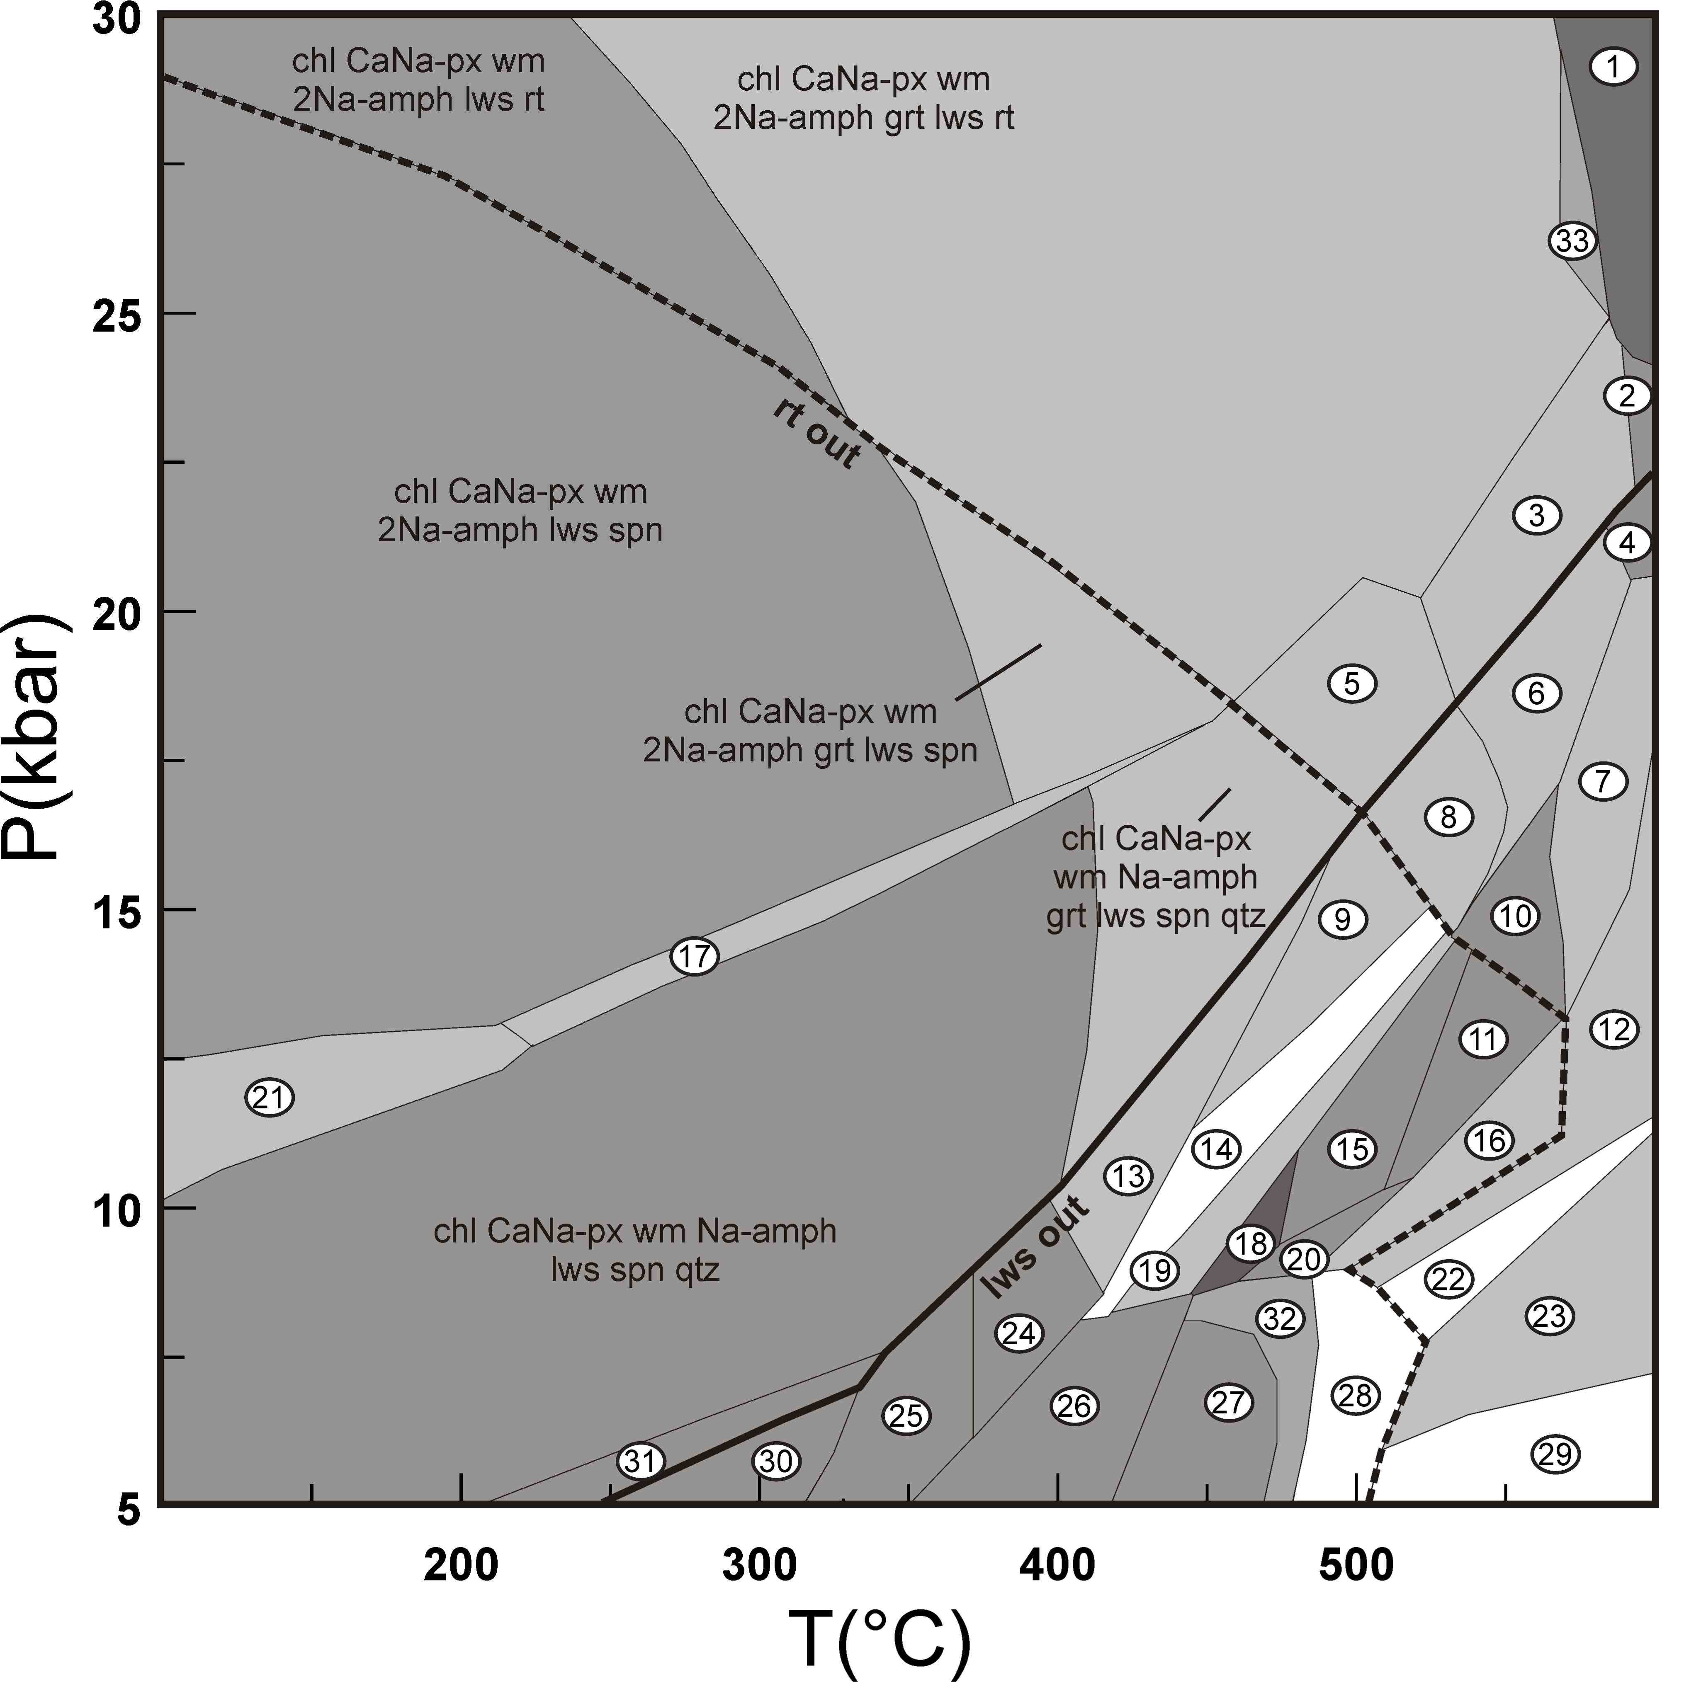Figure S1. P-T pseudosection (Figure 9 in the text) in the KMnTiNCFMASH system and H₂O in excess. The mineral abbreviations are after Kretz (1983) except for: cpx (clinopyroxene), Na-amph (Na-amphibole), Ca-amph (Ca-amphibole), wm (white mica), CaNa-px (CaNa-pyroxene) and Na-px (Na-pyroxene). Narrow and small fields have been neglected for the sake of clarity. The fields variance goes from three (i.e. 9 phases, white fields) to six (i.e. 6 phases, dark grey). Numbers in the white circles are the assemblages listed in the following:

1. CaNa-px wm Na-amph grt lws rt
2. CaNa-px wm Ca-amph Na-amph grt lws rt
3. chl CaNa-px wm Ca-amph Na-amph grt lws rt
4. CaNa-px wm Ca-amph Na-amph grt zo rt
5. chl CaNa-px wm Na-amph grt cpx lws rt
6. chl CaNa-px wm Ca-amph Na-amph grt zo rt
7. CaNa-px wm Ca-amph Na-amph grt cpx zo rt
8. chl CaNa-px wm Na-amph grt cpx zo rt
9 chl CaNa-px wm Na-amph grt cpx zo spn
10. wm Ca-amph Na-amph grt cpx zo rt
11. wm Ca-amph Na-amph grt cpx zo spn
12. wm Ca-amph Na-amph grt cpx zo qtz spn
13. chl CaNa-px wm Na-amph grt zo spn qtz
14. chl CaNa-px wm Ca-amph Na-amph grt cpx zo spn
15. CaNa-px wm Ca-amph Na-amph grt zo spn
16. wm Ca-amph Na-amph grt zo spn ab qtz
17. chl CaNa-px wm Ca-amph Na-amph lws spn qtz
18. wm Ca-amph Na-amph grt zo spn
19. chl CaNa-px wm Ca-amph Na-amph grt zo spn
20. wm Ca-amph Na-amph grt zo spn ab
21. chl CaNa-px wm Na-amph Na-amph lws spn qtz
22. wm Ca-amph Na-amph grt zo pg ab qtz rt
23. wm Ca-amph Na-amph grt zo ab qtz rt
24. chl CaNa-px wm Na-amph zo spn qtz
25. chl wm cpx czo spn ab qtz
26. chl wm Ca-amph cpx zo spn ab
27. chl wm Ca-amph grt zo spn ab
28. chl wm Ca-amph Na-amph grt zo spn ab qtz
29. wm Ca-amph Na-amph grt zo spn ab qtz rt
30. chl CaNa-px wm pmp spn ab qtz
31. chl CaNa-px wm lws spn ab qtz
32. chl wm Ca-amph Na-amph grt zo spn ab
33. chl CaNa-px wm Na-amph grt lws rt
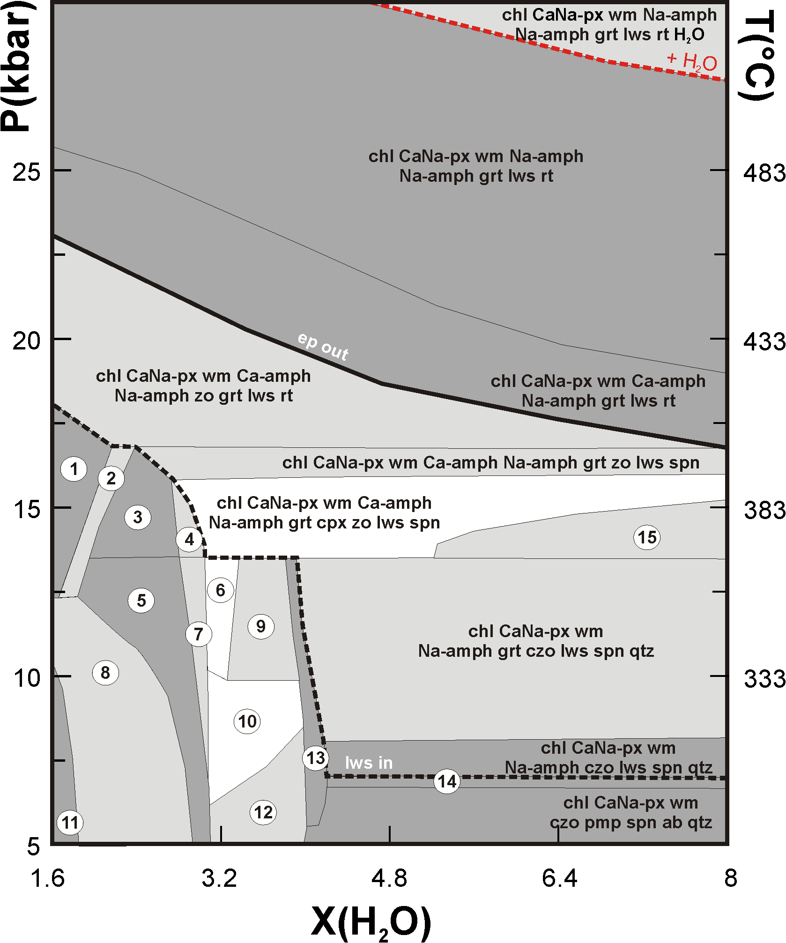
Figure S2. P/T - X(H₂O) pseudosection calculated along a 3°C/km geotherm (see text for explanation), in the KMnTiNCFMASH system. The fields variance goes from 1 (i.e. 10 phases, white fields) to three (i.e. 8 phases, dark grey). The dashed red line depicts the H₂O-saturation surface of the system; the great part of the pseudosection shows H₂O-undersaturated conditions. The black solid and dashed line highlight the epidote-out and lawsonite-in reactions, respectively. Lawsonite and epidote coexist in H₂O-undersaturated conditions. The mineral abbreviations are after Kretz (1983) except for: cpx (clinopyroxene), Na-amph (Na-amphibole), Ca-amph (Ca-amphibole), wm (white mica) and Na-px (Na-pyroxene). Narrow and small fields have been neglected for the sake of clarity. Numbers in the white circles are the assemblages listed in the following:

1. chl CaNa-px wm Ca-amph Na-amph grt zo rt
2. chl CaNa-px wm Ca-amph Na-amph grt zo spn rt
3. chl CaNa-px wm Ca-amph Na-amph grt zo spn
4. chl CaNa-px wm Ca-amph Na-amph grt cpx zo spn
5. chl CaNa-px wm Ca-amph Na-amph grt czo spn
6. chl CaNa-px CaNa-px wm Ca-amph Na-amph grt czo spn qtz
7. chl CaNa-px wm Ca-amph Na-amph grt cpx czo spn qtz
8. chl CaNa-px wm Ca-amph Ca-amph Na-amph grt czo spn
9. chl CaNa-px wm Na-amph grt cpx czo spn qtz
10. chl CaNa-px wm Ca-amph Na-amph grt cpx czo spn qtz
11. chl wm Ca-amph Ca-amph Na-amph grt czo spn
12. chl CaNa-px wm Ca-amph Na-amph grt czo spn qtz
13. chl CaNa-px wm Na-amph grt czo spn qtz
14. chl CaNa-px wm Na-amph czo pmp spn qtz
15. chl CaNa-px wm Na-amph grt cpx czo lws spn

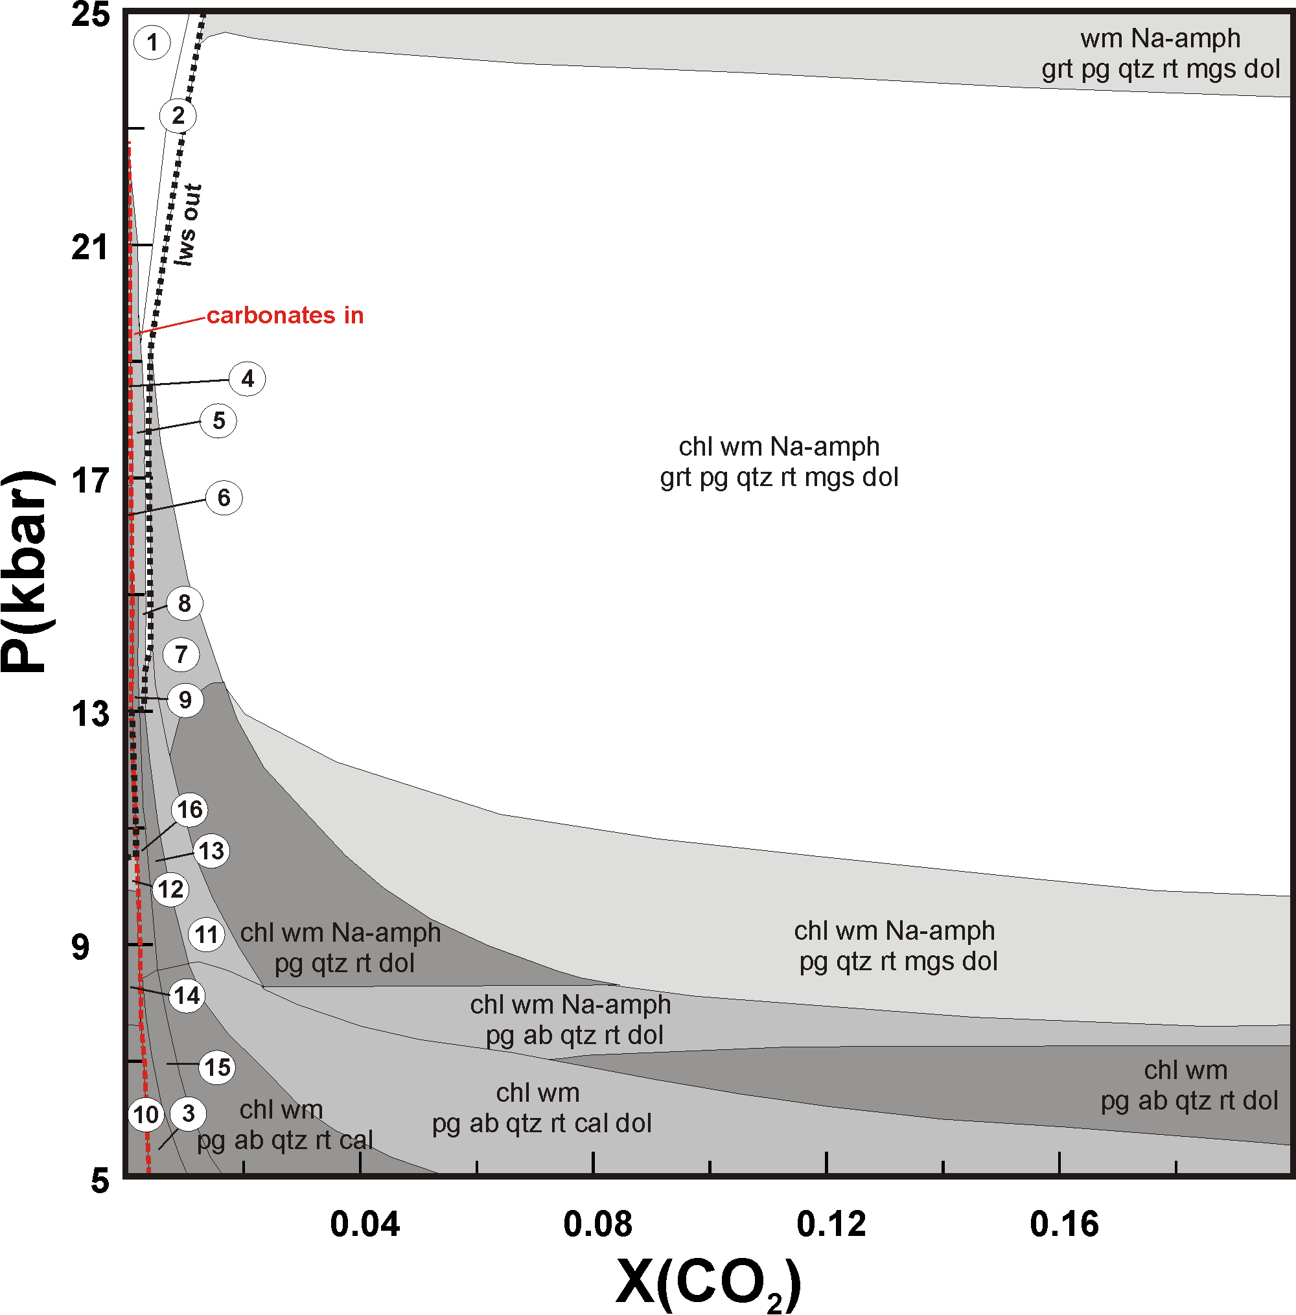
Figure S3. P- X(CO₂) pseudosection, at T= 400°C, in the KMnTiNCFMASHC system (see text for explanation). Narrow and small fields have been neglected for the sake of clarity. The fields variance goes from three (i.e. 9 phases, white fields) to five (i.e. 7 phases, dark grey). Numbers in the white circles are the assemblages listed in the following:

1. wm Na-amph grt cpx lws qtz rt mgs dol
2. wm Na-amph grt lws pg qtz rt mgs dol
3. chl wm zo spn ab qtz cal
4. chl CaNa-cpx wm 2Na-amph grt lws spn
5. chl wm Na-amph grt lws qtz rt dol
6. chl CaNa-px wm Na-amph lws spn qtz
7. chl wm Na-amph grt pg qtz rt dol
8. chl wm Na-amph grt lws qtz rt cal dol
9. chl wm Na-amph lws spn qtz cal
10. chl wm Ca-amph cpx zo spn ab
11. chl wm Na-amph pg qtz rt cal dol
12. chl CaNa-px wm Na-amph grt zo spn qtz
13. chl wm Na-amph pg qtz rt cal
14. chl CaNa-px wm Na-amph zo spn qtz
15. chl wm spn pg ab qtz cal
16. chl wm Na-amph spn pg qtz cal
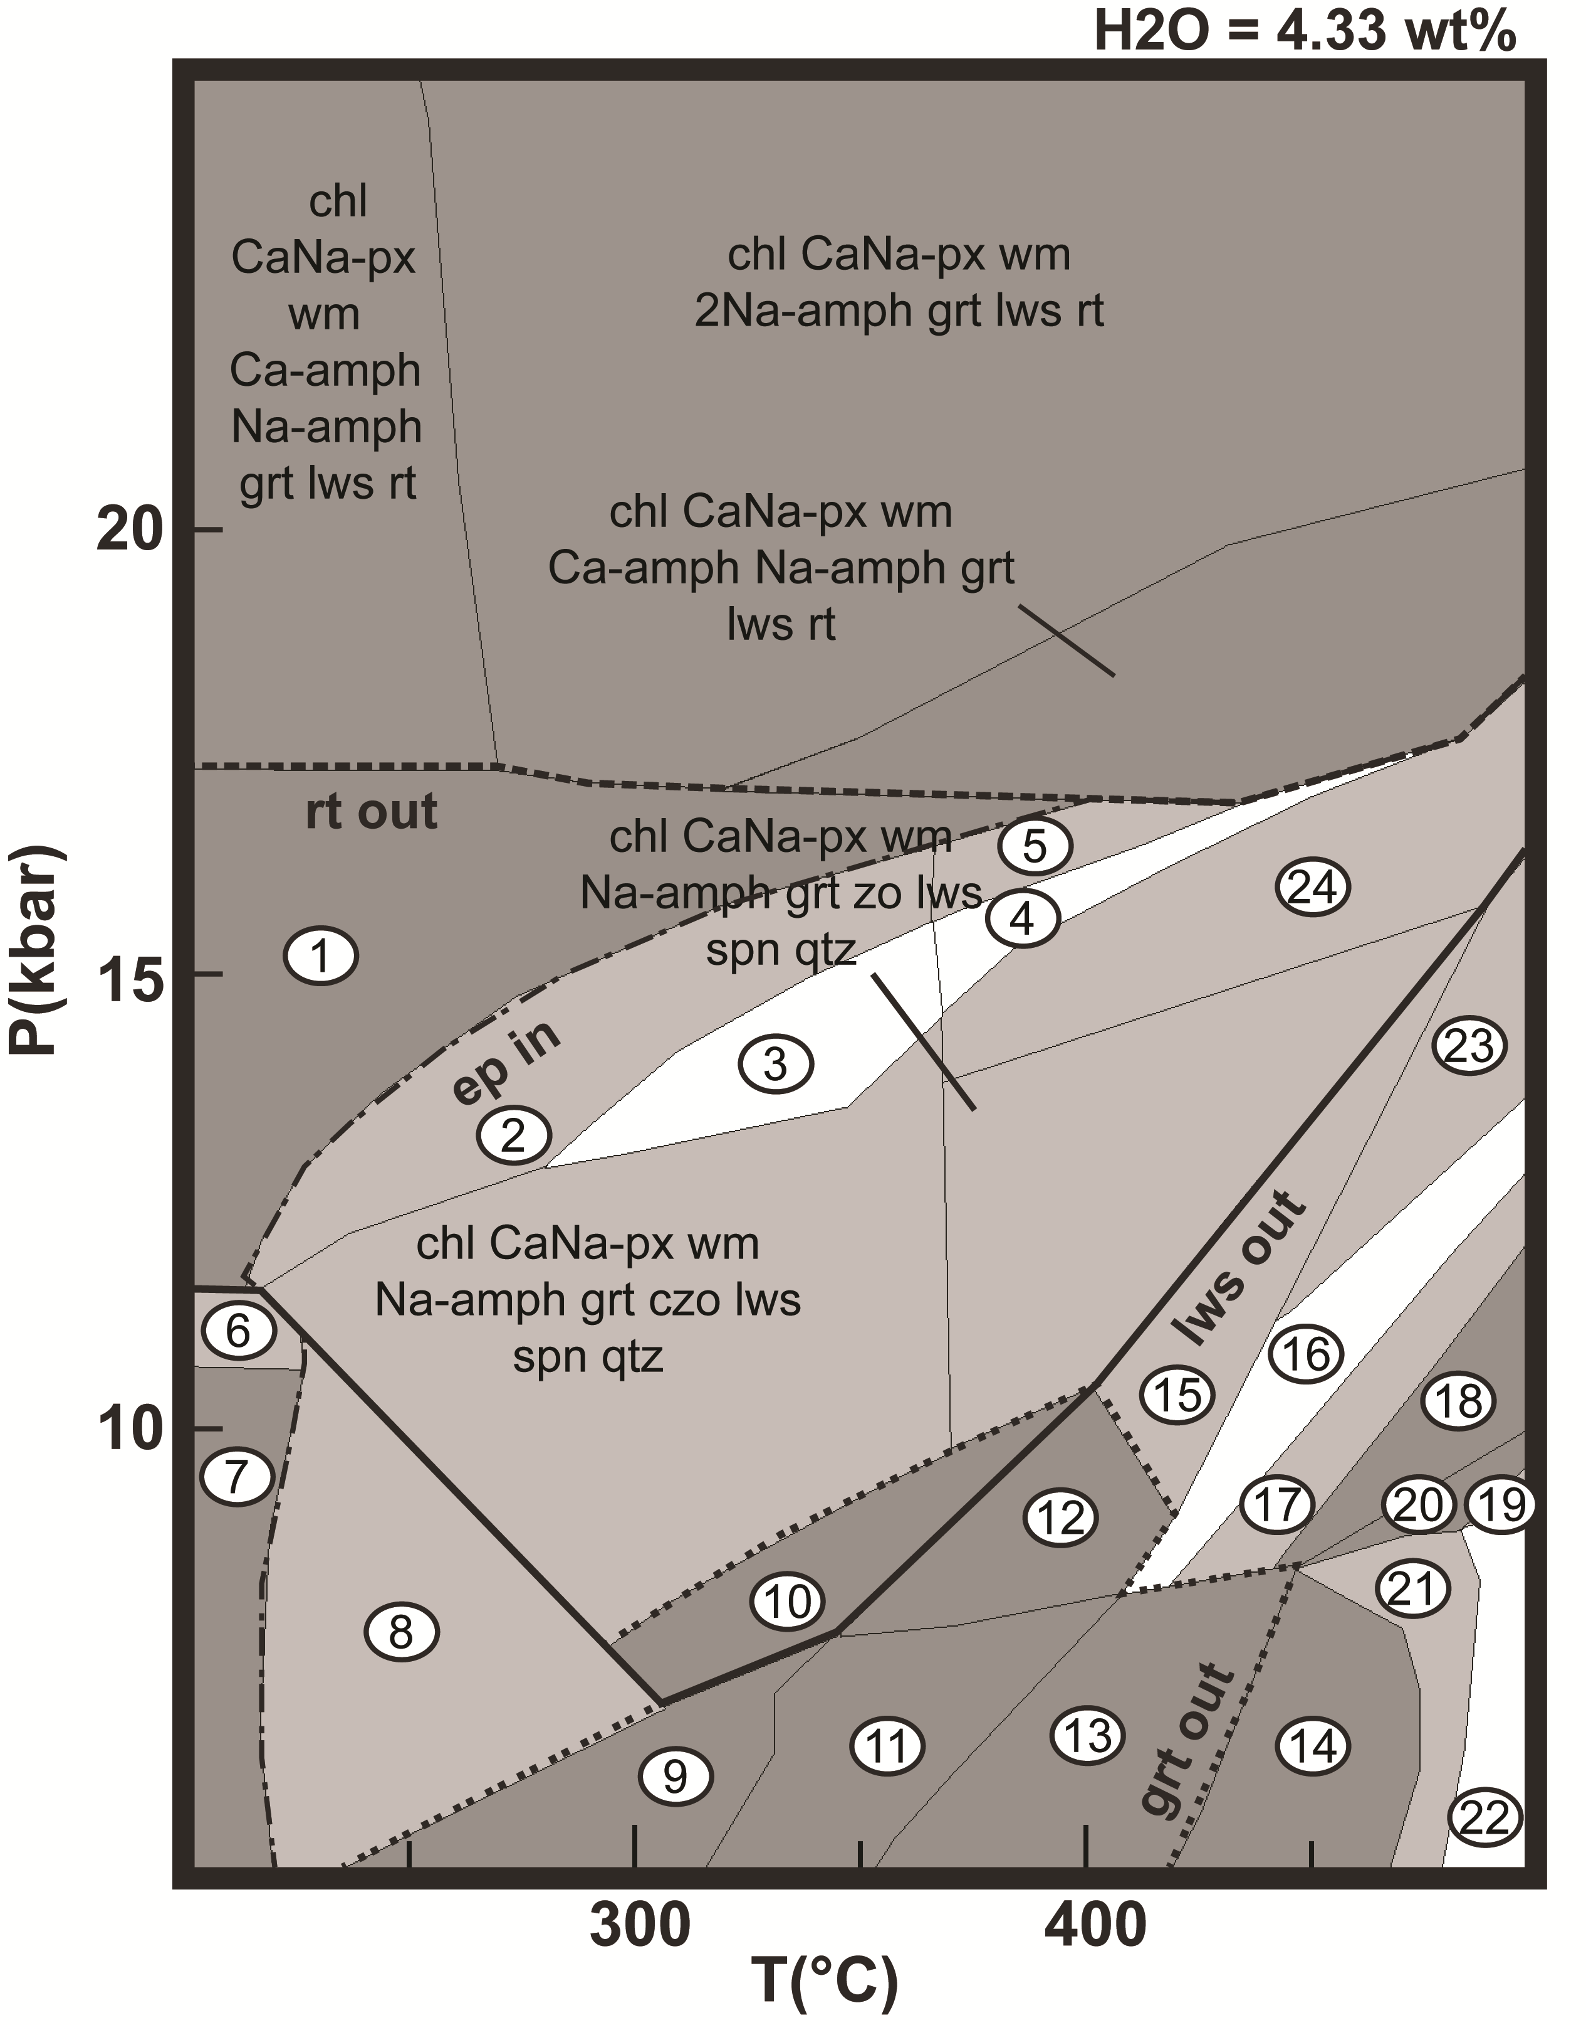
Figure S4. P-T pseudosection with under-saturated conditions (H₂O= LOI) in the KMnTiNCFMASH system (see text for explanation). Numbers in the white circles are the assemblages listed in the following:

1. chl CaNa-px wm Ca-amph Na-amph grt lws spn
2. chl CaNa-px wm Ca-amph Na-amph grt czo lws spn
3. chl CaNa-px Na-px wm Ca-amph Na-amph grt czo lws spn
4. chl CaNa-px wm Ca-amph Na-amph grt cpx zo lws spn
5. chl CaNa-px wm Ca-amph Na-amph grt zo lws spn
6. chl CaNa-px wm Na-amph grt lws pmp spn qtz
7. chl CaNa-px wm Na-amph grt pmp spn qtz
8. chl CaNa-px wm Na-amph grt czo pmp spn qtz
9. chl CaNa-px wm czo pmp spn ab qtz
10. chl CaNa-px wm Na-amph czo lws spn qtz
11. chl wm cpx czo spn ab qtz H₂O
12. chl CaNa-px wm Na-amph zo spn qtz H₂O
13. chl wm Ca-amph cpx zo spn ab H₂O
14. chl wm Ca-amph grt zo spn ab H₂O
15. chl CaNa-px wm Na-amph grt zo spn qtz H₂O
16. chl CaNa-px wm Ca-amph Na-amph grt cpx czo spn H₂O
17. chl CaNa-px wm Ca-amph Na-amph grt zo spn H₂O
18. CaNa-px wm Ca-amph Na-amph grt zo spn H₂O
19. wm Ca-amph Na-amph grt zo spn ab qtz H₂O
20. wm Ca-amph Na-amph grt zo spn ab H₂O
21. chl wm Ca-amph Na-amph grt zo spn ab H₂O
22. chl wm Ca-amph Na-amph grt zo spn ab qtz H₂O
23. chl CaNa-px wm Na-amph grt cpx zo spn H₂O
24. chl CaNa-px wm Na-amph cpx grt zo lws spn

