Geological Magazine
Late Permian to Triassic isotope composition of sulfates in the Eastern Alps: palaeogeographic implications
Ana-Voica Bojar, Stanislaw Hałas, Hans-Peter Bojar & Andrzej Trembaczowski
Online Supplementary Material
1. Sampled sulfate and sulfides from the investigated evaporitic deposits
Locality | Age | Sample | Mineral
Salt, NCA
Hall in Tirol | Late Permian  and Anisian | HT_1 | anhydrite | coarse crystalline white grey anhydrite with slight pink-violet reflexes 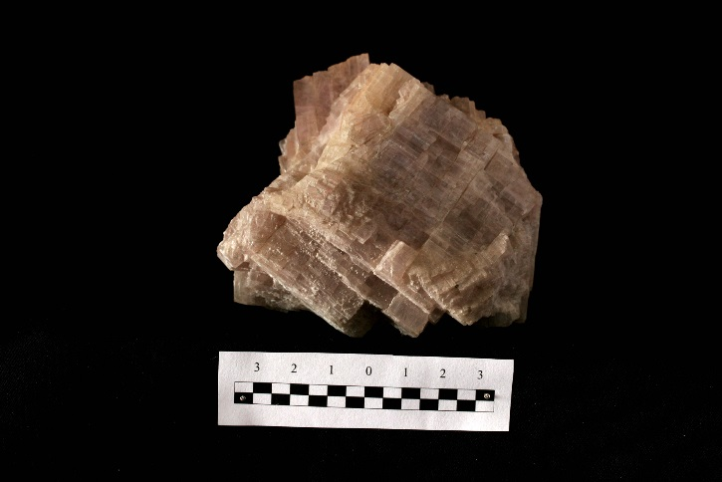
 |  | HT_2 | gypsum | fine grained grey gypsum overgrown by large transparent gypsum crystals with tabular habit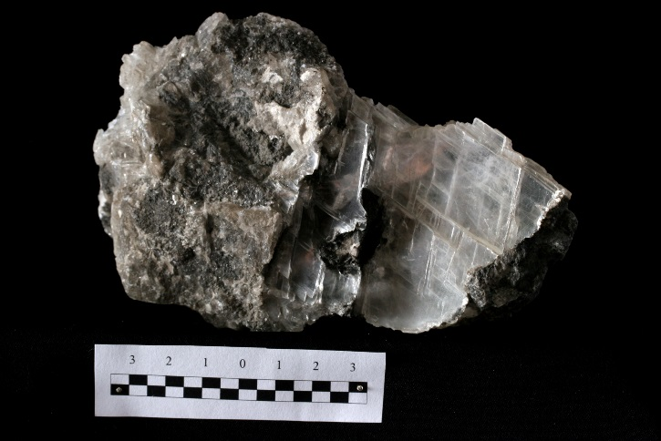
Hallein  (Dürrenberg) | Late Permian | D_1 | polyhalite | fine grained porous polyhalite as wall-rock for a halite vein, possible both vein filling material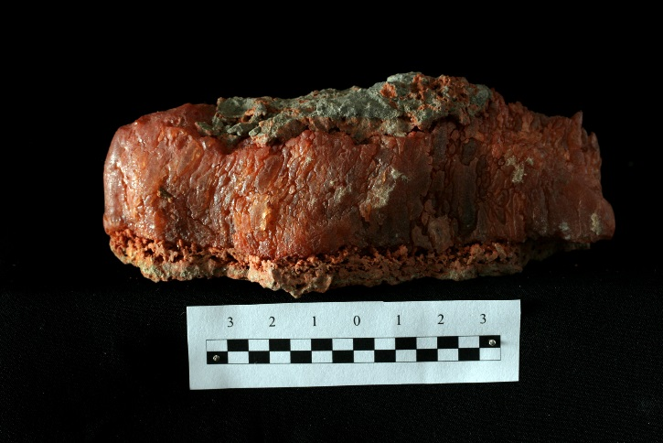
 |  | D_2 | polyhalite | coarse crystalline, massive polyhalite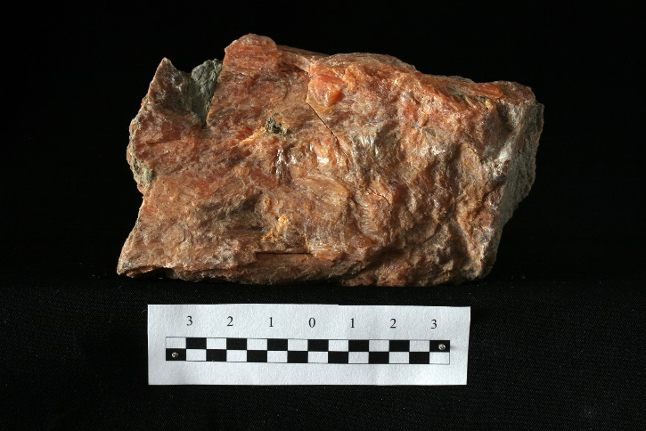
 |  | D_3 | anhydrite | coarse crystalline white grey anhydrite with slight yellow-violet reflexes 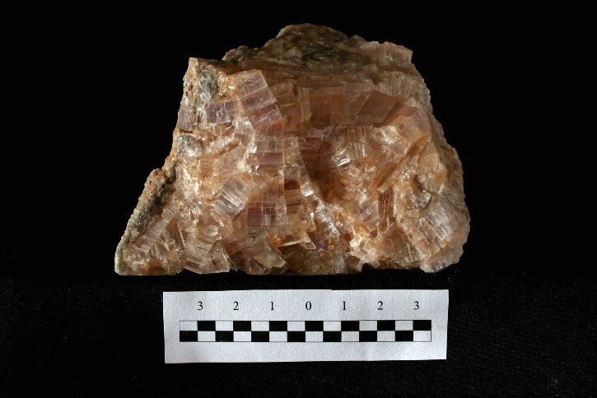
Hallstatt | Late Permian | H_1 | polyhalite | fibrous massive polyhalite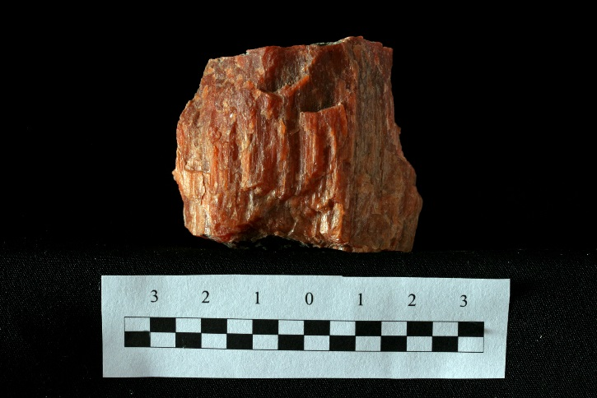
 |  | H_2 | blödite | fine echigranular crystals from a blödite layer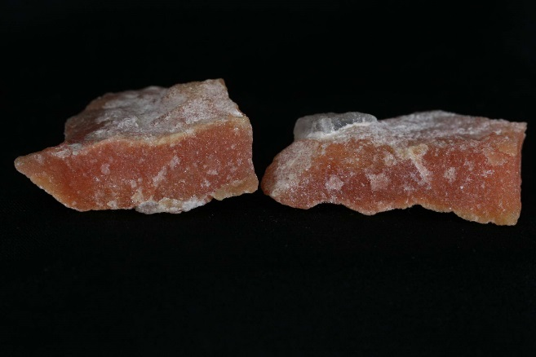
 |  | H_4 | gypsum | secondary gypsum crystals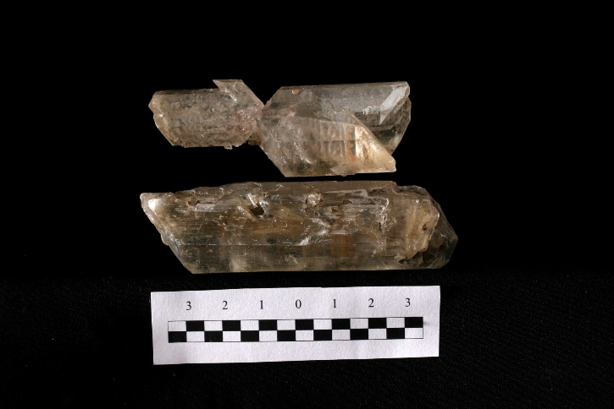
Altausee | Late Permian | A_1 | polyhalite | coarse crystalline grey anhydrite with polyhalite grown on cleavages and thin joints
 |  | A_2 | anhydrite | 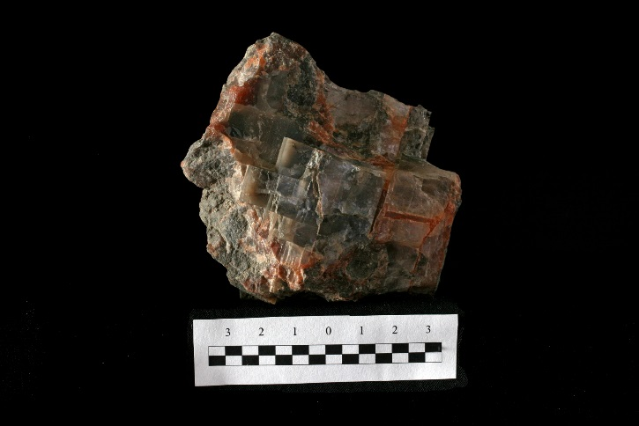
 |  | A_3 | anhydrite | anhydrite crystals in a vug overgrown by needle shaped polyhalite and gypsum
 |  | A_4 | gypsum | 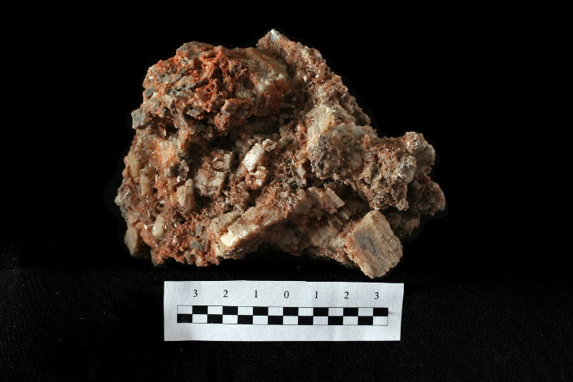
 |  | A_5 | gypsum | lath shaped transparent gypsum crystals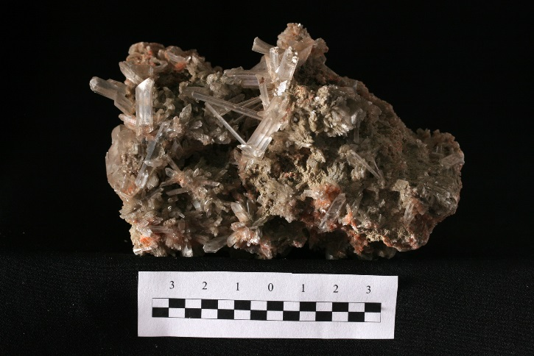
Bad Ischl | Late Permian | BI_1 | polyhalite | 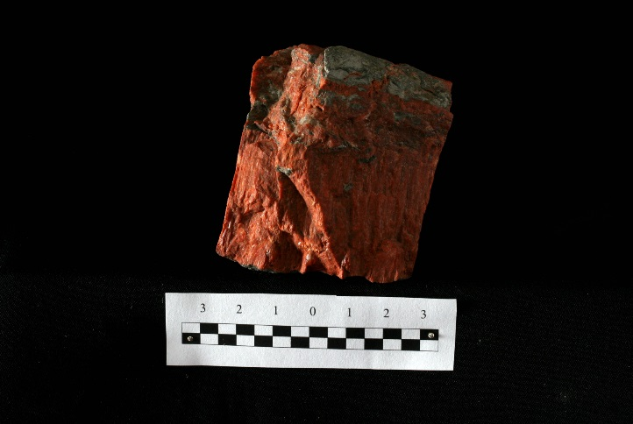  fibrous polyhalite vein grown in salt clay
 |  | BI_2 | polyhalite | fine crystallised polyhalite on grey salt clay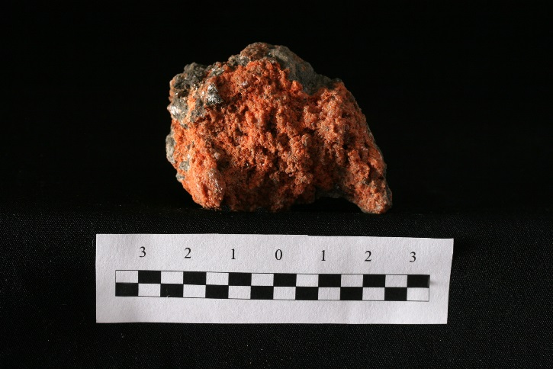
Gypsum, NCA
Golling |  | G_2 | gypsum | grey dolomite breccia cemented with gypsum and crossed by a gypsum and sulfur joint
 |  | G_1 | sulfur | 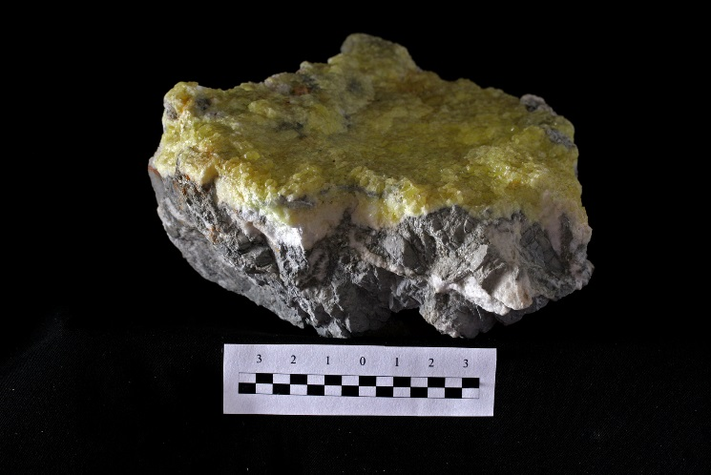
 |  | G_3 | dolomite
 |  | G_4 | gypsum | grey dolomite breccia cemented with gypsum and crossed by a gypsum joint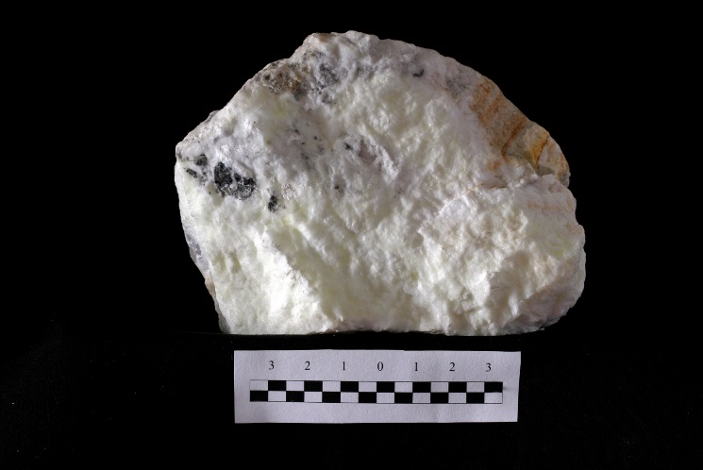
Wienern |  | W_2 | dolomite | grey dolomite breccia cemented with gypsum and crossed by a gypsum and sulfur joint; sulfur is grown in the inner part of the joint
 |  | W_3 | gypsum | 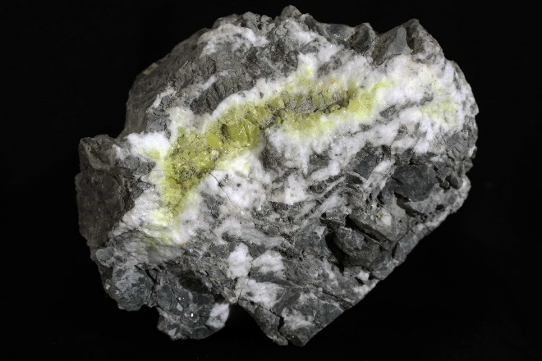
 |  | W_4 | pyrite | sugar like gypsum with pyrite and hematite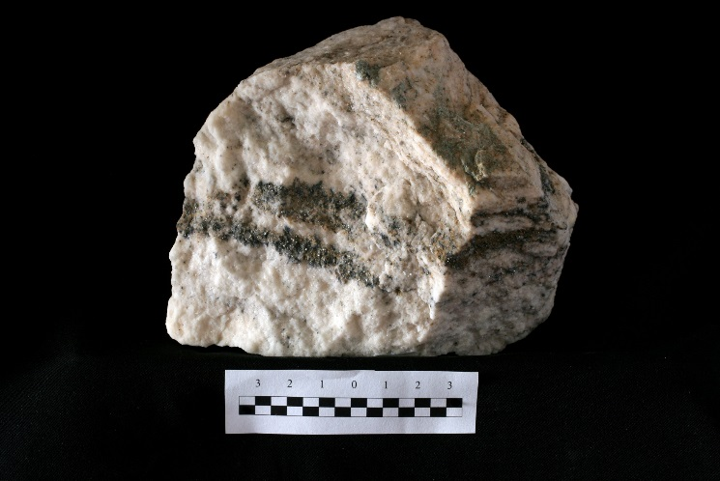
 |  | W_5 | magnesite
 |  | W_6 | galenite | fine grained sulfides in grey, sugar like gypsum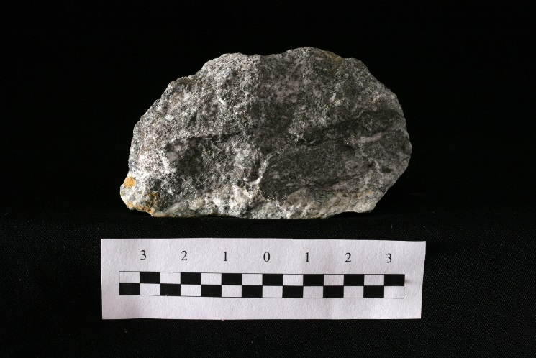
 |  | W_7 | sphalerite
 |  | W_8 | gypsum
 |  | W_9 | gypsum | white sugar like gypsum with sulfur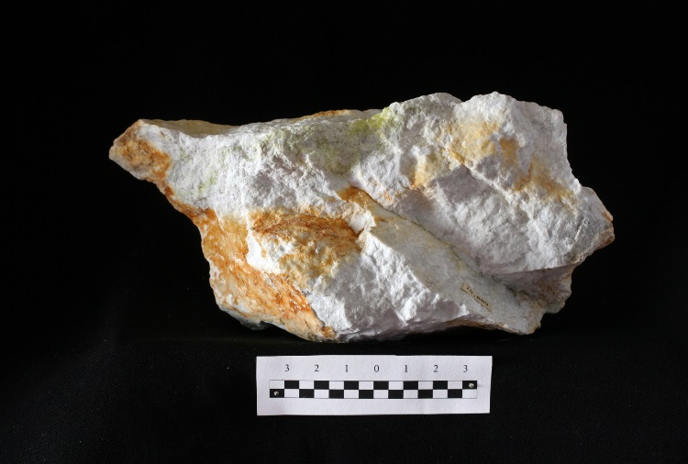
Lessern-Tauplitz | Late Permian | L_2 | gypsum | grey dolomite, brittle deformed, with gypsum crossed by a gypsum and sulfur joint; sulfur is grown in the center of the joint
 |  | L_1 | sulfur | 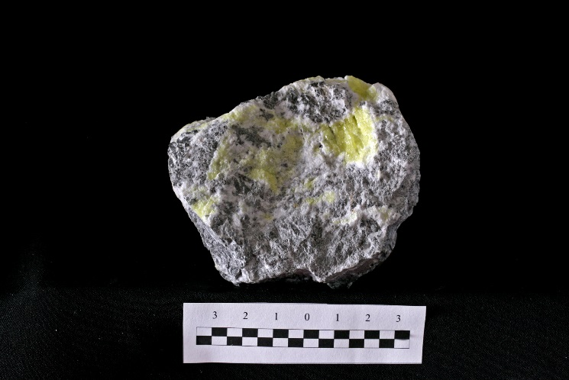
Unterlaussa |  | Wd_3 | gypsum | dark grey compact gypsum, deformed. No other major component could be detected using XRD.  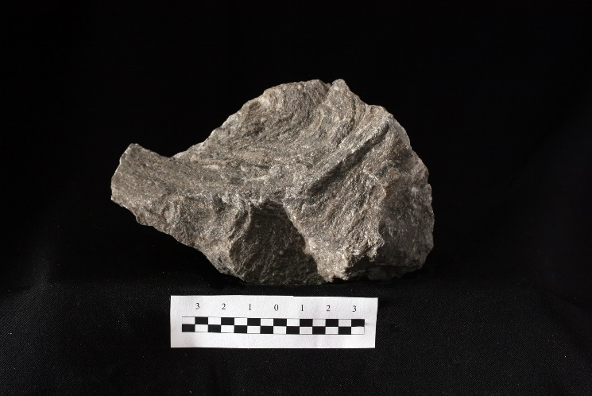
Wildalpen-St Gilgen |  | Wd_1 | gypsum | white, slightly pink-grey gypsum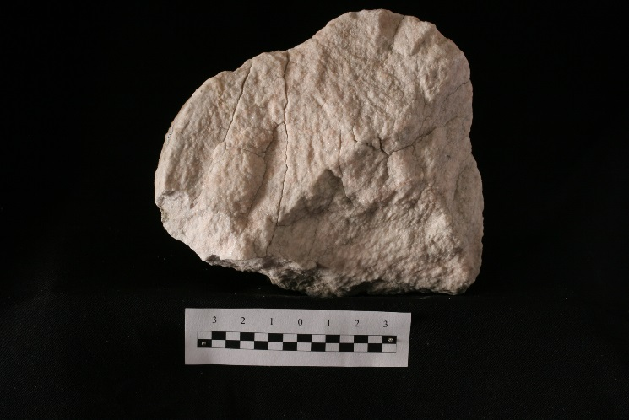
Tragöß | Late Permian | T_1 | galena | grey dolomite with white gypsum crossed by veins with gypsum, sphalerite, galena, pyrite and sulfur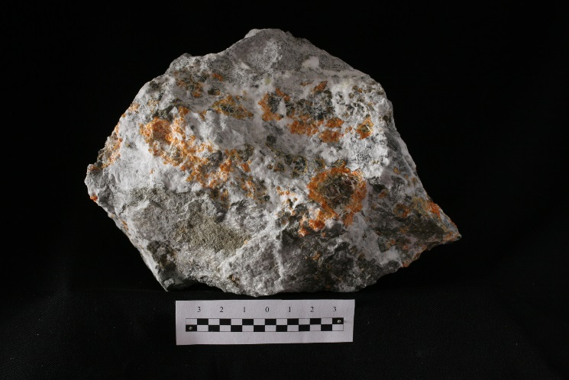
 |  | T_2 | sphalerite
 |  | T_3 | pyrite
 |  | T_4 | sulfur | vug filled with white gypsum and sulfur, brecciated dolomitic host rock remains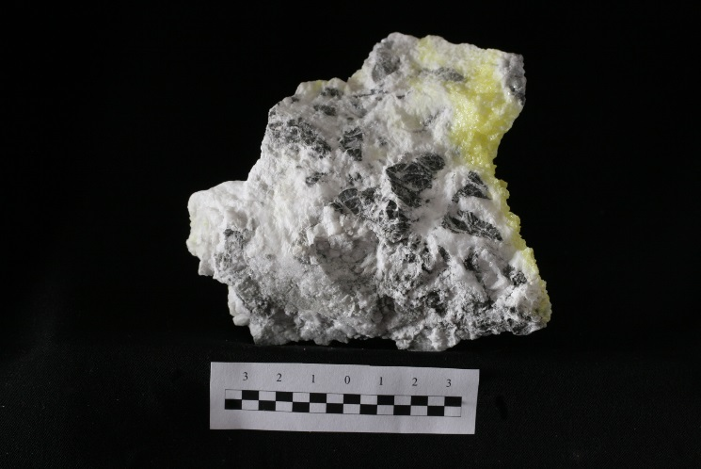
 |  | T_5 | gypsum | white slightly pink gypsum with hematite  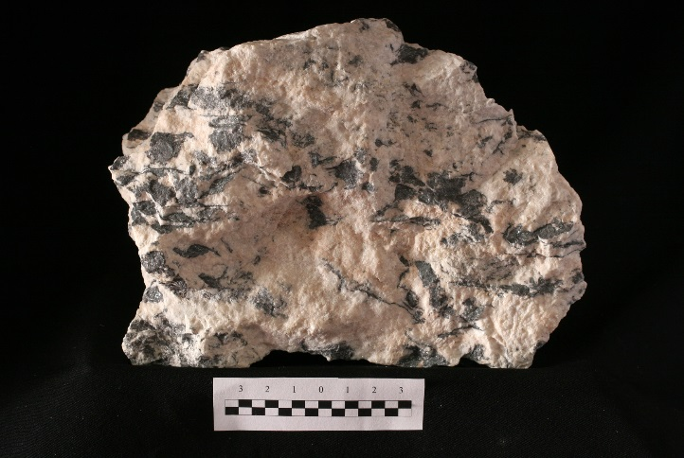
 |  | T_6 | anhydrite | massive white-slightly pink anhydrite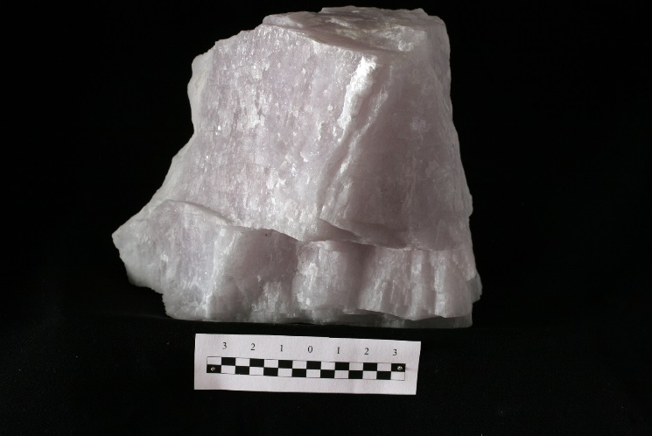
 |  | T_7 | gypsum | grey dolomite with white gypsum crossed by veins with gypsum, sphalerite, galena and sulfur
 |  | T_8 | dolomite | 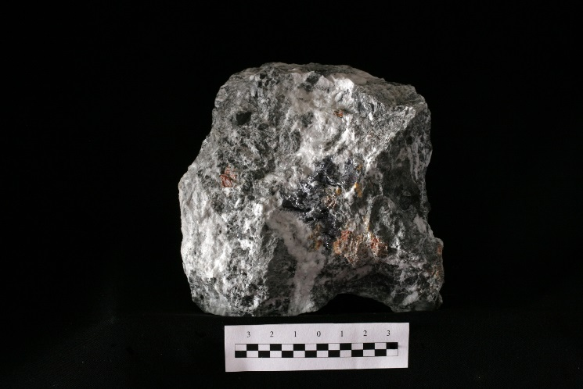
 |  | T_8/1 | sphalerite
 |  | T_8 | gypsum
 |  | T_9 | dolomite
 |  | T_10 | sphalerite | grey dolomite with white gypsum crossed by veins with gypsum, sphalerite, galena and sulfur
 |  | T_11 | gypsum | 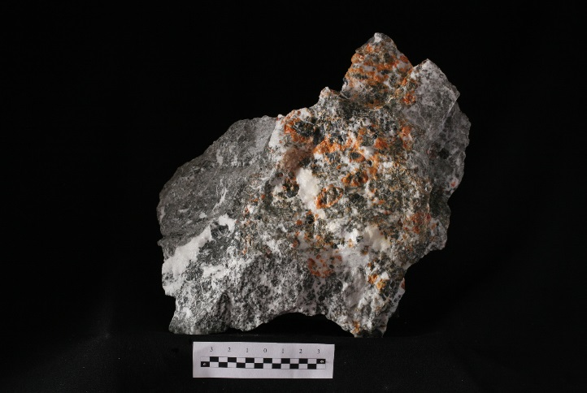
 |  | T_12 | sphalerite (I, core, dark)
 |  | T_13 | sphalerite
 |  | T_14 | dolomite
 |  | T_15 | pyrite
Seewiesen |  | Wd_2 | gypsum | grey gypsum with detrital material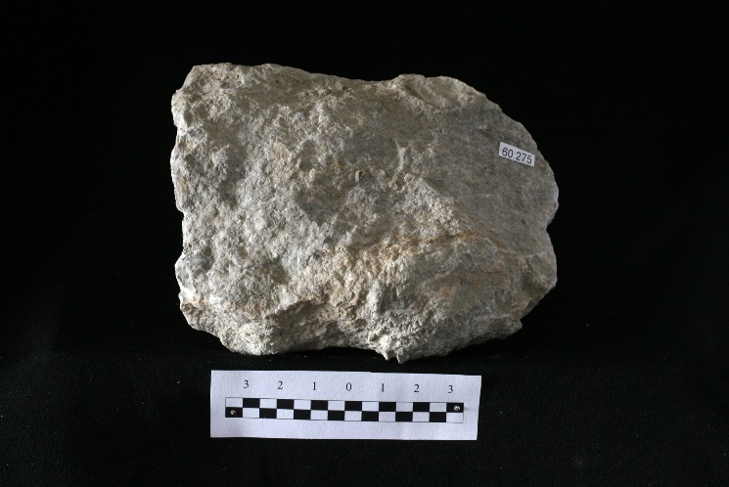
Gyum, CAM
Stanz | Triassic  (Carnian-Norian) | St_1 | anhydrite | light grey, marble like anhydrite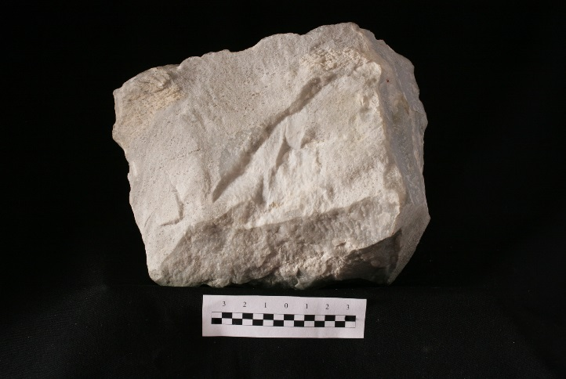
 |  | St_2 | gypsum | white marble like gypsum  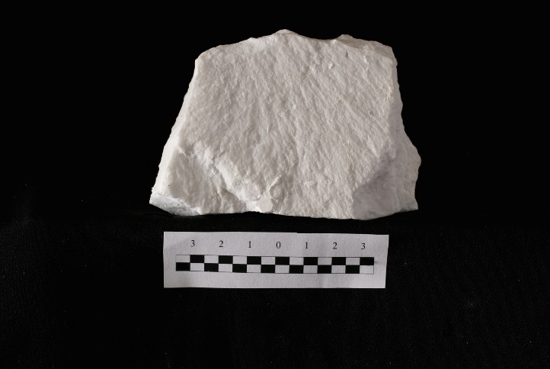
Göstritz | Triassic (Carnian) | Gt_1 | anhydrite | light grey, marble like anhydrite  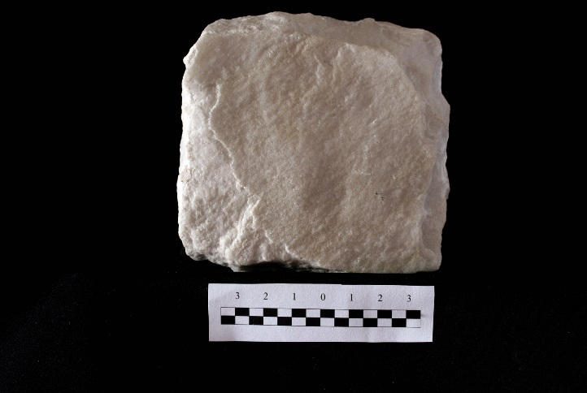
 |  | Gt_2 | gypsum | white-grey marble like gypsum  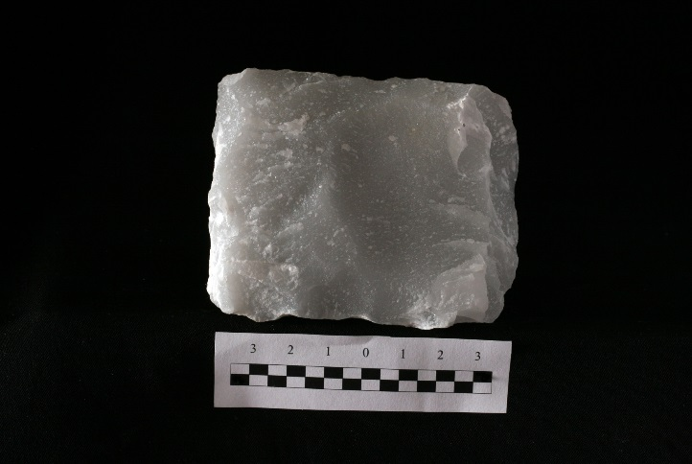
 |  | Gt_3 | dolomite | grey dolomite with gypsum joints
 |  | Gt_4 | gypsum | 