Geological Magazine

Darriwilian shallow-marine deposits from The Sultanate of Oman, a poorly known portion of the Arabian margin of Gondwana

A.P. Heward, G.A. Booth, R.A. Fortey, C.G. Miller & I.J. Sansom

Supplementary Material

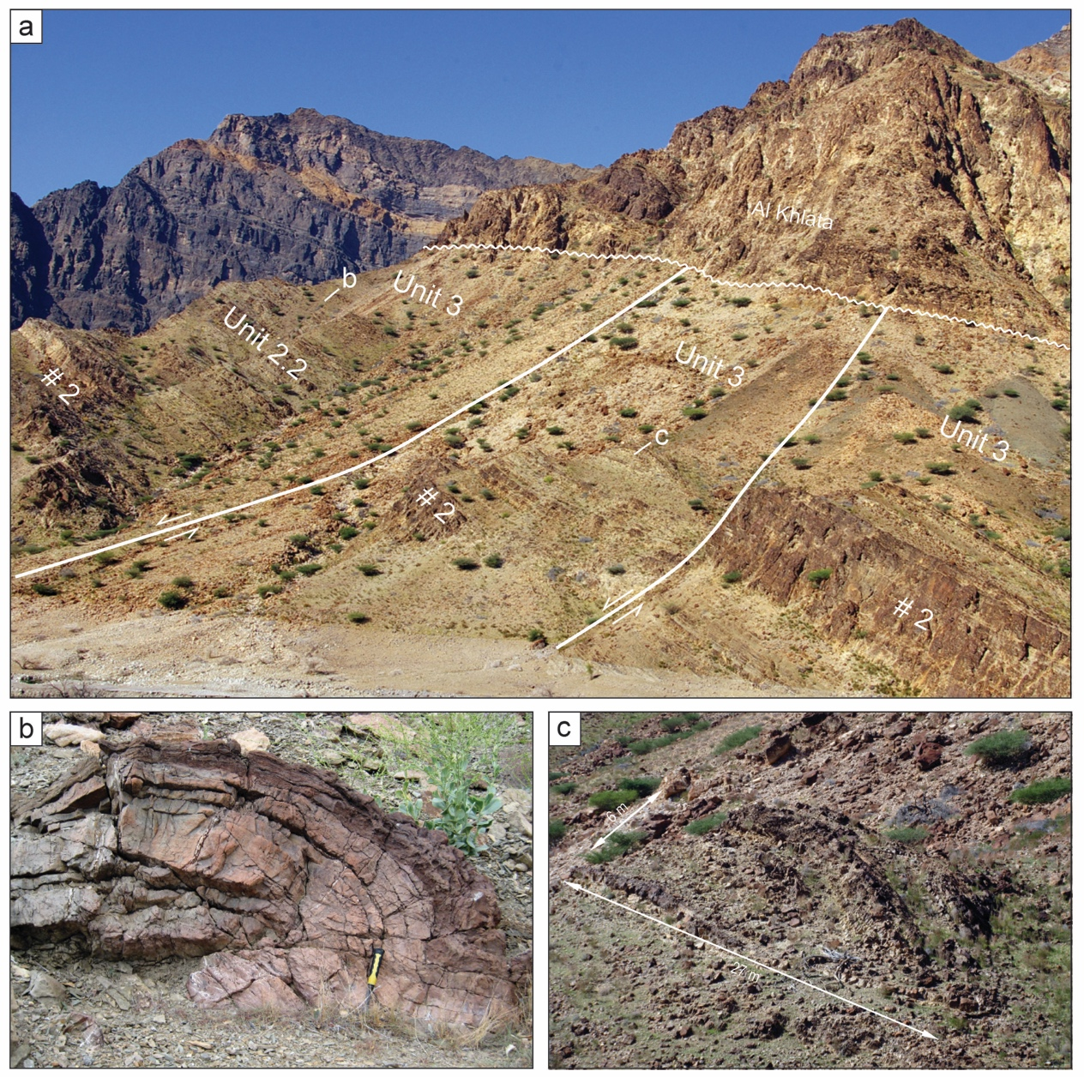

Figure S1. Structural deformation within the Am 5 at Wadi Daiqa. (a) Annotated photograph of northern flank of the inlier showing block faulting, folding and subunit 2.2 varying in thickness, capped by the shales of unit 3. Up to 50 m of subunit 2.2 is missing in the fault blocks in the foreground. Iron-stained shoreface sand body #2, bottom right, is 15 m thick. (b) Small asymmetric fold verging to north-east, located in photo above. Hammer handle 280 mm. (c) Larger asymmetric fold verging to north-east, located in photo above. Fold is 27 x 6 m.
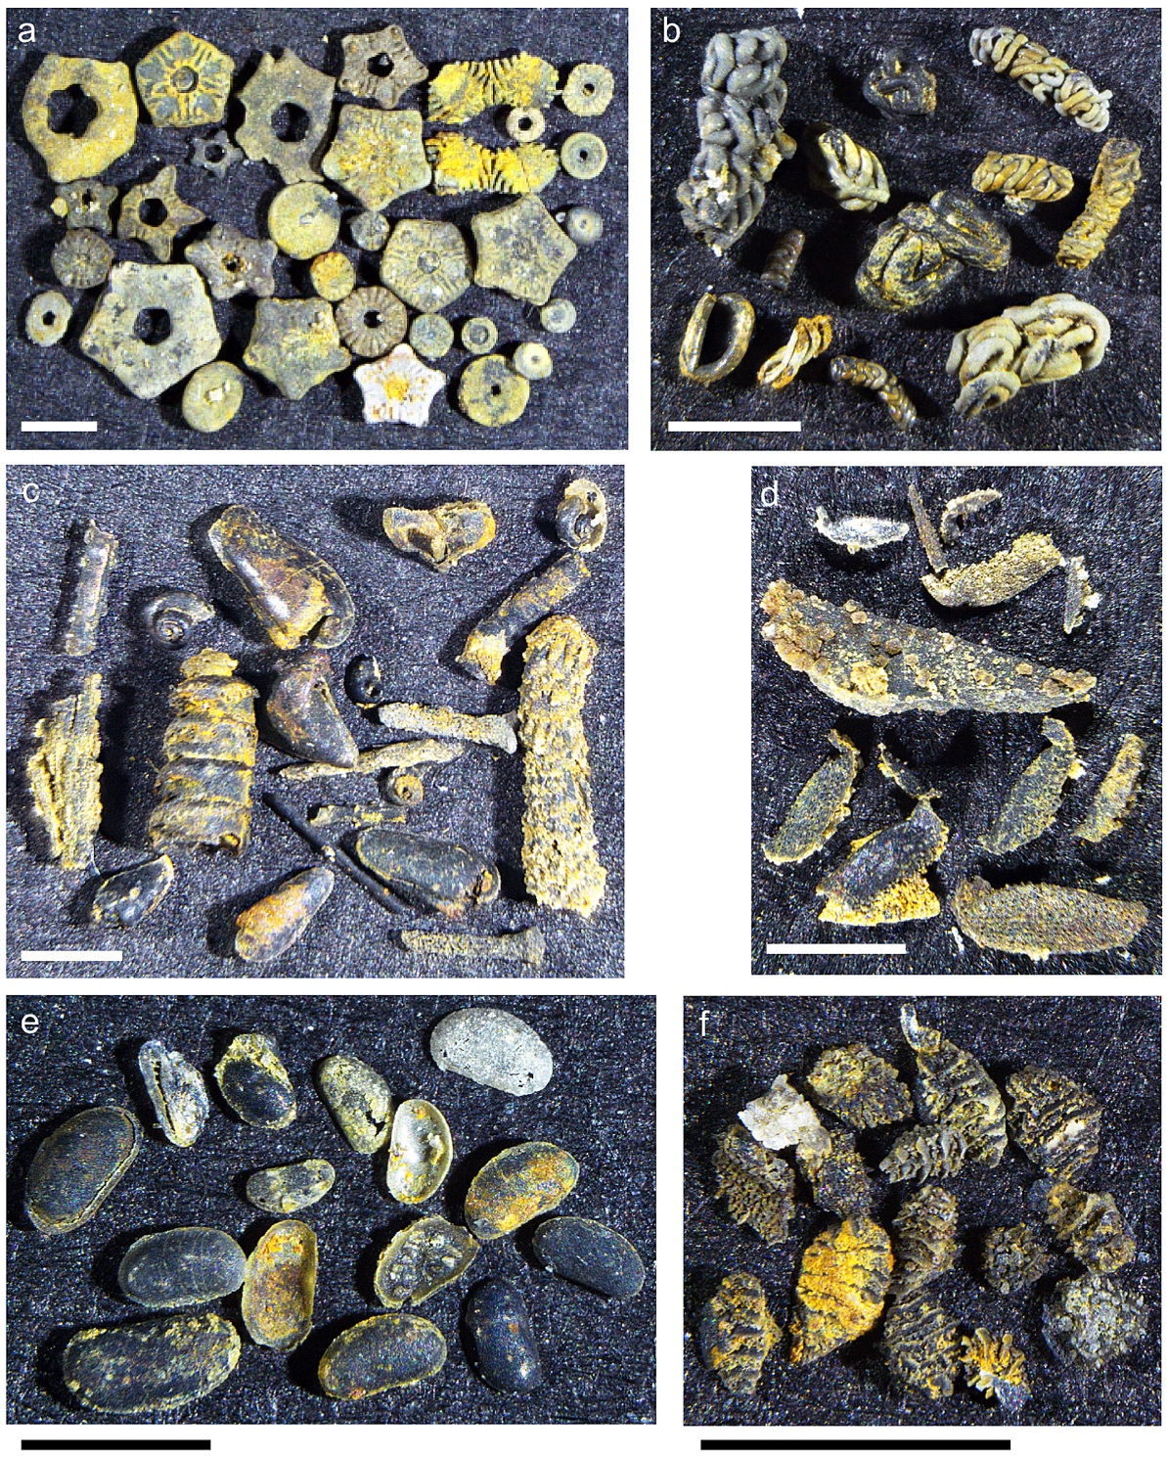
Figure S2. Other faunal elements picked from the conodont residues, common to both Wadi Daiqa and Hayl al Quwasim except where indicated. Scale bars are 1 mm. (a) Variety of crinoid ossicles of different shapes and form, NHMUK PI E 83914. Only the pentastellate Iocrinus has been identified thus far. (b) worm tubes or coprolite? NHMUK PM PF 74486. (c) Variety of internal moulds of bivalves (Redonia ?sp. nov., ?Ambonidiidae gen. et sp. nov., Noel Morris pers. comm. to CGM, 2015), gastropods, orthoconic nautiloids, bryozoans and other elongate fragments, NHMUK PI PEI 5371-5373). (d) Spiny saddle-like features of unknown affinity, possibly from echinoderm, NHMUK PI E 83919). Wadi Daiqa only. (e) Internal moulds of carapaces and individual valves of non-palaeocope ostracods, NHMUK PM OS 19593. (f) Oval, ‘scale-like’ features with transverse or radial arrangements of ribbed ornament, NHMUK PV P 73829. Hayl al Quwasim, but also present in WD C2010.

Table S1. List of Sample Locations.

Regional Overview of Palynomorph Assemblages

Outside of Oman, the palynomorph assemblages most comparable to those obtained from the Wadi Daiqa and Hayl al Quwasim outcrops were described by Quintavalle et al. (2000) from the Yarkhun Formation, Vidiacot section located in the northern Karakorum Mountains, Chitral, Pakistan. Their VK2 assemblage contains the key genera Arkonia, Dicrodiacrodium and Stelliferidium. Citing the work of Servais (1997), Servais et al. (1996), Brocke et al. (1995), and Chen et al. (1997) they conclude that the VK2 assemblage most likely falls within the hirundo graptolite zone. This equates to an age of early Darriwilian.

The VK2 assemblage is carbonised due to its derivation from rocks, which Quintavalle et al. (2000) describe as of low metamorphic grade. The Wadi Daiqa and Hayl al Quwasim assemblages are also similar in this respect.

Molyneux & Al-Hajri (2000) studied the palynomorph assemblages obtained from the core material of several wells in central Saudi Arabia. They demonstrated that part of the sandstone-dominated unit being analysed was of Llanvirn age and attributable to the Hanadir Member of the Qasim Formation. The assemblages are of low diversity and, while compatible with Saih Nihayda Formation microfloras from Oman, detailed comparison of the acritarch successions is not possible. Some of the variances are likely to be due to differences in the depositional environments.

In Iran the material studied was from the Faraghan Mountains, south eastern Zagros Ranges, where the Seyahou Formation is exposed. Ghavidel-Syooki et al. (2014) demonstrated the existence of a stratigraphic gap within the lower part of the Seyahou Formation, which is a partial equivalent of the stratigraphic gap existing at the base of the Saih Nihayda Formation in the Ghaba Salt Basin of Oman. The Darriwilian assemblage they record is broadly similar to the assemblages derived from wells penetrating the Saih Nihayda Formation in northern Oman, but there is no equivalent to the Wadi Daiqa DX3A assemblage due to the absence of section.

In Iraq, the work of Al-Hadidy (2007) and Al-Ameri (2010) was of broader geological aspect, but each employed defined biozones. Within the Ordovician Khabour Formation, Al-Hadidy (2007) used the PZ-8 and PZ-7 biozones of Baban (D. Baban, unpub. Ph.D. thesis, Univ, of Baghdad, 1996) to distinguish an interval, which was defined as of ‘Llanvirn’ – Darriwilian age. The palynomorph assemblages associated with these biozones do not have a strong resemblance to the well and outcrop assemblages from the Saih Nihayda Formation in Oman. This is most likely due to restricted distribution at the species level and local variation in ranges. Al-Ameri (2010) assigned an Arenig - Llanvirn age to his Palynozone 9. Again, the defining content has only broad similarity to the Oman Saih Nihayda Formation assemblages and does not provide a means of detailed correlation.

To the west, in Jordan, Keegan et al. (1990) assigned a Llanvirn age to their Zone JO-3, which equates, in part, to the Hiswah Formation. A key taxon in their defining assemblage for the zone is the occurrence of Stelliferidium striatulum. This taxon is also one of the most important diagnostic species of the Saih Nihayda Formation in Oman. Correlative support is also provided by the occurrence in both localities of Peteinosphaeridium trifurcatum and Striatotheca principalis.

Systematic Palaeontology: Acritarchs

Studies of the Am5 outcrops in Wadi Daiqa and Hayl al Quwasim, and of the Saih Nihayda Formation in Ghaba Salt Basin wells, have resulted in the discovery of a number of unusual acritarch taxa, some of which are provided with a preliminary description here. The slides from which these forms are described are archived in the PDO palynological collection, Muscat, Sultanate of Oman. The slide numbers and England Finder references to described specimens are provided in the captions for Figures 8 and 9.

Incertae sedis Group Acritarcha Evitt, 1963
Genus Disparifusa Loeblich Jr., 1970
Type species: Disparifusa hystrichosa Loeblich Jr., 1970
Disparifusa sp. aff. D. hystrichosa
Fig. 8g

Description: This taxon has an asymmetrically fusiform central body with opposing convex and concave sides. A single short blunt process is developed at each pole (although they may possibly be shortened by corrosion). The vesicle wall is relatively thin and transparent, and ornamented by short conical spines. On some areas of the body the ornament appears to be aligned and where better preserved it may be clavate in form.
Dimensions: Vesicle length (total): 53 µm; breadth: 23 µm. Process length: 5 – 8 µm.

Remarks: The taxon has affinity with D. hystricosa, but differs in that the spiny ornament is partially aligned and not entirely random. In addition, the ornament may be clavate in form and is not restricted to short conical spines. Disparifusa hystricosa has been recorded from Ghudun Formation in Oman, which underlies the Saih Nihayda Formation.

Genus Pterospermella Eisenack, 1972
Type species: Pterospermella aureolata Cookson & Eisenack, 1958
Pterospermella? sp.
Fig. 8d

Description: The taxon is subcircular to ovate in outline, disc-like, with a marginal fringe of short, variably branched processes. The central area of some specimens is clearly thickened to form a central body similar to that which is characteristic of the genus Pterospermella. The vesicle wall is smooth, very thin, and consequently is often folded and very pale in appearance. The marginal processes number between 24 and 36. The majority have a curved proximal contact with the periphery of the body, then taper distally before expanding into branches of up to the 3rd order. In length they vary from between one sixth to one third of the body diameter. No excystment opening is apparent.
Dimensions: Vesicle diameter: 50-62 µm. Process length: 11-17 µm.

Remarks: The processes on the specimens from Wadi Daiqa are rather more coarsely developed than those seen on specimens from GB-1, which bear more numerous and shorter marginal processes. The GB-1 specimens are also of greater diameter and lack a central thickened area. The Wadi Daiqa (early Darriwilian) and the younger GB-1 specimens are clearly related, the latter perhaps being an evolutionary development of the former. Unfortunately, both forms are rare and the transparency of the latter specimens makes them difficult to photograph.

Incertae sedis
Incertae sedis 24 PDO
Fig. 8i

Description: The thin-walled, dome shaped body compresses to a sub-circular outline. The central area of the body displays several curved lines of thickening, which are convex to the outer margin and which together join to form a near symmetrical lobed structure, which is characteristic of the taxon.
Dimensions: Vesicle diameter: 32-38 µm. Maximum diameter of the lobed structure: 22 µm.

Remarks: The taxon has been recorded in Wadi Daiqa outcrop material (Am5, samples DX3A and 06P5), but has also been noted rarely in samples from GB-1 and another nearby well in the Ghaba Salt Basin.

Incertae sedis 27 PDO
Fig. 9m

Description: The central body is ovate to sub-circular in outline with folds which suggest a previous ovoid to spherical form, prior to compression. The body wall is basically smooth to finely granular, but also bears numerous rounded verrucae, which in better preserved specimens may be seen to be between 20 and 30 in number. In addition, a few short processes (usually 2 - 6) are present, which are variable in length and irregularly distributed. They are conical in form with rounded distal terminations and have a curved proximal contact with the central body. The process interiors are in communication with the interior of the central body.
Dimensions: Vesicle diameter: 27-35 µm. Process length: 2-9 µm (often broken).

Remarks: Characteristic features of this species are its ovate form and combination of a few short blunt processes, together with numerous verrucae.

Incertae sedis 40 PDO
Fig. 9 i

Description: The central body outline is sub-circular. Limited folding of the body wall suggests that the original shape was lenticular rather than spherical. The body wall is ornamented by a fine reticulum. The lacunae are sub-polygonal in shape and relatively consistent in size, varying in diameter between 1.0 and 2.5 µm. The ridges bounding the lacunae are 0.25 – 0.5 µm in width.
Dimensions: Vesicle diameter: 30 to 58 µm. Lacunae diameter: 1.0 to 2.5 µm.

Remarks: The taxon occurs most commonly in assemblages which lack spinose acritarchs, are cyptospore- and leiosphere-dominated, and consequently interpreted to be marginal marine in character.

Systematic Palaeontology: Trilobite

Family Trinucleidae Hawle & Corda 1847
Genus Yinpanolithus Lu in Lu & Chang 1974
Yinpanolithus cf. yinpanensis Lu in Lu & Chang 1974
Fig. 11a-k

Description: The phosphatised material is fragmentary and generally small. However, between the various pieces a fairly complete picture of the morphology can be obtained. The cephalic shield was more than twice as wide at the posterior margin as long (sag.), with a highly transversely convex and vaulted, but narrow, pestle-shaped glabella, which expands forwards only gently without notable exaggeration of the frontal lobe. Glabellar furrows not defined. Occipital ring very narrow (sag.) with indication of median node. There are inflated areas in the axial furrows adjacent to the posterior part of the glabella (bacculae) that are comparatively prominent in small individuals. Inflated genae have a prominent eye (ocellum) opposite about glabellar mid-length and closer to glabella in larger specimens. The eye ridge is particularly prominent in small cranidia. Mature specimens show a lateral genal vein extending beyond the eye across the cheek towards its posterolateral corner, to either side of which a fine genal reticulation is evident. Small cranidium is smooth behind eye ridge. Posterior border furrow well defined and narrow; posterior border prominent laterally. Weakly declined pitted fringe narrowing forwards and inwards, to a single row or even no pits medially. Arrangement of pits is not entirely regular. Outer row continues towards midline and pits prominent, 15 or possibly as many as 17 in a half-fringe. Laterally and posterolaterally there are typically four rows of large pits (a segment of a fifth row seen on largest individual fragment) where the fringe turns towards the posterior; they are arranged radially. The pits reduced to two rows anteriorly in front of the eye lobe and one at the glabella, with none on the midline in at least two specimens. The anterior pits in particular may be sunk in sulci, but the posterior pits are not. Marginal rim is quite prominent and upturned. The small cranidium shows only three rows of pits laterally. However, it appears that the mature arrangement of pits is attained when the cranidium is only a few millimetres across. Interpretation of the pits is informed by incomplete lower lamellae carrying strong genal spines. The ventral structure is not easy to interpret. A prominent ridge with a single large row of pits exterior to it could be interpreted as the girder separating E and I arcs. In this case the single E arc would include the outer row of pits that extend as far as the glabella. However, the interpretation of the girder could be called into question by such specimens as that shown in Figure 11d where the continuation of the ventral ridge into the genal spine is interrupted by two prominent pits. This might rather suggest that the ridge is a pseudogirder, in the usage of Hughes et al. (1975). If this were correct, the girder would be marginal and E arcs would be lacking altogether. Zhou & Hughes (1989) interpreted the ventral structures of Yinpanolithus in this way, which is probably the preferred option to recognise the homologies of our material.

A single pygidium presumably belongs with this species as there are no other trinuculeoideans in the residues (Fig. 11k). It is perhaps more reminiscent of a raphiophorid, being very short and transverse with only three or four axial rings and a deep border. Two interesting cranidia show a circular attachment on the edge of the fringe. It appears to be in continuity with the trilobite cuticle, rather than a holdfast belonging to an imposed organism (Fig. 11j). It is possible that this curious structure represents the trinucleid response to a parasite.

Discussion: We are indebted to Dr Keith Ingham for drawing our attention to the similarity of our material to described species of Yinpanolithus (written comm. to RAF, 2015), which is a rare genus known from very little material, all from China. The Omani collection strikingly resemble the type species, Y. yinpanensis Lu (in Lu & Chang, 1974, pl. 54, fig. 9) from the mid- to late Arenig (top Floian – Dapingian) of south-west China. The only differences relate to minor details of the fringe, which is wider in front of the glabella in the Chinese material than it is in our specimens, while the pits in the outer rows on the left hand side of the holotype appear to be more irregular and tending to amalgamation. Nothing is known of the variation within the species from the type locality. We are obliged to be cautious in our assignment of the new material to the type species (hence ‘cf.’), not least because of differences in preservation. It is also younger (Dariwillian) than its Chinese relative. Nonetheless, the Amdeh species gives the best information we have on the ventral structure of the genus. Bowdler-Hicks et al. (2002) list other species assigned to Yinpanolithus, which all display more significant differences in fringe structure from the new isolated material than does Y. yinpanensis.

Bowdler-Hicks et al. (2002) also discussed the phylogenetic importance of Yinpanolithus, which displays an intermediate morphology between plesiomorphic Subfamily Hanchungolithinae, and more advanced Marrolithinae and Cryptolithinae. Ours are the first examples of "Llanvirn [Dariwillian] forms potentially linking Yinpanolithus with the Caradoc cryptolithine stocks" (ibid, p. 1089) that were hitherto lacking in the fossil record. This is of particular interest because Cryptolithinae appear suddenly in Avalonia, in early Caradoc (Sandbian) strata, without any apparent precursors in Western Europe. It seems plausible that this group of trinucleids migrated across the Ordovician Gondwana continent from the southern China plate during the earlier half of the Ordovician, with Oman about half way in that journey. However, our material of Y. cf. yinpanensis retains some features (such as ocelli) that are not typical of derived Marrolithinae or Cryptolithinae, and we do not offer a subfamilial classification here.

Additional References
AL-AMERI, T. K. 2010. Palynostratigraphy and the assessment of gas and oil
generation and accumulations in the Lower Palaeozoic, Western Iraq. Arabian Journal of Geosciences 3, 155-79.
BABAN, D.H.M. 1996.Palynostratigraphy and organic maturation of the lower part of Paleozoic in the western desert of Iraq. Unpublished Ph.D. Thesis, Baghdad University, Iraq, 220pp.
BOWDLER-HICKS, A., INGHAM, J.K. & OWEN, A.W. 2002. The taxonomy and stratigraphical significance of the Anglo-Welsh Cryptolithinae (Trinucleidae, Trilobita). Palaeontology 45, 1075-105.
BROCKE, R., FATKA, O., MOLYNEUX, S. G. & SERVAIS, T. 1995. First
appearance of selected Early Ordovician acritarch taxa from peri-Gondwana. In
Ordovician Odyssey: Short Papers for the Seventh International Symposium on the Ordovician System (eds J.D. COOPER, M.L. DROSER, & S.C. FINNEY, S. C.), pp. 473-76. Pacific Section Society Sedimentary Geology (SEPM).
CHEN, X., MITCHELL, C. E., ZHANG, Y.-D., WANG, Z.-H., BERGSTRÖM, S.M.,
WINSTON, D. & PARIS, F. 1997. GSSP of Darriwilian (Middle Ordovician) in China.
Acta Palaeontologica Sinica 36, 423-31.
COOKSON, I.C. & EISENACK, A. 1958. Microplankton from Australian and New Guinea Upper Mesozoic sediments. Proceedings of the Royal Society of Victoria 70, 1, 19-79, 1-12.
EISENACK, A. 1972. Kritische Bemerkung zur Gattung Pterospermopsis (Chlorophyta, Prasinophyceae). Neues Jahrbuch für Geologie und Paläontologie Monatshefte 10, 596-601.
HUGHES, C.P., INGHAM, J.K. & ADDISON, R. 1975. The morphology, classification and evolution of the Trinucleidae (Trilobita). Philosophical Transactions of the Royal Society of London (Biological Sciences) 272 (920), 537-607.
KEEGAN, J. B., RASUL, S. M. & SHAHEEN, Y. 1990. Palynostratigraphy of the Lower Palaeozoic, Cambrian to Silurian, sediments of the Hashemite Kingdom of Jordan. Review of Palaeobotany and Palynology 66, 167-80.
LOEBLICH, A.R. Jr. 1970. Morphology, ultrastructure and distribution of Paleozoic acritarchs. Proc. N. American Paleont. Conv., Chicago, 1969, part G, 2, 705-88.
LU, Y.-H. & CHANG, W.-T. (ZHANG, W.-T.) 1974. Ordovician trilobites. In A handbook of the stratigraphy and palaeontology of Southwest China, pp. 124-36. Science Press [in Chinese].
SERVAIS, T., BROCKE, R. & FATKA, O. 1996. Variability in the Ordovician acritarch
Dicrodiacrodium. Palaeontology 39, 389-405.
ZHOU, Z.-Y. & HUGHES, C.P. 1989. A review of the trinucleid trilobites of China. Palaontologische Zeitschrift 63, 55-78.

