GEOLOGICAL MAGAZINE
Detrital zircon U–Pb ages and Hf isotopic composition of the Ordovician Duguer quartz schist, central Tibetan Plateau: constraints on tectonic affinity and sedimentary source regions
YIMING LIU, CAI LI, CHAOMING XIE, JIANJUN FAN & HAO WU
Supplementary figure captions
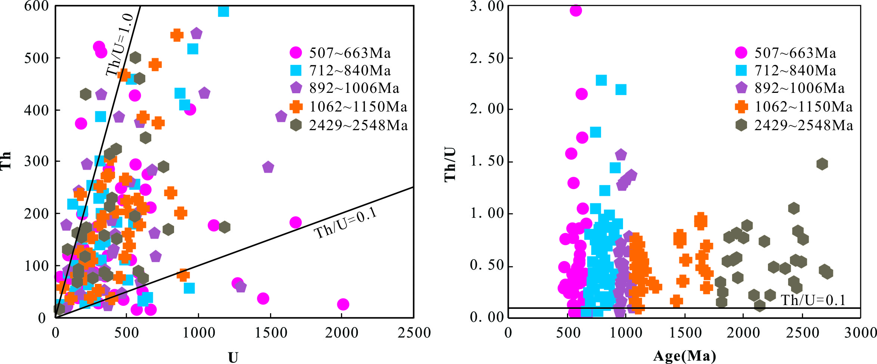
Supplementary Fig. S1. (a) U–Th diagram and (b) age-Th/U diagram of detrital zircons in Duguer quartz schist.

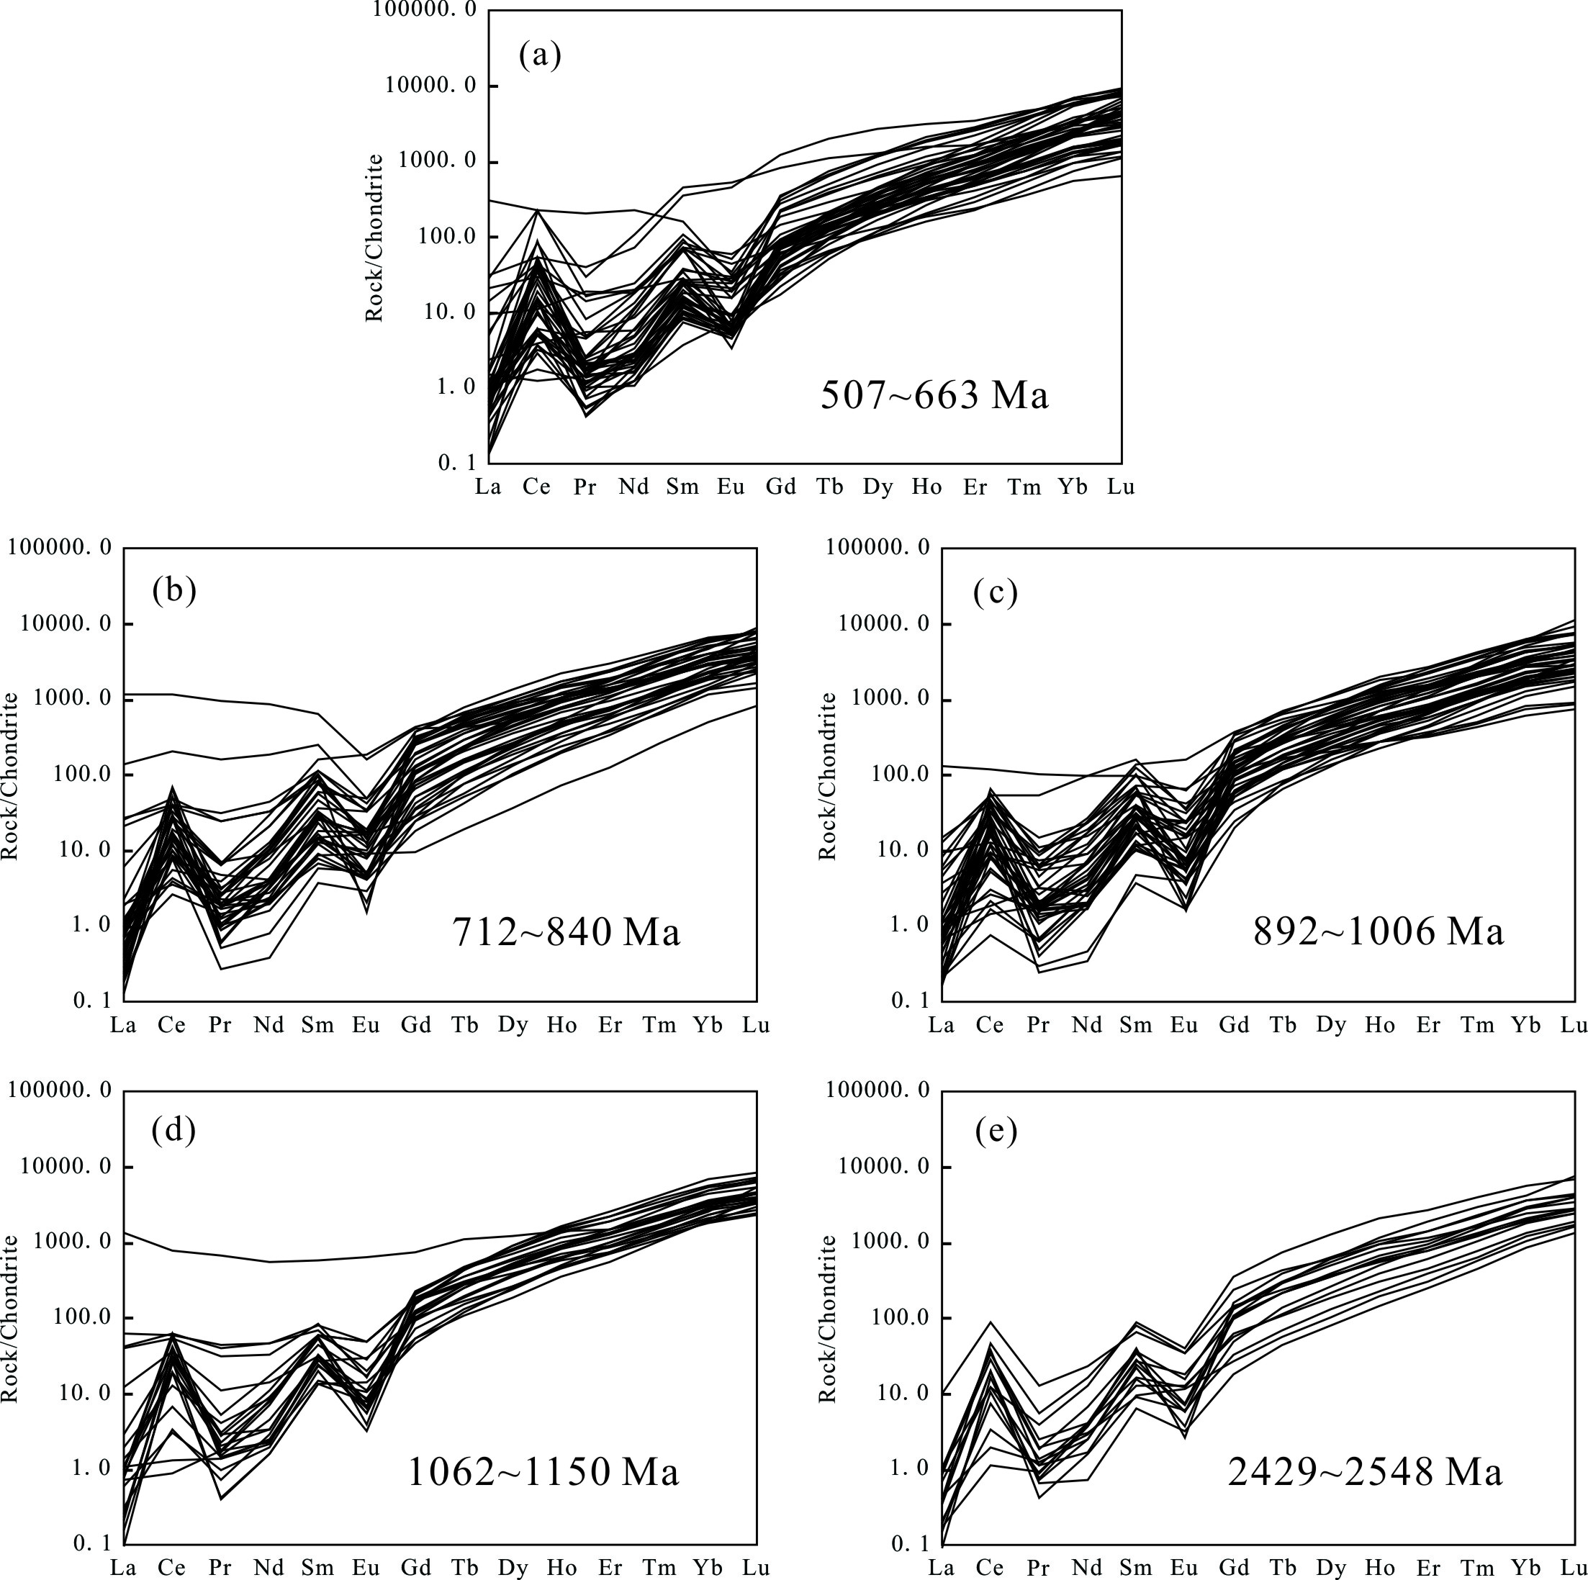
Supplementary Fig. S2. Chondrite-normalized REE (rare earth elements) patterns for detrital zircons from Duguer quartz schist, South Qiangtang terrane, Tibet. The REE data for chondrites are after Sun & McDonough (1989).

