Biomineral structure and crystallographic arrangement of cerioid and phaceloid growth in corals belonging to the Syringoporicae (Tabulata, Devonian-Carboniferous): a genetic reflection
Ismael Coronado¹, Sergio Rodríguez ^{1,2}
^{SUPPLEMENTARY MATERIAL}
¹ Departamento de Paleontología, Universidad Complutense de Madrid. C/ José Antonio Nováis 12, Ciudad Universitaria. E-28040 Madrid. Spain. ismael.coronado@geo.ucm.es
² Instituto de Geociencias (IGEO. CSIC-UCM). C/ José Antonio Nováis 2, Ciudad Universitaria. E-28040 Madrid. Spain.

Supplementary Images.
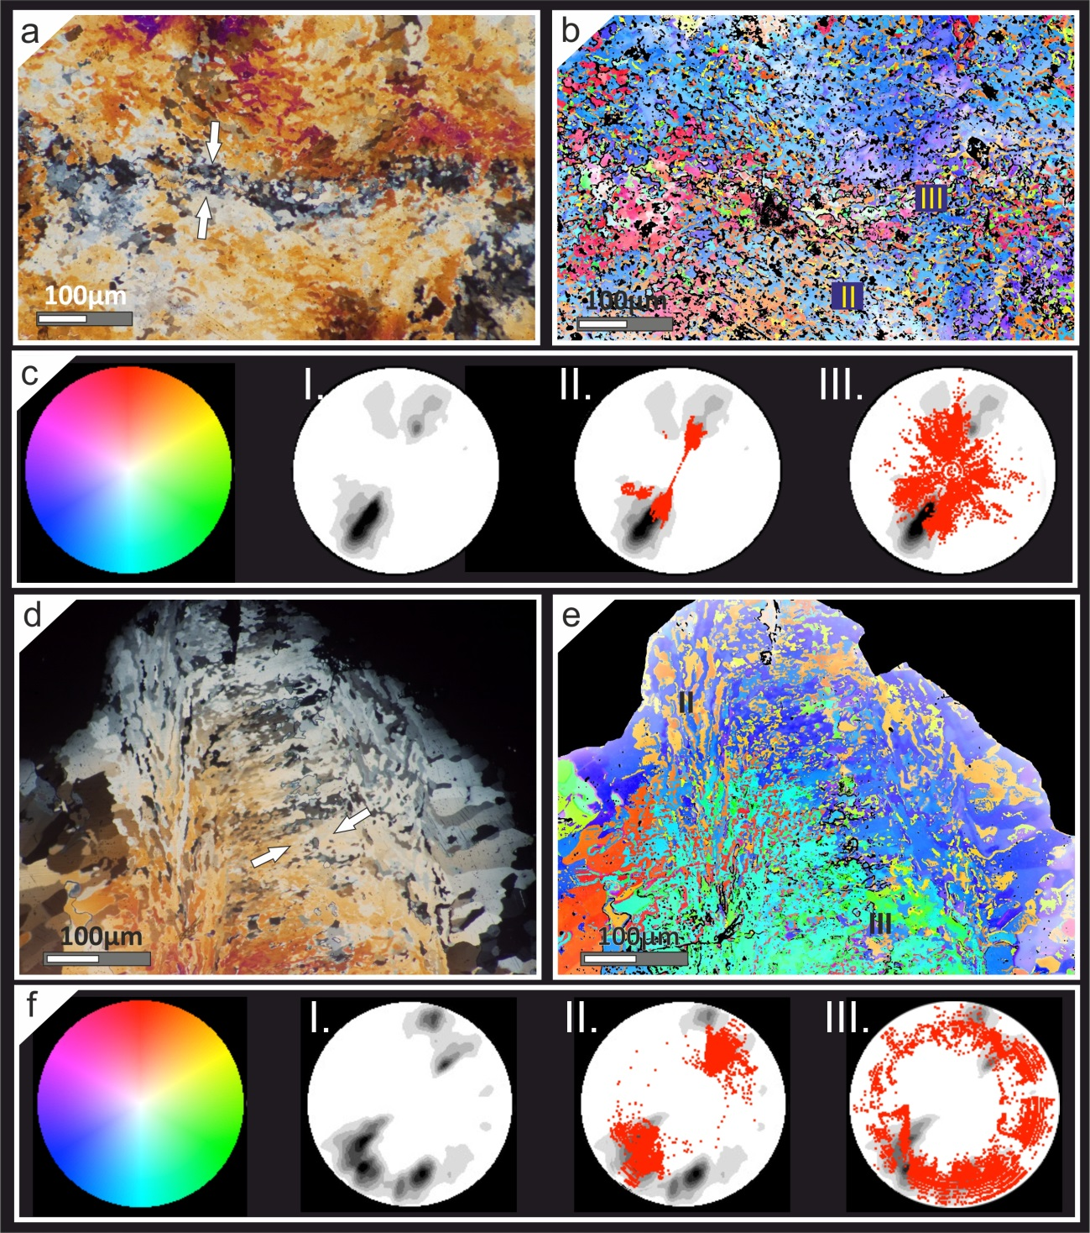
Figure SP1. (a-c) CIP analysis of a transverse section of Neomultithecopora cantabrica in the area between shared-walls of cerioid growth from Hontoria section. (a) Petrographic micrograph of the investigated area. White arrows point to lamina media. (b) Orientation image of the studied area. (c) Standard colour look-up table (CLUT). I: Pole figure of the entire investigated area. II-III: Pole figures of some areas studied in detail and superimposed to the whole pole figure (lamellar domain and granular median lamina respectively). d-f) CIP analysis of a longitudinal section of Roemeria infundibulifera in the area between shared-walls. (d) Petrographic micrograph of the investigated area. White arrows point to lamina media. (e) Orientation image of the studied area. (f) Standard colour look-up table (CLUT). I: Pole figure of the entire investigated area calculated. II-III: Pole figures of some areas studied in detail and superimposed to the whole pole figure (lamellar domain and altered area respectively).
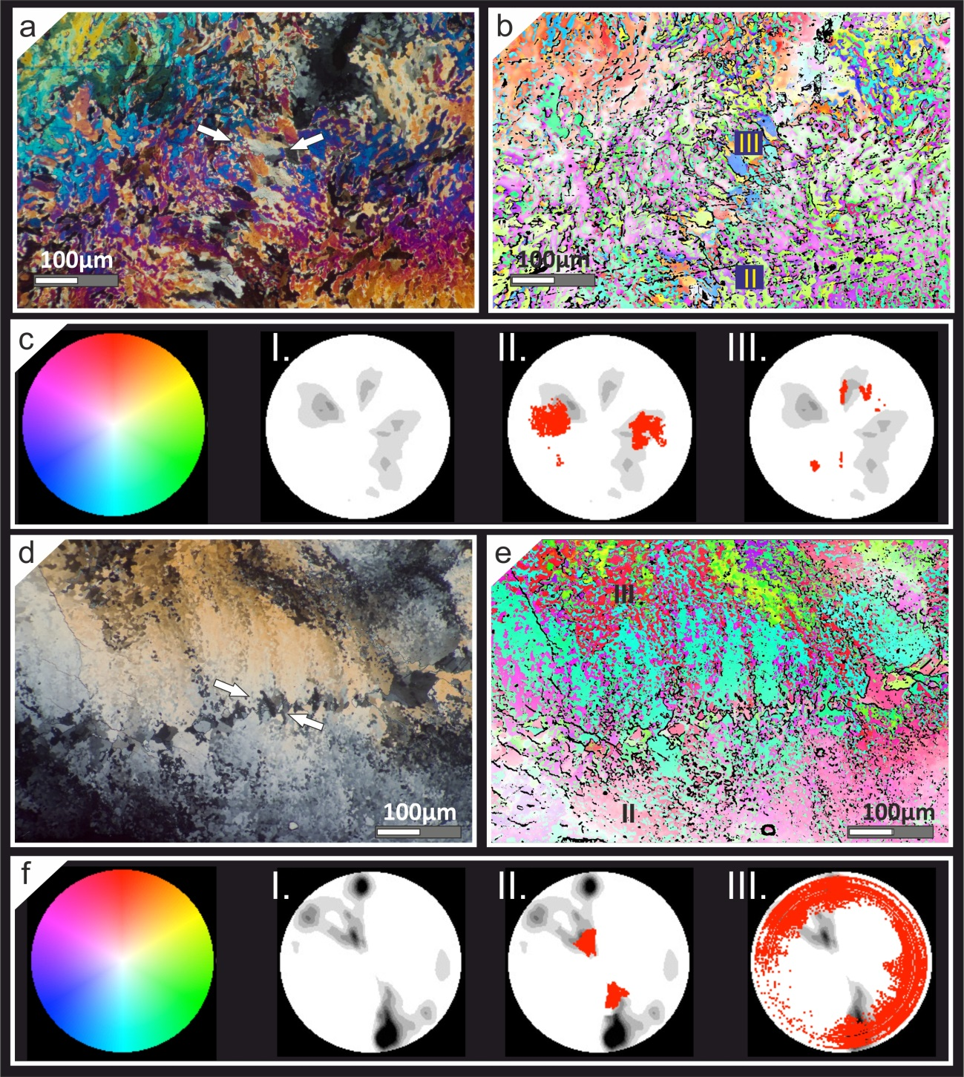
Figure SP2. (a-c) CIP analysis of a transverse section of Roemeria bohemica in the area between shared-walls. (a) Petrographic micrograph of the investigated area. White arrows point to lamina media. (b) Orientation image of the studied area. (c) Standard colour look-up table (CLUT). I: Pole figure of the entire investigated area. II-III: Pole figures of some areas studied in detail and superimposed to the whole pole figure (fibrous domain and hyaline elements respectively). (d-f) CIP analysis of a transverse section of Roemeria cubiniensis in the area between shared-walls. (d) Petrographic micrograph of the investigated area. White arrows point to lamina media. (e) Orientation image of the studied area. (f) Standard colour look-up table (CLUT). I: Pole figure of the entire investigated area calculated. II-III: Pole figures of some areas studied in detail and superimposed to the whole pole figure (fibrous domain and altered area respectively).
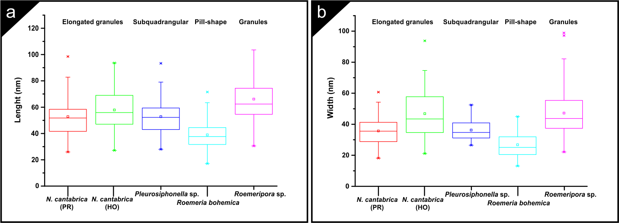
Figure SP3. (a-b) Box charts of length and width sizes of nanocrystals in the different taxa studied by AFM, compared with their morphology. PR: Prioro section, HO: Hontoria section.
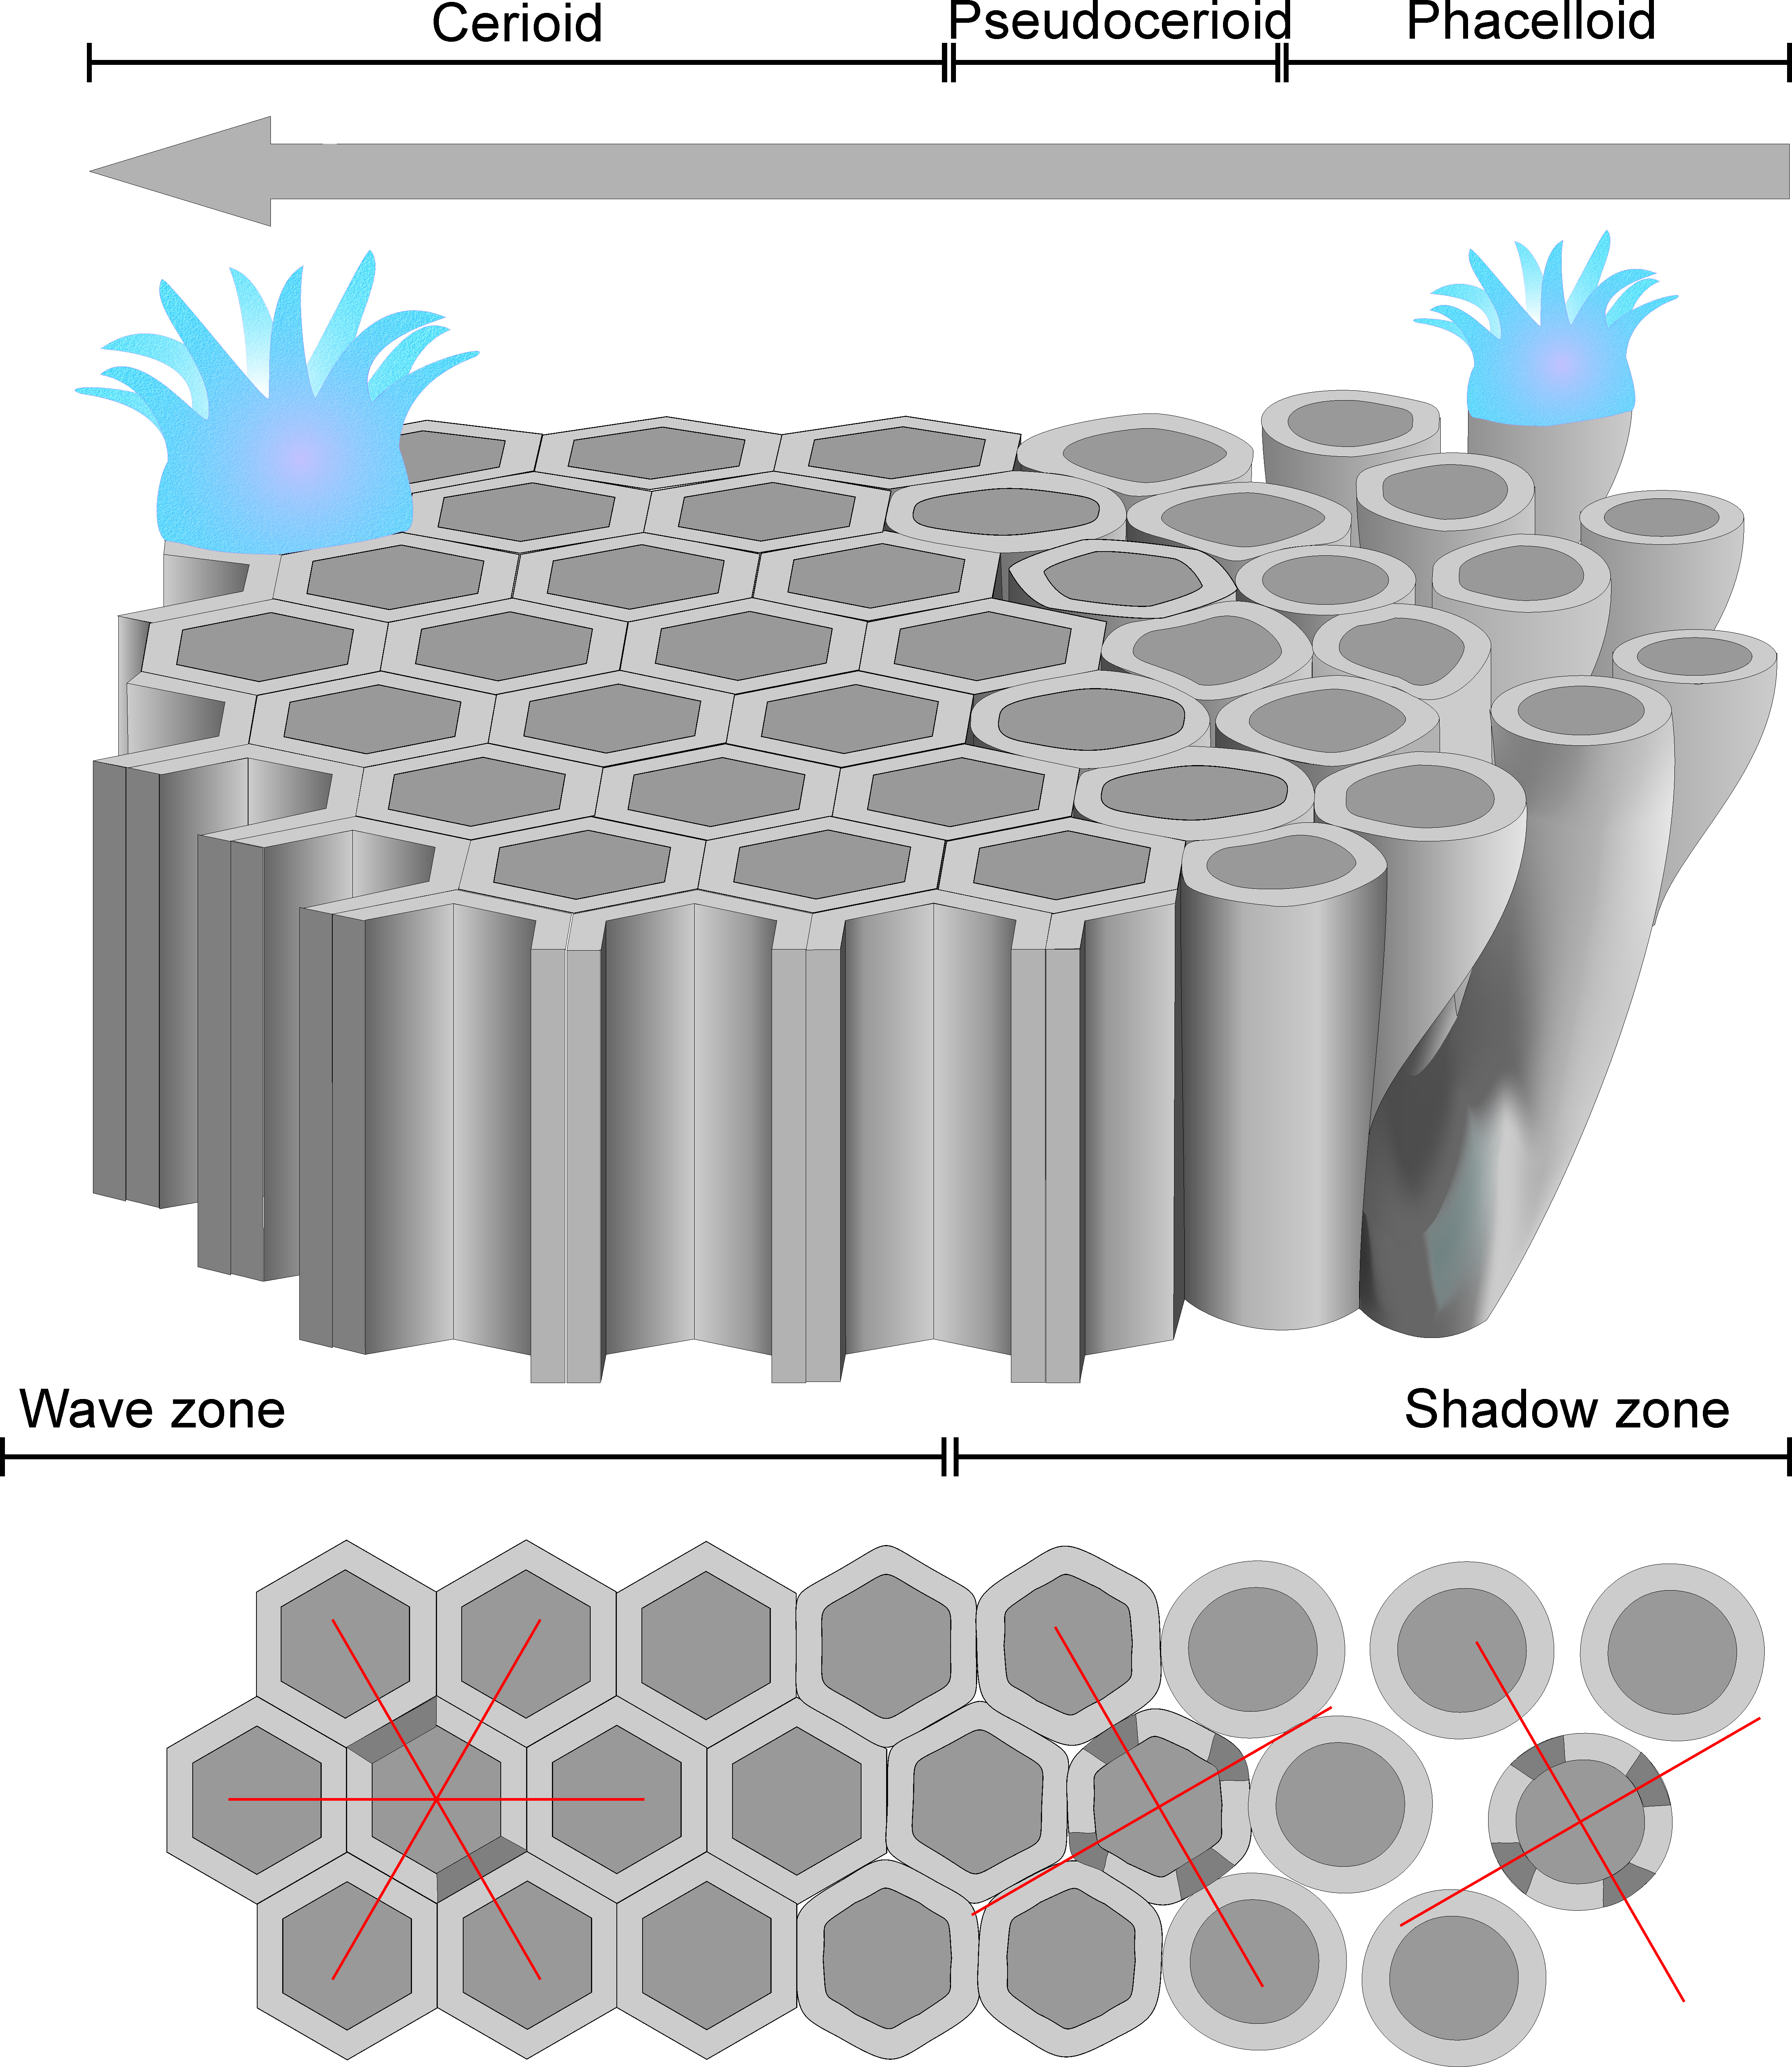
Figure 15. Schematic representation of the passage from cerioid to phaceloid zones into a colony and their relation with the exposition to waves. The red lines represent the c-axis orientation versus the extinction areas (shadow areas) in each internal structural organization (cerioid, pseudocerioid and phaceloid).

