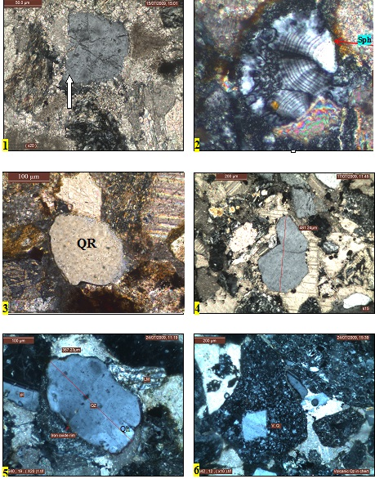
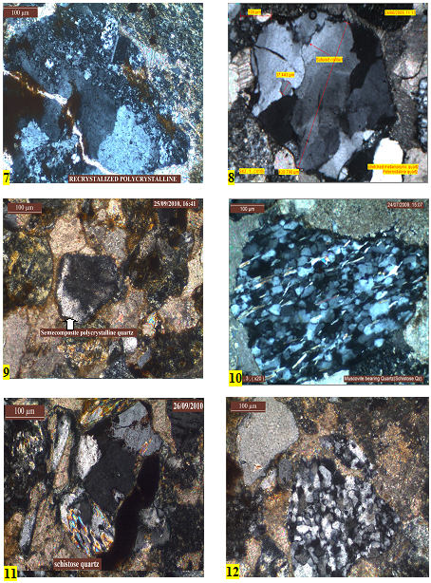
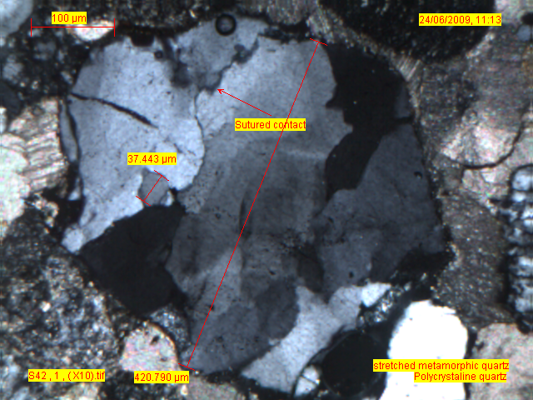
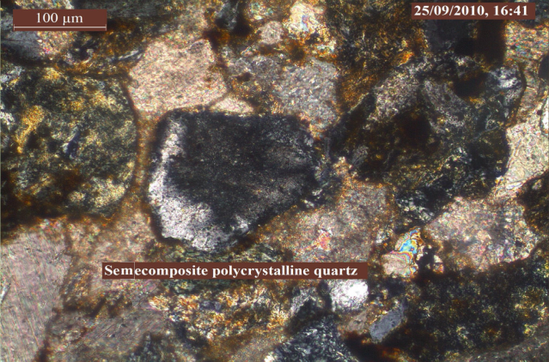
S. 1. Thin section photograph of monocrystalline quartz (Qm) in calcite cement which contains inclusions such as iron oxides (white arrow) which are regarded as a diagnostic characteristic of volcanic quartz. Sample (S28) from unit one in the Sorakalat section. Cross polarize light.
S. 2. Thin section photograph showing cracked quartz (QH) within the middle part of the Tagaran section sample (T24). Cross polarised light.

S. 4. Photograph of recrystallised polycrystalline quartz present in unit two in the Merga section,sample M18. Cross polarised light.
S. 5. Thin section photograph of stretched metamorphic quartz in unit two in the Sorakalat section,sample S42, Cross polarised light.

S. 3. Photograph of well-rounded monocrystalline quartz representing recycled orogenic quartz (QR) present in the upper part of the Tagaran section sample (T36). Cross polarised light.

S. 6. Photograph shows a semi-composite quartz grain in unit two in Merga section,sample (M31). Cross polarised light. This grain is also gives an impression that it is like a composite grains when in fact it is a single quartz grain containing an area of wavy extinction

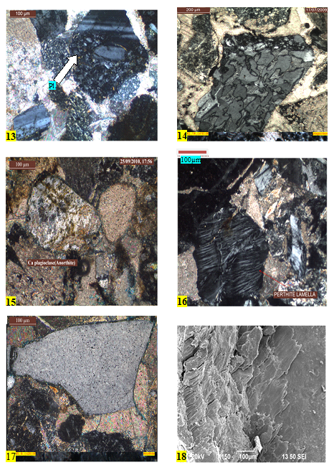
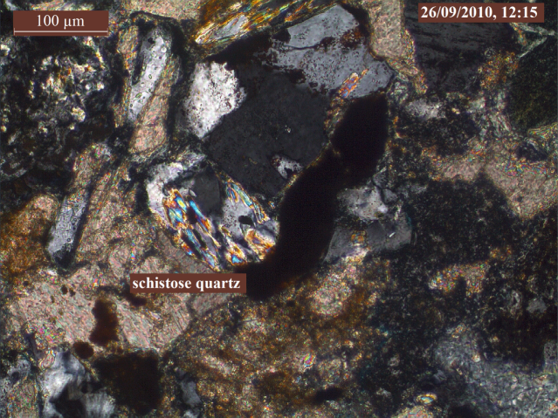
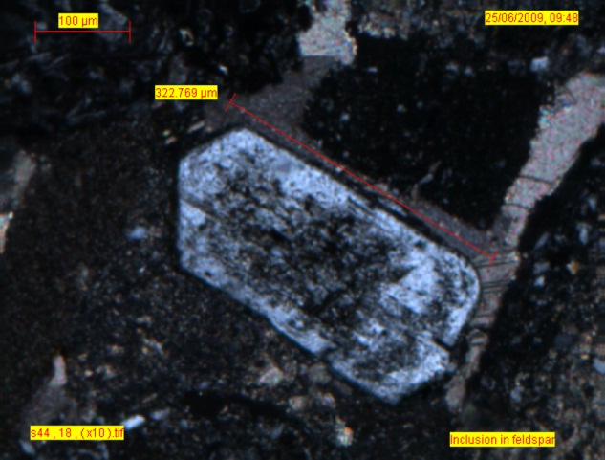
S. 7 Thin section photograph of a schistose grain in unit three in the Tagaran section, sample (T29). Cross polarized section
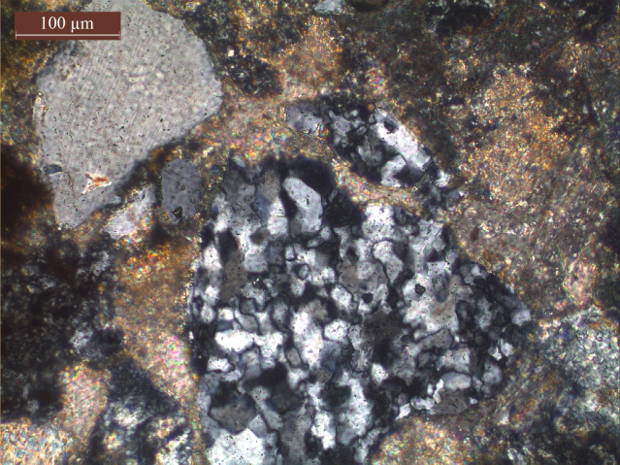
S. 8. This section photograph of a polycrystalline composite quartz grain in unit three in the Tagaran section, sample (T27). Cross polarized section.

S. 9. Thin section photograph of fresh (white arrow) and altered (yellow arrow) albite grains showing a lath shapes with angular edges, present in the middle part of the Kalacholan-Mawat section, sample (KM22). Cross polarised light.

S. 10. Photograph of orthoclase feldspar in the middle part of unit two in the Tagaran section, sample (T30). Cross polarize light.

S. 11. Photograph of K-feldspar (sanidine type) containing inclusions in the centre of the grain. Occurs in the lower part of unit one in the Tagaran section, sample (T52). Cross polarised light.

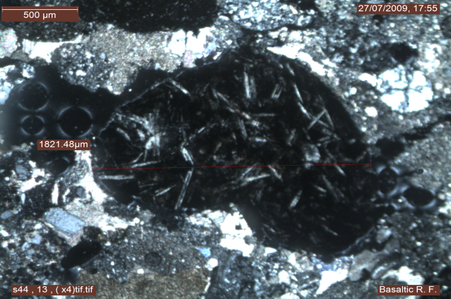
S.12. Photograph of volcanic rock fragment (diorite) in the middle part of the Sorakalat section, sample (S44). Cross polarised light.

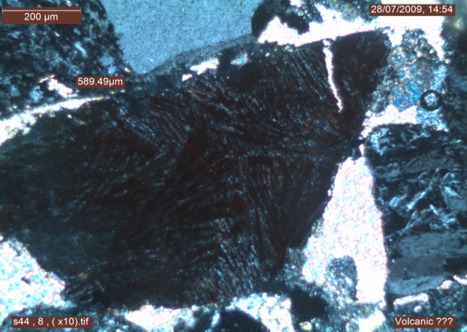
S. 13. Photograph of basaltic lithic fragment representing ophiolite from the middle part of the Sorakalat section, sample (S44). Cross polarised light.

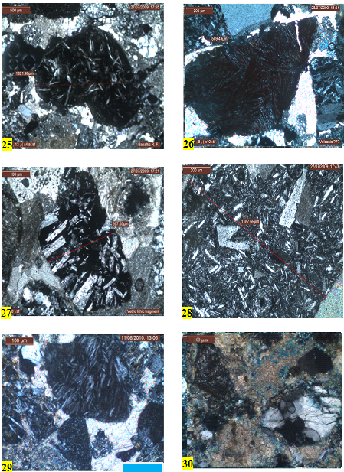
S.14. Photograph of igneous rock fragments (granite type) in unit two in the Kalacholan-Mawat section, sample (KM29). Cross polarised light.

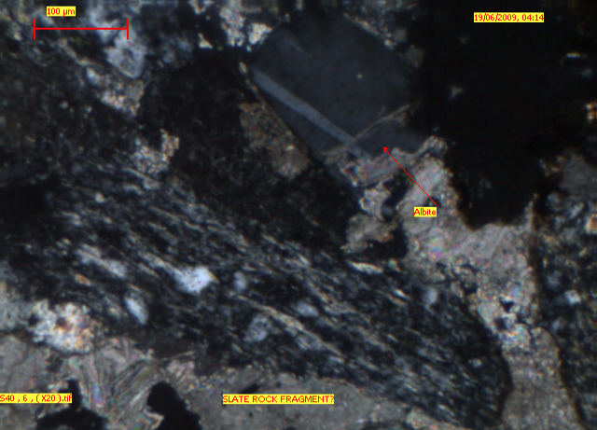

S. 15. Photograph of metamorphic rock fragment (slate) in the middle part of the Sorakalat section (sample S40). Cross polarised light.

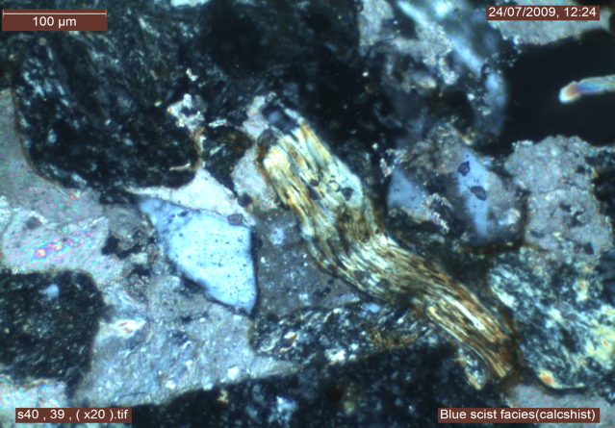
S. 16. Photograph of slate fragments with cleavage deformed by adjacent grains in the middle part of the Tagaran section (sample T32). Cross polarised light.

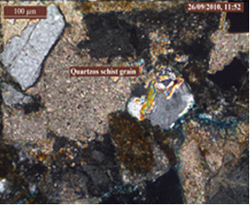
S. 17. Photograph of quartz schist fragment in the uppermost part of the middle unit in the Tagaran section (sample T41). Cross polarised light.

S. 18. Point counting results of the Suwais section
Section  units |  |  | QFR% |  |  | QmFLt% |  |  | QmPK% |  |  |  | QpLvLm |  |  |  | LvLsLm
Section  units | Samples | S.ht. | Qz | F | R | Qm | F | Lt | Qm | P | K | Qm+P+K | Qp | Lv | Lm | QpLvLm | Lv | Ls | Lm | LvLsLm
Lower part unit one | T.L 1.5 | 6.6 | 24.8 | 5.3 | 69.9 | 14.6 | 5.3 | 80.1 | 73.3 | 24.4 | 2.2 | 19.9 | 59.0 | 28.2 | 12.8 | 17.3 | 7.0 | 89.9 | 3.2 | 69.9
Lower part unit one | T.L 2 | 13.2 | 25.3 | 3.6 | 71.0 | 15.4 | 3.6 | 81.0 | 81.0 | 14.3 | 4.8 | 19.0 | 43.1 | 41.2 | 15.7 | 23.1 | 13.4 | 81.5 | 5.1 | 71.0
Lower part unit one | T.L 3 | 19.8 | 25.2 | 4.1 | 70.7 | 17.4 | 4.1 | 78.5 | 80.8 | 15.4 | 3.8 | 21.5 | 42.2 | 44.4 | 13.3 | 18.6 | 11.7 | 84.8 | 3.5 | 70.7
Lower part unit one | T.L 4 | 33.0 | 30.2 | 3.9 | 65.9 | 17.3 | 3.9 | 78.8 | 81.5 | 14.8 | 3.7 | 21.2 | 54.1 | 34.4 | 11.5 | 23.9 | 12.5 | 83.3 | 4.2 | 65.9
Lower part unit one | T.L 5 | 46.0 | 28.4 | 2.7 | 68.9 | 14.8 | 2.7 | 82.5 | 84.4 | 13.3 | 2.2 | 17.5 | 53.8 | 32.3 | 13.8 | 25.3 | 11.9 | 83.1 | 5.1 | 68.9
Lower part unit one | T.L 6 | 79.0 | 23.4 | 3.7 | 73.0 | 15.6 | 3.7 | 80.7 | 80.9 | 12.8 | 6.4 | 19.3 | 40.4 | 42.6 | 17.0 | 19.3 | 11.2 | 84.3 | 4.5 | 73.0
Lower part unit one | T.L 7 | 105.0 | 20.3 | 3.9 | 75.8 | 14.8 | 3.9 | 81.3 | 79.2 | 12.5 | 8.3 | 18.8 | 29.2 | 47.9 | 22.9 | 18.8 | 11.9 | 82.5 | 5.7 | 75.8
Lower part unit one | T.L 8 | 118.0 | 25.2 | 3.0 | 71.7 | 17.4 | 3.0 | 79.6 | 85.1 | 8.5 | 6.4 | 20.4 | 30.5 | 39.0 | 30.5 | 25.7 | 13.9 | 75.2 | 10.9 | 71.7
Lower part unit one | T.L 9 | 141.0 | 19.3 | 3.6 | 77.1 | 14.5 | 3.6 | 81.9 | 80.0 | 8.9 | 11.1 | 18.1 | 22.6 | 54.7 | 22.6 | 21.3 | 15.1 | 78.6 | 6.3 | 77.1
Lower part unit one | T.L 10 | 194.0 | 30.5 | 1.9 | 67.6 | 22.4 | 1.9 | 75.7 | 92.2 | 3.9 | 3.9 | 24.3 | 42.5 | 42.5 | 15.0 | 19.0 | 12.0 | 83.8 | 4.2 | 67.6
Lower part unit one | T.L 11 | 224.0 | 26.7 | 3.8 | 69.5 | 14.8 | 3.8 | 81.4 | 79.5 | 6.8 | 13.6 | 18.6 | 43.8 | 43.8 | 12.5 | 27.1 | 17.1 | 78.0 | 4.9 | 69.5
Lower part unit one | T.L 12 | 247.0 | 28.3 | 2.7 | 69.0 | 21.2 | 2.7 | 76.1 | 88.9 | 5.6 | 5.6 | 23.9 | 32.0 | 50.0 | 18.0 | 22.1 | 16.0 | 78.2 | 5.8 | 69.0
Lower part unit one | T.L 13 | 257.0 | 28.8 | 4.4 | 66.8 | 21.8 | 4.4 | 73.8 | 83.3 | 5.0 | 11.7 | 26.2 | 42.1 | 47.4 | 10.5 | 16.6 | 11.8 | 85.6 | 2.6 | 66.8
Lower part unit one | T.L 14 | 267 | 26.5 | 4.8 | 68.7 | 12.6 | 4.8 | 82.6 | 72.5 | 7.5 | 20.0 | 17.4 | 68.1 | 25.5 | 6.4 | 20.4 | 7.6 | 90.5 | 1.9 | 68.7
Lower part unit one | T.L 15 | 273.0 | 27.3 | 7.6 | 65.1 | 18.5 | 7.6 | 73.9 | 71.0 | 14.5 | 14.5 | 26.1 | 60.0 | 34.3 | 5.7 | 14.7 | 7.7 | 91.0 | 1.3 | 65.1
Lower part unit one | T.L 16 | 306.0 | 28.5 | 5.4 | 66.2 | 14.6 | 5.4 | 80.0 | 73.1 | 13.5 | 13.5 | 20.0 | 50.7 | 31.0 | 18.3 | 27.3 | 12.8 | 79.7 | 7.6 | 66.2
Lower part unit one | T.L 17 | 326.0 | 18.0 | 4.9 | 77.1 | 9.0 | 4.9 | 86.1 | 64.7 | 23.5 | 11.8 | 13.9 | 41.5 | 47.2 | 11.3 | 21.6 | 13.2 | 83.6 | 3.2 | 77.1
Lower part unit one | T.L 18 | 346.0 | 20.9 | 4.3 | 74.8 | 12.4 | 4.3 | 83.3 | 74.4 | 20.5 | 5.1 | 16.7 | 39.2 | 49.0 | 11.8 | 21.8 | 14.3 | 82.3 | 3.4 | 74.8
Lower part unit one | T.L 19 | 359.0 | 22.9 | 4.7 | 72.5 | 10.2 | 4.7 | 85.2 | 68.6 | 22.9 | 8.6 | 14.8 | 53.6 | 37.5 | 8.9 | 23.7 | 12.3 | 84.8 | 2.9 | 72.5
Lower part unit one | T.L 20 | 379 | 28.5 | 4.6 | 66.9 | 18.8 | 4.6 | 76.5 | 80.3 | 11.5 | 8.2 | 23.5 | 45.5 | 38.2 | 16.4 | 21.2 | 12.1 | 82.8 | 5.2 | 66.9
Middle part unit two | T.L 21 | 392 | 28.8 | 2.3 | 68.8 | 20.4 | 2.3 | 77.3 | 89.8 | 1.7 | 8.5 | 22.7 | 35.5 | 37.1 | 27.4 | 23.8 | 12.8 | 77.7 | 9.5 | 68.8
Middle part unit two | T.L 22 | 405 | 27.3 | 0.4 | 72.3 | 17.4 | 0.4 | 82.2 | 97.7 | 2.3 | 0.0 | 17.8 | 42.1 | 38.6 | 19.3 | 23.6 | 12.6 | 81.1 | 6.3 | 72.3
Middle part unit two | T.L 23 | 415 | 32.6 | 2.8 | 64.7 | 22.8 | 2.8 | 74.4 | 89.1 | 7.3 | 3.6 | 25.6 | 58.3 | 33.3 | 8.3 | 16.7 | 8.6 | 89.2 | 2.2 | 64.7
Middle part unit two | T.L 24 | 425.0 | 28.0 | 5.2 | 66.8 | 19.0 | 5.2 | 75.8 | 78.4 | 17.6 | 3.9 | 24.2 | 45.2 | 47.6 | 7.1 | 19.9 | 14.2 | 83.7 | 2.1 | 66.8
Middle part unit two | T.L 25 | 465.0 | 23.3 | 5.5 | 71.2 | 17.8 | 5.5 | 76.7 | 76.4 | 16.4 | 7.3 | 23.3 | 25.0 | 50.0 | 25.0 | 22.0 | 15.5 | 76.8 | 7.7 | 71.2
Middle part unit two | T.L 26 | 478.0 | 34.0 | 4.1 | 61.9 | 27.5 | 4.1 | 68.4 | 87.0 | 10.4 | 2.6 | 31.6 | 35.6 | 44.4 | 20.0 | 18.4 | 13.2 | 80.8 | 6.0 | 61.9
Middle part unit two | T.L 27 | 481.0 | 36.9 | 5.3 | 57.8 | 24.3 | 5.3 | 70.3 | 82.1 | 12.8 | 5.1 | 29.7 | 55.0 | 31.7 | 13.3 | 22.8 | 12.5 | 82.2 | 5.3 | 57.8
Middle part unit two | T.L 28 | 504.0 | 33.3 | 8.1 | 58.5 | 23.5 | 8.1 | 68.4 | 74.3 | 18.9 | 6.8 | 31.6 | 56.1 | 24.4 | 19.5 | 17.5 | 7.3 | 86.9 | 5.8 | 58.5
Middle part unit two | T.L 29 | 518.0 | 23.6 | 6.5 | 69.9 | 15.9 | 6.5 | 77.6 | 70.9 | 16.4 | 12.7 | 22.4 | 38.8 | 42.9 | 18.4 | 19.9 | 12.2 | 82.6 | 5.2 | 69.9
Middle part unit two | T.L 30 | 528.0 | 26.3 | 6.0 | 67.7 | 21.9 | 6.0 | 72.1 | 78.6 | 11.4 | 10.0 | 27.9 | 25.6 | 53.5 | 20.9 | 17.1 | 13.5 | 81.2 | 5.3 | 67.7
Middle part unit two | T.L 31 | 534.0 | 26.3 | 5.6 | 68.1 | 22.0 | 5.6 | 72.4 | 79.7 | 7.8 | 12.5 | 27.6 | 22.7 | 50.0 | 27.3 | 19.0 | 13.9 | 78.5 | 7.6 | 68.1
Middle part unit two | T.L 32 | 544.0 | 28.0 | 6.6 | 65.4 | 21.4 | 6.6 | 72.0 | 76.5 | 10.3 | 13.2 | 28.0 | 41.0 | 41.0 | 17.9 | 16.0 | 10.1 | 85.5 | 4.4 | 65.4
Middle part unit two | T.L 33 | 554.0 | 27.8 | 4.6 | 67.5 | 21.9 | 4.6 | 73.4 | 82.5 | 14.3 | 3.2 | 26.6 | 30.4 | 41.3 | 28.3 | 19.4 | 11.9 | 80.0 | 8.1 | 67.5
Middle part unit two | T.L 34 | 564 | 29.0 | 3.1 | 67.9 | 21.0 | 3.1 | 75.9 | 87.0 | 7.4 | 5.6 | 24.1 | 33.3 | 40.7 | 25.9 | 24.1 | 14.5 | 76.3 | 9.2 | 67.9
Middle part unit two | T.L 35 | 574.0 | 25.7 | 3.5 | 70.8 | 19.0 | 3.5 | 77.4 | 84.3 | 7.8 | 7.8 | 22.6 | 33.3 | 40.0 | 26.7 | 19.9 | 11.3 | 81.3 | 7.5 | 70.8
Middle part unit two | T.L 36 | 588.0 | 24.1 | 3.2 | 72.7 | 19.3 | 3.2 | 77.5 | 85.7 | 7.1 | 7.1 | 22.5 | 23.1 | 48.1 | 28.8 | 20.9 | 13.8 | 77.9 | 8.3 | 72.7
Middle part unit two | T.L 37 | 590.0 | 26.1 | 4.3 | 69.7 | 19.2 | 4.3 | 76.5 | 81.8 | 10.9 | 7.3 | 23.5 | 25.4 | 57.1 | 17.5 | 26.9 | 22.1 | 71.2 | 6.7 | 69.7
Middle part unit two | T.L 38 | 597 | 31.7 | 3.8 | 64.6 | 25.4 | 3.8 | 70.8 | 87.1 | 7.1 | 5.7 | 29.2 | 34.1 | 45.5 | 20.5 | 18.3 | 12.9 | 81.3 | 5.8 | 64.6
Middle part unit two | T.L 39 | 607.0 | 22.6 | 3.9 | 73.5 | 17.8 | 3.9 | 78.3 | 82.0 | 10.0 | 8.0 | 21.7 | 25.6 | 48.8 | 25.6 | 18.7 | 12.4 | 81.1 | 6.5 | 73.5
Middle part unit two | T.L 40 | 610.0 | 30.7 | 3.2 | 66.1 | 22.0 | 3.2 | 74.8 | 87.3 | 7.3 | 5.5 | 25.2 | 35.2 | 31.5 | 33.3 | 24.8 | 11.8 | 75.7 | 12.5 | 66.1
Middle part unit two | T.L 41 | 620 | 26.9 | 2.8 | 70.3 | 21.2 | 2.8 | 75.9 | 88.2 | 7.8 | 3.9 | 24.1 | 27.9 | 46.5 | 25.6 | 20.3 | 13.4 | 79.2 | 7.4 | 70.3
Middle part unit two | T.L 42 | 627.0 | 24.0 | 2.4 | 73.6 | 16.7 | 2.4 | 80.9 | 87.2 | 8.5 | 4.3 | 19.1 | 27.7 | 44.6 | 27.7 | 26.4 | 16.0 | 74.0 | 9.9 | 73.6
Middle part unit two | T.L 43 | 643 | 17.7 | 1.8 | 80.5 | 11.9 | 1.8 | 86.3 | 87.1 | 6.5 | 6.5 | 13.7 | 23.6 | 47.3 | 29.1 | 24.3 | 14.3 | 76.9 | 8.8 | 80.5
Middle part unit two | T.L 44 | 673 | 22.0 | 2.2 | 75.8 | 15.9 | 2.2 | 81.9 | 87.8 | 7.3 | 4.9 | 18.1 | 28.6 | 44.9 | 26.5 | 21.6 | 12.8 | 79.7 | 7.6 | 75.8
Middle part unit two | T.L 45 | 689 | 20.9 | 1.6 | 77.5 | 14.8 | 1.6 | 83.6 | 90.0 | 7.5 | 2.5 | 16.4 | 30.6 | 36.7 | 32.7 | 20.1 | 9.5 | 82.0 | 8.5 | 77.5
Middle part unit two | T.L 46 | 762 | 15.7 | 4.1 | 80.2 | 10.7 | 4.1 | 85.1 | 72.2 | 22.2 | 5.6 | 14.9 | 24.5 | 51.0 | 24.5 | 20.2 | 12.9 | 80.9 | 6.2 | 80.2
Middle part unit two | T.L 47 | 815 | 17.5 | 6.7 | 75.8 | 11.5 | 6.7 | 81.7 | 63.0 | 23.9 | 13.0 | 18.3 | 23.1 | 50.8 | 26.2 | 25.8 | 17.3 | 73.8 | 8.9 | 75.8
Upper part unit three | T.L 49 | 838 | 18.6 | 1.8 | 79.6 | 12.8 | 1.8 | 85.4 | 87.9 | 6.1 | 6.1 | 14.6 | 39.4 | 42.4 | 18.2 | 14.6 | 7.8 | 88.9 | 3.3 | 79.6
Upper part unit three | T.L 55 | 907 | 23.8 | 2.2 | 74.0 | 17.6 | 2.2 | 80.2 | 88.9 | 6.7 | 4.4 | 19.8 | 24.6 | 49.1 | 26.3 | 25.1 | 16.7 | 74.4 | 8.9 | 74.0
Upper part unit three | T.L 57 | 953 | 21.3 | 1.6 | 77.2 | 15.7 | 1.6 | 82.7 | 90.9 | 6.8 | 2.3 | 17.3 | 25.5 | 45.5 | 29.1 | 21.7 | 12.8 | 79.1 | 8.2 | 77.2

S. 19. Point counting results of the Merga section
Section |  |  | QFR% |  |  | QmFLt% |  |  | QmPK% |  |  |  | QpLvLm |  |  |  | LvLsLm
Units
 | Snu | S.ht | Qz | F | R | Qm | F | Lt | Qm | P | K | Qm+P+K | Qp | Lv | Lm | QpLvLm | Lv | Ls | Lm | LvLsLm
Lower part unit one | M1.5 | 8.0 | 37.1 | 19.5 | 43.4 | 26.3 | 19.5 | 54.1 | 57.4 | 23.4 | 19.1 | 45.9 | 52.4 | 26.2 | 21.4 | 20.5 | 12.4 | 77.5 | 10.1 | 43.4
Lower part unit one | M2 | 16.0 | 53.1 | 14.7 | 32.2 | 41.2 | 14.7 | 44.1 | 73.7 | 13.6 | 12.7 | 55.9 | 61.0 | 26.8 | 12.2 | 19.4 | 16.2 | 76.5 | 7.4 | 32.2
Lower part unit one | M3 | 20.0 | 52.7 | 10.7 | 36.6 | 40.6 | 10.7 | 48.7 | 79.1 | 14.8 | 6.1 | 51.3 | 51.9 | 34.6 | 13.5 | 23.2 | 22.0 | 69.5 | 8.5 | 36.6
Lower part unit one | M4 | 32.0 | 55.6 | 10.3 | 34.1 | 46.2 | 10.3 | 43.5 | 81.7 | 13.5 | 4.8 | 56.5 | 41.2 | 43.1 | 15.7 | 22.9 | 28.9 | 60.5 | 10.5 | 34.1
Lower part unit one | M5 | 56.0 | 50.0 | 10.1 | 39.9 | 40.9 | 10.1 | 49.0 | 80.2 | 12.3 | 7.5 | 51.0 | 44.2 | 34.9 | 20.9 | 20.7 | 18.1 | 71.1 | 10.8 | 39.9
Lower part unit one | M6 | 76.0 | 44.5 | 9.8 | 45.7 | 37.6 | 9.8 | 52.7 | 79.3 | 8.6 | 12.1 | 47.3 | 37.0 | 28.3 | 34.8 | 18.8 | 11.6 | 74.1 | 14.3 | 45.7
Lower part unit one | M7 | 116.0 | 36.1 | 17.6 | 46.4 | 24.0 | 17.6 | 58.4 | 57.7 | 15.5 | 26.8 | 41.6 | 44.4 | 36.5 | 19.0 | 27.0 | 21.3 | 67.6 | 11.1 | 46.4
Lower part unit one | M8 | 135.0 | 42.2 | 10.4 | 47.4 | 16.5 | 10.4 | 73.0 | 61.3 | 19.4 | 19.4 | 27.0 | 63.4 | 22.6 | 14.0 | 40.4 | 19.3 | 68.8 | 11.9 | 47.4
Lower part unit one | M9 | 148.0 | 39.8 | 12.8 | 47.4 | 28.6 | 12.8 | 58.7 | 69.1 | 19.8 | 11.1 | 41.3 | 41.5 | 35.8 | 22.6 | 27.0 | 20.4 | 66.7 | 12.9 | 47.4
Lower part unit one | M10 | 212.0 | 39.6 | 11.2 | 49.2 | 29.9 | 11.2 | 58.9 | 72.8 | 17.3 | 9.9 | 41.1 | 35.2 | 40.7 | 24.1 | 27.4 | 22.7 | 63.9 | 13.4 | 49.2
Lower part unit one | M11 | 220.0 | 35.4 | 14.3 | 50.2 | 26.2 | 14.3 | 59.5 | 64.6 | 19.8 | 15.6 | 40.5 | 36.1 | 41.0 | 23.0 | 25.7 | 21.0 | 67.2 | 11.8 | 50.2
Lower part unit one | M12 | 300.0 | 30.0 | 10.8 | 59.1 | 24.6 | 10.8 | 64.5 | 69.4 | 22.2 | 8.3 | 35.5 | 19.0 | 62.1 | 19.0 | 28.6 | 30.0 | 60.8 | 9.2 | 59.1
Lower part unit one | M13 | 316.0 | 37.3 | 14.9 | 47.8 | 27.9 | 14.9 | 57.2 | 65.1 | 25.6 | 9.3 | 42.8 | 33.3 | 45.6 | 21.1 | 28.4 | 27.1 | 60.4 | 12.5 | 47.8
Middle part unit two | M14 | 444 | 44.7 | 12.6 | 42.7 | 35.7 | 12.6 | 51.8 | 74.0 | 16.7 | 9.4 | 48.2 | 36.0 | 42.0 | 22.0 | 25.1 | 24.7 | 62.4 | 12.9 | 42.7
Middle part unit two | M15 | 456.0 | 42.3 | 14.9 | 42.8 | 32.1 | 14.9 | 53.0 | 68.3 | 18.8 | 12.9 | 47.0 | 42.3 | 34.6 | 23.1 | 24.2 | 19.6 | 67.4 | 13.0 | 42.8
Middle part unit two | M16 | 496.0 | 44.0 | 8.4 | 47.6 | 35.6 | 8.4 | 56.0 | 80.8 | 10.1 | 9.1 | 44.0 | 46.3 | 39.0 | 14.6 | 18.2 | 15.0 | 79.4 | 5.6 | 47.6
Middle part unit two | M17 | 504.0 | 46.2 | 8.1 | 45.7 | 38.5 | 8.1 | 53.4 | 82.6 | 10.1 | 7.3 | 46.6 | 47.4 | 34.2 | 18.4 | 16.2 | 12.1 | 81.3 | 6.5 | 45.7
Middle part unit two | M18 | 512.0 | 39.0 | 9.6 | 51.3 | 32.0 | 9.6 | 58.3 | 76.8 | 13.7 | 9.5 | 41.7 | 38.1 | 38.1 | 23.8 | 18.4 | 13.7 | 77.8 | 8.5 | 51.3
Middle part unit two | M19 | 556.0 | 39.7 | 7.4 | 52.9 | 32.2 | 7.4 | 60.3 | 81.3 | 11.5 | 7.3 | 39.7 | 34.6 | 44.2 | 21.2 | 21.5 | 18.0 | 73.4 | 8.6 | 52.9
Middle part unit two | M20 | 580 | 37.4 | 9.1 | 53.5 | 30.8 | 9.1 | 60.1 | 77.2 | 12.7 | 10.1 | 39.9 | 38.2 | 41.2 | 20.6 | 17.2 | 13.2 | 80.2 | 6.6 | 53.5
Middle part unit two | M21 | 596 | 51.4 | 7.3 | 41.3 | 36.4 | 7.3 | 56.3 | 83.3 | 9.3 | 7.4 | 43.7 | 63.8 | 22.4 | 13.8 | 23.5 | 12.7 | 79.4 | 7.8 | 41.3
Middle part unit two | M22 | 612 | 43.5 | 11.0 | 45.5 | 30.5 | 11.0 | 58.5 | 73.5 | 15.7 | 10.8 | 41.5 | 59.3 | 25.9 | 14.8 | 22.0 | 12.5 | 80.4 | 7.1 | 45.5
Middle part unit two | M23 | 624 | 46.9 | 7.1 | 46.0 | 19.5 | 7.1 | 73.5 | 73.3 | 16.7 | 10.0 | 26.5 | 68.1 | 19.8 | 12.1 | 40.3 | 17.3 | 72.1 | 10.6 | 46.0
Middle part unit two | M24 | 632.0 | 44.0 | 8.8 | 47.2 | 18.0 | 8.8 | 73.2 | 67.2 | 17.9 | 14.9 | 26.8 | 73.0 | 16.9 | 10.1 | 35.6 | 12.7 | 79.7 | 7.6 | 47.2
Middle part unit two | M25 | 640.0 | 45.8 | 8.3 | 45.8 | 28.3 | 8.3 | 63.3 | 77.3 | 13.6 | 9.1 | 36.7 | 56.0 | 21.3 | 22.7 | 31.3 | 14.5 | 70.0 | 15.5 | 45.8
Middle part unit two | M26 | 656.0 | 46.5 | 8.3 | 45.2 | 30.0 | 8.3 | 61.7 | 78.4 | 12.5 | 9.1 | 38.3 | 63.3 | 21.7 | 15.0 | 26.1 | 12.5 | 78.8 | 8.7 | 45.2
Middle part unit two | M27 | 692.0 | 46.3 | 6.9 | 46.7 | 27.8 | 6.9 | 65.3 | 80.0 | 11.1 | 8.9 | 34.7 | 56.5 | 22.4 | 21.2 | 32.8 | 15.7 | 69.4 | 14.9 | 46.7
Middle part unit two | M28 | 704.0 | 51.0 | 7.8 | 41.2 | 23.5 | 7.8 | 68.6 | 75.0 | 13.8 | 11.3 | 31.4 | 70.7 | 21.2 | 8.1 | 38.8 | 20.0 | 72.4 | 7.6 | 41.2
Middle part unit two | M29 | 712.0 | 53.6 | 8.5 | 37.9 | 31.0 | 8.5 | 60.5 | 78.6 | 13.3 | 8.2 | 39.5 | 74.7 | 17.3 | 8.0 | 30.2 | 13.8 | 79.8 | 6.4 | 37.9
Middle part unit two | M30 | 796.0 | 51.8 | 6.5 | 41.7 | 31.6 | 6.5 | 61.9 | 83.0 | 8.5 | 8.5 | 38.1 | 66.7 | 16.0 | 17.3 | 30.4 | 11.7 | 75.7 | 12.6 | 41.7

S. 20. Point counting results of the Sorakalat section
 |  |  | QFR% |  |  | QmFLt% |  |  | QmPK% |  |  |  | QpLvLm |  |  |  | LvLsLm
Section  units |  |  | Qz | F | R | Qm | F | Lt | Qm | P | K | Qm+P+K | Qp | Lv | Lm | QpLvLm | Lv | Ls | Lm | LvLsLm
Section  units | Snu | S.ht | 9.3 | 23.7 | 67.0 | 6.5 | 23.7 | 69.9 | 21.4 | 57.1 | 21.4 | 30.1 | 5.5 | 48.9 | 45.6 | 51.9 | 37.9 | 26.8 | 35.4 | 67.0
Unit one | DM1.5 | 3.0 | 8.7 | 22.0 | 69.3 | 5.4 | 22.0 | 72.6 | 19.7 | 60.5 | 19.7 | 27.4 | 5.7 | 52.8 | 41.6 | 57.3 | 43.6 | 22.0 | 34.4 | 69.3
Unit one | DM2 | 13.0 | 10.6 | 22.5 | 66.9 | 7.2 | 22.5 | 70.3 | 24.3 | 55.5 | 20.2 | 29.7 | 5.5 | 52.0 | 42.4 | 60.8 | 47.3 | 14.2 | 38.5 | 66.9
Unit one | S30.5 | 33.0 | 10.0 | 19.0 | 71.0 | 6.2 | 19.0 | 74.8 | 24.7 | 49.7 | 25.6 | 25.2 | 6.3 | 48.8 | 44.9 | 59.9 | 41.2 | 21.0 | 37.9 | 71.0
Unit one | S31 | 72.0 | 9.1 | 20.4 | 70.4 | 6.1 | 20.4 | 73.5 | 22.9 | 55.3 | 21.8 | 26.5 | 5.3 | 47.5 | 47.2 | 58.2 | 39.2 | 21.8 | 39.0 | 70.4
Unit one | S31.5 | 75.0 | 8.3 | 18.2 | 73.5 | 4.9 | 18.2 | 76.9 | 21.2 | 55.8 | 23.0 | 23.1 | 6.2 | 47.4 | 46.5 | 55.5 | 35.7 | 29.2 | 35.1 | 73.5
Unit one | DM5.5 | 99.0 | 7.3 | 22.6 | 70.1 | 4.2 | 22.6 | 73.2 | 15.7 | 56.7 | 27.6 | 26.8 | 5.6 | 48.9 | 45.5 | 55.7 | 38.9 | 25.0 | 36.1 | 70.1
Unit one | DM7 | 112.0 | 9.3 | 21.1 | 69.6 | 5.7 | 21.1 | 73.2 | 21.2 | 60.6 | 18.2 | 26.8 | 6.5 | 57.8 | 35.6 | 55.8 | 46.4 | 25.1 | 28.6 | 69.6
Unit one | DM8 | 125.0 | 7.8 | 18.0 | 74.1 | 3.9 | 18.0 | 78.0 | 17.9 | 51.8 | 30.4 | 22.0 | 6.8 | 55.8 | 37.4 | 57.7 | 43.4 | 27.5 | 29.1 | 74.1
Unit one | DM9.5 | 141.0 | 9.7 | 15.4 | 74.9 | 5.3 | 15.4 | 79.4 | 25.5 | 37.3 | 37.3 | 20.6 | 7.4 | 58.7 | 33.9 | 59.8 | 46.8 | 26.1 | 27.0 | 74.9
Unit one | S33 | 171.0 | 8.4 | 14.9 | 76.7 | 5.3 | 14.9 | 79.8 | 26.1 | 41.3 | 32.6 | 20.2 | 5.1 | 70.1 | 24.8 | 60.2 | 55.0 | 25.5 | 19.5 | 76.7
Unit one | S34 | 178.0 | 10.9 | 15.4 | 73.7 | 6.1 | 15.4 | 78.5 | 28.4 | 38.9 | 32.7 | 21.5 | 8.3 | 62.9 | 28.8 | 57.9 | 49.4 | 28.0 | 22.6 | 73.7
Unit one | S34.80 | 244.0 | 8.0 | 15.1 | 76.9 | 4.2 | 15.1 | 80.7 | 21.7 | 39.1 | 39.1 | 19.3 | 6.6 | 65.7 | 27.7 | 57.5 | 49.1 | 30.2 | 20.7 | 76.9
Unit one | S34.85 | 260.0 | 8.5 | 17.4 | 74.1 | 5.1 | 17.4 | 77.5 | 22.6 | 41.5 | 35.8 | 22.5 | 5.9 | 67.6 | 26.5 | 57.7 | 52.6 | 26.8 | 20.6 | 74.1
Unit one | S35 | 277.0 | 6.7 | 11.8 | 81.5 | 3.7 | 11.8 | 84.5 | 23.8 | 45.2 | 31.0 | 15.5 | 4.2 | 70.7 | 25.1 | 70.7 | 61.3 | 16.9 | 21.8 | 81.5
Unit one | S35.75 | 300.0 | 5.2 | 10.5 | 84.3 | 3.6 | 10.5 | 85.8 | 25.7 | 28.6 | 45.7 | 14.2 | 2.3 | 38.9 | 58.7 | 65.4 | 30.2 | 24.2 | 45.6 | 84.3
Unit one | S36 | 316.0 | 6.1 | 15.8 | 78.1 | 2.6 | 15.8 | 81.6 | 14.3 | 45.2 | 40.5 | 18.4 | 6.3 | 31.8 | 61.9 | 55.3 | 22.5 | 33.6 | 43.8 | 78.1
Unit one | S36.5 | 320.0 | 8.9 | 15.2 | 75.9 | 4.2 | 15.2 | 80.6 | 21.7 | 39.1 | 39.1 | 19.4 | 8.3 | 48.1 | 43.6 | 56.2 | 35.6 | 32.1 | 32.3 | 75.9
Unit one | S37 | 349.0 | 10.1 | 15.0 | 74.9 | 5.2 | 15.0 | 79.8 | 25.9 | 42.1 | 32.1 | 20.2 | 9.0 | 50.4 | 40.6 | 53.8 | 36.2 | 34.6 | 29.2 | 74.9
Unit one | S37.05 | 359.0 | 10.4 | 12.6 | 77.0 | 5.4 | 12.6 | 81.9 | 30.1 | 31.8 | 38.1 | 18.1 | 8.6 | 39.9 | 51.6 | 57.9 | 30.0 | 31.2 | 38.8 | 77.0
Unit one | S37.3 | 382.0 | 12.8 | 18.9 | 68.3 | 6.8 | 18.9 | 74.4 | 26.5 | 41.2 | 32.4 | 25.6 | 11.7 | 37.2 | 51.1 | 51.7 | 28.1 | 33.2 | 38.6 | 68.3
Unit one | S37.5 | 396.0 | 8.5 | 21.6 | 69.8 | 5.0 | 21.6 | 73.3 | 18.8 | 49.3 | 31.9 | 26.7 | 8.4 | 52.5 | 39.1 | 41.5 | 31.2 | 45.6 | 23.2 | 69.8
Unit one | S38 | 415.0 | 19.0 | 19.8 | 61.2 | 1.7 | 19.8 | 78.5 | 7.8 | 54.9 | 37.3 | 21.5 | 28.5 | 43.1 | 28.5 | 60.8 | 42.8 | 29.0 | 28.3 | 61.2
Unit three | S40 | 439.0 | 38.2 | 16.3 | 45.5 | 2.4 | 16.3 | 81.3 | 13.0 | 39.1 | 47.8 | 18.7 | 57.7 | 25.2 | 17.1 | 62.0 | 34.3 | 42.5 | 23.2 | 45.5
Unit three | S42 | 448.0 | 26.1 | 20.7 | 53.2 | 3.8 | 20.7 | 75.5 | 15.6 | 59.4 | 25.0 | 24.5 | 38.6 | 44.7 | 16.6 | 57.6 | 48.4 | 33.6 | 18.0 | 53.2
Unit three | S43 | 458.0 | 8.6 | 16.9 | 74.5 | 1.9 | 16.9 | 81.3 | 10.0 | 56.0 | 34.0 | 18.7 | 9.2 | 71.4 | 19.4 | 73.4 | 70.4 | 10.6 | 19.1 | 74.5
Unit three | S44 | 475.0 | 29.2 | 23.9 | 46.9 | 5.3 | 23.9 | 70.8 | 18.3 | 54.9 | 26.8 | 29.2 | 43.7 | 39.7 | 16.6 | 54.6 | 46.2 | 34.5 | 19.3 | 46.9
Unit three | S45 | 485.0 | 15.6 | 23.6 | 60.8 | 2.5 | 23.6 | 73.8 | 9.7 | 62.9 | 27.4 | 26.2 | 22.5 | 52.9 | 24.6 | 58.2 | 50.7 | 25.7 | 23.6 | 60.8
Unit three | S46 | 518.0 | 16.2 | 17.9 | 66.0 | 4.3 | 17.9 | 77.9 | 19.2 | 50.0 | 30.8 | 22.1 | 21.0 | 57.3 | 21.7 | 56.7 | 49.3 | 32.0 | 18.7 | 66.0
Unit three | S47 | 551.0 | 21.4 | 19.8 | 58.8 | 2.9 | 19.8 | 77.3 | 13.0 | 55.6 | 31.5 | 22.7 | 32.7 | 45.7 | 21.6 | 56.5 | 43.9 | 35.3 | 20.7 | 58.8
Unit three | S48 | 567.0 | 23.4 | 20.6 | 56.1 | 4.4 | 20.6 | 75.0 | 17.6 | 53.3 | 29.1 | 25.0 | 33.0 | 50.5 | 16.5 | 57.5 | 51.8 | 31.3 | 16.9 | 56.1
Unit three | S49 | 607.0 | 24.4 | 19.4 | 56.2 | 5.1 | 19.4 | 75.6 | 20.8 | 50.7 | 28.5 | 24.4 | 35.8 | 40.6 | 23.6 | 54.1 | 39.1 | 38.2 | 22.7 | 56.2
Unit three | S50 | 633.0 | 26.5 | 17.2 | 56.3 | 3.4 | 17.2 | 79.4 | 16.5 | 60.2 | 23.3 | 20.6 | 41.0 | 39.8 | 19.1 | 56.4 | 39.9 | 40.9 | 19.1 | 56.3
Unit three | S51 | 643.0 | 27.3 | 17.2 | 55.5 | 3.8 | 17.2 | 79.0 | 18.0 | 58.0 | 24.0 | 21.0 | 33.9 | 47.9 | 18.2 | 69.3 | 59.8 | 17.4 | 22.7 | 55.5
Unit three | S52 | 650.0 | 29.9 | 17.9 | 52.1 | 5.1 | 17.9 | 76.9 | 22.2 | 51.9 | 25.9 | 23.1 | 36.5 | 42.8 | 20.8 | 67.9 | 55.7 | 17.2 | 27.0 | 52.1
Unit three | S53 | 656.0 | 30.5 | 15.7 | 53.8 | 7.2 | 15.7 | 77.1 | 31.5 | 40.7 | 27.8 | 22.9 | 35.3 | 46.2 | 18.6 | 66.1 | 56.7 | 20.5 | 22.8 | 53.8
Unit three | S54 | 663.0 | 30.0 | 16.2 | 53.7 | 4.8 | 16.2 | 78.9 | 22.9 | 52.7 | 24.3 | 21.1 | 37.1 | 44.0 | 18.9 | 67.9 | 55.7 | 20.4 | 23.9 | 53.7
Unit three | S55 | 666.0 | 27.2 | 17.2 | 55.6 | 6.3 | 17.2 | 76.6 | 26.8 | 48.2 | 25.0 | 23.4 | 31.1 | 48.4 | 20.5 | 67.4 | 58.6 | 16.5 | 24.8 | 55.6
Unit three | S56 | 689.0 | 23.2 | 16.9 | 59.9 | 4.2 | 16.9 | 78.9 | 20.0 | 56.0 | 24.0 | 21.1 | 33.1 | 50.7 | 16.2 | 57.4 | 48.6 | 35.9 | 15.5 | 59.9
Unit three | S57 | 702.0 | 26.0 | 20.5 | 53.5 | 5.6 | 20.5 | 74.0 | 21.4 | 55.4 | 23.2 | 26.0 | 30.8 | 46.9 | 22.4 | 66.5 | 58.3 | 13.9 | 27.8 | 53.5
Unit three | S58 | 712.0 | 26.8 | 18.0 | 55.3 | 2.6 | 18.0 | 79.4 | 12.8 | 63.8 | 23.4 | 20.6 | 35.7 | 45.5 | 18.8 | 67.5 | 55.6 | 21.4 | 23.0 | 55.3
Unit three | S59 | 726.0 | 21.7 | 17.1 | 61.2 | 3.9 | 17.1 | 79.1 | 18.5 | 61.1 | 20.4 | 20.9 | 29.5 | 45.5 | 25.0 | 60.5 | 44.9 | 30.4 | 24.7 | 61.2
Unit three | S60 | 745.0 | 21.5 | 19.1 | 59.4 | 4.3 | 19.1 | 76.6 | 18.3 | 60.0 | 21.7 | 23.4 | 32.6 | 45.2 | 22.2 | 52.7 | 40.1 | 40.1 | 19.7 | 59.4
Unit three | S61 | 768.0 | 24.5 | 21.4 | 54.1 | 3.2 | 21.4 | 75.5 | 13.0 | 59.3 | 27.8 | 24.5 | 38.2 | 35.8 | 26.0 | 55.9 | 37.0 | 36.1 | 26.9 | 54.1
Unit three | S62 | 775.0 | 22.6 | 18.7 | 58.7 | 3.6 | 18.7 | 77.8 | 16.1 | 55.4 | 28.6 | 22.2 | 35.6 | 41.5 | 23.0 | 53.6 | 37.8 | 41.2 | 20.9 | 58.7
Unit three | S63 | 785.0 | 21.4 | 16.3 | 62.3 | 2.3 | 16.3 | 81.3 | 12.5 | 62.5 | 25.0 | 18.7 | 42.6 | 38.3 | 19.1 | 44.7 | 27.5 | 58.8 | 13.8 | 62.3
Unit three | S64 | 808.0 | 21.5 | 19.6 | 58.9 | 3.4 | 19.6 | 77.0 | 14.8 | 60.7 | 24.6 | 23.0 | 32.2 | 42.3 | 25.5 | 56.2 | 40.4 | 35.3 | 24.4 | 58.9
Unit three | S65 | 831.0

S. 21. Point counting results of the Kalacholan-Mawat section
Section  units | Snu |  | QFR% |  |  | QmFLt% |  |  | QmPK% |  |  |  | QpLvLm |  |  |  | LvLsLm
Section  units | Snu | S.ht | Qz | F | R | Qm | F | Lt | Qm | P | K | Qm+P+K | Qp | Lv | Lm | QpLvLm | Lv | Ls | Lm | LvLsLm
Unit one | KM3.5 | 28.0 | 19.6 | 14.7 | 65.7 | 13.7 | 14.7 | 71.6 | 48.3 | 36.2 | 15.5 | 28.4 | 11.7 | 76.7 | 11.7 | 50.5 | 59.0 | 32.1 | 9.0 | 65.7
Unit one | KM9 | 72.0 | 42.3 | 20.5 | 37.2 | 35.9 | 20.5 | 43.6 | 63.6 | 23.5 | 12.9 | 56.4 | 15.5 | 43.3 | 41.2 | 41.5 | 48.3 | 5.7 | 46.0 | 37.2
Unit one | KM10 | 112.0 | 10.9 | 20.5 | 68.6 | 7.4 | 20.5 | 72.1 | 26.4 | 55.6 | 18.1 | 27.9 | 5.6 | 53.1 | 41.3 | 62.0 | 48.0 | 14.7 | 37.3 | 68.6
Unit one | KM11 | 132.0 | 52.2 | 10.2 | 37.6 | 33.3 | 10.2 | 56.5 | 76.6 | 16.2 | 7.2 | 43.5 | 40.0 | 18.3 | 41.7 | 47.1 | 22.9 | 25.0 | 52.1 | 37.6
Unit one | KM12 | 148.0 | 53.6 | 15.2 | 31.1 | 48.3 | 15.2 | 36.4 | 76.0 | 18.8 | 5.2 | 63.6 | 17.4 | 45.7 | 37.0 | 30.5 | 44.7 | 19.1 | 36.2 | 31.1
Unit one | KM13 | 188.0 | 52.3 | 14.8 | 32.9 | 47.1 | 14.8 | 38.1 | 76.0 | 18.8 | 5.2 | 61.9 | 16.0 | 50.0 | 34.0 | 32.3 | 49.0 | 17.6 | 33.3 | 32.9
Unit one | KM14 | 232.0 | 7.3 | 22.6 | 70.1 | 4.2 | 22.6 | 73.2 | 15.7 | 56.7 | 27.6 | 26.8 | 5.6 | 48.9 | 45.5 | 55.7 | 38.9 | 25.0 | 36.1 | 70.1
Unit one | KM15 | 248.0 | 10.2 | 22.2 | 67.7 | 6.8 | 22.2 | 71.1 | 23.4 | 46.8 | 29.9 | 28.9 | 6.3 | 76.1 | 17.6 | 53.4 | 60.0 | 26.1 | 13.9 | 67.7
Unit one | KM16 | 292.0 | 7.8 | 18.0 | 74.1 | 3.9 | 18.0 | 78.0 | 17.9 | 51.8 | 30.4 | 22.0 | 6.8 | 55.8 | 37.4 | 57.7 | 43.4 | 27.5 | 29.1 | 74.1
Unit one | KM17 | 304.0 | 39.1 | 6.2 | 54.7 | 22.4 | 6.2 | 71.4 | 78.3 | 6.5 | 15.2 | 28.6 | 26.7 | 59.4 | 13.9 | 62.7 | 68.2 | 15.9 | 15.9 | 54.7
Unit one | KM18 | 316.0 | 8.4 | 14.9 | 76.7 | 5.3 | 14.9 | 79.8 | 26.1 | 41.3 | 32.6 | 20.2 | 5.1 | 70.1 | 24.8 | 60.2 | 55.0 | 25.5 | 19.5 | 76.7
Unit one | KM19 | 340.0 | 27.0 | 8.1 | 64.9 | 15.4 | 8.1 | 76.4 | 65.6 | 9.8 | 24.6 | 23.6 | 24.6 | 58.2 | 17.2 | 47.1 | 42.3 | 45.2 | 12.5 | 64.9
Unit one | KM20 | 356.0 | 36.7 | 9.6 | 53.7 | 23.6 | 9.6 | 66.8 | 71.1 | 15.8 | 13.2 | 33.2 | 26.8 | 33.9 | 39.3 | 48.9 | 30.9 | 33.3 | 35.8 | 53.7
Unit one | KM21 | 376 | 31.4 | 25.1 | 43.5 | 23.4 | 25.1 | 51.5 | 48.3 | 25.9 | 25.9 | 48.5 | 22.4 | 50.6 | 27.1 | 35.6 | 41.3 | 36.5 | 22.1 | 43.5
Unit one | KM22 | 396.0 | 18.8 | 3.7 | 77.5 | 9.4 | 3.7 | 86.9 | 72.0 | 12.0 | 16.0 | 13.1 | 16.2 | 64.0 | 19.8 | 58.1 | 48.0 | 37.2 | 14.9 | 77.5
Unit one | KM23 | 416.0 | 53.8 | 21.7 | 24.4 | 49.3 | 21.7 | 29.0 | 69.4 | 19.7 | 10.8 | 71.0 | 20.0 | 36.0 | 44.0 | 22.6 | 33.3 | 25.9 | 40.7 | 24.4
Unit two | KM24 | 428.0 | 50.9 | 21.3 | 27.8 | 37.5 | 21.3 | 41.2 | 63.8 | 22.8 | 13.4 | 58.8 | 35.8 | 23.5 | 40.7 | 37.5 | 31.7 | 13.3 | 55.0 | 27.8
Unit two | KM25 | 476.0 | 49.1 | 18.8 | 32.1 | 39.7 | 18.8 | 41.5 | 67.9 | 19.0 | 13.1 | 58.5 | 34.9 | 33.3 | 31.7 | 26.9 | 28.0 | 45.3 | 26.7 | 32.1
Unit two | KM26 | 508.0 | 11.0 | 15.6 | 73.4 | 5.9 | 15.6 | 78.5 | 27.5 | 41.2 | 31.4 | 21.5 | 9.0 | 50.4 | 40.6 | 56.1 | 38.5 | 30.5 | 31.0 | 73.4
Unit two | KM27 | 524 | 10.4 | 12.6 | 77.0 | 5.4 | 12.6 | 81.9 | 30.1 | 31.8 | 38.1 | 18.1 | 8.6 | 39.9 | 51.6 | 57.9 | 30.0 | 31.2 | 38.8 | 77.0
Unit two | KM28 | 540 | 12.8 | 18.9 | 68.3 | 6.8 | 18.9 | 74.4 | 26.5 | 41.2 | 32.4 | 25.6 | 11.7 | 37.2 | 51.1 | 51.7 | 28.1 | 33.2 | 38.6 | 68.3
Unit two | KM29 | 560 | 14.3 | 11.3 | 74.4 | 7.8 | 11.3 | 80.9 | 41.1 | 33.9 | 25.0 | 19.1 | 10.0 | 72.6 | 17.4 | 64.8 | 63.3 | 21.6 | 15.1 | 74.4
Unit two | KM30 | 584 | 17.3 | 10.5 | 72.2 | 11.0 | 10.5 | 78.5 | 51.0 | 37.3 | 11.8 | 21.5 | 10.2 | 66.0 | 23.8 | 62.0 | 56.7 | 22.8 | 20.5 | 72.2
Unit two | KM31 | 604.0 | 38.2 | 16.3 | 45.5 | 2.4 | 16.3 | 81.3 | 13.0 | 39.1 | 47.8 | 18.7 | 57.7 | 25.2 | 17.1 | 62.0 | 34.3 | 42.5 | 23.2 | 45.5
Unit two | KM32 | 628.0 | 21.7 | 12.0 | 66.3 | 18.5 | 12.0 | 69.5 | 60.5 | 25.0 | 14.5 | 30.5 | 6.3 | 69.5 | 24.2 | 51.4 | 53.9 | 27.3 | 18.8 | 66.3
Unit two | KM33 | 640.0 | 22.4 | 10.8 | 66.8 | 18.3 | 10.8 | 71.0 | 64.7 | 23.5 | 11.8 | 28.2 | 7.5 | 63.9 | 28.6 | 55.2 | 52.8 | 23.6 | 23.6 | 66.8
Unit two | KM34 | 648.0 | 23.1 | 12.2 | 64.7 | 18.5 | 12.2 | 69.3 | 60.3 | 26.0 | 13.7 | 30.7 | 8.6 | 64.1 | 27.3 | 53.8 | 53.2 | 24.0 | 22.7 | 64.7
Unit two | KM35 | 656.0 | 23.8 | 13.9 | 62.3 | 21.2 | 13.9 | 64.9 | 60.5 | 25.9 | 13.6 | 35.1 | 5.0 | 69.7 | 25.2 | 51.5 | 57.6 | 21.5 | 20.8 | 62.3
Unit two | KM36 | 660.0 | 22.9 | 17.8 | 59.3 | 16.9 | 17.8 | 65.3 | 48.8 | 31.7 | 19.5 | 34.7 | 11.6 | 64.5 | 24.0 | 51.3 | 55.7 | 23.6 | 20.7 | 59.3
Unit two | KM37 | 664.0 | 22.6 | 17.6 | 59.8 | 17.6 | 17.6 | 64.9 | 50.0 | 29.8 | 20.2 | 35.1 | 10.3 | 63.2 | 26.5 | 49.0 | 51.7 | 26.6 | 21.7 | 59.8
Unit two | KM38 | 672.0 | 22.2 | 18.5 | 59.3 | 12.3 | 18.5 | 69.1 | 40.0 | 36.0 | 24.0 | 30.9 | 18.5 | 59.2 | 22.3 | 53.5 | 53.5 | 26.4 | 20.1 | 59.3
Unit two | KM39 | 680.0 | 24.9 | 21.1 | 54.0 | 16.0 | 21.1 | 62.9 | 43.2 | 36.4 | 20.5 | 37.1 | 19.4 | 50.0 | 30.6 | 45.6 | 42.2 | 32.0 | 25.8 | 54.0
Unit two | KM40 | 692.0 | 25.6 | 19.4 | 55.0 | 19.4 | 19.4 | 61.2 | 50.0 | 33.0 | 17.0 | 38.8 | 13.9 | 57.4 | 28.7 | 44.6 | 46.6 | 30.1 | 23.3 | 55.0
Unit two | KM41 | 700 | 21.7 | 17.1 | 61.3 | 16.3 | 17.1 | 66.7 | 48.8 | 36.3 | 15.0 | 33.3 | 10.7 | 64.8 | 24.6 | 50.8 | 53.7 | 25.9 | 20.4 | 61.3
Unit two | KM42 | 712.0 | 22.4 | 17.4 | 60.2 | 18.3 | 17.4 | 64.3 | 51.2 | 32.6 | 16.3 | 35.7 | 8.4 | 63.9 | 27.7 | 49.4 | 52.4 | 24.8 | 22.8 | 60.2
Unit two | KM43 | 744.0 | 22.0 | 15.7 | 62.3 | 16.9 | 15.7 | 67.4 | 51.9 | 28.6 | 19.5 | 32.6 | 9.8 | 61.5 | 28.7 | 51.7 | 51.0 | 25.2 | 23.8 | 62.3
Unit two | KM44 | 752.0 | 23.2 | 16.5 | 60.3 | 15.2 | 16.5 | 68.4 | 48.0 | 34.7 | 17.3 | 31.6 | 15.2 | 60.0 | 24.8 | 52.7 | 52.4 | 25.9 | 21.7 | 60.3
Unit two | KM45 | 772 | 23.9 | 16.0 | 60.1 | 14.7 | 16.0 | 69.3 | 47.9 | 37.0 | 15.1 | 30.7 | 16.9 | 57.7 | 25.4 | 54.6 | 52.4 | 24.5 | 23.1 | 60.1
Unit two | KM46 | 800.0 | 23.5 | 17.1 | 59.4 | 19.7 | 17.1 | 63.2 | 53.5 | 32.6 | 14.0 | 36.8 | 8.0 | 64.3 | 27.7 | 47.9 | 51.8 | 25.9 | 22.3 | 59.4
Unit two | KM47 | 824.0 | 21.1 | 18.2 | 60.7 | 15.3 | 18.2 | 66.5 | 45.7 | 38.3 | 16.0 | 33.5 | 11.6 | 62.0 | 26.4 | 50.0 | 51.0 | 27.2 | 21.8 | 60.7
Unit two | KM48 | 836 | 28.2 | 17.5 | 54.3 | 20.1 | 17.5 | 62.4 | 53.4 | 34.1 | 12.5 | 37.6 | 16.2 | 59.0 | 24.8 | 50.0 | 54.3 | 22.8 | 22.8 | 54.3
Unit two | KM49 | 840.0 | 22.0 | 17.9 | 60.2 | 15.4 | 17.9 | 66.7 | 46.3 | 40.2 | 13.4 | 33.3 | 12.5 | 57.0 | 30.5 | 52.0 | 49.3 | 24.3 | 26.4 | 60.2
Unit two | KM50 | 848 | 21.1 | 20.7 | 58.2 | 15.2 | 20.7 | 64.1 | 42.4 | 42.4 | 15.3 | 35.9 | 11.9 | 60.2 | 28.0 | 49.8 | 51.4 | 24.6 | 23.9 | 58.2
Unit two | KM51 | 860 | 18.7 | 20.0 | 61.3 | 14.0 | 20.0 | 66.0 | 41.3 | 40.0 | 18.8 | 34.0 | 9.2 | 63.9 | 26.9 | 50.6 | 52.8 | 25.0 | 22.2 | 61.3
Unit two | KM52 | 868 | 18.5 | 18.9 | 62.7 | 12.0 | 18.9 | 69.1 | 39.0 | 40.3 | 20.8 | 30.9 | 12.2 | 64.1 | 23.7 | 52.6 | 53.8 | 26.3 | 19.9 | 62.7
Unit two | KM53 | 872 | 22.9 | 17.1 | 60.0 | 17.1 | 17.1 | 65.7 | 50.0 | 35.7 | 14.3 | 34.3 | 11.5 | 60.7 | 27.9 | 49.8 | 50.3 | 26.5 | 23.1 | 60.0
Unit two | KM54 | 880 | 21.7 | 19.8 | 58.6 | 14.4 | 19.8 | 65.8 | 42.2 | 41.1 | 16.7 | 34.2 | 14.7 | 59.7 | 25.6 | 49.0 | 50.0 | 28.6 | 21.4 | 58.6

S. 22. Point counting results of the Tagaran section
Section  units |  |  | QFR% |  |  | QmFLt% |  |  | QmPK% |  |  |  | QpLvLm |  |  |  | LvLsLm
Section  units | Snu | S.ht | Qz | F | R | Qm | F | Lt | Qm | P | K | Qm+P+K | Qp | Lv | Lm | QpLvLm | Lv | Ls | Lm | LvLsLm
Lower part unit two | T5 | 40.0 | 11.5 | 29.1 | 59.5 | 7.9 | 29.1 | 63.0 | 21.4 | 57.1 | 21.4 | 37.0 | 10.7 | 33.3 | 56.0 | 33.0 | 18.5 | 50.4 | 31.1 | 59.5
Lower part unit two | T6 | 48.0 | 10.3 | 26.1 | 63.7 | 6.4 | 26.1 | 67.5 | 19.7 | 60.5 | 19.7 | 32.5 | 9.6 | 43.6 | 46.8 | 40.2 | 27.5 | 43.0 | 29.5 | 63.7
Lower part unit two | T8 | 84.0 | 14.0 | 15.8 | 70.2 | 10.1 | 15.8 | 74.1 | 39.0 | 49.2 | 11.9 | 25.9 | 9.1 | 35.4 | 55.6 | 43.4 | 21.9 | 43.8 | 34.4 | 70.2
Lower part unit two | T13 | 120.0 | 15.8 | 16.7 | 67.4 | 11.3 | 16.7 | 71.9 | 40.3 | 50.0 | 9.7 | 28.1 | 9.6 | 40.4 | 50.0 | 47.1 | 28.2 | 36.9 | 34.9 | 67.4
Lower part unit two | T15 | 144.0 | 21.6 | 18.6 | 59.8 | 17.6 | 18.6 | 63.8 | 48.6 | 36.1 | 15.3 | 36.2 | 10.0 | 43.8 | 46.3 | 40.2 | 29.4 | 39.5 | 31.1 | 59.8
Lower part unit two | T15.2 | 164.0 | 9.5 | 19.8 | 70.7 | 5.8 | 19.8 | 74.4 | 22.6 | 54.8 | 22.6 | 25.6 | 8.1 | 31.5 | 60.4 | 45.9 | 20.5 | 40.4 | 39.2 | 70.7
Lower part unit two | T15.8 | 180.0 | 11.0 | 25.2 | 63.8 | 7.3 | 25.2 | 67.4 | 22.5 | 40.8 | 36.6 | 32.6 | 8.4 | 42.1 | 49.5 | 43.6 | 28.8 | 37.4 | 33.8 | 63.8
Lower part unit two | T16 | 184.0 | 10.2 | 23.1 | 66.7 | 6.2 | 23.1 | 70.7 | 21.2 | 60.6 | 18.2 | 29.3 | 10.0 | 44.4 | 45.6 | 40.0 | 26.7 | 46.0 | 27.3 | 66.7
Lower part unit two | T16.5 | 196.0 | 11.7 | 16.2 | 72.1 | 16.9 | 16.2 | 81.2 | 51.0 | 31.4 | 17.6 | 33.1 | 19.7 | 49.3 | 31.0 | 46.1 | 31.5 | 48.6 | 19.8 | 72.1
Lower part unit two | T17 | 212.0 | 11.6 | 10.6 | 77.8 | 6.3 | 10.6 | 83.1 | 37.1 | 40.0 | 22.9 | 16.9 | 9.0 | 54.9 | 36.1 | 58.9 | 41.6 | 31.1 | 27.3 | 77.8
Lower part unit two | T18 | 264.0 | 8.7 | 15.6 | 75.7 | 5.5 | 15.6 | 78.9 | 26.1 | 41.3 | 32.6 | 21.1 | 6.2 | 54.0 | 39.8 | 51.8 | 37.0 | 35.8 | 27.3 | 75.7
Lower part unit two | T19 | 280.0 | 18.8 | 11.2 | 70.1 | 13.2 | 11.2 | 75.6 | 54.2 | 33.3 | 12.5 | 24.4 | 13.1 | 36.9 | 50.0 | 42.6 | 22.5 | 47.1 | 30.4 | 70.1
Lower part unit two | T19.5 | 292.0 | 14.7 | 16.9 | 68.4 | 9.6 | 16.9 | 73.4 | 36.2 | 46.8 | 17.0 | 26.6 | 11.8 | 38.2 | 50.0 | 42.9 | 24.0 | 44.6 | 31.4 | 68.4
Lower part unit two | T20 | 400 | 17.8 | 14.8 | 67.5 | 13.0 | 14.8 | 72.2 | 46.8 | 34.0 | 19.1 | 27.8 | 13.6 | 50.8 | 35.6 | 34.9 | 26.3 | 55.3 | 18.4 | 67.5
Lower part unit two | T21 | 420.0 | 16.4 | 16.9 | 66.7 | 11.6 | 16.9 | 71.4 | 40.7 | 35.2 | 24.1 | 28.6 | 12.0 | 46.7 | 41.3 | 39.7 | 27.8 | 47.6 | 24.6 | 66.7
Lower part unit two | T22 | 460.0 | 12.0 | 13.0 | 75.0 | 9.5 | 13.0 | 77.5 | 42.2 | 22.2 | 35.6 | 22.5 | 5.9 | 68.2 | 25.9 | 42.5 | 38.7 | 46.7 | 14.7 | 75.0
Middle part unit three | T23 | 492.0 | 13.8 | 20.7 | 65.5 | 9.2 | 20.7 | 70.1 | 30.8 | 36.5 | 32.7 | 29.9 | 11.6 | 58.0 | 30.4 | 39.7 | 35.1 | 46.5 | 18.4 | 65.5
Middle part unit three | T24 | 504.0 | 16.8 | 19.5 | 63.8 | 10.8 | 19.5 | 69.7 | 35.7 | 32.1 | 32.1 | 30.3 | 15.3 | 54.2 | 30.6 | 38.9 | 33.1 | 48.3 | 18.6 | 63.8
Middle part unit three | T25 | 512.0 | 22.2 | 18.7 | 59.1 | 13.1 | 18.7 | 68.2 | 41.3 | 33.3 | 25.4 | 31.8 | 19.4 | 47.3 | 33.3 | 47.0 | 37.6 | 35.9 | 26.5 | 59.1
Middle part unit three | T26 | 520 | 21.1 | 18.9 | 60.0 | 13.7 | 18.9 | 67.4 | 42.1 | 26.3 | 31.6 | 32.6 | 16.0 | 45.7 | 38.3 | 46.3 | 35.2 | 35.2 | 29.5 | 60.0
Middle part unit three | T27 | 540 | 37.6 | 18.6 | 43.8 | 20.0 | 18.6 | 61.4 | 51.9 | 27.2 | 21.0 | 38.6 | 37.8 | 40.8 | 21.4 | 46.7 | 43.5 | 33.7 | 22.8 | 43.8
Middle part unit three | T28 | 584 | 31.7 | 22.6 | 45.7 | 17.2 | 22.6 | 60.2 | 43.2 | 35.2 | 21.6 | 39.8 | 32.7 | 41.8 | 25.5 | 44.3 | 40.6 | 34.7 | 24.8 | 45.7
Middle part unit three | T29 | 592 | 37.1 | 15.3 | 47.6 | 16.5 | 15.3 | 68.1 | 51.9 | 27.8 | 20.3 | 31.9 | 40.2 | 37.8 | 22.0 | 51.2 | 40.7 | 35.6 | 23.7 | 47.6
Middle part unit three | T30 | 600.0 | 40.6 | 17.1 | 42.3 | 17.1 | 17.1 | 65.8 | 50.0 | 22.5 | 27.5 | 34.2 | 48.2 | 28.9 | 22.8 | 48.7 | 33.3 | 40.4 | 26.3 | 42.3
Middle part unit three | T31 | 612.0 | 33.9 | 11.6 | 54.5 | 10.3 | 11.6 | 78.1 | 46.9 | 16.3 | 36.7 | 21.9 | 43.1 | 34.1 | 22.8 | 54.9 | 34.4 | 42.6 | 23.0 | 54.5
Middle part unit three | T32 | 624.0 | 43.9 | 13.1 | 42.9 | 24.7 | 13.1 | 62.1 | 65.3 | 24.0 | 10.7 | 37.9 | 44.2 | 46.5 | 9.3 | 43.4 | 47.1 | 43.5 | 9.4 | 42.9
Middle part unit three | T33 | 632.0 | 53.9 | 16.1 | 30.0 | 33.0 | 16.1 | 50.9 | 67.3 | 25.7 | 7.1 | 49.1 | 50.5 | 29.5 | 20.0 | 41.3 | 40.6 | 31.9 | 27.5 | 30.0
Middle part unit three | T34 | 640.0 | 55.3 | 16.1 | 28.6 | 35.0 | 16.1 | 48.8 | 68.5 | 23.4 | 8.1 | 51.2 | 56.4 | 33.3 | 10.3 | 35.9 | 41.9 | 45.2 | 12.9 | 28.6
Middle part unit three | T35 | 648.0 | 67.8 | 20.7 | 11.5 | 63.2 | 20.7 | 16.1 | 75.3 | 19.2 | 5.5 | 83.9 | 47.1 | 17.6 | 35.3 | 9.8 | 15.0 | 55.0 | 30.0 | 11.5
Middle part unit three | T36 | 680.0 | 40.3 | 8.2 | 51.5 | 14.8 | 8.2 | 77.0 | 64.4 | 17.8 | 17.8 | 23.0 | 61.7 | 19.8 | 18.5 | 41.3 | 15.8 | 69.3 | 14.9 | 51.5
Middle part unit three | T37 | 688.0 | 42.9 | 11.3 | 45.8 | 17.0 | 11.3 | 71.7 | 58.1 | 29.0 | 12.9 | 29.2 | 65.5 | 25.0 | 9.5 | 39.6 | 21.6 | 70.1 | 8.2 | 45.8
Middle part unit three | T38 | 696.0 | 46.1 | 11.5 | 42.4 | 21.7 | 11.5 | 66.8 | 65.3 | 20.0 | 14.7 | 33.2 | 48.8 | 34.3 | 16.9 | 49.9 | 40.4 | 39.7 | 19.9 | 42.4
Middle part unit three | T39 | 732.0 | 50.9 | 18.8 | 30.4 | 25.0 | 18.8 | 56.3 | 57.1 | 28.6 | 14.3 | 43.8 | 64.4 | 22.2 | 13.3 | 40.2 | 29.4 | 52.9 | 17.6 | 30.4
Middle part unit three | T40 | 740 | 47.9 | 21.7 | 30.4 | 24.4 | 21.7 | 53.9 | 53.0 | 31.0 | 16.0 | 46.1 | 61.4 | 25.3 | 13.3 | 38.2 | 31.8 | 51.5 | 16.7 | 30.4
Middle part unit three | T41 | 744.0 | 48.9 | 22.9 | 28.2 | 23.3 | 22.9 | 53.7 | 50.5 | 31.4 | 18.1 | 46.3 | 65.2 | 24.7 | 10.1 | 39.2 | 34.4 | 51.6 | 14.1 | 28.2
Middle part unit three | T42 | 756.0 | 46.1 | 16.1 | 37.8 | 22.2 | 16.1 | 61.7 | 58.0 | 25.0 | 17.0 | 38.3 | 53.4 | 35.9 | 10.7 | 44.8 | 42.5 | 44.8 | 12.6 | 37.8
Middle part unit three | T43 | 796.0 | 45.7 | 15.4 | 38.9 | 13.2 | 15.4 | 71.4 | 46.3 | 30.0 | 23.8 | 28.6 | 58.7 | 31.6 | 9.7 | 55.4 | 45.0 | 41.3 | 13.8 | 38.9
Middle part unit three | T44 | 812 | 56.1 | 14.6 | 29.3 | 23.8 | 14.6 | 61.5 | 62.0 | 22.8 | 15.2 | 38.5 | 61.6 | 26.4 | 12.0 | 52.3 | 47.1 | 31.4 | 21.4 | 29.3
Middle part unit three | T45 | 840.0 | 11.1 | 17.9 | 71.0 | 45.9 | 17.9 | 103.9 | 72.0 | 15.9 | 12.1 | 63.8 | 42.0 | 45.7 | 12.3 | 78.3 | 50.3 | 36.1 | 13.6 | 71.0
Middle part unit three | T46 | 856.0 | 52.7 | 19.9 | 27.4 | 41.8 | 19.9 | 38.3 | 67.7 | 25.8 | 6.5 | 61.7 | 42.3 | 30.8 | 26.9 | 25.9 | 29.1 | 45.5 | 25.5 | 27.4
Middle part unit three | T47 | 872 | 36.2 | 13.6 | 50.2 | 20.8 | 13.6 | 65.6 | 60.5 | 26.3 | 13.2 | 34.4 | 28.6 | 54.6 | 16.8 | 53.8 | 58.6 | 23.4 | 18.0 | 50.2
Middle part unit three | T48 | 880.0 | 34.3 | 18.2 | 47.5 | 17.4 | 18.2 | 64.5 | 48.8 | 38.4 | 12.8 | 35.5 | 32.8 | 49.6 | 17.6 | 51.7 | 53.9 | 27.0 | 19.1 | 47.5
Middle part unit three | T49 | 892 | 29.8 | 16.8 | 53.4 | 14.3 | 16.8 | 68.9 | 45.9 | 39.2 | 14.9 | 31.1 | 28.9 | 47.7 | 23.4 | 53.8 | 48.0 | 28.3 | 23.6 | 53.4
Middle part unit three | T50 | 900 | 33.6 | 17.5 | 48.8 | 14.3 | 17.5 | 68.2 | 44.9 | 39.1 | 15.9 | 31.8 | 34.7 | 40.5 | 24.8 | 55.8 | 46.2 | 25.5 | 28.3 | 48.8
Middle part unit three | T51 | 908 | 32.0 | 20.0 | 48.0 | 12.4 | 20.0 | 67.6 | 38.4 | 39.7 | 21.9 | 32.4 | 35.5 | 41.9 | 22.6 | 55.1 | 48.1 | 25.9 | 25.9 | 48.0
Middle part unit three | T52 | 916 | 50.2 | 21.1 | 28.6 | 35.2 | 21.1 | 43.6 | 62.5 | 25.0 | 12.5 | 56.4 | 44.7 | 21.1 | 34.2 | 33.5 | 24.6 | 35.4 | 40.0 | 28.6
Middle part unit three | T53 | 920 | 42.4 | 10.4 | 47.2 | 18.4 | 10.4 | 71.2 | 63.9 | 22.2 | 13.9 | 28.8 | 45.8 | 42.0 | 12.2 | 52.4 | 46.6 | 39.8 | 13.6 | 47.2

S. 23. Point counting results of the Kanarroy section
Section  units |  |  | QFR% |  |  | QmFLt% |  |  | QmPK% |  |  |  | QpLvLm |  |  |  | LvLsLm
Section  units | sn | S.ht | Qz | F | R | Qm | F | Lt | Qm | P | K | Qm+P+K | Qp | Lv | Lm | QpLvLm | Lv | Ls | Lm | LvLsLm
Unit four | K2 | 18.0 | 18.9 | 26.7 | 54.4 | 12.8 | 26.7 | 60.6 | 32.4 | 43.7 | 23.9 | 39.4 | 18.3 | 45.0 | 36.7 | 33.3 | 27.6 | 50.0 | 22.4 | 54.4
Unit four | K5 | 30.0 | 17.6 | 22.9 | 59.5 | 11.9 | 22.9 | 65.2 | 34.2 | 45.2 | 20.5 | 34.8 | 13.6 | 50.0 | 36.4 | 41.9 | 35.2 | 39.2 | 25.6 | 59.5
Unit four | K8 | 42.0 | 22.8 | 19.7 | 57.5 | 16.6 | 19.7 | 63.7 | 45.7 | 41.4 | 12.9 | 36.3 | 17.1 | 50.0 | 32.9 | 36.3 | 31.5 | 47.7 | 20.7 | 57.5
Unit four | K11 | 60.0 | 22.0 | 21.1 | 56.9 | 14.8 | 21.1 | 64.1 | 41.3 | 42.7 | 16.0 | 35.9 | 18.1 | 49.4 | 32.5 | 39.7 | 34.5 | 42.9 | 22.7 | 56.9
Unit four | K14 | 69.0 | 22.5 | 20.9 | 56.7 | 16.6 | 20.9 | 62.6 | 44.3 | 37.1 | 18.6 | 37.4 | 16.2 | 52.9 | 30.9 | 36.4 | 34.0 | 46.2 | 19.8 | 56.7
Unit four | K15 | 72.0 | 15.7 | 20.5 | 63.8 | 11.4 | 20.5 | 68.1 | 35.8 | 43.3 | 20.9 | 31.9 | 9.9 | 41.8 | 48.4 | 43.3 | 28.4 | 38.8 | 32.8 | 63.8
Unit four | K16 | 75.0 | 19.3 | 22.2 | 58.5 | 14.6 | 22.2 | 63.2 | 39.7 | 33.3 | 26.9 | 36.8 | 13.5 | 56.8 | 29.7 | 34.9 | 33.9 | 48.4 | 17.7 | 58.5
Unit four | K19 | 87.0 | 19.8 | 19.8 | 60.4 | 13.9 | 19.8 | 66.3 | 41.2 | 33.8 | 25.0 | 33.7 | 16.0 | 56.0 | 28.0 | 37.1 | 34.4 | 48.4 | 17.2 | 60.4
Unit four | K20 | 90.0 | 11.2 | 18.6 | 70.2 | 21.7 | 18.6 | 77.6 | 53.8 | 26.2 | 20.0 | 40.4 | 16.9 | 52.1 | 31.0 | 44.1 | 32.7 | 47.8 | 19.5 | 70.2
Unit four | K21 | 93.0 | 20.7 | 16.8 | 62.5 | 13.6 | 16.8 | 69.6 | 44.6 | 25.0 | 30.4 | 30.4 | 16.7 | 47.4 | 35.9 | 42.4 | 32.2 | 43.5 | 24.3 | 62.5
Unit four | K22 | 96.0 | 18.3 | 19.4 | 62.3 | 13.1 | 19.4 | 67.5 | 40.3 | 35.5 | 24.2 | 32.5 | 12.3 | 61.7 | 25.9 | 42.4 | 42.0 | 40.3 | 17.6 | 62.3
Unit four | K23 | 100.0 | 22.9 | 18.9 | 58.3 | 14.3 | 18.9 | 66.9 | 43.1 | 34.5 | 22.4 | 33.1 | 21.7 | 44.9 | 33.3 | 39.4 | 30.4 | 47.1 | 22.5 | 58.3
Unit four | K24 | 103.0 | 23.2 | 18.6 | 58.2 | 16.9 | 18.6 | 64.4 | 47.6 | 33.3 | 19.0 | 35.6 | 15.9 | 52.2 | 31.9 | 39.0 | 35.0 | 43.7 | 21.4 | 58.2
Unit four | K28 | 106 | 22.8 | 17.0 | 60.2 | 14.6 | 17.0 | 68.4 | 46.3 | 35.2 | 18.5 | 31.6 | 20.9 | 47.8 | 31.3 | 39.2 | 31.1 | 48.5 | 20.4 | 60.2
Unit four | K29 | 114.0 | 22.2 | 17.0 | 60.8 | 15.3 | 17.0 | 67.6 | 47.4 | 33.3 | 19.3 | 32.4 | 17.6 | 54.4 | 27.9 | 38.6 | 34.6 | 47.7 | 17.8 | 60.8
Unit four | K30 | 120.0 | 21.6 | 14.6 | 63.8 | 14.6 | 14.6 | 70.9 | 50.0 | 24.1 | 25.9 | 29.1 | 14.9 | 61.7 | 23.4 | 47.2 | 45.7 | 37.0 | 17.3 | 63.8
Unit four | K31 | 124.0 | 22.3 | 17.3 | 60.3 | 16.2 | 17.3 | 66.5 | 48.3 | 25.0 | 26.7 | 33.5 | 15.1 | 56.2 | 28.8 | 40.8 | 38.0 | 42.6 | 19.4 | 60.3
Unit four | K32 | 126.0 | 19.1 | 17.0 | 63.8 | 14.4 | 17.0 | 68.6 | 45.8 | 30.5 | 23.7 | 31.4 | 12.9 | 55.7 | 31.4 | 37.2 | 32.5 | 49.2 | 18.3 | 63.8
Unit four | K33 | 128.0 | 18.6 | 15.1 | 66.3 | 13.6 | 15.1 | 71.4 | 47.4 | 26.3 | 26.3 | 28.6 | 12.0 | 53.0 | 34.9 | 41.7 | 33.3 | 44.7 | 22.0 | 66.3
Unit four | K34 | 131 | 23.3 | 19.4 | 57.2 | 16.1 | 19.4 | 64.4 | 45.3 | 26.6 | 28.1 | 35.6 | 16.7 | 47.4 | 35.9 | 43.3 | 35.9 | 36.9 | 27.2 | 57.2

