Variations in mango fruit quality in response to management factors on a pre- and post-harvest continuum- Supplementary Materials

Antoine Drouillard^{1,2}, Mathieu Léchaudel^{3,4}, Michel Génard⁵, Anna Doizy⁶, Isabelle Grechi^{1,2,*}

¹ CIRAD, UPR HortSys, F-97455 Saint-Pierre, La Réunion, France
² HortSys, Université Montpellier, CIRAD, Montpellier, France
³ CIRAD, UMR QualiSud, F-97130 Capesterre-Belle-Eau, Guadeloupe, France
⁴ Qualisud, Université Montpellier, Institut Agro, CIRAD, Avignon Université, Université de la Réunion, Montpellier, France
⁵ INRAE, UR PSH, 228 route de l’Aérodrome, F-84914 Avignon, France
⁶ DoAna - Statistiques Réunion, F-97480 Saint-Joseph, La Réunion, France
* Present address: CIRAD, UPR HortSys, F-34398 Montpellier, France

Corresponding author: Isabelle Grechi; Email: isabelle.grechi@cirad.fr

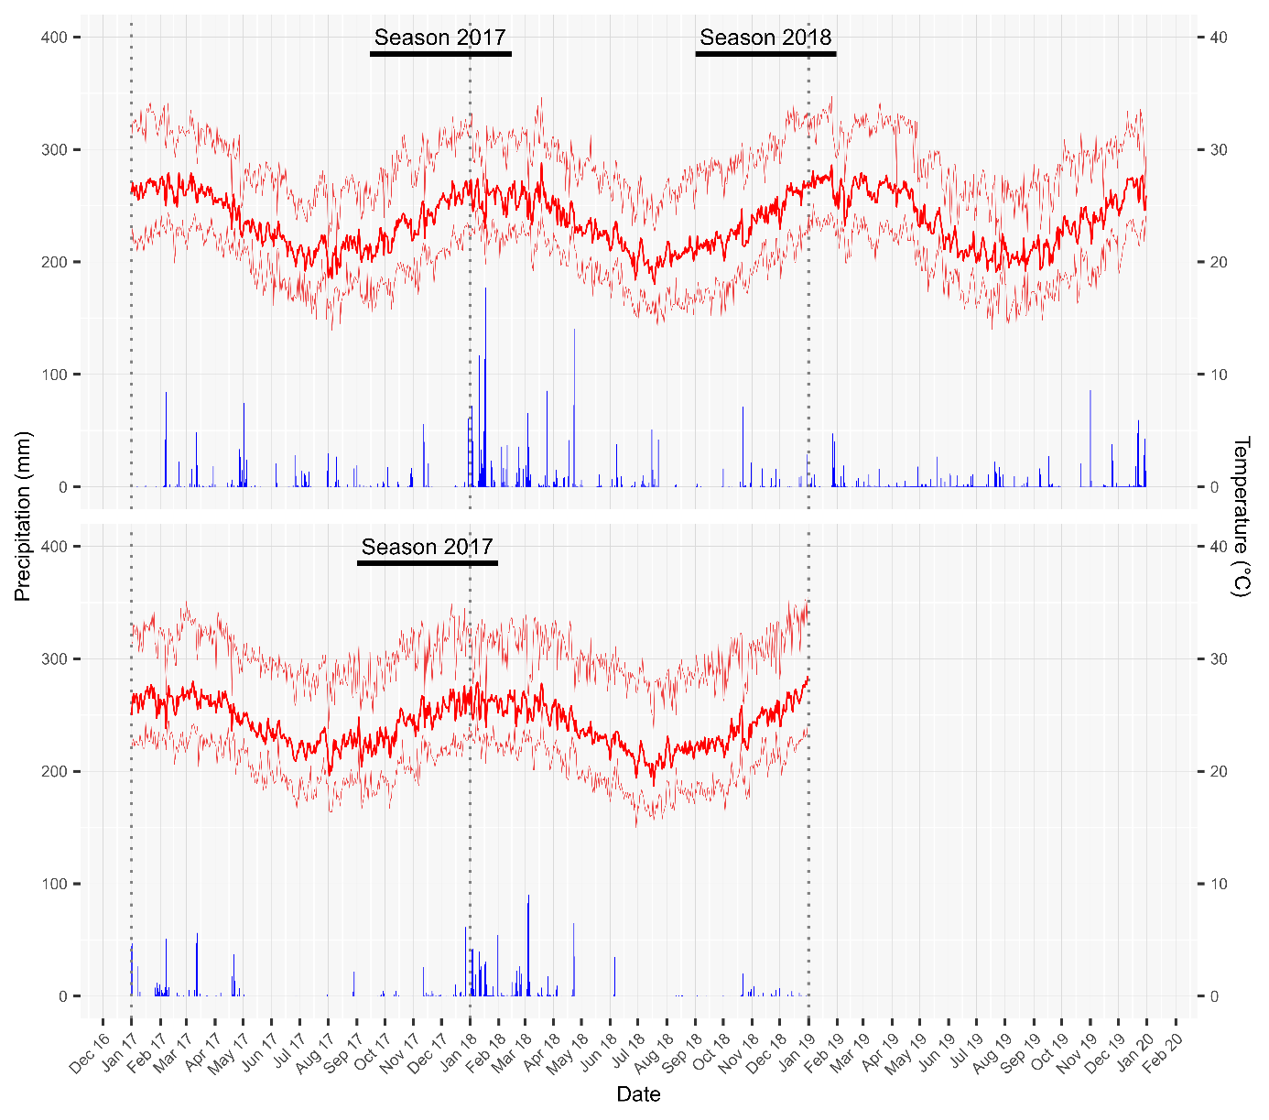
Figure S1. Daily precipitations (mm) and daily minimal, mean and maximal temperatures (°C) from January 2017 to December 2019 in Orchard A, and from January 2017 to December 2018 in Orchard B. The solid horizontal lines at the top of the graph represent the production seasons (starting from full flowering to fruit ripening) during which the experiments were carried out in each of the two orchards.

Table S1. Wald test P-values indicating the statistical significance of the two- or three-ways interaction effects of leaf-to-fruit ratio (LF), maturity stage at harvest (Stage), and storage temperature (Temp) on quality traits of stored fruit sampled in orchard B during the 2017 production season and in orchard A during the 2018 production season.
Variable (unit) | Orchard B (2017) |  | Orchard A (2018)
 | Stage : Temp |  | LF : Stage | LF : Temp | Stage : Temp | LF : Stage : Temp
FM (g) | 0.70 |  | 0.90 | 0.70 | 0.91 | 0.35
DMC (gDM.gFM⁻¹) | 0.52 |  | 0.53 | 0.77 | 0.95 | 0.74
Sucrose (g.gFM⁻¹) | 0.37 |  | 0.10 | 0.54 | 0.78 | 0.77
Starch (g.gFM⁻¹) | 0.23 |  | 0.57 | 0.57 | 0.76 | 0.81
Fructose (g.gFM⁻¹) | 0.24 |  | <0.05 | 0.54 | 0.20 | 0.17
Glucose (g.gFM⁻¹) | 0.59 |  | <0.01 | <0.01 | <0.01 | <0.05
TTA (meq.100 gFM⁻¹) | 0.22 |  | 0.80 | 0.19 | <0.05 | 0.40
Hue angle (°) | 0.42 |  | 0.23 | 0.11 | 0.20 | 0.15

Table S2. Wald test P-values indicating the statistical significance of the effect of time (in days after harvest, DAH) for each treatment, defined as the combination of maturity stage at harvest (Stage; G: Green, MG: Mature Green) × storage temperature (Temp; 12: 12°C, 20: 20°C) modalities, on quality traits of stored fruit sampled in orchard B during the 2017 production season.
Variable (unit) | Treatment
 | G-12 | G-20 | MG-12 | MG-20
FM (g) | 0.81 | 0.35 | 0.22 | 0.66
DMC (gDM.gFM⁻¹) | 0.30 | 0.19 | 0.49 | 0.18
Sucrose (g.gFM⁻¹) | <0.001 | <0.001 | <0.001 | <0.001
Starch (g.gFM⁻¹) | <0.001 | <0.001 | <0.001 | <0.001
Fructose (g.gFM⁻¹) | <0.01 | <0.001 | 0.43 | 0.41
Glucose (g.gFM⁻¹) | <0.05 | 0.07 | <0.01 | 0.06
TTA (meq.100 gFM⁻¹) | <0.01 | <0.001 | 0.83 | <0.001
Hue angle (°) | <0.01 | <0.001 | 0.76 | <0.001

Table S3. Wald test P-values indicating the statistical significance of the effect of time (in days after harvest, DAH) for each treatment, defined as the combination of leaf-to-fruit ratio (LF; 100: 100 leaves per fruit, 25: 25 leaves per fruit) × maturity stage at harvest (Stage; G: Green, MG: Mature Green) × storage temperature (Temp; 12: 12°C, 20: 20°C) modalities on quality traits of stored fruit sampled in orchard A during the 2018 production season.
Variable (unit) | Treatment
 | 100-G-12 | 100-G-20 | 100-MG-12 | 100-MG-20 | 25-G-12 | 25-G-20 | 25-MG-12 | 25-MG-20
FM (g) | 0.34 | 0.11 | 0.47 | 0.11 | 0.09 | 0.45 | 0.29 | <0.05
DMC (gDM.gFM⁻¹) | 0.84 | 0.11 | 0.77 | <0.05 | 0.63 | 0.06 | 0.32 | 0.77
Sucrose (g.gFM⁻¹) | <0.001 | <0.001 | <0.001 | <0.001 | <0.001 | <0.001 | <0.001 | <0.001
Starch (g.gFM⁻¹) | <0.001 | <0.001 | <0.001 | <0.001 | <0.01 | <0.001 | <0.001 | <0.001
Fructose (g.gFM⁻¹) | <0.001 | <0.05 | <0.05 | <0.01 | 0.07 | 0.09 | 0.19 | <0.01
Glucose (g.gFM⁻¹) | 0.12 | <0.05 | 0.49 | 0.16 | 0.43 | 0.27 | 0.56 | 0.20
TTA (meq.100 gFM⁻¹) | 0.27 | <0.001 | 0.18 | <0.001 | 0.33 | <0.001 | 0.44 | <0.001
Hue angle (°) | <0.001 | <0.001 | 0.11 | <0.001 | <0.001 | <0.001 | 0.11 | <0.001

Table S4. Comparison of the change-point date and the daily rate of sweetness increase after ripening initiation (i.e., parameters cp and β₂ in Eq.1) between fruit stored at 20°C and 12°C in orchard A during the 2018 production season, based on the overlapping index (η) and the probability of superiority (A). Fruit stored at 20°C were compared to those stored at 12°C, for each of the four treatments defined by the combination of the leaf-to-fruit ratio (LF) and maturity stage at harvest (Stage; G: Green, MG: Mature Green) modalities. A > 0.5 indicates that the change-point date was later and that the daily rate of sweetness increase was higher for the fruit stored at 12°C than the fruit stored at 20°C.
Treatment |  |  | Change-point date (cp) |  |  | Daily sweetness increase (β₂)
LF | Stage |  | η | A |  | η | A
100 | G |  | 0.16 | 0.97 |  | 0.26 | 0.93
100 | MG |  | 0.72 | 0.63 |  | 0.62 | 0.25
25 | G |  | 0.71 | 0.47 |  | 0.47 | 0.17
25 | MG |  | 0.46 | 0.16 |  | 0.16 | 0.03

Table S5. Comparison of the change-point date and the daily rate of sweetness increase after ripening initiation (i.e., parameters cp and β₂ in Eq.1) between fruit with high (LF 100) and low (LF 25) leaf-to-fruit ratio in orchard A during the 2018 production season, based on the overlapping index (η) and the probability of superiority (A). LF 100 fruit were compared to LF 25 fruit for each of the four treatments of stored fruit, defined by the combination of the maturity stage at harvest (Stage; G: Green, MG: Mature Green) and storage temperature (Temp) modalities, and for on-tree fruit. A > 0.5 indicates that the change-point date was later and that the daily rate of sweetness increase was higher for the LF 25 than the LF 100 fruit.
Treatment |  |  |  |  | Change-point date (cp) |  |  |  | Daily sweetness increase (β₂)
Stored fruit | Stage | Temp |  |  |  | η | A |  | η | A
 | G | 12 |  |  |  | 0.50 | 0.22 |  | 0.05 | 0
 | G | 20 |  |  |  | 0.42 | 0.86 |  | 0.38 | 0.12
 | MG | 12 |  |  |  | 0.34 | 0.09 |  | 0.17 | 0.03
 | MG | 20 |  |  |  | 0.85 | 0.41 |  | 0.61 | 0.24
On-tree fruit | - | - |  |  |  | 0.70 | 0.69 |  | 0.39 | 0.11

