Supplementary material

Table S1
The main nutrient elements of the biochar
C  （g kg⁻¹） | N  （g kg⁻¹） | P  （g kg⁻¹） | Ca  （g kg⁻¹） | Fe  （g kg⁻¹） | K  （g kg⁻¹） | Si  （g kg⁻¹） | Mg  （g kg⁻¹） | S  （g kg⁻¹）
422.53 | 10.49 | 1.56 | 19.09 | 4.82 | 18.01 | 105.76 | 8.52 | 1.68

Table S2
RM-ANOVA of biochar and growth stage differences in soil physicochemical properties in early and late paddies.
 | Temperature | Salinity | pH | Bulk density | Fe²⁺ | Fe³⁺ | Total Fe
Early paddy
Treatment | 0.078 | 0.041 | 0.028 | 0.485 | 0.313 | 0.675 | 0.725
Growth stage | 0.000 | 0.000 | 0.003 | 0.000 | 0.000 | 0.000 | 0.000
Treatment×growth stage | 0.089 | 0.237 | 0.000 | 0.953 | 0.013 | 0.096 | 0.583
Late paddy
Treatment | 0.003 | 0.003 | 0.047 | 0.138 | 0.043 | 0.012 | 0.118
Growth stage | 0.000 | 0.000 | 0.000 | 0.000 | 0.000 | 0.000 | 0.000
Treatment×growth stage | 0.000 | 0.024 | 0.000 | 0.152 | 0.005 | 0.006 | 0.026

Table S3
RM-ANOVA of biochar and growth stage differences in soil nutrient content in early and late paddies.
Factor | Variable | Early paddy field |  |  |  | Late paddy field
 |  | df | MS | F | P | df | MS | F | P
TC | Treatment | 3,8 | 673.128 | 140.432 | 0.000 | 3,8 | 1091.949 | 3416.993 | 0.000
 | Growth stage | 3,24 | 240.969 | 37.818 | 0.000 | 3,24 | 227.678 | 1165.833 | 0.000
 | Treatment×growth stage | 9,24 | 79.270 | 12.441 | 0.000 | 9,24 | 165.921 | 849.605 | 0.000
TN | Treatment | 3,8 | 0.285 | 14.814 | 0.001 | 3,8 | 0.176 | 49.068 | 0.000
 | Growth stage | 3,24 | 0.109 | 3.064 | 0.047 | 3,24 | 0.040 | 13.823 | 0.000
 | Treatment×growth stage | 9,24 | 0.033 | 0.933 | 0.515 | 9,24 | 0.055 | 19.009 | 0.000
TP | Treatment | 3,8 | 0.314 | 43.892 | 0.000 | 3,8 | 0.241 | 17.061 | 0.001
 | Growth stage | 3,24 | 0.483 | 53.036 | 0.000 | 3,24 | 0.124 | 6.007 | 0.003
 | Treatment×growth stage | 9,24 | 0.119 | 13.041 | 0.000 | 9,24 | 0.048 | 2.314 | 0.049
TOC | Treatment | 3,8 | 958.456 | 1.290 | 0.341 | 3,8 | 1133.826 | 1.658 | 0.252
 | Growth stage | 3,24 | 1084.349 | 1.217 | 0.325 | 3,24 | 2718.438 | 3.349 | 0.036
 | Treatment×growth stage | 9,24 | 1045.274 | 1.173 | 0.355 | 9,24 | 926.555 | 1.142 | 0.374
AN | Treatment | 3,8 | 8.021 | 0.187 | 0.903 | 3,8 | 153.749 | 20.212 | 0.000
 | Growth stage | 3,24 | 191.341 | 6.656 | 0.002 | 3,24 | 1307.684 | 156.677 | 0.000
 | Treatment×growth stage | 9,24 | 25.705 | 0.894 | 0.545 | 9,24 | 123.472 | 14.793 | 0.000
AP | Treatment | 3,8 | 171.288 | 1.893 | 0.209 | 3,8 | 117.157 | 1.070 | 0.415
 | Growth stage | 3,24 | 231.804 | 3.353 | 0.036 | 3,24 | 2485.093 | 29.746 | 0.000
 | Treatment×growth stage | 9,24 | 96.390 | 1.250 | 0.313 | 9,24 | 145.243 | 1.739 | 0.134

Table S4
RM-ANOVA of biochar and growth stage differences in soil nutrient stoichiometry in early and late paddies.
Factor | Variable | Early paddy field |  |  |  | Late paddy field
 |  | df | MS | F | P | df | MS | F | P
C:N | Treatment | 3,8 | 103.593 | 65.580 | 0.000 | 3,8 | 247.445 | 638.567 | 0.000
 | Growth stage | 3,24 | 39.121 | 12.716 | 0.000 | 3,24 | 43.525 | 169.702 | 0.000
 | Treatment×growth stage | 9,24 | 15.029 | 4.885 | 0.001 | 9,24 | 26.925 | 104.979 | 0.000
C:P | Treatment | 3,8 | 308.608 | 466.256 | 0.000 | 3,8 | 255.965 | 56.390 | 0.000
 | Growth stage | 3,24 | 190.807 | 80.103 | 0.000 | 3,24 | 146.540 | 31.453 | 0.000
 | Treatment×growth stage | 9,24 | 29.744 | 12.487 | 0.000 | 9,24 | 50.629 | 10.867 | 0.000
N:P | Treatment | 3,8 | 0.287 | 33.880 | 0.000 | 3,8 | 0.015 | 0.579 | 0.645
 | Growth stage | 3,24 | 0.321 | 12.403 | 0.000 | 3,24 | 0.147 | 4.256 | 0.015
 | Treatment×growth stage | 9,24 | 0.077 | 2.965 | 0.016 | 9,24 | 0.035 | 1.030 | 0.446
DOC:AN | Treatment | 3,8 | 1.345 | 2.359 | 0.144 | 3,8 | 0.273 | 0.153 | 0.925
 | Growth stage | 3,24 | 3.029 | 1.566 | 0.224 | 3,24 | 5.268 | 3.109 | 0.045
 | Treatment×growth stage | 9,24 | 1.682 | 0.869 | 0.564 | 9,24 | 3.429 | 2.024 | 0.081
DOC:AP | Treatment | 3,8 | 0.241 | 5.742 | 0.021 | 3,8 | 0.353 | 3.196 | 0.084
 | Growth stage | 3,24 | 0.113 | 1.009 | 0.406 | 3,24 | 0.735 | 5.827 | 0.004
 | Treatment×growth stage | 9,24 | 0.194 | 1.731 | 0.136 | 9,24 | 0.177 | 1.403 | 0.241
AN:AP | Treatment | 3,8 | 0.002 | 0.704 | 0.576 | 3,8 | 0.042 | 18.105 | 0.001
 | Growth stage | 3,24 | 0.027 | 4.058 | 0.018 | 3,24 | 0.450 | 95.570 | 0.000
 | Treatment×growth stage | 9,24 | 0.009 | 1.363 | 0.258 | 9,24 | 0.036 | 7.628 | 0.000

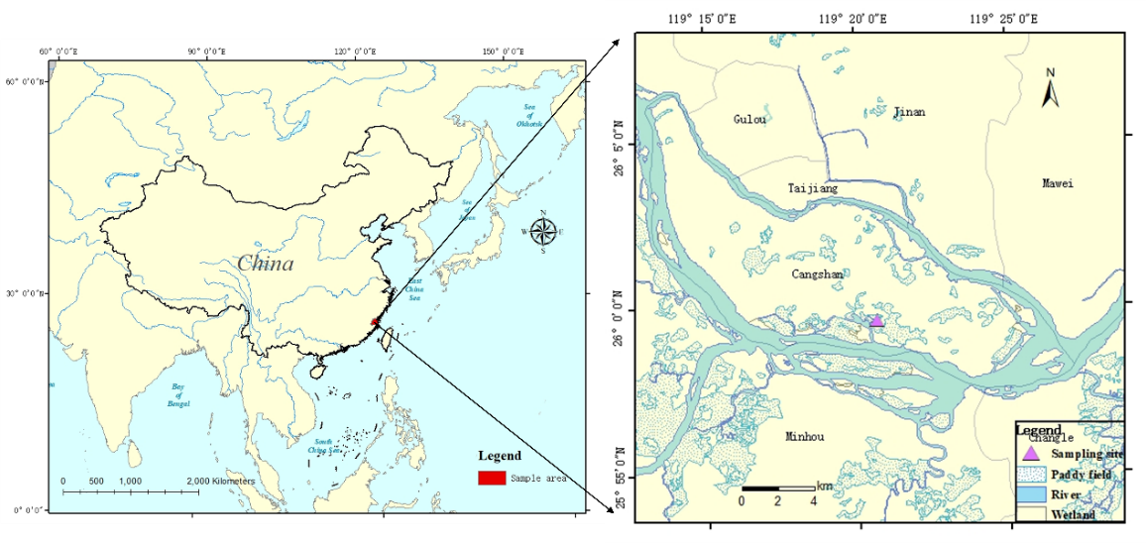Fig.S1 Location of the study area and sampling sites in Fujian Province, southeastern China

Fig.S2 Effects of rate of biochar on concentrations of soil DOC, available N, and available P within growth stages in early and late paddies. Data are means ±SE; different lowercase letters indicate within growth stage treatment differences at P<0.05.

Fig.S3 Effects of rate of biochar on soil DOC:AN, DOC:AP and AN:AP ratios within growth stages in early and late paddies. Data are means ±SE; different lowercase letters indicate within growth stage treatment differences at P<0.05.

