Supplementary materials

Tab. S1 Composition of the N-enriched 2-mm granular biochar used in this study. Notes: The table data comes from published articles that are uniformly processed in the same way. Yin X. L., Peñuelas J., Sardans J., Xu X. P., Chen Y. Y., Fang Y. Y., Wu L. Q., Singh P. B., Tavakkoli E. and Wang W. Q. (2021a). Effects of nitrogen-enriched biochar on rice growth and yield, iron dynamics, and soil carbon storage and emissions: A tool to improve sustainable rice cultivation. Environmental Pollution 287, 117565. Yin X. L., Peñuelas J., Xu X. P., Sardans J., Fang Y. Y., Wiesmeier M., Chen Y. Y., Chen X. X. and Wang W. Q (2021b). Effects of addition of nitrogen-enriched biochar on bacteria and fungi community structure and C, N, P, and Fe stoichiometry in subtropical paddy soils. European Journal of Soil Biology 106, 103351.

Variables | Total carbon | Total nitrogen | Total phosphorous | Sodium | Magnesium | Aluminum | Sulfur | Potassium | Calcium | Manganese | Iron | Zinc
Composition (%) | 6.01 | 8.11 | 0.41 | 0.11 | 1.08 | 0.94 | 2.65 | 1.54 | 0.73 | 0.33 | 0.4 | 0.05

Tab. S2 Repeated-measures ANOVA of C, N, P contents, stoichiometric ratio and storages in rice. Notes: NEB: N-enriched biochar treatment; Time: different rice seasons (early and later rice); NEB × Time represents the interaction between them.
Index | Treatment | Root | Stem | Leaf | Grain
C | NEB | P=0.67 | P<0.01 | P<0.05 | P<0.05
 | Time | P<0.05 | P<0.01 | P<0.01 | P<0.01
 | NEB × Time | P=0.33 | P=0.67 | P<0.05 | P=0.27
N | NEB | P<0.01 | P<0.01 | P=0.11 | P<0.01
 | Time | P<0.01 | P<0.01 | P<0.01 | P<0.01
 | NEB × Time | P<0.01 | P<0.01 | P<0.01 | P<0.01
P | NEB | P=0.86 | P=0.61 | P=0.16 | P=0.63
 | Time | P<0.01 | P=0.86 | P=0.21 | P<0.01
 | NEB × Time | P<0.05 | P=0.29 | P=0.11 | P=0.23
C/N | NEB | P<0.05 | P<0.05 | P=0.11 | P<0.01
 | Time | P<0.01 | P<0.05 | P=0.69 | P<0.01
 | NEB× Time | P=0.16 | P<0.05 | P<0.01 | P<0.05
C/P | NEB | P=0.72 | P=0.33 | P=0.13 | P=0.67
 | Time | P<0.01 | P=0.78 | P<0.05 | P=0.09
 | NEB × Time | P<0.05 | P=0.34 | P=0.10 | P=0.32
N/P | NEB | P<0.01 | P<0.01 | P=0.25 | P=0.09
 | Time | P<0.01 | P<0.01 | P<0.01 | P<0.05
 | NEB × Time | P<0.01 | P<0.01 | P=0.08 | P=0.11
C storage | NEB | P<0.05 | P<0.01 | P<0.01 | P<0.01
 | Time | P<0.05 | P=0.90 | P=0.62 | P=0.09
 | NEB × Time | P=0.32 | P=0.71 | P=0.24 | P=0.98
N storage | NEB | P<0.01 | P<0.01 | P<0.01 | P<0.01
 | Time | P<0.01 | P<0.01 | P<0.01 | P<0.01
 | NEB × Time | P<0.01 | P<0.01 | P<0.01 | P=0.11
P storage | NEB | P=0.23 | P=0.19 | P<0.01 | P<0.01
 | Time | P=0.20 | P=0.32 | P=0.06 | P=0.40
 | NEB × Time | P=0.63 | P=0.56 | P=0.64 | P=0.34

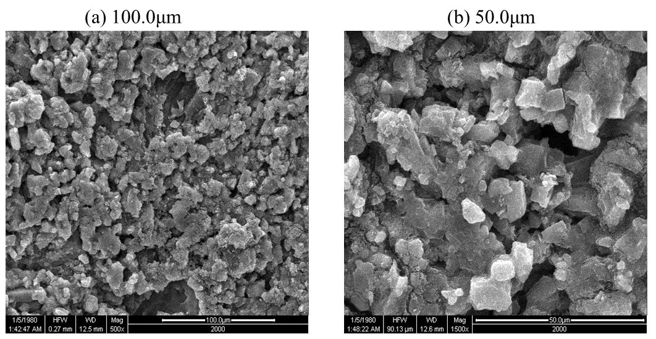
Fig. S1 Electron microscopy image of N-enriched biochar (4 and 8 t ha⁻¹) at 100.0μm (a) and 50.0μm (b)

Fig. S2 Content (a-c), ecological stoichiometric ratio (d-f) and storage (g-l) of C, N and P in roots, stems, leaves and grains of rice plants. Notes: The data (including early and later rice) given in the figure are the mean values and standard errors. Uppercase letters indicate within-growth stage treatment differences, respectively (p< 0.05). T stands for tillering stage and M stands for maturity stage in the legend.

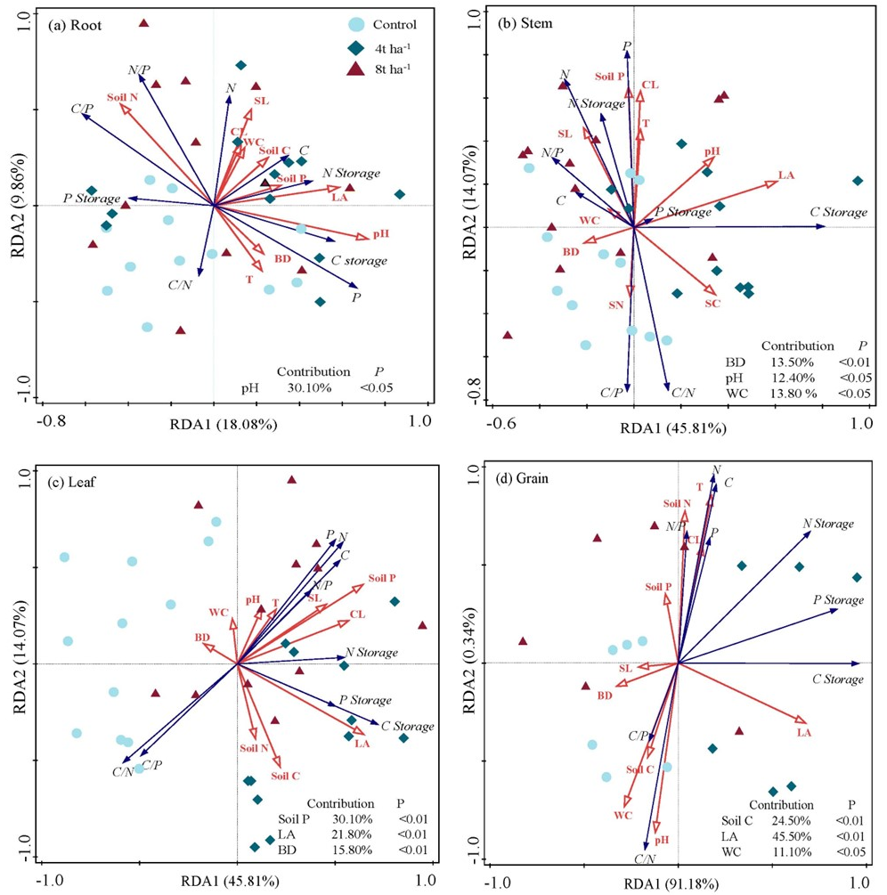
Fig. S3 RDA analysis of C, N and P contents, storage and ecological stoichiometric ratio in rice roots (a), stems (b), leaves (c) and grains (d) of rice plants. Notes: WC: Soil water content; CL: Chlorophyll; BD: Soil bulk density T: Soil temperature; SL: Soil salinity; LA: Leaf surface area.

Fig. S4 Effects of N-enriched biochar on the contents of C (a-d), N (e-h) and P (i-l) in roots (a,e,i), stems (b,f,j), leaves (c,g,k) and grains (d,h,l) of rice plants. Notes: The data given in the figure are the mean values and standard errors. Uppercase letters indicate within-growth stage treatment differences, respectively (p< 0.05). T stands for tillering stage and M stands for maturity stage in the legend.

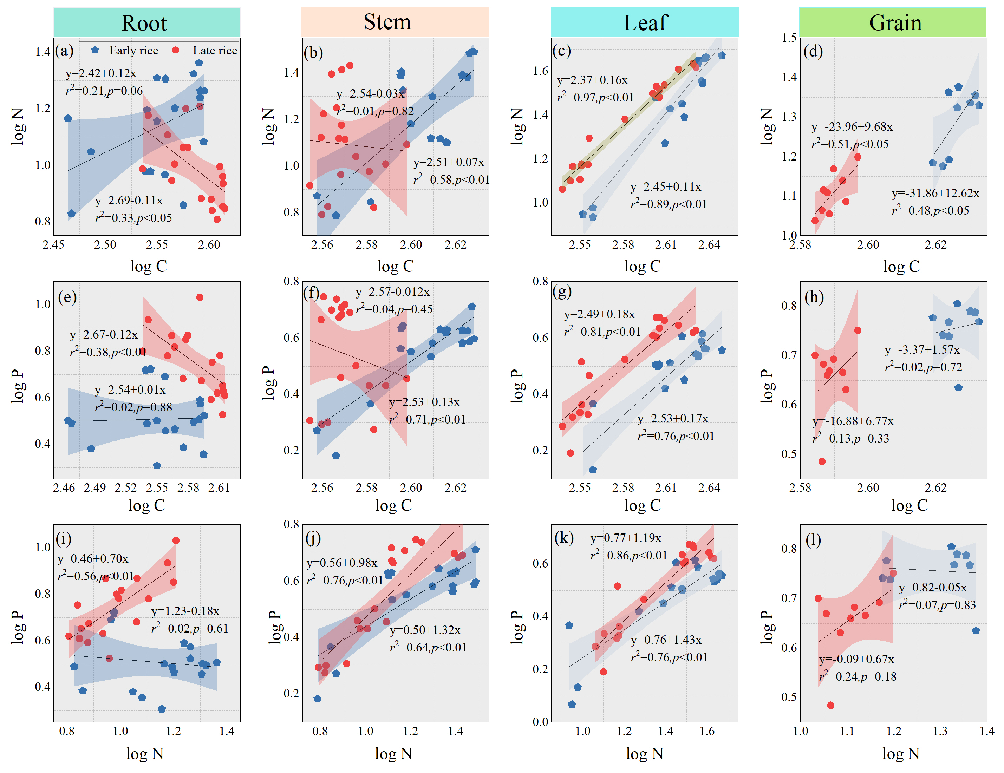
Fig. S5 Theoretical model of allometric growth of C, N and P contents in roots (a,e,i), stems (b,f,j), leaves (c,g,k) and grains (d,h,l) of rice plants. Note: r² is the fitting coefficient.

