Socio demographic factors and ethnobotanical knowledge associated with sesame management practices across agroecological zones in Benin.
Supplementary materials

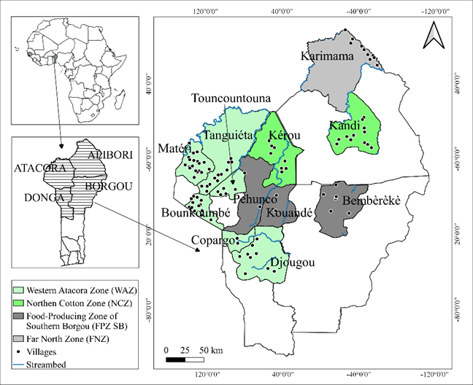
Fig S1: Map of surveyed areas across agroecological zones in northern Benin

Table S1: Socio demographic factors influencing sesame management practices such as intercropping, use of fertiliser and pesticide.
Intercropping
Variable | Coefficient | Standard Error | Z value | P > |Z|
Gender | -1.82727 | 0.38601 | -4.734 | 2.2e-06 ***
Age | 0.02764 | 0.01287 | 2.148 | 0.0317 *
Educational attainment | 0.10580 | 0.13561 | 0.780 | 0.332
Peulh and related | -15.68830 | 1014.83210 | -0.015 | 0.9877
Bariba and related | -2.48353 | 9.64042 | -0.258 | 0.7967
Yoa-lokpa and related | -1.08939 | 7.93151 | -0.137 | 0.8908
Dendi and related | 0.80038 | 6.25344 | 0.128 | 0.8982
Otamari and related | -0.36010 | 4.59370 | -0.078 | 0.9375
Yoruba and related | -0.25551 | 3.17070 | -0.081 | 0.9358
Mossi | 0.4336 | 4.78956 | 0.087 | 0.9572
Zerma | -0.3429 | 3.1589 | -0.078 | 0.9365
Intercept | -0.17603 | 13.02574 | -0.014 | 0.9892
Use of fertiliser
Gender | 4.967e-01 | 8.329e-01 | 0.68 | 0.00331**
Age | -1.506e-02 | 2.214e-02 | -0.596 | 0.496
Educational attainment | -2.407e-01 | 2.156e-01 | -1.116 | 0.264
Peulh and related | -4.513e+15 | 5.501e+14 | -8.202 | 2.36e-16 ***
Bariba and related | -7.667e+12 | 4.716e+14 | -0.016 | 0.987
Yoa-lokpa and related | -6.389e+12 | 3.930e+14 | -0.016 | 0.987
Dendi and related | -5.112e+12 | 3.144e+14 | -0.016 | 0.987
Otamari and related | -3.834e+12 | 2.358e+14 | -0.016 | 0.987
Yoruba and related | -2.556e+12 | 1.572e+14 | -0.016 | 0.987
Mossi | -1.278e+12 | 7.859e+13 | -0.016 | 0.987
Zerma | -1.078e+12 | 7.859e+13 | -0.016 | 0.987
Intercept | -4.303944 | 1.450504 | -2.967 | 0.00301 **
Use of pesticide
Gender | 1.817e+00 | 3.661e-01 | 4.961 | 7e-07 ***
Age | -8.490e-03 | 1.229e-02 | -0.691 | 0.490
Educational attainment | 3.670e-02 | 1.202e-01 | 0.305 | 0.760
Peulh and related | 4.477e+15 | 1.377e+14 | 32.507 | 2e-16 ***
Bariaba and related | -2.269e+13 | 1.181e+14 | -0.192 | 0.848
Yoa-lokpa and related | -1.891e+13 | 9.838e+13 | -0.192 | 0.848
Dendi and related | -1.513e+13 | 7.870e+13 | -0.192 | 0.848
Otamari and related | -1.513e+13 | 5.903e+13 | -0.192 | 0.848
Yoruba and related | -7.564e+12 | 3.935e+13 | -0.192 | 0.848
Mossi | -3.782e+12 | 1.968e+13 | -0.192 | 0.848
Zerma | -3.769e+12 | 1.965e+13 | -0.192 | 0.848
Intercept | 3.026e+13 | 1.574e+14 | 0.192 | 0.848
***: p<0.001; **: p<0.01; *: p<0.05, Z-value is the regression coefficient divided by standard error

Table S2: Scores of variables related to sesame farm typology and reason for sesame production on five first principal component
Variables | Dim 1 | Dim 2 | Dim 3 | Dim 4 | Dim 5
Use of fertiliser | -0.244 | -0.21 | 0.487 | -0.452 | -0.074
Use of pesticide | 0.735 | -0. 056 | 0.06 | -0.452 | 0.204
Intercropping | -0.532 | -0.0.36 | -0.078 | 0.098 | 0.146
Seed origin | -0.016 | -0.42 | -0.553 | -0.243 | -0.139
Type of field ploughing | -0.057 | 0.274 | 0.35 | -0.570 | -0.447
Seed drying place | 0.19 | 0.694 | -0.367 | -0.032 | -0.242
Storage material | -0.034 | -0.603 | -0.104 | 0.561 | 0.004
Source of labour | 0.508 | -0.14 | -0.421 | 0.203 | 0.379
Reason for sesame production | 0.04 | 0.032 | 0.235 | -0.432 | 0.757
Yield kg.ha⁻¹ | 0.508 | -0.033 | 0.458 | -0.107 | 0.088
Area devoted to sesame production | 0.67 | -0.125 | 0.126 | 0.112 | -0.059
% of variance | 17.23 | 11.99 | 11.66 | 10.65 | 9.78
Cumulative % of variance | 17.23 | 29.22 | 40.89 | 51.55 | 61.34
Dim: principal component

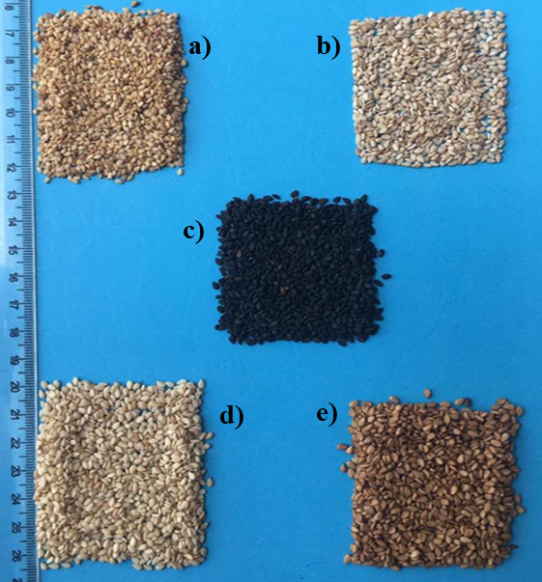
Fig S2: Different types of cultivars of sesame based on seed color and seed size; a) yellowish-seeded with small size b) withe-seeded with small size c) black-seeded with big size d) white-seeded with big size e) reddish-seeded with big size.

Table S3: Local nomenclature of sesame cultivars according to sociolinguistic groups and agroecological zones of Benin
Socio linguistic group | Far North Zone (FNZ) | Food-producing zone of southern Borgou (FPZSB) | Northern Cotton Zone (NCZ) | West Atacora Zone (WAZ)
Bariba and related |  | Boussoum, moussoum, houwin | lempti | Kaham; kassam, mounssimin
Dendi and related | Lempti,
Yoa-lokpa and related |  | Sowa, sosowan |  | Sowa, saham,
Peulh and related |  | Boussoumari | lempti
Otamari and related | hignin | hignin, ngnin, Ngné, | hignin, | Wôgounmou, sari,  Wôgoundam, Wôdomepè, Ognangou, Ignin, Mouwalowouan, N'ssodomepime, Sonkouessi;sonda,
Yoruba and related |  | Monhin |  | Sari, gouolo; yinti
Others | Lempti | Lempti |  | Sonwin, sonda, N'sôromou

