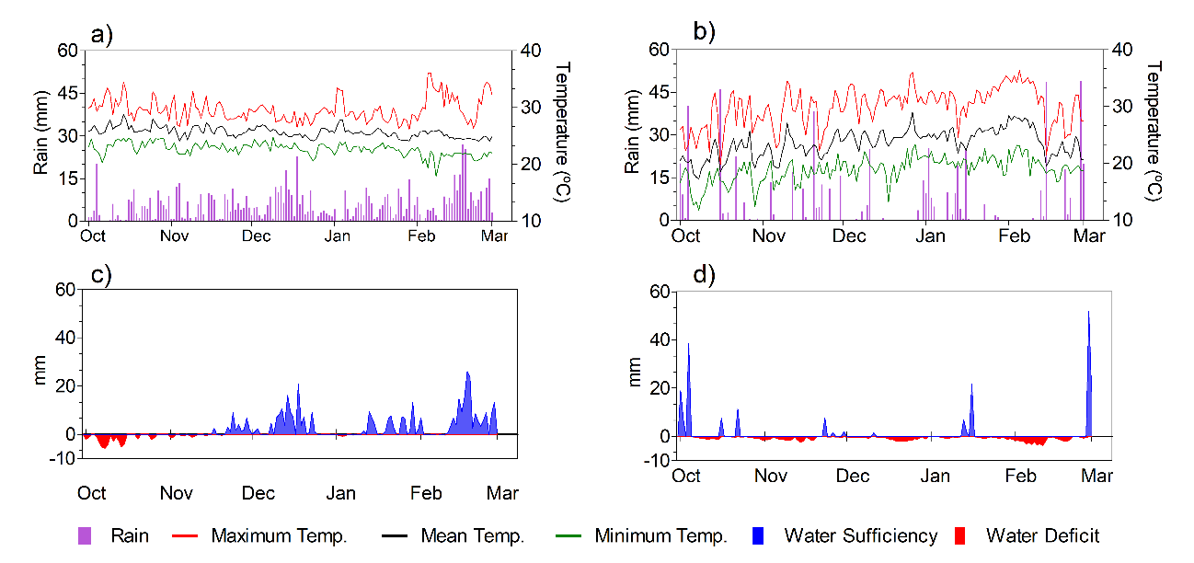
Supplementary Figure 1 Average precipitation, maximum and minimum daily temperatures in the crop season 2013/2014 under (a) tropical and (b) subtropical conditions. Soil water balance during the growing season 2013/2014 for (c) tropical and (d) subtropical environment, respectively.

Supplementary Figure 2 Effect of N fertilizer on N content in grains. Vertical bars are means of both environmental conditions (a) and N treatments (b). Statistical significance (Fisher’s LSD test at 5% probability) is indicated by different letters, ns = not significant. The error bars indicate the standard errors of the means. Control with no N fertilizer (N0); common urea (CU); controlled release urea with a lag time of 30 days (CRU30); 1:1 mix of controlled release urea with a lag time of 30 and 60 days (CRU 30-60); controlled release urea with a lag time of 60 days (CRU60); and common urea applied at the beginning pod, R3 growth stage (CU-R3). TROP and SubTROP mean tropical and subtropical environment, respectively.

