Valle JF - ‘Enabling cumulative learning in user-oriented research for root, tuber, and banana crop breeding.’

Supplementary material
Database: Valle,J.F; Arnaud, E.; Marimo, P.; van Etten, J., (2022), "A review of the scope of farmer participatory research to inform breeding of root, tuber and banana crops", https://doi.org/10.7910/DVN/TIKPWY, Harvard Dataverse, V1

Table S1. Data extraction template for the database (Valle J. et al, 2022)

Variables | Definition
ID | identifier of the individual paper
YOP | Year of publication
Coordinates | (Yes/No) Availability of coordinates in the paper
Site_ID | Study location identifier
Location | Indicates the most precise location for trials and/or survey sites as indicated in the paper
Geounit | Administrative unit corresponding to the location name
PVE | Participatory Variety Evaluation
Preferences | Trait prioritization
PRA | Participatory Rural Assessment
N/A | Not applicable, variable doesn't apply to data entry
N/I | Not informed, data missing in paper
FGD | Focus Group Discussion
OST | On Station Trial
OFT | On Farm Trial
KII | Key Informant Interview
MLT | Multi Location Trial
DEMO | Demonstration trial
Mother | is the demonstration trial within Mother and Baby trials
Baby | Is the farmer replication trial within Mother and Baby trials
N_Participant | Number of participants
Sampling_gender | (Yes/No) Records if the gender of participants was taken in account during sampling
Gender_disaggregation | (Yes/No) Records if the data was disaggregated by gender of participants during the analysis
Gender_focus | (Yes/No) Records if there was a focus on the gender of participants within the discussion
Socioeconomic_Aspects | Qualitative social and economical traits
CO ID | Crop Ontology trait identifier
Trait_feedback_original | Trait as expressed in the paper
Trait_standardized | Trait after homogenization
Trait_category | See Table S2 for categorization
Protocol | Protocol followed for collecting the trait
Entity | When the trait followed an evaluation, it indicates the part or stage of the plant observed
Preferred_form | When indicated, it records the preferred phenotypical expression of the trait

Table S2: Trait categories for first analysis and definitions

Abiotic stress tolerance | Tolerance to wind, drought, waterlogging, poor soils and weed competition
Biotic stress tolerance (pest and disease) | Tolerance to diseases and pests including vertebrates
Post-harvest conservation | Suitability for storage and post-harvest ripening
Phenological | Related with plant cycle stages: germination, establishment, flowering, maturing
Plant morphology | Related with the plant’s general appearance like architecture
Fruit or tuber morphology | Related with the appearance of the main harvestable part
Productivity | Harvestable yield and total biomass production
Organoleptic | Sensory traits of the fresh and processed foods, excluding those related with sight and touch that fall under fruit or tuber morphology
Bromatological | Analytical properties related to food composition
Management | Indicators related to the response to management practices
Social | Social factors like familiarity and general acceptance
Economic | Marketability and other factors related to economic performance
Processing | Suitability to processing and quality of the resulting product

Table S3: Number per region of study types cited in the 123 publications.
 | East Africa | Central Africa | West Africa | South Africa | Latin America and Caribbean | Asia and Southeast Asia, Pacific | Total of publications citing the  study type
TP | 27 | 6 | 20 | 2 | 3 | 0 | 58
PVE | 7 | 0 | 6 | 1 | 4 | 3 | 21
Both | 3 | 1 | 4 | 0 | 9 | 0 | 17
Others | 11 | 0 | 12 | 1 | 1 | 2 | 27
Total publications | 48 | 7 | 42 | 4 | 17 | 5 | 123
TP= Trait Prioritization, PVE= Participatory Variety Evaluation, Both= TP+PVE, Others= clonal evaluation, consumer tests, etc

Table S4: Number of study types per region.

 | East Africa | Central Africa | West Africa | South Africa | South America & Caribbean | Asia, Southeast Asia & Pacific
TP | 35 | 6 | 31 | 2 | 8 | 0
PVS | 7 | 1 | 10 | 1 | 11 | 4
both | 2 | 2 | 2 | 0 | 5 | 0
others | 47 | 5 | 45 | 4 | 25 | 7
total | 91 | 14 | 88 | 7 | 49 | 11
TP= Trait Prioritization, PVE= Participatory Variety Evaluation, Both= TP+PVE, Others= clonal evaluation, consumer tests, etc

Table S5: Number of publications citing method types for each crop.

Crop | Banana (n=41) | Cassava (n=31) | Sweetpotato (n=24) | Potato (n=13) | Yam (n=16)
Method type
TP | 25 | 15 | 9 | 2 | 9
PVs | 2 | 4 | 7 | 6 | 5
Both | 2 | 8 | 1 | 2 | 0
Others | 12 | 4 | 7 | 3 | 2
Total per crop | 41 | 31 | 24 | 13 | 16
TP= Trait Prioritization, PVE= Participatory Variety Evaluation, Both= TP+PVE, Others= clonal evaluation, consumer tests, etc

Table S6: % of study types per crop in all regions (Total study types=260). TP= Trait Prioritization, PVE= Participatory Variety Evaluation, Both= TP+PVE, Others= clonal evaluation, consumer tests, etc

 | banana (n=69) | cassava (n=79) | sweetpotato (n=44) | potato (n=34) | yam (n=34)
TP | 46 | 34 | 20 | 9 | 32
PVS | 7 | 14 | 16 | 21 | 15
Both | 0 | 9 | 2 | 9 | 0
Others | 46 | 43 | 61 | 62 | 53
TP= Trait Prioritization, PVE= Participatory Variety Evaluation, Both= TP+PVE, Others= clonal evaluation, consumer tests, etc

Table S7. Percentage of publications including gender disaggregation of data by crop and region

Crop | % Publications including gender disaggregation
Yam | 37.5
Banana/plantain | 37.1
Potato | 33.3
Sweet potato | 22.7
Cassava | 13.3
Region | % Publications including gender disaggregation
Central Africa | 57.1
Southern Africa | 40
South America and Caribbean | 28.6
East Africa | 25
West Africa | 22.5
Asia and Pacific | 0.4
Total | 27.8

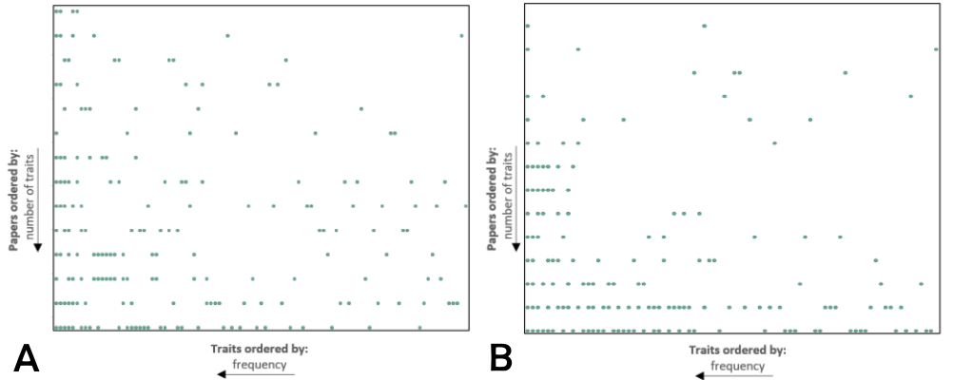
Figure S1. Trait (y-axis) vs publication (x-axis) unique frequency matrix plot for researcher traits in banana. (A) and cassava (B), axes are in descending order

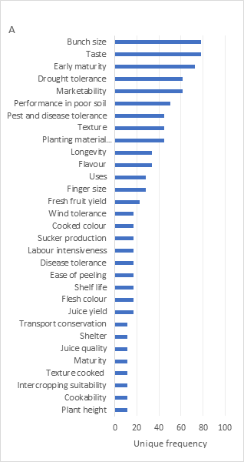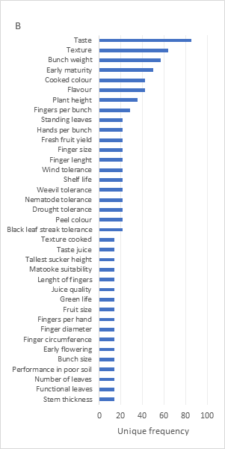
Figure S2. Musa spp. traits listed by decreasing frequency across all publications in percentage, farmer-prioritized (A) and researcher-prioritized (B). Farmers selected traits through elicitation exercises (mainly free listing), whereas researchers selected traits to be included in PVS trials.

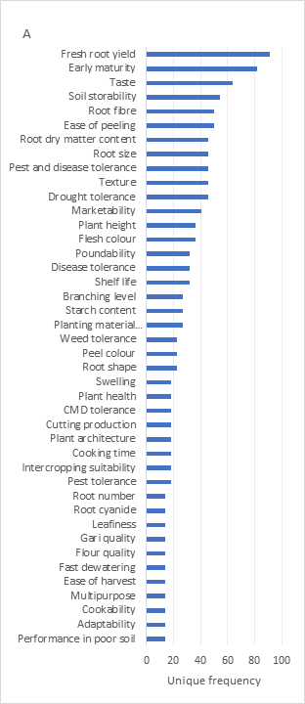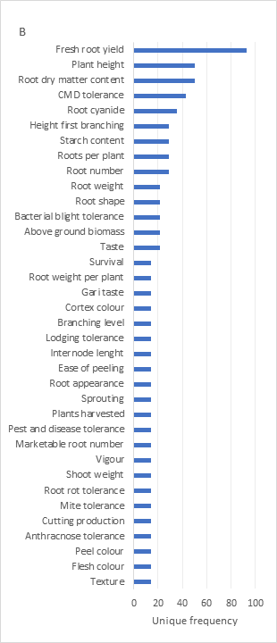
Figure S3. Cassava traits listed by decreasing frequency across all publications in percentage, farmer-prioritized (A) and researcher-prioritized (B). Farmers selected traits through elicitation exercises (mainly free listing), whereas researchers selected traits to be included in PVS trials.

