Baptistella, João Leonardo Corte; Teles, Ana Paula Bettoni; Favarin, José Laércio; Pavinato, Paulo Sergio; Mazzafera, Paulo.
Supplementary Material
Rhizotron experiment
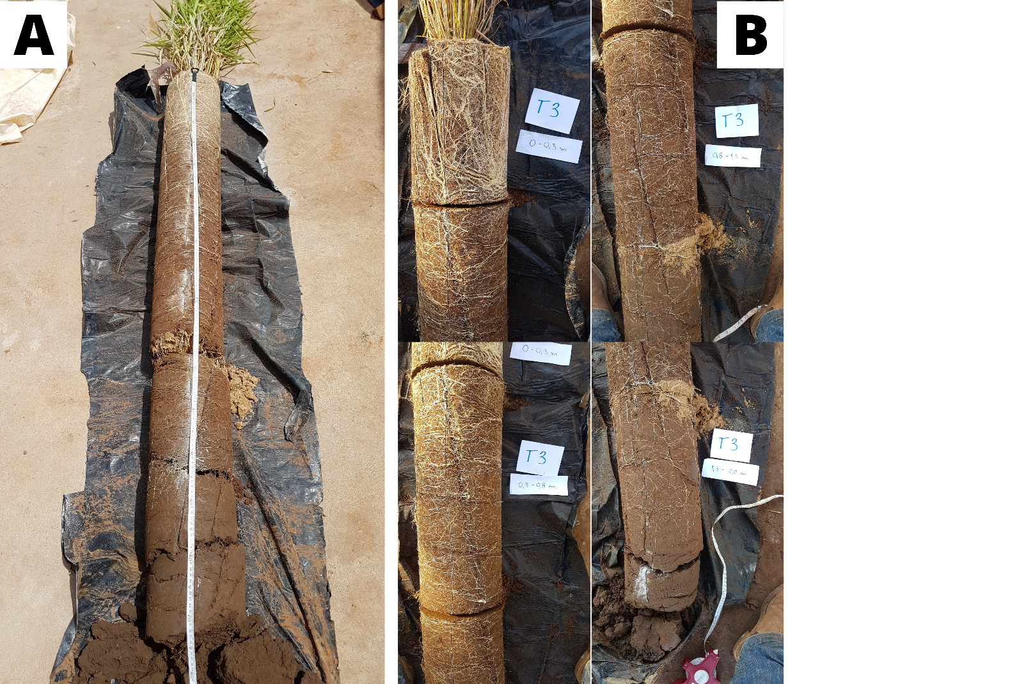
Figure S1. Rhizotron harvest in detail. After cutting the PVC tube longitudinally in half, we obtained a nearly integer soil profile (A); which was cut, afterwards, using a camp knife according to each soil layer (B). The yellow arrows indicates the thin sand layer that helped to clearly identify the layer where P was supplied.

Table S1 Chemical analysis of the soil used to fill the rhizotrons prior to the establishment of greenhouse experiment.
pH | SOM | P | K | Ca | Mg | H+Al | Al | S-SO₄ | BS | CEC | V | m
CaCl₂ | g dm⁻³ | mg dm⁻³ | --------- mmol_{c} dm⁻³ --------- |  |  |  |  | mg dm⁻³ | --- mmol_{c} dm⁻³ --- |  | ---%---
5.1 | 14 | 6 | 0.8 | 10 | 6 | 18 | 0 | 5 | 17 | 35 | 48 | 0
SOM = soil organic matter; BS = base sum; CEC = cation exchange capacity; V = base saturation; m = aluminum saturation.

Table S2. U. decumbens root architecture parameters. Specific root length (SRL), specific root superficial area (SRSA) and root diameter. Treatments description: 1 - adequate P availability from 0.0 to 0.3 m; 2 - adequate P availability from 0.0 to 0.8 m; 3 - adequate P availability from 0.0 to 1.3 m; 4 - adequate P availability from 0.0 to 2.0 m; 5 - adequate P availability from 1.3 to 2.0 m; 6 - adequate P availability from 0.8 to 2.0 m; and a control treatment with low P availability trough the profile.
Treatment | Layer | SRL |  | SRSA |  | Diameter
 | m | mm g⁻¹ |  | mm² g⁻¹ |  | mm
Control | 0.0 – 0.3 | 718 | Aa | 83 | A | 0.38 | A
 | 0.3 – 0.8 | 1128 | Aa | 117 | A | 0.36 | A
 | 0.8 – 1.3 | - | Bc | - | Bc | - | B
 | 1.3 – 2.0 | - | Bc | - | Bc | - | Bb
1 | 0.0 – 0.3 | 502 | Ba | 54 | B | 0.36 | A
 | 0.3 – 0.8 | 421 | Bb | 44 | B | 0.34 | A
 | 0.8 – 1.3 | 830 | Aa | 90 | A | 0.34 | A
 | 1.3 – 2.0 | - | Cc | - | Cc | - | Bb
2 | 0.0 – 0.3 | 536 | a | 72 |  | 0.40
 | 0.3 – 0.8 | 579 | ab | 64 |  | 0.35
 | 0.8 – 1.3 | 570 | a | 71 |  | 0.42
 | 1.3 – 2.0 | 691 | b | 90 | ab | 0.43 | a
3 | 0.0 – 0.3 | 408 | a | 46 |  | 0.36
 | 0.3 – 0.8 | 435 | b | 48 |  | 0.37
 | 0.8 – 1.3 | 641 | a | 73 |  | 0.37
 | 1.3 – 2.0 | 731 | abc | 85 | ac | 0.37 | a
4 | 0.0 – 0.3 | 219 | Ba | 26 | B | 0.37 | A
 | 0.3 – 0.8 | 853 | Aab | 85 | A | 0.34 | A
 | 0.8 – 1.3 | 753 | Aa | 89 | A | 0.39 | A
 | 1.3 – 2.0 | - | Cc | - | Cc | - | Bb
5 | 0.0 – 0.3 | 554 | Ba | 57 | B | 0.33
 | 0.3 – 0.8 | 799 | Bab | 75 | B | 0.31
 | 0.8 – 1.3 | 528 | Ba | 57 | B | 0.36
 | 1.3 – 2.0 | 1622 | Aa | 168 | Aa | 0.34 | a
6 | 0.0 – 0.3 | 623 | Ba | 59 | A | 0.30 | A
 | 0.3 – 0.8 | 749 | Aab | 74 | A | 0.32 | A
 | 0.8 – 1.3 | 738 | Aa | 82 | A | 0.37 | A
 | 1.3 – 2.0 | - | Cc | - | Bc | - | Bb
Letters represent significant differences by Tukey’s test (p < 0.05). Uppercase letters denote differences among layers of each treatment; lowercase letters denote differences among treatments for each layer.
Table S3. Nutrient concentration on U. decumbens shoot grown on greenhouse conditions – rhizotron experiment. Treatments description: 1 - adequate P availability from 0.0 to 0.3 m; 2 - adequate P availability from 0.0 to 0.8 m; 3 - adequate P availability from 0.0 to 1.3 m; 4 - adequate P availability from 0.0 to 2.0 m; 5 - adequate P availability from 1.3 to 2.0 m; 6 - adequate P availability from 0.8 to 2.0 m; and a control treatment with low P availability trough the profile.
Treatment | N | P | K | Ca | Mg | S | Cu | Fe | Zn | Mn | B
 | g g⁻¹ |  |  |  |  |  | mg g⁻¹
Control | 8.1 | 0.8 b | 17.6 a | 3.7 ab | 2.2 ab | 1.0 | 3.0 | 186 | 26.3 | 88 | 14.0
1 | 8.1 | 1.3 a | 12.0 b | 4.6 a | 2.7 a | 1.1 | 2.5 | 206 | 29.3 | 103 | 11.2
2 | 8.4 | 1.4 a | 17.1 a | 3.7 ab | 2.3 ab | 1.1 | 3.0 | 219 | 28.8 | 101 | 8.8
3 | 6.8 | 1.4 a | 14.9 b | 3.4 b | 1.8 b | 1.0 | 2.0 | 188 | 23.3 | 84 | 6.3
4 | 7.4 | 1.5 a | 14.4 b | 3.7 ab | 2.0 ab | 0.9 | 3.5 | 196 | 26.8 | 98 | 11.2
5 | 7.5 | 1.0 b | 14.8 b | 3.1 b | 2.1 ab | 1.1 | 3.3 | 192 | 27.3 | 74 | 7.0
6 | 7.5 | 1.0 b | 16.4 b | 3.2 b | 2.0 ab | 1.2 | 3.3 | 185 | 27.3 | 73 | 10.3
Letters represent significant differences by Tukey’s test (p < 0.05). Uppercase letters denote differences among layers of each treatment; lowercase letters denote differences among treatments for each layer.

Table S4. Total nutrient content in U. decumbens shoot. Treatments description: 1 - adequate P availability from 0.0 to 0.3 m; 2 - adequate P availability from 0.0 to 0.8 m; 3 - adequate P availability from 0.0 to 1.3 m; 4 - adequate P availability from 0.0 to 2.0 m; 5 - adequate P availability from 1.3 to 2.0 m; 6 - adequate P availability from 0.8 to 2.0 m; and a control treatment with low P availability trough the profile.
Treatment | N | K* | Ca | Mg | S |  | Cu | Fe | Zn | Mn | B
 | g plot⁻¹ |  |  |  |  | mg plot⁻¹
Control | 0.8 | 1.8 bc | 0.4 | 0.2 | 0.1 |  | 0.3 | 18.9 | 2.7 | 9.0 | 1.4
1 | 1.1 | 1.5 c | 0.6 | 0.4 | 0.1 |  | 0.3 | 27.2 | 4.0 | 14.1 | 1.3
2 | 1.3 | 2.6 ab | 0.6 | 0.4 | 0.2 |  | 0.5 | 33.2 | 4.4 | 15.2 | 1.3
3 | 1.2 | 2.7 a | 0.6 | 0.3 | 0.2 |  | 0.4 | 33.9 | 4.3 | 15.5 | 1.2
4 | 1.1 | 2.1 ac | 0.5 | 0.3 | 0.1 |  | 0.5 | 29.0 | 3.9 | 14.3 | 1.6
5 | 0.8 | 1.6 bc | 0.3 | 0.2 | 0.1 |  | 0.4 | 21.0 | 3.0 | 8.0 | 0.8
6 | 0.8 | 1.7 bc | 0.3 | 0.2 | 0.1 |  | 0.4 | 19.4 | 2.8 | 7.6 | 1.1
*Letters represent significant differences by Tukey’s test (p < 0.05). Uppercase letters denote differences among layers of each treatment; lowercase letters denote differences among treatments for each layer.

Table S5. Sequential soil P fractionation for the rhizotron experiment. Inor: inorganic; Org: organic. Treatments description: 1 - adequate P availability from 0.0 to 0.3 m; 2 - adequate P availability from 0.0 to 0.8 m; 3 - adequate P availability from 0.0 to 1.3 m; 4 - adequate P availability from 0.0 to 2.0 m; 5 - adequate P availability from 1.3 to 2.0 m; 6 - adequate P availability from 0.8 to 2.0 m; and a control treatment with low P availability trough the profile.

Treatment | Layer (m) | AER |  | NaHCO₃ inorg |  | NaHCO₃ org |  | NaOH 0.1M inorg |  | NaOH 0.1M org |  | HCl 1M |  | NaOH 0.5M inorg |  | NaOH 0.5M org |  | Residual
 |  | P – mg kg⁻¹
Control | 0.0 – 0.3 | 2.35 | Ac | 12.5 | Ac | 14.6 |  | 31.7 | c | 41.6 | B | 6.2 |  | 16.4 | BC | 9.3 |  | 61
 | 0.3 – 0.8 | 2.70 | Ab | 13.2 | Ac | 14.0 | B | 32.4 | c | 42.1 | Bab | 6.1 |  | 12.7 | C | 12.5 |  | 66
 | 0.8 – 1.3 | 2.75 | Ad | 12.9 | Ac | 32.1 |  | 28.4 | d | 83.9 | ABa | 8.0 |  | 22.2 | BC | 27.8 | ab | 64
 | 1.3 – 2.0 | 2.68 | Ad | 14.8 | Ab | 32.3 |  | 24.6 | d | 84.4 | Aa | 8.8 | c | 30.4 | Aab | 40.3 | b | 75 | b
1 | 0.0 – 0.3 | 9.27 | Ab | 23.0 | Aab | 14.8 |  | 45.7 | ac | 45.9 |  | 14.2 |  | 14.2 | AB | 15.0 |  | 61
 | 0.3 – 0.8 | 4.44 | Bb | 14.4 | Bbc | 16.5 | ab | 36.1 | ac | 46.7 | ab | 7.9 |  | 13.1 | BC | 13.6 |  | 68
 | 0.8 – 1.3 | 2.87 | Bcd | 12.5 | Bc | 30.0 |  | 36.0 | cd | 45.7 | ab | 8.0 |  | 20.5 | AB | 12.5 | ab | 75
 | 1.3 – 2.0 | 3.05 | Bd | 13.2 | Bb | 22.0 |  | 40.5 | cd | 43.7 | ab | 8.2 | c | 21.5 | Abc | 13.3 | b | 79 | b
2 | 0.0 – 0.3 | 9.88 | Bb | 22.1 | Aab | 17.2 |  | 49.5 | ab | 46.5 | AB | 12.5 |  | 16.2 |  | 16.6 |  | 76
 | 0.3 – 0.8 | 12.13 | Aa | 25.6 | Aa | 14.3 | b | 53.0 | a | 54.0 | Aab | 16.5 |  | 17.0 |  | 13.5 |  | 68
 | 0.8 – 1.3 | 5.11 | Cc | 15.5 | Bbc | 19.4 |  | 42.4 | cd | 51.1 | ABa | 9.7 |  | 19.8 |  | 8.6 | ab | 67
 | 1.3 – 2.0 | 3.48 | Ccd | 14.8 | Bb | 15.6 |  | 44.9 | bc | 38.4 | Bb | 10.6 | ac | 17.1 | c | 10.5 | b | 64 | b
3 | 0.0 – 0.3 | 10.21 | Bab | 26.1 | Aa | 14.7 | B | 59.3 | Ba | 44.2 |  | 16.0 |  | 17.6 |  | 13.4 |  | 68
 | 0.3 – 0.8 | 12.30 | Aa | 21.4 | Abab | 26.8 | Aa | 51.5 | Bab | 57.0 | a | 11.4 |  | 18.9 |  | 12.1 |  | 77
 | 0.8 – 1.3 | 12.92 | Aa | 22.7 | ABab | 23.8 | AB | 53.9 | Abc | 50.6 | a | 13.8 |  | 15.4 |  | 16.4 | a | 63
 | 1.3 – 2.0 | 5.45 | Cc | 16.7 | Bb | 25.2 | AB | 44.9 | Abbc | 48.9 | ab | 10.1 | c | 17.4 | c | 12.9 | b | 65 | b

Table S5. Continuation.
4 | 0.0 – 0.3 | 12.10 | Aa | 21.4 | Bab | 22.7 |  | 50.2 | ab | 51.4 |  | 13.6 |  | 16.7 | B | 13.8 |  | 57 | B
 | 0.3 – 0.8 | 11.95 | Aa | 22.4 | Bab | 19.0 | ab | 47.7 | ac | 50.5 | ab | 11.4 |  | 16.3 | B | 11.9 |  | 58 | B
 | 0.8 – 1.3 | 12.03 | Aa | 27.4 | ABb | 18.8 |  | 66.9 | ab | 47.7 | a | 17.9 |  | 16.3 | B | 14.0 | ab | 62 | B
 | 1.3 – 2.0 | 11.77 | Aa | 29.6 | Aa | 52.0 |  | 61.0 | ab | 119.8 | a | 16.4 | a | 35.8 | Aa | 43.7 | b | 248 | Aa
5 | 0.0 – 0.3 | 3.45 | Bc | 12.9 | Bc | 17.9 |  | 35.6 | Bbc | 48.0 |  | 8.6 | B | 19.7 | AB | 7.9 |  | 73
 | 0.3 – 0.8 | 2.95 | Bb | 12.8 | Bc | 16.0 | ab | 34.8 | Bc | 40.0 | b | 7.6 | B | 13.6 | B | 10.2 |  | 72
 | 0.8 – 1.3 | 3.00 | Bcd | 14.6 | Bbc | 15.9 |  | 38.7 | Bcd | 41.7 | ab | 7.1 | B | 21.2 | AB | 3.3 | b | 72
 | 1.3 – 2.0 | 8.47 | Ba | 34.4 | Aa | 15.0 |  | 67.1 | Aa | 45.1 | ab | 21.7 | Aa | 23.2 | Ab | 13.4 | b | 76 | b
6 | 0.0 – 0.3 | 4.38 | Cc | 15.8 | Bbc | 20.5 |  | 39.2 | Cbc | 52.2 | A | 8.0 | C | 15.5 |  | 13.1 |  | 53
 | 0.3 – 0.8 | 3.24 | Cb | 14.2 | Bbc | 18.5 | ab | 37.5 | Bac | 49.3 | Aab | 8.9 | C | 18.9 |  | 6.9 |  | 50
 | 0.8 – 1.3 | 8.45 | Bb | 29.4 | Aa | 20.0 |  | 82.5 | Aa | 30.8 | Bb | 32.9 | Aa | 18.6 |  | 15.2 | ab | 59
 | 1.3 – 2.0 | 10.74 | Aa | 32.4 | Aa | 51.9 |  | 63.1 | Bab | 121.9 | Aa | 20.8 | Bab | 24.3 | A | 52.0 | a | 55 | b

Different letters represent significant differences in soil P fractions by Tukey’s test (p < 0.05). Uppercase letters indicate differences among soil layers of different treatments; lowercase letter indicate differences among treatments in the same layer.

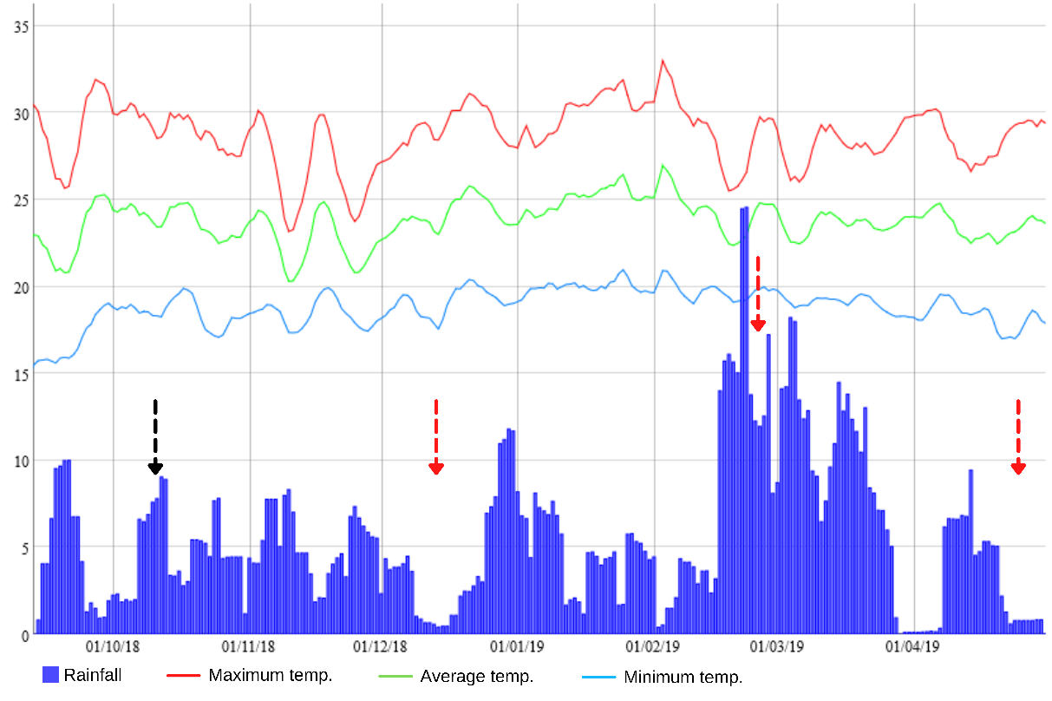
Field experiment
Figure S2. Climate data for Capetinga-MG during the period of the experiment. Black arrow indicates the time of installation and red arrows indicate U. decumbens shoot sampling dates

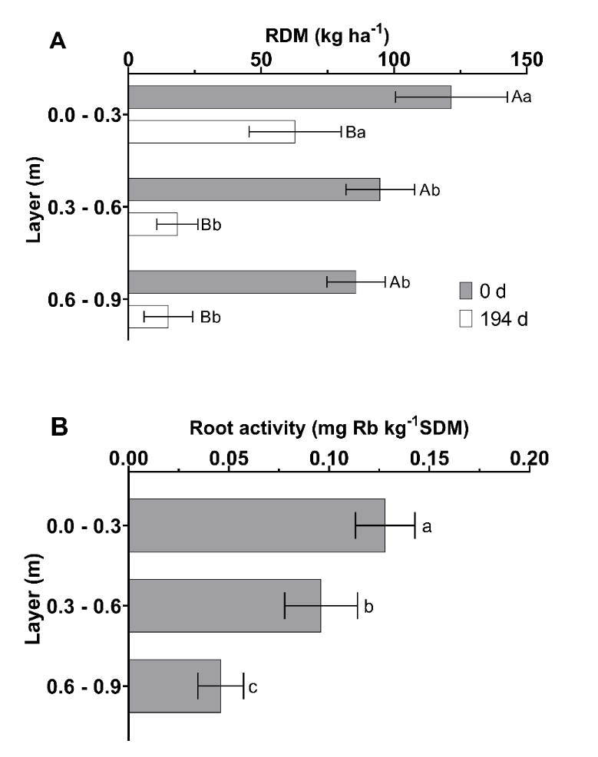
Figure S3. U. decumbens root dry mass (A) at the beginning (0 d) and at the end of the field experiment (194 d); and root activity (B). Uppercase letters denote differences among sampling dates; lowercase letters denote differences among soil layers on each sampling date. Different letters denote significant differences by Tukey’s test (p < 0.05).
Table S6. Soil chemical analysis at the time of experiment establishment in the field.
Layer (m) | pH | SOM | P | K | Ca | Mg | H+Al | Al | BS | CEC | V | m | S
 | CaCl₂ |  | resin |  |  |  |  |  |  |  | % |  | SO₄
 |  | g dm⁻³ | mg dm⁻³ | ----------- mmol_{c} dm⁻³ ----------- |  |  |  |  |  |  |  |  | mg dm⁻³
0.0 – 0.3 | 5.4 | 11.6 | 4.2 | 0.5 | 19.4 | 5.8 | 22.4 | 0.0 | 25.8 | 48 | 54 | 0 | 3.8
0.3 – 0.6 | 4.8 | 5.0 | 3.0 | 0.3 | 5.8 | 2.8 | 27.4 | 0.6 | 8.8 | 36 | 25 | 8 | 3.8
0.6 – 0.9 | 4.4 | 5.0 | 2.0 | 0.3 | 2.8 | 1.4 | 29.2 | 1.2 | 4.4 | 34 | 13 | 22 | 7.4
SOM = soil organic matter; BS = base sum; CEC = cation exchange capacity; V = base saturation; m = aluminum saturation.

Table S7. Root parameters at 194 d after the field experiment was installed.
Layer (m) | Specific Root Length (SRL) | Superficial area (SA) | Diameter (DM)
 | mm | mm² | mm
0.0 – 0.3 | 1112 | 207 | 0.66
0.3 – 0.6 | 1567 | 294 | 0.61
0.6 – 0.9 | 1588 | 295 | 0.49

Table S8. U. decumbens shoot nutrient content on each sample date and the total accumulation over the period.
Treat. | Sampling date | N | P * | K * | Ca | Mg | S | Cu | Fe | Zn | Mn | B
 |  | ------------------ kg ha⁻¹ ------------------ |  |  |  |  |  | ----------- g ha⁻¹ -------------
Control | 60 d | 24.4 | 2.4 b | 44.2 | 9.5 | 7.6 | 1.6 | 14.6 | 432 | 65 | 84 | 13
 | 137 d | 28.1 | 3.8 | 65.6 a | 24.1 | 20.4 | 3.4 | 32.3 | 971 | 144 | 137 | 84
 | 194 d | 47.6 | 4.8 | 66.2 | 14.7 | 12.4 | 3.2 | 24.3 | 552 | 123 | 107 | 24
 | Total | 100 | 11.0 | 176 | 48 | 40 | 8.2 | 71 | 1956 | 332 | 328 | 121
P03 | 60 d | 37.9 | 4.1 a | 44.8 | 8.0 | 8.6 | 3.0 | 15.2 | 219 | 77 | 58 | 20
 | 137 d | 28.3 | 3.1 | 28.8 b | 5.8 | 7.0 | 2.0 | 12.0 | 166 | 72 | 36 | 14
 | 194 d | 59.9 | 2.6 | 26.8 | 6.1 | 9.5 | 2.0 | 8.5 | 273 | 77 | 36 | 8
 | Total | 126 | 9.79 | 100 | 20 | 25 | 6.9 | 36 | 657 | 226 | 131 | 42
P06 | 60 d | 30.1 | 3.4 ab | 33.9 | 6.1 | 7.0 | 2.7 | 11.7 | 153 | 59 | 49 | 18
 | 137 d | 26.7 | 2.5 | 28.b | 6.5 | 7.8 | 1.9 | 9.7 | 203 | 71 | 44 | 7
 | 194 d | 94.0 | 7.7 | 87.1 | 18.5 | 22.2 | 5.7 | 28.5 | 963 | 224 | 140 | 27
 | Total | 151 | 13.63 | 149.1 | 31.1 | 37.0 | 10.2 | 50 | 1318 | 353 | 233 | 52
P09 | 60 d | 38.2 | 3.6 ab | 54.6 | 9.3 | 9.3 | 2.2 | 12.8 | 194 | 82 | 72 | 21
 | 137 d | 32.4 | 2.9 | 33.9 b | 7.8 | 7.9 | 1.8 | 11.2 | 310 | 88 | 54 | 29
 | 194 d | 59.8 | 5.1 | 58.9 | 11.9 | 11.9 | 3.8 | 23.6 | 555 | 134 | 88 | 22
 | Total | 130 | 11.56 | 147 | 29 | 29 | 7.8 | 48 | 1060 | 305 | 214 | 72
Average total |  | 127 | 11.5 | 143 | 32 | 33 | 8 | 51 | 1248 | 304 | 227 | 72
*Denote significant differences by Tukey’s test (p< 0.05). Lowercase letters denote differences among sampling dates for the respective nutrient.

Table S9. Sequential soil P fractionation for the field experiment. Inor: inorganic; Org: organic.
Layer | Sampling date | AER |  | NaHCO₃ inorg |  | NaHCO₃ org |  | NaOH 0.1M inorg |  | NaOH 0.1M org |  | HCl 1M |  | NaOH 0.5M inorg |  | NaOH 0.5M org |  | Residual
 |  | P mg kg⁻¹
P applied at 0.3 m
0.0 – 0.3 m | 0 d | 2.2 | a | 10.6 | a | 9.2 | a | 21.9 | a | 24.1 | a | 1.4 | a | 12.9 | a | 30.3 | a | 78.4 | a
 | 194 d | 1.6 | a | 9.7 | a | 5.7 | a | 21.5 | a | 25.1 | a | 1.2 | a | 9.7 | a | 13.5 | a | 80.2 | a
P applied at 0.6 m
0.0 – 0.3 m | 0 d | 2.24 | a | 11.1 | a | 7.6 | a | 27.2 | a | 29.4 | a | 1.0 | a | 10.1 | a | 22.0 | a | 87.3 | a
 | 194 d | 1.66 | b | 10.7 | a | 4.5 | b | 25.6 | a | 26.9 | a | 0.8 | b | 10.0 | a | 18.0 | a | 84.7 | a
0.3 – 0.6 m | 0 d | 1.45 | a | 8.6 | a | 8.8 | a | 18.6 | a | 18.1 | a | 1.4 | a | 8.4 | a | 10.0 | a | 75.1 | b
 | 194 d | 1.37 | a | 9.2 | a | 5.1 | a | 19.5 | a | 18.7 | a | 0.5 | a | 8.2 | a | 8.8 | a | 89.5 | a
P applied at 0.9 m
0.0 – 0.3 m | 0 d | 2.36 | a | 10.8 | a | 9.1 | a | 24.9 | a | 32.1 | a | 1.8 | a | 12.6 | a | 19.1 | a | 82.4 | b
 | 194 d | 1.70 | b | 10.0 | b | 6.0 | b | 24.7 | a | 24.2 | b | 0.6 | b | 10.2 | a | 15.5 | a | 94.8 | a
0.3 – 0.6 m | 0 d | 1.48 | a | 8.9 | a | 3.2 | b | 17.2 | a | 16.9 | a | 0.8 | a | 7.5 | a | 16.3 | a | 73.2 | b
 | 194 d | 1.18 | a | 8.2 | b | 6.7 | a | 18.3 | a | 14.4 | a | 0.7 | b | 8.3 | a | 13.9 | a | 86.1 | a
0.6 – 0.9 m | 0 d | 0.79 | a | 8.1 | a | 4.4 | b | 14.3 | a | 16.2 | a | 0.9 | a | 8.7 | a | 8.1 | a | 83.0 | b
 | 194 d | 0.70 | a | 7.1 | b | 6.0 | a | 9.8 | a | 19.8 | a | 0.3 | b | 10.7 | a | 8.2 | a | 108.2 | a
* Lowercase letters denote differences by Tukey’s test (p< 0.05) among sampling dates within each treatment.

