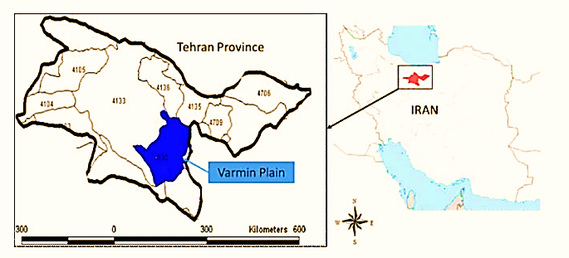

**Figure S1.** The geographical location of the experimental farm in Varamin city (35.80°N, 51.40°E), Iran.

|  |  |
| --- | --- |
| A | C  B |
|  |

**Figure S2.** Implementation plan of a randomized complete block design (RCBD) with four nitrogen fertilizer rates (0%, 50%, 100% and 150% of recommended dosage) in four replications (A); aerial multispectral imaging of a silage maize field by UAV in V8 (B) and VT (C) stages of silage maize growth and development.