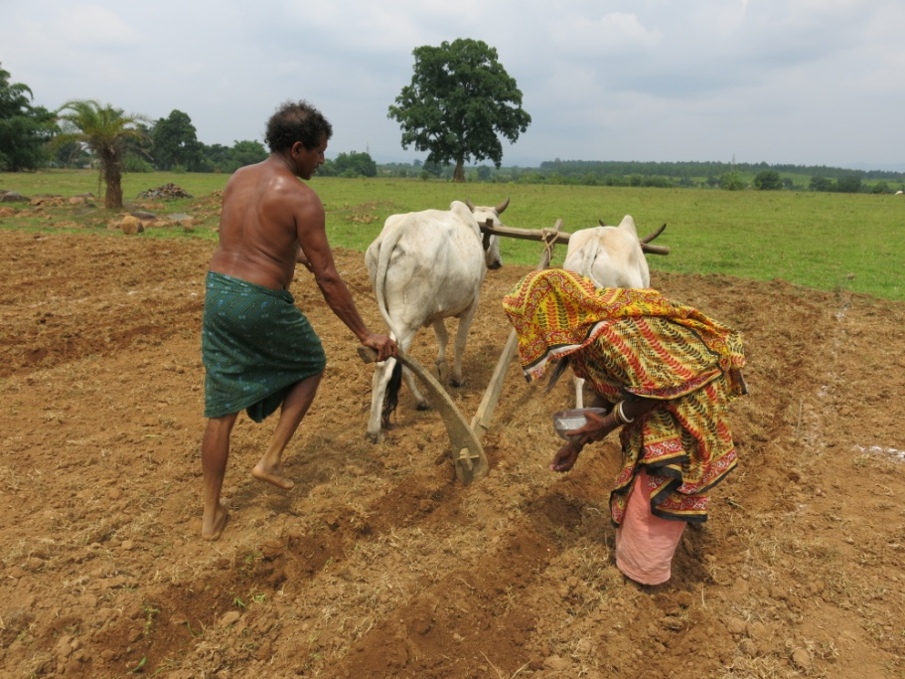
Fig. S1. Farmer’s practice of sowing of maize seeds in Mayurbhanj district.

Farmers name | N Omission +( Micro-nutrient +S) +lime (NPK:0:70:120 kg ha⁻¹) | P Omission +( Micro-nutrient +S) +lime (NPK 150:0:120 kg ha⁻¹) | K Omission +( Micro-nutrient +S) +lime (NPK 150:70:0 kg ha⁻¹)
2013
Hrishikesh Mohanto | 1.51 | 1.65 | 4.14
Konhoi Murmu | 1.08 | 0.91 | 4.08
Raghunath Ghuia | 1.08 | 0.58 | 4.28
Rahino Mohanto | 1.57 | 1.26 | 5.35
Mukundaram Mohanto | 0.93 | 0.91 | 4.05
Gurucharan Mohanto | 0.61 | 0.50 | 4.23
Chotu Mohanto | 2.07 | 0.62 | 4.38
Pramod Sethi | 2.04 | 0.49 | 4.16
Debendra Mohanto | 0.98 | 0.80 | 4.09
Bhupati Mohanto | 0.54 | 0.28 | 4.23
2014
Satyaban Mohanta | 0.84 | 0.80 | 5.18
Chaitanya Majhi | 1.39 | 1.27 | 5.15
Meghrai Tudu | 1.04 | 0.71 | 5.45
Sonaram Hembram | 1.05 | 0.73 | 5.11
Chotu Mohanto | 0.96 | 0.91 | 5.08
Joy Ma Ambika (SHG) | 0.80 | 0.68 | 5.00
Sagar Hensa | 0.97 | 0.76 | 4.93
Johar Jaher Aayo(SHG) | 0.97 | 0.82 | 4.89
Table S1. Maize grain yield (t ha⁻¹) under omission plots

