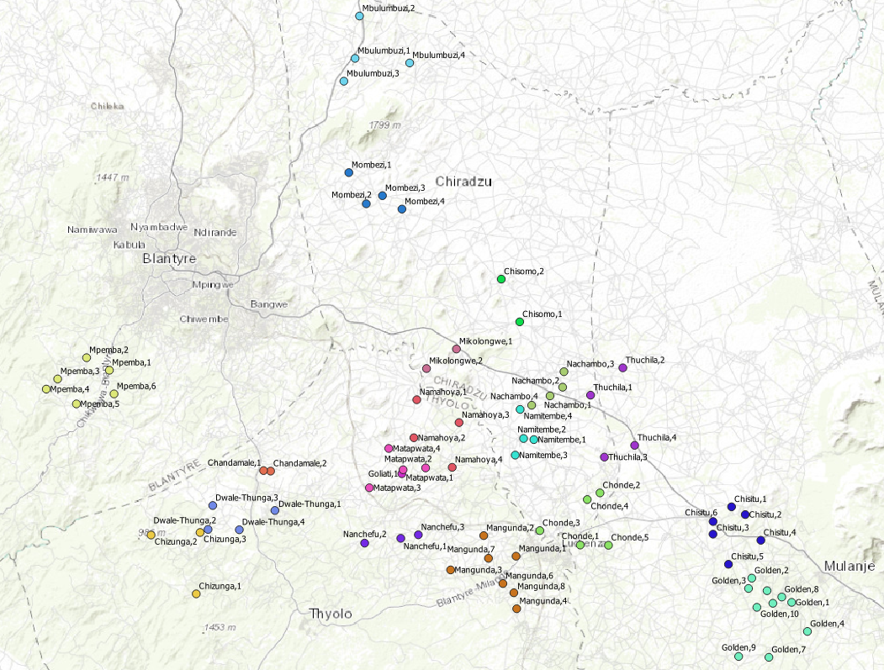

**Figure S1: Geographic locations of MBG zones targeted by S4C**

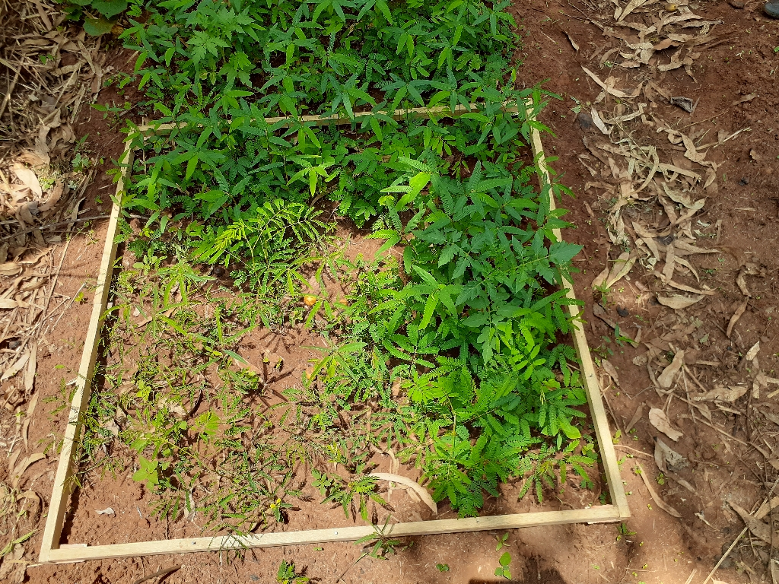

**Figure S2: Measurement frame used to support estimating number of seedlings germinated in large nurseries**