Supplementary Information

Enhanced-efficiency nitrogen fertilizer boosts cauliflower productivity and farmers income: Multi-location and multi-year field trials across Nepal.

Naba Raj Pandit ¹ *, Yam Kanta Gaihre ^{1, 2}, Shriniwas Gautam ³, Shashish Maharjan ¹, Shree Prasad Vista ⁴, Dyutiman Choudhary ¹
¹ International Maize and Wheat Improvement Center (CIMMYT), P.O. Box 5186, Lalitpur, Nepal
² International Fertilizer Development Center (IFDC), Lalitpur, Nepal
³ Pulte Institute for Global Development, University of Notre Dame, Indiana, USA
⁴ National Soil Science Research Center (NSSRC), Nepal Agricultural Research Council (NARC), Lalitpur, Nepal

*Corresponding author email: N.PANDIT@cgiar.org

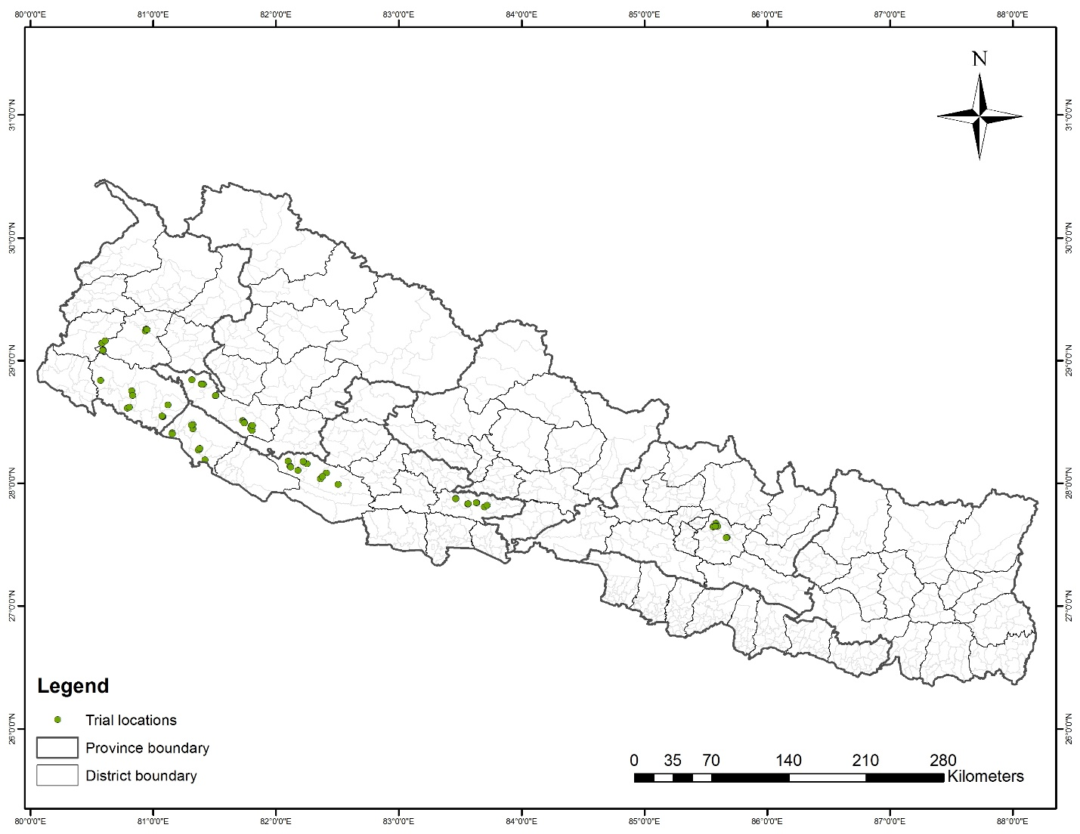
Fig S1. Map showing the location of maize and rice field trials across seven districts in Nepal.

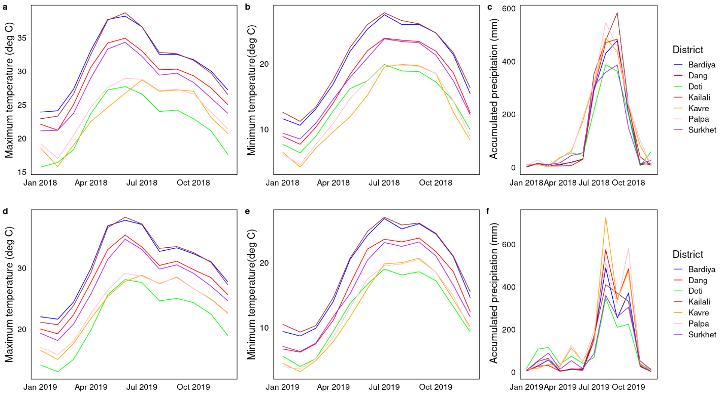
Fig S2. Minimum and maximum temperature and cumulative annual precipitation across trial location for the year 2018 and 2019.

Fig. S3. Cauliflower yield in response to variable nitrogen (N) rates following traditional conventional N management practices across seven districts (Dang, Palpa, Doti, Kavre, Surkhet, Bardiya and Kailali) in the year 2017 (n=60). Across the districts, optimal N rate was identified as 150 kg N ha⁻¹ with the use of conventional granular urea (CIMMYT, NSAF, unpublished results).

Fig S4. Effect of EENFs (SCU, PCU and UB) on cauliflower yield (fig a) and productivity (fig b) in two agroecological region (hills and terai).

Fig S5. Relationship between soil properties (pH, OM, total N%, available P and K) and cauliflower yield across the districts (n=81).

Table. S1. Total variable cost (TVC) and gross margin (GM) of cauliflower for various treatments across seven districts.
Districts | Description | Unit | CK | FP | CU | SCU | PCU | UB
Dang | Seed¹ | USD | 210 | 210 | 210 | 210 | 210 | 210
 | Fertilizers² | USD | 0 | 27 | 239 | 285 | 278 | 234
 | Labor³ | USD | 1380 | 1397 | 1397 | 1392 | 1392 | 1392
 | Cauliflower yield⁴ | Kg ha⁻¹ | 19691 | 30188 | 30188 | 39846 | 40542 | 40355
 | Gross margin (GM) | USD | 3417 | 6041 | 5830 | 8243 | 8427 | 8424
Palpa | Seed¹ | USD | 210 | 210 | 210 | 210 | 210 | 210
 | Fertilizers² | USD | 0 | 31 | 239 | 285 | 278 | 234
 | Labor³ | USD | 1380 | 1397 | 1397 | 1392 | 1392 | 1392
 | Cauliflower yield⁴ | Kg ha⁻¹ | 21821 | 27383 | 35340 | 42155 | 43560 | 51962
 | Gross margin (GM) | USD | 3958 | 5324 | 7139 | 8830 | 9195 | 11374
Doti | Seed¹ | USD | 210 | 210 | 210 | 210 | 210 | 210
 | Fertilizers² | USD | 0 | 87 | 239 | 285 | 278 | 234
 | Labor³ | USD | 1380 | 1397 | 1397 | 1392 | 1392 | 1392
 | Cauliflower yield⁴ | Kg ha⁻¹ | 16783 | 22838 | 28009 | 38461 | 38518 | 37160
 | Gross margin (GM) | USD | 2677 | 4113 | 5276 | 7891 | 7913 | 7611
Kavre | Seed¹ | USD | 210 | 210 | 210 | 210 | 210 | 210
 | Fertilizers² | USD | 0 | 91 | 239 | 285 | 278 | 234
 | Labor³ | USD | 1380 | 1397 | 1397 | 1392 | 1392 | 1392
 | Cauliflower yield⁴ | Kg ha⁻¹ | 17000 | 25766 | 45453 | 55302 | 61605 | 53278
 | Gross margin (GM) | USD | 2732 | 4854 | 9710 | 12172 | 13782 | 11709
Surkhet | Seed¹ | USD | 210 | 210 | 210 | 210 | 210 | 210
 | Fertilizers² | USD | 0 | 90 | 239 | 285 | 278 | 234
 | Labor³ | USD | 1380 | 1397 | 1397 | 1392 | 1392 | 1392
 | Cauliflower yield⁴ | Kg ha⁻¹ | 17498 | 28933 | 39313 | 50023 | 50729 | 51051
 | Gross margin (GM) | USD | 2859 | 5660 | 8149 | 10830 | 11017 | 11143
Bardiya | Seed¹ | USD | 210 | 210 | 210 | 210 | 210 | 210
 | Fertilizers² | USD | 0 | 69 | 239 | 285 | 278 | 234
 | Labor³ | USD | 1380 | 1397 | 1397 | 1392 | 1392 | 1392
 | Cauliflower yield⁴ | Kg ha⁻¹ | 20012 | 22827 | 41362 | 50502 | 50308 | 53166
 | Gross margin (GM) | USD | 3498 | 4128 | 8670 | 10952 | 10910 | 11681
Kailali | Seed¹ | USD | 210 | 210 | 210 | 210 | 210 | 210
 | Fertilizers² | USD | 0 | 97 | 239 | 285 | 278 | 234
 | Labor³ | USD | 1380 | 1397 | 1397 | 1392 | 1392 | 1392
 | Cauliflower yield⁴ | Kg ha⁻¹ | 13688 | 23839 | 40908 | 55387 | 48942 | 48918
 | Gross margin (GM) | USD | 1890 | 4358 | 8555 | 12194 | 10563 | 10601
Disaggregated by region
Mid-hills | Seed¹ | USD | 210 | 210 | 210 | 210 | 210 | 210
 | Fertilizers² | USD | 0 | 65 | 239 | 285 | 278 | 234
 | Labor³ | USD | 1380 | 1397 | 1397 | 1392 | 1392 | 1392
 | Cauliflower yield⁴ | Kg ha⁻¹ | 18559 | 27022 | 35661 | 45157 | 46991 | 46761
 | Gross margin (GM) | USD | 3128 | 5198 | 7220 | 9593 | 10066 | 10052
Terai | Seed¹ | USD | 210 | 210 | 210 | 210 | 210 | 210
 | Fertilizers² | USD | 0 | 83 | 239 | 285 | 278 | 234
 | Labor³ | USD | 1380 | 1397 | 1397 | 1392 | 1392 | 1392
 | Cauliflower yield⁴ | Kg ha⁻¹ | 16850 | 23333 | 41135 | 52944 | 49625 | 51052
 | Gross margin (GM) | USD | 2693 | 4242 | 8612 | 11573 | 10736 | 11143
¹ Cost of seed for farmers practice (FP) is calculated based on seed price in their districts.
² Cumulative cost of CU, DAP, MOP, PCU, briquetted urea and micronutrients required per hectare.
³ labor cost used for fertilizer application and other agronomical practices such as weeding, pest management and harvesting.
⁴ Average cauliflower yield from both years (cauliflower price per kg is NRs 30 (USD 0.25))

