Supplementary Table
Table S1
Socio-demographics of farmers and their perception of third generation Push-Pull technology (3G-PPT)
Response/Ratings | Suba | Bondo | Siaya | Kisumu | Vihiga
 | n=4 | n=5 | n=4 | n=4 | n=4 | Mean
Gender (Male) (%) | 75 | 60 | 25 | 75 | 25 | 52
Age category (%)
18-30 | 0 | 0 | 0 | 25 | 0 | 5
31-40 | 75 | 0 | 25 | 25 | 0 | 25
41-50 | 25 | 20 | 50 | 25 | 0 | 24
51-60 | 0 | 80 | 25 | 0 | 75 | 36
>60 | 0 | 0 | 0 | 25 | 25 | 10
Education level (%)
None | 0 | 0 | 0 | 0 | 0 | 0
Primary | 50 | 60 | 25 | 50 | 25 | 42
Secondary | 25 | 40 | 75 | 25 | 75 | 48
Tertiary | 25 | 0 | 0 | 25 | 0 | 10
Number of years practicing CS-PPT (%)
1-2 yrs | 0 | 0 | 0 | 25 | 0 | 5
3-4 yrs | 50 | 20 | 25 | 25 | 0 | 24
5yrs and over | 50 | 20 | 75 | 50 | 100 | 59
Intention to continue with 3G-PPT (%)
Yes | 100 | 80 | 100 | 75 | 75 | 86
No | 0 | 20 | 0 | 25 | 25 | 14
Reasons for intending to continue 3G-PPT (%)
Reduces attack by FAW | 25 | 0 | 0 | 0 | 50 | 15
Companion crops are drought tolerant | 25 | 0 | 75 | 0 | 0 | 20
Good biomass yield by Xaraes | 0 | 60 | 0 | 25 | 0 | 17
Spider mites resistance in Xaraes | 25 | 20 | 0 | 25 | 0 | 14
Reasons for not intending to continue with 3G-PPT (%)
Desmodium has low biomass | 0 | 0 | 0 | 25 | 50 | 15
Intending to expand existing 3G-PPT (%)
Yes | 100 | 60 | 75 | 75 | 50 | 72
No | 0 | 0 | 25 | 25 | 50 | 20
Reasons for not intending to expand 3G-PPT (%)
Limited land for farming | 0 | 0 | 50 | 25 | 0 | 15
Lack of access to seeds of companion crops | 0 | 0 | 0 | 0 | 25 | 5
Are other farmers interested in 3G-PPT? (%)
Yes | 100 | 75 | 50 | 100 | 50 | 75
No | 0 | 20 | 50 | 0 | 50 | 24
CS-PPT, climate-smart Push-Pull technology; 3G-PPT, third generation Push-Pull technology; FP, farmer practice;
FAW, fall armyworm

Supplementary Figures
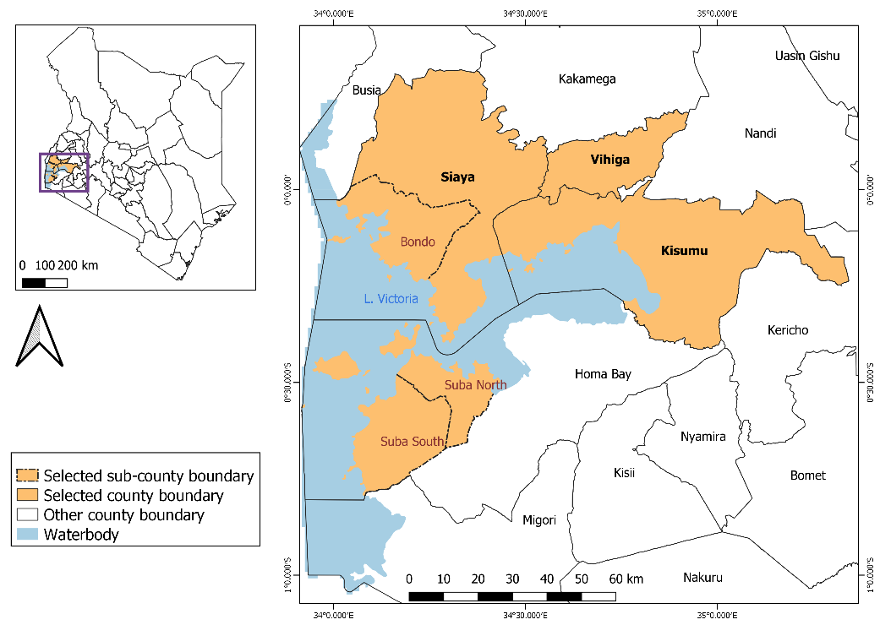
Fig. S1. Location of study sites in western Kenya

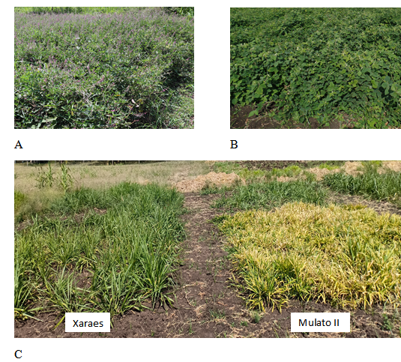
Fig S2. Companion plants used in climate-smart (CS) and third generation (3G) Push-Pull technology (PPT). A) Flowering Desmodium incanum, B) Greenleaf Desmodium intortum and C) Side by side comparison of Brachiaria brizantha cv Xaraes and B. brizantha cv Mulato II under heavy infestation of spider mites (Oligonychus trichardti), characterized by yellowing of leaves and stunting as observed on Mulato II.

