Supplementary Figures

Figure S1: Variations in SOC, pH and clay content with soil type
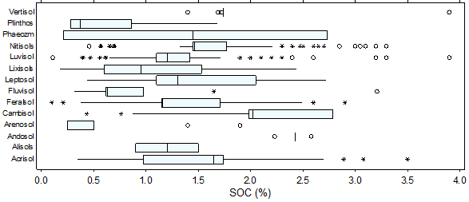
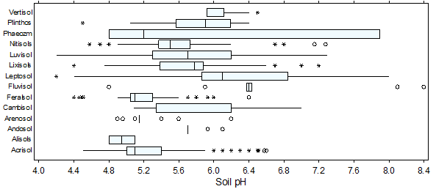
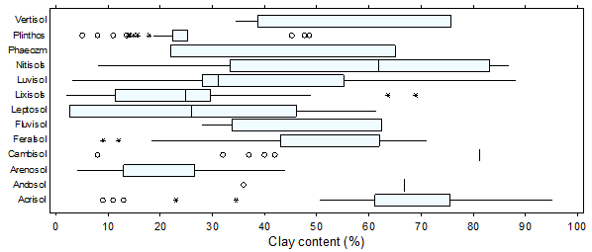
Figure S1. Variations in SOC, pH and clay content with soil type. The boxes represent the lower quartile, upper quartile and the median, whiskers represent the range, while xxxx and OOOO represent possible and probable outliers, respectively.

Figure S2: Variations in sand content, control yield and treatment yield of maize with soil type
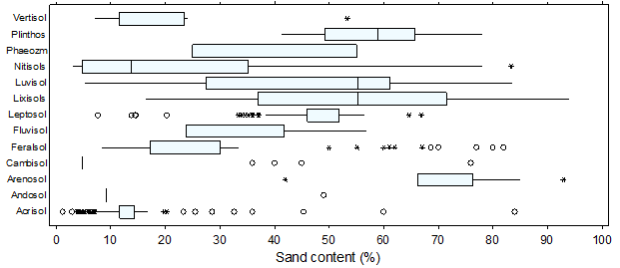
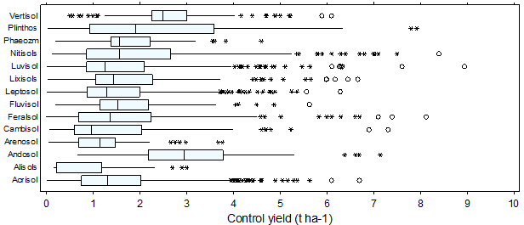
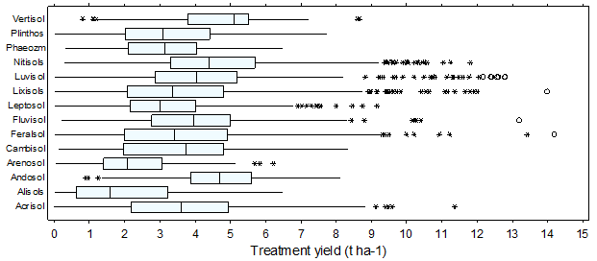
Figure S1. Variations in sand content, control yield and treatment yield of maize with soil type. The boxes represent the lower quartile, upper quartile and the median, whiskers represent the range, while xxxx and OOOO represent possible and probable outliers, respectively.

