Supplementary Figures

Figure S1
Figure S1. The frequency distribution of coefficients a (top panel), b (middle panel) and c (bottom panel) of the asymptotic function (equation 5) for maize yield response to nitrogen, phosphorus and potassium in the database used in Tesfahunegn & Wortmann (2017).

Important note
Negative and 0 values of a and b are implausible because some yield is always obtained where no fertilizer nutrient has been applied. Acceptable values of c fall between 0.90 and 1.0. When c < 0.90, the resultant EOR will be significantly biased downwards.

Figure S2
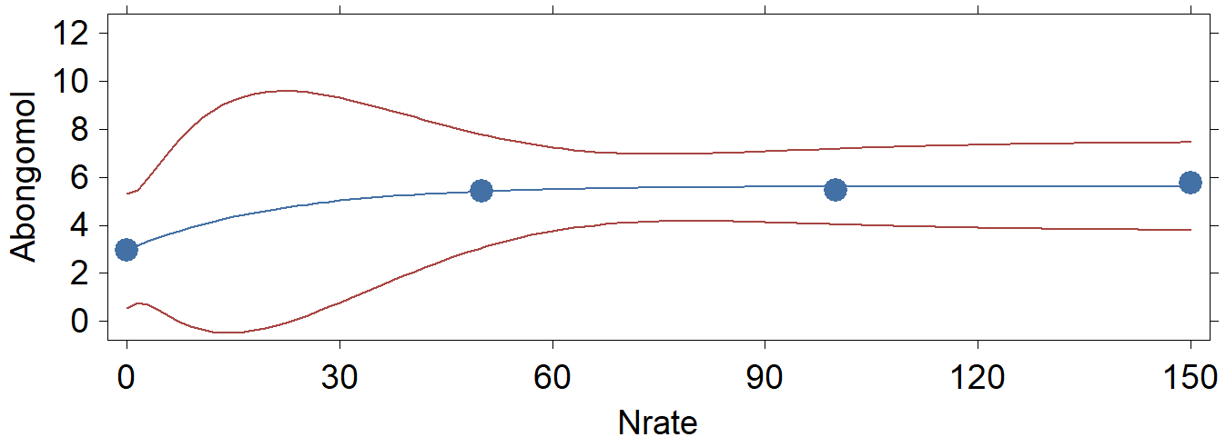 | 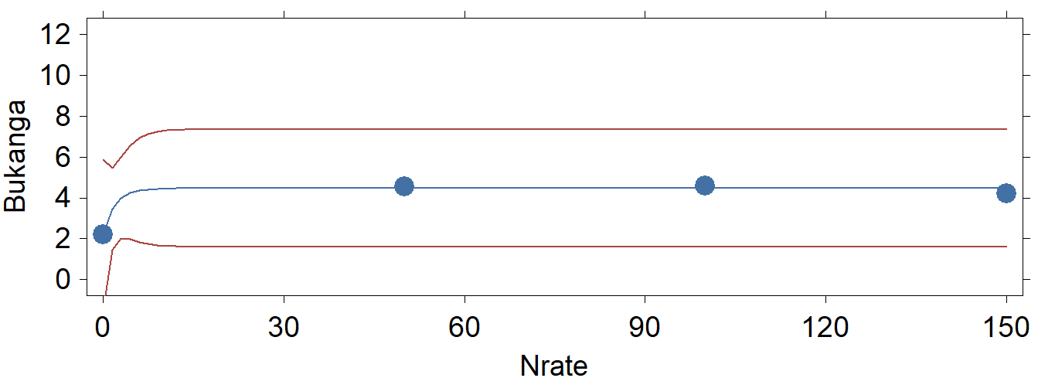
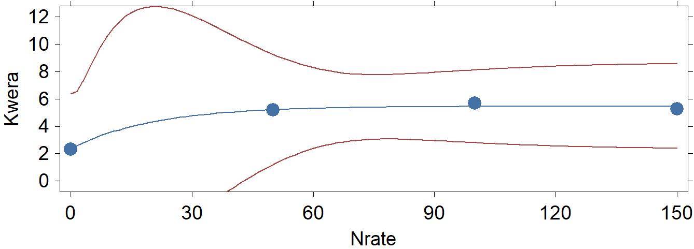 | 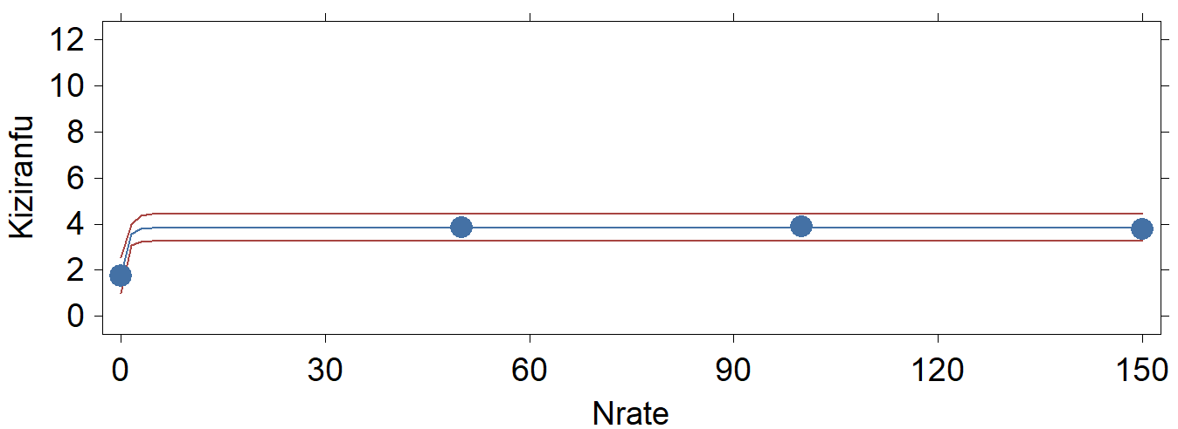
Figure S2. Predictions (smooth lines) of yield using the asymptotic model and uncertainty around predictions (red lines) of maize yield response to N on farmers’ fields in Uganda in the 2010a season. Blue circles represent measured yields, while the smooth blue line represents predicted yield. The red lines represent the 95% confidence limits of predictions.

Sites | a | b | c | pR² | AICc*
Abongomola | 5.6 (3.8; 7.5) | 2.7 (-0.3; 5.7) | 0.95 (0.68; 1.22) | 0.993 | Can’t be estimated
Bukanga | 4.6 (2.6; 6.3) | 2.3 (-0.7; 5.3) | 0.59 (0.32; 0.86) | 0.979 | Can’t be estimated
Kwera | 5.5 (2.3; 8.6) | 3.2 (-2.0; 8.3) | 0.95 (0.56; 1.34) | 0.986 | Can’t be estimated
Kiziramfumbi | 3.8 (0.7; 7.0) | 2.1 (-3.1; 7.2) | 0.28 (-0.11; 0.67) | 0.999 | Can’t be estimated
Values in red colour represent parameters estimated with large uncertainty. These estimates have inflated standard errors and 95% confidence limits that cover both negative and positive values.
*AICc cannot be estimated because the four N rates do not leave enough degrees of freedom to do so.

Supplementary Tables
Table S1. Examples of problematic EOR estimates for nitrogen (N) and phosphorus (P) for trials covering maize in the literature from SSA (summarized from Wortmann, C.S. & Sones K. (ed) (2016). Fertilizer Use Optimization in Sub-Saharan Africa. CAB International, Nairobi, Kenya).
 |  | Target region and/or agroecological zones | Estimated parameters |  |  |  | EOR  (kg ha⁻¹) | Existing recommended  rate (kg ha⁻¹)
Nutrient | Country |  | Asymptote  (a) | Amplitude  (b) | Curvature  (c)
Nitrogen | Kenya | Rift Valley upper | 3.7 | 0.2 | 0.886 |  | 6 | 75
 |  | Eastern Upper | 2.4 | 0.8 | 0.875 |  | 9 | 75
 |  | Rift Valley upper | 7.5 | 2.6 | 0.903 |  | 16 | 75
 |  | Coastal lowlands | 2.1 | 0.4 | 0.950 |  | 11 | 75
 | Mali | Sahel zone | 1.3 | 0.7 | 0.951 |  | 31 | 84
 | Tanzania | Lake zone | 2.3 | 0.8 | 0.947 |  | 16 | 50-80
 |  | Lake zone | 2.1 | 1.0 | 0.960 |  | 21 | 50
 |  | Lake zone | 4.5 | 1.4 | 0.966 |  | 27 | 80
 |  | Central zone | 4.7 | 1.2 | 0.862 |  | 27 | NA
 | Uganda | Eastern Uganda | 2.6 | 0.8 | 0.930 |  | 28 | 60
Phosphorus | Ethiopia | Hot-warm lowland | 2.8 | 0.6 | 0.897 |  | 4 | 20
 | Ghana | Derived savanna trans. | 0.9 | 0.2 | 0.780 |  | 0 | 17
 | Kenya | Eastern lower | 2.0 | 0.1 | 0.885 |  | 0 | NA
 |  | Rift Valley upper | 4.7 | 0.8 | 0.990 |  | 0 | NA
 | Mali | Sahel zone | 1.3 | 0.7 | 0.951 |  | 0 | 7
 |  | North Sudan savanna | 2.9 | 0.3 | 0.928 |  | 3 | 7
 |  | South Sudan savanna | 2.9 | 0.3 | 0.928 |  | 2 | 7
 | Niger | Sahel AEZ | 2.9 | 0.03 | 0.938 |  | 0 | 0
 | Nigeria | Derived savanna | 0.9 | 0.2 | 0.780 |  | 0 | 26
 |  | Mid-altitude zone | 2.6 | 0.2 | 0.860 |  | 0 | 26
 |  | Sudan savanna | 2.9 | 0.3 | 0.928 |  | 0 | 26
 |  | Sahel savanna | 1.3 | 0.7 | 0.951 |  | 0 | 26
 |  | South Guinea savanna | 3.2 | 0.3 | 0.880 |  | 5 | 26
 | Rwanda | North-eastern AEZ | 4.7 | 0.4 | 0.899 |  | 1 | 20
 | Tanzania | Lake zone | 2.0 | 0.1 | 0.858 |  | 0 | 8
 |  | Central zone | 3.4 | 0.1 | 0.917 |  | 0 | NA
 |  | Southern zone | 3.7 | 0.3 | 0.958 |  | 3 | 10
 |  | Southern highland | 3.8 | 0.5 | 0.600 |  | 5 | 20-40
 | Uganda | Central region | 3.9 | 0.2 | 0.840 |  | 5 | 25
 |  | Easter Uganda | 3.9 | 0.2 | 0.840 |  | 5 | 25
 |  | Northern & western | 3.9 | 0.2 | 0.840 |  | 5 | 25
 |  | S. Western highlands | 3.9 | 0.2 | 0.840 |  | 5 | 25
Potassium | Ghana | Derived savanna | 3.8 | 0.04 | 0.550 |  | 0 | 50
 |  |  | 2.6 | 0.4 | 0.855 |  | 0 | 33
 | Malawi | Mid-elevation plateau | 4.1 | 0.1 | 0.900 |  | 2 | 6-8
 |  | Lakeshore | 4.1 | 0.1 | 0.900 |  | 2 | 6-8
 | Nigeria | Derived savanna | 3.8 | 0.04 | 0.550 |  | 2 | 62
 | Tanzania | Southern highlands | 2.8 | 0.1 | 0.800 |  | 7 | NA
 | Zambia | Region II | 4.1 | 0.1 | 0.900 |  | 0 | 17
Values in red colour represent significantly biased parameter estimates resulting in a significant downward bias in EORs. Acceptable values of c fall between 0.90 and 1.0. When c < 0.90, the resultant EOR will be significantly biased downwards.

Table S2. Comparison of different models for maize yield response to nitrogen on contrasting sites where (1) yields are still increasing and (2) apparent maximum yields have been reached
Country | Site | Model | Y_{max}  (t ha⁻¹) | X_{max}  (kg ha¹) | R² or  pR² | Converged
Niger | 1. Bengou (Luvisols) | Quadratic | ND† | ND | 0.663 | NANA
 |  | Asymptotic | 1.2 | 130 | 0.353 | No
 |  | Mitscherlich | 1.0 | ND | 0.316 | No
 |  | Linear-plateau | 1.2 | 70 | 0.825 | Yes
 | 2. Maradi (Fluvisols) | Quadratic | 1.8 | 67 | 0.907 | NA
 |  | Asymptotic | 2.0 | 160 | 0.939 | Yes
 |  | Mitscherlich | 2.0 | 210 | 0.939 | Yes
 |  | Linear-plateau | 1.9 | 40 | 0.991 | Yes
Tanzania | 1. Selian (Chernozems) | Quadratic | ND† | ND | 0.667 | NA
 |  | Asymptotic | 6.3 | 200 | -0.718 | No
 |  | Mitscherlich | ND† | ND | None | No
 |  | Linear-plateau | 6.4 | 143 | 0.833 | No
 | 2. Ilonga (Fluvisols) | Quadratic | 5.5 | 105 | 0.987 | NA
 |  | Asymptotic | 5.7 | 200 | 0.978 | Yes
 |  | Mitscherlich | 5.7 | 200 | 0.987 | Yes
 |  | Linear-plateau | 5.5 | 73.9 | 0.981 | Yes
Uganda | 1. Abongomola (Soil: unknown) | Quadratic | 5.6 | 113 | 0.790 | NA
 |  | Asymptotic | 5.6 | 130 | 0.993 | Yes
 |  | Mitscherlich | 5.6 | 130 | 0.993 | Yes
 |  | Linear-plateau | 5.6 | 54 | 0.993 | Yes
 | 2. Bukanga (Soil: unknown) | Quadratic | 4.9 | 98 | 0.790 | NA
 |  | Asymptotic | 4.4 | 90 | 0.979 | Yes
 |  | Mitscherlich | 4.5 | 90 | 0.979 | Yes
 |  | Linear-plateau | 4.5 | 48 | 0.978 | Yes
Rwanda | 1. Burera (Regosols) | Quadratic | ND† | ND | 0.933 | NA
 |  | Asymptotic | 6.7 | 200 | -0.625 | Yes
 |  | Mitscherlich | ND† | ND† | 0.967 | No
 |  | Linear-plateau | 6.7 | 108 | 0.974 | Yes
 | 2. Bugesera (Ferralsols) | Quadratic | 5.5 | 148 | 0.927 | NA
 |  | Asymptotic | 6.7 | 400 | 0.957 | Yes
 |  | Mitscherlich | 6.7 | 450 | 0.957 | Yes
 |  | Linear-plateau | 5.3 | 90 | 0.996 | Yes
Malawi | 1. Bunda (Luvisols) | Quadratic | ND† | ND | 0.983 | NA
 |  | Asymptotic | 5.3 | 170 | -1.995 | No
 |  | Mitscherlich | 4.9 | ND | None | No
 |  | Linear-plateau | 5.5 | 141 | 0.942 | Yes
 | 2. Salima (Cambisols) | Quadratic | ND | ND | 0.997 | NA
 |  | Asymptotic | 6.1 | 190 | -0.844 | No
 |  | Mitscherlich | 4.0 | ND | 0.308 | No
 |  | Linear-plateau | 8.2 | 119 | 0.998 | Yes
Kenya | 1. Eldoret (Nitisols) | Quadratic | ND | ND | 0.968 | NA
 |  | Asymptotic | 8.0 | ND | -0.807 | Yes
 |  | Mitscherlich | 6.0 | ND | None | No
 |  | Linear-plateau | 8.1 | 130 | 0.967 | Yes
 | 2. Migori (Ferralsols) | Quadratic | 3.0 | 94 | 0.943 | NA
 |  | Asymptotic | 3.0 | 210 | 0.897 | Yes
 |  | Mitscherlich | 3.0 | 210 | 0.897 | Yes
 |  | Linear-plateau | 2.9 | 58.8 | 0.890 | Yes
†ND = The maximum yield could not be determined, i.e., yields were still increasing but N application was limited to segment A; NA = Not applicable
Values in red represent problematic models
Estimates of the asymptotic or plateau yield (Y_{max}), the N rate (X_{max}) that gives Y_{max} estimated using the different models. The R² is given for linear models and pseudo R² (pR²) for nonlinear models. The last column shows convergence of the algorithm (yes or no) for non-linear models.

