Supplementary materials
Table S1. Economic yield and biomass of different cropping systems: sole maize (T₁); sole maize with plastic mulch (T₂); maize and cowpea under plastic mulching (T₃); and maize and soybean under plastic mulching (T₄). Within a given season, different lowercase letters indicate significant differences (p ≤ 0.05) among treatments.

Treatment | Maize (kg ha⁻¹) |  |  |  | Intercrop (kg ha⁻¹) |  |  |  | Wheat (kg ha⁻¹) |  |  |  | Total Straw/Stover (kg ha⁻¹)
 | 2012 | 2013 | 2014 | Mean | 2012 | 2013 | 2014 | Mean | 2012-13 | 2013-14 | 2014-15 | Mean
T₁-wheat | 2014b | 1643b | 2110c | 1922b | - | - | - |  | 3064b | 3083b | 3181a | 3109a | 8259d
T₂-wheat | 2278b | 1832a | 2650a | 2253a | - | - | - |  | 3310b | 3255a | 3205a | 3257a | 9107c
T₃-wheat | 2681a | 1883a | 2350b | 2305a | 560a | 690a | 1805a | 1018a | 3267ab | 3152a | 2985b | 3135a | 10170a
T₄-wheat | 2688a | 1875a | 2310bc | 2291a | 510a | 481b | 590b | 527b | 3216ab | 3189a | 2957b | 3121a | 9802b

Table S2. Runoff and soil loss as affected by different treatments along with intercrop and plastic mulches
Treatments | Runoff |  |  |  |  |  |  |  | Soil loss (t ha⁻¹)
 | mm |  |  |  | %
 | 2012 | 2013 | 2014 | Mean | 2012 | 2013 | 2014 | Mean | 2012 | 2013 | 2014 | Mean
T₁: Maize pure (without intercrop and mulch) | 394.5 | 323.9 | 206.5 | 308.3 | 32.93 | 29.00 | 23.10 | 28.34^{b} | 21.08 | 17.88 | 11.82 | 16.93ª
T₂: Maize pure with Plastic mulch | 453.7 | 379.6 | 235.1 | 356.1 | 37.87 | 33.98 | 26.30 | 32.72ª | 9.89 | 10.63 | 7.60 | 9.37^{b}
T₃: Maize + Cowpea + Plastic mulch | 235.8 | 254.5 | 195.8 | 228.7 | 19.89 | 22.78 | 21.90 | 21.46^{c} | 4.8 | 6.11 | 5.57 | 5.49^{c}
T₄: Maize + Soybean + Plastic mulch | 439.8 | 384.1 | 169.5 | 331.1 | 36.71 | 34.39 | 18.96 | 30.02^{ab} | 10.5 | 9.04 | 4.67 | 8.07^{b}
Within a given season, different lowercase letters indicate significant differences (p ≤ 0.05) among treatments.

Table S3. Nutrient loss (kg ha⁻¹) as affected by different treatments along with intercrop and plastic mulches
Treatments | N (kg ha⁻¹) |  |  |  | P (kg ha⁻¹) |  |  |  | K (kg ha⁻¹)
 | 2012 | 2013 | 2014 | Mean | 2012 | 2013 | 2014 | Mean | 2012 | 2013 | 2014 | Mean
T₁: Maize pure (without intercrop and mulch) | 36.3a | 32.3a | 25.5a | 31.4a | 1.53a | 1.21a | 2.48a | 1.74a | 17.36b | 14.61b | 12.77a | 14.91ab
T₂: Maize pure with Plastic mulch | 34.0ab | 24.3b | 23.3a | 27.2b | 0.67b | 0.52bc | 1.29b | 0.83b | 18.15ab | 13.16b | 11.40a | 14.24b
T₃: Maize + Cowpea + Plastic mulch | 15.3c | 12.3c | 12.1b | 13.2d | 0.37c | 0.41c | 0.61c | 0.46c | 11.32c | 9.14d | 9.35b | 9.94c
T₄: Maize + Soybean + Plastic mulch | 31.1b | 26.2b | 11.2b | 22.8c | 0.75b | 0.64b | 0.71c | 0.70b | 20.23a | 17.15a | 9.33b | 15.57a
Within a given season, different lowercase letters indicate significant differences (p ≤ 0.05) among treatments.

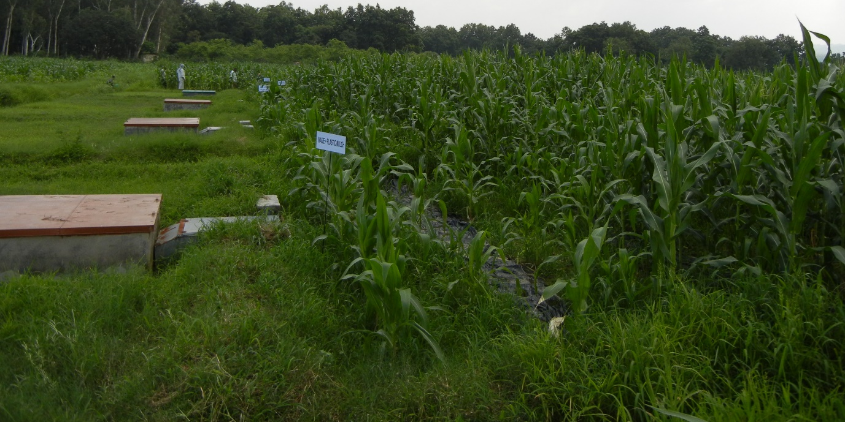
T₃

T₄

T₁

T₂

Figure S1. Experimental plots with runoff collection unit

