Supplementary material

Appendix I – Experimental field lay-out

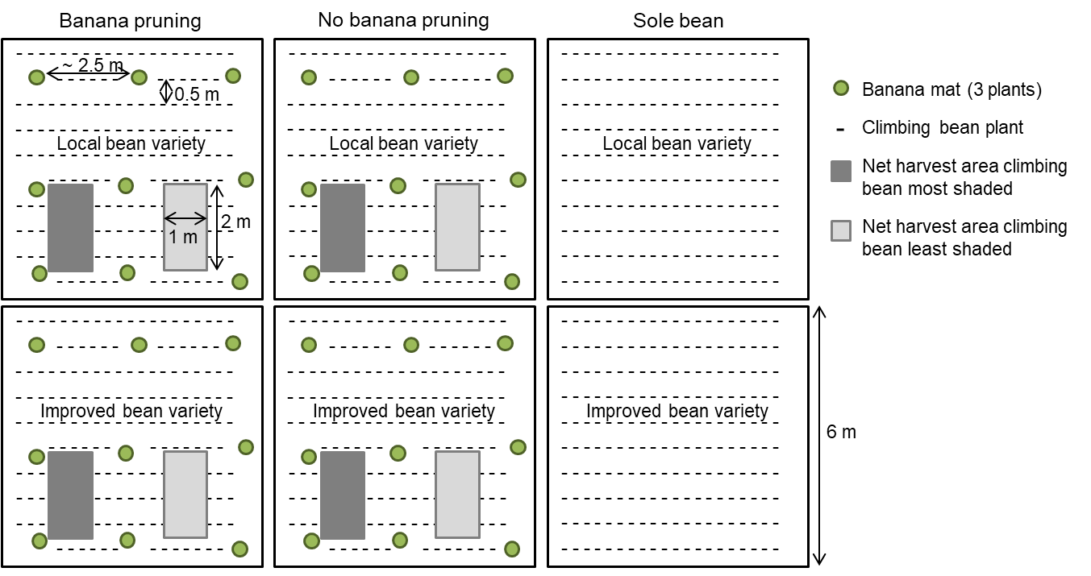

**Figure I**. Layout of the experimental field with six subplots. Banana mats were somewhat irregularly spaced at approximately 2.5 x 2.5 m, shading some portions of the subplot more than other.

Appendix II – Transects of PAR readings

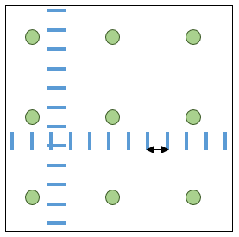

PAR reading

Banana plant

0.5 m

**Figure II**. PAR readings below the banana canopy along two transects per subplot.

of the banana mats.

Appendix III – Light transmission profiles per farm

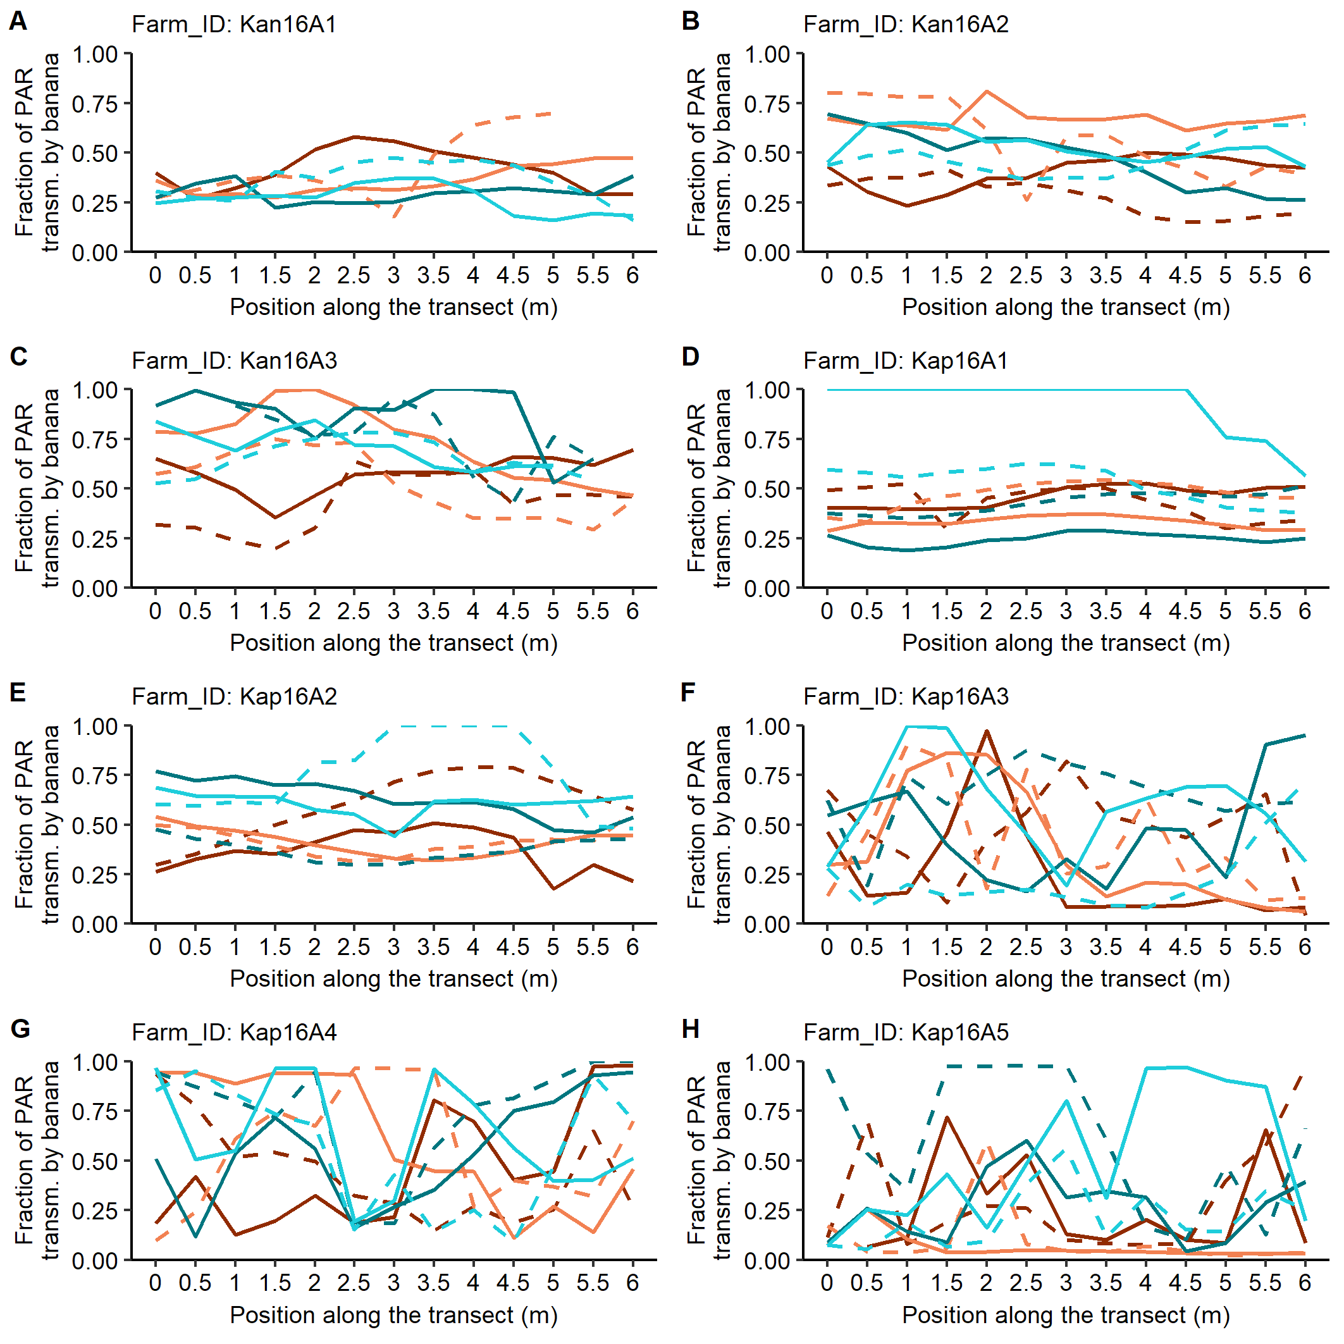

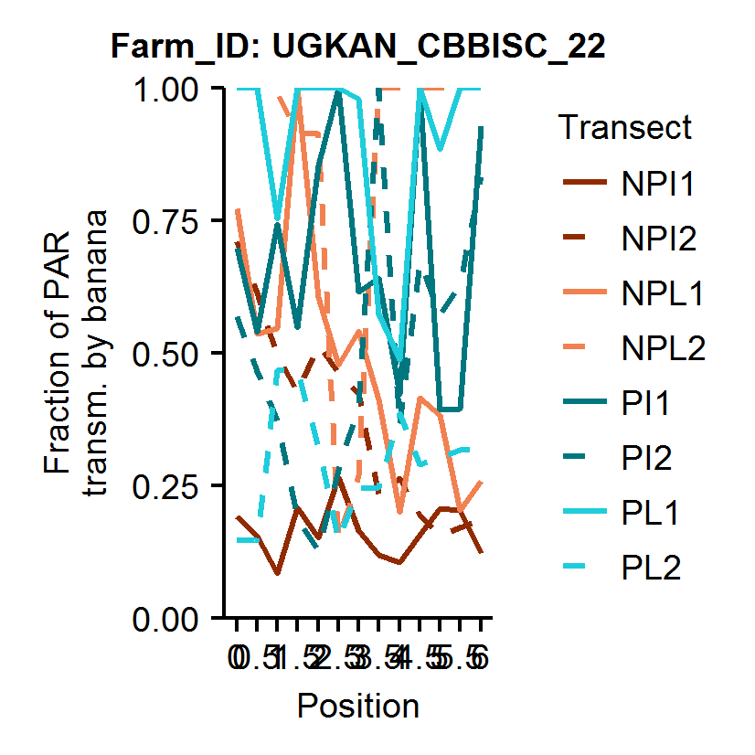

**Figure I.1**. Fractions of incident PAR transmitted by the banana canopy and available for intercropped beans at thirteen positions on six-meter transects (two per treatment) in **Kanungu** and **Kapchorwa** in season **2016A**. P = pruning, NP = no pruning, L = local bean variety Mubano (Kanungu) and Atawa (Kapchorwa), I = improved bean variety Nabe 12C.

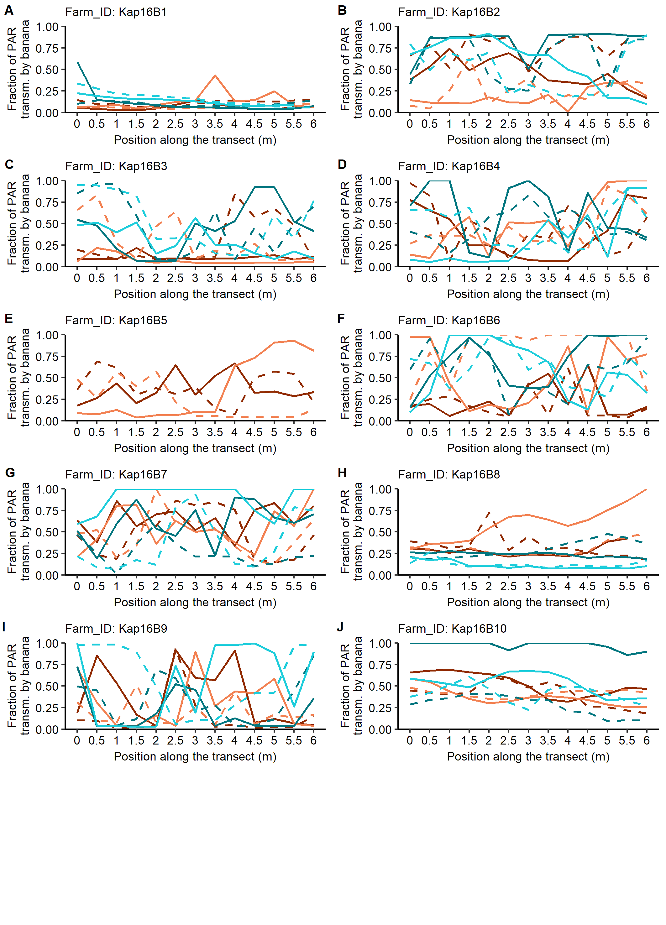



**Figure I.2**. Fractions of incident PAR transmitted by the banana canopy and available for intercropped beans at thirteen positions on six-meter transects (two per treatment) in **Kapchorwa** in season **2016B**. P = pruning, NP = no pruning, L = local bean variety Atawa, I = improved bean variety Nabe 12C.

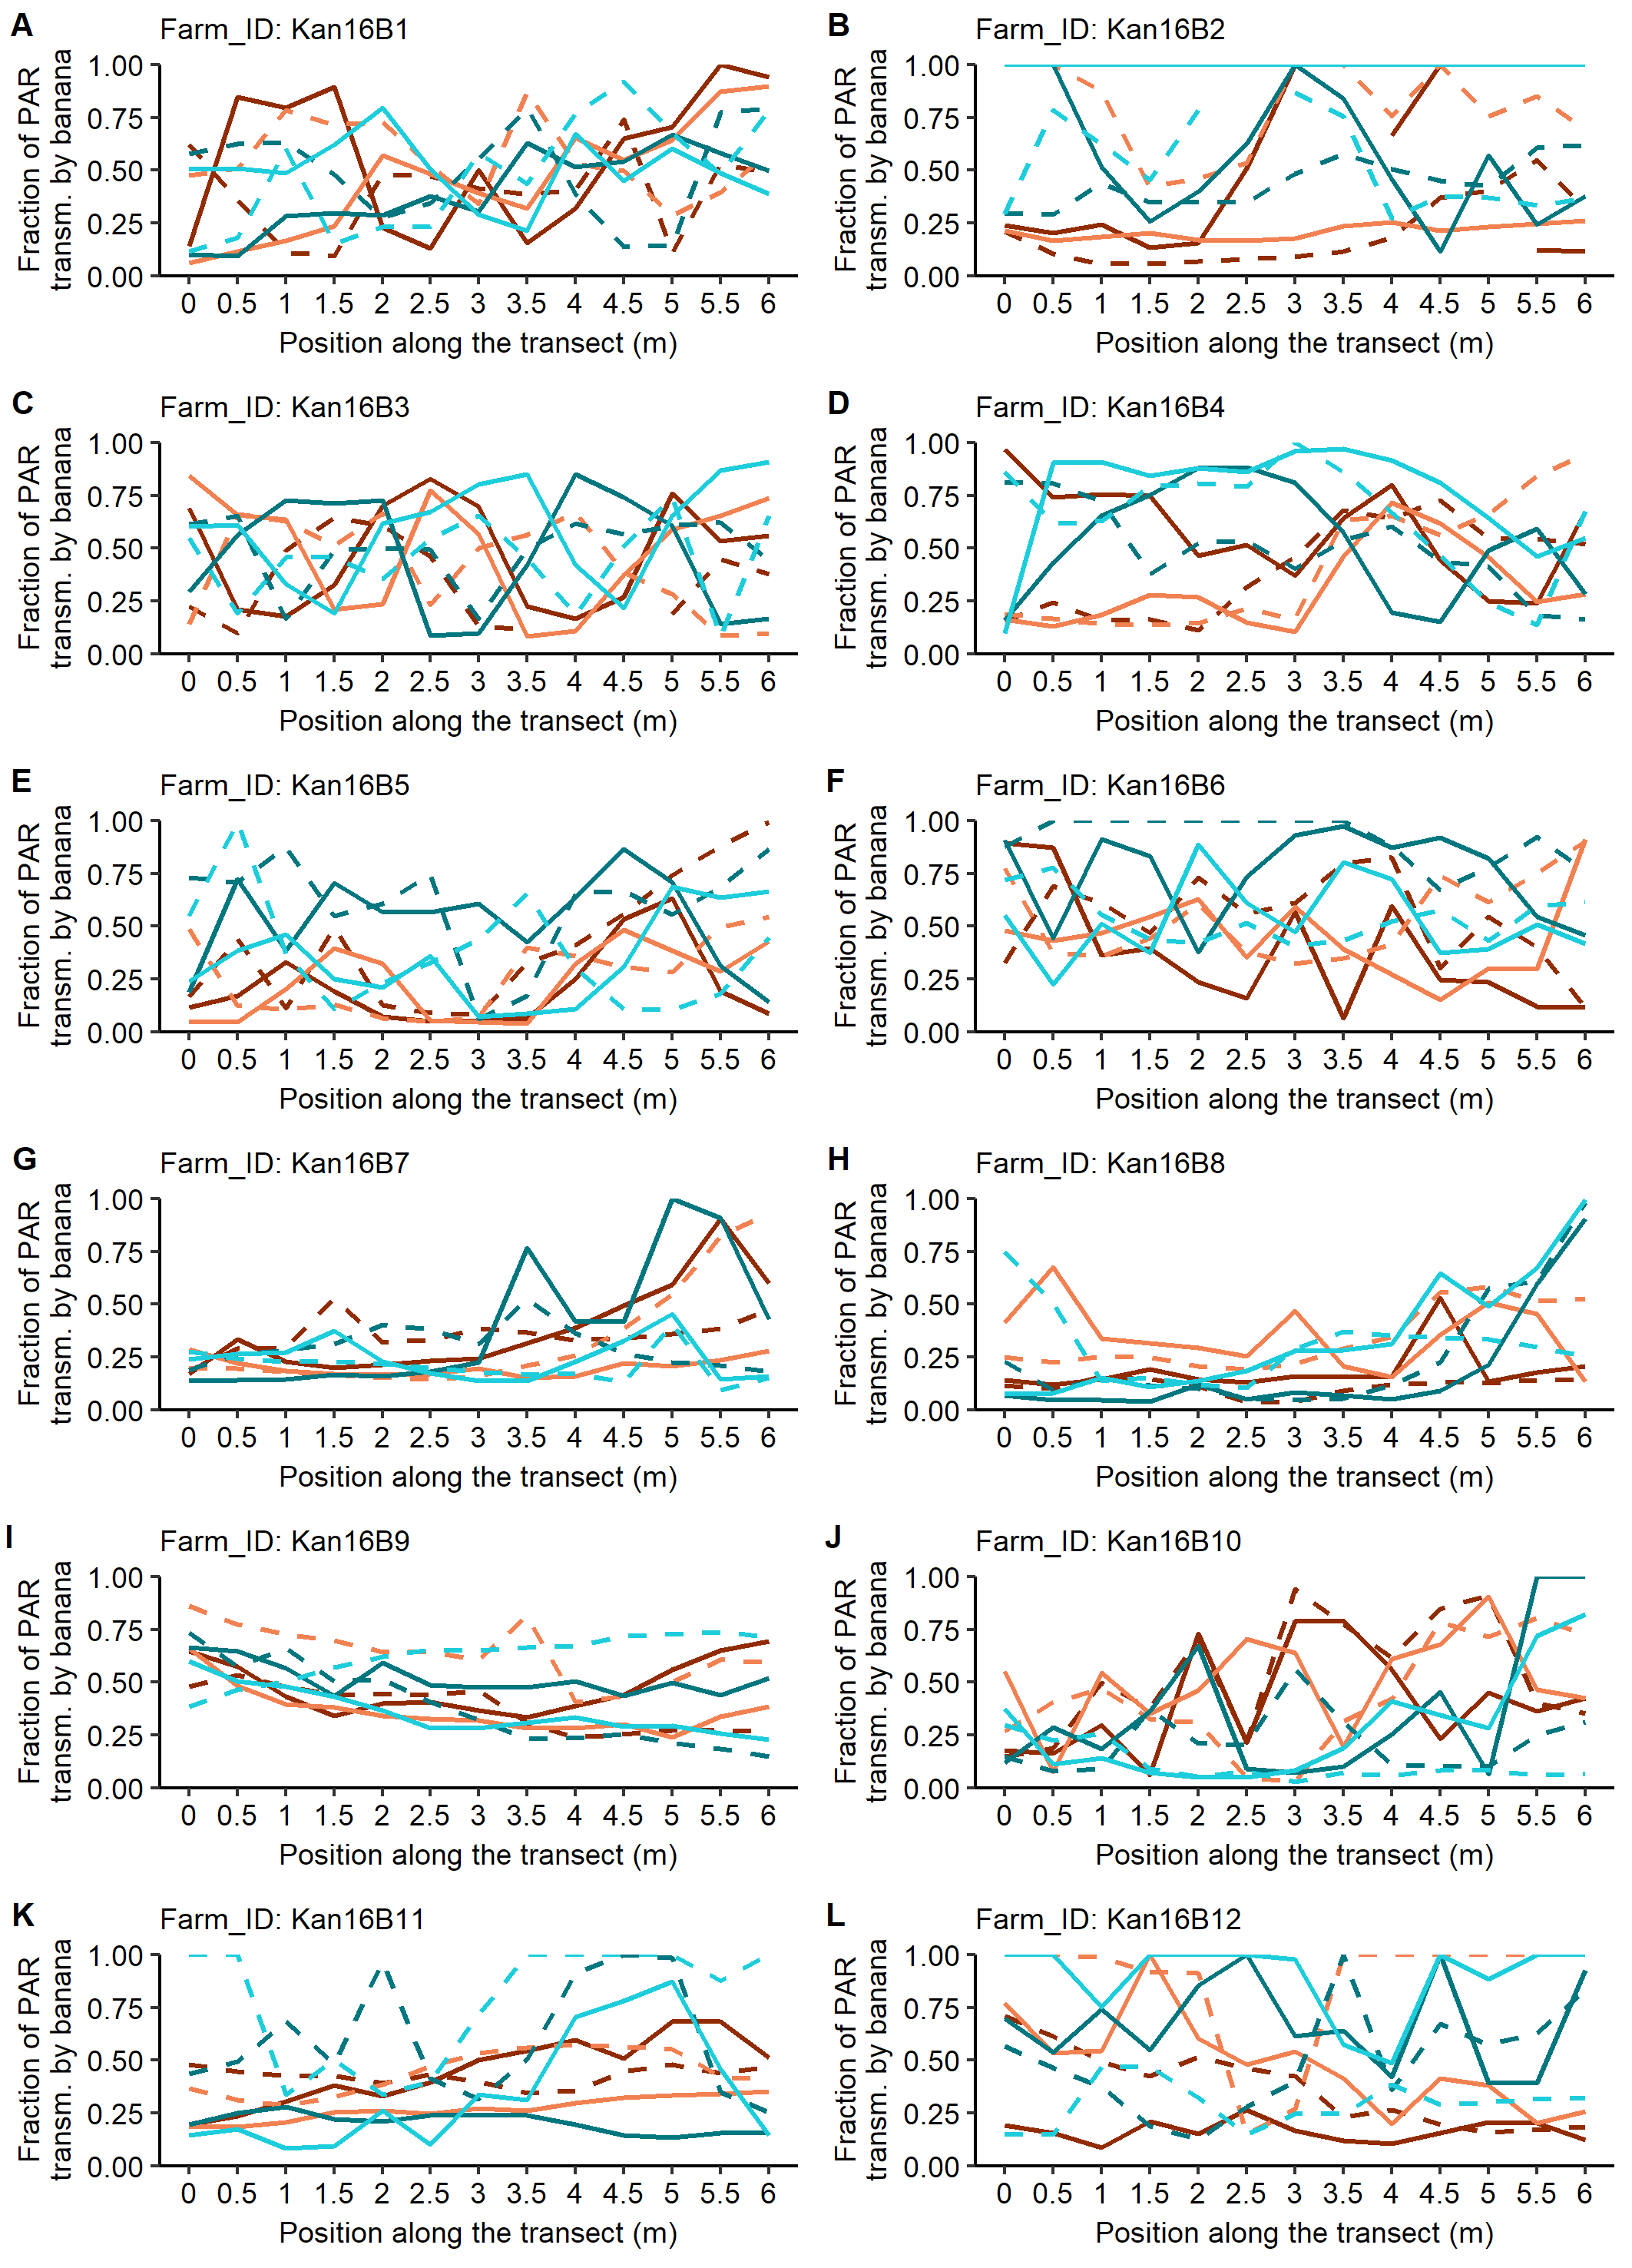



**Figure I.3**. Fractions of incident PAR transmitted by the banana canopy and available for intercropped beans at thirteen positions on six-meter transects (two per treatment) in **Kanungu** in season **2016B**. P = pruning, NP = no pruning, L = local bean variety Kabweseri, I = improved bean variety Nabe 12C.