EAG-D-20-00038
Improving vegetable production under semi-arid and saline conditions in south-western
Madagascar
Andriamparany et al.

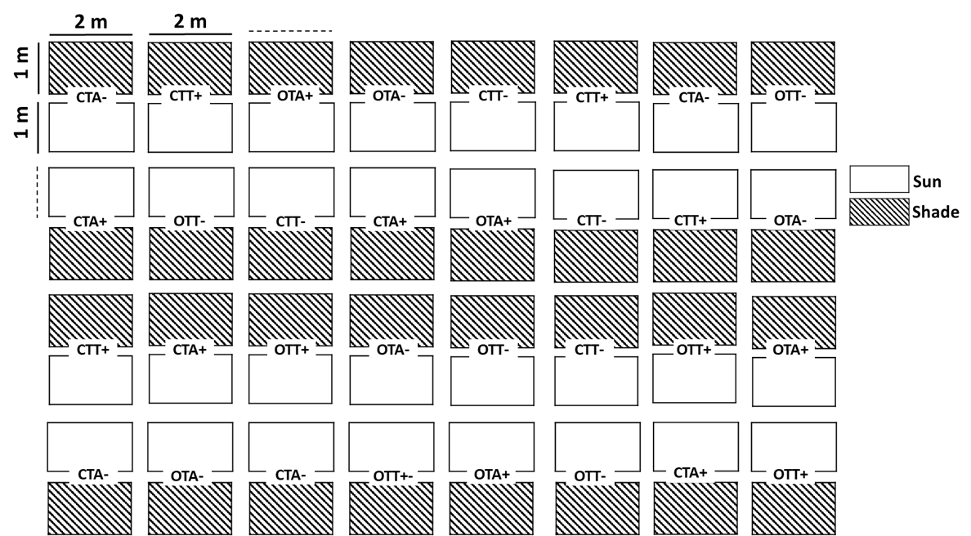
Supplementary Material to Figure S1. Plot structure using a split plot design in a field experiment on onion and carrot production in 2016, in SW-Madagascar. C = carrot, O = onion, treatments (TA+ = carrot seed lot of ‘Antananarivo’ with manure, TA- = carrot seed lot of ‘Antananarivo’ without manure, TT+ = carrot seed lot of ‘Toliara’ with manure, TT- = carrot seed lot of ‘Toliara’ without manure). The same plot structure was set up for the field experiment on carrot and onion production in 2013 but with the following treatments: C = control, M = manure, CC = charcoal, M+CC = manure + charcoal.

