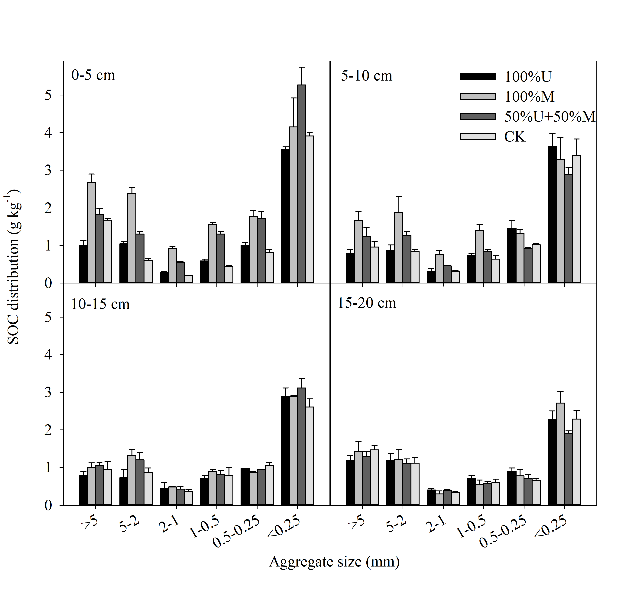Figure S1. Distribution of soil organic carbon (SOC) associated with aggregate fractions (dry–sieving) as affected by fertilization: 100% urea (100%U), 100% manure (100%M), half manure and half urea (50%U+50%M), no nitrogen fertilizer (CK).

