Supplementary material

Table S1: Characteristics of surveyed households divided into three groups (treatment group, control-in group, and control-out group) before matching

Characteristics | Treatment mean  (n=355) | Control-in mean  (n=452) | Control-out mean  (n=406) | t-test  (mean treatment – mean control-in) | t-test  (mean control-in mean control-out)
Continuous Variables
Time to nearest market (minutes for one-way travel) | 62.73  (2.62) | 63.69  (2.17) | 85.31  (3.58) | -0.29 ns | -5.28 ***
Time to nearest CBSPª (minutes for one-way travel) | 10.73  (0.54) | 11.38  (0.63) | NA | -0.78 ns | NA
Total cultivable area (ha) | 0.51  (0.03) | 0.43  (0.03) | 0.56  (0.03) | 2.34 ** | -3.84 ***
Years growing maize | 35.96  (0.76) | 36.99  (0.67) | 35.58  (0.72) | -1.00 ns | 1.43 ns
Percentage of females in the household | 0.50  (0.009) | 0.49  (0.007) | 0.47  (0.01) | 0.46 ns | 1.34 ns
Economically-active population in the family (ages 16-65 years) | 3.88  (0.10) | 3.81  (0.09) | 3.90  (0.09) | 0.57 ns | -0.80 ns
Percentage of bari land (upland) of the total agricultural land | 0.69  (0.015) | 0.66  (0.014) | 0.70  (0.017) | 1.51 ns | -1.76 *
Number of relatives who are available when support needed | 6.37  (0.44) | 6.11  (0.36) | 6.97  (0.42) | 0.47 ns | -1.52 ns
Time to agricultural extension office (minutes for one-way travel) | 53.49  (2.52) | 56.12  (1.94) | 63.22  (3,31) | -0.84 ns | -1.97 **
Percent increase in maize area in the past five years | 0.19  (0.021) | 0.13  (0.016) | 0.19  (0.02) | 2.26 ** | -2.08 **
Binary Variables (dummy, 1: yes; 0: no)
Male household head | 0.78  (0.02) | 0.80  (0.02) | 0.86  (0.02) | -0.52 ns | -2.23 **
Rice-growing household | 0.67  (0.025) | 0.69  (0.22) | 0.52  (0.02) | -0.38 ns | 5.14 ***
Household had television in base year | 0.54  (0.02) | 0.50  (0.02) | 0.62  (0.02) | 1.13 ns | -3.38 ***
Household uses fertilizer | 0.67  (0.025) | 0.59  (0.02) | 0.50  (0.02) | 2.39 ** | 2.54 **
Household head literate | 0.72  (0.024) | 0.68  (0.022) | 0.70  (0.02) | 1.20 ns | -66 ns
Household had kacchi^{b} house in the base year | 0.76  (0.02) | 0.76  (0.02) | 0.72  (0.02) | -0.07 ns | 1.52 ns
Household grew more than two varieties of maize in base year | 0.19  (0.025) | 0.05  (0.01) | 0.03  (0.01) | 6.37 *** | 1.50 ns
Note: *, **, *** denote significance of mean difference at the 10%, 5%, and 1% level, respectively; ns=not significant at 10%, standard error in brackets
ªTime to nearest CBSP is not included for comparing spillover impact (control-in vs. control-out) as CBSPs are only formed in project districts, and control-out group households are from outside project districts
^{b}Kacchi house means non-concrete/non-brick house

Table S2: Test of matching quality by comparing the mean of the treatment and control group after matching with percentage bias reduction

Variable | Treatment group | Control-in group | % Bias | % Reduction in bias | p-value for equality of mean after matching
Time to nearest market (minutes for one-way travel) | 62.47 | 62.59 | -0.2 | 90.2 | 0.97
Time to nearest CBSP (minutes for one-way travel) | 10.73 | 11.49 | -6.5 | -16.2 | 0.40
Total cultivable area (ha) | 0.51 | 0.53 | -4.4 | 73.6 | 0.61
Years growing maize | 35.93 | 35.71 | 1.6 | 79.4 | 0.83
Percentage of females in the household | 0.49 | 0.49 | 1.5 | 44.5 | 0.84
Economically-active population in the family (ages 16 – 65 years) | 3.91 | 4.08 | -9.6 | -85.3 | 0.22
Percentage of bari (upland) land of the total agricultural land | 0.69 | 0.67 | 6.7 | 39.5 | 0.36
Number of relatives who are available when support needed | 6.44 | 6.66 | -2.8 | 36.4 | 0.72
Time to agricultural extension office (minutes for one-way travel) | 53.84 | 53.64 | 0.5 | 90.5 | 0.95
Percent increase in maize area in the past five years | 0.19 | 0.21 | -4.9 | 70.2 | 0.55
Male household head | 0.78 | 0.79 | -3.3 | 8.7 | 0.67
Rice-growing household | 0.67 | 0.71 | -7.4 | -143.0 | 0.33
Household had television in base year | 0.54 | 0.58 | -7.8 | 2.0 | 0.29
Household uses fertilizer | 0.67 | 0.67 | -0.8 | 95.3 | 0.91
Household head literate | 0.72 | 0.74 | -4.8 | 48.0 | 0.52
Household had kacchi house in the base year | 0.76 | 0.77 | -4.0 | -147.5 | 0.59
Household grew more than two varieties of maize in base year | 0.20 | 0.19 | 2.9 | 93.4 | 0.75
 | unmatched | matched
PS R2 | 0.06 | 0.01
Mean bias | 10 | 4

Table S3: Summary statistics of the impact outcome indicators comparing the treatment and control-in group

Outcome | Treatment mean | Control-in mean | t-test
Maize income | 442*** (20) | 308 (15) | 5.5
Maize sufficiency | 9.4* (0.17) | 9.0 (0.16) | 1.68
Food expenditure | 26.6 ns (1.40) | 27.4 (1.17) | 0.44
Female workload | 0.69ns (0.87) | 0.67 (0.79) | 1.47
Female leadership | 40.3*** (2.47) | 23.6 (1.95) | 5.39
Note: *, **, *** denote significance of difference in mean at the 10%, 5%, and 1% level, respectively; ns=not significant at 10%.The figures in the parentheses are std error.

Table S4: Sensitivity of average treatment effect of five outcome indicators based on three different matching methods

Matching  methods | Average treatment effect on outcomes
 | Maize income | Maize sufficiency | Food expenditure | Female workload | Female leadership
Nearest neighbor | 122.33 *** (24.75) | -0.02 ns  (0.23) | -0.59 ns  (1.69) | 1.50 ns  (1.42) | 16.25 ***  (3.22)
Kernel matching (bandwidth (0.05)) | 135.19 ***  (27.62) | 0.06 ns  (0.27) | 1.57 ns  (2.05) | 1.36 ns  (1.33) | 15.92 ns  (3.52)
Radium matching caliper (0.05) | 134.06***  (27.56) | 0.09 ns  (0.27) | 1.43 ns  (2.04) | 1.43 ns  (1.34) | 15.72 ***  (3.51)
Note: *, **, *** denote significance of difference in mean at the 10%, 5%, and 1% level. Treatment effect for nearest neighbor matching using teffects psmatch while that for Kernel matching and radium matching were done using psmatch2 command in Stata

Table S5: Results of placebo regression to re-affirm no hidden bias due to omitted variable

Dependent variable:  years spouse involved in farming | Coefficients | Standard error
HH is member of CBSP group (1=yes, 0=no) | 0.97 ns | 1.02
Time to nearest market (minutes for one-way travel) | -0.01 ns | 0.01
Time to nearest CBSP (minutes for one-way travel) | 0.56 ns | 0.04
Total cultivable area (ha) | 0.99 ns | 1.18
Years growing maize | 0.54*** | 0.04
Percentage of females in the household | -6.25* | 3.22
Economically-active population in the family (ages 16 – 65 years) | 0.28 ns | 0.27
Percentage of bari (upland) land of the total agricultural land | -0.29 ns | 2.45
Number of relatives who are available when support needed | 0.07 ns | 0.06
Time to agricultural extension office (minutes for one-way travel) | 0.03** | 0.01
Percent increase in maize area in the past five years | 0.93 ns | 1.35
Male household head (1=yes, 0=No) | 18.22*** | 1.31
Rice-growing household (1=yes, 0=No) | 0.90 ns | 1.51
Household had television in base year (1=yes, 0=No) | -0.53 ns | 1.05
Household uses fertilizer (1=yes, 0=No) | -1.36 ns | 1.04
Household head literate (1=yes, 0=No) | 2.59** | 1.19
Household had non-concrete house (1=yes, 0=No) | 0.19 ns | 1.19
Household grew more than two varieties of maize in base year (1=yes, 0=No) | -0.44 ns | 1.62
Constant | -13.37** | 3.95
R-sq | 0.43
Num obs | 796

Table S6: Summary statistics of variety adoption, yield, food expenditure, and maize sufficiency for control-in and control-out households

Outcome | Control-in mean | Control-out mean | t-test
Improved seed adoption | 0.27*** (0.02) | 0.10 (0.02) | 6.29
Maize yield | 2.21* (0.0.06) | 1.90 (0.06) | 3.58
Food expenditure | 27.39 (1.17) | 35.49*** (1.58) | -4.17
Maize sufficiency | 9.0* (0.16) | 8.58 (0.18) | 1.72
Note: *, **, *** denote significance of difference in mean at the 10%, 5%, and 1% level, respectively; ns=not significant at 10%.The figures in the parentheses are std error.

Table S7: Sensitivity of the treatment effect of spillover impact based on different methods for outcome indicators
Outcome variable | ATE for impact outcome variables
 | HMRP variety adoption | Yield | PC cereal expenditure | Maize sufficiency
Nearest neighbor | 0.18 *** (0.03) | 0.37*** (0.09) | -5.74** (2.23) | 0.68*** (0.26)
Radium matching caliper (0.05) | 0.17*** (0.03) | 0.38*** (0.10) | -5.28*** (2.60) | 0.89*** (0.32)
Kernel matching (bandwidth (0.05) | 0.17 *** (0.32) | 0.38*** (0.10) | -5.38** (2.60) | 0.90*** (0.32)
Note: *, **, *** denote significance of difference in mean at the 10%, 5%, and 1% level. ATE for nearest neighbor matching using teffects psmatch while that for Kernel matching, and radium matching were done using psmatch2 command in Stata

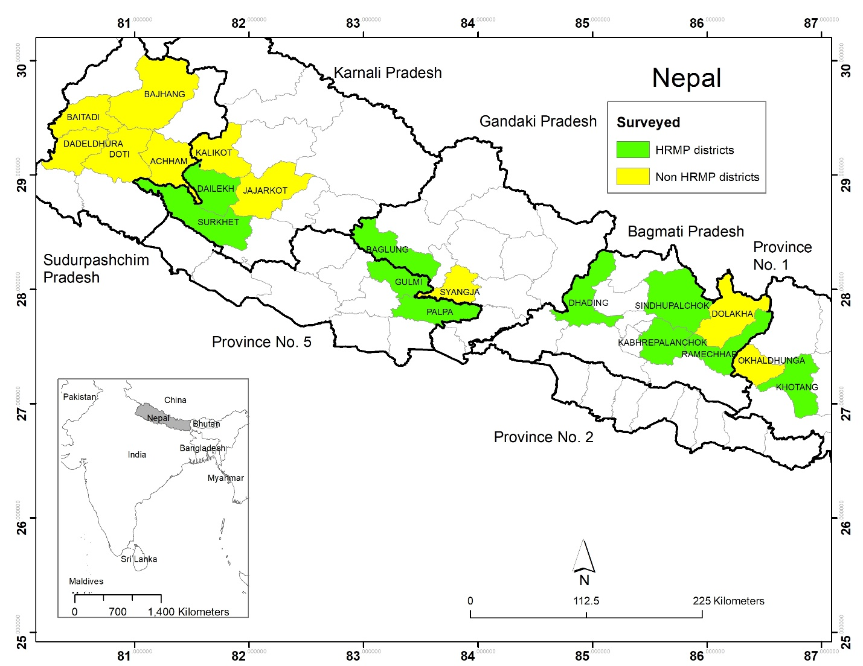
Figure S1: Map of Nepal (75 districts) with surveyed districts (10 from project districts; 10 from non-project districts)

