Supplementary materials.
Wiraguna, Malik, Colmer, Erskine. Waterlogging tolerance of grass pea (Lathyrus sativus L.) at germination related to country of origin.

Table S1. Results of Shapiro-Wilk tests for normality of residuals of morpho-agronomic traits from 53 grass pea genotypes – flowering time (d), maturity time (d), 100 seed weight (g), pod width (cm) and pod length (cm) in Experiment 1, and percentage of germination under waterlogging and of waterlogged seedling survival at final sampling in Experiment 2
Morpho-agronomic traits | Test statistic W | p-value
Flowering time | 0.996 | 0.997
Maturity time | 0.976 | 0.374
100 seed weight | 0.996 | 0.996
Pod width | 0.981 | 0.572
Pod length | 0.983 | 0.639
Germination | 0.972 | 0.251
Seedling survival | 0.996 | 0.981

Table S2. Latent vectors of two canonical variates (CV1 and CV2) for six morpho-agronomic traits.
Morpho-agronomic traits | Canonical Variate
 | 1 | 2
Flowering | -0.052 | -0.078
Maturity | 0.009 | 0.038
Pod length | 0.060 | 0.096
Pod width | 0.002 | 0.232
Seedling survival | 0.542 | -0.050
100 seed weight | -0.066 | 0.447

Table S3. A one-way ANOVA of 53 grass pea genotypes when seeds were sown into waterlogged soil for 6 days and then the soil was drained for 8 days.
Fixed term | Df | Sum Sq | Mean Sq | F value | F probability (P)
Genotypes | 52 | 77819 | 1496.5 | 5.6 | <0.001
Replicates | 2 | 1486 | 743.0 | 2.8 | 0.065
Residual | 104 | 27598 | 265.4

Table S4. Surviving seedlings of 53 grass pea genotypes (mean over replicates) during 6 days of waterlogging followed by 8 days of drainage (Experiment 2).
No | Genotype | Percent surviving seedlings by Day
 |  | 1 | 2 | 3 | 4 | 5 | 6 | 7 | 8 | 9 | 10 | 11 | 12 | 13 | 14
1 | 8603 | 0 | 0 | 0 | 30 | 40 | 40 | 37 | 37 | 37 | 40 | 43 | 43 | 43 | 43
2 | 8604 | 0 | 0 | 0 | 69 | 71 | 71 | 42 | 42 | 42 | 42 | 42 | 47 | 47 | 47
3 | 8605 | 0 | 0 | 0 | 44 | 56 | 67 | 100 | 89 | 89 | 89 | 89 | 89 | 89 | 89
4 | Ceora | 0 | 0 | 0 | 49 | 36 | 36 | 0 | 0 | 0 | 0 | 0 | 0 | 0 | 0
5 | Chalus | 0 | 0 | 0 | 33 | 36 | 36 | 2 | 2 | 4 | 4 | 4 | 9 | 9 | 9
6 | CPI 10782 | 0 | 0 | 0 | 20 | 29 | 29 | 2 | 4 | 7 | 7 | 7 | 9 | 9 | 9
7 | CPI 14162 | 0 | 0 | 0 | 0 | 0 | 0 | 3 | 22 | 31 | 36 | 36 | 36 | 39 | 39
8 | CPI 14162.1 | 0 | 0 | 0 | 23 | 18 | 18 | 0 | 5 | 5 | 5 | 5 | 5 | 5 | 5
9 | CPI 14162.3 | 0 | 0 | 0 | 0 | 0 | 0 | 0 | 0 | 0 | 0 | 0 | 3 | 3 | 3
10 | CPI 16230 | 0 | 0 | 0 | 10 | 8 | 8 | 0 | 0 | 0 | 0 | 0 | 0 | 0 | 0
11 | CPI 20487 | 0 | 0 | 0 | 7 | 17 | 17 | 24 | 24 | 31 | 38 | 38 | 38 | 40 | 40
12 | CPI 20490 | 0 | 0 | 0 | 11 | 0 | 0 | 0 | 0 | 0 | 0 | 0 | 0 | 0 | 0
13 | CPI 20491 | 0 | 0 | 0 | 14 | 6 | 6 | 3 | 3 | 3 | 3 | 3 | 3 | 3 | 3
14 | CPI 20492 | 0 | 0 | 0 | 9 | 9 | 9 | 0 | 3 | 3 | 3 | 3 | 3 | 6 | 6
15 | CPI 20495 | 0 | 0 | 0 | 7 | 7 | 7 | 7 | 9 | 9 | 13 | 13 | 13 | 13 | 13
16 | CPI 24772 | 0 | 0 | 0 | 18 | 18 | 11 | 0 | 0 | 0 | 0 | 0 | 0 | 0 | 0
17 | CPI 31617 | 0 | 0 | 0 | 23 | 23 | 23 | 0 | 0 | 0 | 0 | 3 | 3 | 3 | 3
18 | CPI 9997 | 0 | 0 | 0 | 18 | 9 | 9 | 0 | 0 | 4 | 4 | 4 | 7 | 9 | 9
19 | GP.13 | 0 | 0 | 0 | 83 | 86 | 86 | 79 | 79 | 79 | 79 | 79 | 81 | 83 | 83
20 | GP.14 | 0 | 0 | 0 | 71 | 74 | 69 | 31 | 31 | 38 | 38 | 38 | 45 | 45 | 45
21 | GP.15 | 0 | 0 | 0 | 73 | 61 | 61 | 9 | 9 | 9 | 12 | 15 | 15 | 15 | 15
22 | GP.16 | 0 | 0 | 0 | 48 | 48 | 48 | 45 | 45 | 52 | 55 | 55 | 55 | 58 | 58
23 | GP.2 | 0 | 0 | 0 | 61 | 58 | 58 | 39 | 39 | 39 | 39 | 39 | 39 | 42 | 42
24 | GP.27 | 0 | 0 | 0 | 69 | 75 | 75 | 42 | 42 | 42 | 42 | 47 | 50 | 53 | 53
25 | GP.29 | 0 | 0 | 0 | 41 | 44 | 44 | 36 | 36 | 46 | 51 | 51 | 56 | 56 | 56
26 | GP.30 | 0 | 0 | 0 | 62 | 60 | 60 | 29 | 29 | 29 | 29 | 29 | 29 | 31 | 31
27 | IFLA 21 | 0 | 0 | 0 | 5 | 0 | 0 | 0 | 0 | 0 | 0 | 0 | 0 | 0 | 0
28 | IFLA 235 | 0 | 0 | 0 | 31 | 20 | 20 | 2 | 2 | 2 | 2 | 2 | 2 | 2 | 2
29 | IFLA 239 | 0 | 0 | 0 | 62 | 50 | 50 | 0 | 2 | 2 | 7 | 5 | 5 | 5 | 5
30 | IFLA 240 | 0 | 0 | 0 | 46 | 41 | 41 | 0 | 0 | 3 | 5 | 5 | 5 | 5 | 5
31 | IFLA 241 | 0 | 0 | 0 | 52 | 33 | 33 | 0 | 3 | 3 | 3 | 3 | 3 | 3 | 3
32 | IFLA 244 | 0 | 0 | 0 | 7 | 7 | 7 | 10 | 13 | 20 | 20 | 20 | 20 | 23 | 23
33 | IFLA 246 | 0 | 0 | 0 | 36 | 28 | 28 | 3 | 5 | 5 | 5 | 3 | 3 | 3 | 3
34 | IFLA 247 | 0 | 0 | 0 | 81 | 83 | 83 | 0 | 0 | 0 | 0 | 0 | 0 | 0 | 0
35 | IFLA 248 | 0 | 0 | 0 | 52 | 5 | 7 | 0 | 0 | 0 | 0 | 0 | 0 | 0 | 0
36 | IFLA 251 | 0 | 0 | 0 | 59 | 59 | 59 | 0 | 0 | 0 | 0 | 0 | 0 | 0 | 0
37 | IFLA 320 | 0 | 0 | 0 | 0 | 0 | 0 | 0 | 17 | 17 | 17 | 17 | 17 | 17 | 17
38 | K100.23 | 0 | 0 | 0 | 71 | 74 | 74 | 0 | 0 | 0 | 0 | 0 | 0 | 0 | 0
39 | K100.24 | 0 | 0 | 0 | 100 | 100 | 100 | 0 | 0 | 0 | 0 | 0 | 0 | 0 | 0
40 | K100.31 | 0 | 0 | 0 | 95 | 95 | 95 | 0 | 0 | 0 | 0 | 0 | 0 | 0 | 0
41 | K100.32 | 0 | 0 | 0 | 88 | 88 | 88 | 0 | 0 | 0 | 0 | 4 | 4 | 8 | 8
42 | K100.33 | 0 | 0 | 0 | 51 | 51 | 51 | 0 | 0 | 0 | 0 | 0 | 2 | 2 | 2
43 | K100.35 | 0 | 0 | 0 | 59 | 59 | 59 | 8 | 8 | 8 | 5 | 5 | 5 | 5 | 5
44 | K100.36 | 0 | 0 | 0 | 58 | 58 | 33 | 0 | 0 | 0 | 0 | 0 | 0 | 0 | 0
45 | K100.8 | 0 | 0 | 0 | 52 | 62 | 55 | 2 | 2 | 2 | 5 | 5 | 5 | 5 | 5
46 | K209.12 | 0 | 0 | 0 | 81 | 69 | 43 | 0 | 0 | 0 | 0 | 0 | 0 | 0 | 0
47 | SEL 38 | 0 | 0 | 0 | 5 | 5 | 5 | 5 | 5 | 5 | 5 | 5 | 5 | 10 | 10
48 | SEL 439 | 0 | 0 | 0 | 11 | 11 | 11 | 0 | 0 | 4 | 4 | 7 | 7 | 7 | 7
49 | SEL 471 | 0 | 0 | 0 | 26 | 10 | 10 | 0 | 0 | 0 | 0 | 3 | 5 | 5 | 5
50 | SEL 508 | 0 | 0 | 0 | 48 | 52 | 52 | 14 | 14 | 14 | 17 | 17 | 17 | 19 | 19
51 | SEL 526 | 0 | 0 | 0 | 33 | 33 | 33 | 25 | 25 | 25 | 28 | 28 | 31 | 36 | 36
52 | SEL 534 | 0 | 0 | 0 | 6 | 6 | 6 | 6 | 6 | 6 | 6 | 11 | 11 | 11 | 11
53 | Site 41.4 | 0 | 0 | 0 | 0 | 0 | 0 | 0 | 0 | 8 | 21 | 29 | 42 | 42 | 42

Figure S1. Scatter plots and Pearson correlations (r) between morpho-agronomic traits from 53 grass pea genotypes – flowering time (d), maturity time (d), 100 seed weight (g), pod width (cm) and pod length (cm) in Experiment 1, and percentage of germination under waterlogging and of waterlogged seedling survival at final sampling in Experiment 2.
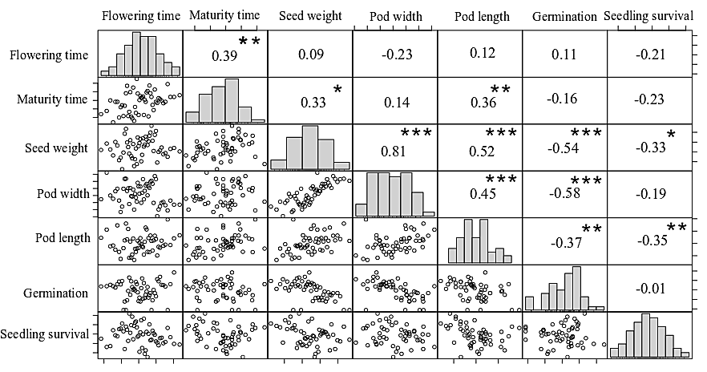

3
Figure S2. Mean of percent seedling survival of primed and non-primed seeds with standard deviation in control and waterlogged conditions (Experiment 3).

