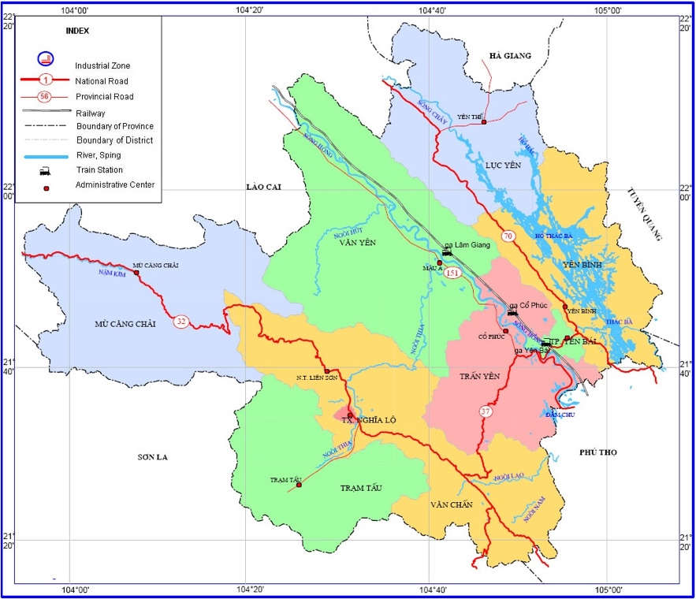 | 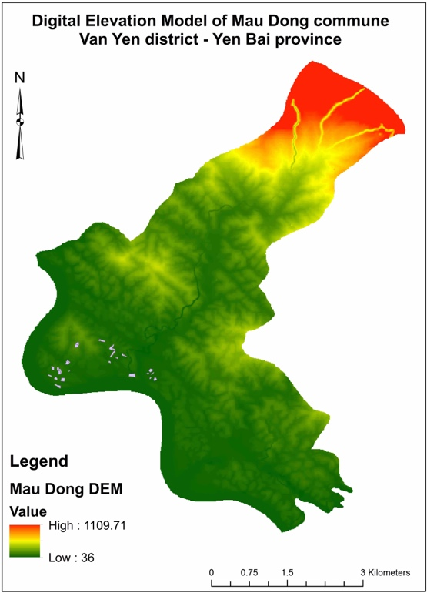
Figure S2. Field experiment location at Mau Dong commune, Van Yen district, Yen Bai province, Vietnam in 2018

