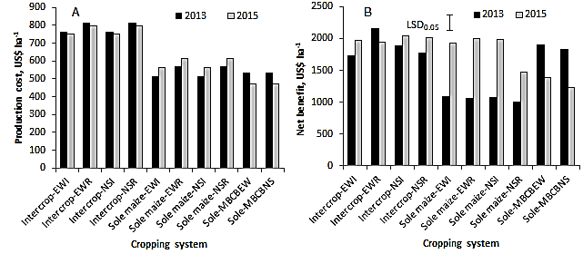
Figure S2. Production cost (A) and net benefit (B) of the intercrops and the associated sole crops in 2013 and 2015. EWI, East-West Intact; EWR, East-West Removed; NSI, North-South Intact; NSR, North-South Removed; MBCBEW, Mungbean-Common bean East-West; MBCBNS, Mungbean-Common bean North-South. 1 US$ was 19.14 ETB in 2013 and 21.29 ETB in 2015.

