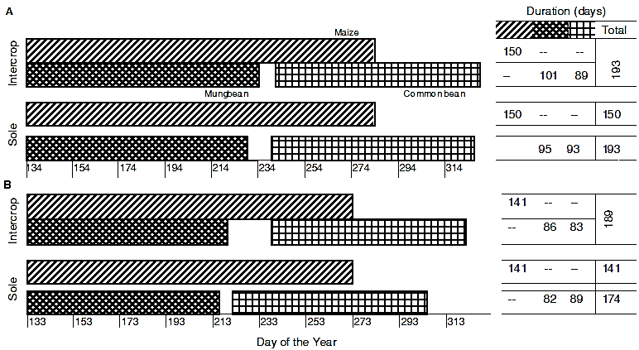
Figure S1. Relative growth periods of the intercrops and sole crops from sowing to harvest in (A) 2013 and (B) 2015. The co-growth period of maize with common bean amounted to 47 days in 2013 and 34 days in 2015 while the overlap of the two pulses with maize was 148 and 120 days, in that order.

