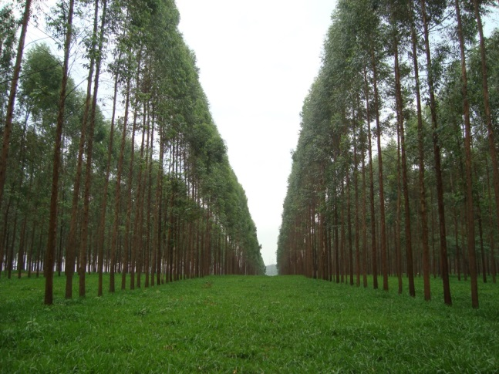

**A**

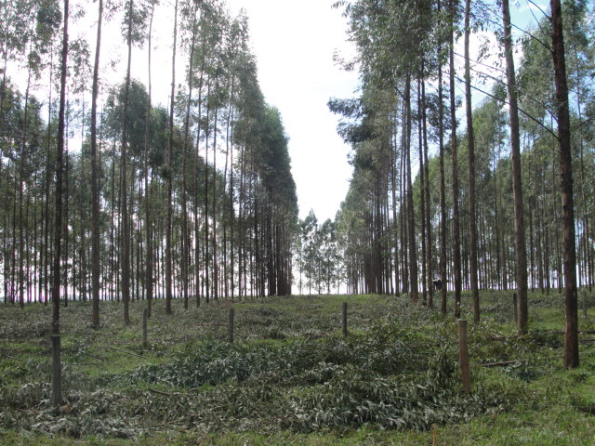

**B**

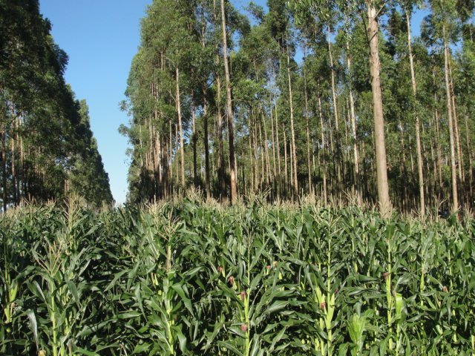

**C**

Figure S1. Pictures of the experimental integrated crop livestock forest area (iCLF) before thinning (A), after thinning (B) and during the corn cultivation (C).



**N**

Figure S2. Pictures of the experimental integrated crop livestock forest system (iCLF) and integrated crop livestock system. The white dotted lines delimit the paddocks used in the evaluation of the pasture renovation in 2016/2017.



Figure S3. Schematic representation of the experimental integrated crop livestock forest area (iCLF) indicating where the data were collected. iCLF_1: 1.9 m, iCLF_2: 3.75 m, iCLF_3: 7.50 m and iCLF_4: 11.25 m from North row.