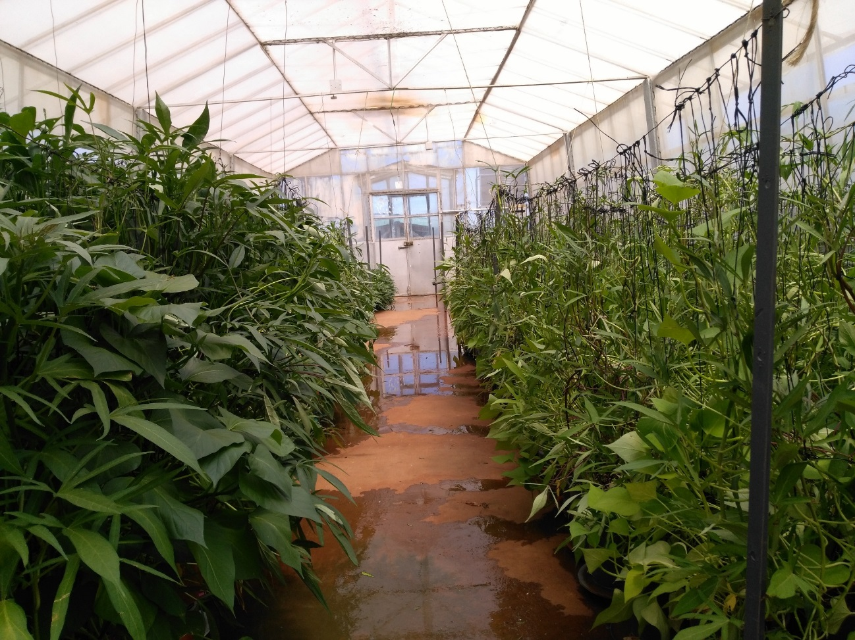
Fig. S1. Trellised experiment showing vigorous sandponics growth (L) compared with conventional (R).

